Jenkins Task-2

Task Description:
Create a simple script file and push it to repo. Create a project in Jenkins connected to your GitHub repository. When a commit is made to your repo, automatically build must get triggered from Jenkins and the output must be shared to me via email.
We are using the same EC2 instance that was used in the Jenkins Task 1.
The following are the steps that needs to be done to complete this task.
- Create a script and push it to a GitHub repo
- Create a GitHub-connected Jenkins project
- Set up a webhook so commits auto-trigger builds
- Configure email notifications for build output

Phase 1: Create the Script and Push to GitHub
Lets create a directory in our EC2 instance (Public IP: 35.90.52.249) which was created the previous task and then navigate to the directory and initiate Git in it.
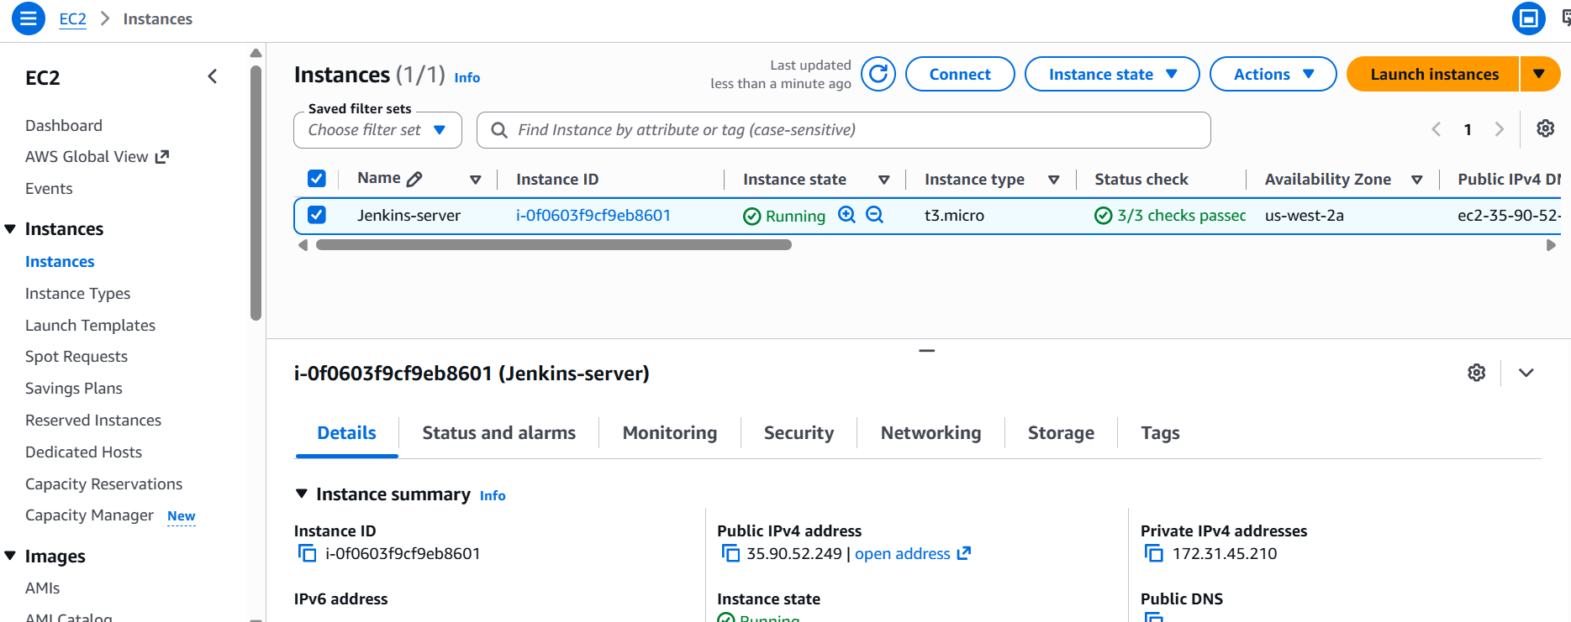

mkdir ~/jenkins-demo-repo
cd ~/jenkins-demo-repo
git init
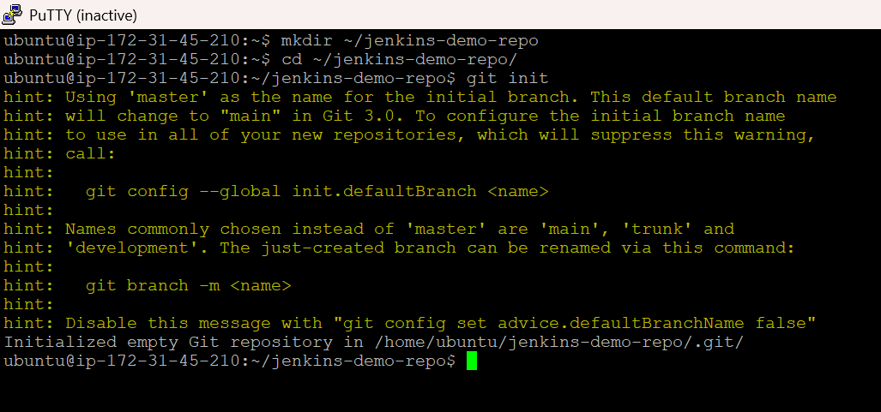
Let’s create a simple script
cat > hello.sh << 'EOF'
#!/bin/bash
echo "Hello from Jenkins pipeline!"
echo "Build triggered at: $(date)"
echo "Running on host: $(hostname)"
EOF
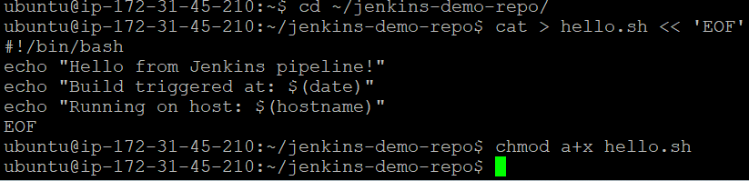
chmod a+x hello.sh
Let’s create a new empty repository on GitHub (via the website) and name it as “jenkins-demo-repo”
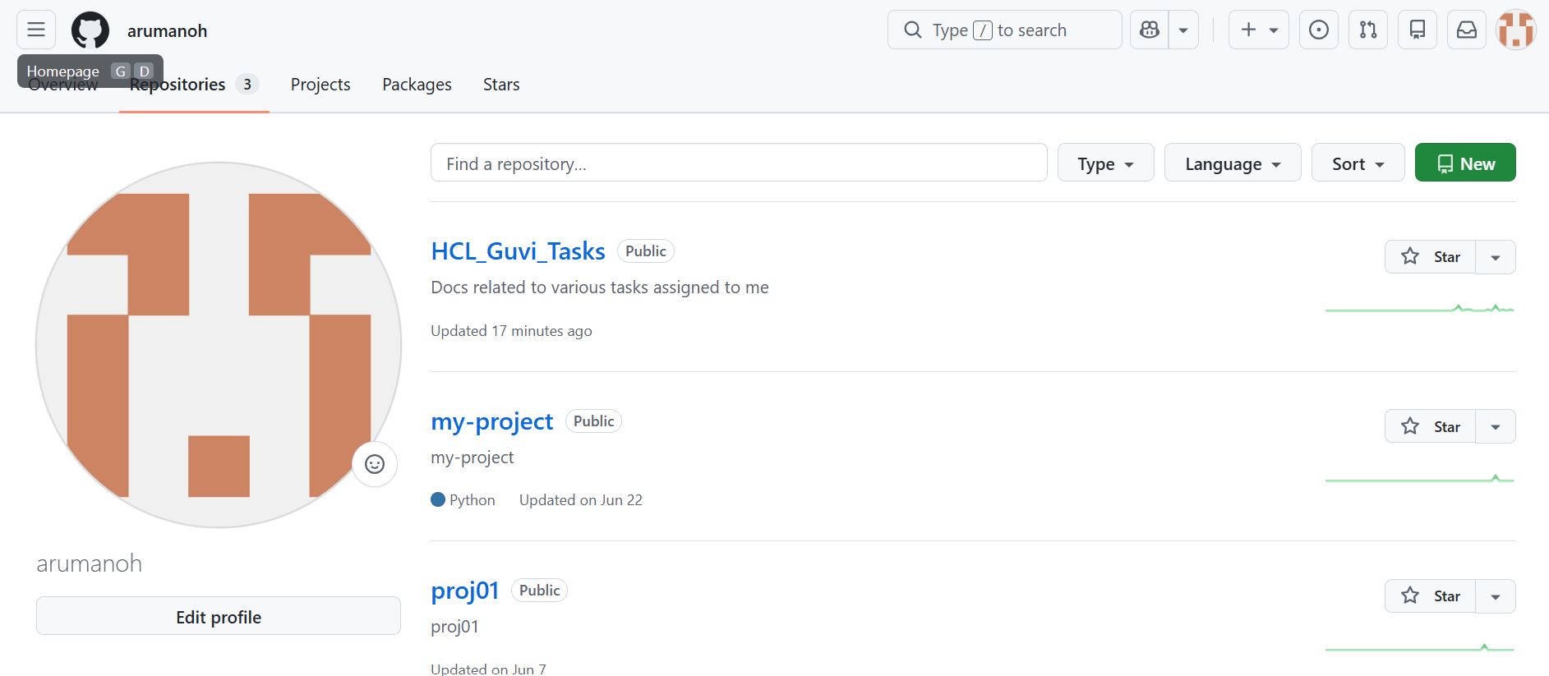

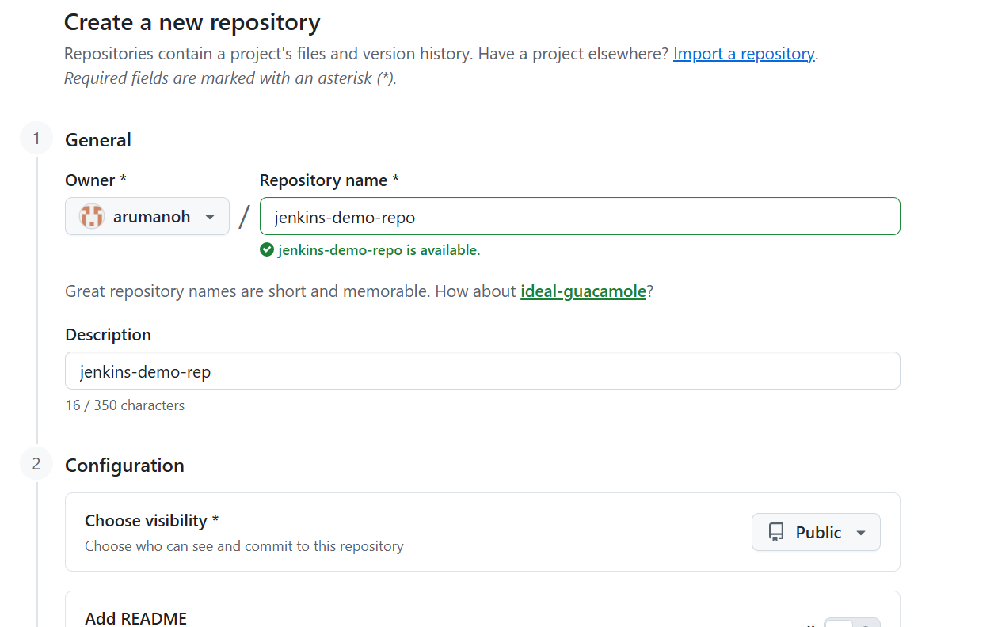

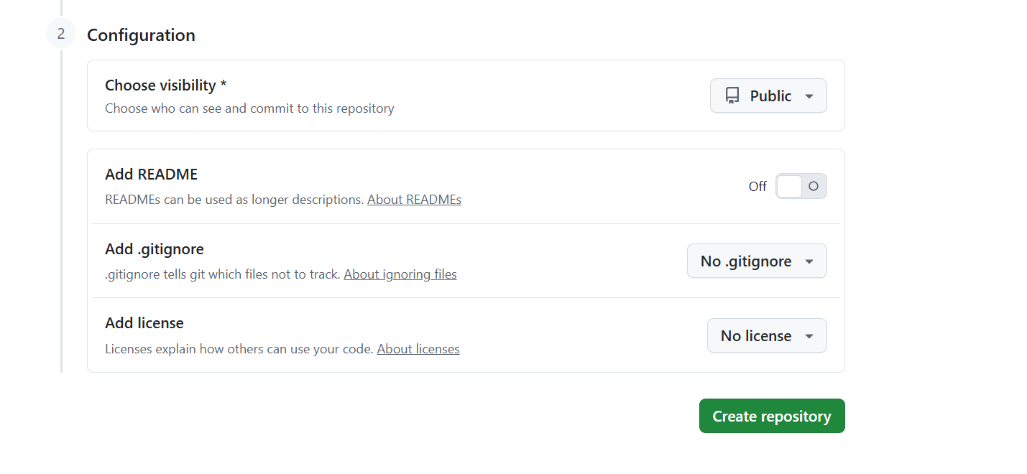
We are not initializing “READ ME”
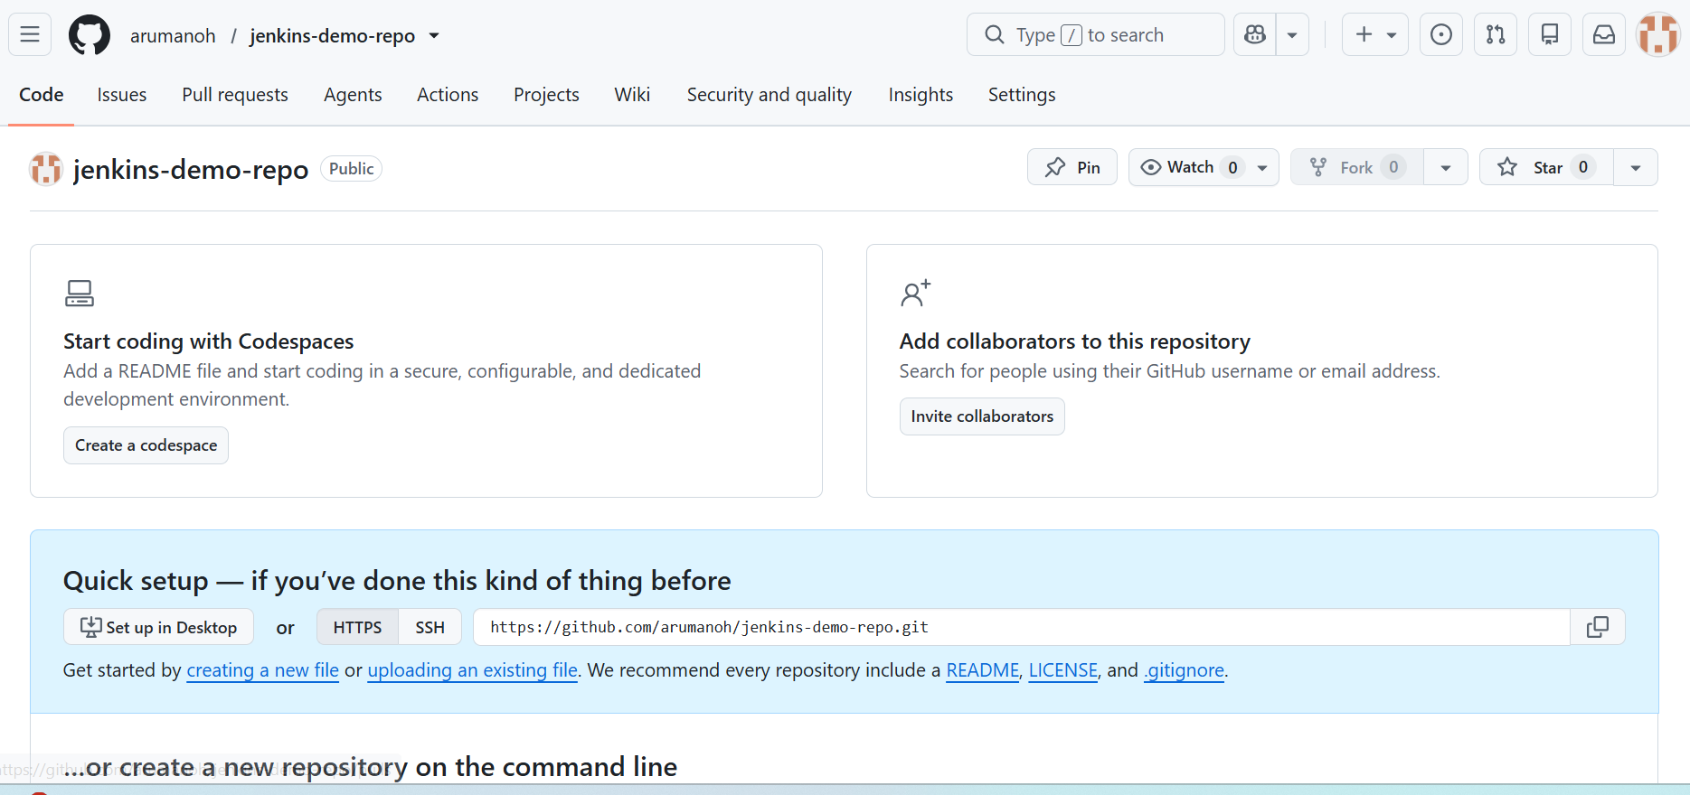
New Repository by name “Jenkins-demo-repo” has been created successfully.
Let’s push the file “hello.sh” from the EC2 instance to the newly created Github repository
git add hello.sh
git commit -m "Add initial hello script"
git branch -M main
git remote add origin https://github.com/arumanoh/jenkins-demo-repo.git
git push -u origin main

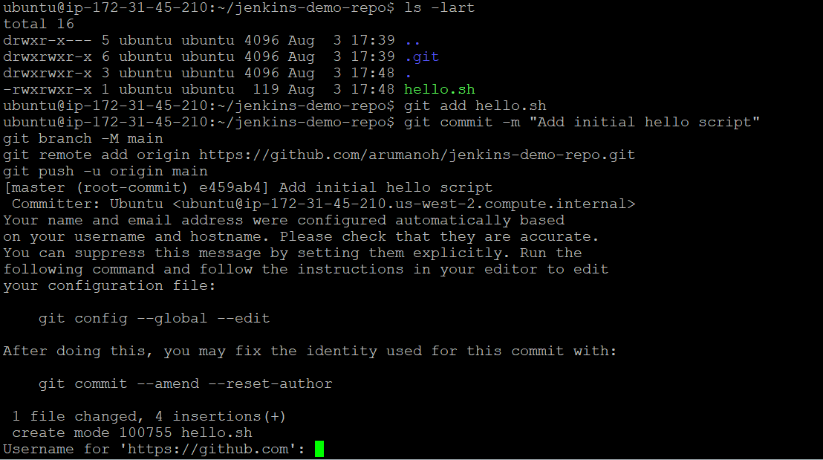

We can give the username as “arumanoh”, however for password we need to get the “Personal Access Token” instead of the actual password since the password based authentication has been retired by Github.

GitHub → Settings → Developer settings → Personal access tokens → Tokens (classic)
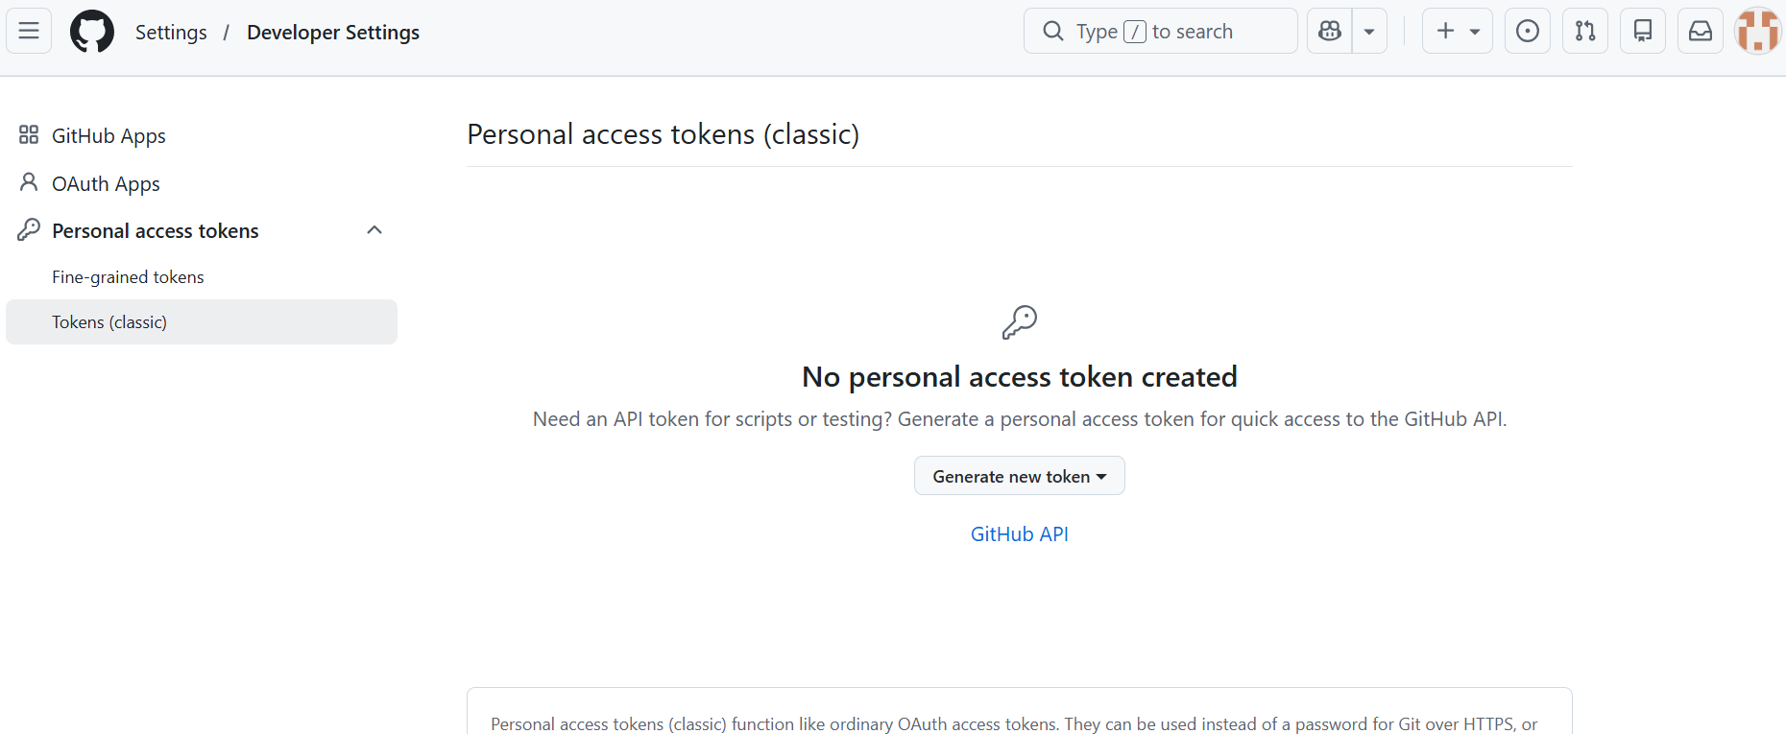
Generate new token → select repo scope → generate

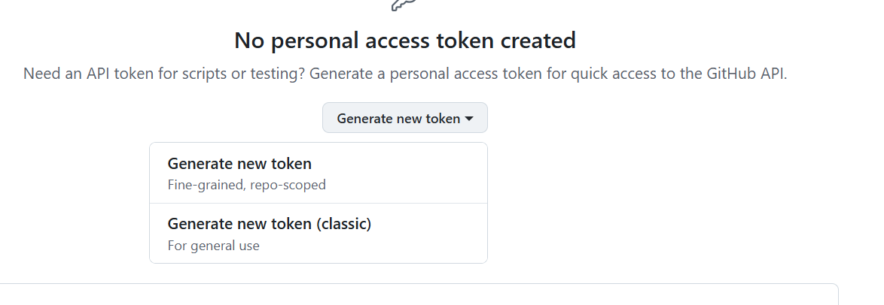
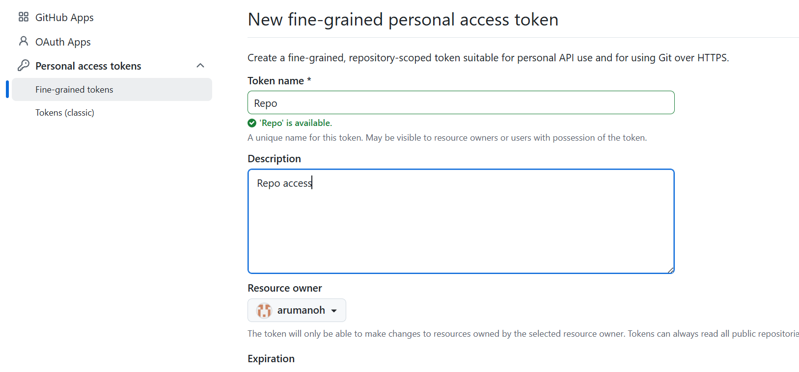

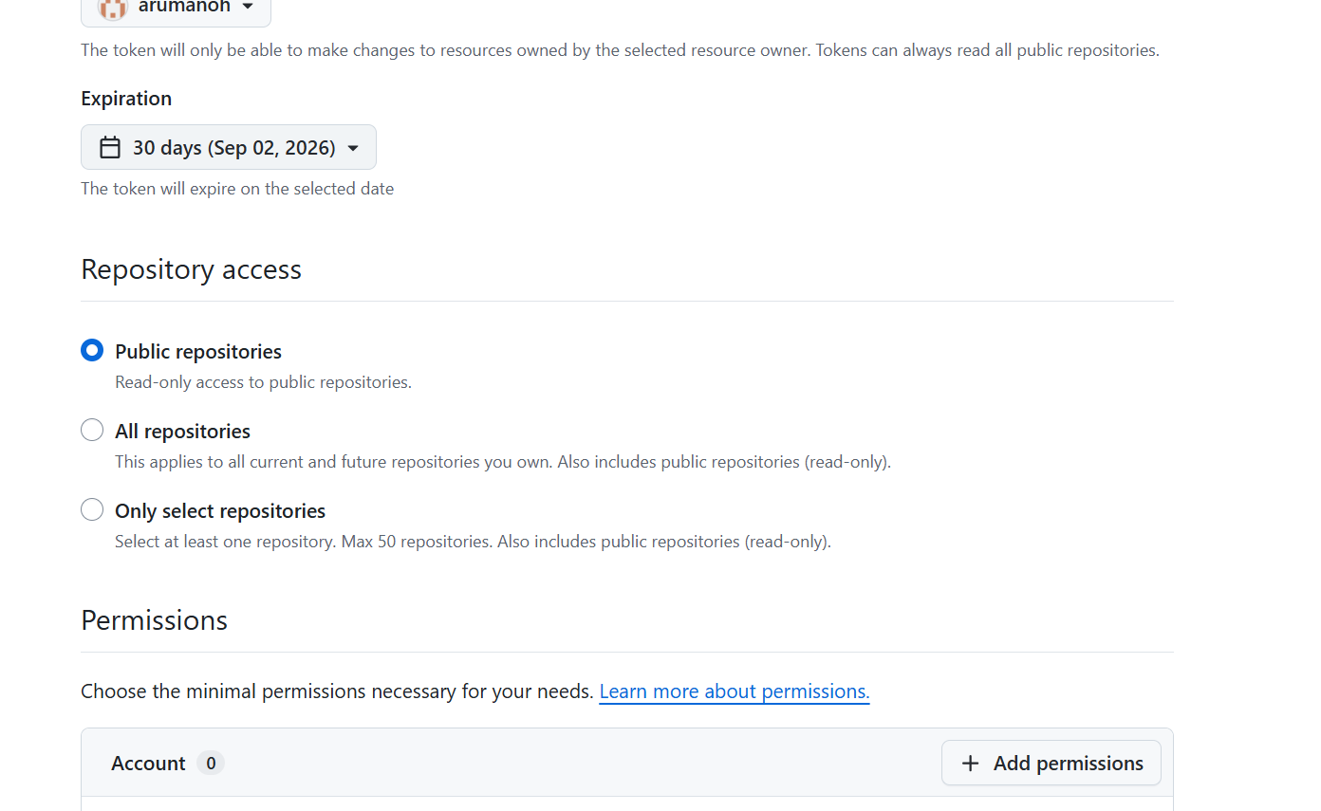

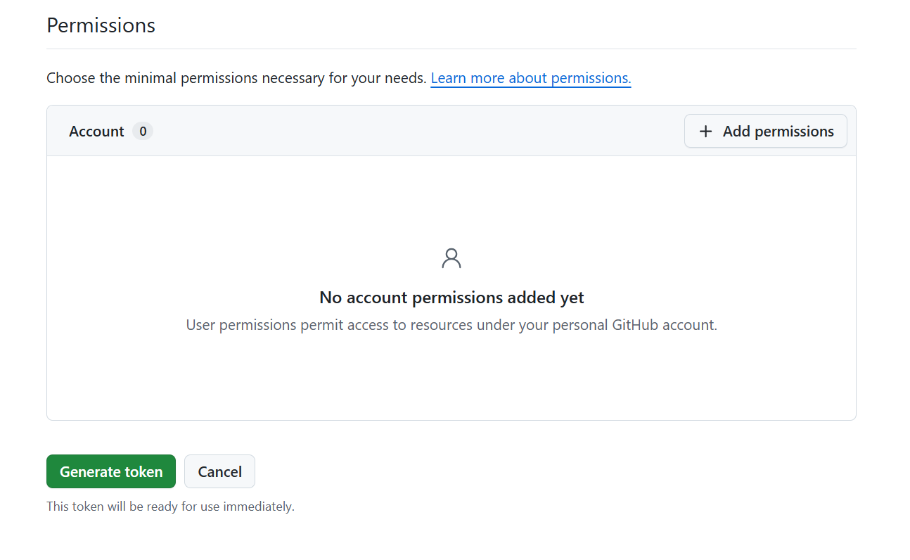
Click on Generate token and then copy and save the token in a notepad safely.
Paste the token in the password field
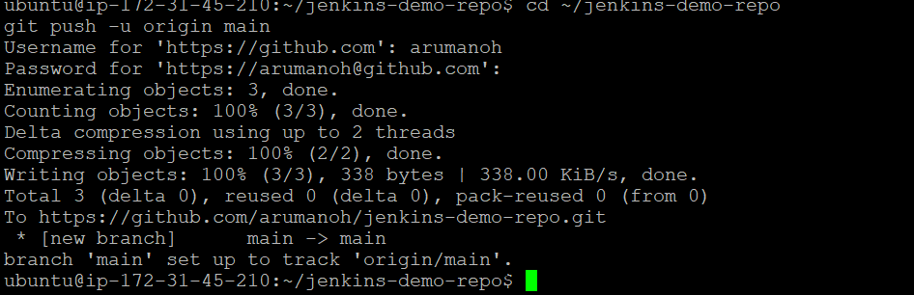

Lets validate whether the file “hello.sh” is present in our Github repository
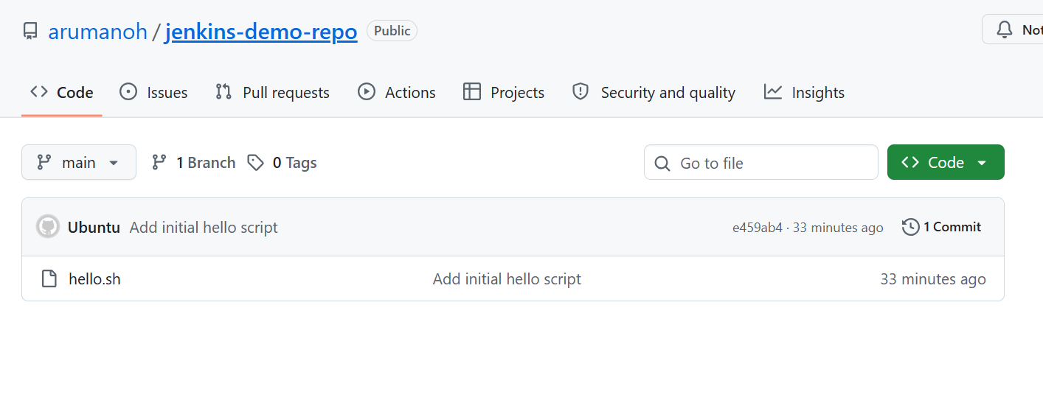
Yes, it is present here, successful pushed from our EC2 instance.
Now let's create the Jenkins project pointed at this repo.
Phase 2: Create the Jenkins Project
Lets login to Jenkins as administrator “arul-admin”
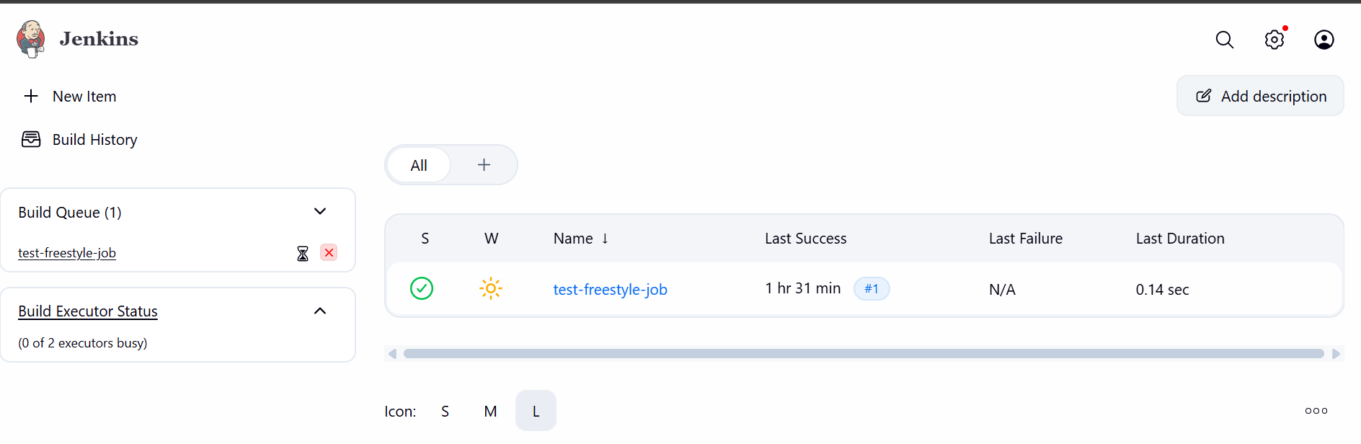
Jenkins dashboard → New Item
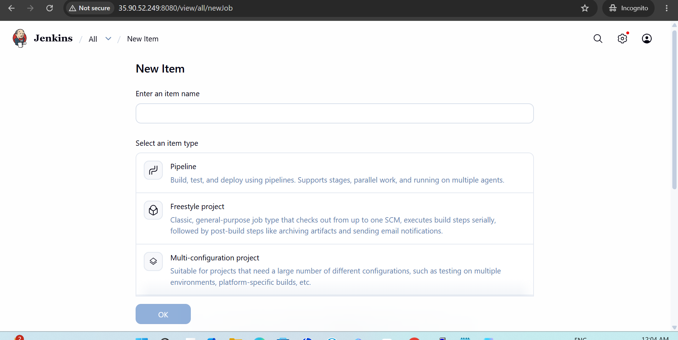
Name: github-triggered-build → select Freestyle project → OK
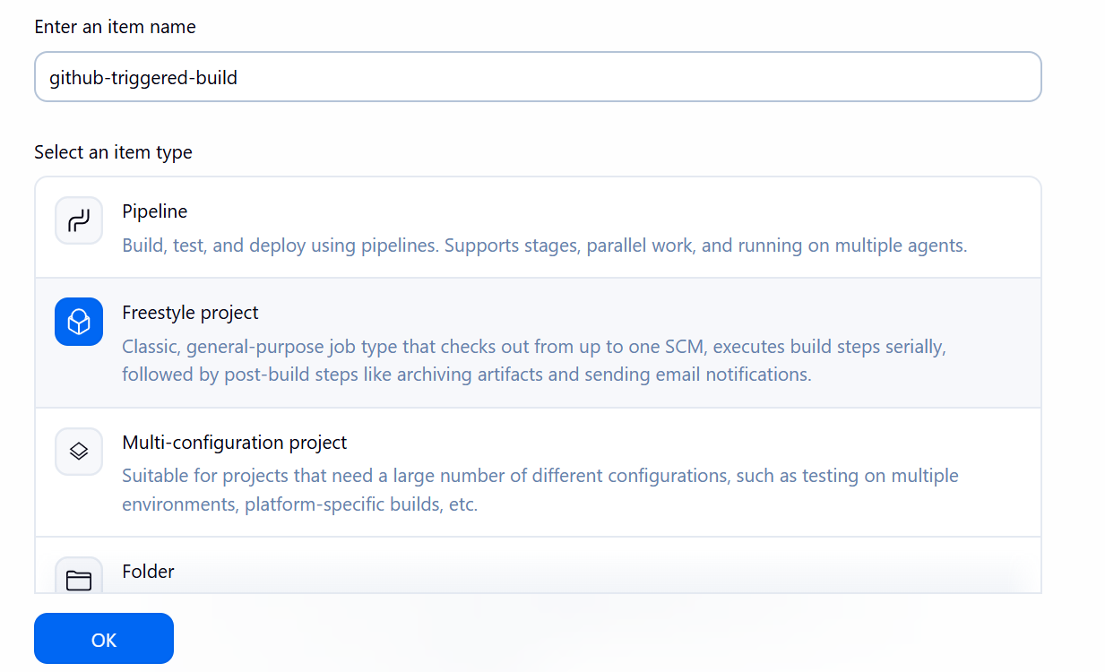
Under Source Code Management → select Git
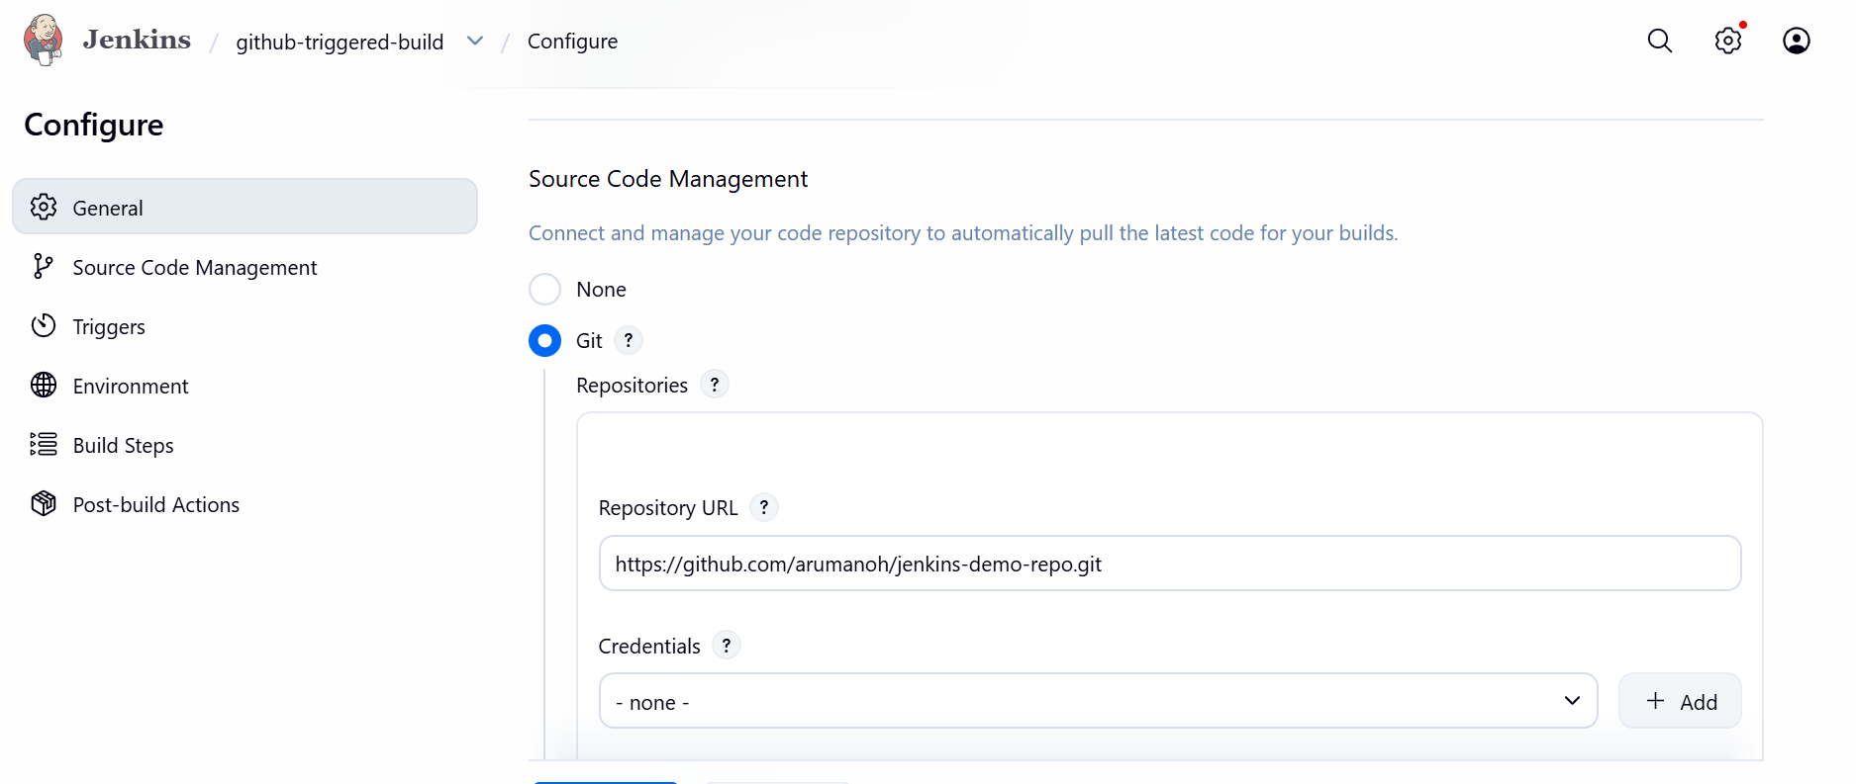
- Repository URL: https://github.com/arumanoh/jenkins-demo-repo.git
- Branch Specifier: */main
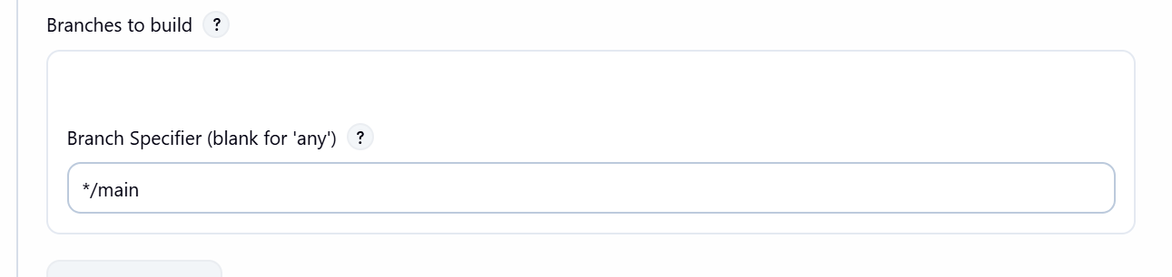
Under Build Triggers, check GitHub hook trigger for GITScm polling
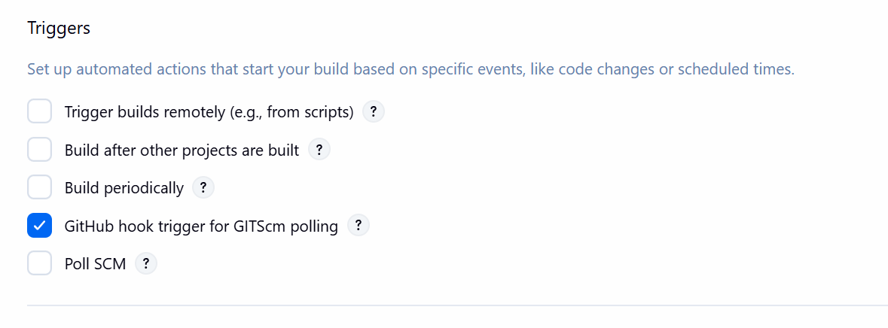
Under Build Steps → Add build step → Execute shell:
chmod +x hello.sh
./hello.sh

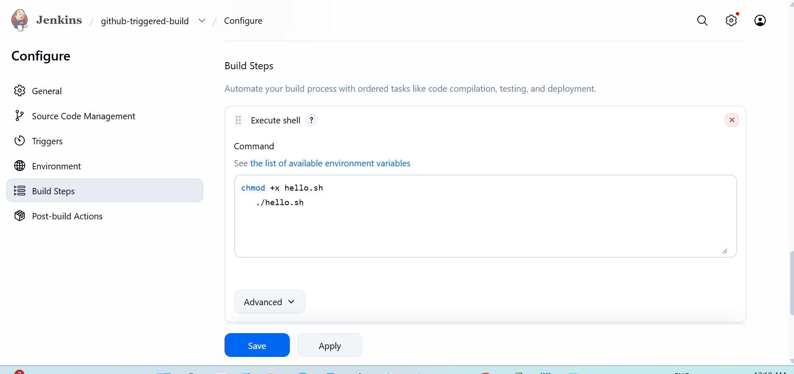

Click Save.
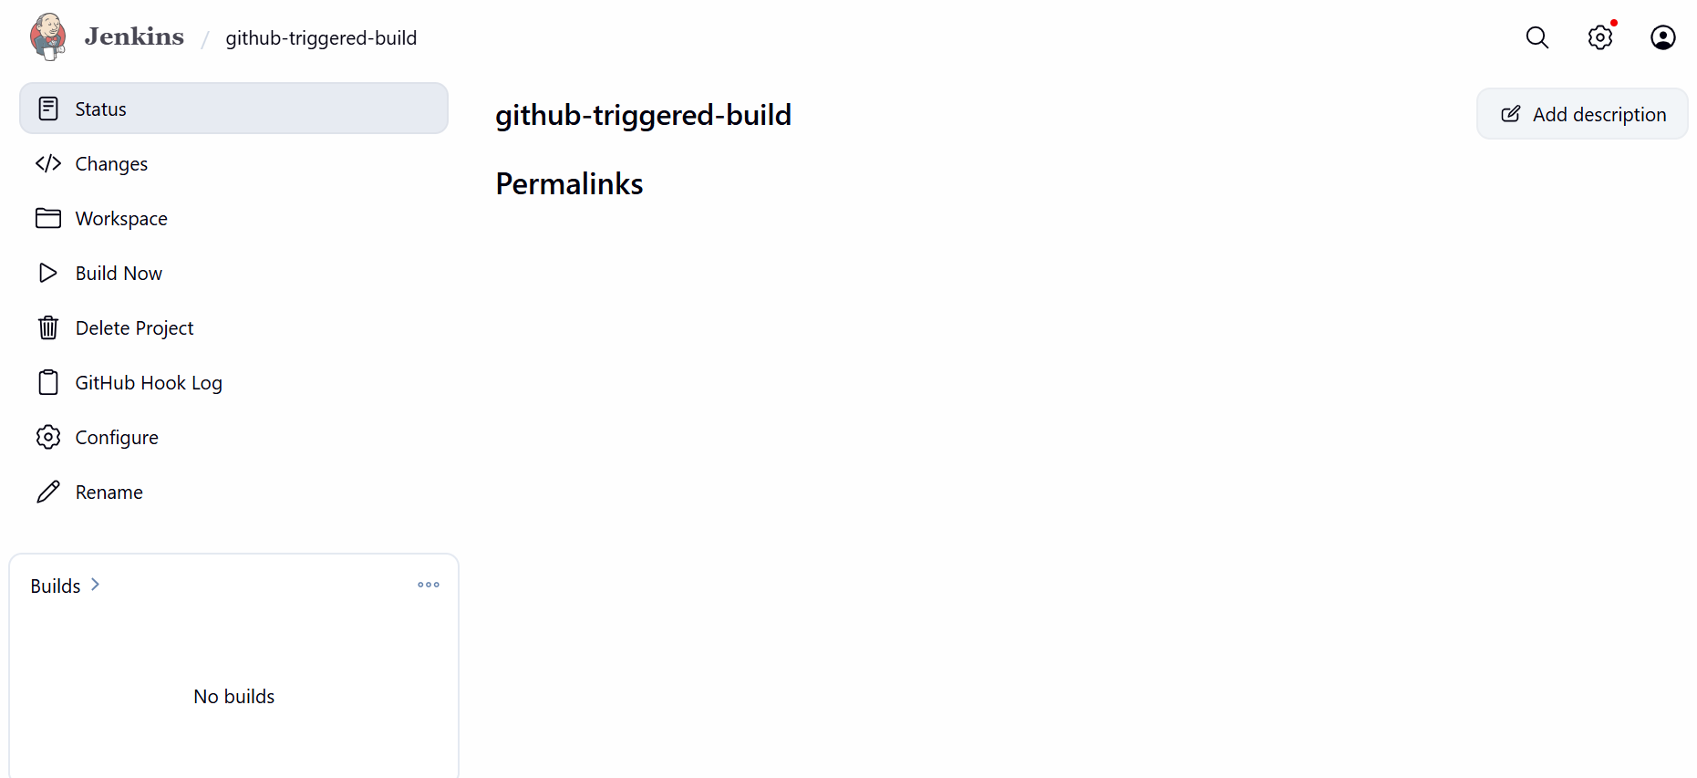

Now click “Build now”

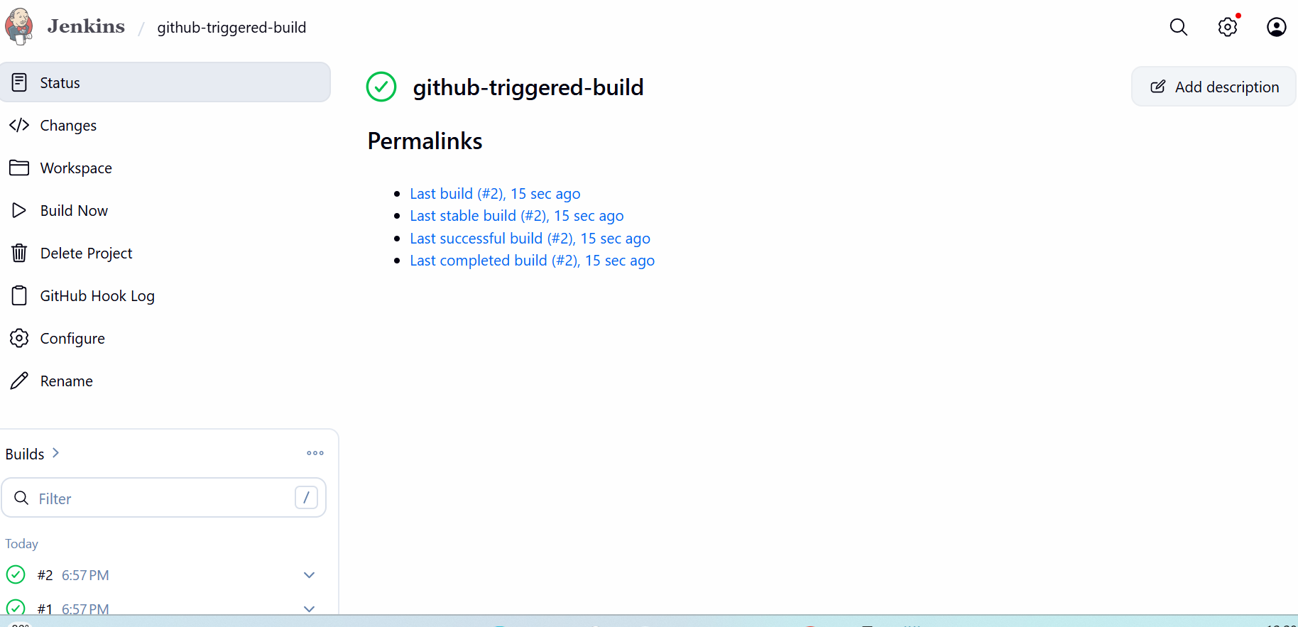

The Job ran successfully. Let’s look at the console output

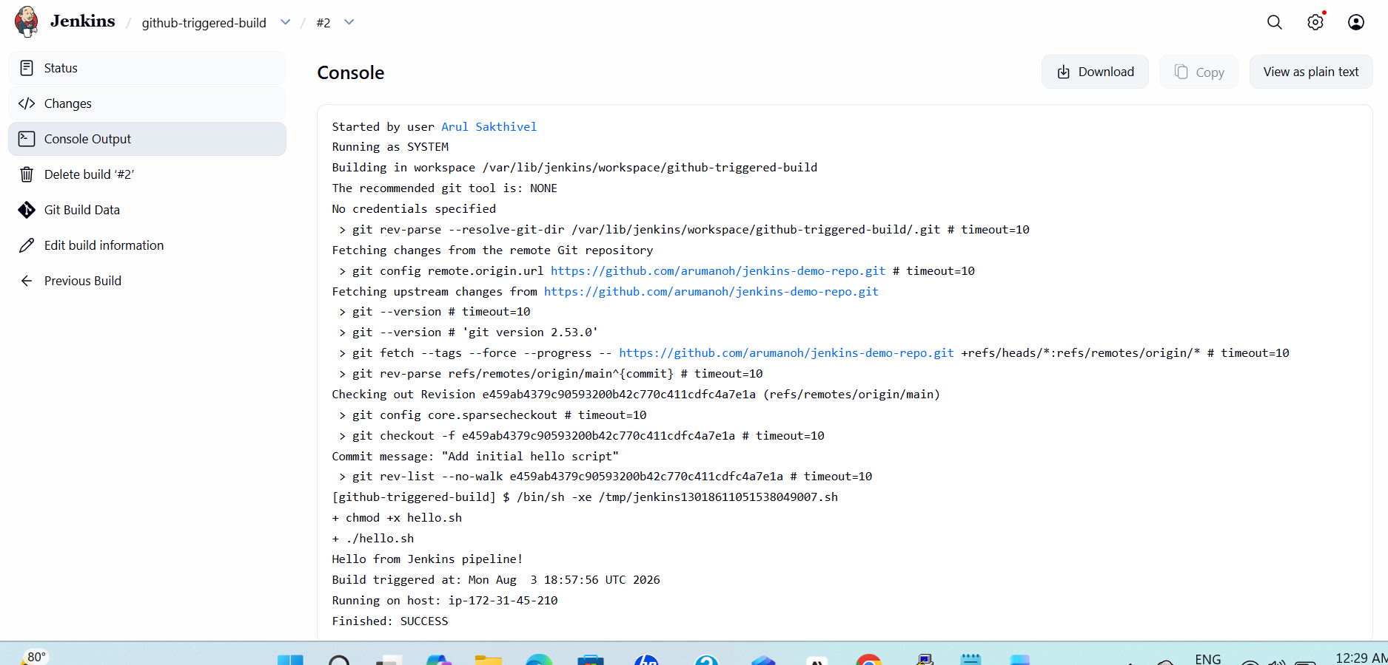

Phase 3: Set Up the Webhook (auto-trigger on commit)

Our Jenkins server is on a public EC2 IP (35.90.52.249:8080), so GitHub's webhook servers can actually reach it directly.
- Go to your GitHub repo → Settings → Webhooks → Add webhook
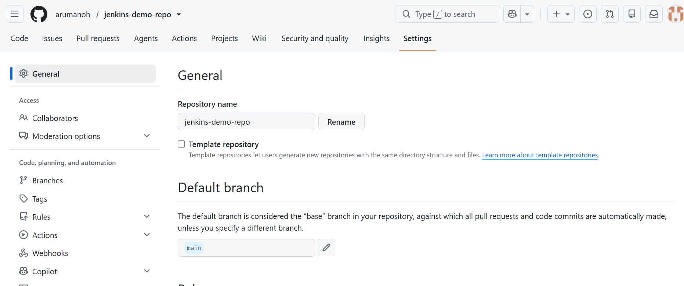
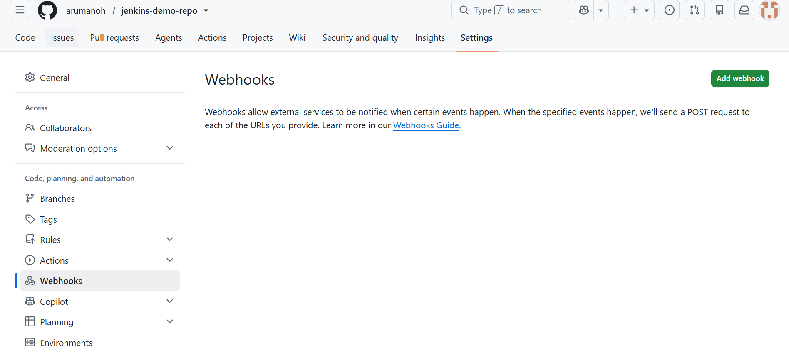
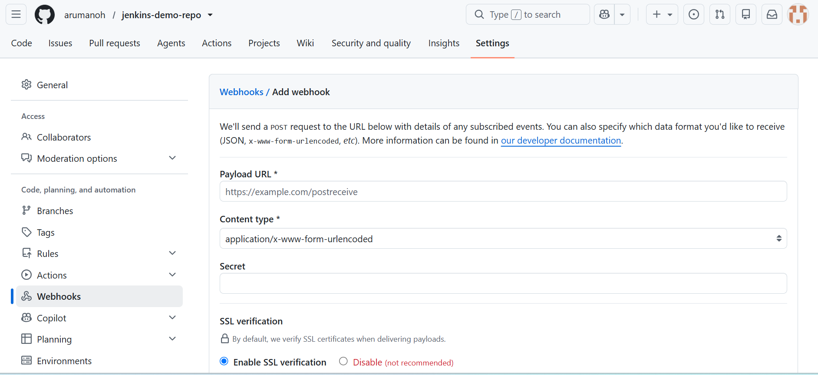

- Payload URL: http://35.90.52.249:8080/github-webhook/
- Content type: application/json
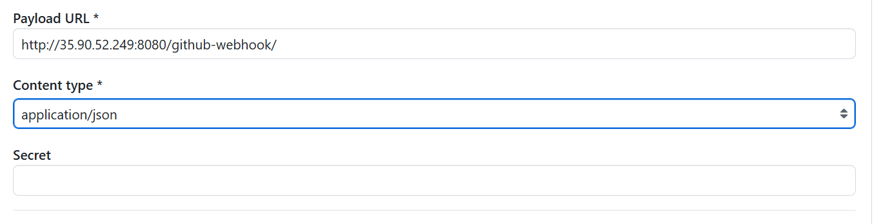
- Which events: leave as "Just the push event"
- Click Add webhook
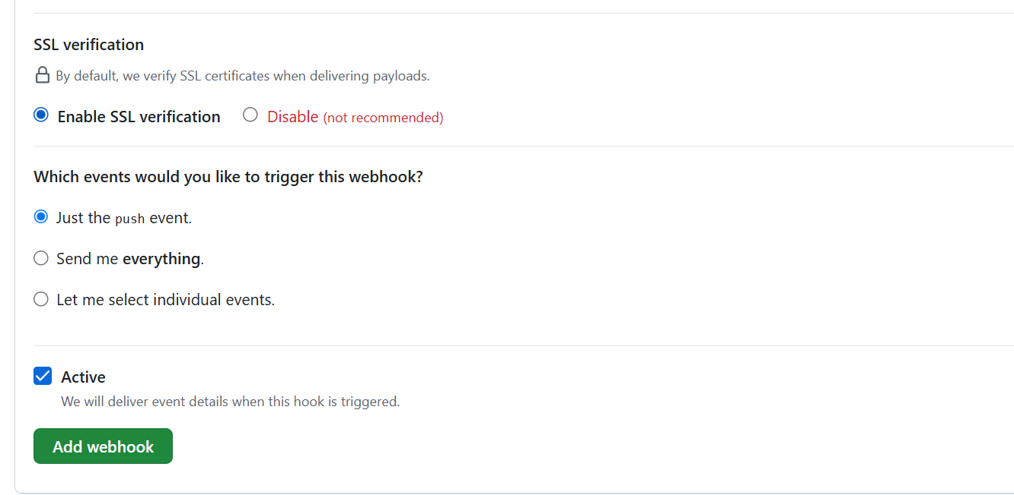

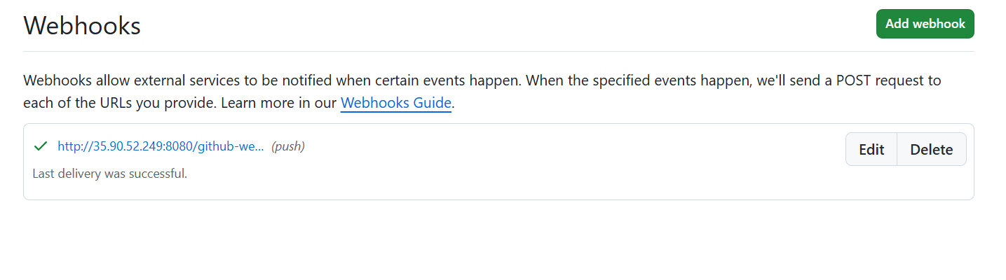
Now let’s verify it actually triggers a Jenkins build (not just receives the ping) by making a small commit:
cd ~/jenkins-demo-repo
echo 'echo "Second line added"' >> hello.sh
git add hello.sh
git commit -m "Test webhook trigger"
git push

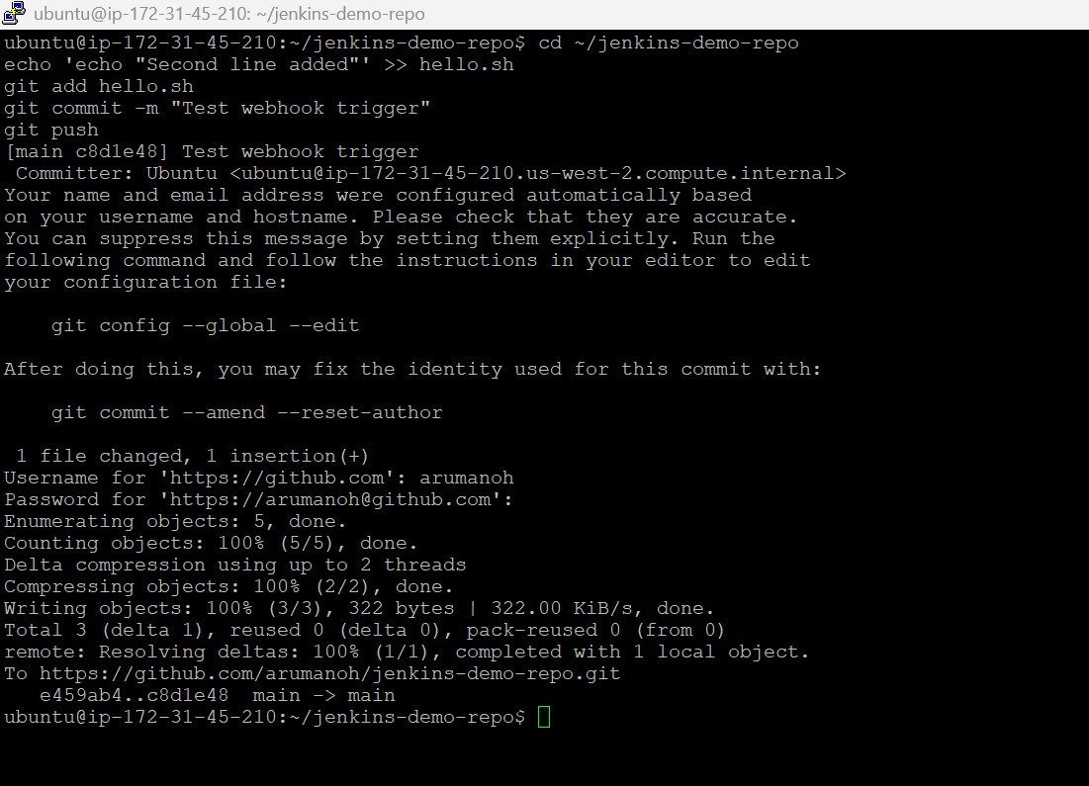

This has actually triggered the 3rd build in Jenkins automatically.

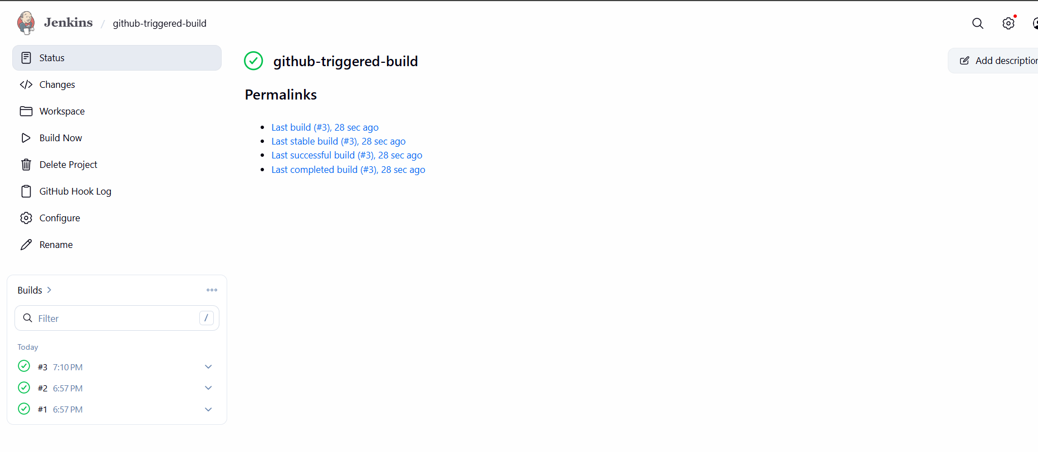

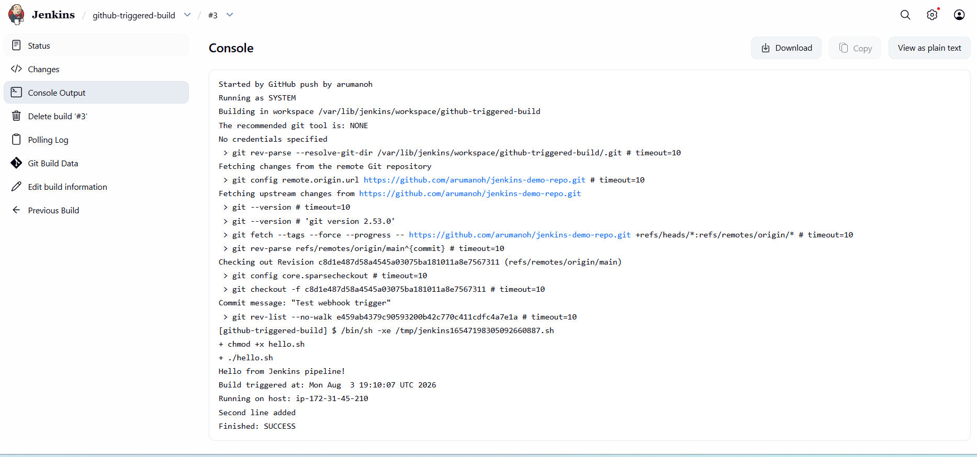

Everything was automatically done and no manual intervention needed.

Phase 4: Email Notifications

Step 1: Generate a Gmail App Password
  - Go to your Google Account → Security
  - Make sure 2-Step Verification is turned on (required for app passwords)
  - Search for "App passwords" (or go to myaccount.google.com/apppasswords)
  - Create one — name it something like jenkins
  - Copy the 16-character password it generates (no spaces needed when you use it)

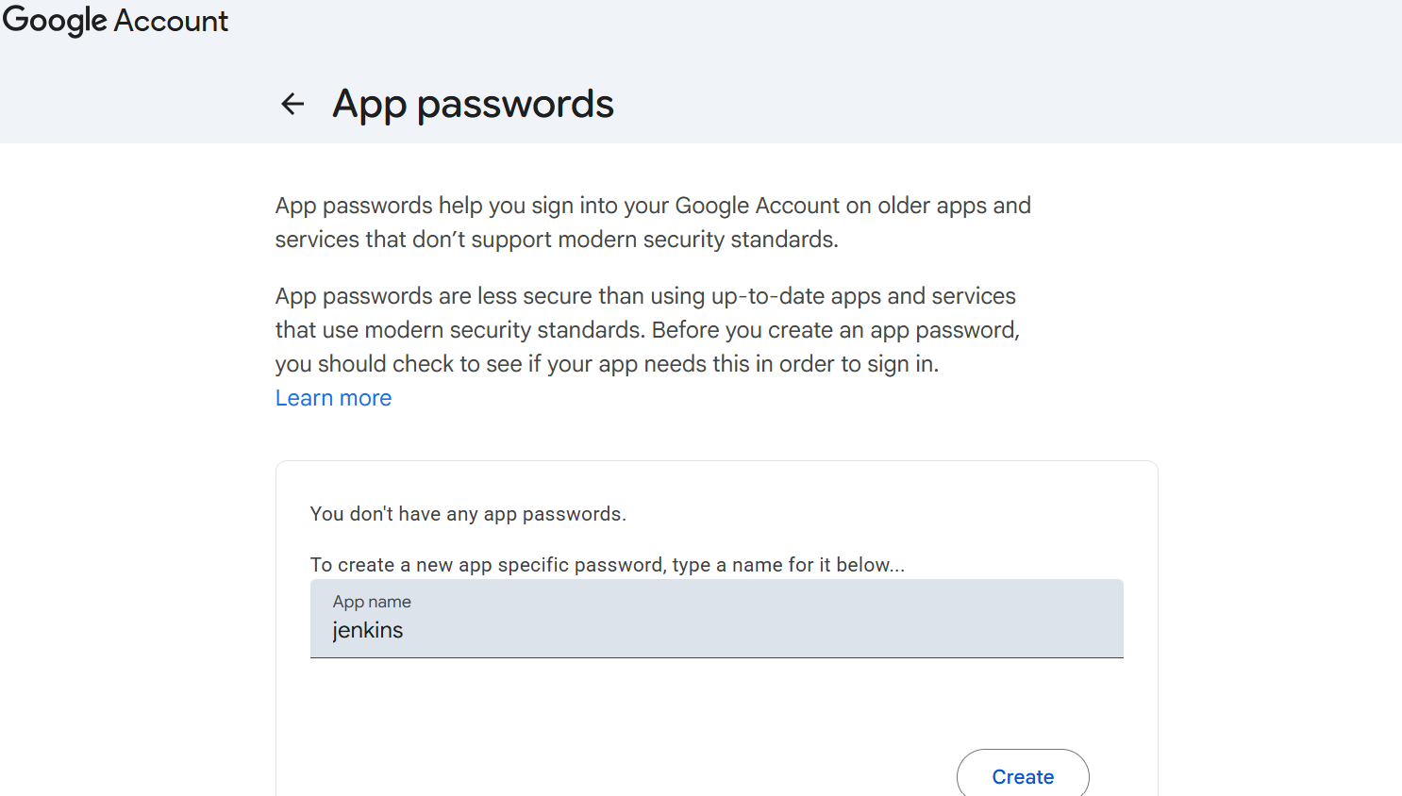
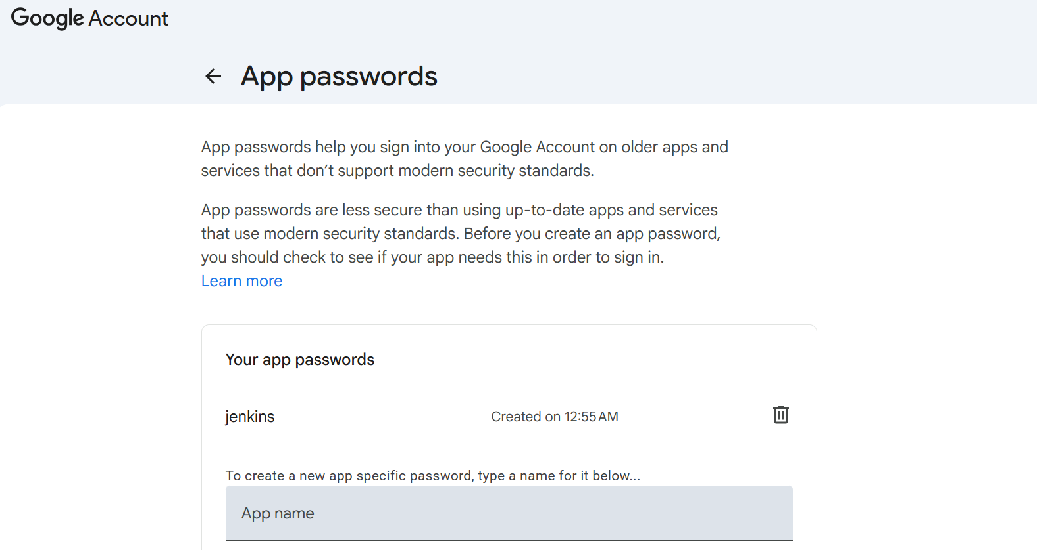
We have successfully generated the 16 digit app password for Jenkins.

Step 2: Configure SMTP in Jenkins
Go to Manage Jenkins → System, scroll down to E-mail Notification:
SMTP server: smtp.gmail.com
Click Advanced...
  - Check Use SMTP Authentication
  - User Name: your full Gmail address
  - Password: the App Password from Step 1
  - Check Use SSL
  - SMTP Port: 465

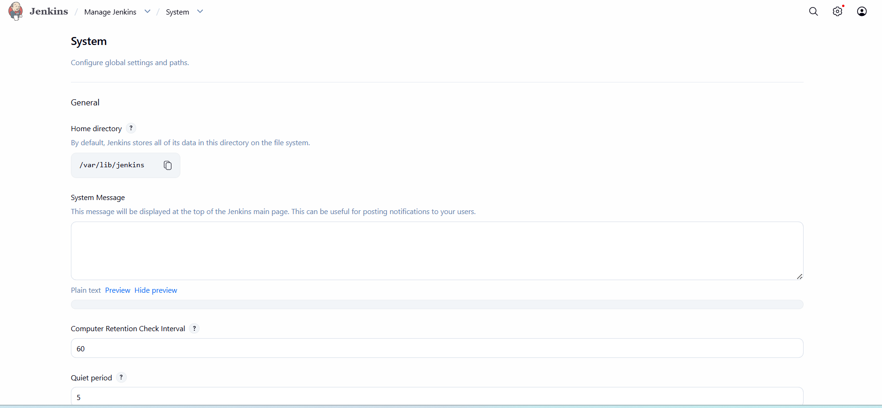

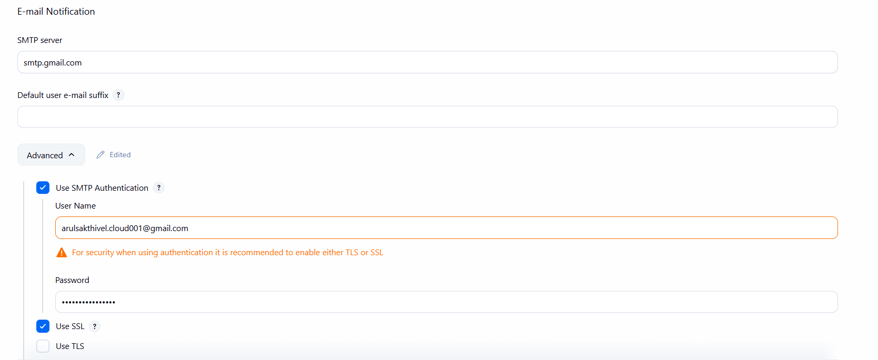

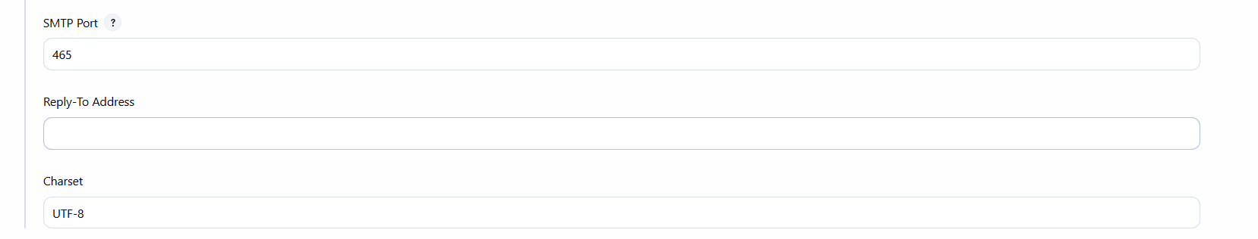

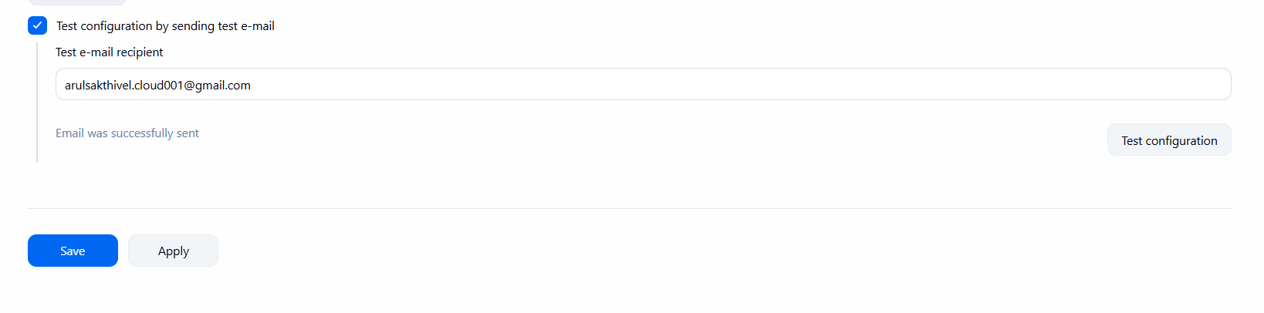
Let’s check whether we have received email in our inbox.

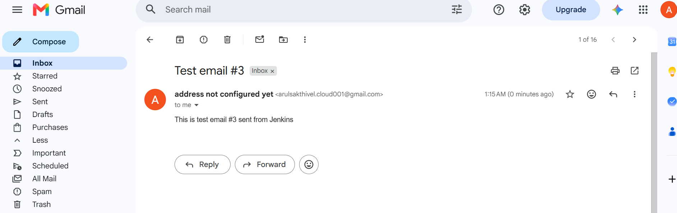

Yes we have received the email from Jenkins successfully.

Now let’s Add Post-Build Email Action to the Job
- Go to github-triggered-build → Configure
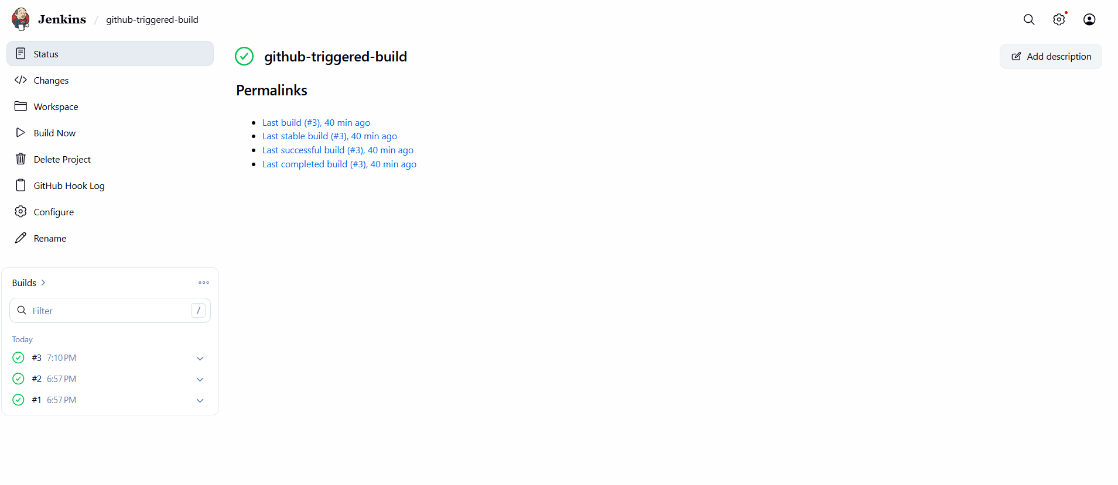
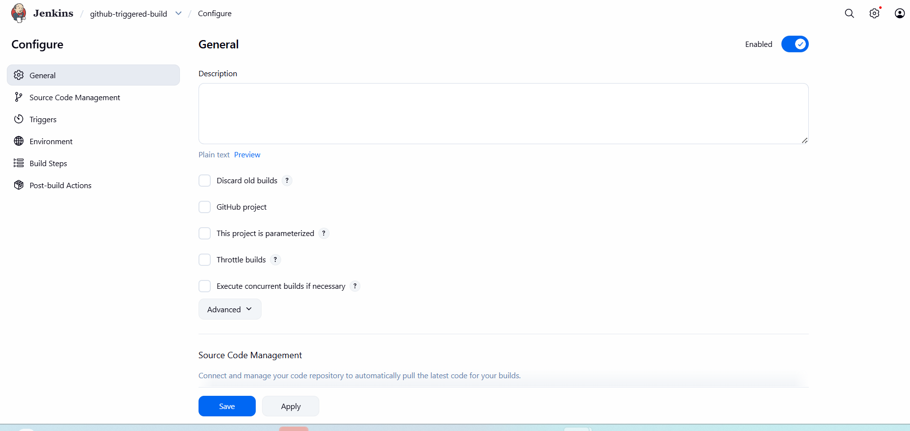
- Scroll to the bottom → Post-build Actions → Add post-build action
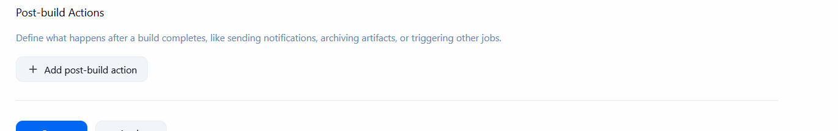

- Choose Editable Email Notification (this comes from the Extended E-mail plugin we just configured)
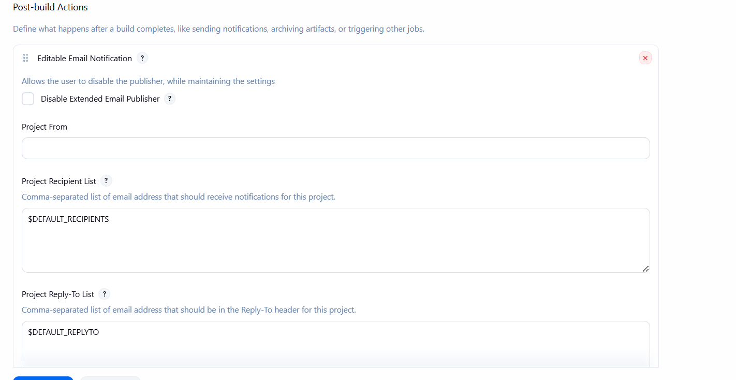

- Fill in:
- Project Recipient List: arulsakthivel.cloud001@gmail.com
- Leave Default Subject / Default Content as-is initially, or customize:
  - Subject: Build #$BUILD_NUMBER - $PROJECT_NAME - $BUILD_STATUS
  - Content: Build $BUILD_NUMBER finished with status: $BUILD_STATUS ${BUILD_URL}console
- Under Triggers (there's usually a default "Failure - Any" trigger listed), click to add or edit it — for our case, let's add a trigger for "Always" so you get an email on every build regardless of pass/fail, since this is just for learning/visibility right now
- To actually include the console output in the email body, check "Attach Build Log" if that option is visible under the trigger's advanced settings
Click Save

Now let’s test from end to end for one final time

cd ~/jenkins-demo-repo
echo 'echo "Final test - full pipeline"' >> hello.sh
git add hello.sh
git commit -m "Final pipeline test"
git push

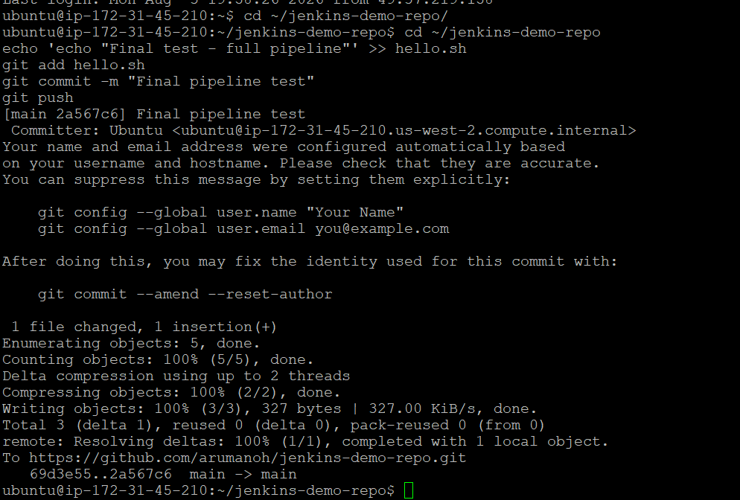

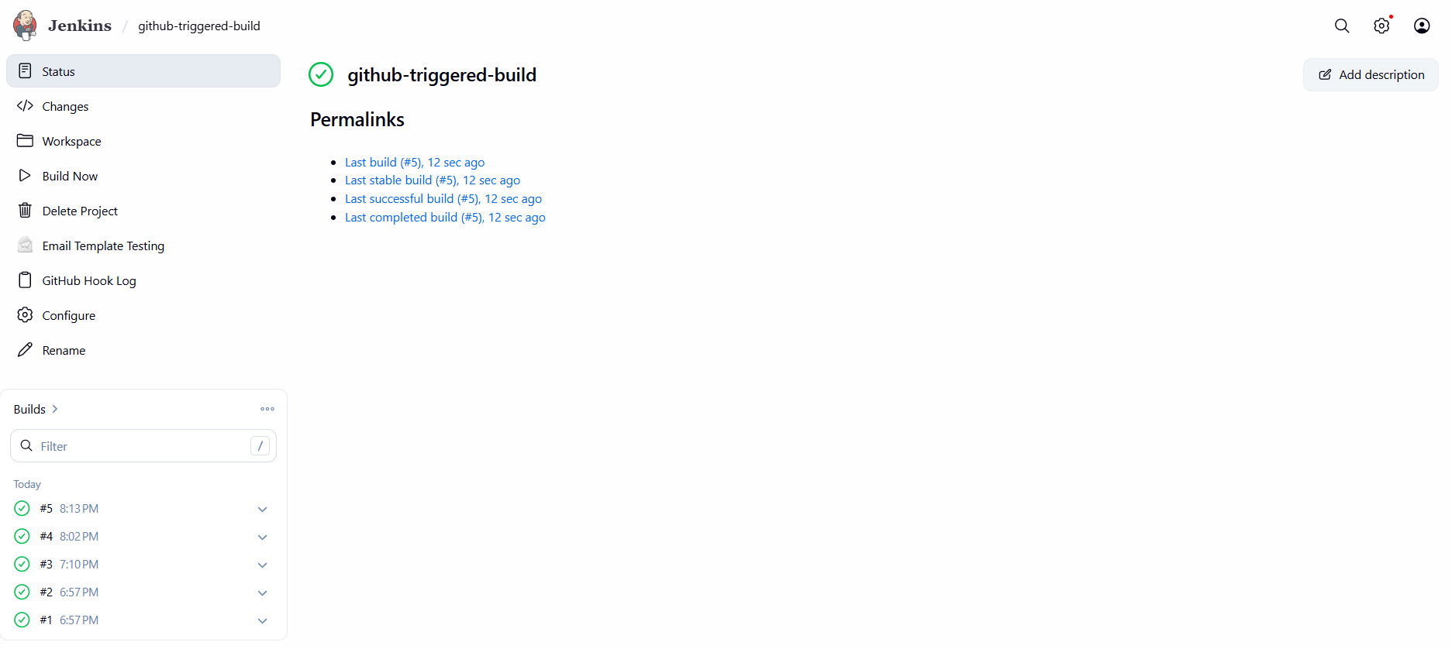

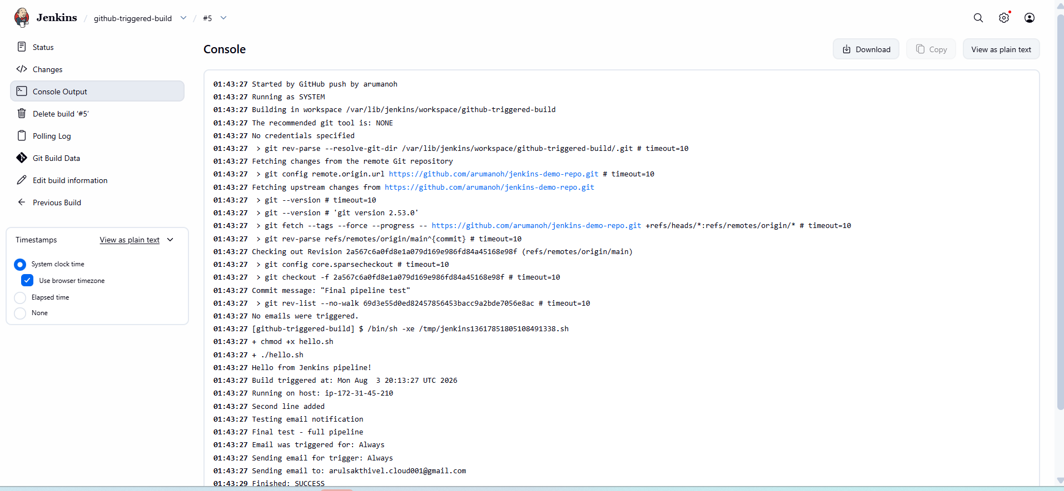

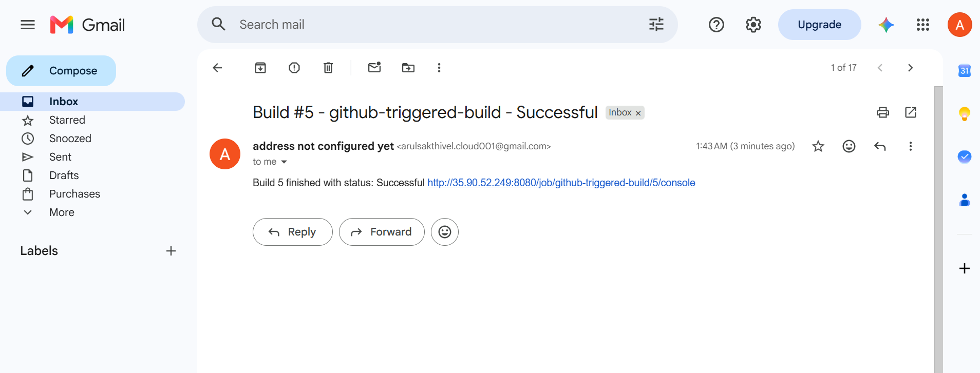

The job ran successfully and it also triggered an email to my mailbox with the output. This concludes the task.

