Docker Task -3

Task Description:
Create a custom docker image for nginx and deploy it using docker compose, where the volume bind mount should be at /var/opt/nginx location. Push the created custom docker image to your docker-hub.
We will use the same EC2 instance which was used in the Docker Task 2.
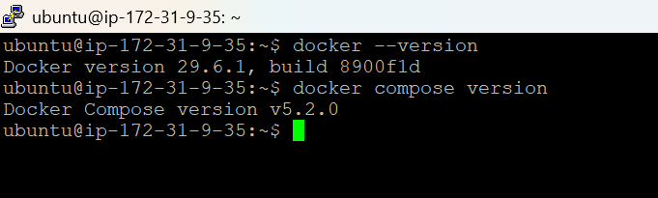
Creating the Folder
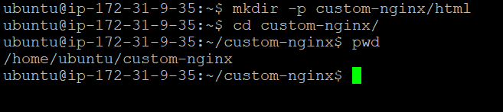
Create the 3 files now
- Dockerfile
- html/index.html
- docker-compose.yml
Dockerfile:
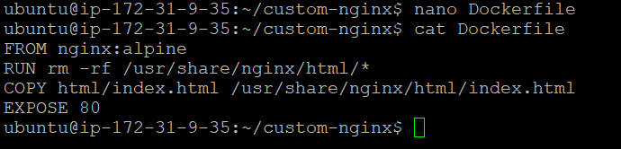

html/index.html:
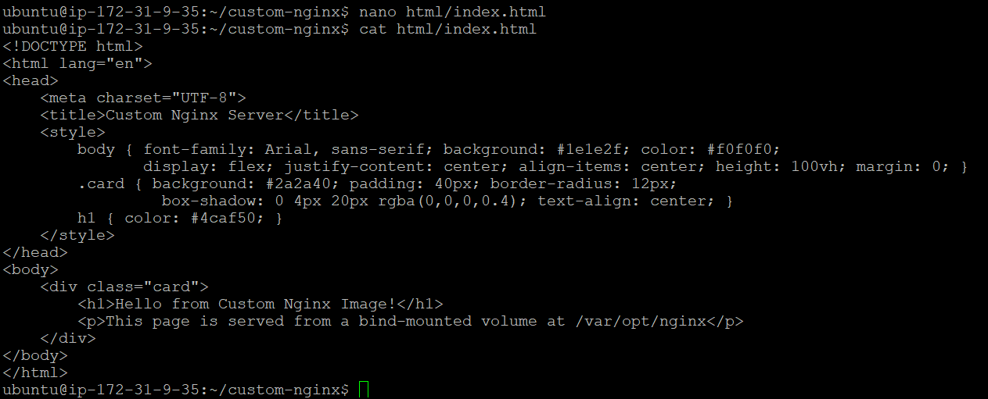

docker-compose.yml:
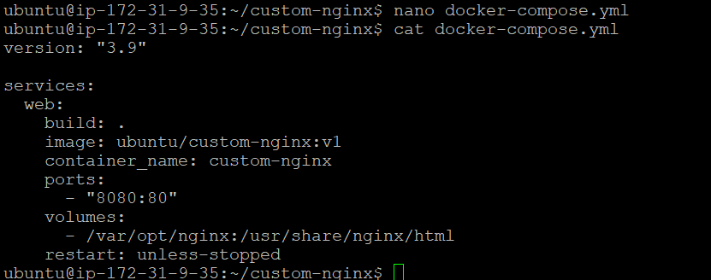
Now lets create the host bind-mount directory
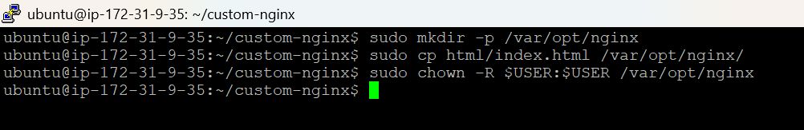
The above command puts a copy of the page in the host folder too, so it's served via the mount (not just from inside the image).
Now it is time to build and run
docker compose up --build -d
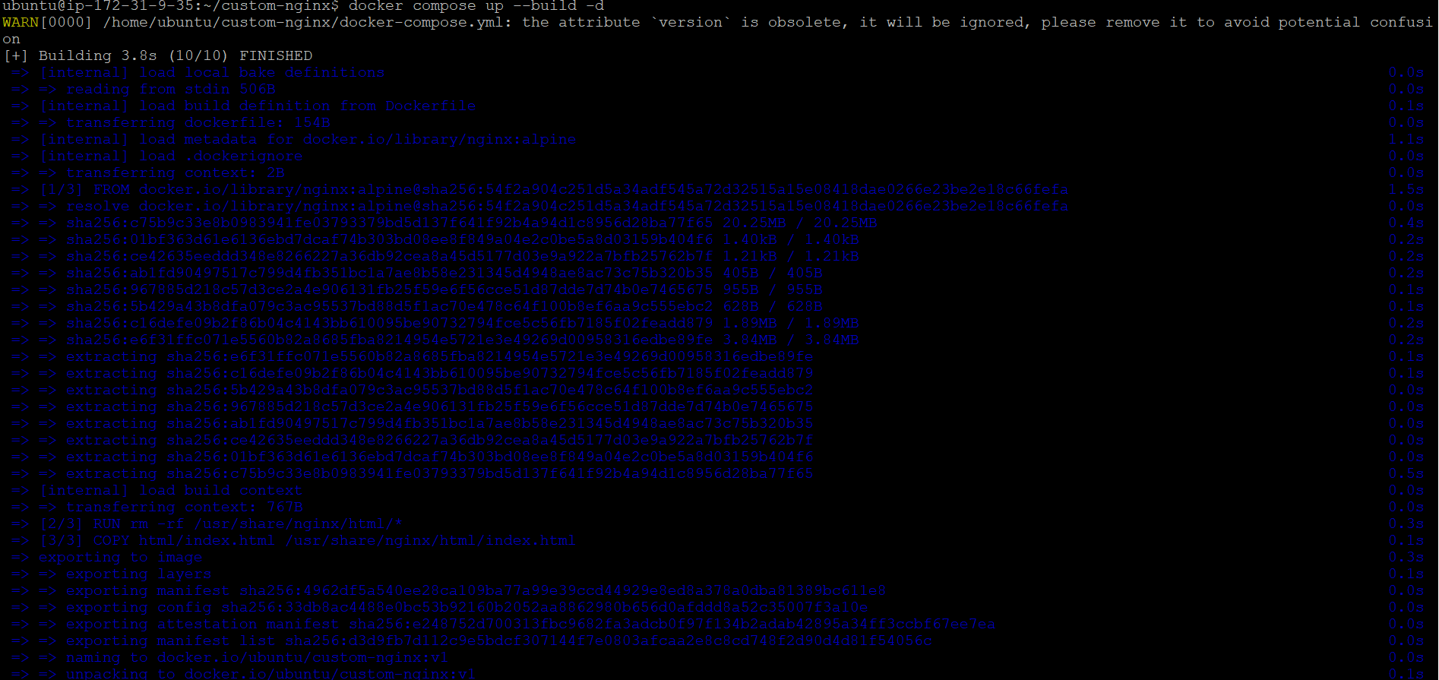
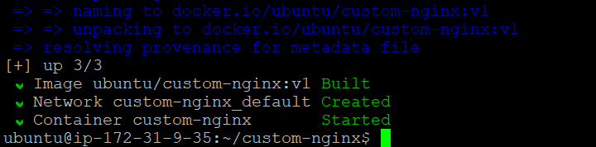
Lets check whether the container is running
docker ps
Now let’s open the port 8080 in the security group attached to our EC2 instance.
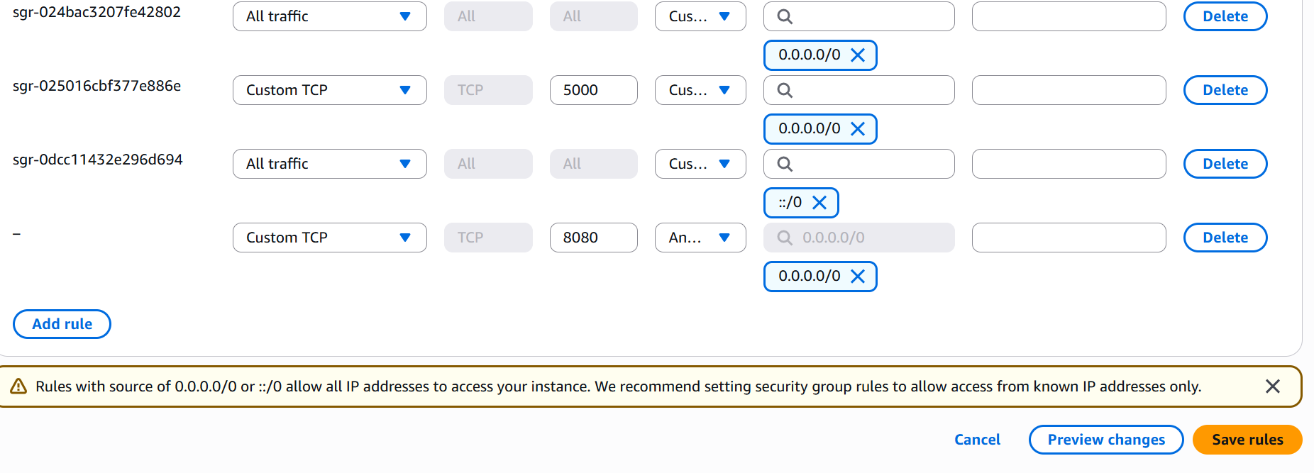
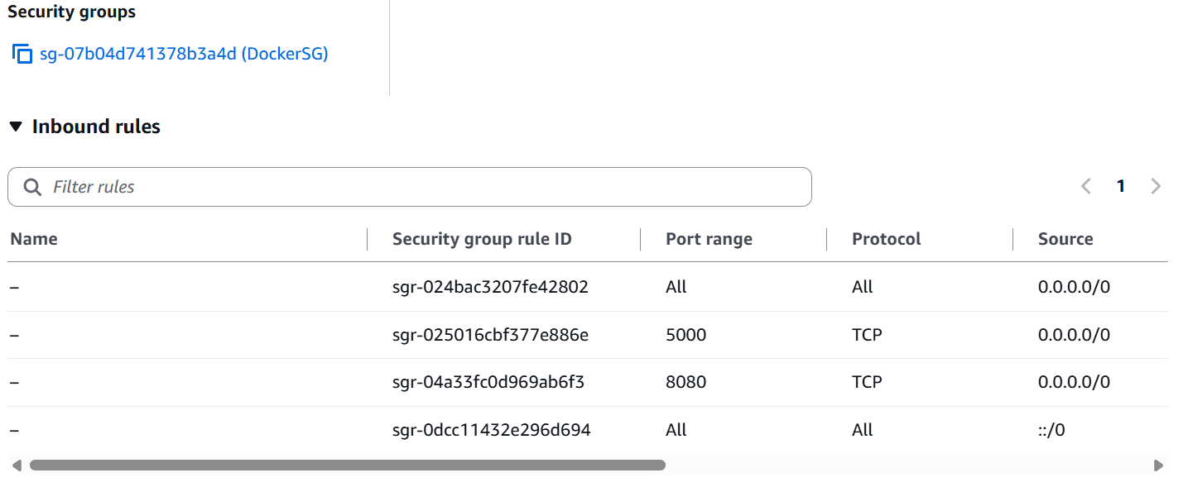
Now lets access the page via browser
http://44.251.6.179:8080
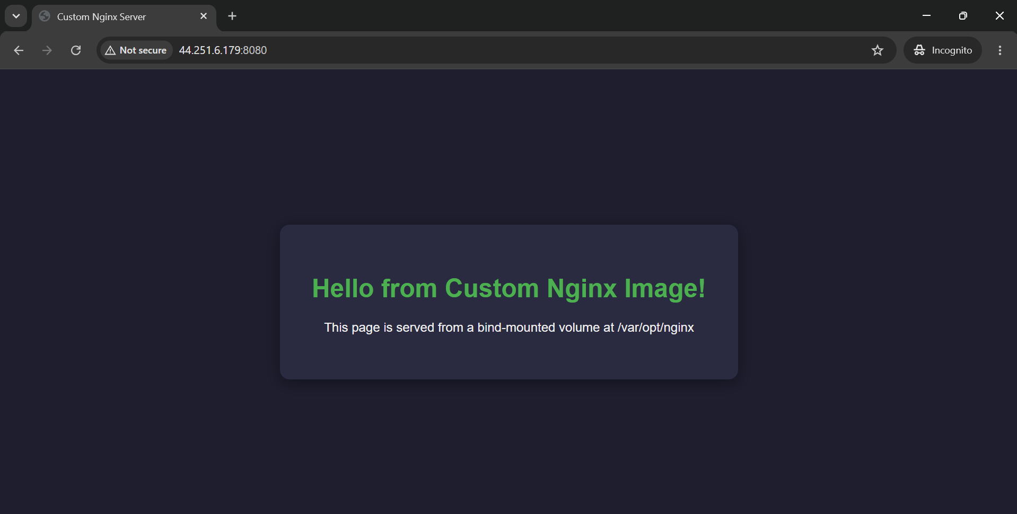
Now creating a new account using Docker hub
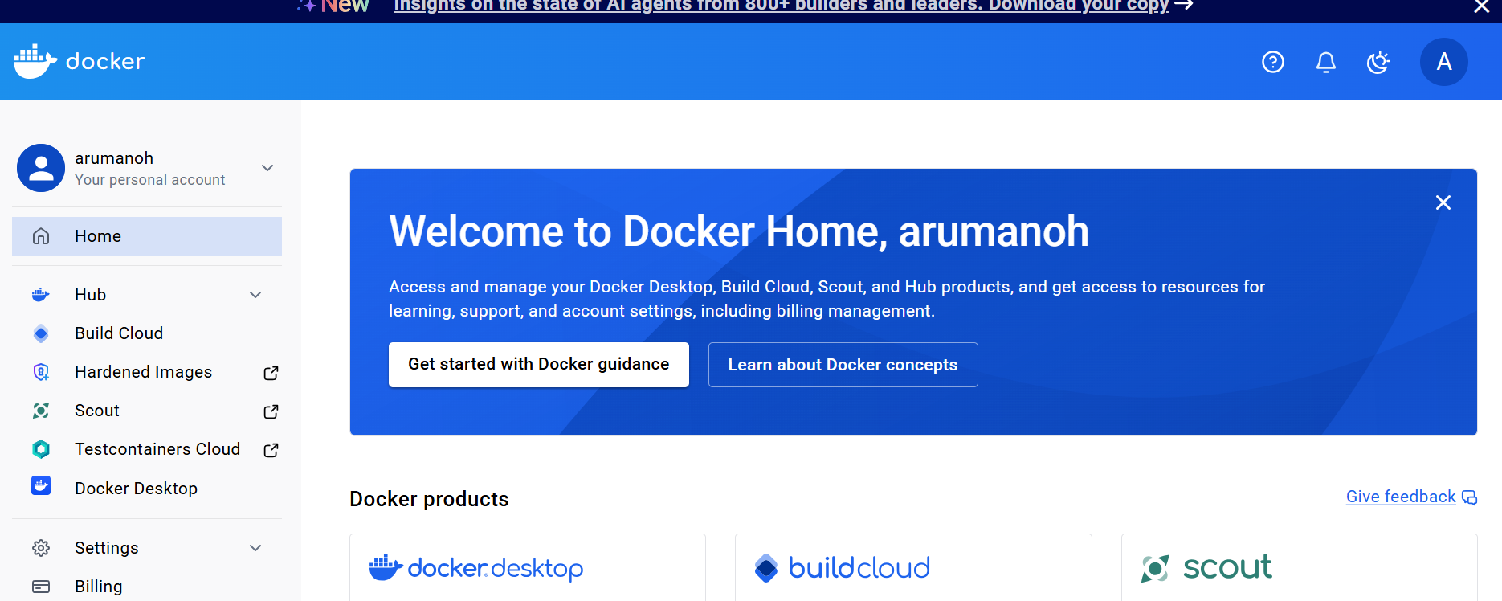

Login to our EC2 instance and execute the following command
docker login
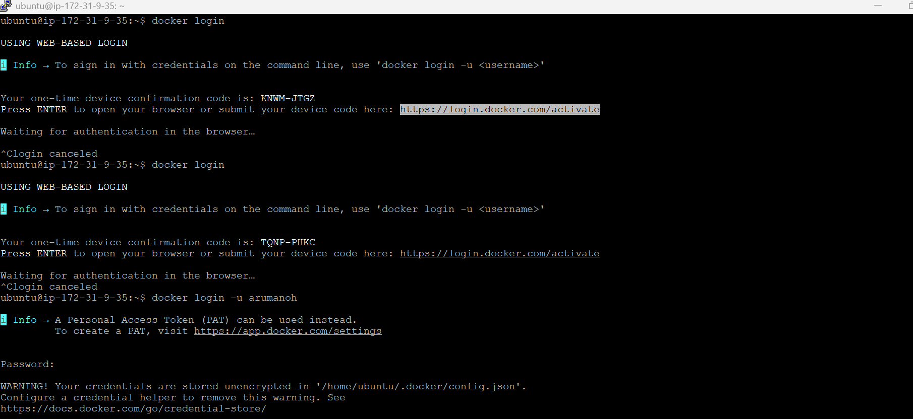
And then authenticate and connect your device with your dockerhub account by entering the one time device confirmation code.
docker images
There was a name mismatch between my custom image name (ubuntu) and my dockerhub account username (arumanoh). As a result the push failed initially.
Hence I had modified the custom image name to arumanoh so that it matches with the dockerhub account user name. docker push worked successfully.
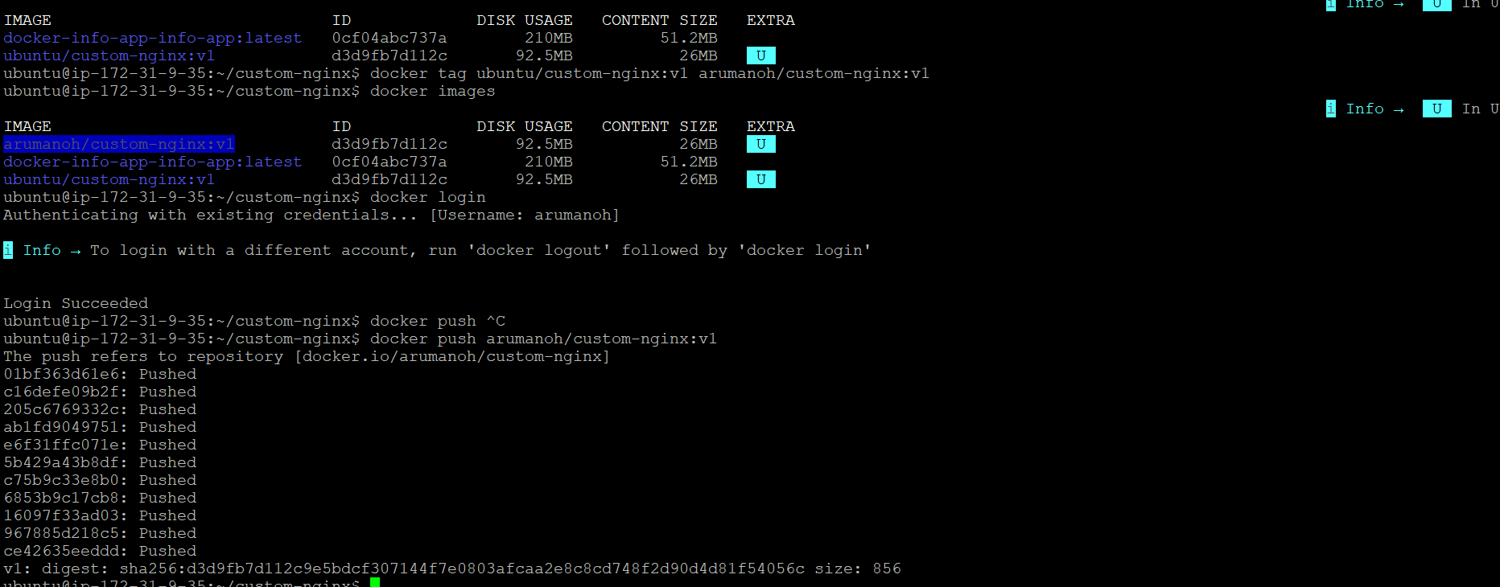
To avoid confusion, I have deleted the ubuntu custom image.
We have got the image pushed into Dockerhub account successfully.
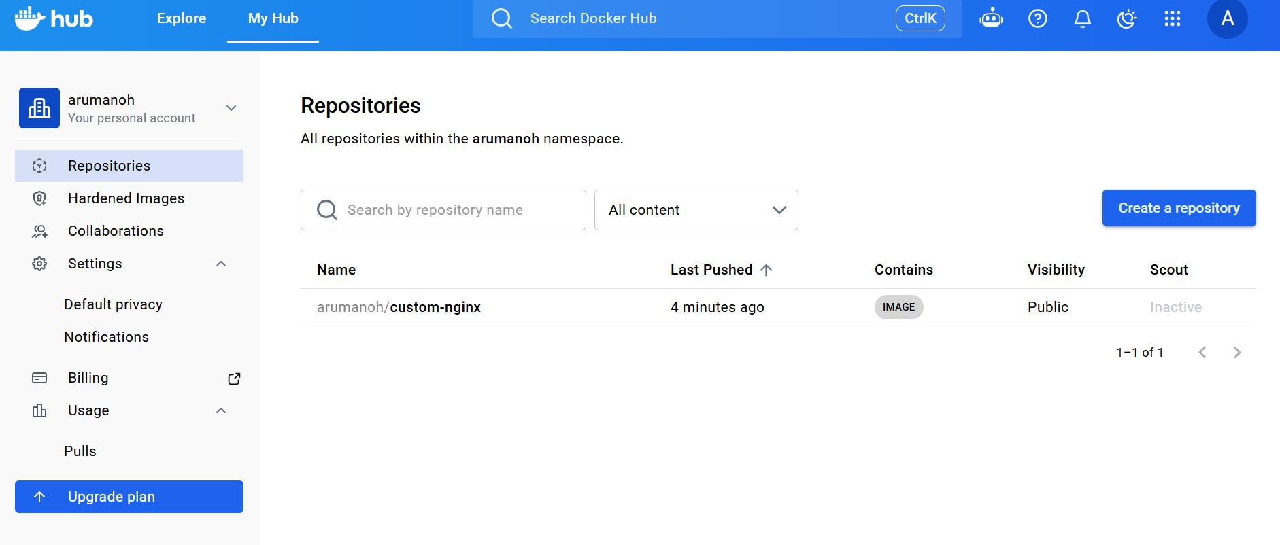
This concludes our task for the day.

