Jenkins Task

Task Description:
Launch Jenkins and explore creating projects and users.
- Lets first create a security group with the following conditions for our Jenkins server.
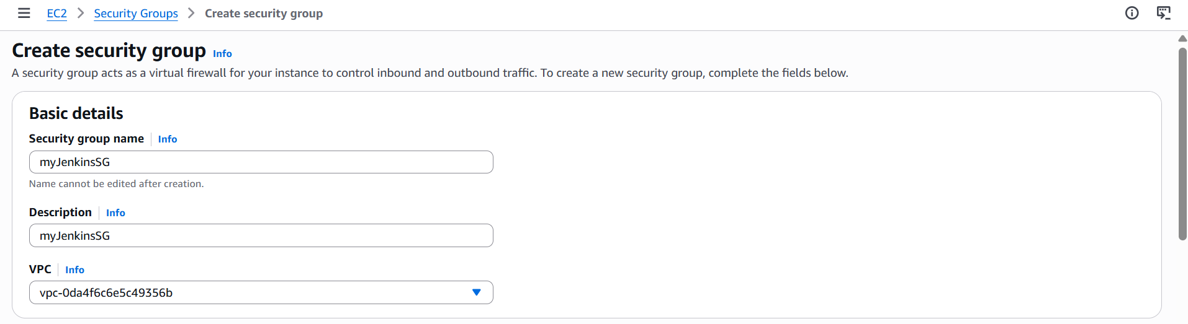

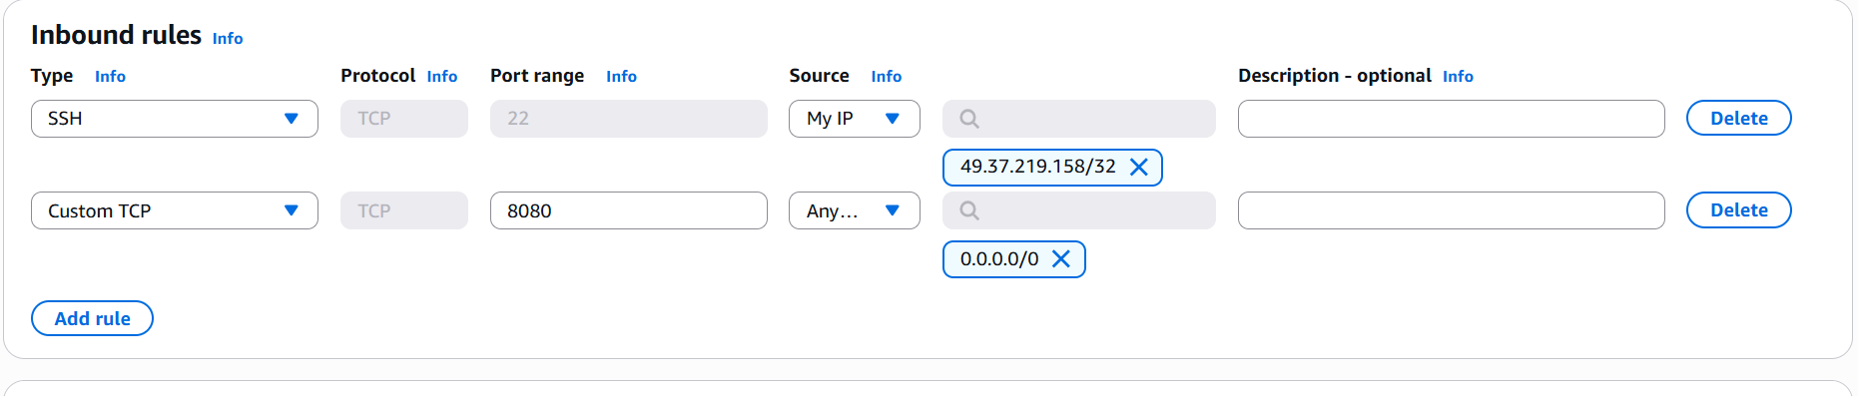
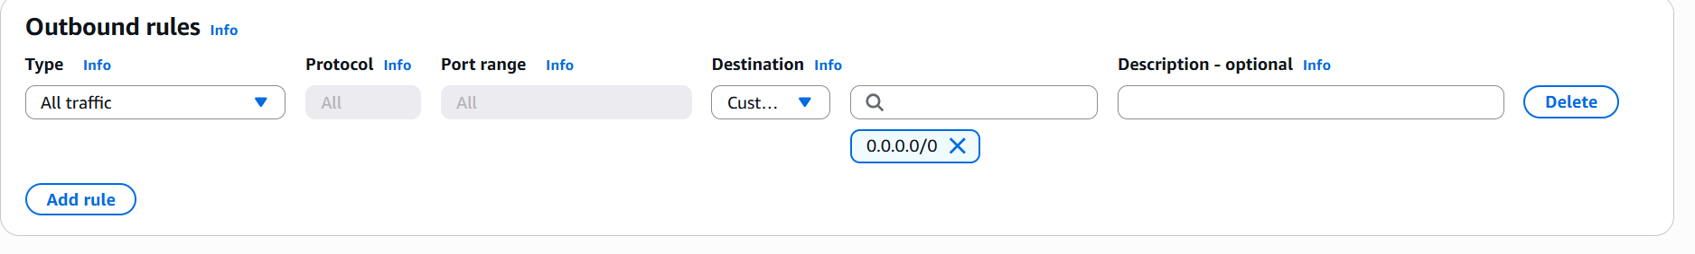
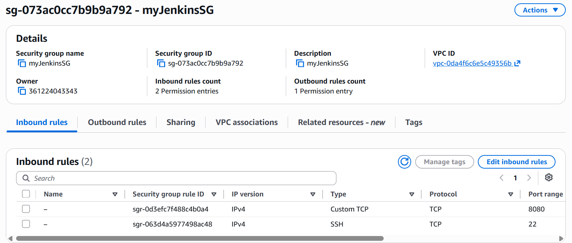

- Next let’s launch an EC2 instance by name “Jenkins-server” via AWS console.
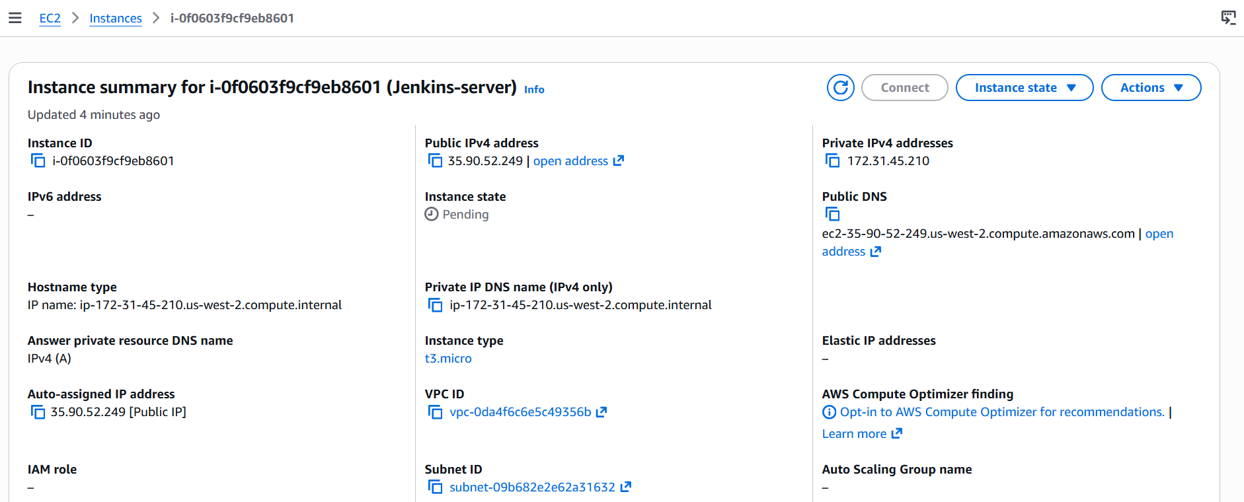

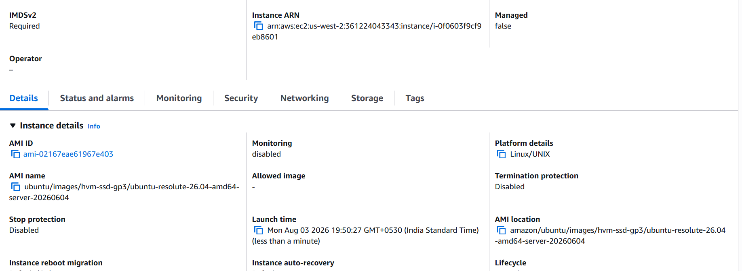
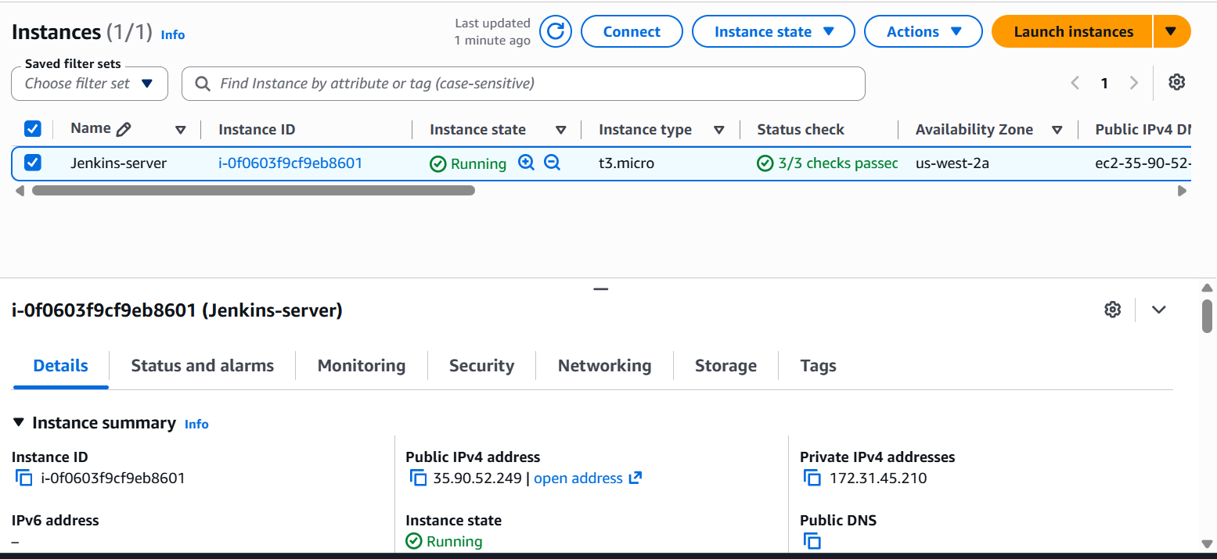
- Lets login to the instance via Putty.
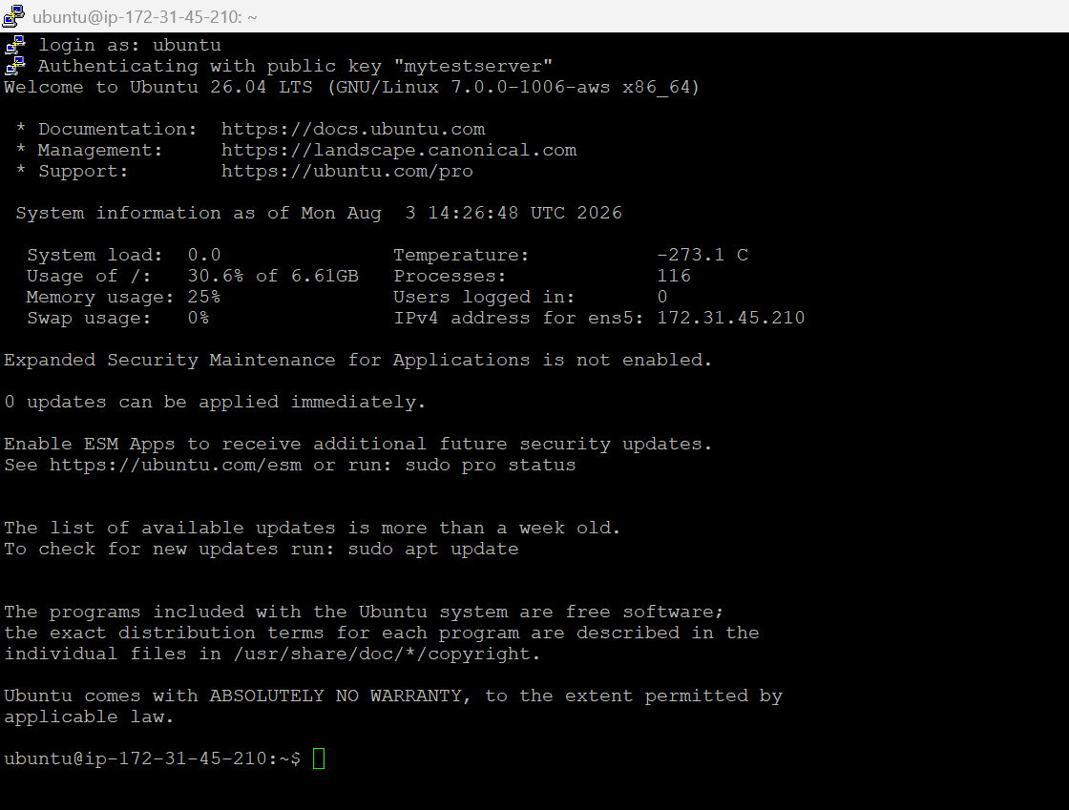
- Now let’s run the following commands to ensure that our instance is healthy and enough room for installing Java and Jenkins on top of it.
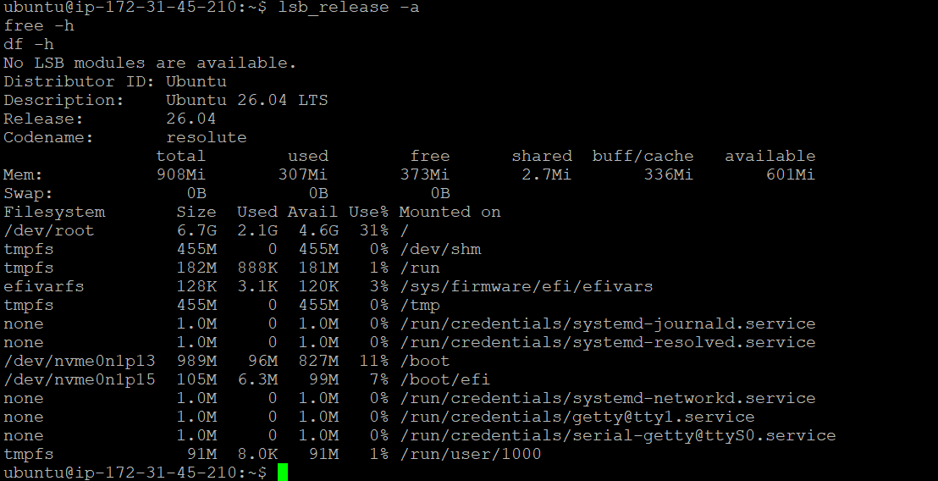
The system looks healthy - Ubuntu 26.04, plenty of disk (4.6G available), but only 908Mi total RAM. That's tight for Jenkins, which runs on the JVM and can be memory-hungry once you start running builds. Since there's no swap configured either.
- Let's add a swap file first to avoid Jenkins crashing or the instance locking up under load.
sudo fallocate -l 1G /swapfile
sudo chmod 600 /swapfile
sudo mkswap /swapfile
sudo swapon /swapfile
echo '/swapfile none swap sw 0 0' | sudo tee -a /etc/fstab
free -h

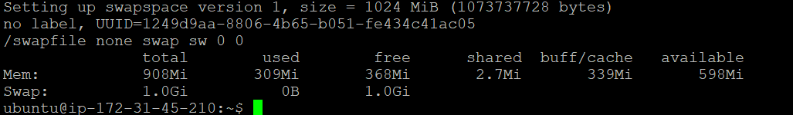
Now we have 1.0 Gi memory available which should be sufficient for our task.

- Let’s install Java now
sudo apt update
sudo apt install -y fontconfig openjdk-21-jre
java -version
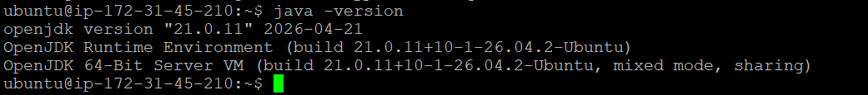

- Let’s install Jenkins now
sudo wget -O /etc/apt/keyrings/jenkins-keyring.asc \
https://pkg.jenkins.io/debian-stable/jenkins.io-2026.key
echo "deb [signed-by=/etc/apt/keyrings/jenkins-keyring.asc]" \
https://pkg.jenkins.io/debian-stable binary/ | sudo tee \
/etc/apt/sources.list.d/jenkins.list > /dev/null
sudo apt update
sudo apt install Jenkins

To validate whether Jenkins is installed correctly, we will use the following command
sudo systemctl status jenkins

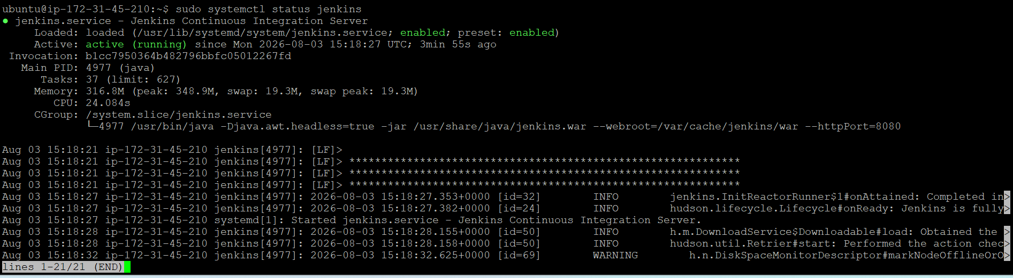

Yes Jenkins is up and running successfully.

- Let’s setup the admin password now
sudo cat /var/lib/jenkins/secrets/initialAdminPassword
copy the password and save it in a notepad.
- Open a browser “http:// 35.90.52.249:8080” where “35.90.52.249” is the Public ip of our EC2 instance.
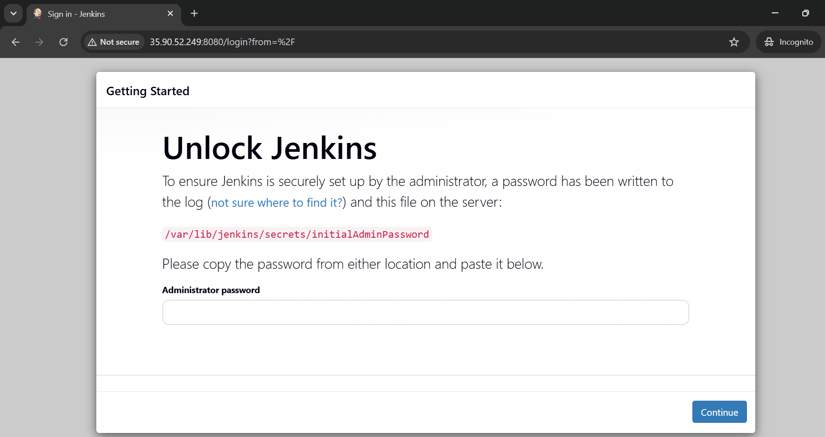

Type in the admin password which you saved recently and then click continue

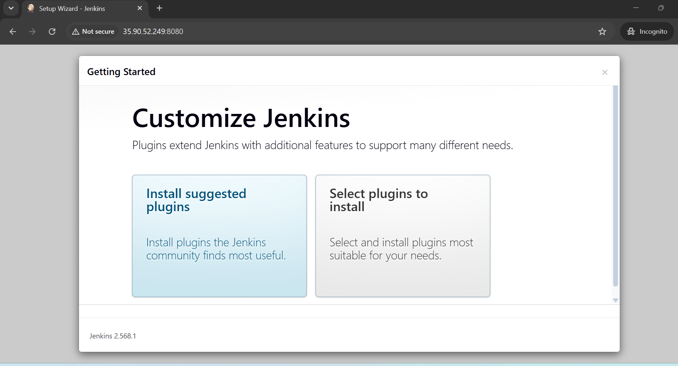

Select “Install suggested plugins”

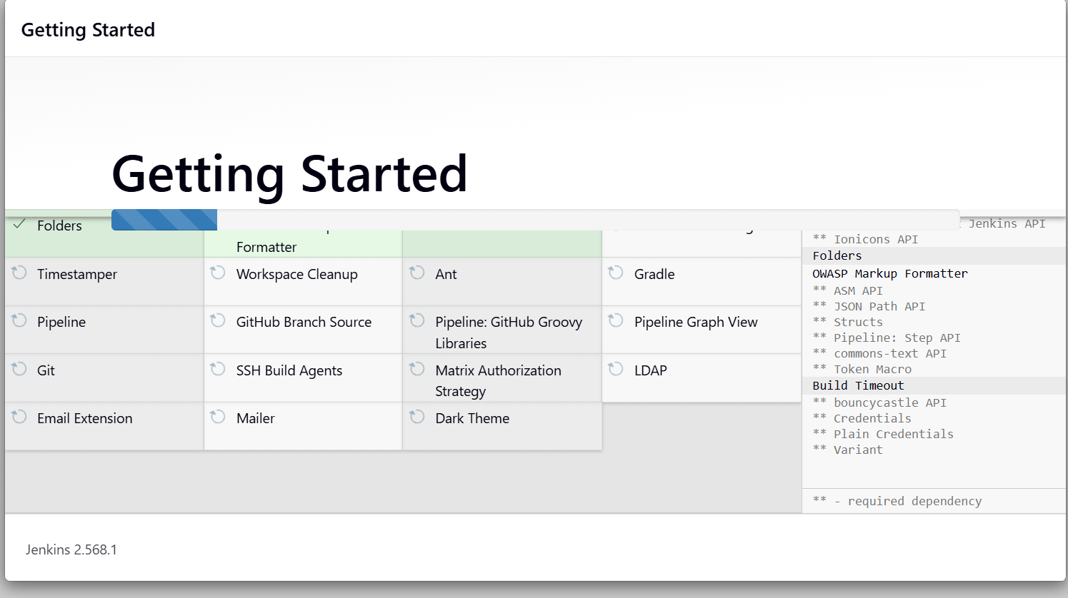

All the Plugins are installed successfully. Now we are at the admin user creation screen.
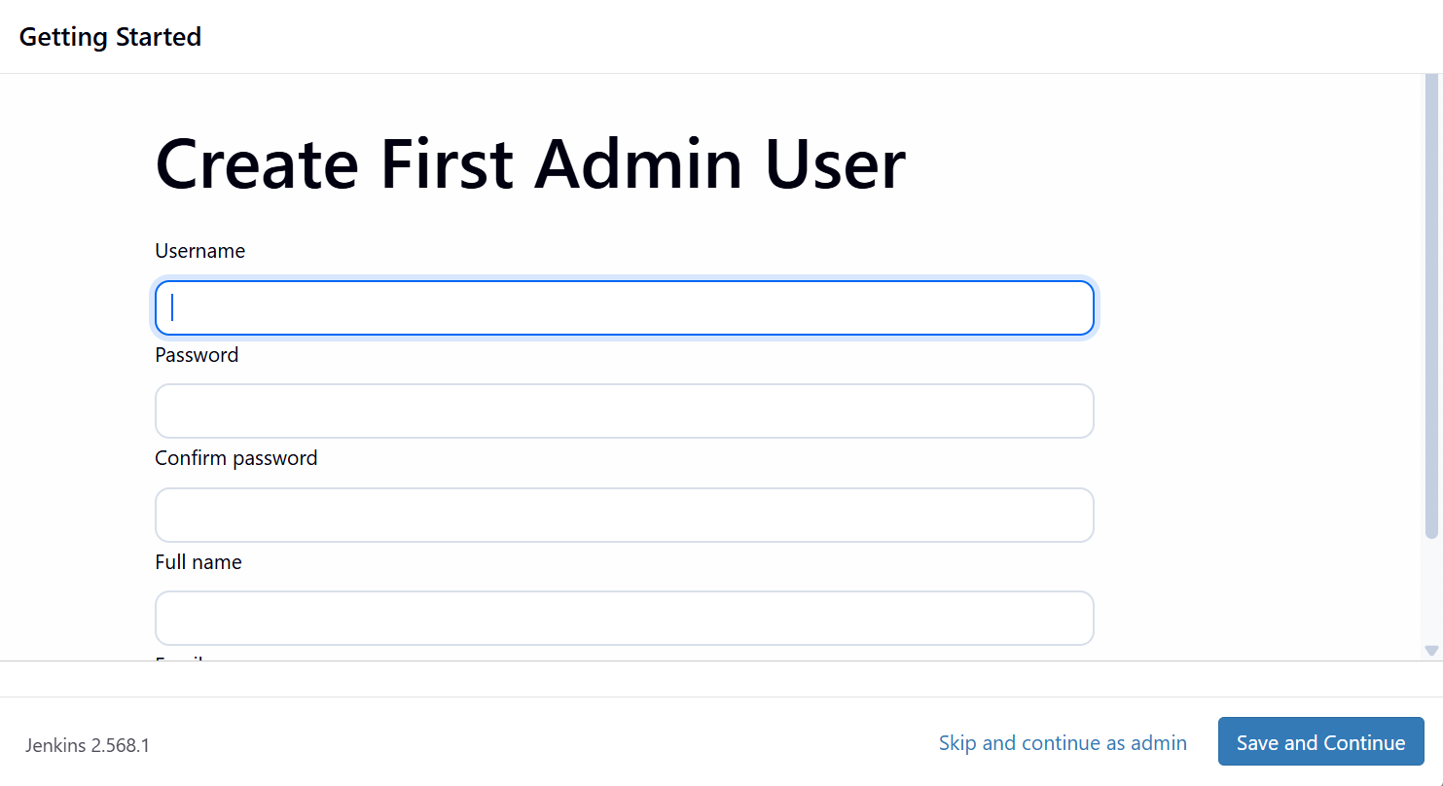
Let the username be “arul-admin”
And then type a suitable password.
And then the Full Name
Email id
Click Save and Continue
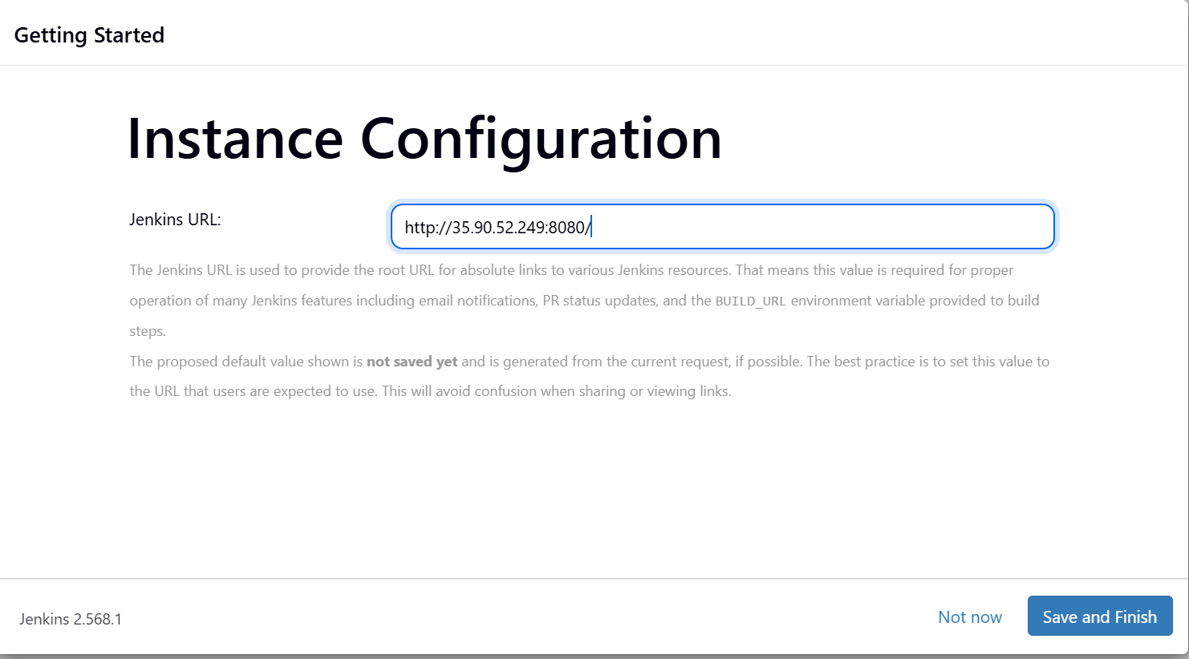

Click Save and Finish

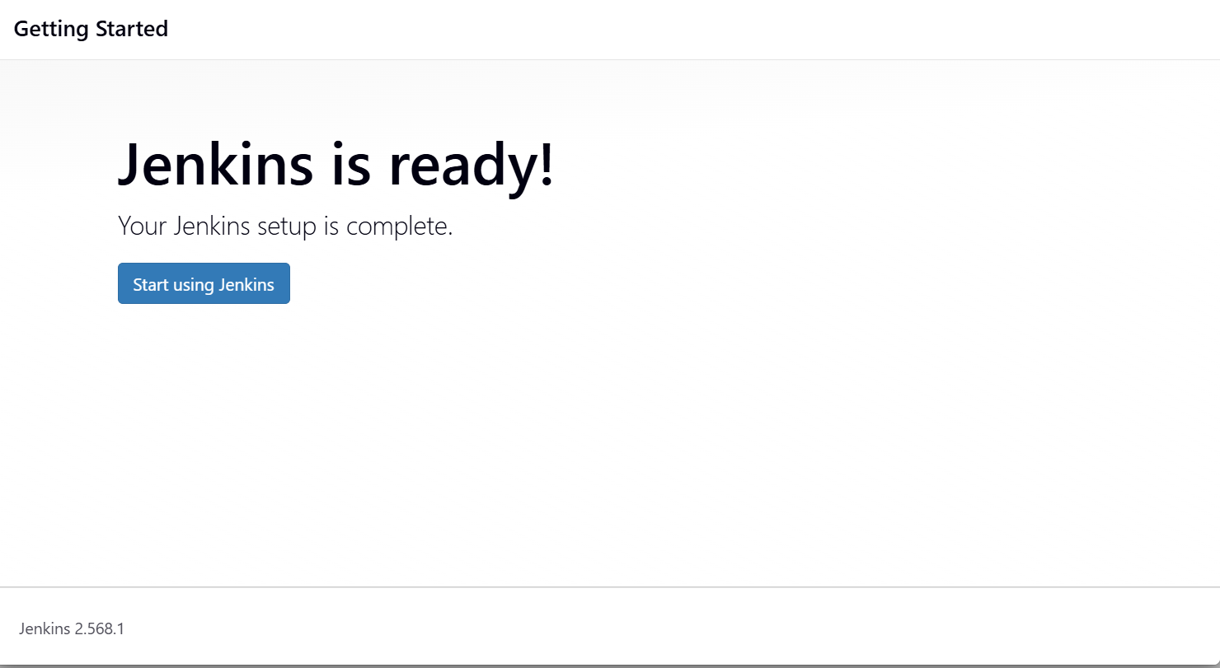

Click Start using Jenkins

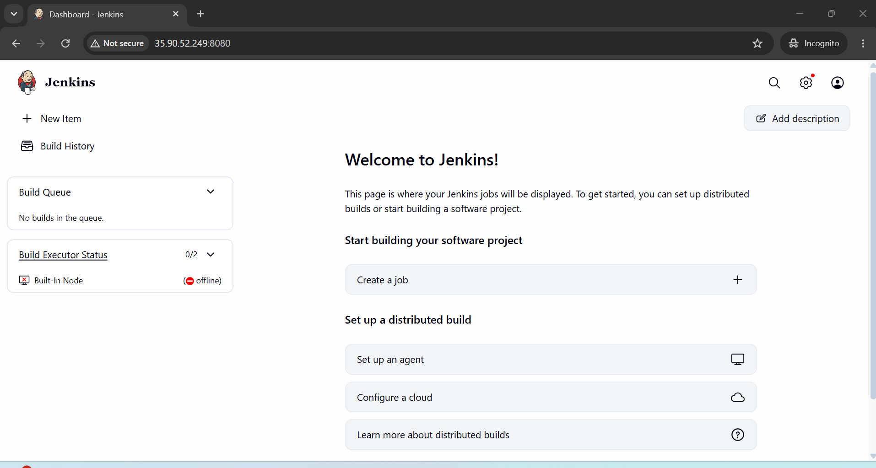

We have successfully landed on the “Dashboard” page of our Jenkins server.

Note: Built-in-Node is offline since the free temp space (449 MiB) is less than the threshold of 1GiB. To fix it we will modify the free temp space threshold to 100MiB instead of 1GiB and Warning free temp space threshold to 200MiB instead of 2GiB.

- Now let’s create our first project

Click on New item on the left side panel

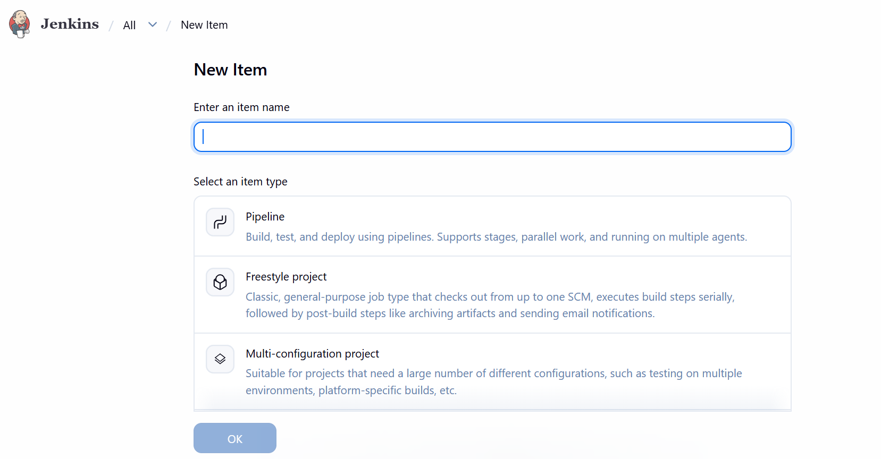

Give the name as “test-freestyle-job” and then select “Freestyle project” and click Ok.

It will take you to the configuration page as shown below

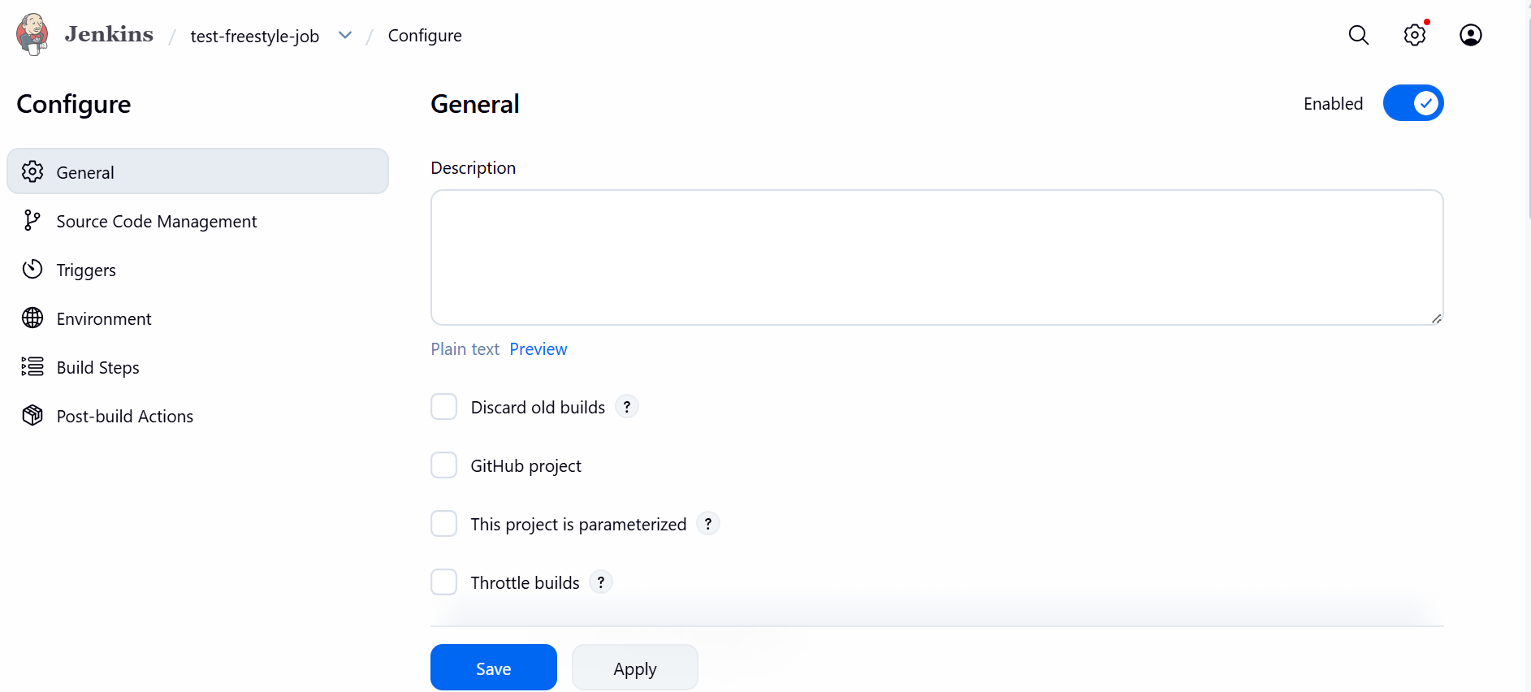

For now, keep it simple:
- Skip Source Code Management (leave as "None")
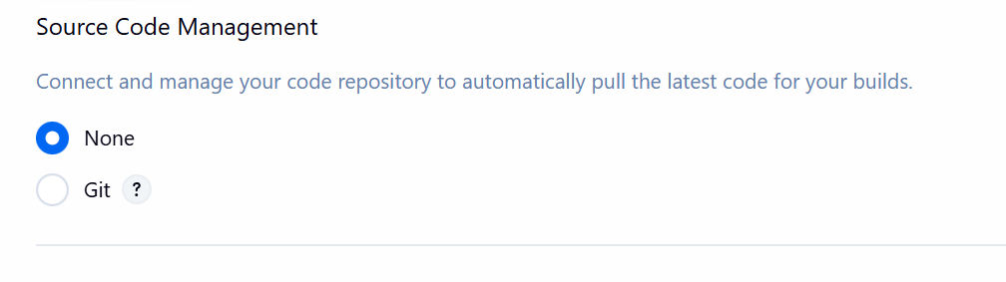
- Under Build Steps, click Add build step → Execute shell
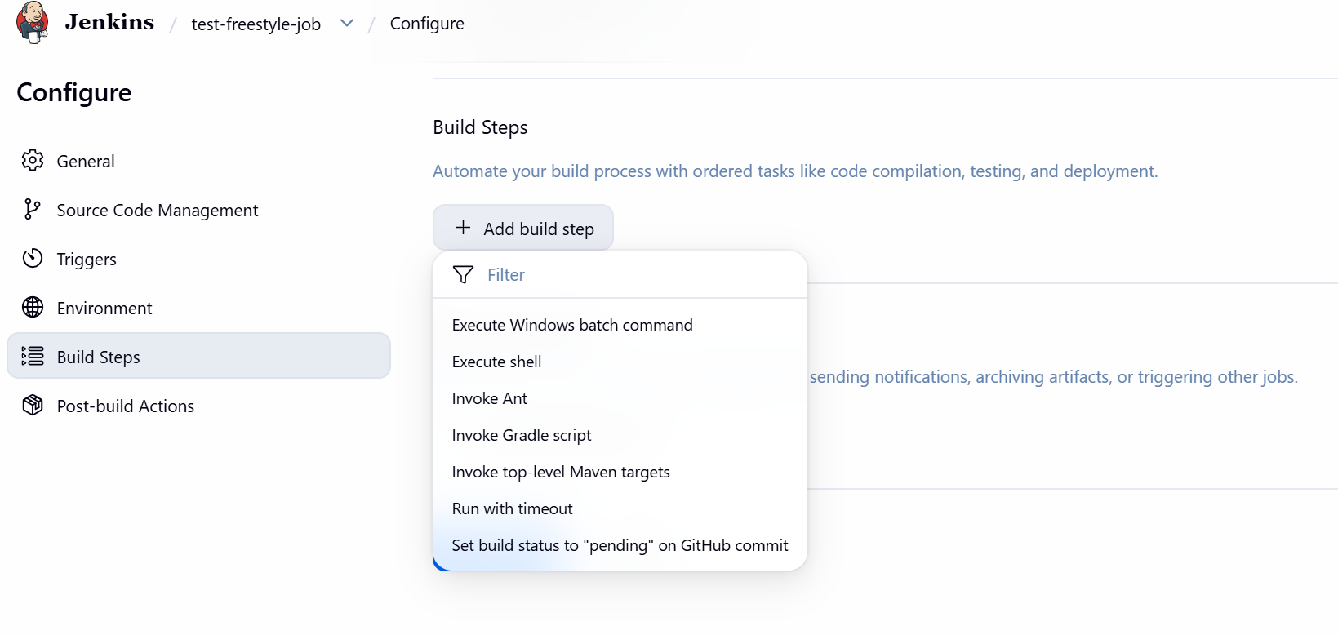
- Enter: echo "Hello from Jenkins" && date && whoami
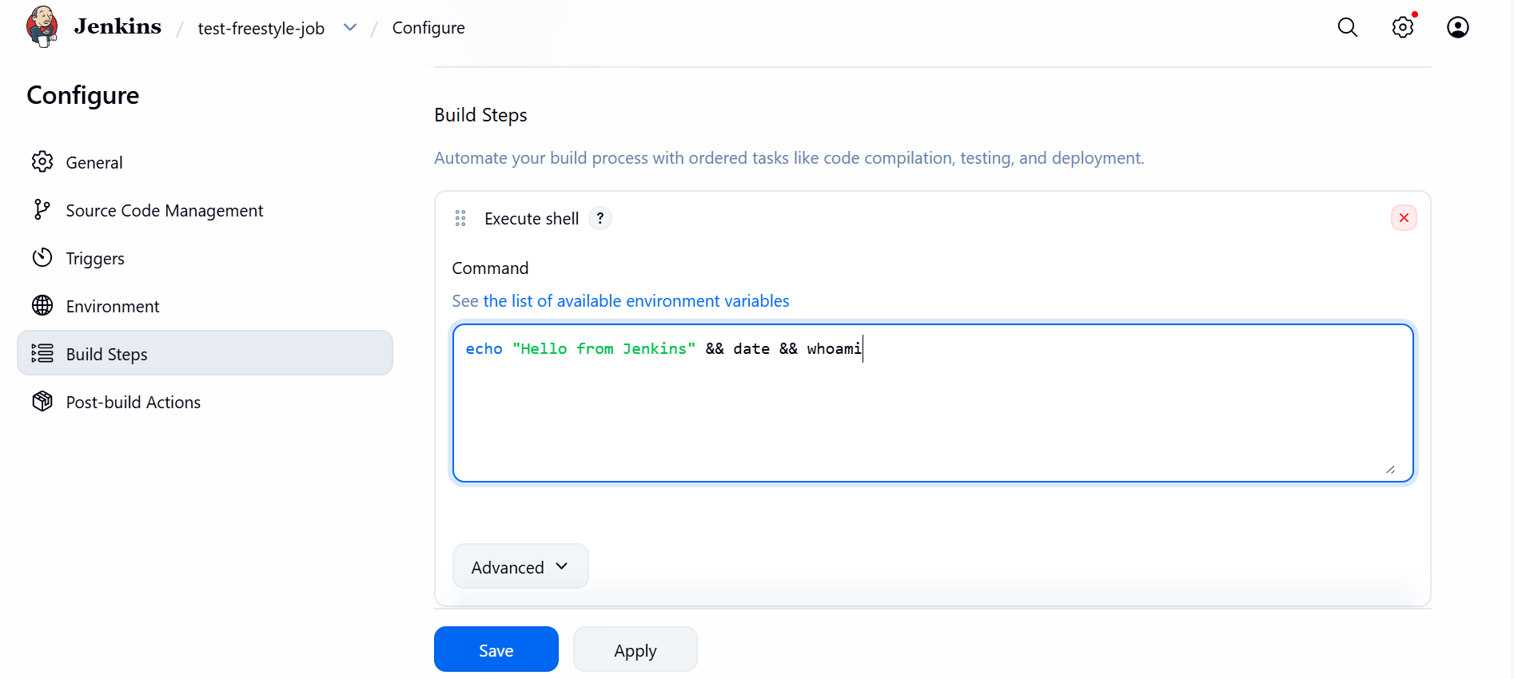
- Click Save



Click on Build now

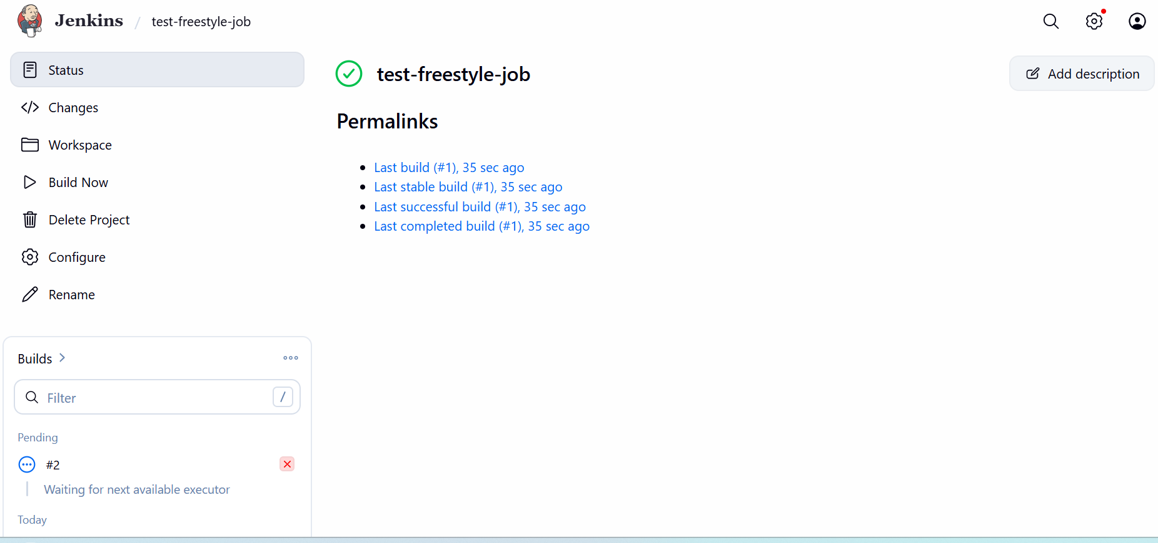

Lets check the console output by clicking the Last build

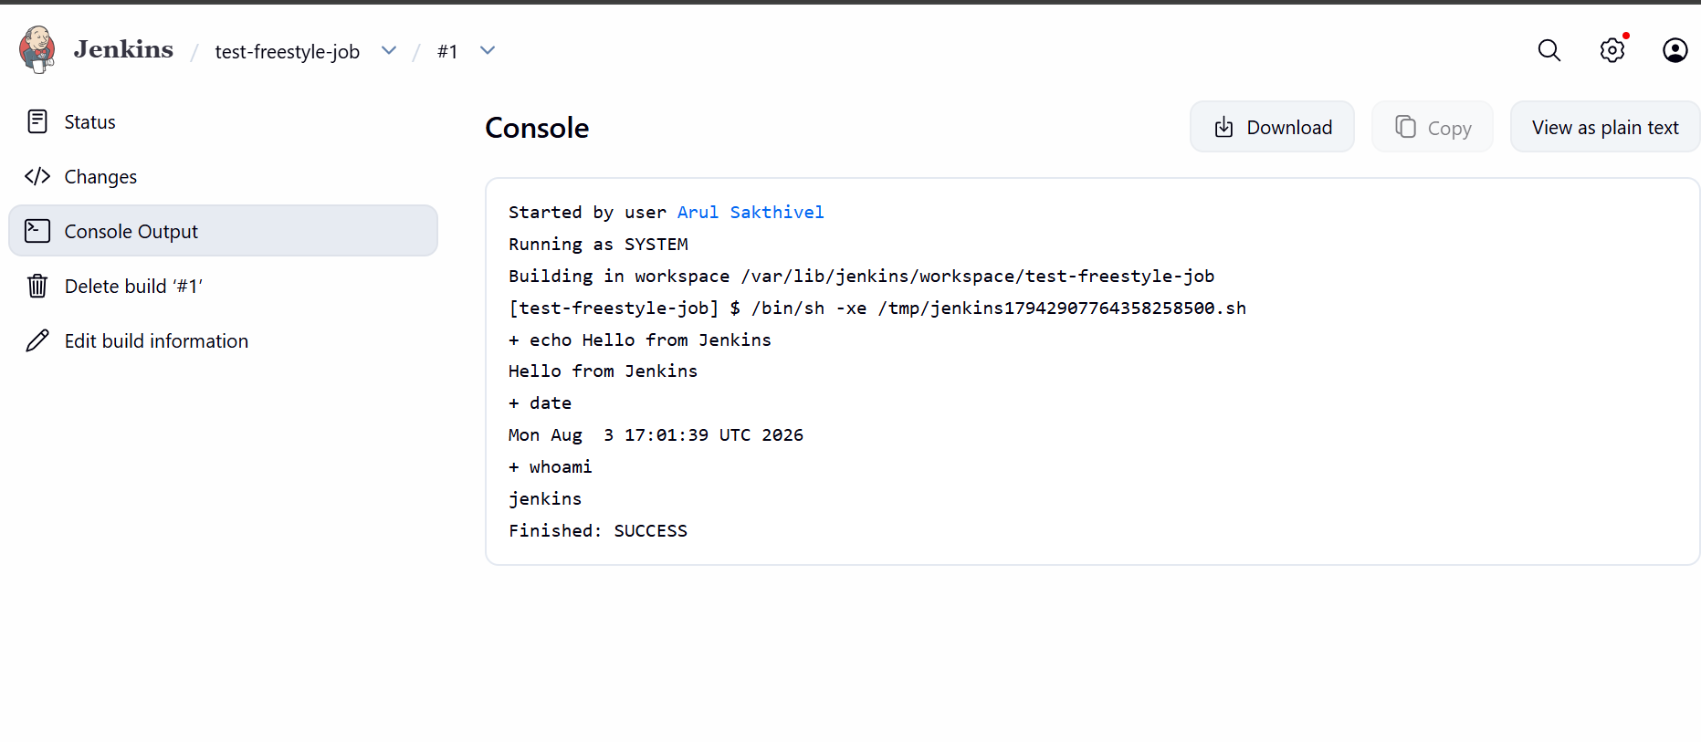
Our Job ran successfully.

- Now let’s create users

Click the gear icon (⚙️) top-right → Manage Jenkins
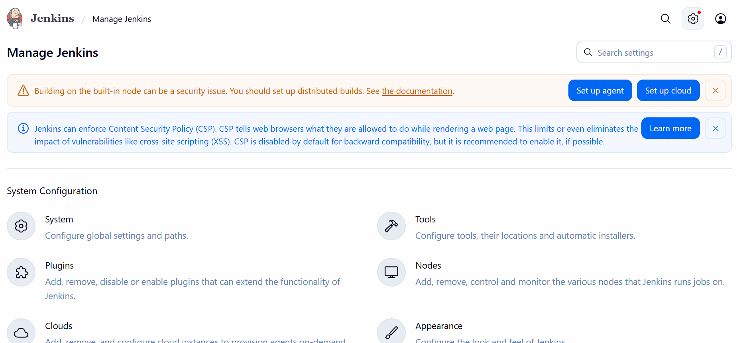
Under Security, click Users
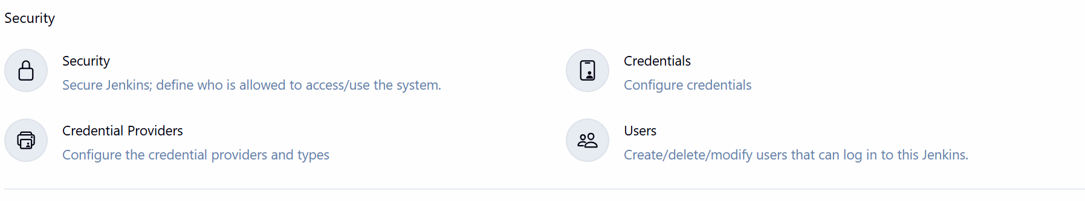
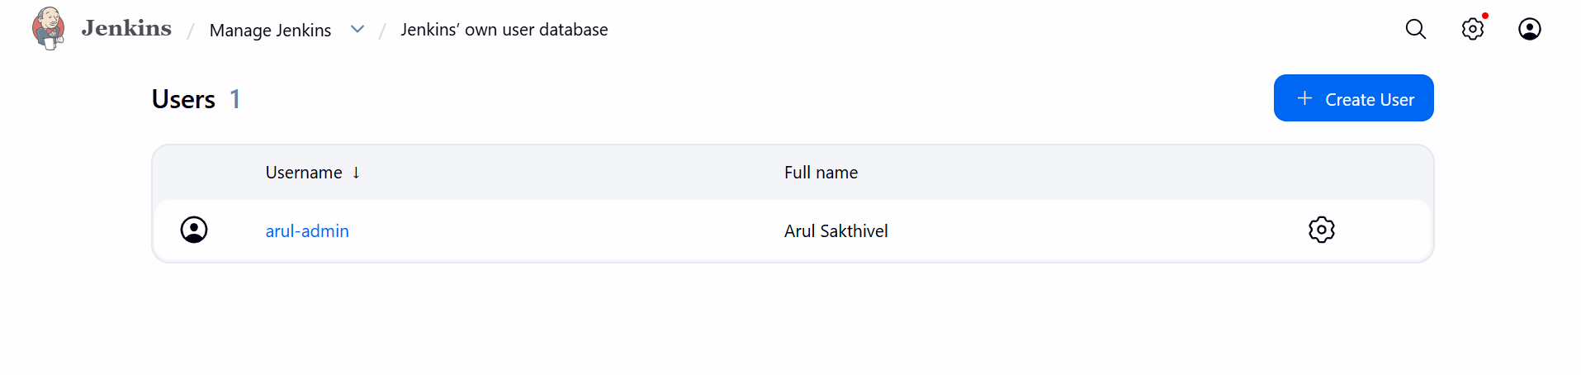
Click Create User (top-left of the Users page)
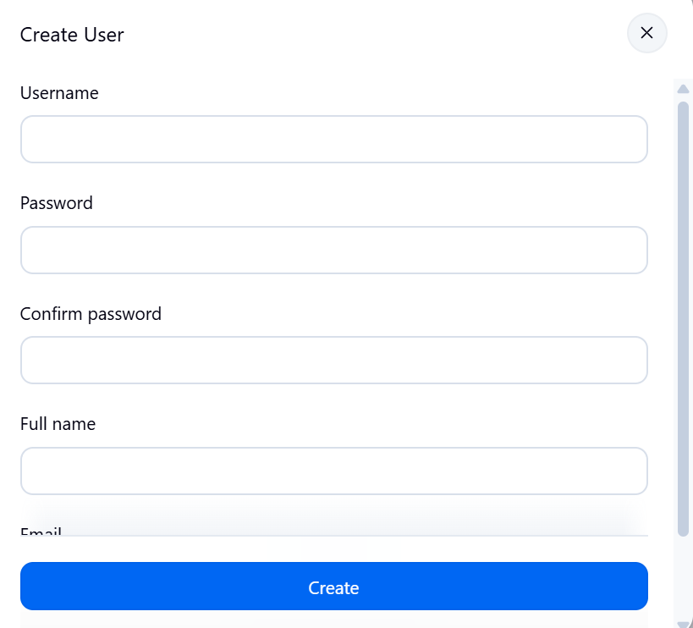
Fill in:
- Username: e.g. devuser
- Password / Confirm password
- Full name
- Email address
Click Create User

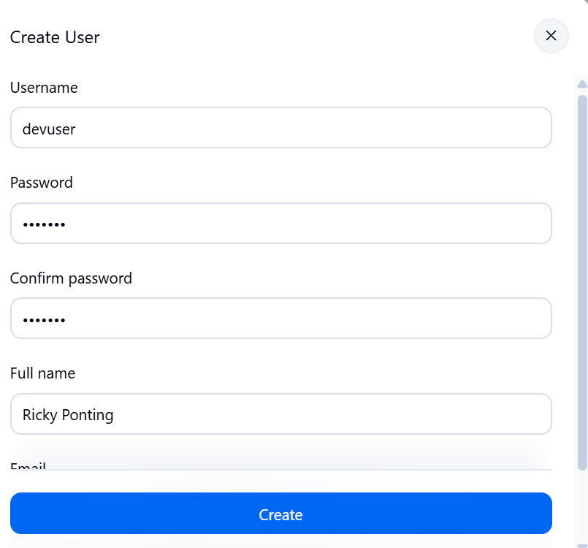

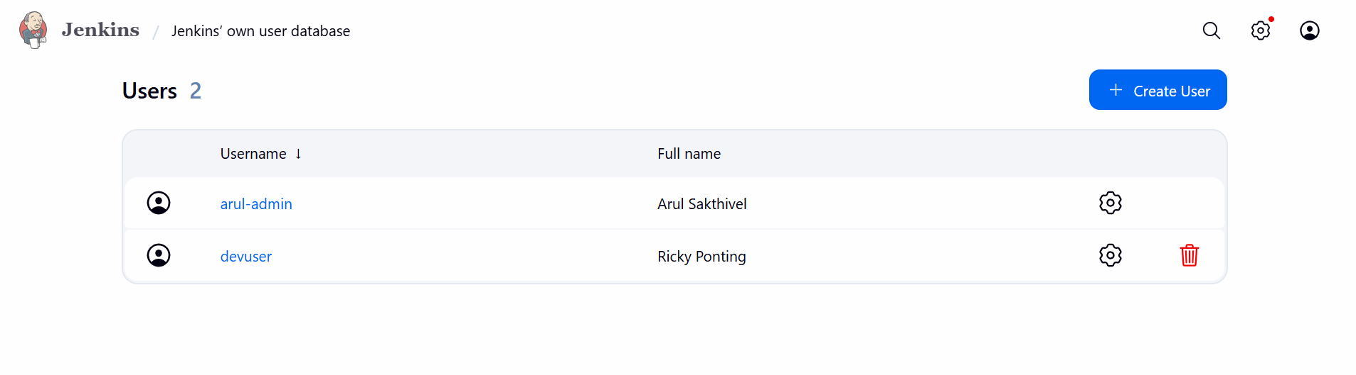
This adds the second user apart from the admin.

Currently the devuser has full administrative rights which is not ideal, hence we will restrict it

Go to Manage Jenkins → Security → Configure Global Security
Under Authorization, select Matrix-based security
You'll see a table with checkboxes per user/group across permission categories (Overall, Job, Run, View, etc.)
Add devuser to the matrix (there's usually an "Add user or group" field)
Give your admin account everything (safest: check "Overall/Administer" for admin, which auto-grants all)
For devuser, check just a few boxes — e.g. Overall/Read, Job/Read, Job/Build — leaving out Job/Configure, Job/Delete, Overall/Administer
Click Save

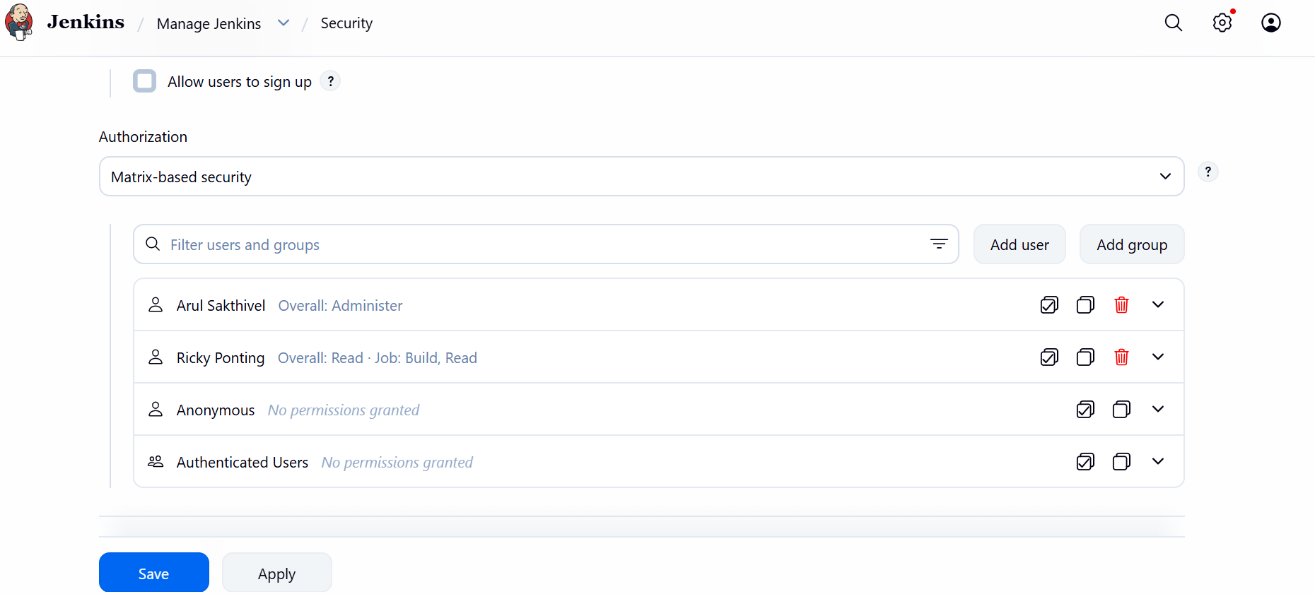

Let’s logout as arul-admin and log in as “devuser” to validate whether the restrictions have been imposed correctly or not.

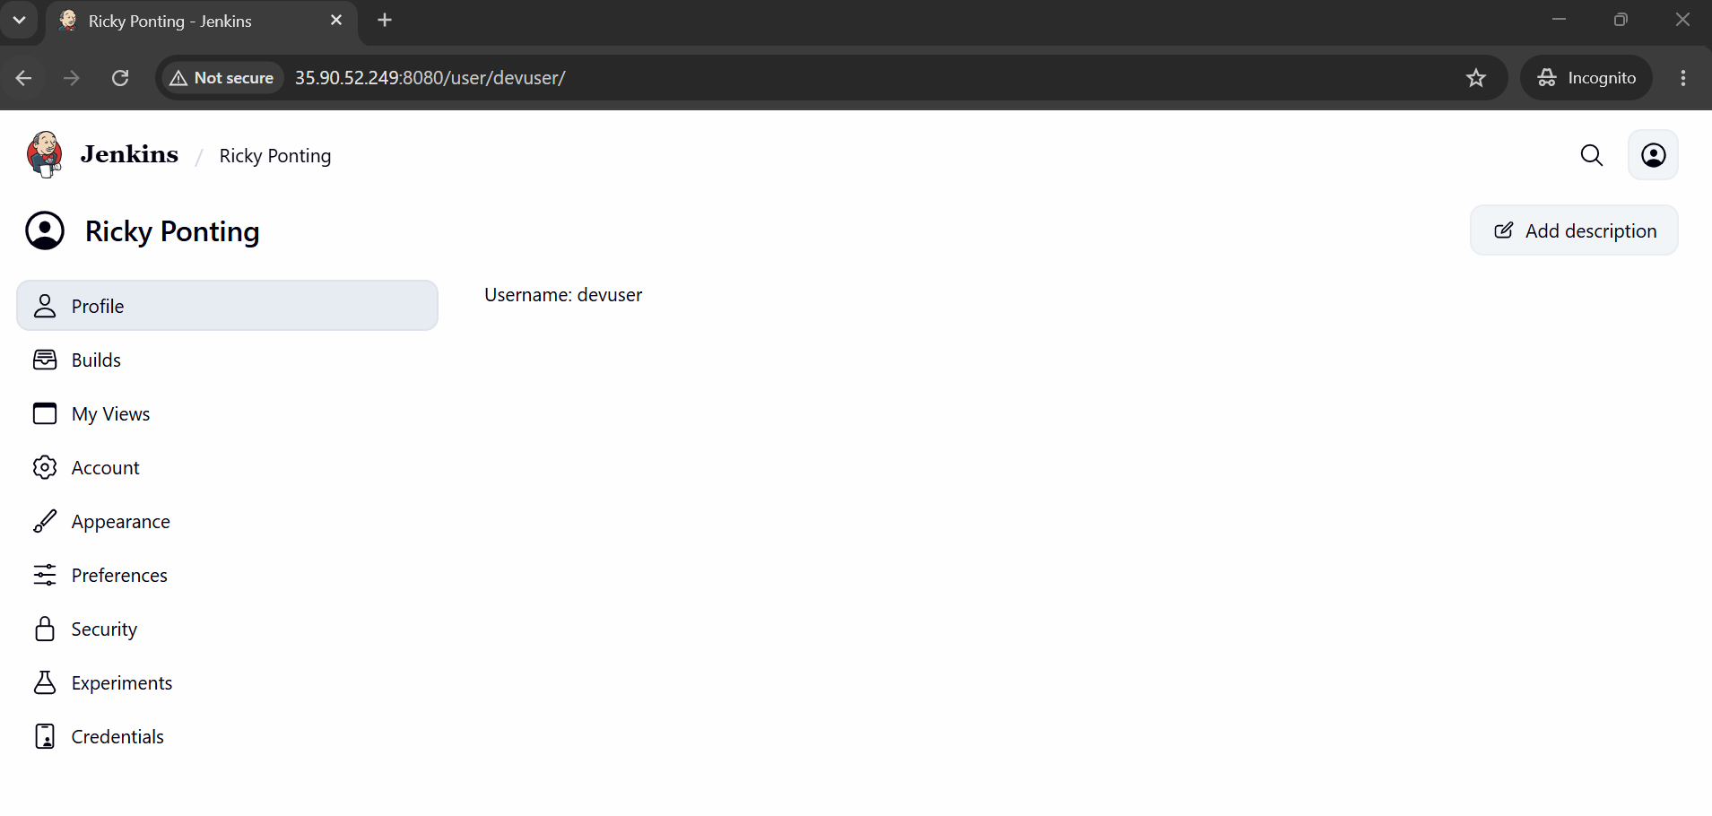

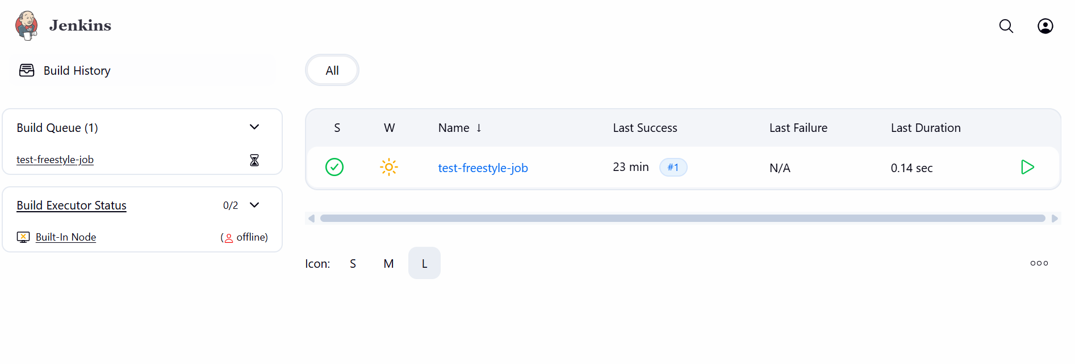
Yes the manage Jenkins page is not accessible for devuser.

Whereas the manage Jenkins page is accessible only to the “arul-admin” who is the administrator

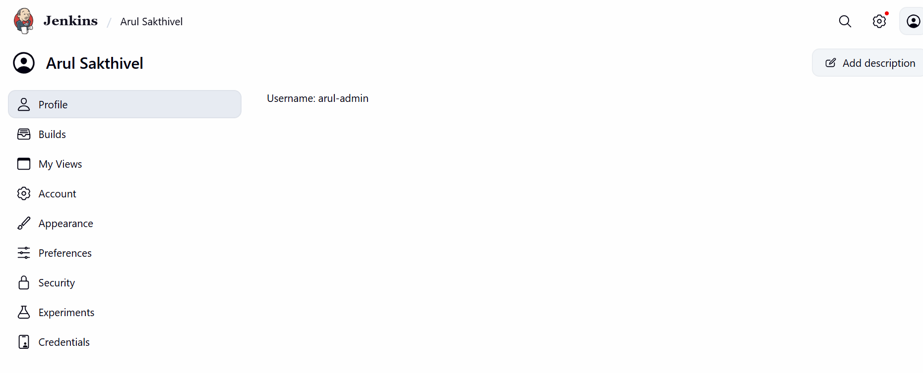

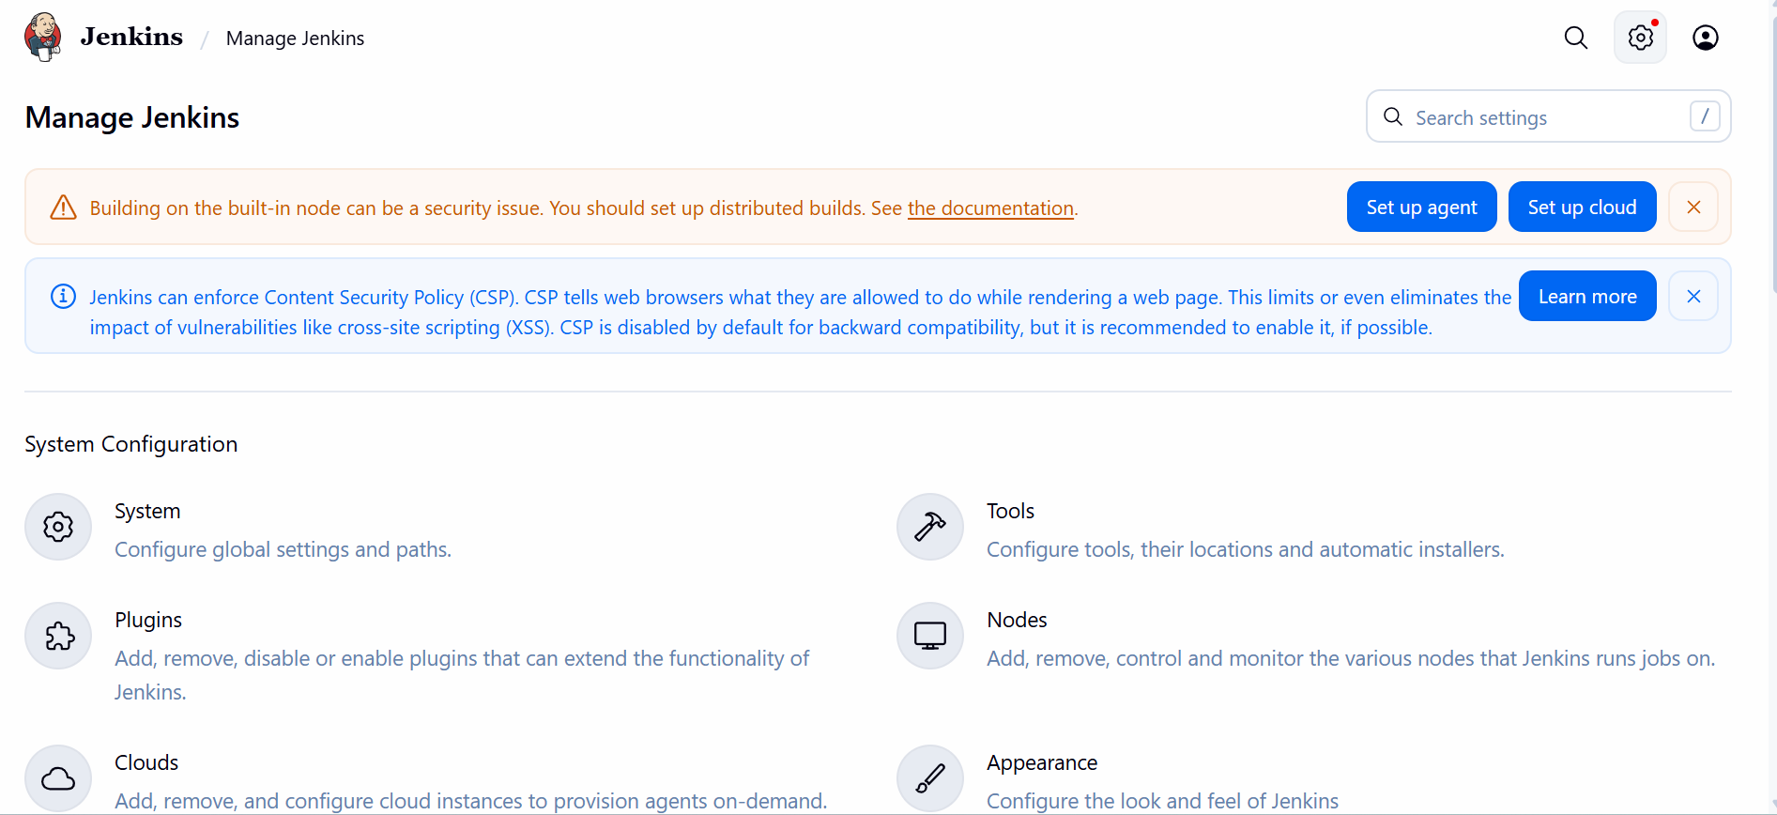

This concludes our task of launching Jenkins and creating projects and users.

