Terraform Task-2

Task Description:
Create 2 EC2 instances on 2 different regions and install nginx using terraform script.
Solution:
Here we are going to use the same EC2 instance which we used in the Terraform Task 1. This EC2 instance will be the Terraform server for our task.
The instance was stopped yesterday. So, we are starting the instance now. As a result, the Public IP has changed for our instance. It is “100.53.116.7” now
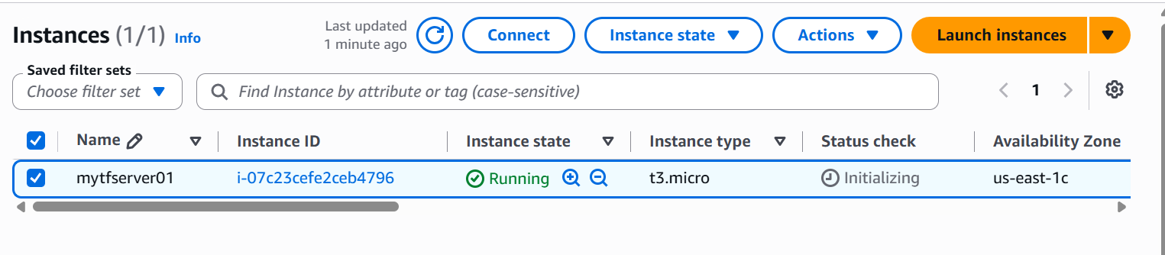
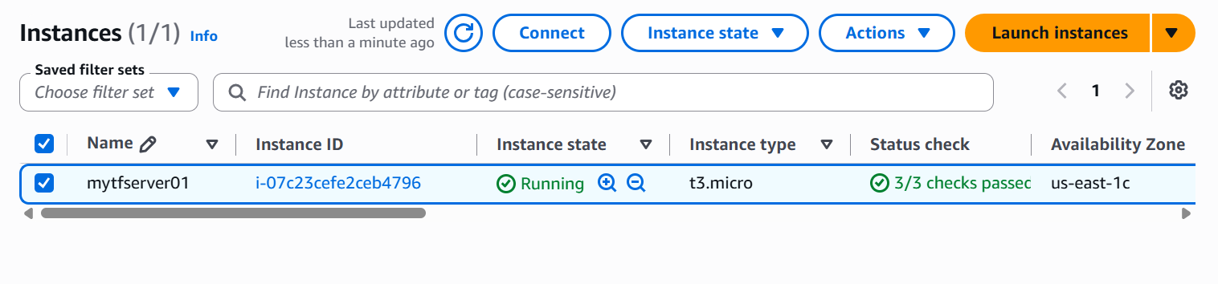
We have also connected to our Terraform server via Putty.
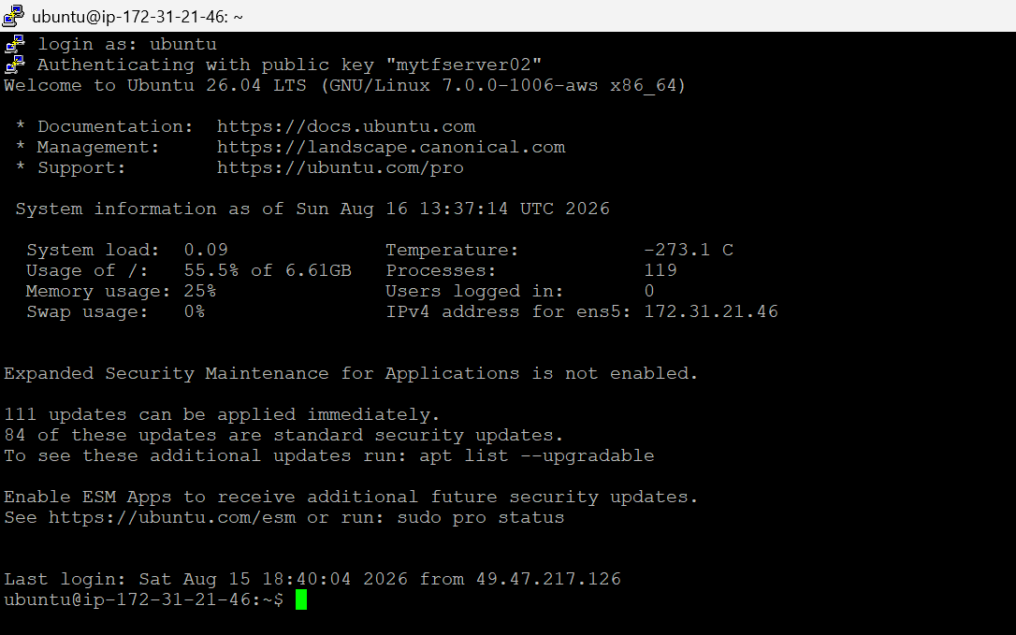
Checking the terraform version
terraform -version
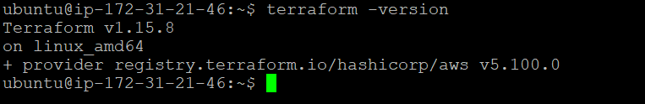
We have version v1.15.8 installed in our system and it is working as expected.
Let’s create a new folder by name “tfo1”
Navigate to that “tf01” folder
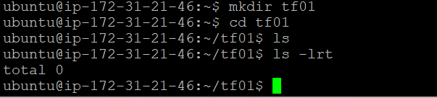

We already have two key pairs created from our earlier task. They are
- mytestserver-east1.pem
- mytestserver-east2.pem

We will use these two key pairs in this task as well.

Let’s create the main.tf file
# 1. Terraform & Provider Declaration
terraform {
required_providers {
aws = {
source = "hashicorp/aws"
version = "~> 5.0"
}
}
}

# 2. Multi-Region Provider Configurations
# Default provider for US East (N. Virginia)
provider "aws" {
region = "us-east-1"
}

# Alternate provider for US West (Oregon) using an alias
provider "aws" {
alias = "us_west_2"
region = "us-west-2"
}

# 2b. Variables for SSH access
variable "key_name_east" {
description = "mytestserver-east1.pem"
type = string
default = ""
}

variable "key_name_west" {
description = "mytestserver-east2.pem"
type = string
default = ""
}

variable "ssh_cidr" {
description = "CIDR block allowed to SSH in. Restrict this to your own IP (e.g. 1.2.3.4/32) instead of 0.0.0.0/0 where possible."
type = string
default = "0.0.0.0/0"
}

# 3. Shared Bootstrapping Script for Nginx
locals {
nginx_user_data = <<-EOF
#!/bin/bash
sudo apt-get update -y
sudo apt-get install nginx -y
sudo systemctl start nginx
sudo systemctl enable nginx
EOF
}

# ==========================================
# REGION 1: us-east-1 (N. Virginia)
# ==========================================
# Dynamically fetch the latest Ubuntu 22.04 AMI for us-east-1
data "aws_ami" "ubuntu_east" {
most_recent = true
owners = ["099720109477"] # Canonical
filter {
name = "name"
values = ["ubuntu/images/hvm-ssd/ubuntu-jammy-22.04-amd64-server-*"]
}
}

# Security Group for HTTP + SSH traffic in us-east-1
resource "aws_security_group" "sg_east" {
name = "allow_nginx_east"
description = "Allow inbound HTTP and SSH traffic"

ingress {
description = "HTTP"
from_port = 80
to_port = 80
protocol = "tcp"
cidr_blocks = ["0.0.0.0/0"]
}

ingress {
description = "SSH"
from_port = 22
to_port = 22
protocol = "tcp"
cidr_blocks = [var.ssh_cidr]
}

egress {
from_port = 0
to_port = 0
protocol = "-1"
cidr_blocks = ["0.0.0.0/0"]
}
}

# EC2 Instance in us-east-1
resource "aws_instance" "nginx_east" {
ami = data.aws_ami.ubuntu_east.id
instance_type = "t2.micro"
key_name = var.key_name_east != "" ? var.key_name_east : null
vpc_security_group_ids = [aws_security_group.sg_east.id]
user_data = local.nginx_user_data
tags = {
Name = "Nginx-Server-US-East-1"
}
}

# ==========================================
# REGION 2: us-west-2 (Oregon)
# ==========================================
# Dynamically fetch the latest Ubuntu 22.04 AMI for us-west-2
data "aws_ami" "ubuntu_west" {
provider = aws.us_west_2
most_recent = true
owners = ["099720109477"] # Canonical
filter {
name = "name"
values = ["ubuntu/images/hvm-ssd/ubuntu-jammy-22.04-amd64-server-*"]
}
}

# Security Group for HTTP + SSH traffic in us-west-2
resource "aws_security_group" "sg_west" {
provider = aws.us_west_2
name = "allow_nginx_west"
description = "Allow inbound HTTP and SSH traffic"

ingress {
description = "HTTP"
from_port = 80
to_port = 80
protocol = "tcp"
cidr_blocks = ["0.0.0.0/0"]
}

ingress {
description = "SSH"
from_port = 22
to_port = 22
protocol = "tcp"
cidr_blocks = [var.ssh_cidr]
}

egress {
from_port = 0
to_port = 0
protocol = "-1"
cidr_blocks = ["0.0.0.0/0"]
}
}

# EC2 Instance in us-west-2
resource "aws_instance" "nginx_west" {
provider = aws.us_west_2
ami = data.aws_ami.ubuntu_west.id
instance_type = "t2.micro"
key_name = var.key_name_west != "" ? var.key_name_west : null
vpc_security_group_ids = [aws_security_group.sg_west.id]
user_data = local.nginx_user_data
tags = {
Name = "Nginx-Server-US-West-2"
}
}

# ==========================================
# OUTPUTS
# ==========================================
output "east_instance_public_ip" {
description = "Public IP of the instance in us-east-1"
value = aws_instance.nginx_east.public_ip
}

output "west_instance_public_ip" {
description = "Public IP of the instance in us-west-2"
value = aws_instance.nginx_west.public_ip
}

output "east_ssh_command" {
description = "SSH command for the us-east-1 instance (only useful if key_name_east was set)"
value = "ssh -i /path/to/${var.key_name_east}.pem ubuntu@${aws_instance.nginx_east.public_ip}"
}

output "west_ssh_command" {
description = "SSH command for the us-west-2 instance (only useful if key_name_west was set)"
value = "ssh -i /path/to/${var.key_name_west}.pem ubuntu@${aws_instance.nginx_west.public_ip}"
}

Now let’s run terraform init

terraform init

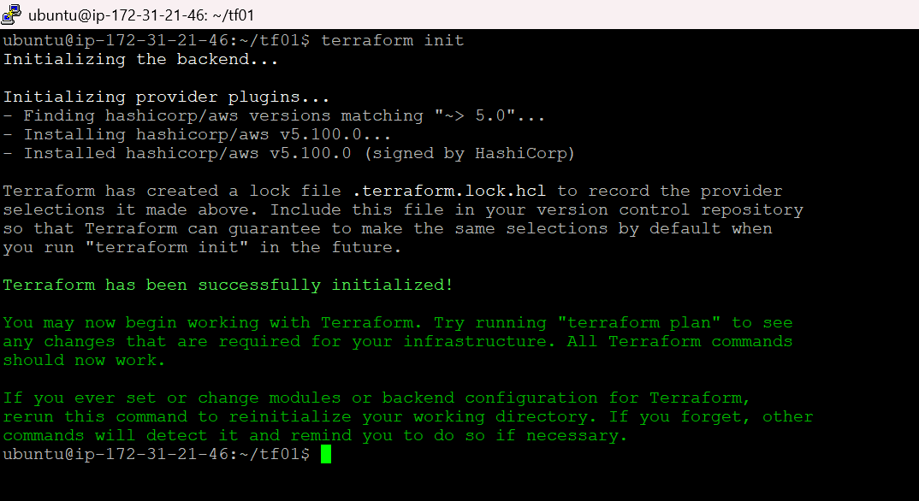

terraform plan

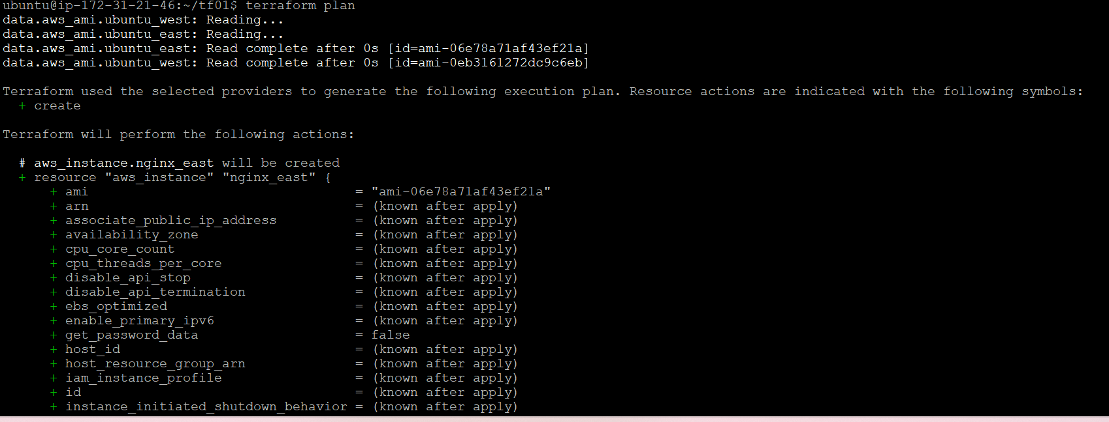

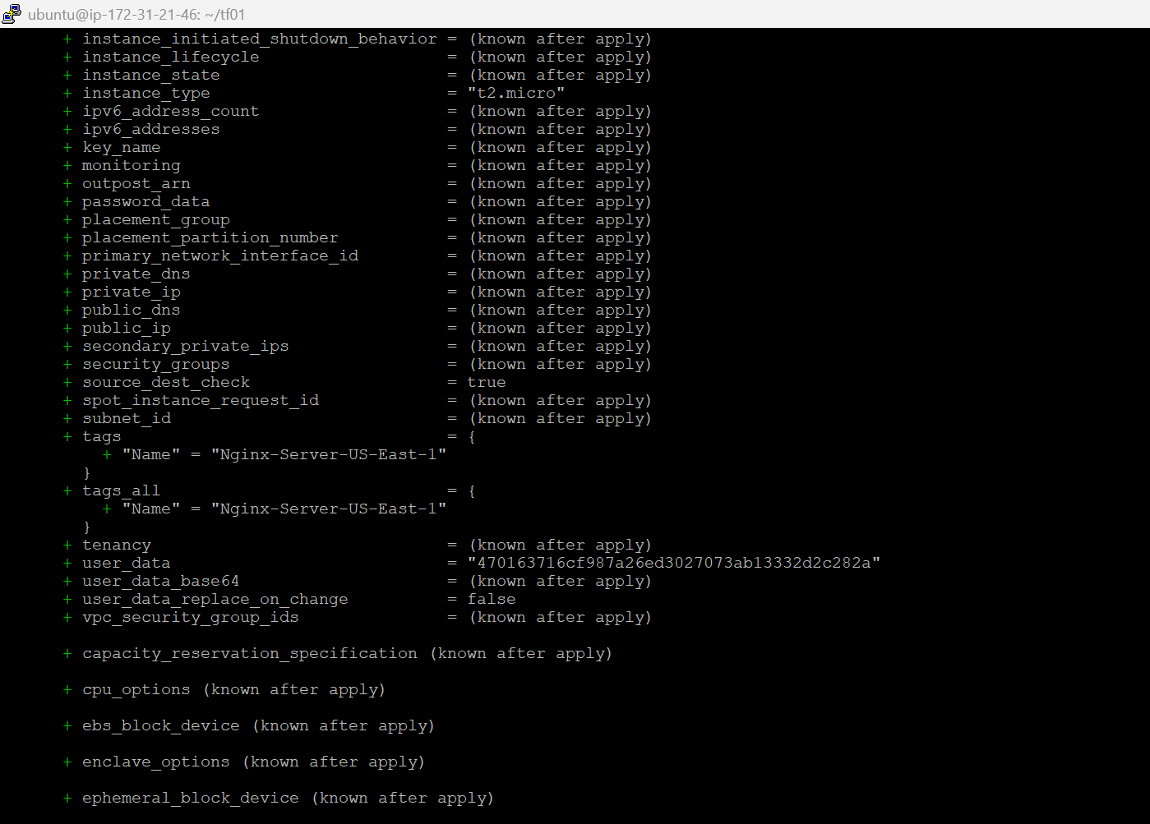

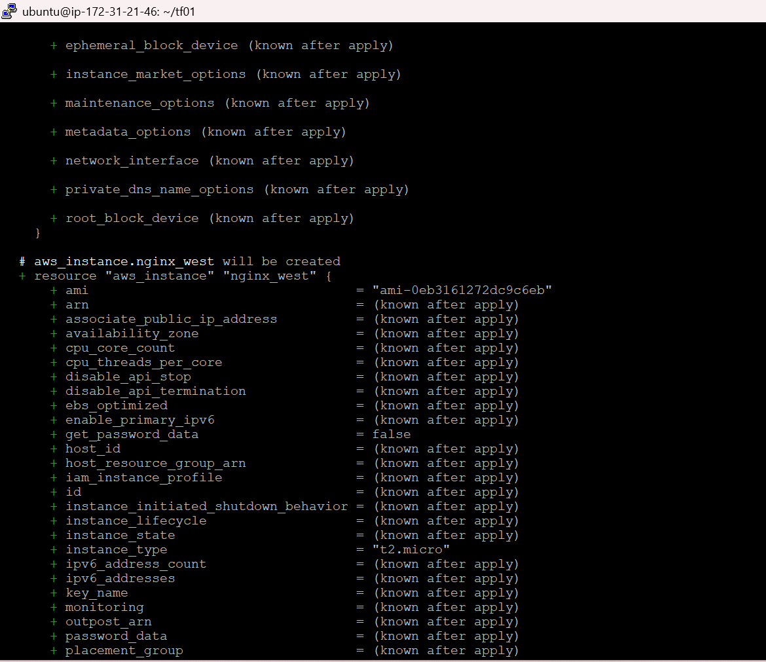

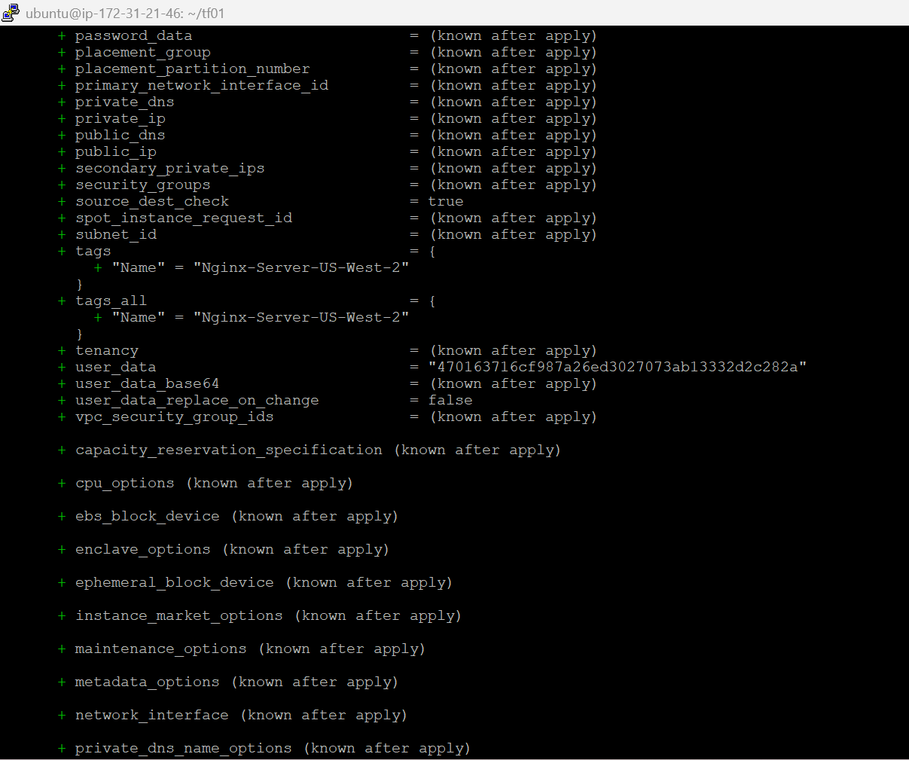

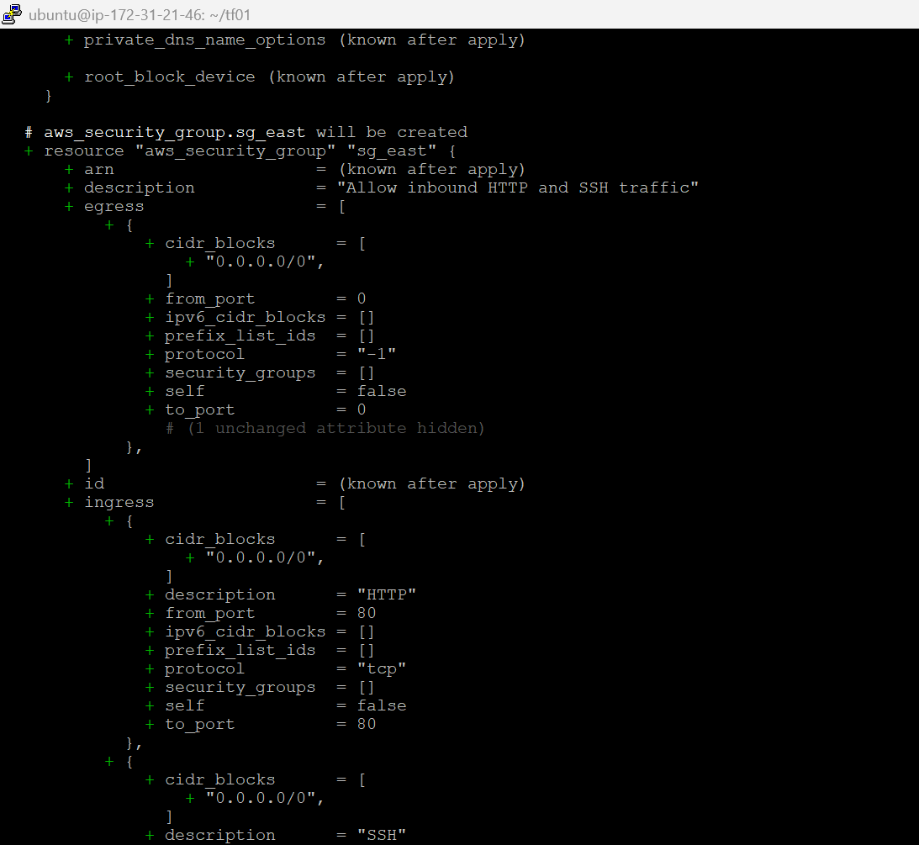

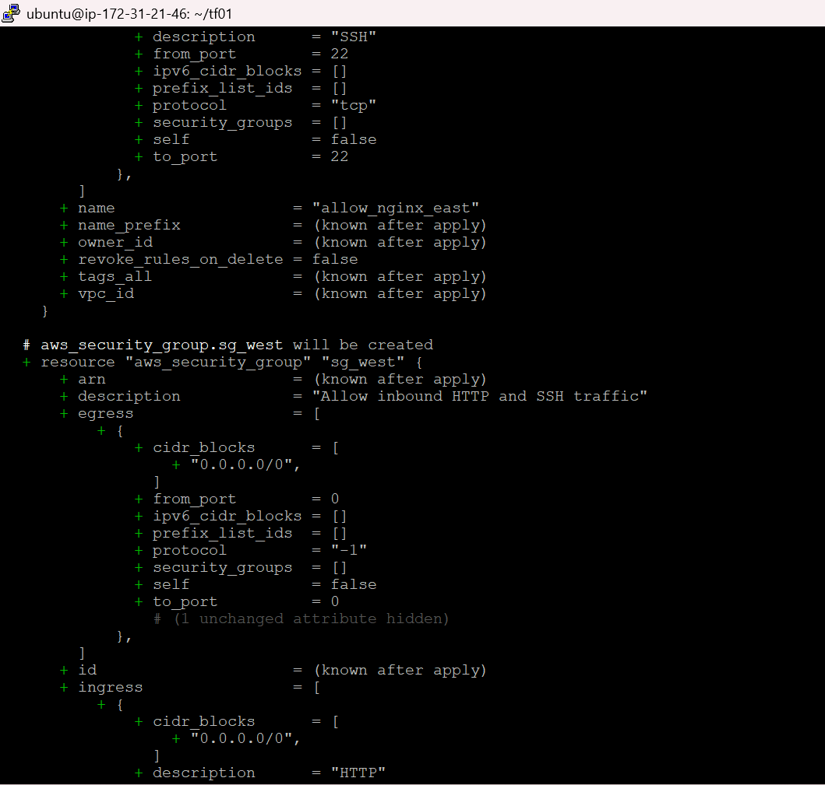

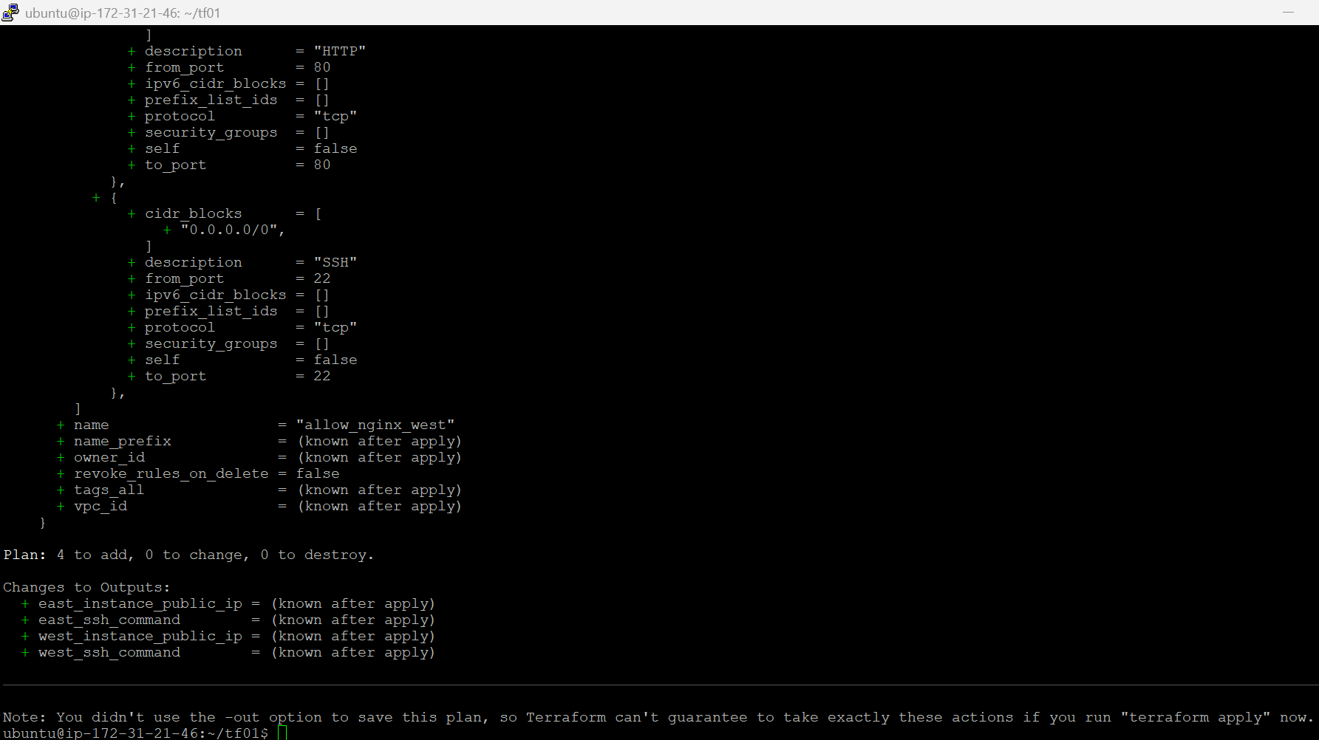

This will add 4 resources. 2 Ec2 instances and 2 security groups.

terraform apply

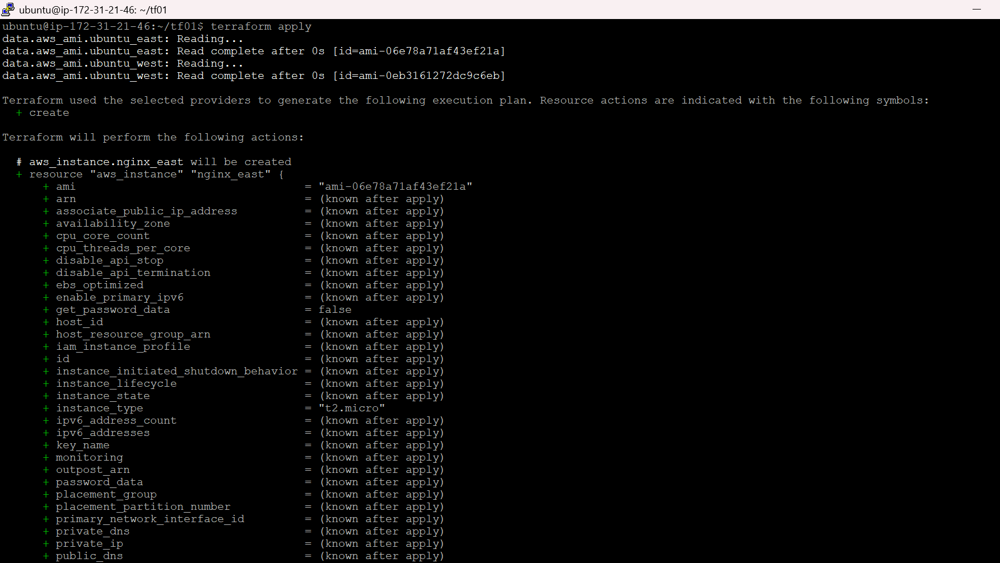

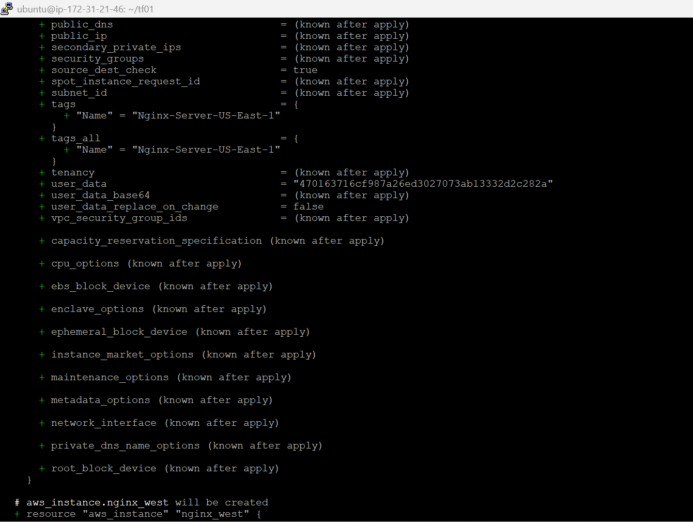

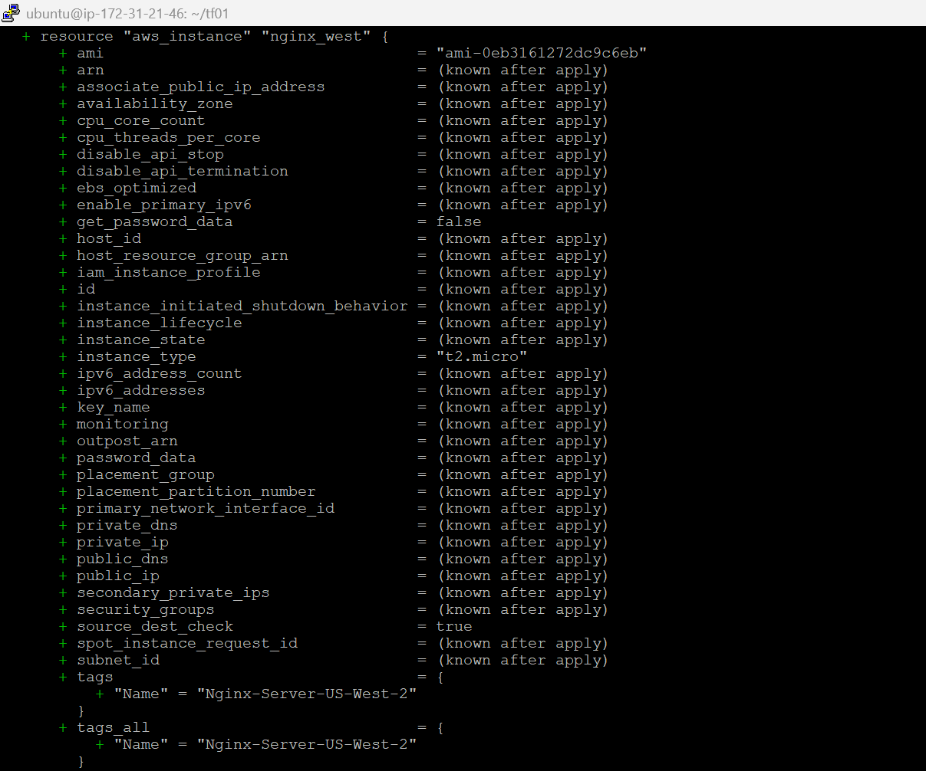

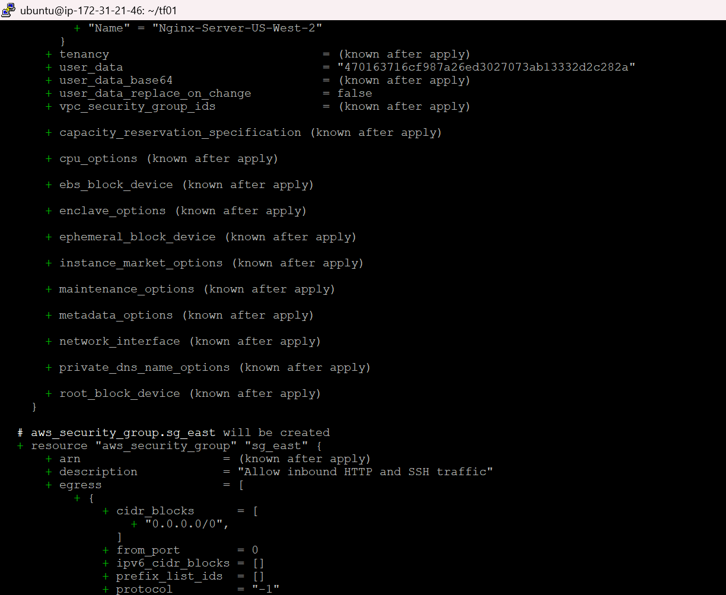

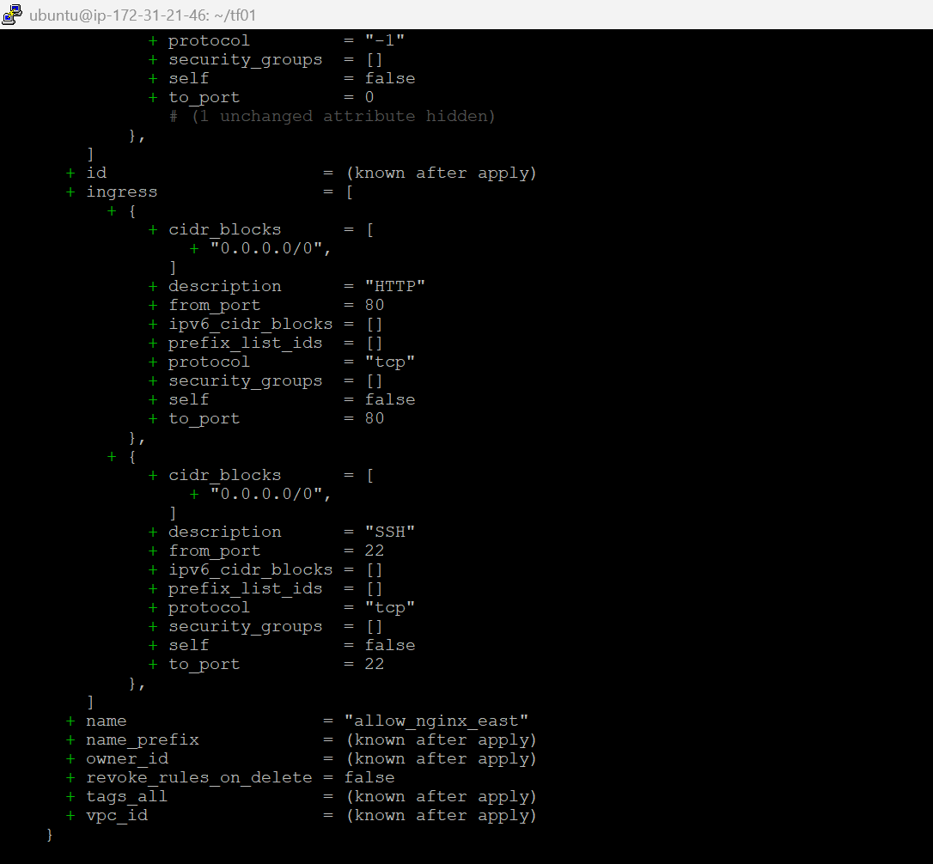

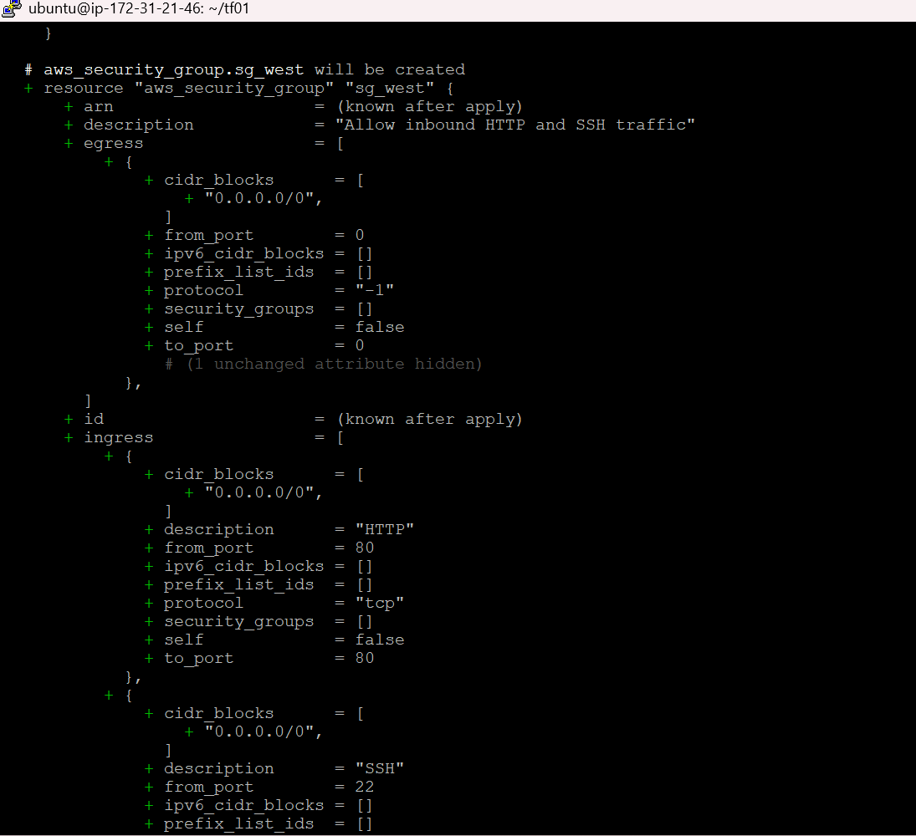

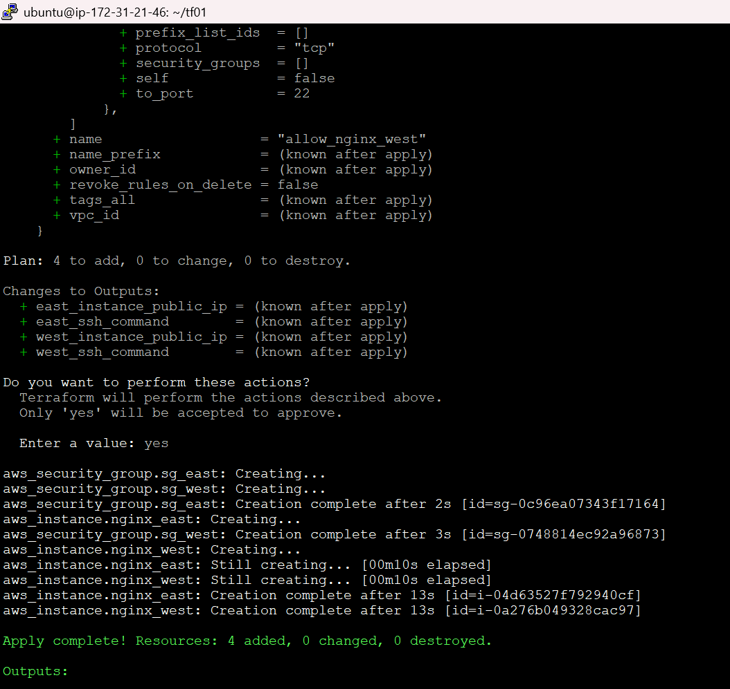

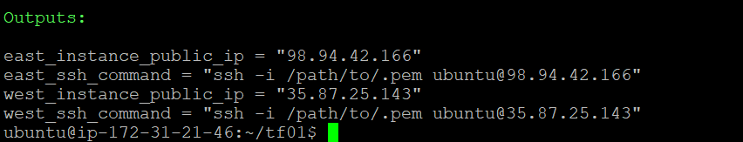

Now let’s validate the AWS console for the resources.

EC2 instance 1: Nginx-Server-US-East-1 in us-east-1
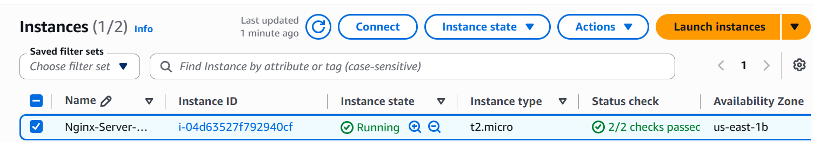

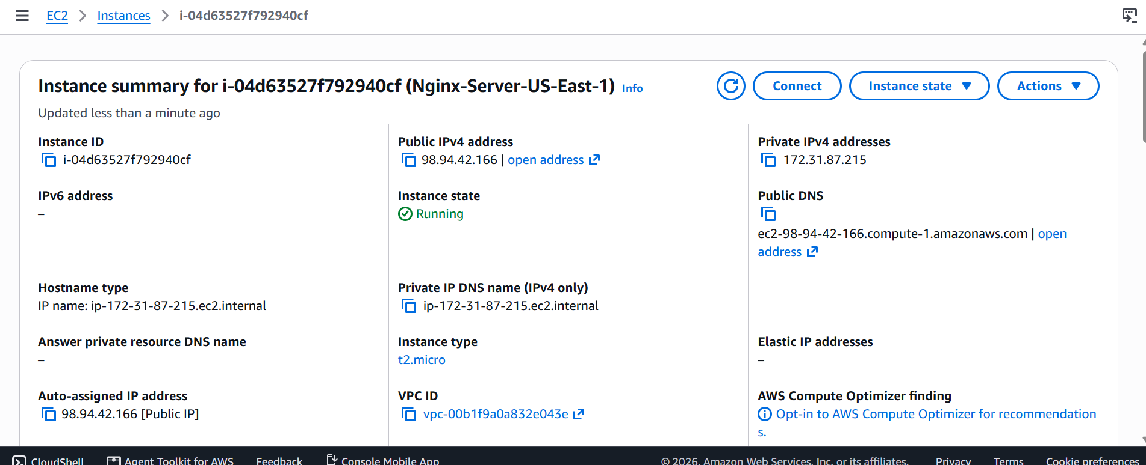

We are able to access the newly created Ec2 instance via browser and nginx is installed in it.

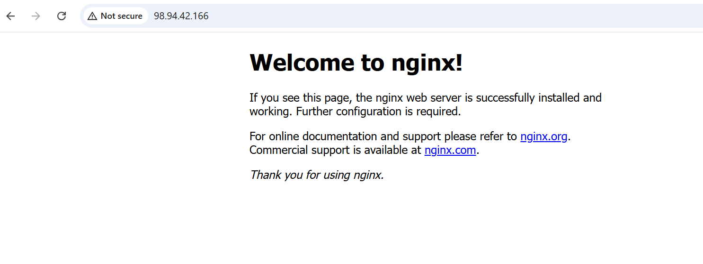

EC2 instance 2: Nginx-Server-US-West-2 in us-west-2

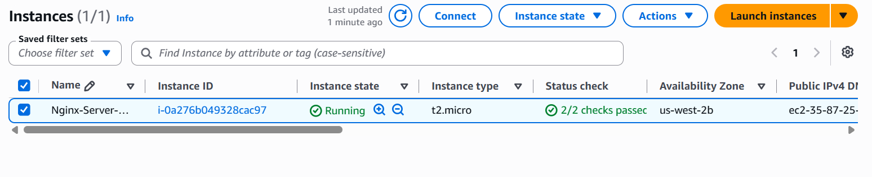
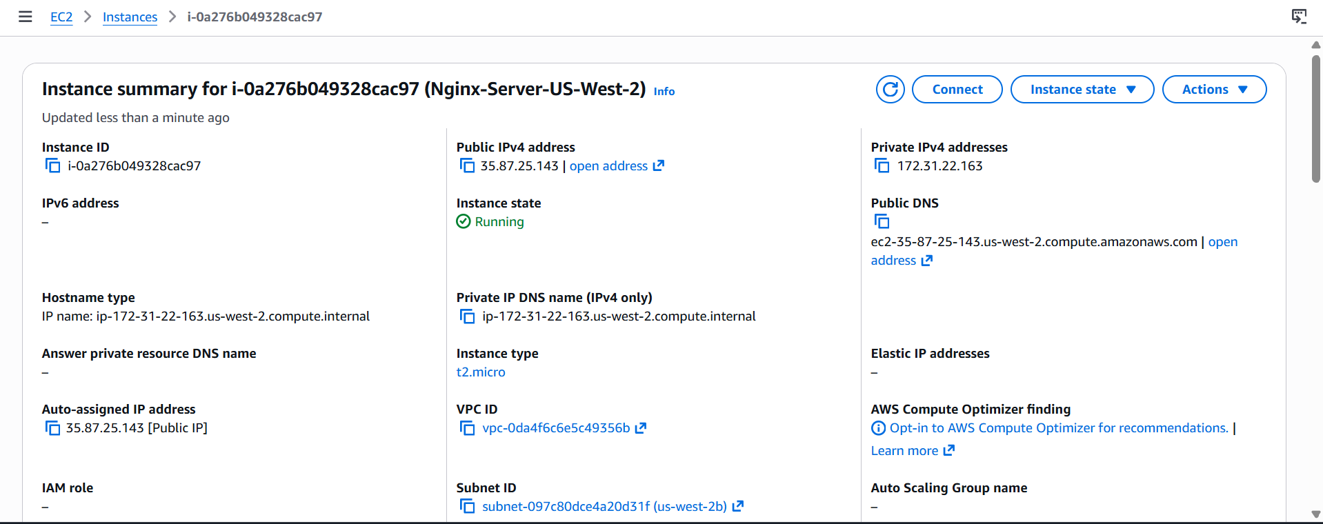

Let’s access this server via browser

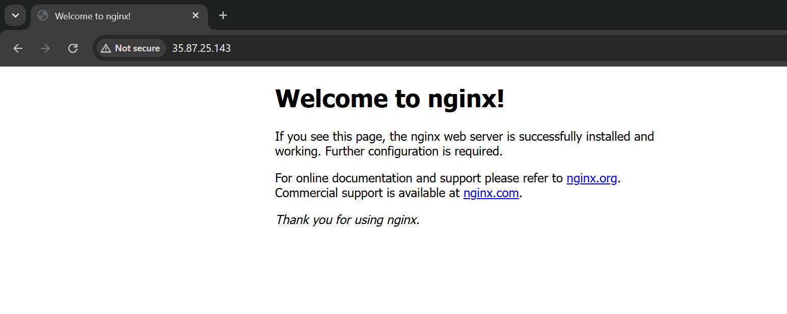

The two security groups are as follows

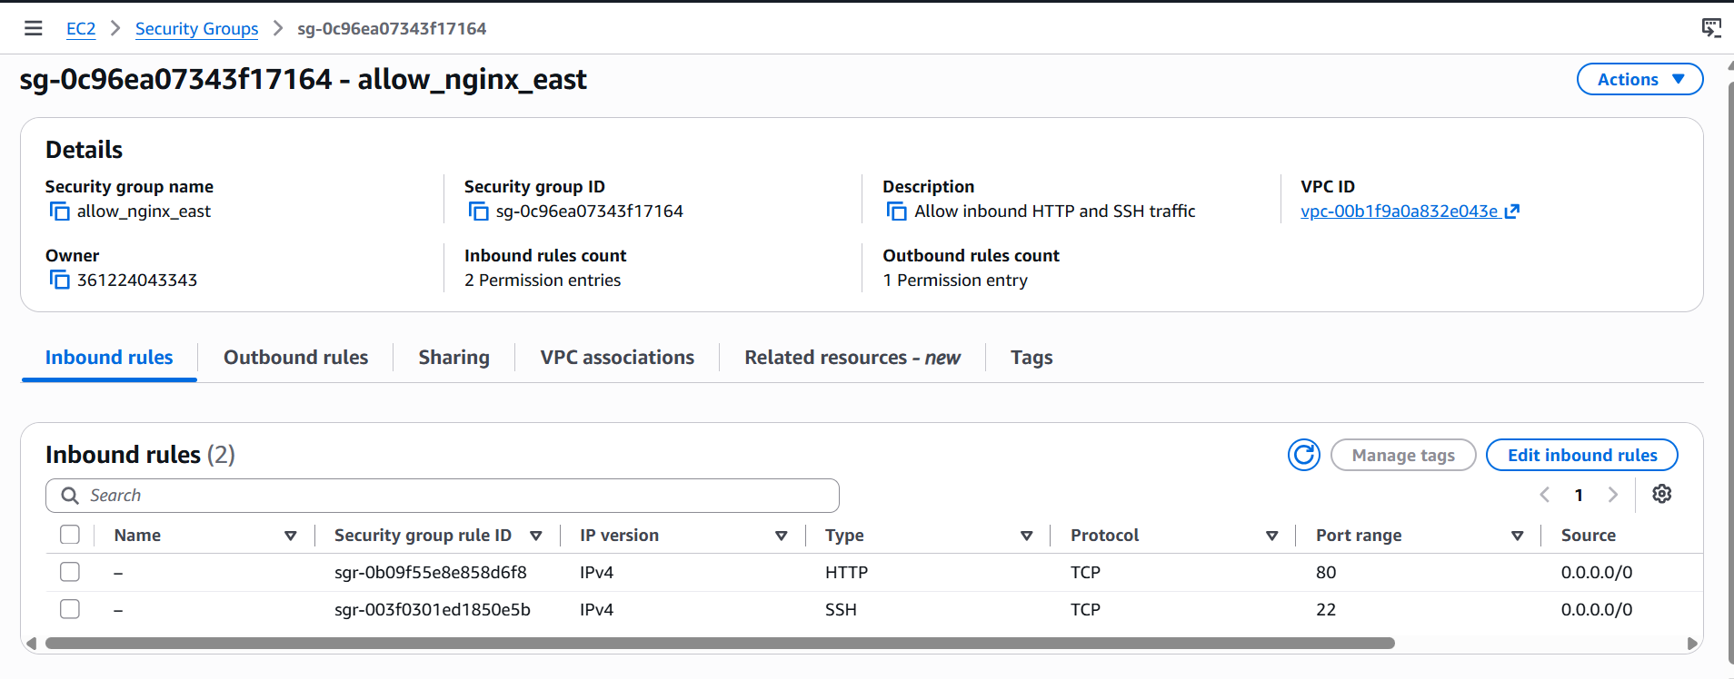

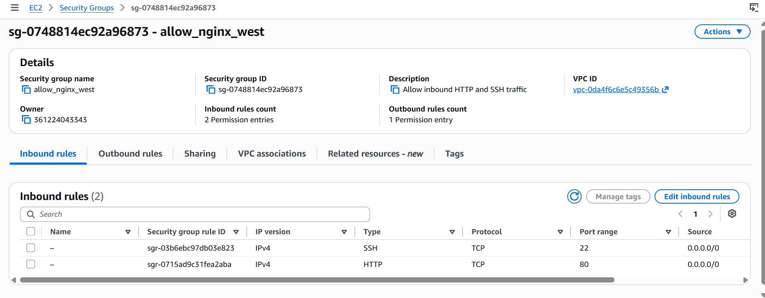

All 4 resources have been created successfully. This concludes our task.

