Kubernetes Task-2

Task Description:
Create the K8s EKS, further you have to do the deployment of the Nginx application and access the application outside the cluster.
Step 1: Creation of EKS Cluster:
Let’s login to AWS and goto IAM for creating the IAM role for the cluster.
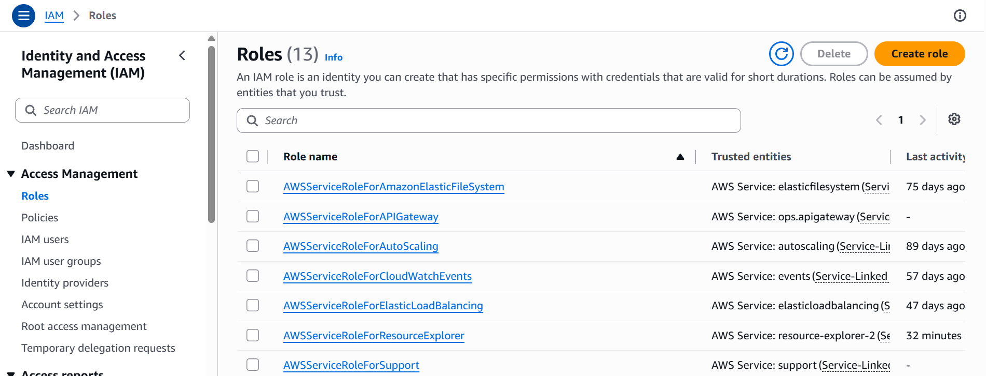
IAM Roles Create Role
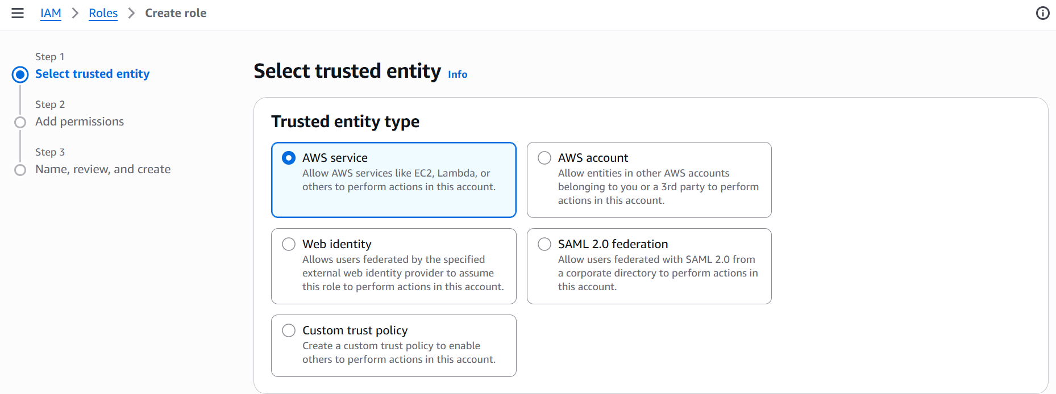
Select “AWS service” for the Trusted Entity Type and select the “EKS - Cluster” for the use case
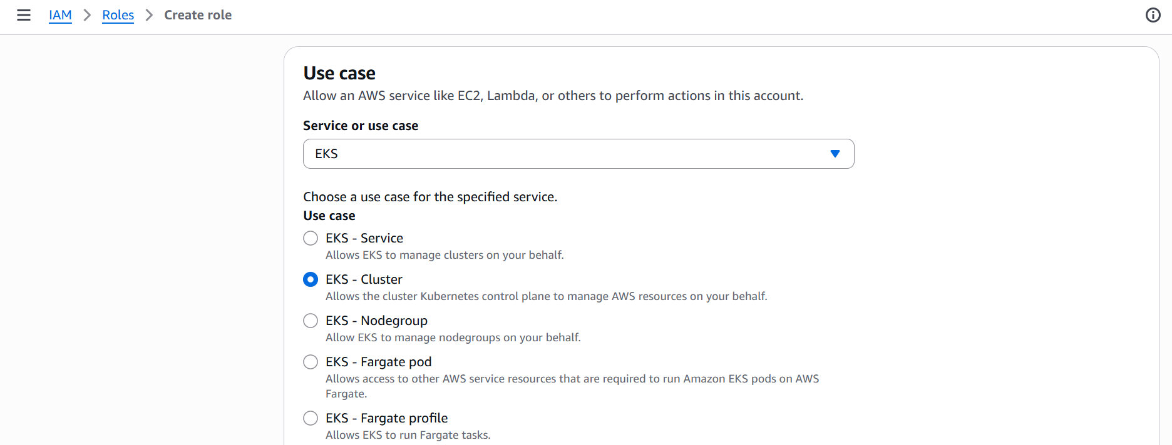
Click Next and then add permissions
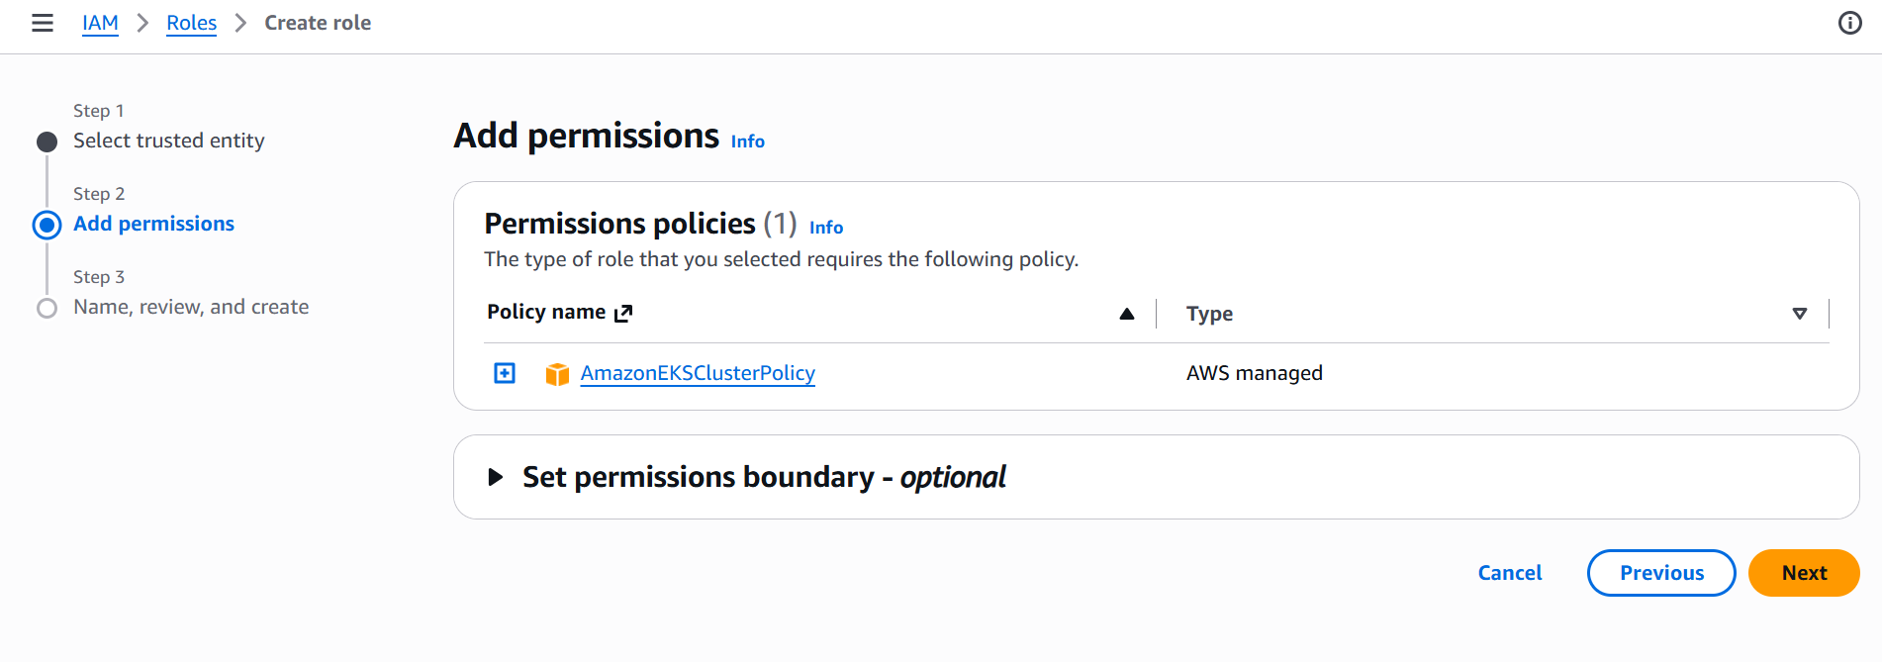
This step will automatically attach the “AmazonEKSClusterPolicy” to the role. Click Next
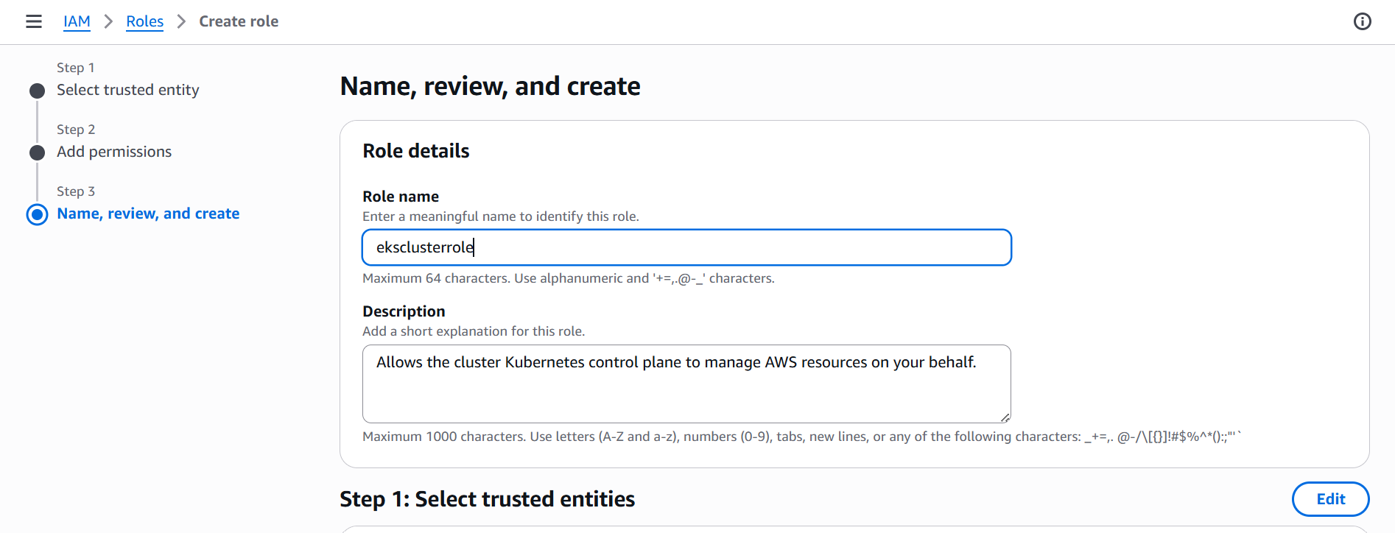
Provide a suitable name to the role “eksclusterrole” and then create role.
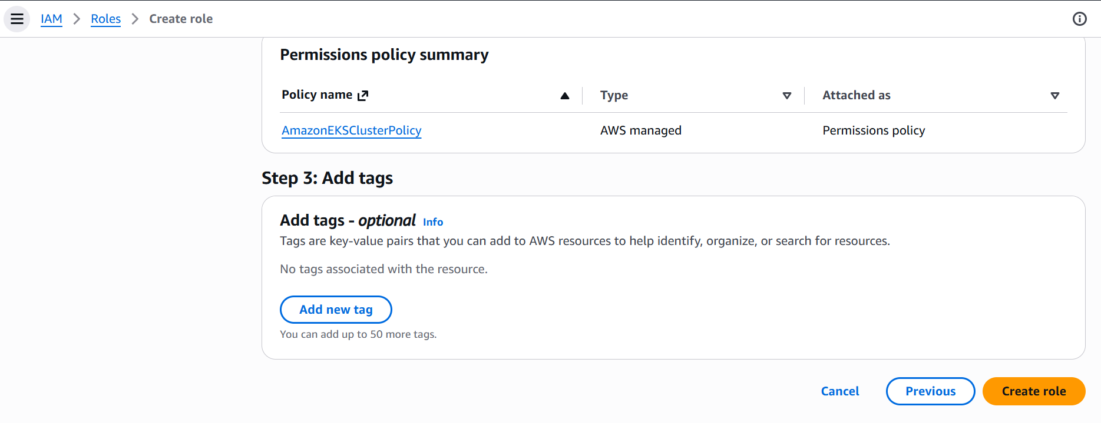
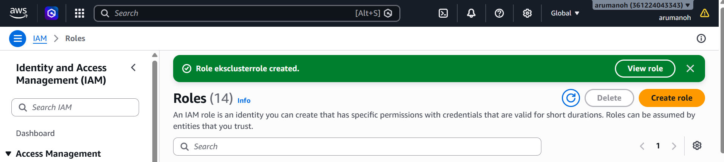

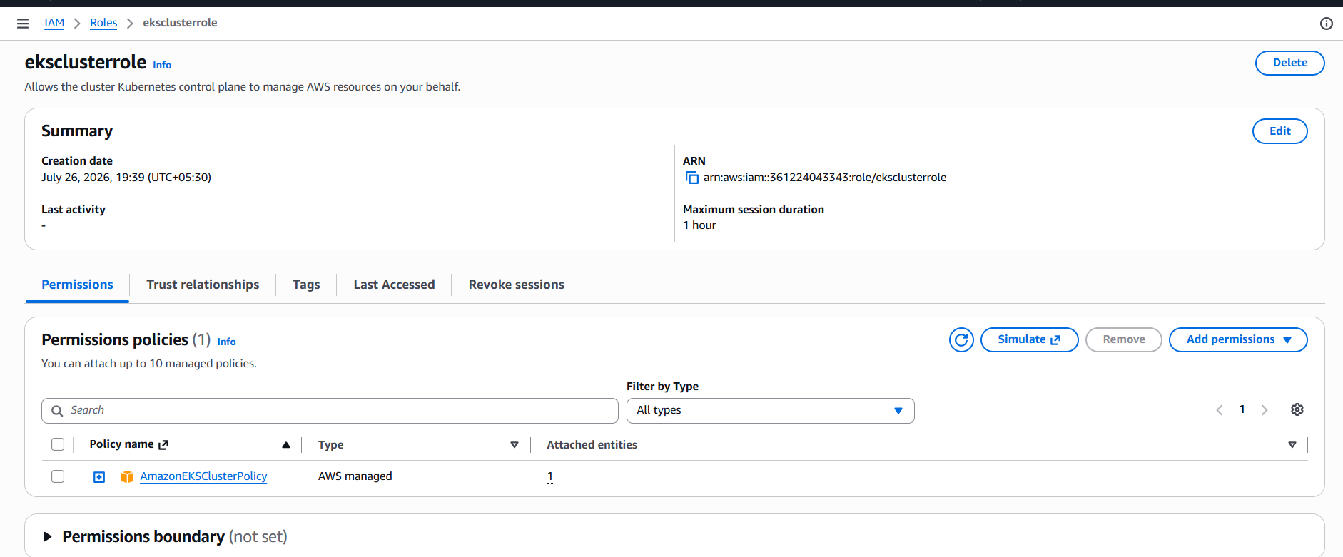
Now we need to set up the VPC networking for our EKS cluster.
Goto VPC Create VPC

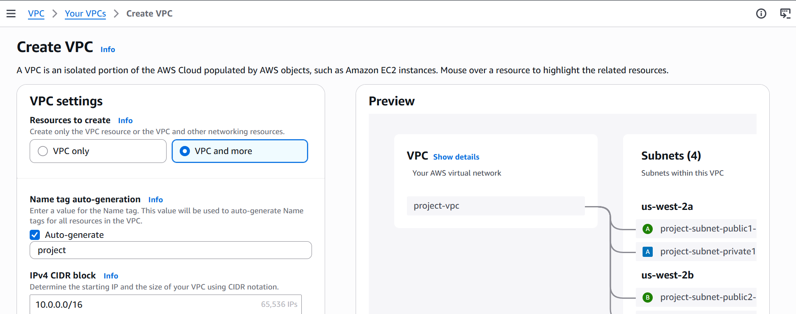

Select VPC and more option to auto-generate public/private subnets across at least 2 Availability Zones, a NAT gateway, and route tables.
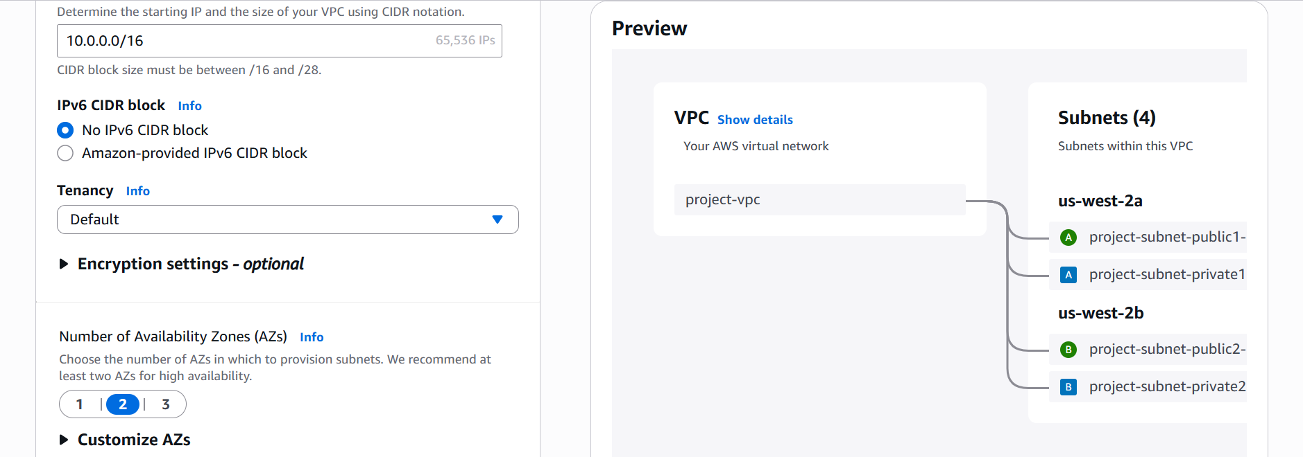
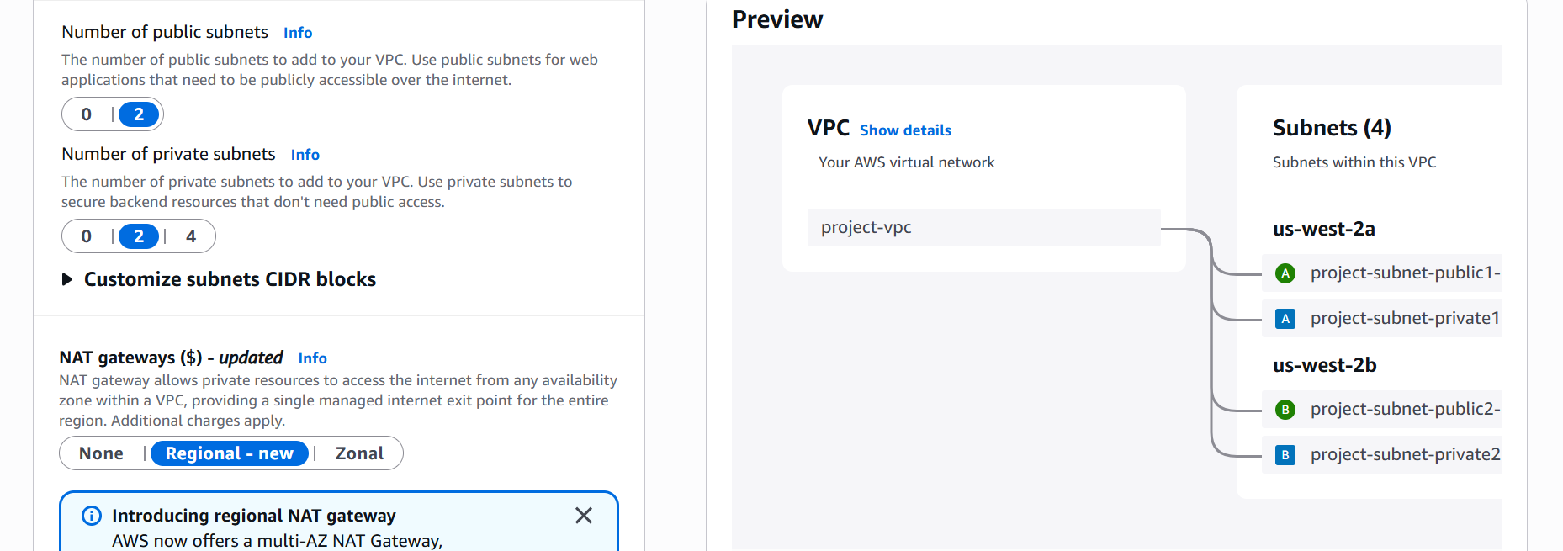
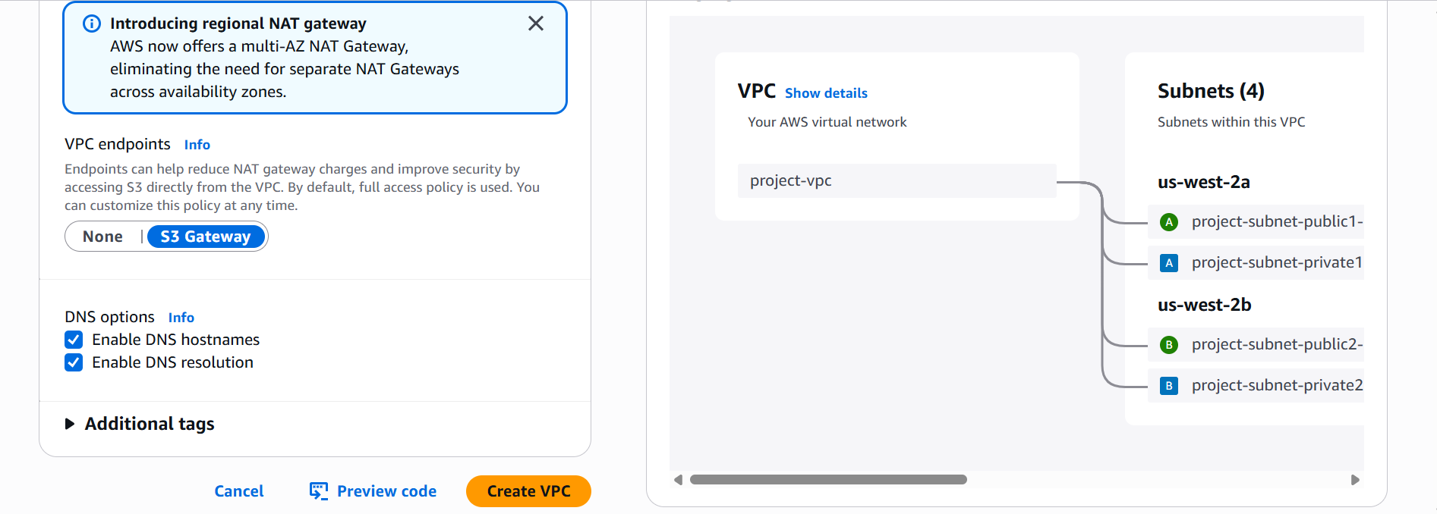
Create VPC
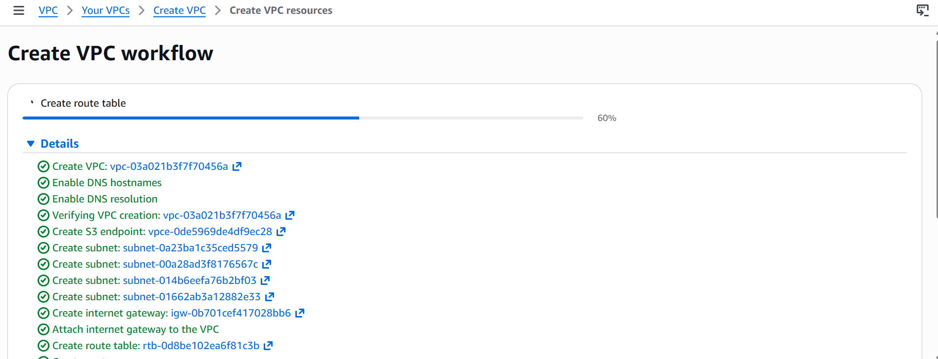

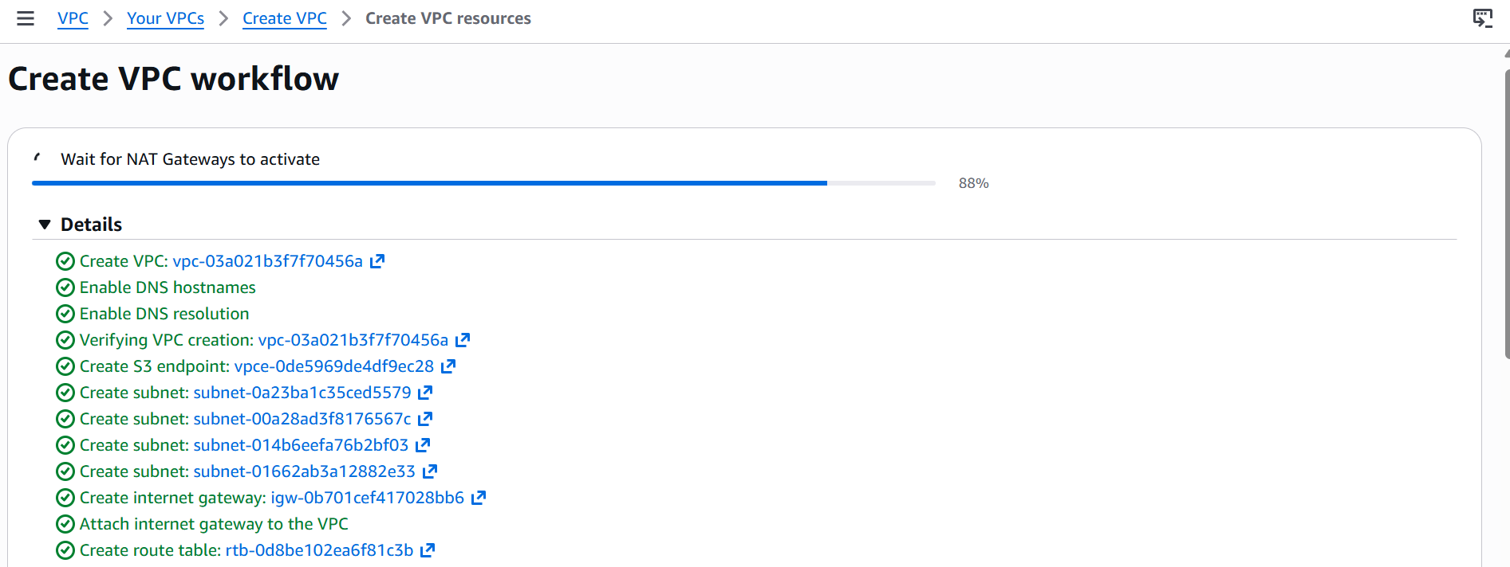
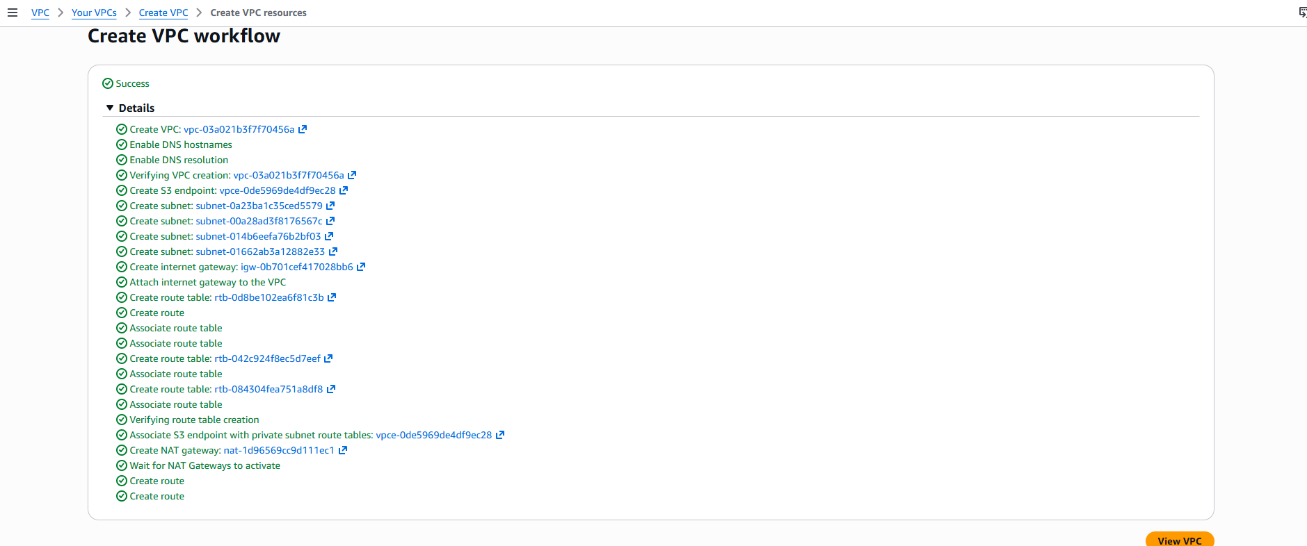
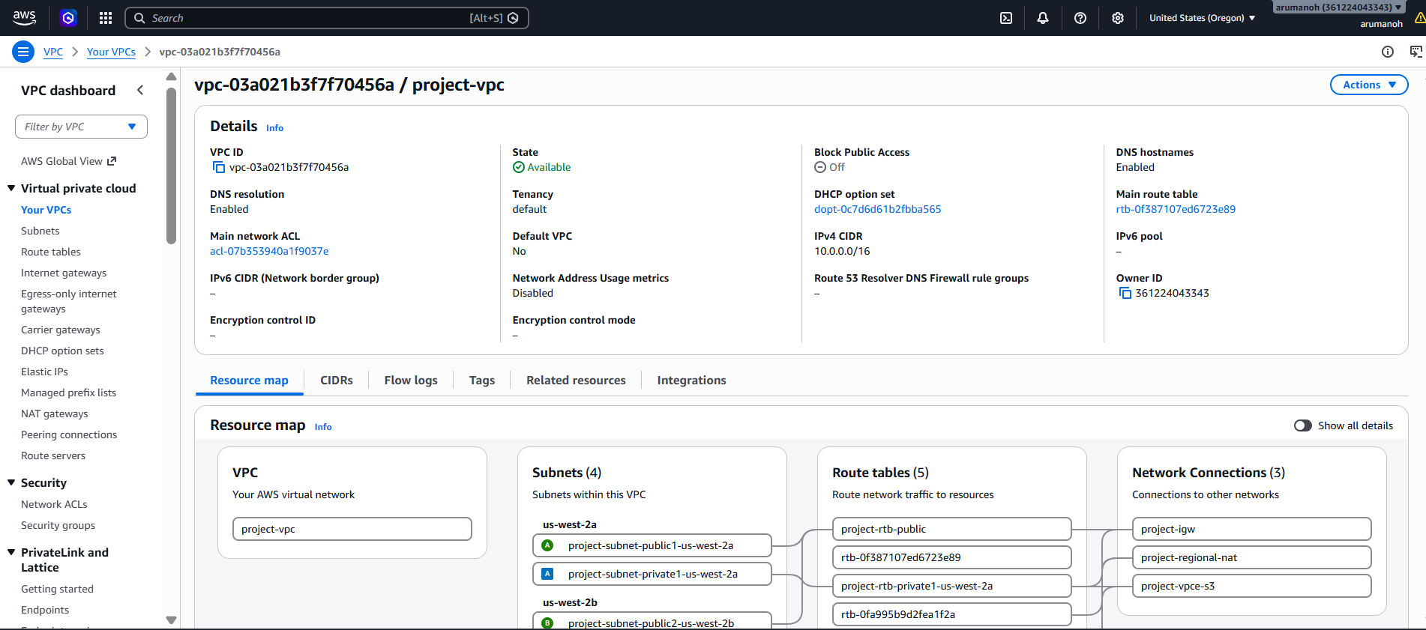
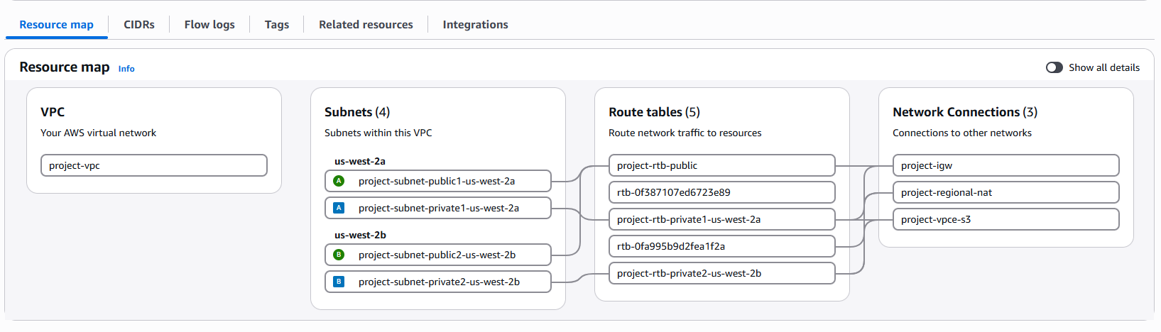
Now we need to tag our subnets for EKS/ELB auto discovery

We have 2 Public Subnets and 2 Private Subnets within our VPC
us-west-2a – 1 Public Subnet and 1 Private Subnet
us-west-2b – 1 Public Subnet and 1 Private Subnet

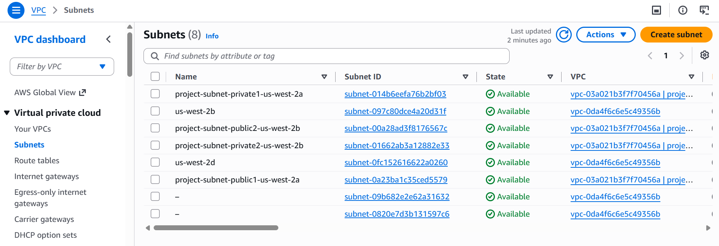

Let’s tag the Public subnet, so that it can place internet facing ELB’s there

Public Subnet -> Tags -> Manage Tags

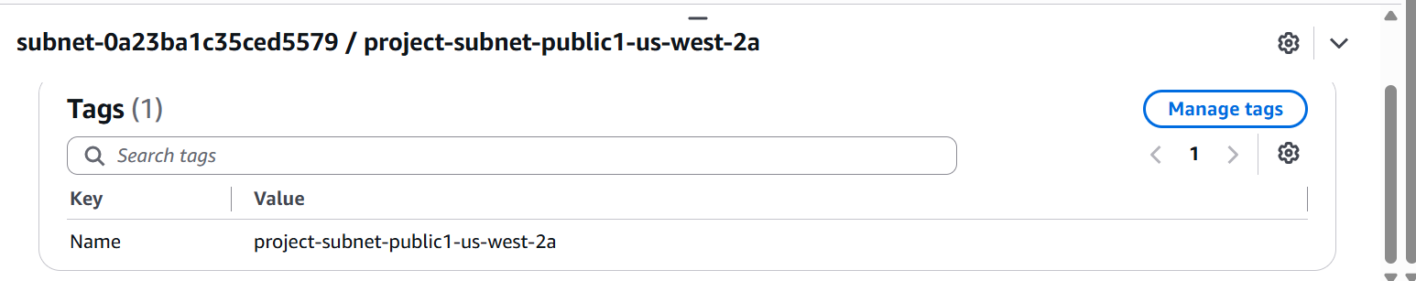

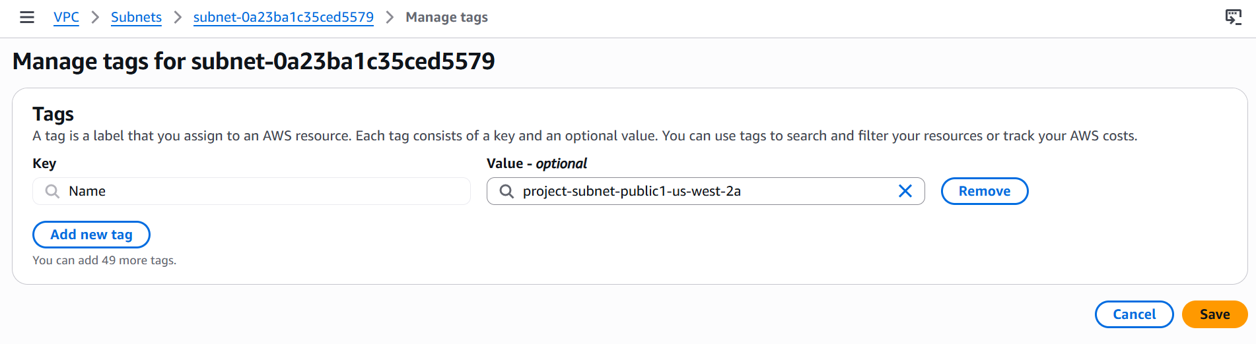
Add new tag

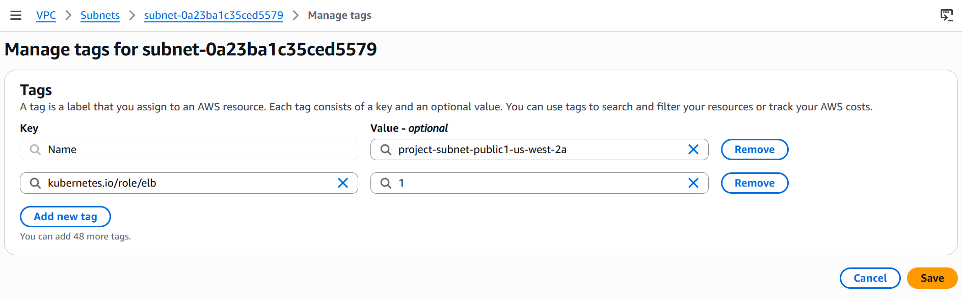
Similarly tag for the other Public Subnet as well.

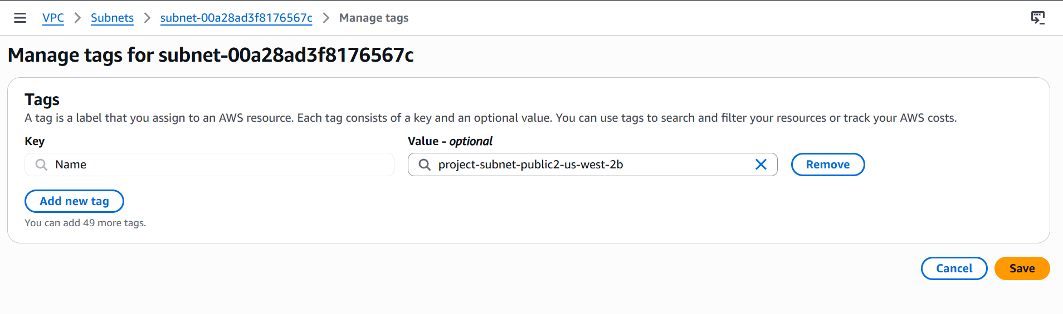
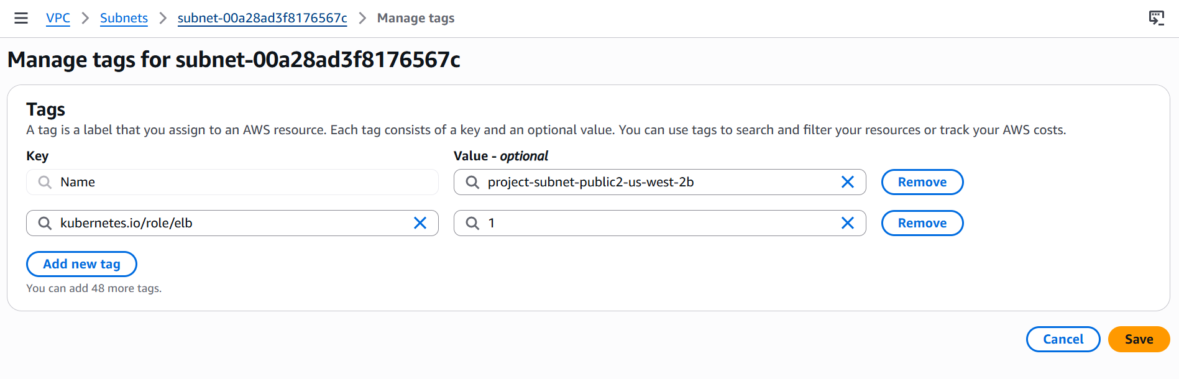
Now lets tag the 2 Private Subnets for placing the internally one Load Balancers when required.

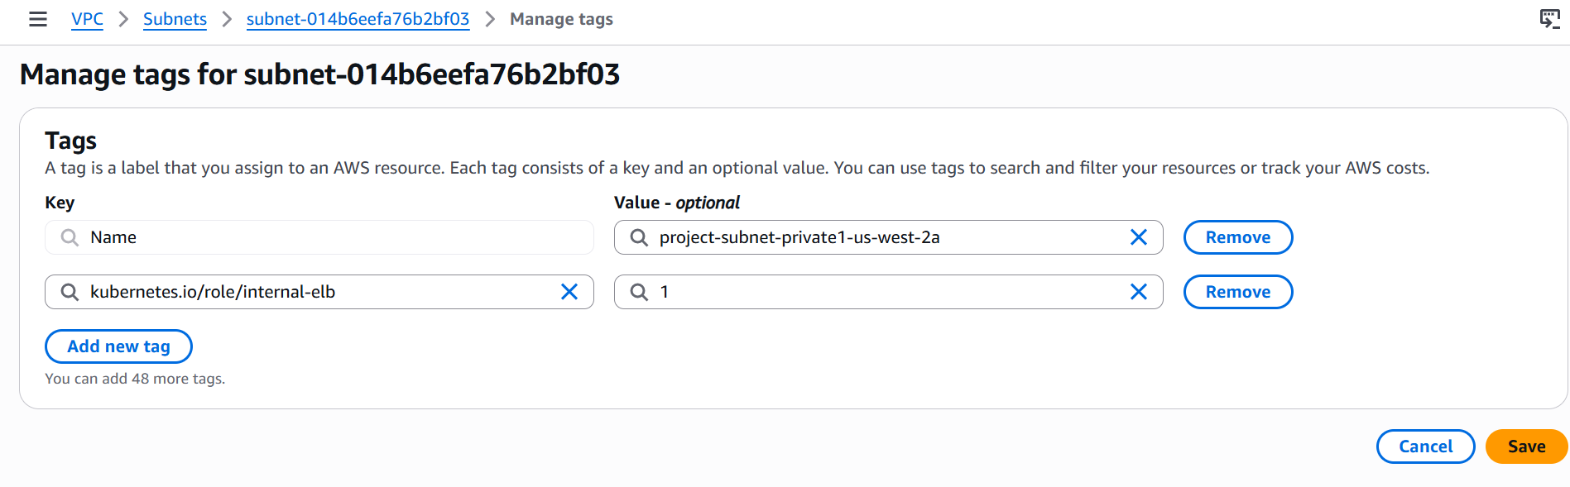
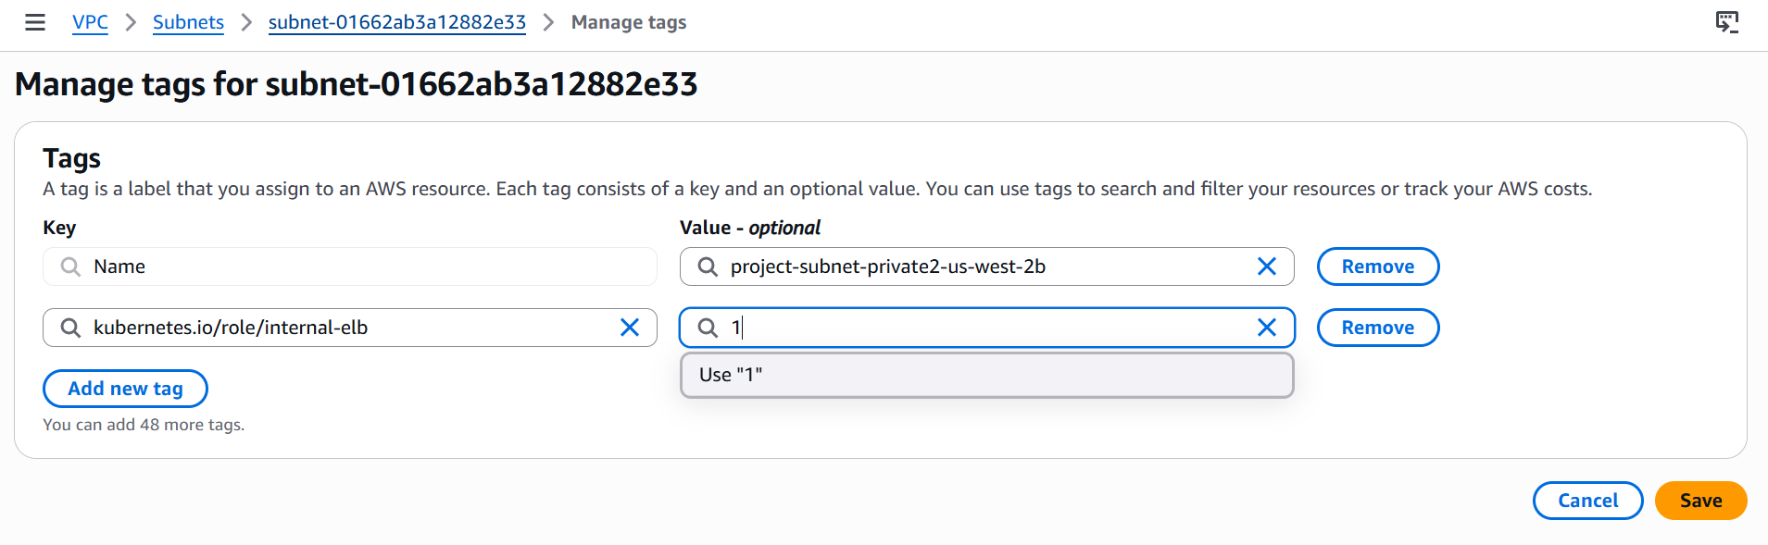
All the ground work has been done, now let’s create the EKS cluster.

Open EKS and create the cluster

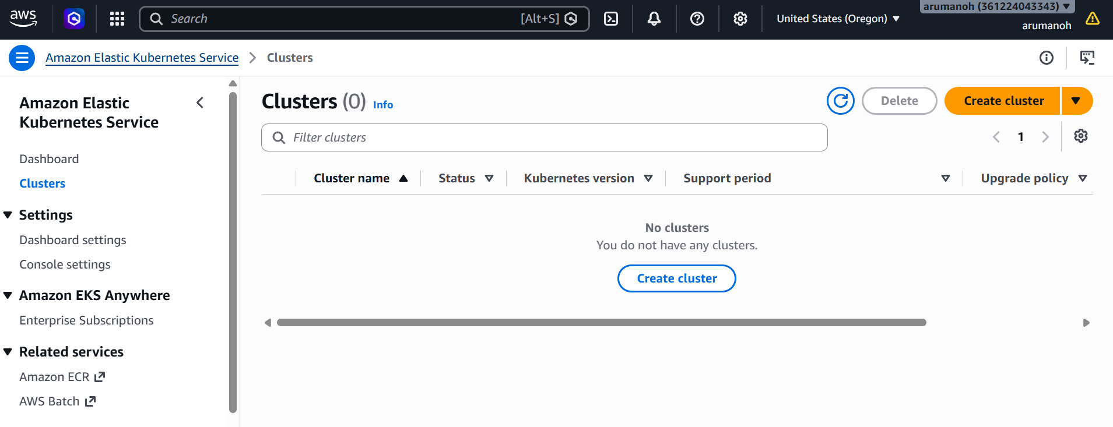

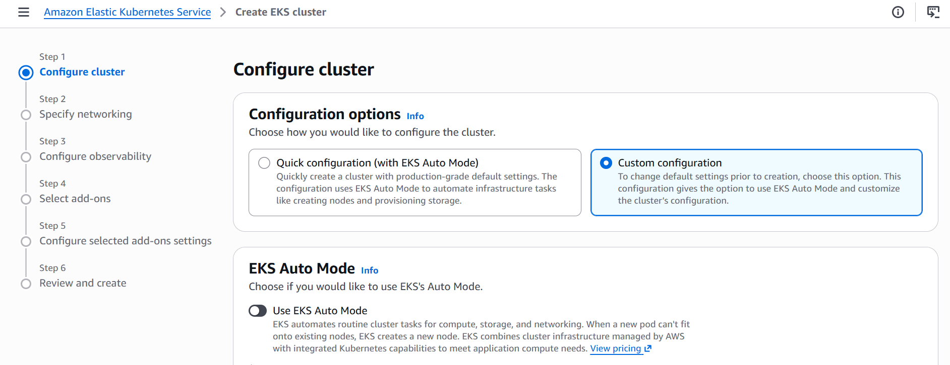

Using Custom Configuration and disabling the EKS Auto mode.

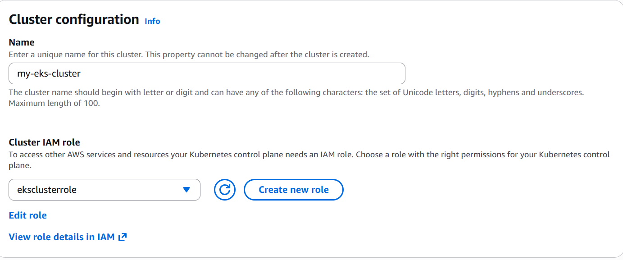
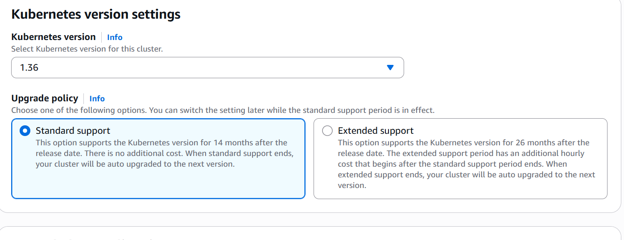
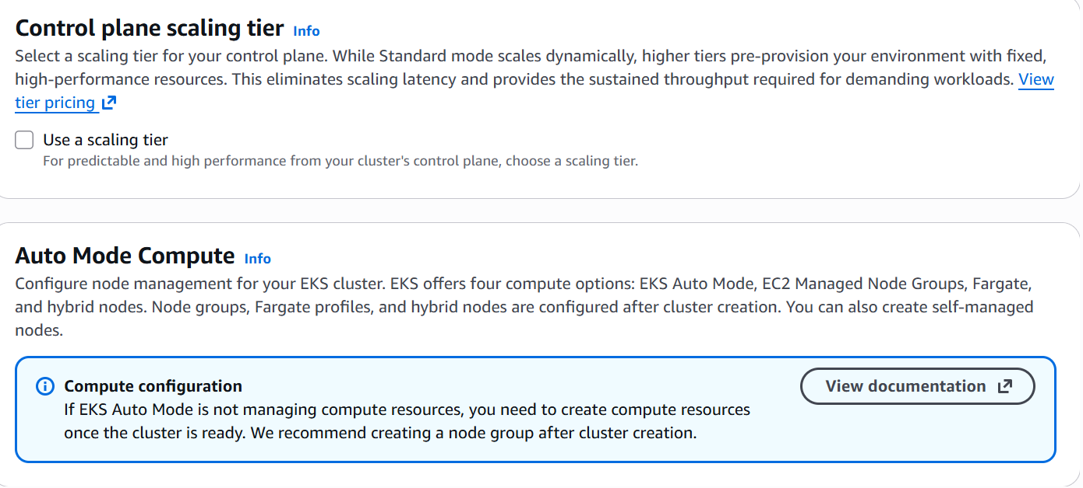
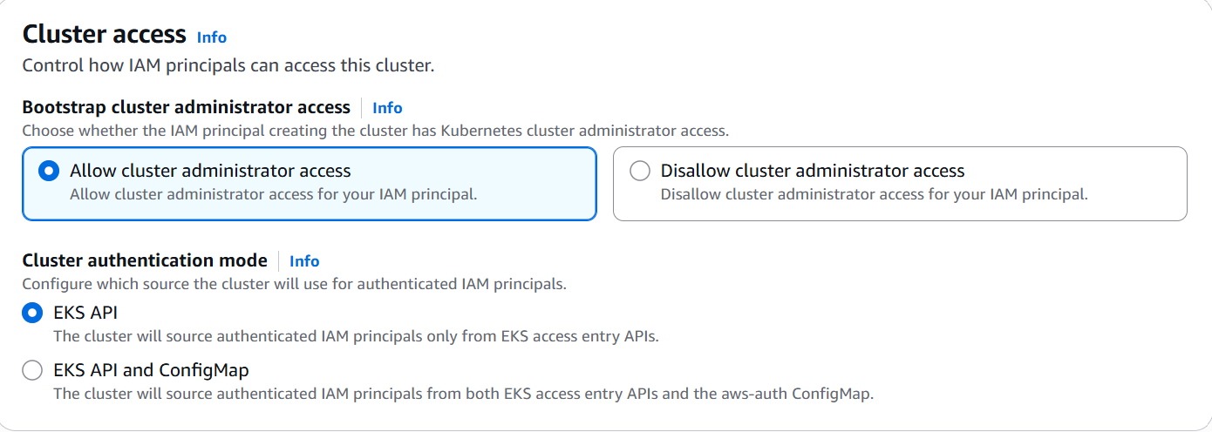
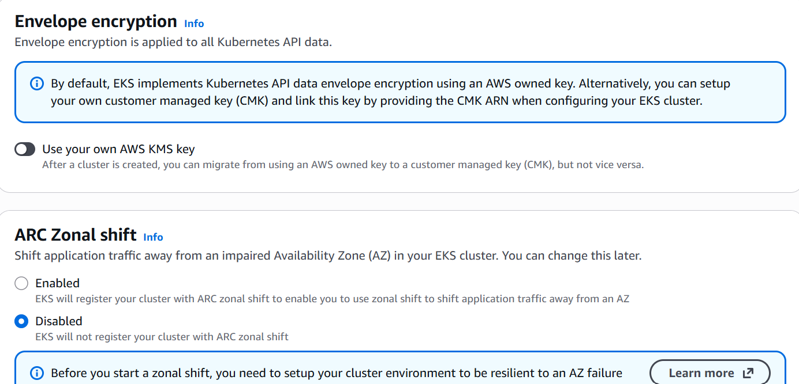

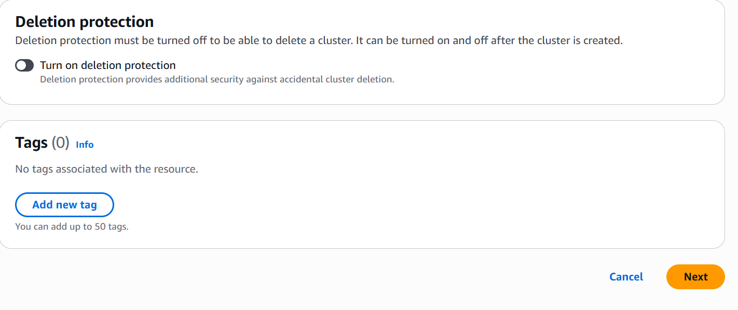
Now let’s setup networking for our cluster

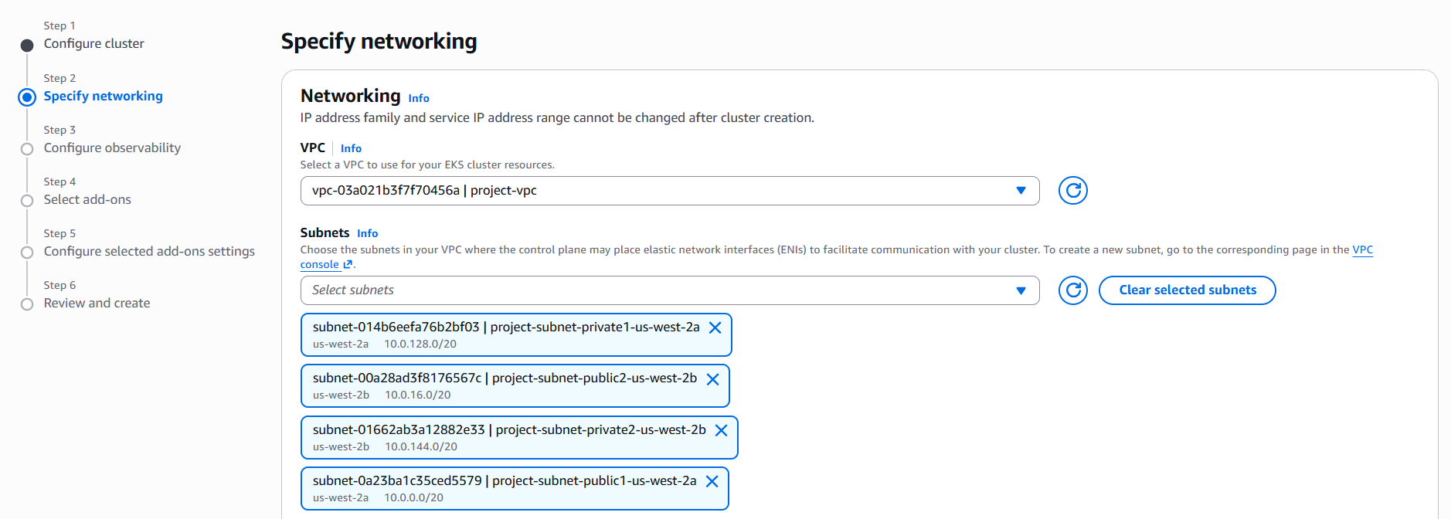
Once you select our VPC which we created earlier, the subnets get selected automatically.

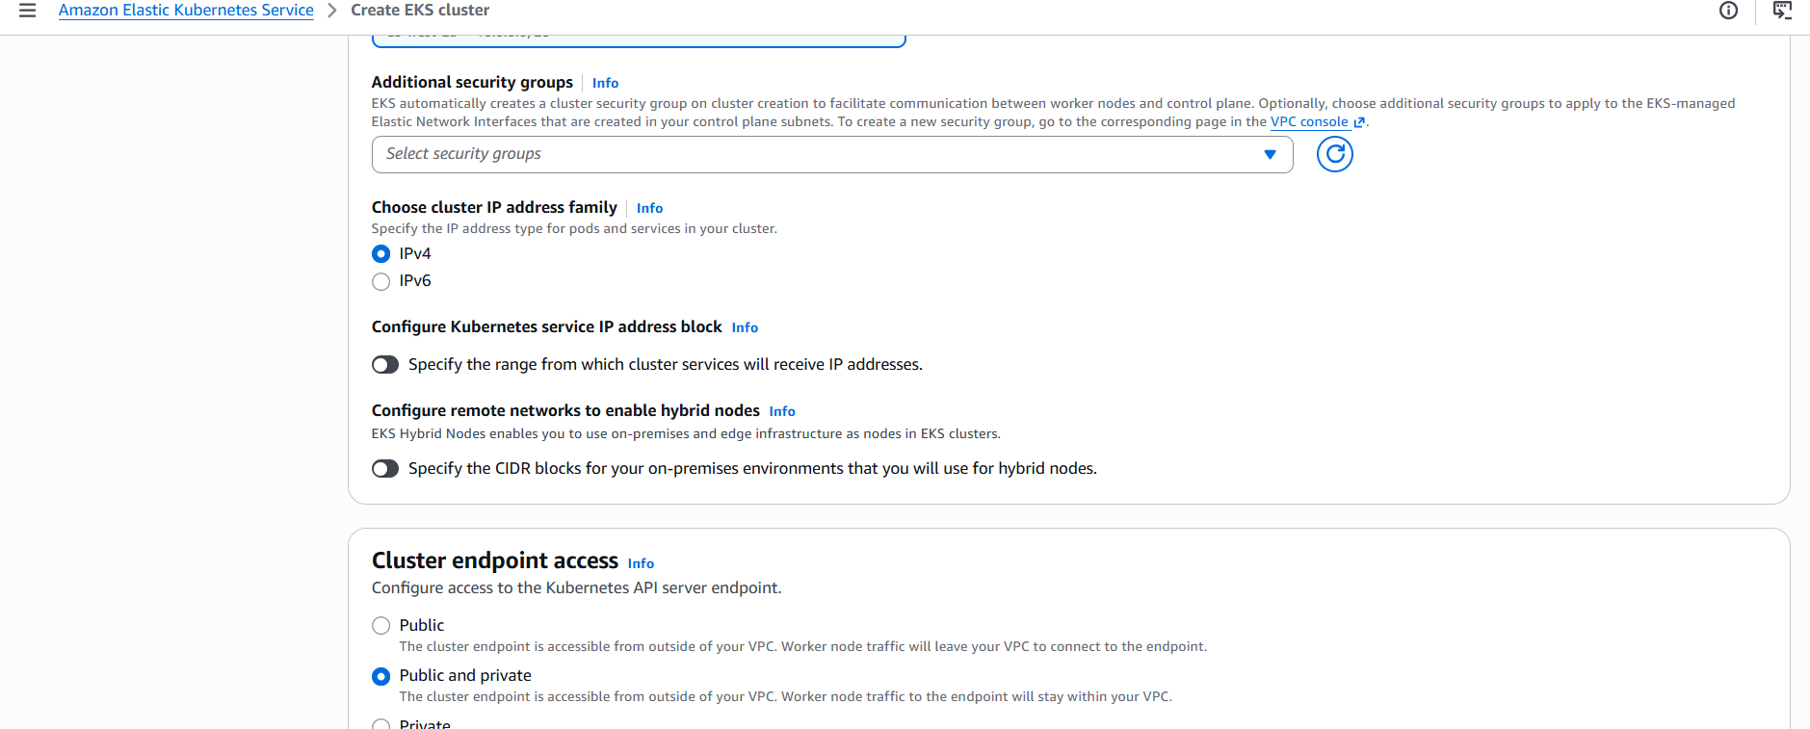

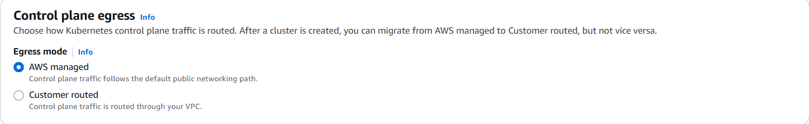

Configure observability is optional for our cluster since it is for learning purpose, hence I am skipping it without selecting any option

By default many add-ons are selected by AWS, we can just leave it as it is and then click next

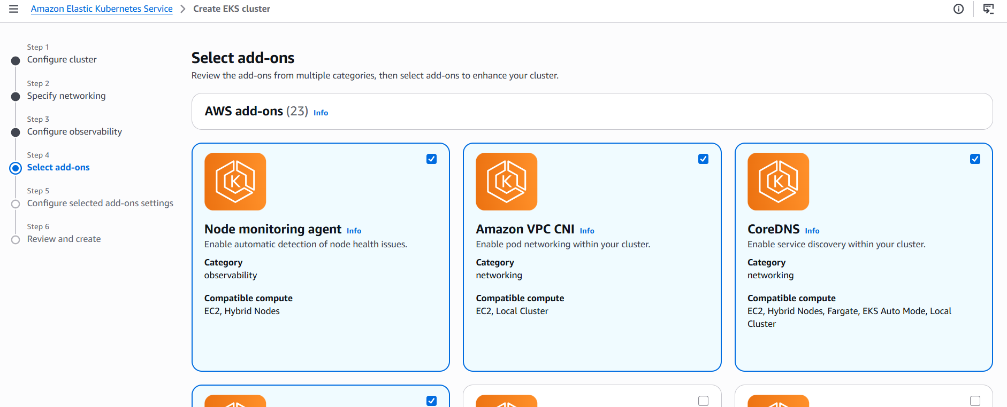

In the “Configure selected Add-ons” page, we need to create IAM roles for aws-node

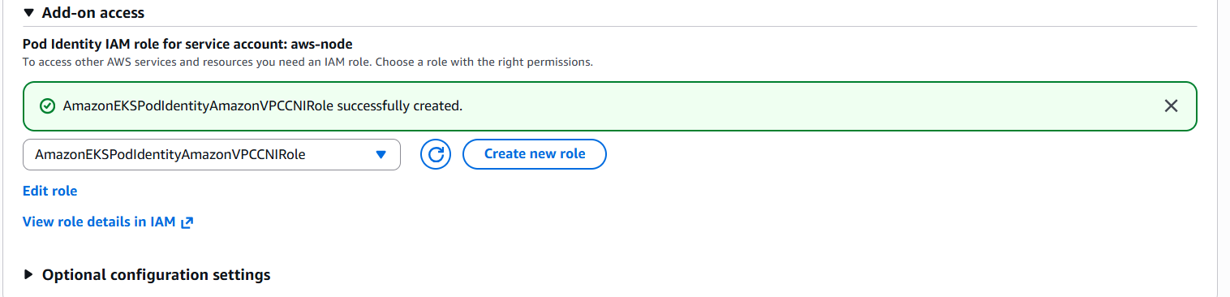

Click Next and then Review the selected options so far and then click create

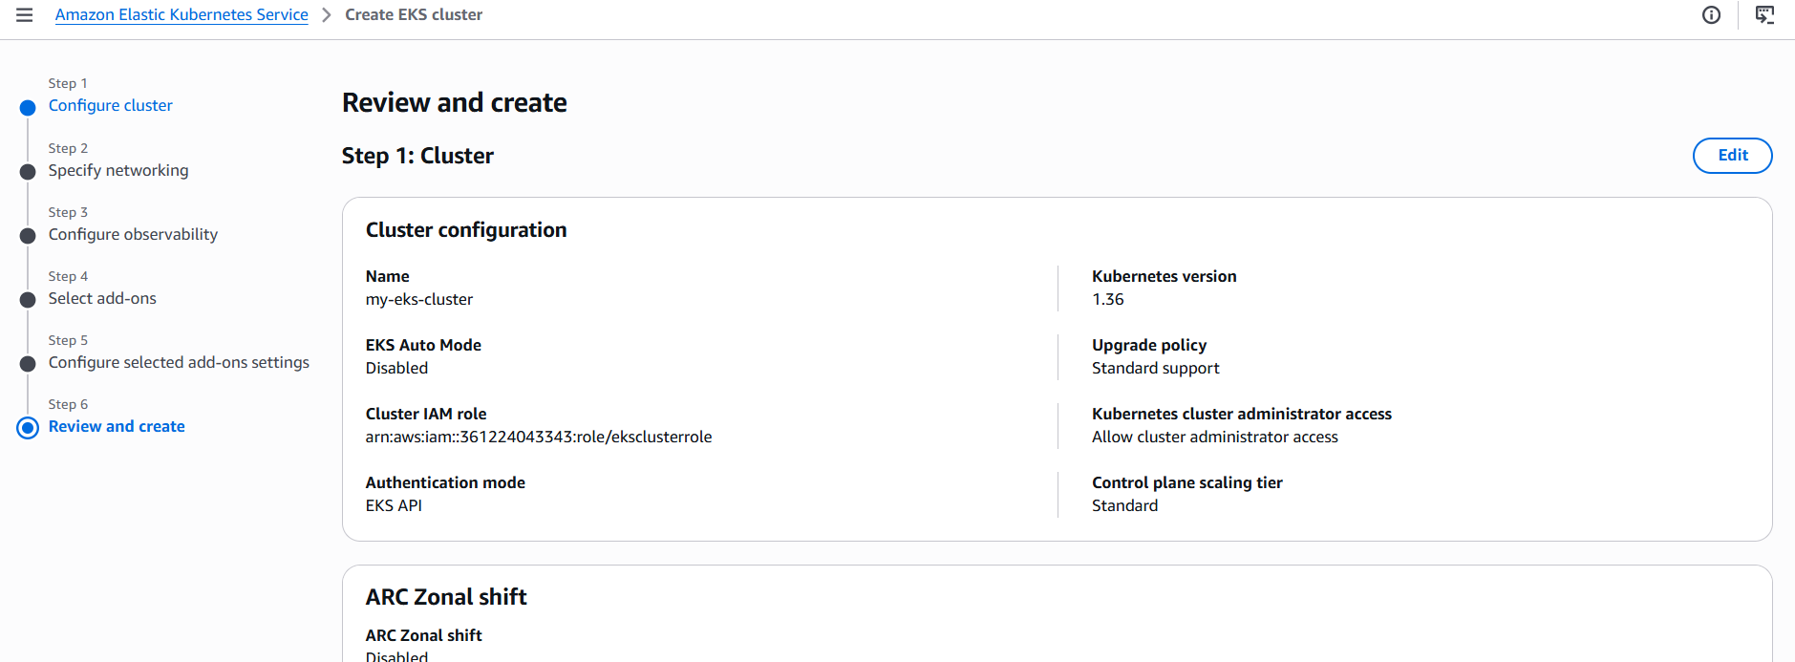

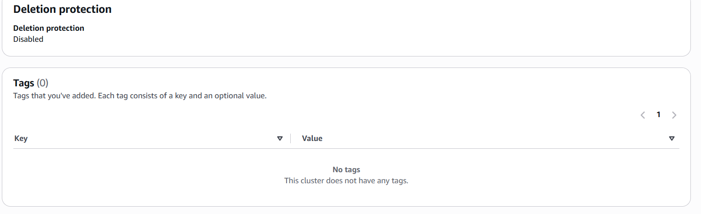
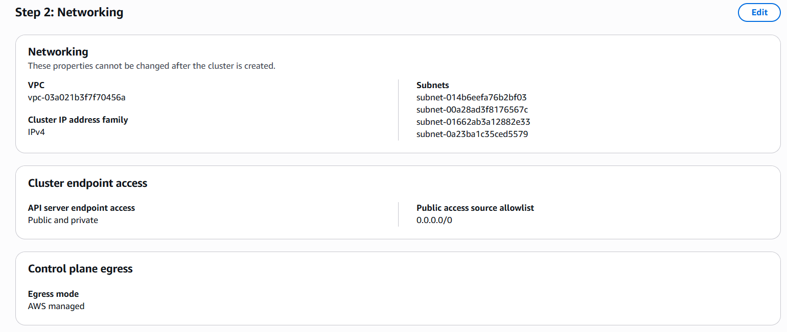
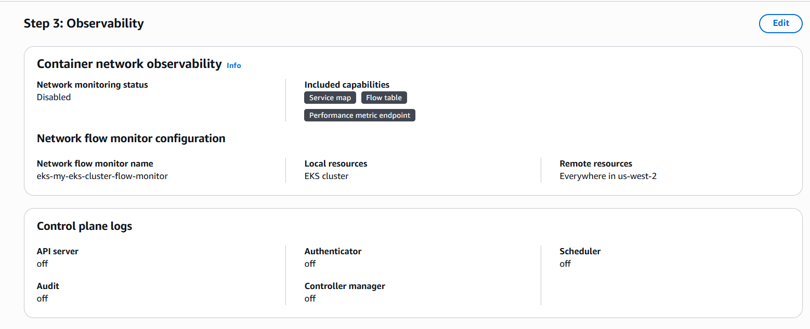

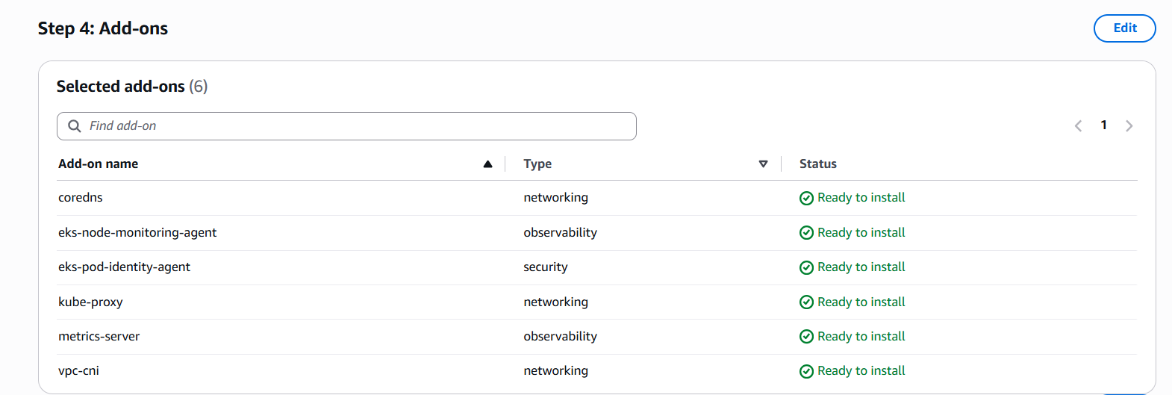

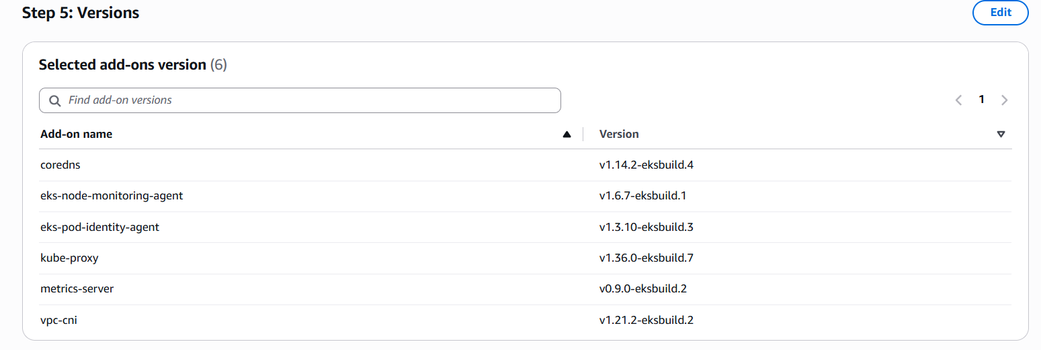
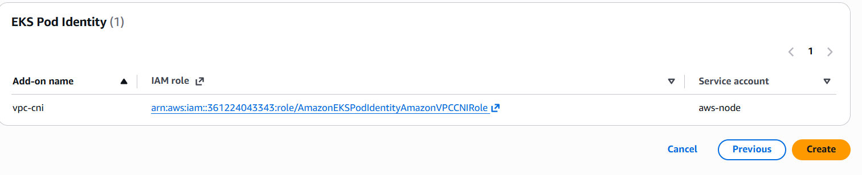
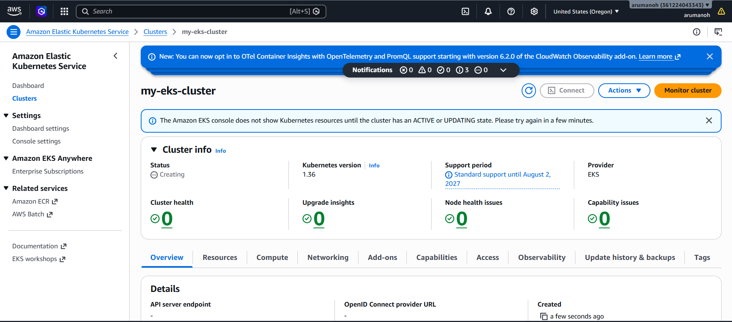

It takes 5 to 8 mins approximately for the cluster to be “Active”

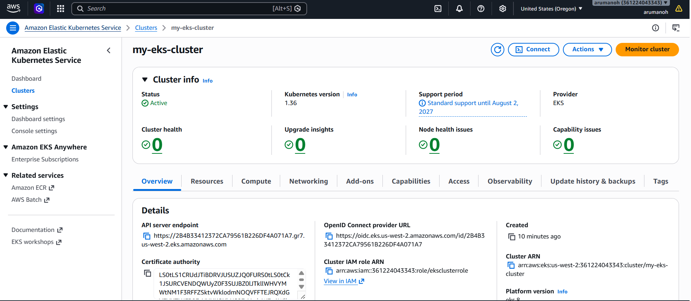

Now let’s create the node IAM role for the EC2 instances to actually join the cluster as worker nodes.

IAM Roles Create Role

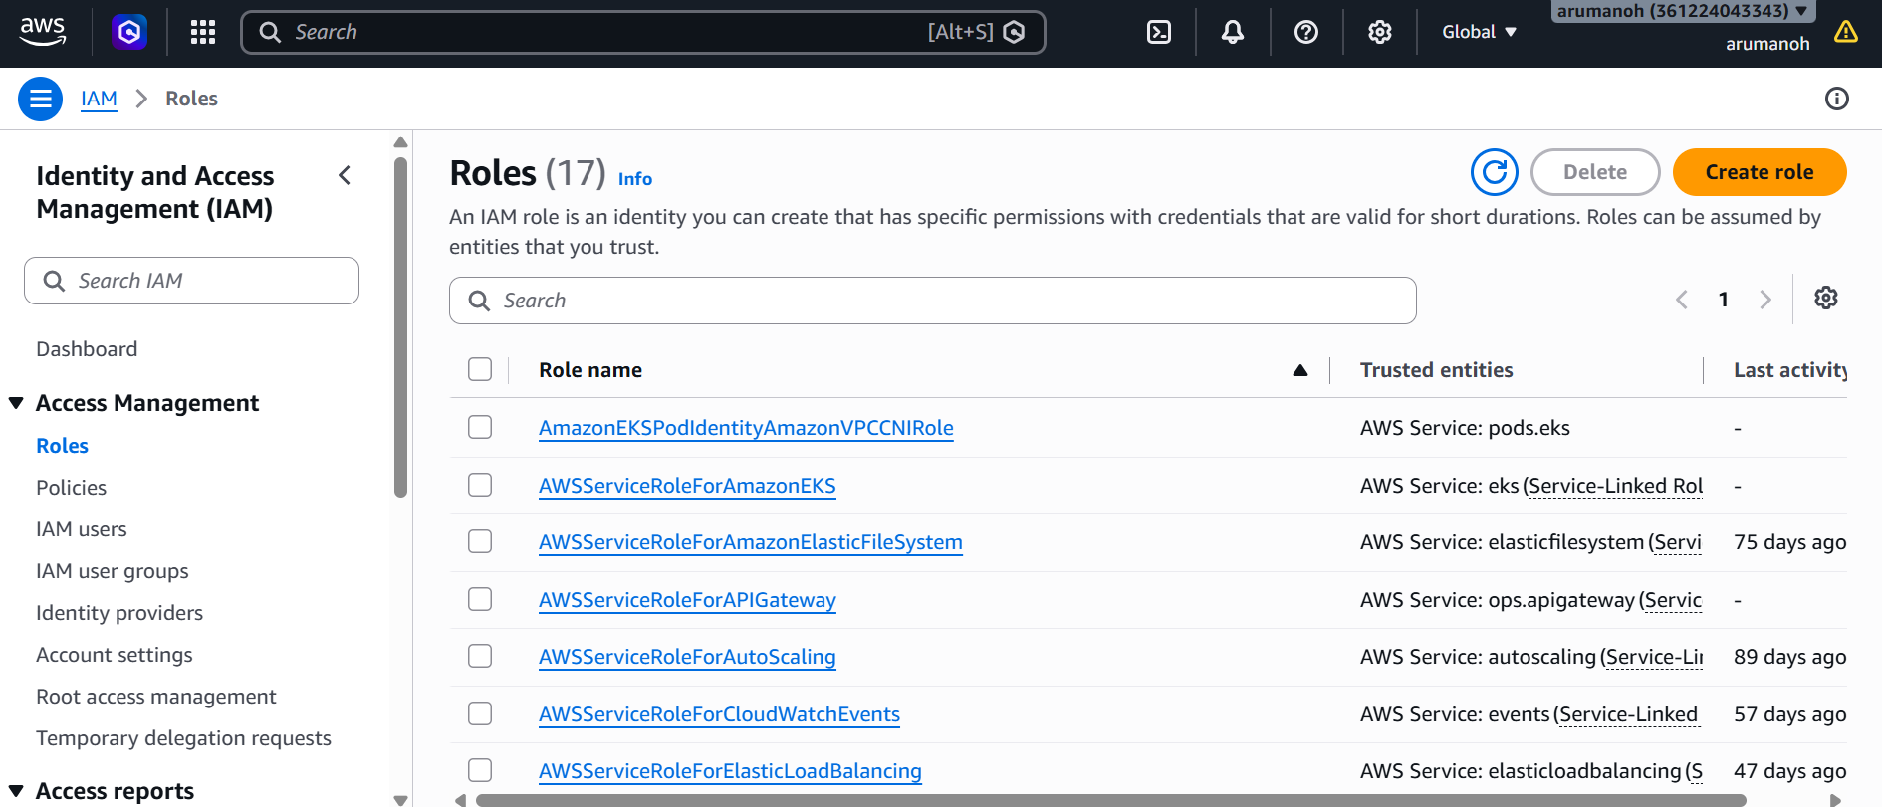

Choose AWS service as the Trusted entity type and EC2 as the use case

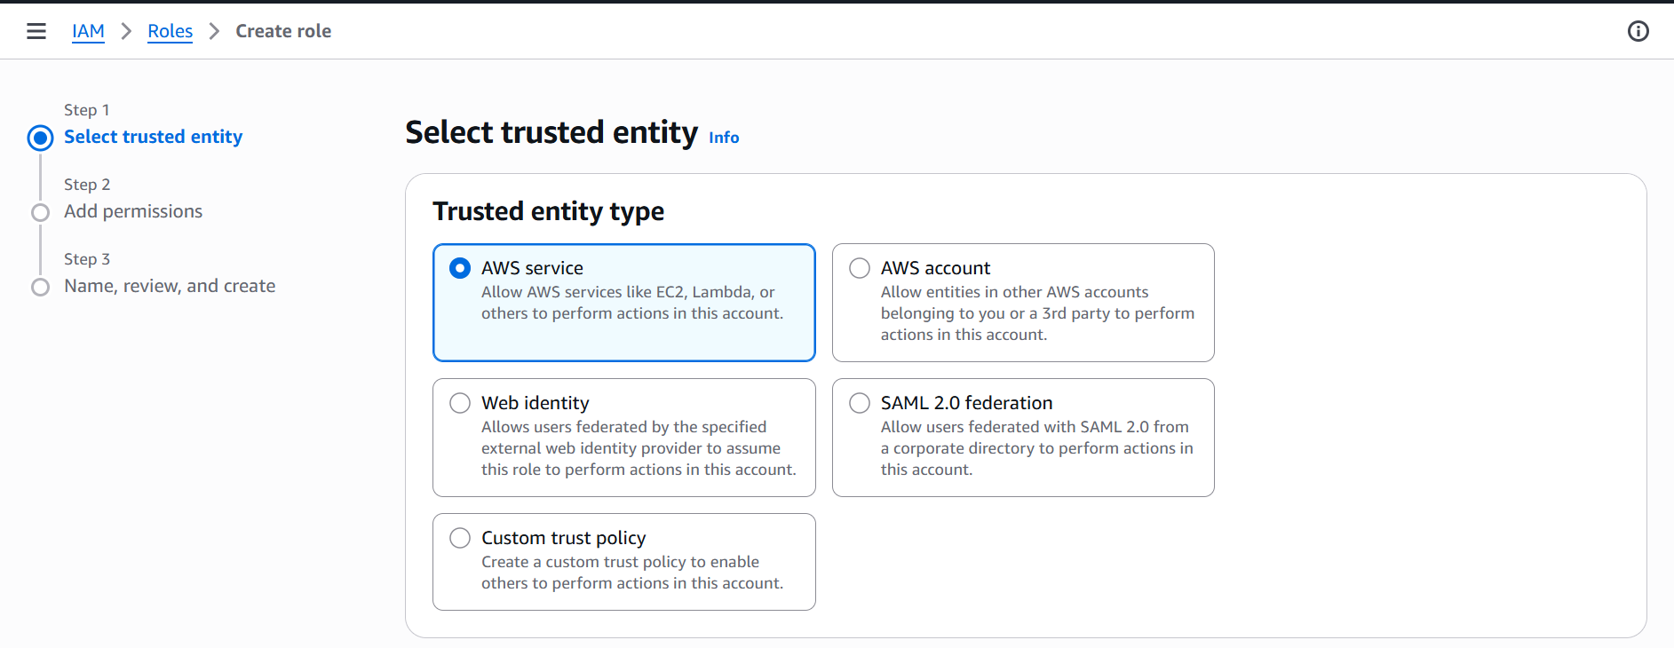

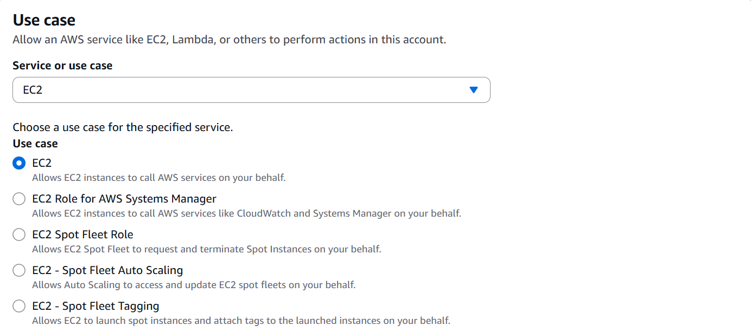

Click Next

Select the following Policies
AmazonEKSWorkerNodePolicy,
AmazonEKS_CNI_Policy
AmazonEC2ContainerRegistryReadOnly

Click Next

Give the “eksNodeRole” as the name

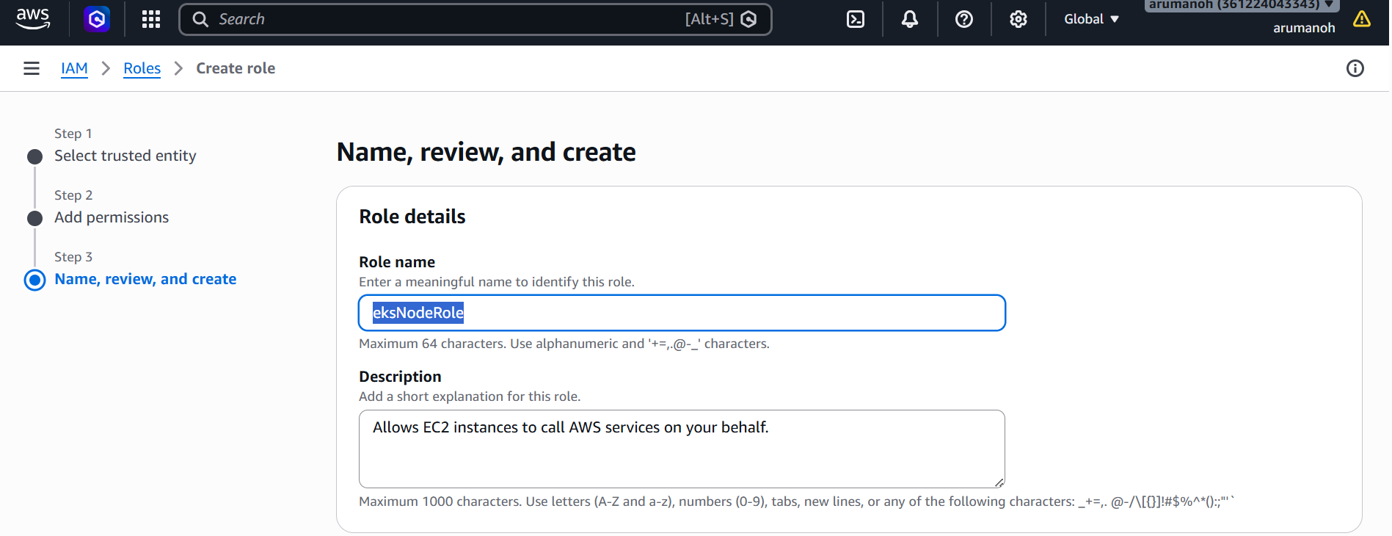

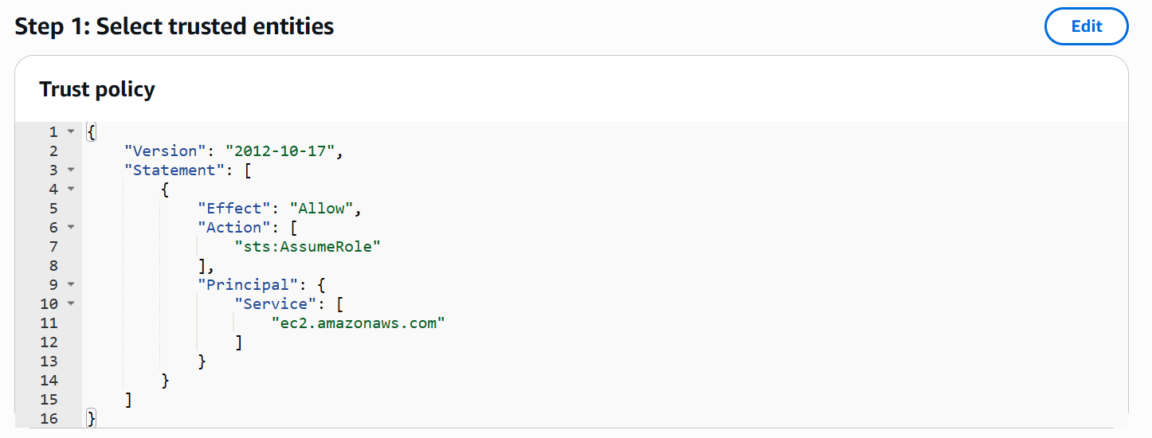

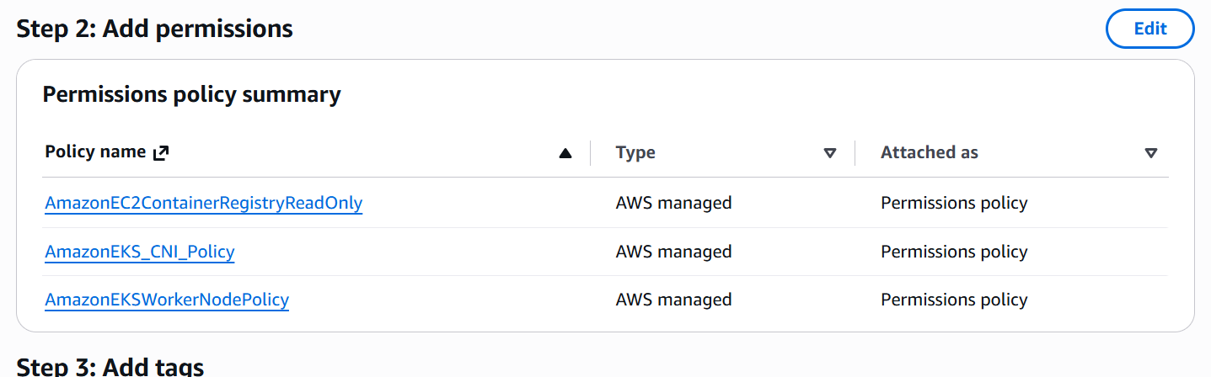

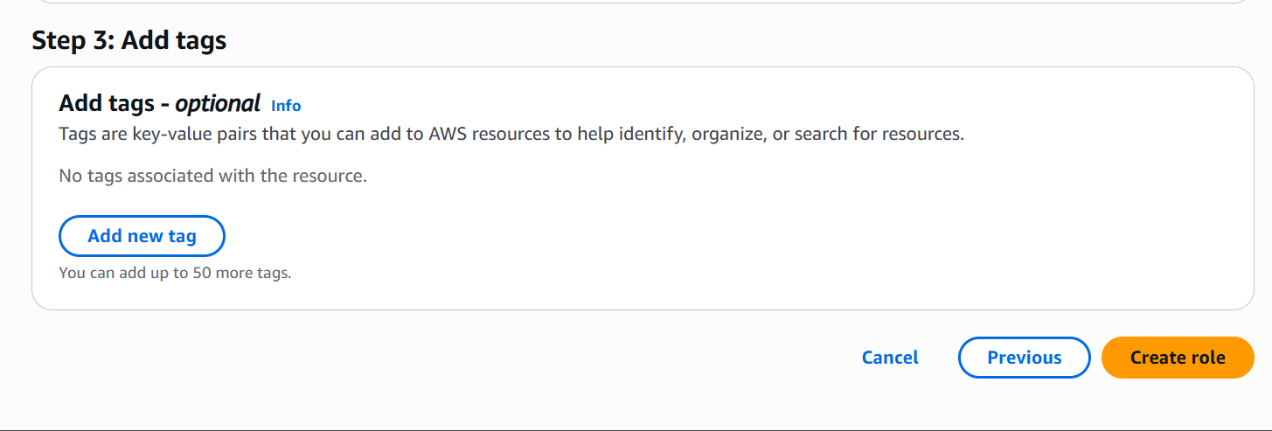

Create role

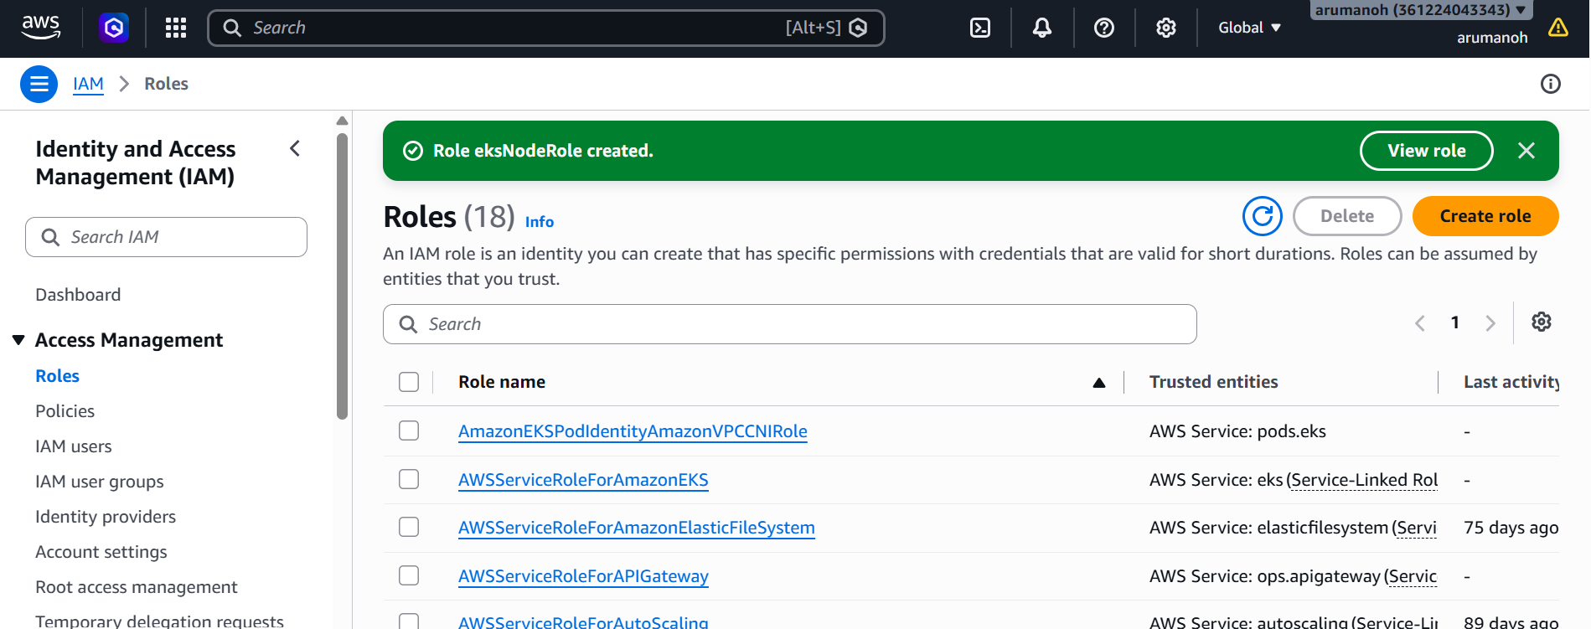

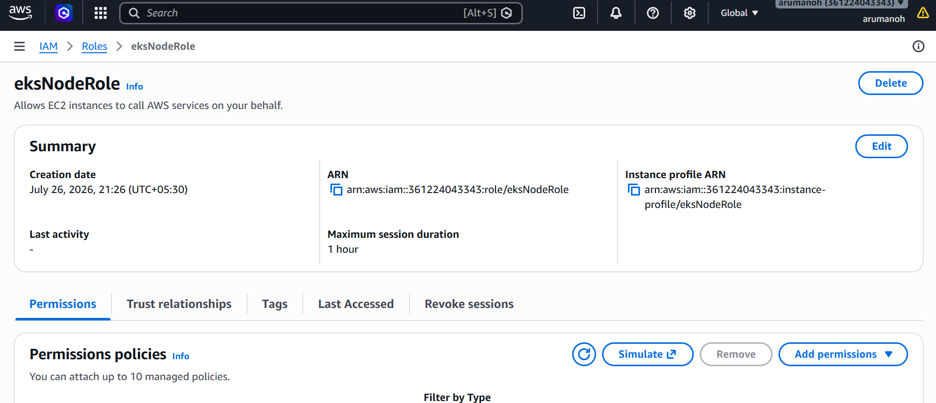

Now goto the EKS cluster and then click on “Compute” tab for creating the node group

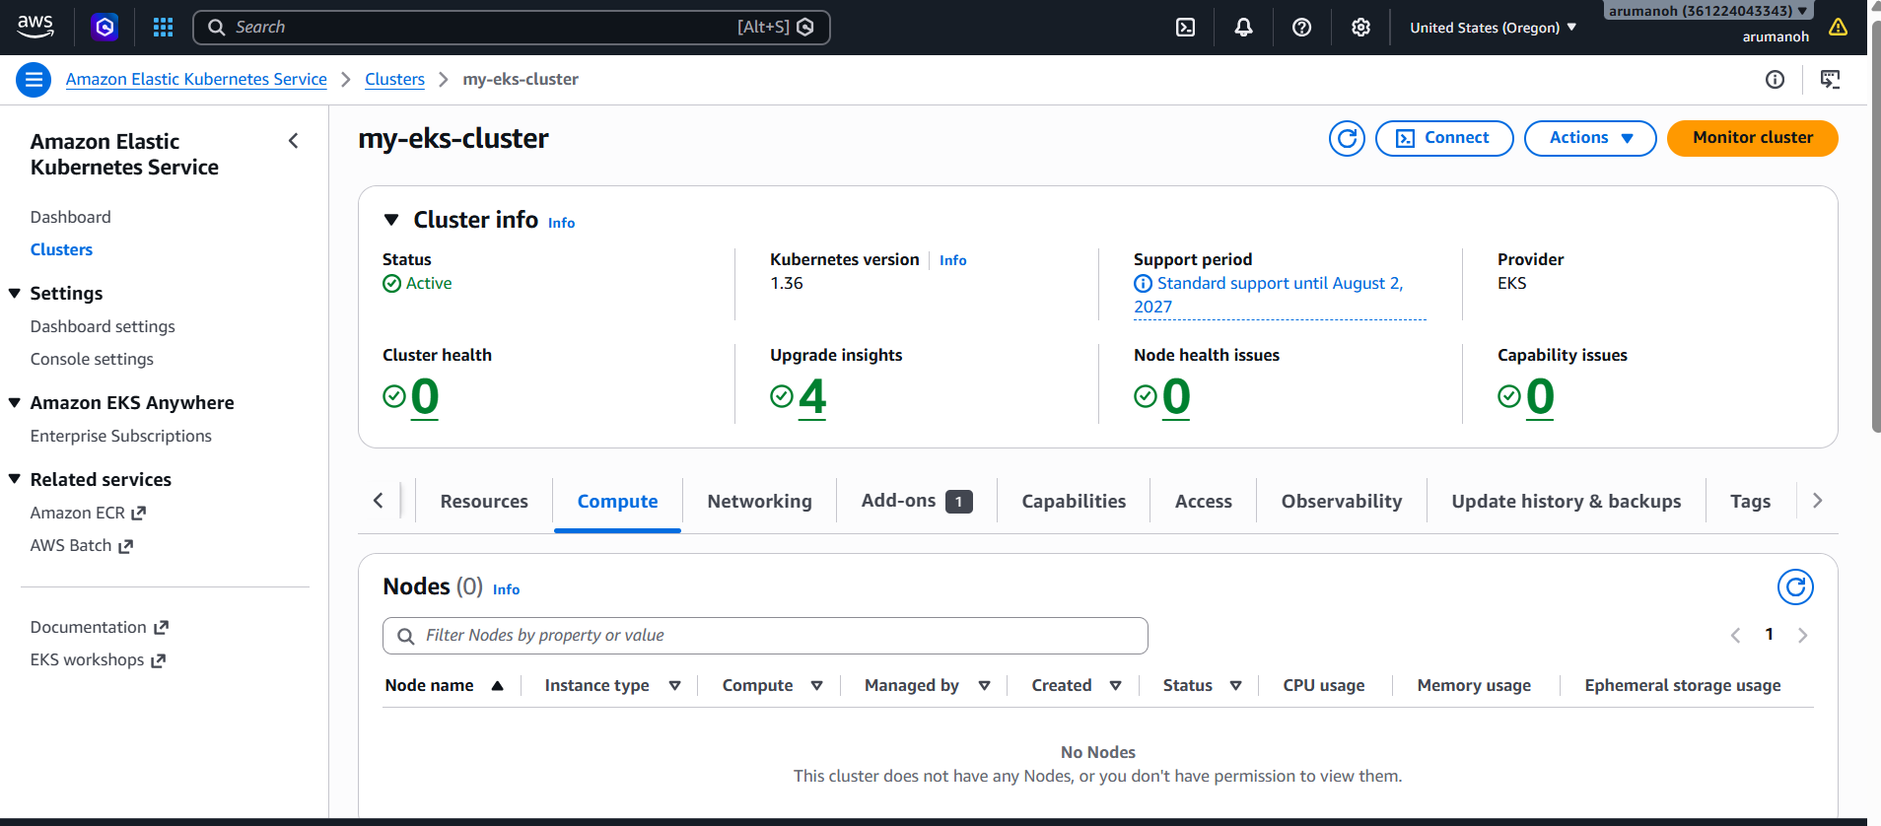

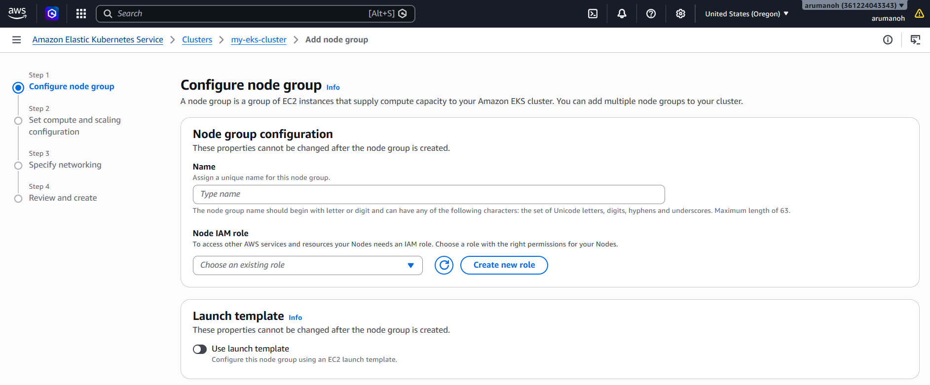

Give the name as “Standard-workers” to the node group and then select the previously created IAM role “eksNodeRole”

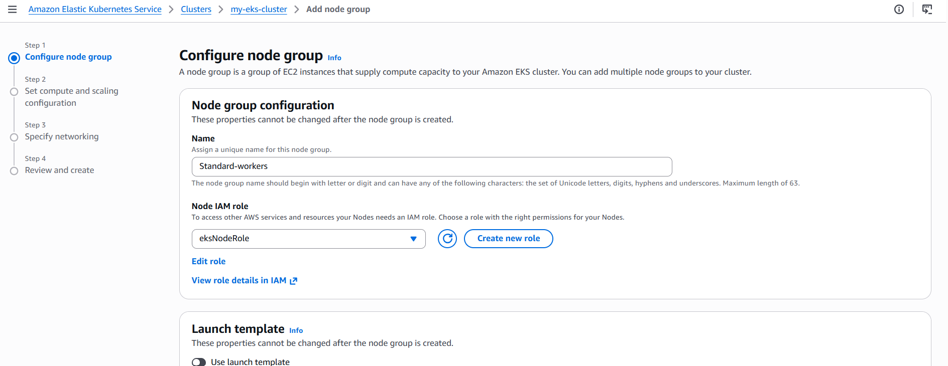

Leave the remaining settings as default and then click “Next”

Let the Amazon Linux 2023 be the AMI type, “On-Demand” be the Capacity type and Disk size as 20. Also set the Desired size as 2, minimum as 1 and maximum as 3 for the node group scaling configuration.

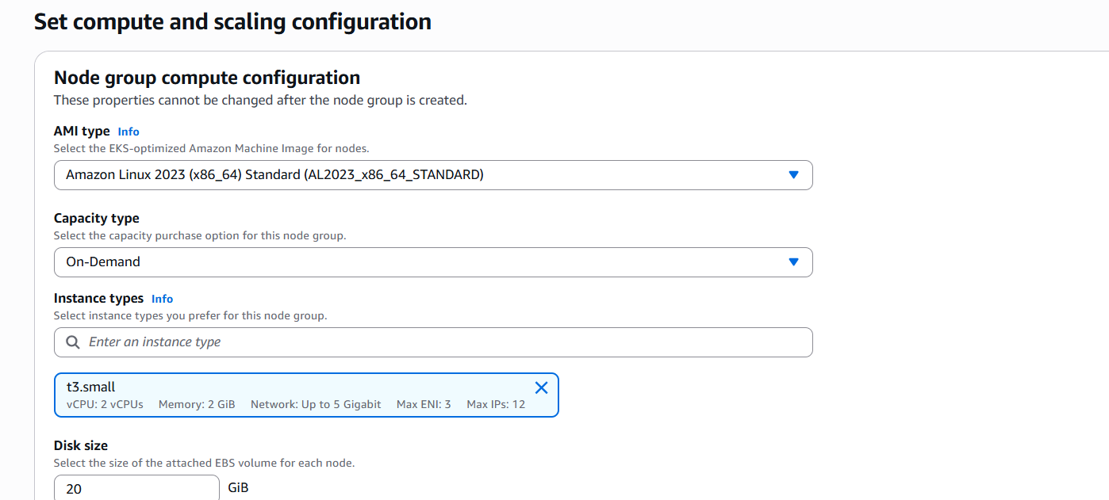

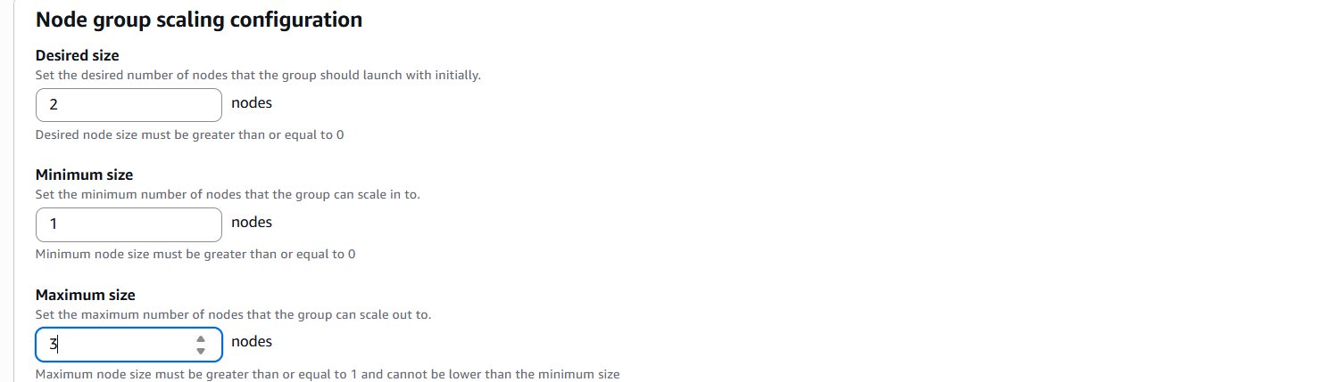

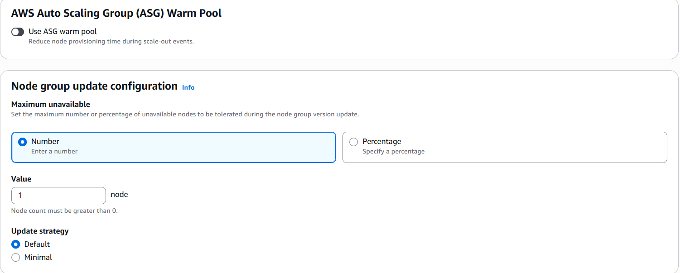

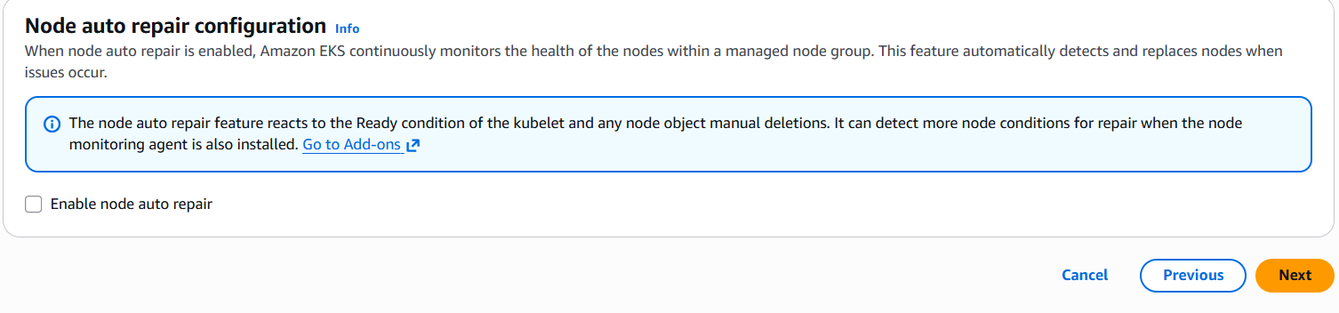
Leave the remaining settings as default and then click “Next”

Select only the 2 Private subnets and then click next

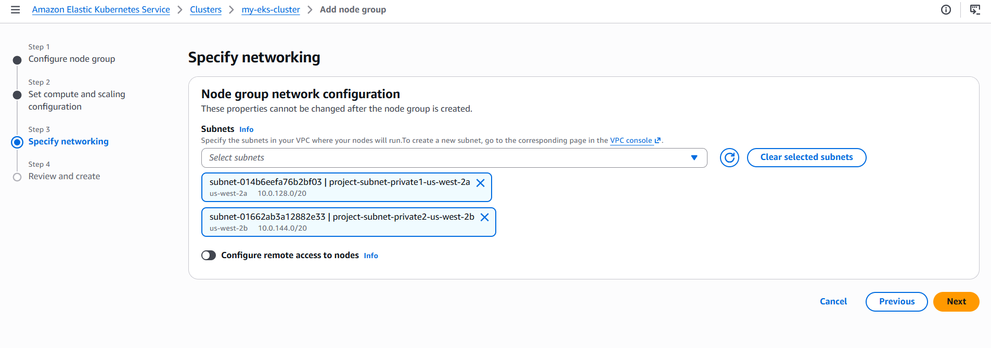

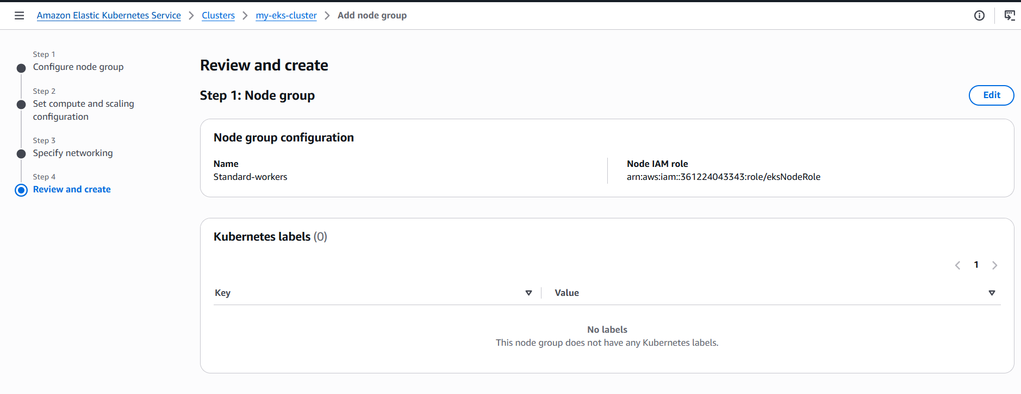

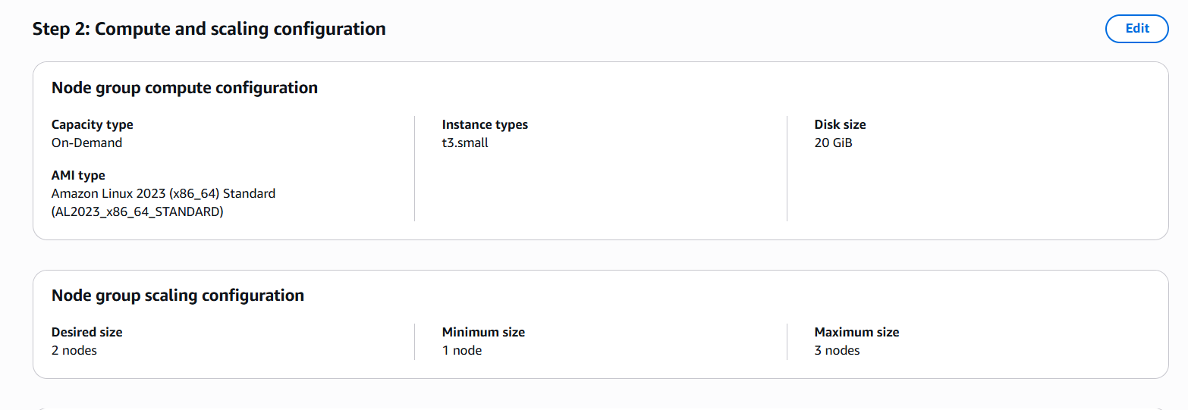

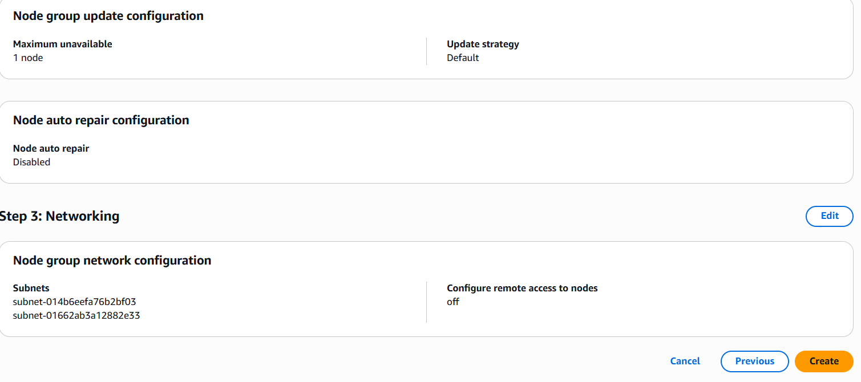

Review and create

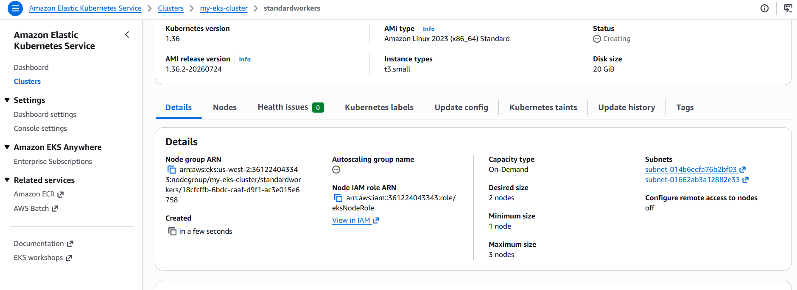

EKS Cluster and node groups are ready.

Let’s spin up an EC2 instance now

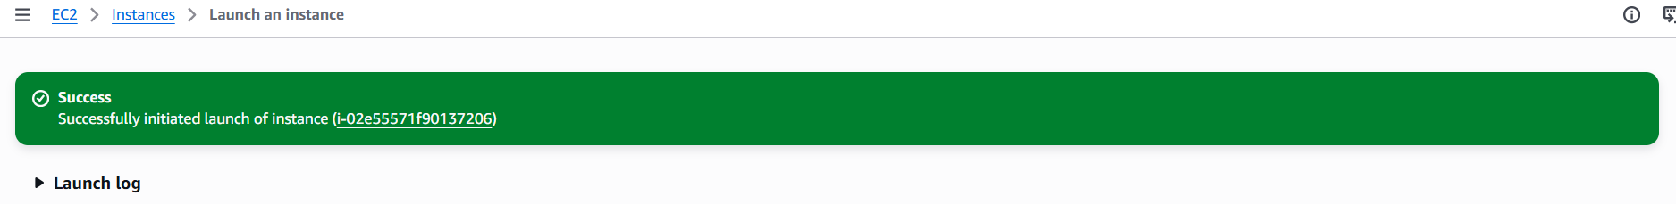

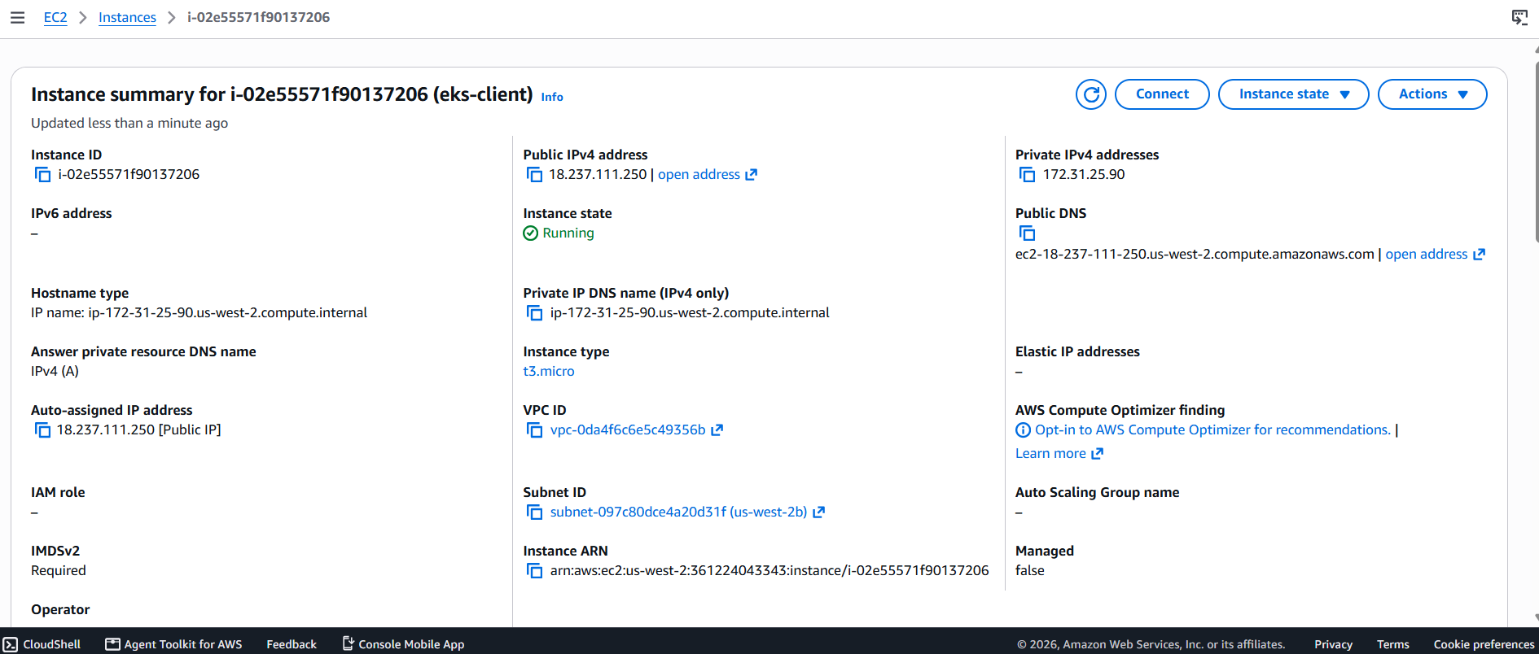

Launch the instance and then SSH it via putty

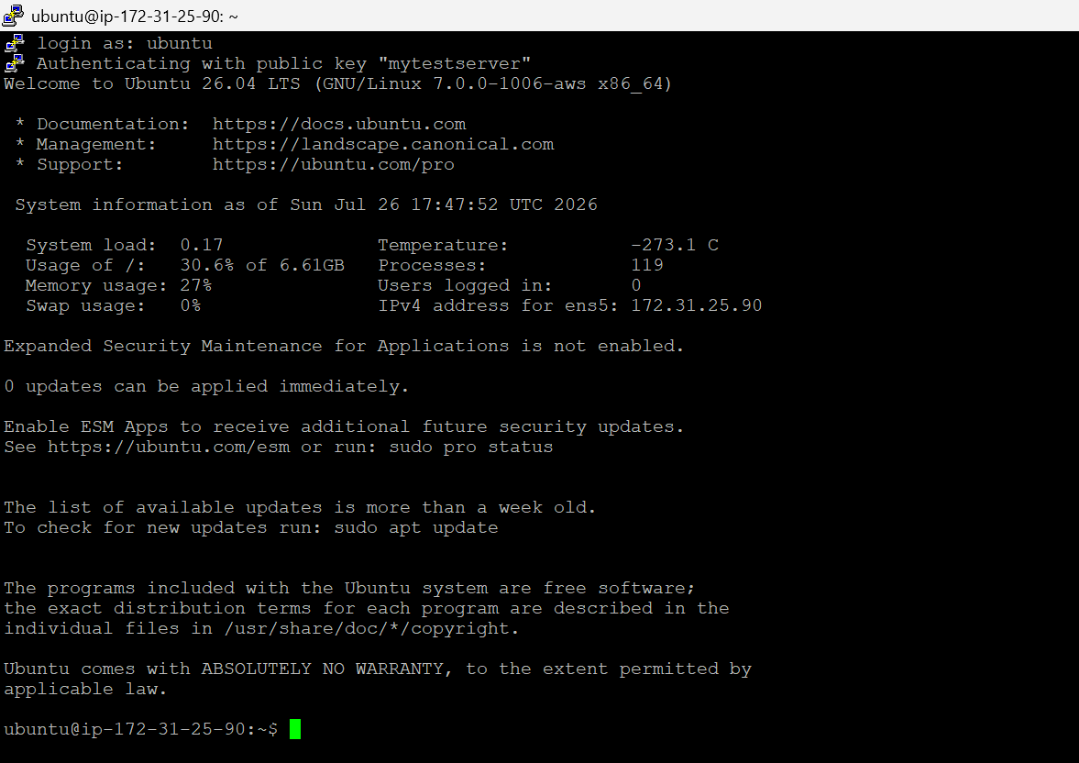

Lets install AWS CLI on it.

sudo apt update
curl "https://awscli.amazonaws.com/awscli-exe-linux-x86_64.zip" -o "awscliv2.zip"
sudo apt install -y unzip
unzip awscliv2.zip
sudo ./aws/install
aws –version

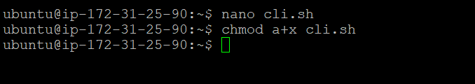

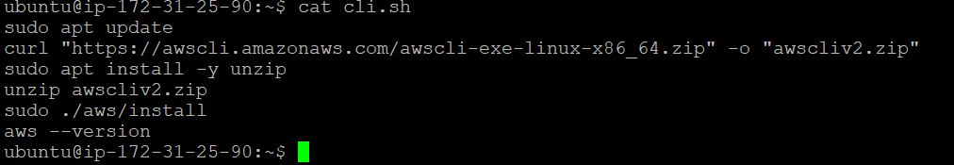

Executing the file cli.sh

Now let’s install kubectl

curl -LO "https://dl.k8s.io/release/$(curl -L -s https://dl.k8s.io/release/stable.txt)/bin/linux/amd64/kubectl"
chmod +x kubectl
sudo mv kubectl /usr/local/bin/
kubectl version --client

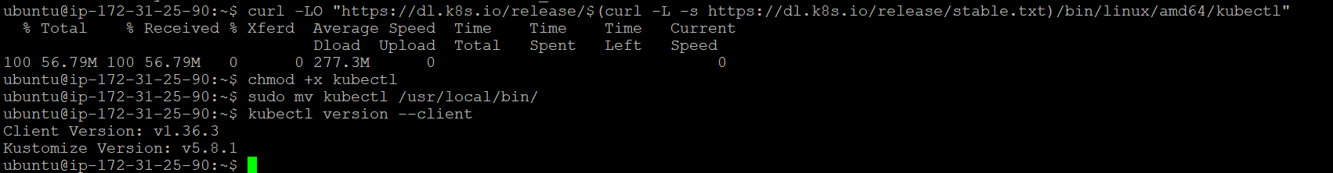

Lets configure the AWS credentials now

aws configure

Create your Access key and then paste the details.

Now lets confirm access to our EKS Cluster

aws eks update-kubeconfig --name my-eks-cluster --region us-west-2
kubectl get nodes

We are able to see the two t3 small nodes in “Ready” state.

We have come to the final step in our task, which is deploying nginx.

Deploy nginx:
kubectl create deployment nginx-deployment --image=nginx:latest --replicas=2

Checking Pod Status:
kubectl get pods -o wide

Now exposing the nginx pods
kubectl expose deployment nginx-deployment --type=LoadBalancer --port=80 --target-port=80 --name=nginx-service

Now let’s look at the external hostname
kubectl get svc nginx-service –watch

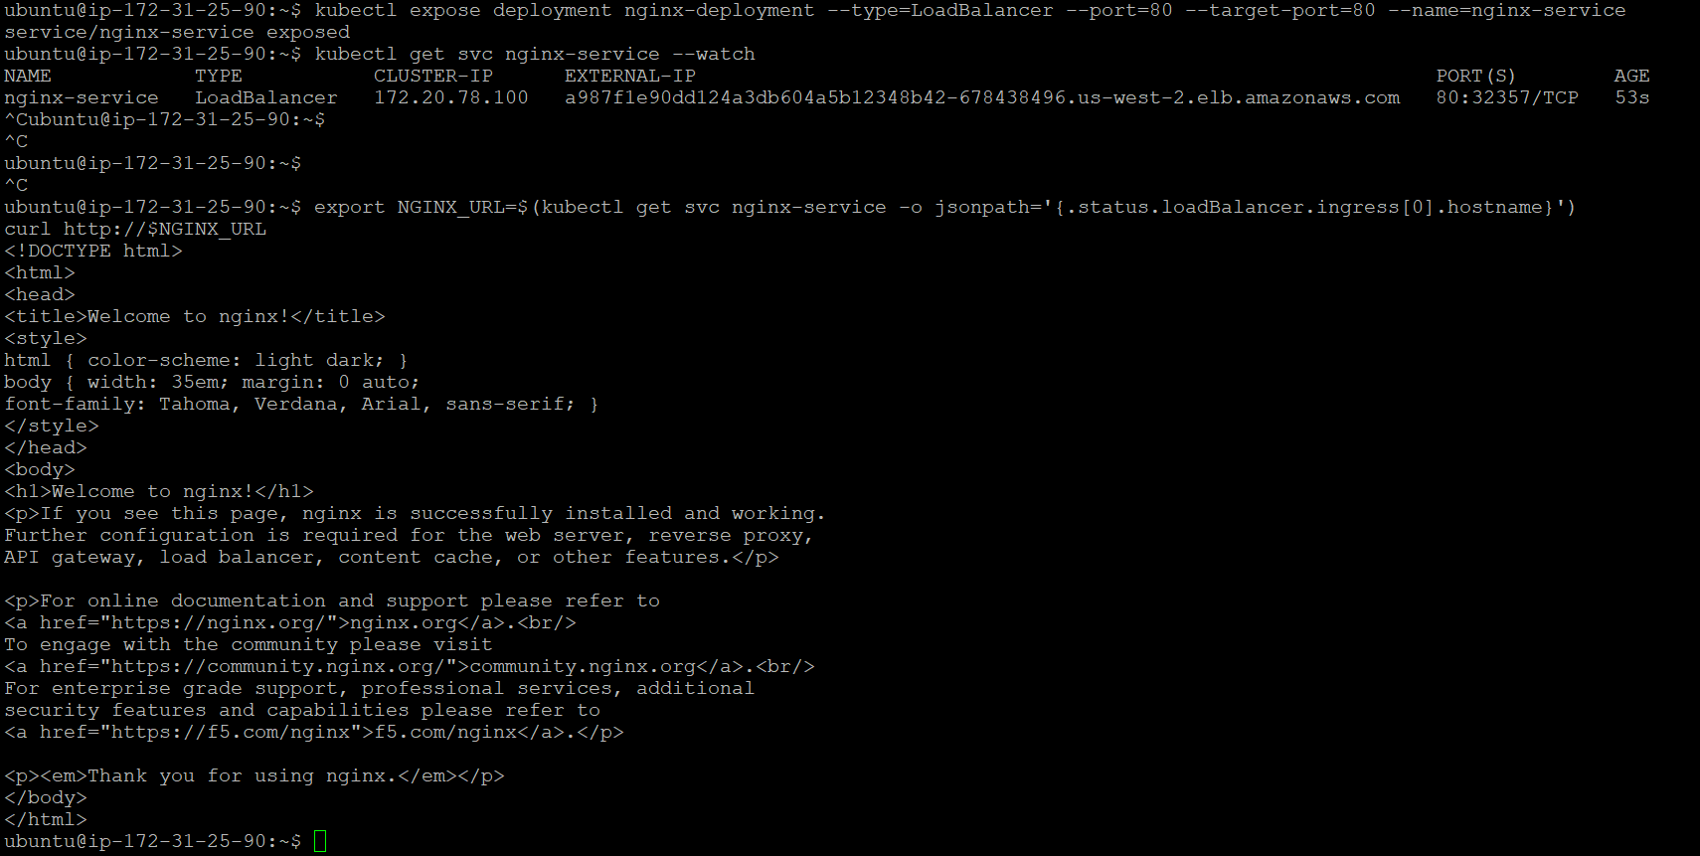

kubectl get nodes
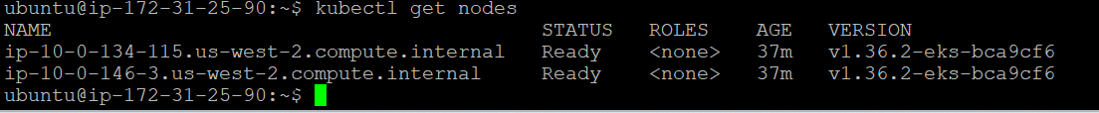
Kubectl get pods -o wide

kubectl get svc nginx-service

External IP is a987f1e90dd124a3db604a5b12348b42-678438496.us-west-2.elb.amazonaws.com

If we paste this in the web browser we should be getting the output.

http://a987f1e90dd124a3db604a5b12348b42-678438496.us-west-2.elb.amazonaws.com/

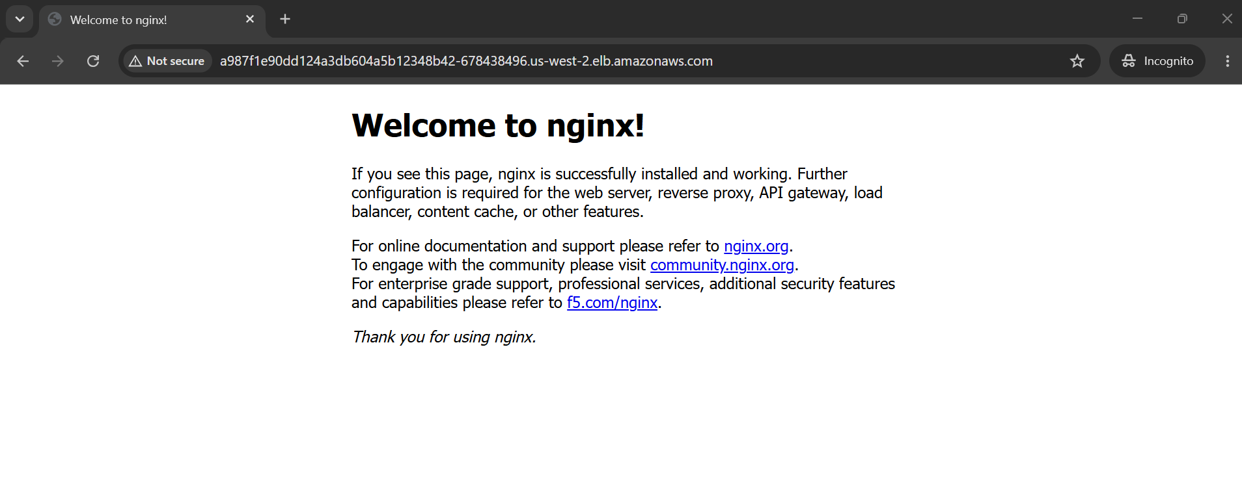

This concludes our task as we are able to access the application from outside the cluster.

