File Creation Task
- Create a directory called ""my_folder"", navigate into it, and create a file named ""my_file.txt"" with some text. Then, create another file named ""another_file.txt"" with some text. Concatenate the content of ""another_file.txt"" to ""my_file.txt"" and display the updated content. Finally, list all files and directories in the current directory.
We can create a directory using the command
- mkdir my_folder
- ls -l
we can validate using the ls -l command
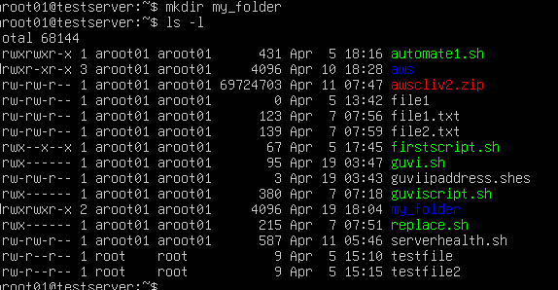
Now we need to create a file “my_file.txt” inside the “my_folder” directory. But for that we need to first go inside the “my_folder” directory.
This can be done using the cd command
- cd my_folder
- pwd
- ls -l
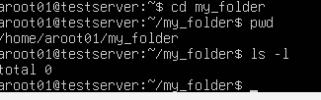
There are no files in the “my_folder” directory.
Now we can create two files “my_file.txt” & “another_file.txt” with some text using the following commands
- echo “This is the content of my file” > my.file.txt
- echo “This is the content of everyone’s life” > another_file.txt
You can validate the contents of these two files using the cat command
- cat my.file.txt
- cat another_file.txt
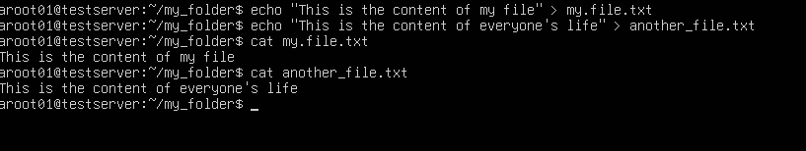
Concatenate the content of ""another_file.txt"" to ""my_file.txt"" and display the updated content.
This can be done using the same cat command
- cat another_file.txt >> my.file.txt
- cat my.file.txt
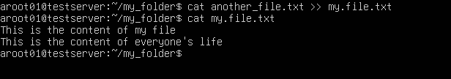
Finally, list all files and directories in the current directory.
This can de done using the command
- ls -l
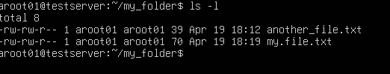
- Create 20 files with .txt extensions and rename the first 5 files to .yml extension and Print the latest created top 5 files among the total no of files".
- for i in {1..20}; do
- echo "This is file$i.txt" > file$i.txt
- done
- ls -l
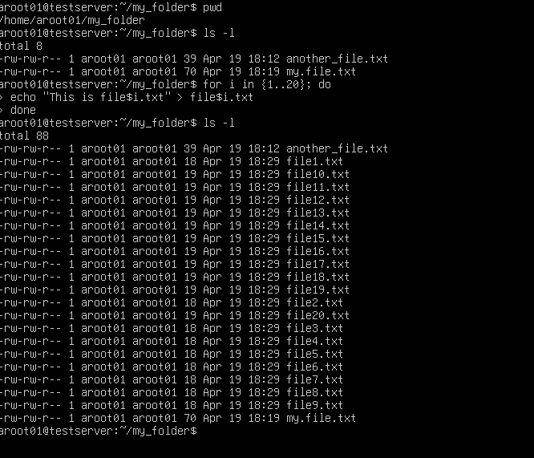
Rename the first 5 files to .yml extension
This can be done using the below commands
- for i in {1..5}; do
- mv file$i.txt file$i.yml
- done
- ls -l
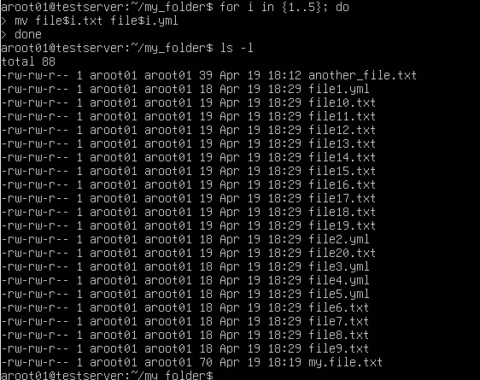
Print the latest created top 5 files among the total no of files.
This can be done using the below command
- ls -lt | head -5
