File Permission Task

Create a file with .txt extension (/home/demo.txt). Change the permission set of that file, so that any user can read it, group can read/write & owner can read/write/execute it.
First we must login to the server using Putty (Terminal Emulator) and then go to home directory.
- cd ..
The above command will take you to the home directory. Then I list the contents of that directory using the command
- ls -l
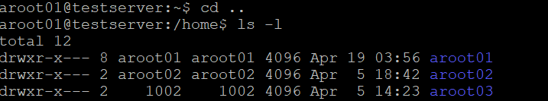
Now we can create the file demo.txt using the touch command. Directly we cannot do it. Hence we can do it using sudo command.
- Sudo touch demo.txt
It will ask for the password, type in the password then the file will be created in the home directory. You can validate it using the command
- ls -lrt
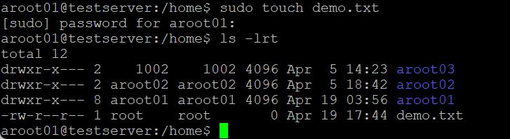
Change the permission set of that file, so that any user can read it, group can read/write & owner can read/write/execute it.
This can be achieved using the chmod command
- sudo chmod 764 demo.txt
- ls -lrt
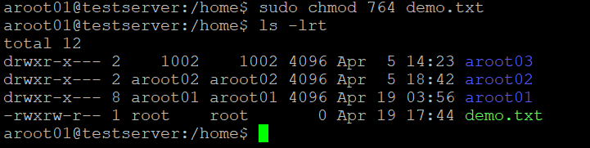
We have given the owner to read/write/execute permission, group to read/write permission and any user can read it. The same can be verified using the ls -lrt command.

