VCS Task
Task Description:
Establish a new directory, populate it with script files, initiate an empty repository on GitHub, convert the local directory into a Git repository, and link it to GitHub for pushing the code into the repository. Perform merge, rebase, stash commands in following github repo.
Step 1: Establish a new directory, populate it with script files & convert the local directory into a Git repository
We are creating a new directory “my-project” using the below command
mkdir my-project
Navigating into that “my-project” directory, two files are created by name
- script1.py
- script2.sh

Execute permissions are given to the second file “script2.sh”

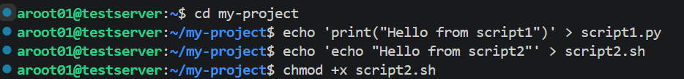

Then we are converting it into a Git Repository using the below commands.
git init
git add .
git commit -m "Initial commit: add script1.py and script2.sh"

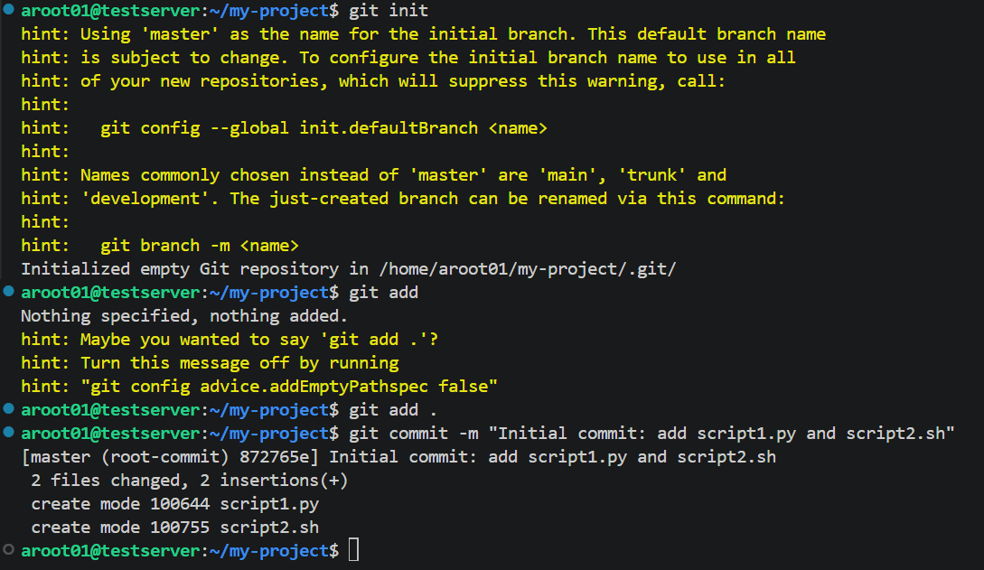

Step 2: Initiate an empty repository on GitHub

We are logging into Github and then creating an empty repository with the same name
“my-project”
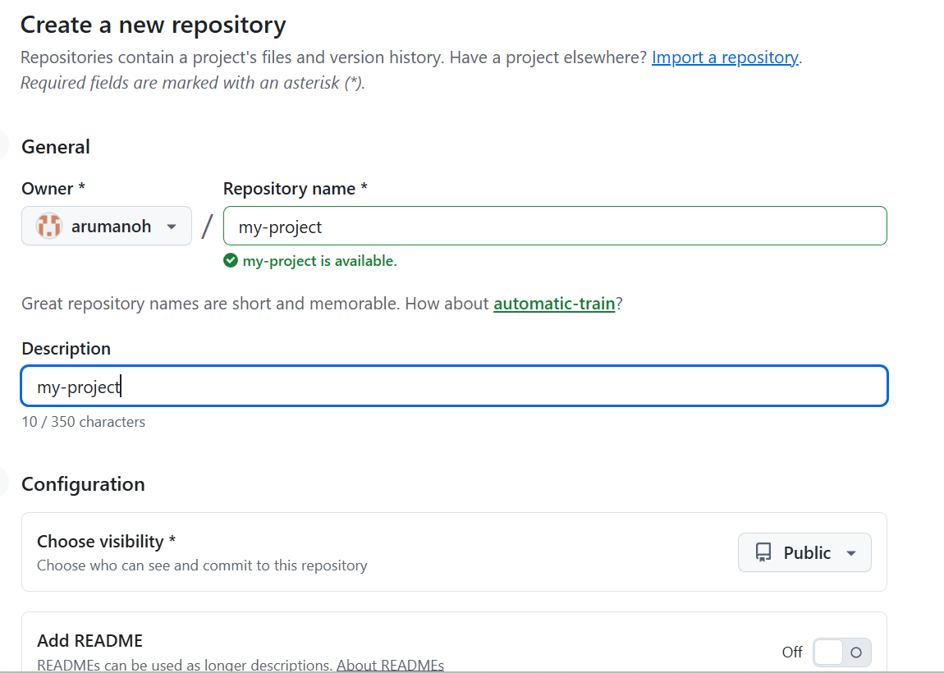

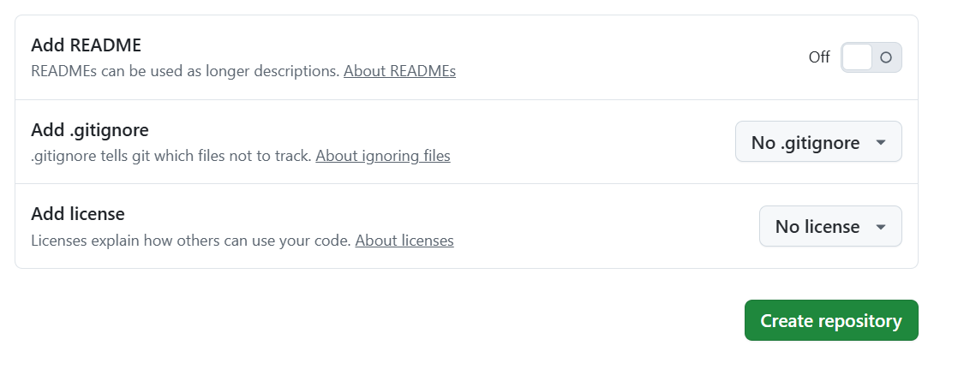
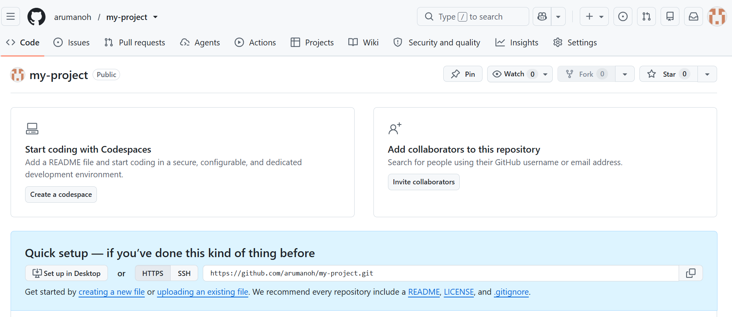

Step 3: Link it to GitHub for pushing the code into the repository
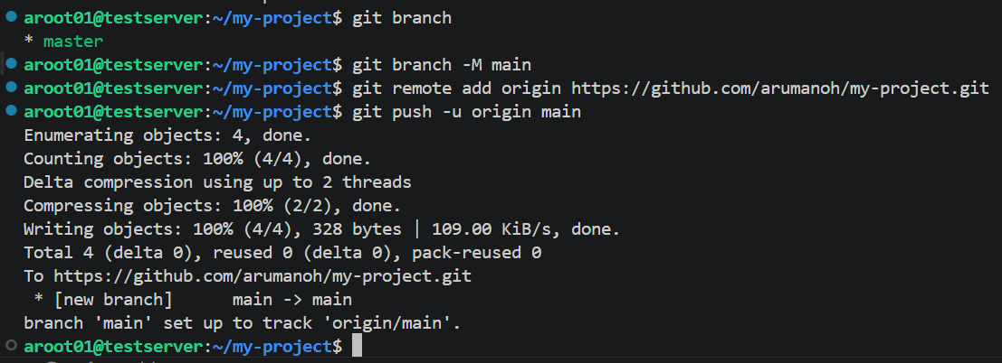

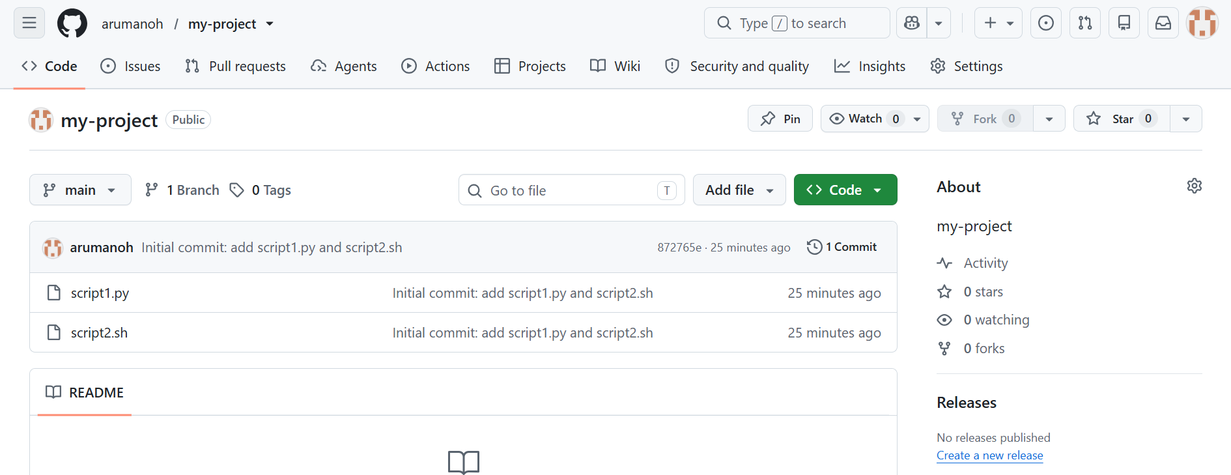

The two files that were created in the remote are now pushed successfully into the Github Repository.

Step 4: Perform merge, rebase, stash commands in following github repo.

- Create a feature branch
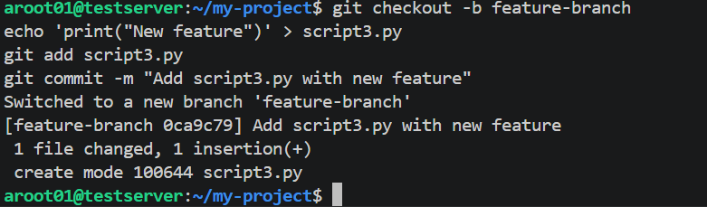

- Merge - bring feature-branch into main
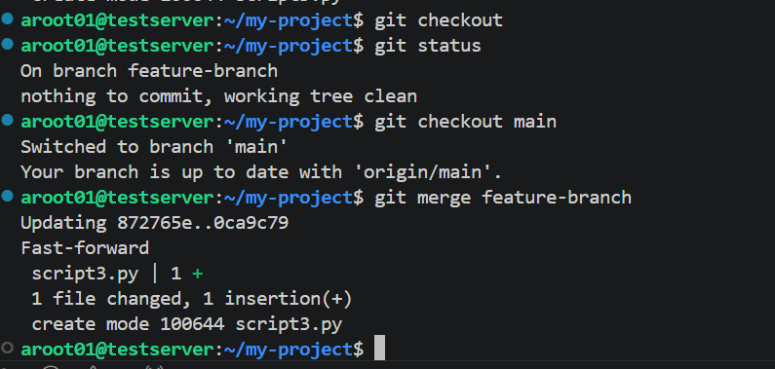

This creates a merge commit (if main has moved on) or fast-forwards main to include your feature branch's commits.

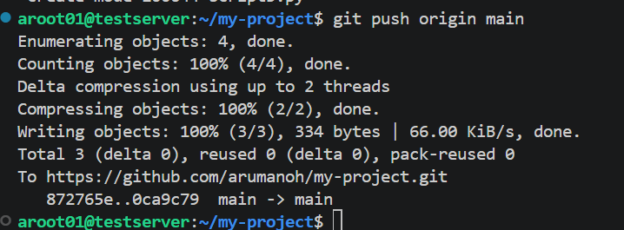
The files are pushed into the Github.

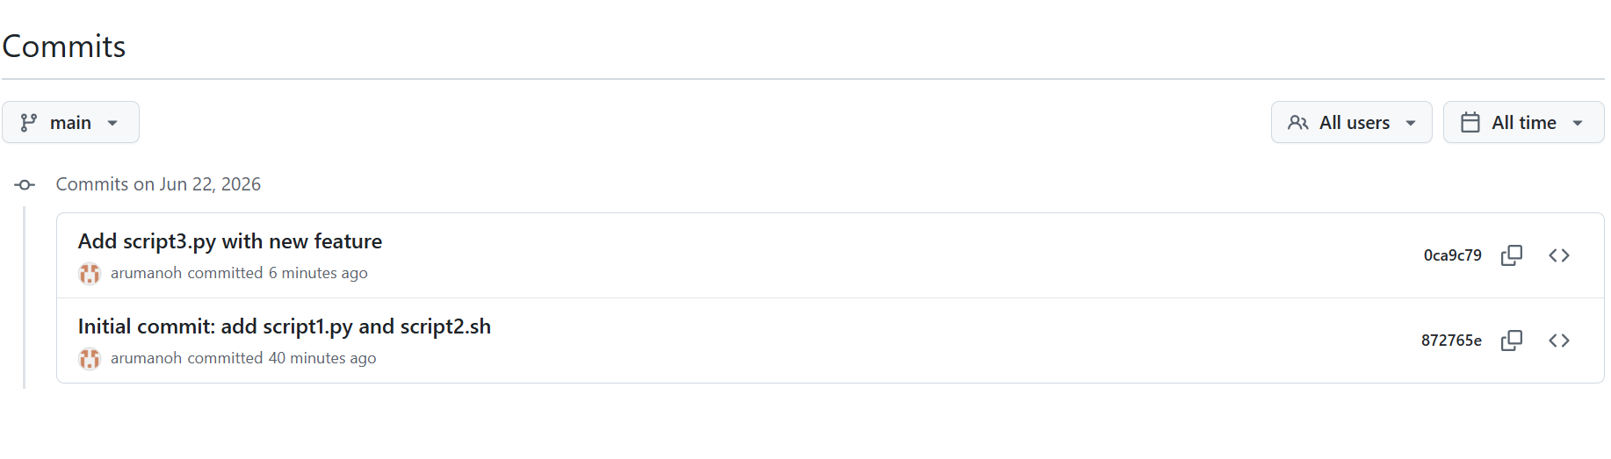
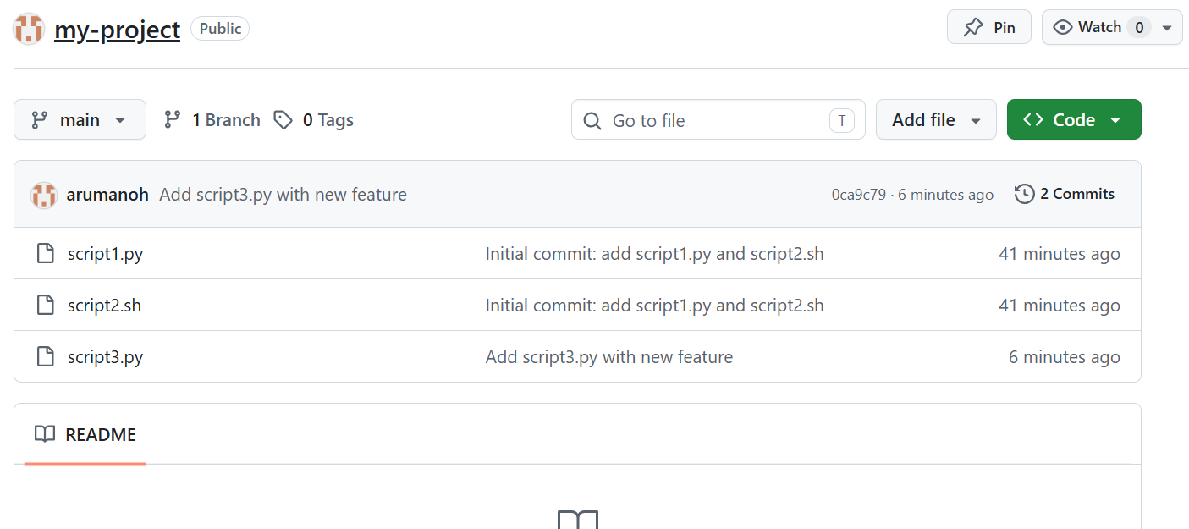

- Rebase command
Let's create a new branch by name “feature-2” and then add a file by name “script4.py” into it
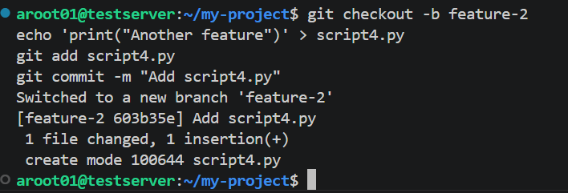

In the meantime, we will add more file by name “NOTES.md” into the main branch.

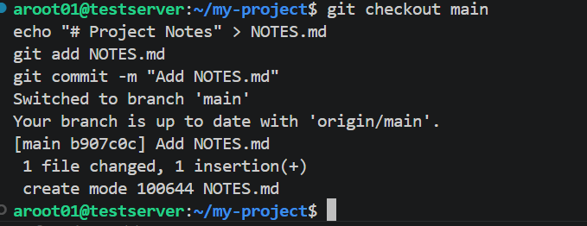

Now rebase feature-2 onto the updated main

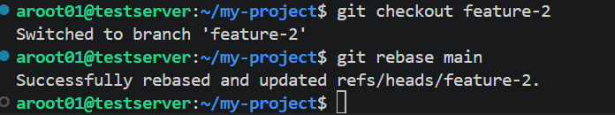

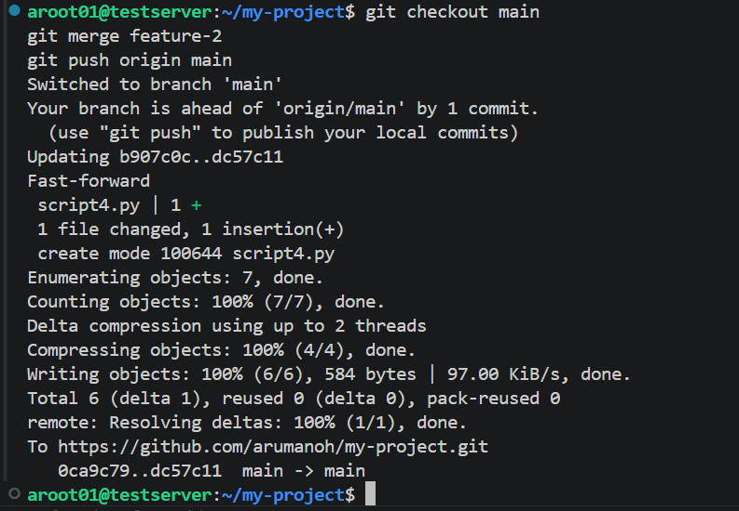

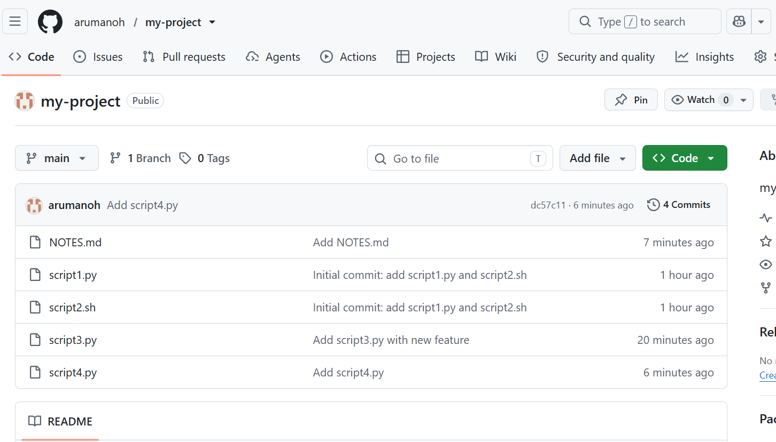

All the commits have been pushed into Github successfully.

- Stash - save uncommitted work temporarily

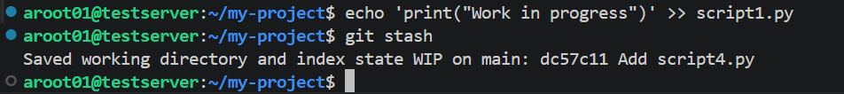

This stores your uncommitted changes and reverts your working directory to the last commit. You can now safely switch branches, pull updates, etc. When ready to bring your changes back:

