Monitoring Task

Task Description:
Install Prometheus and Grafana on a Linux EC2 machine, connect Prometheus to Grafana, and create a dashboard to view metrics.
Let’s launch two EC2 instances having Ubuntu Operating system. One of them can be used as Prometheus server and the other one as Grafana server.
Prometheus Server: (EC2 instance 1)
We will use t3.micro and 20 GB Volume of disk space.
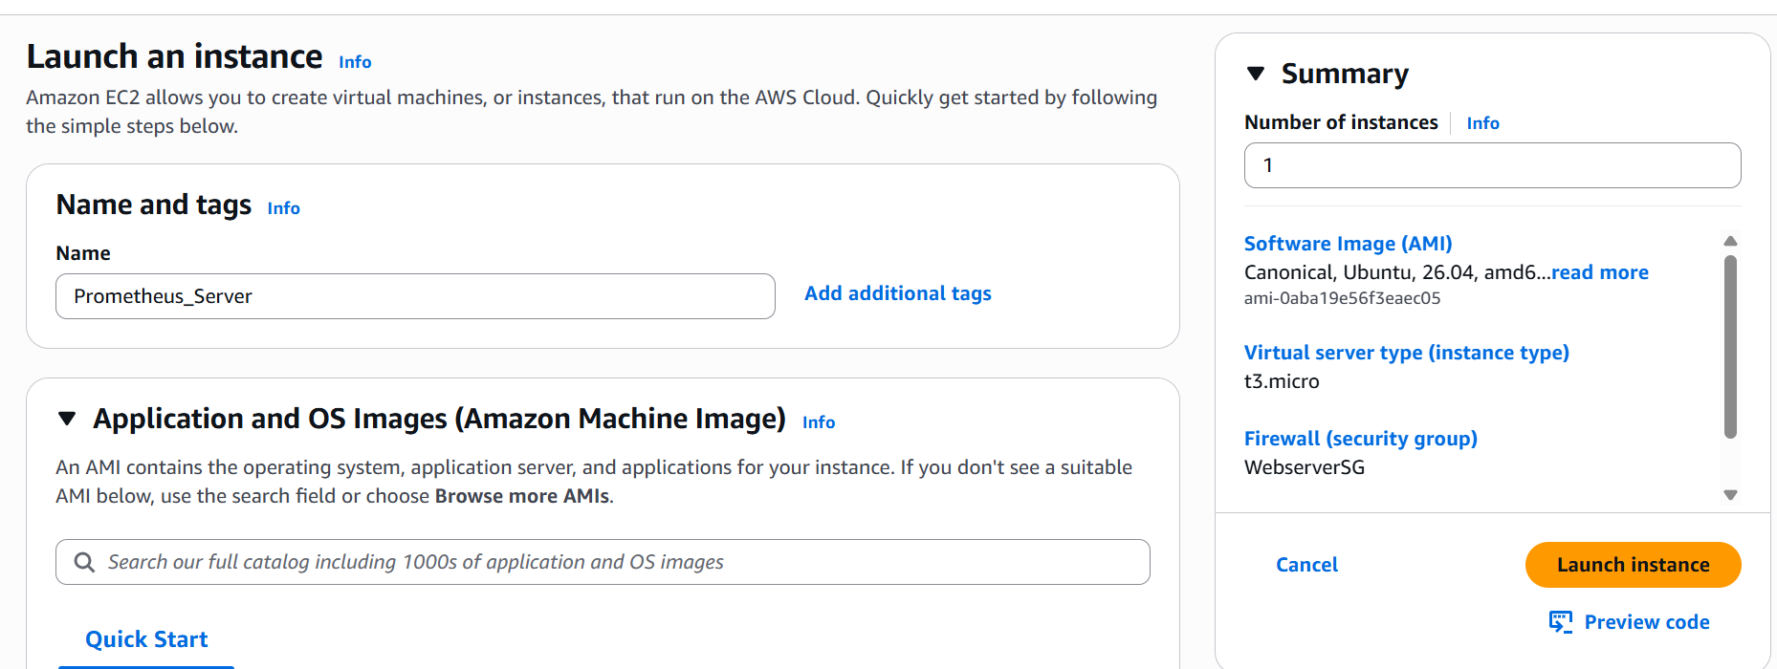

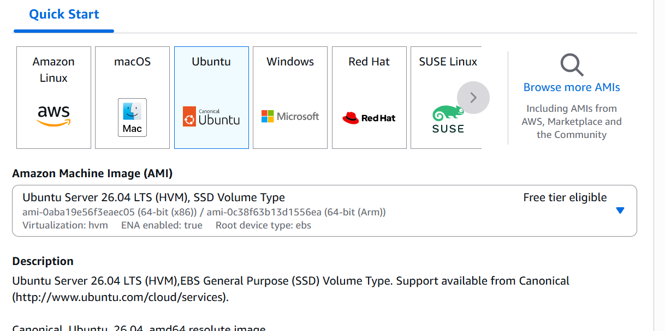
We will create a new Key pair as well
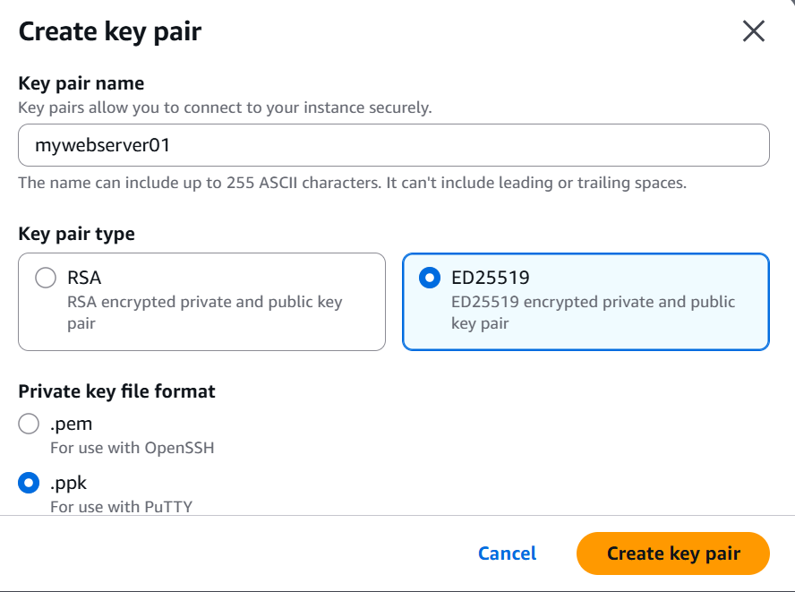
We will also a create a new security group
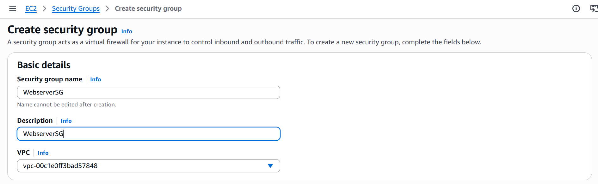
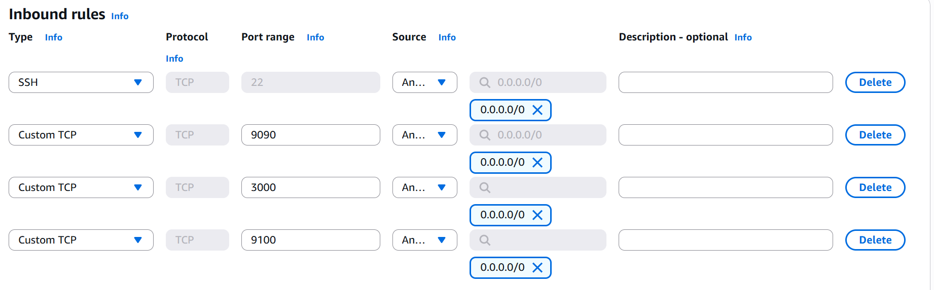
- Port 22 is for SSH
- Port 9090 is for Prometheus UI
- Port 3000 is for Grafana UI
- Port 9100 is for Node Exporter
Let’s leave the outbound rules as default and then create the security group.
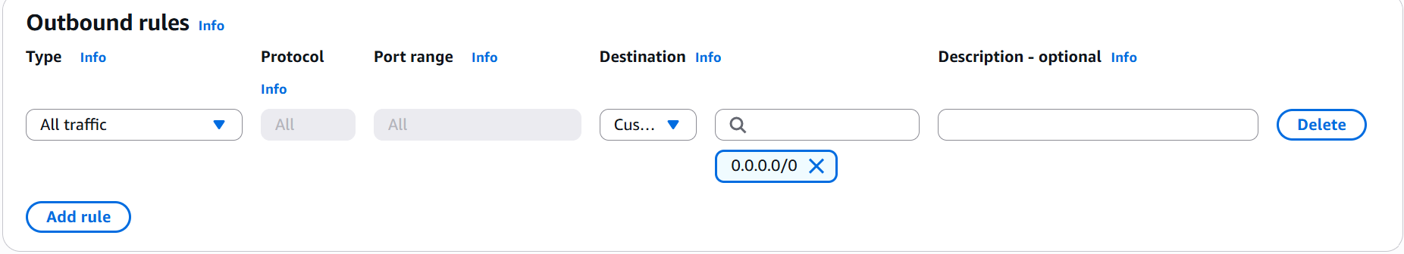
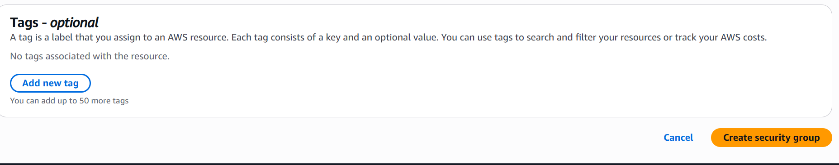
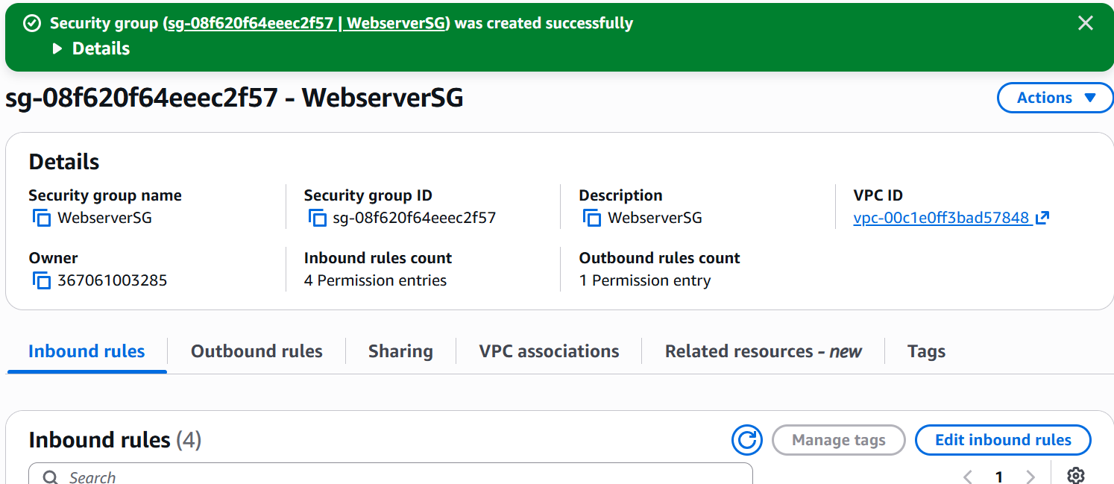

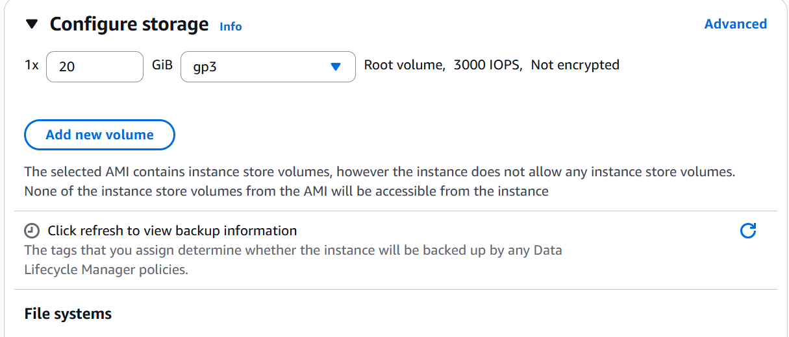

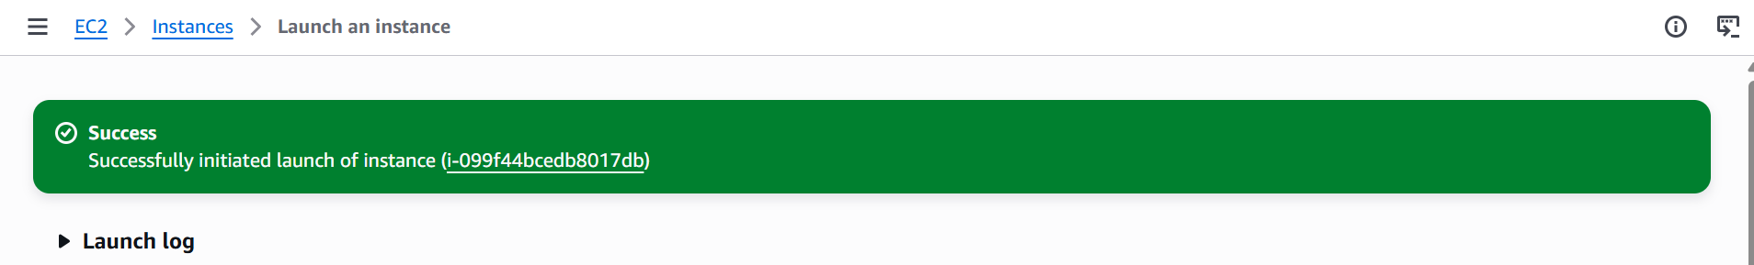
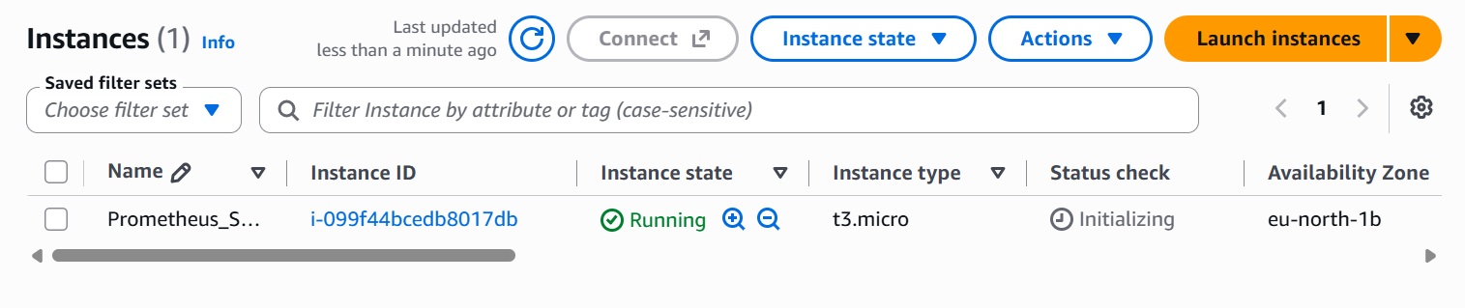
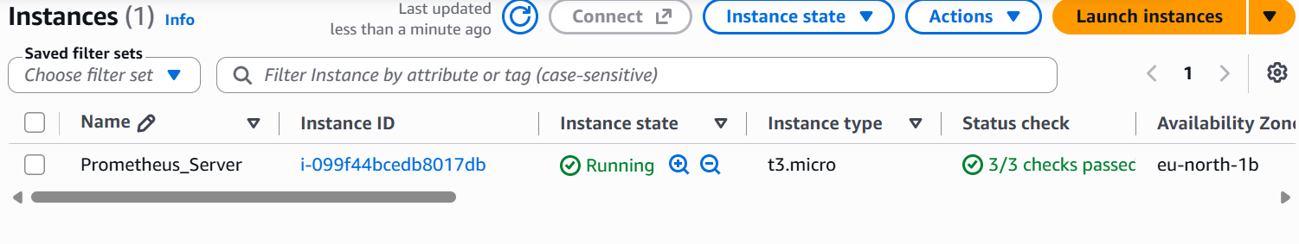
Our server is up and running and let’s login to it via putty.
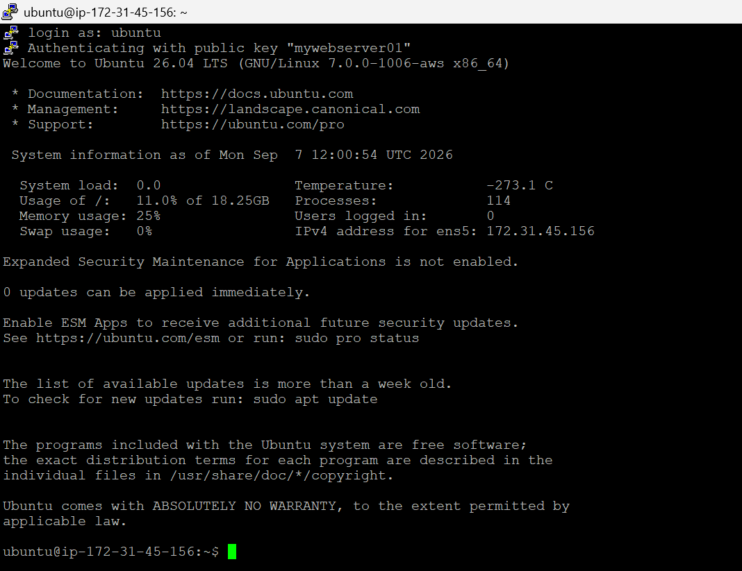
We have successfully logged into the server. It is time to install Prometheus now.

Installation of Prometheus:
- Update the System and Create a User
sudo apt update && sudo apt upgrade -y
sudo useradd --no-create-home --shell /bin/false Prometheus

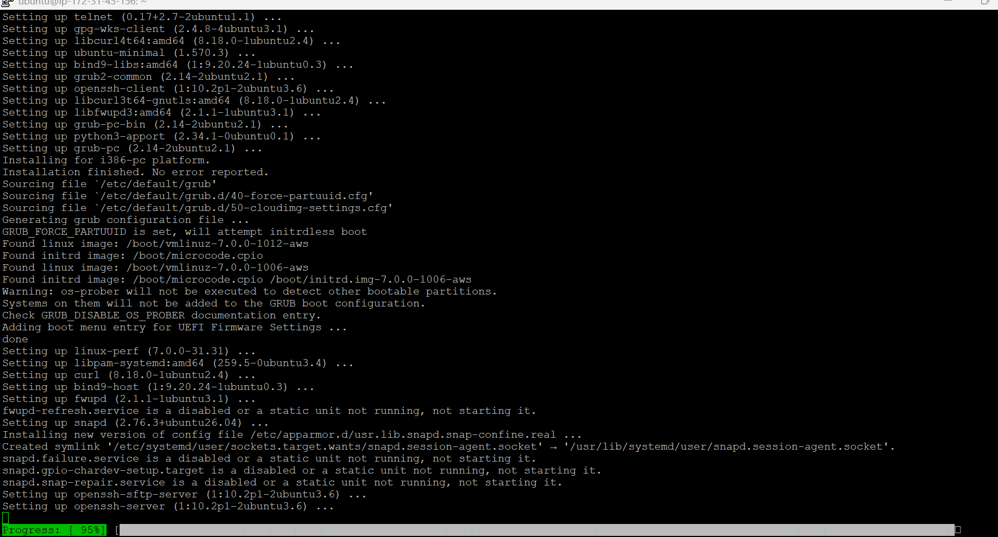

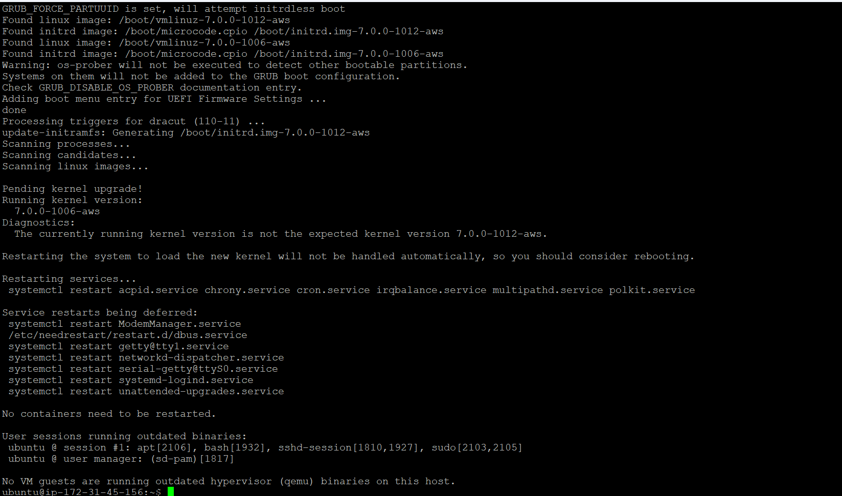
- Create Directories and Download Prometheus
sudo mkdir -p /etc/prometheus /var/lib/prometheus
cd ~
curl -LO https://github.com/prometheus/prometheus/releases/download/v2.55.1/prometheus-2.55.1.linux-amd64.tar.gz
tar -xvf prometheus-2.55.1.linux-amd64.tar.gz
cd prometheus-2.55.1.linux-amd64
sudo cp prometheus promtool /usr/local/bin/
sudo cp -r consoles/ console_libraries/ /etc/prometheus/
sudo cp prometheus.yml /etc/prometheus/
sudo chown -R prometheus:prometheus /etc/prometheus /var/lib/prometheus /usr/local/bin/prometheus /usr/local/bin/promtool

- Verify whether the installation is successful
ls /etc/prometheus/

- Now let’s create the systemd service
sudo tee /etc/systemd/system/prometheus.service > /dev/null <<'EOF'
[Unit]
Description=Prometheus
Wants=network-online.target
After=network-online.target

[Service]
User=prometheus
Group=prometheus
Type=simple
ExecStart=/usr/local/bin/prometheus \
--config.file=/etc/prometheus/prometheus.yml \
--storage.tsdb.path=/var/lib/prometheus/ \
--web.console.templates=/etc/prometheus/consoles \
--web.console.libraries=/etc/prometheus/console_libraries \
--web.listen-address=0.0.0.0:9090

[Install]
WantedBy=multi-user.target
EOF

sudo systemctl daemon-reload
sudo systemctl enable --now prometheus
sudo systemctl status Prometheus

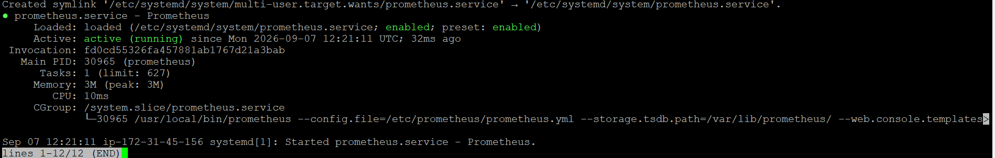

Press q to exit the status pager, then verify it's actually serving requests:
curl localhost:9090
Prometheus 2.55.1 is fully installed and serving on port 9090.

- Now let’s install the Node Exporter on this same instance, so Prometheus has real metrics to scrape.
sudo useradd --no-create-home --shell /bin/false node_exporter

cd ~
curl -LO https://github.com/prometheus/node_exporter/releases/download/v1.8.2/node_exporter-1.8.2.linux-amd64.tar.gz
tar -xvf node_exporter-1.8.2.linux-amd64.tar.gz
sudo cp node_exporter-1.8.2.linux-amd64/node_exporter /usr/local/bin/
sudo chown node_exporter:node_exporter /usr/local/bin/node_exporter

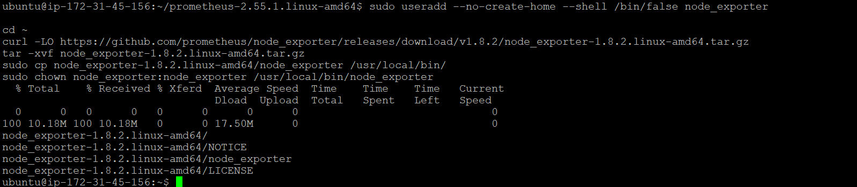
Then the systemd unit

sudo tee /etc/systemd/system/node_exporter.service > /dev/null <<'EOF'
[Unit]
Description=Node Exporter
Wants=network-online.target
After=network-online.target

[Service]
User=node_exporter
Group=node_exporter
Type=simple
ExecStart=/usr/local/bin/node_exporter

[Install]
WantedBy=multi-user.target
EOF

sudo systemctl daemon-reload
sudo systemctl enable --now node_exporter
sudo systemctl status node_exporter

sudo tee /etc/systemd/system/node_exporter.service > /dev/null <<'EOF'
[Unit]
Description=Node Exporter
Wants=network-online.target
After=network-online.target

[Service]
User=node_exporter
Group=node_exporter
Type=simple
ExecStart=/usr/local/bin/node_exporter

[Install]
WantedBy=multi-user.target
EOF

sudo systemctl daemon-reload
sudo systemctl enable --now node_exporter
sudo systemctl status node_exporter

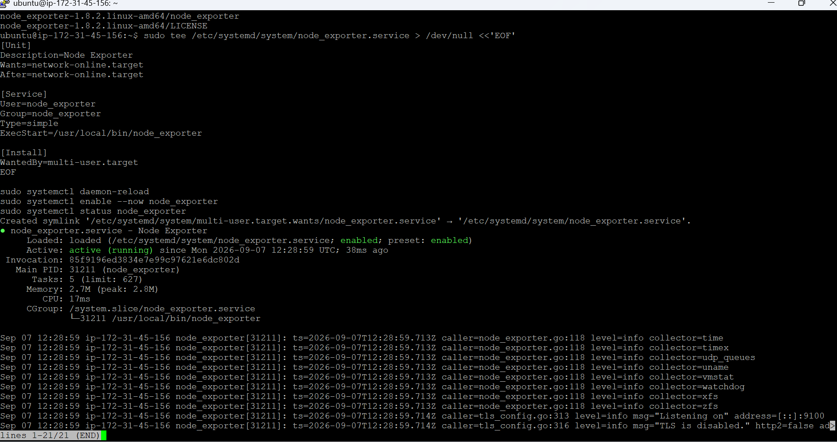

Press q and then type the following command
curl localhost:9100/metrics
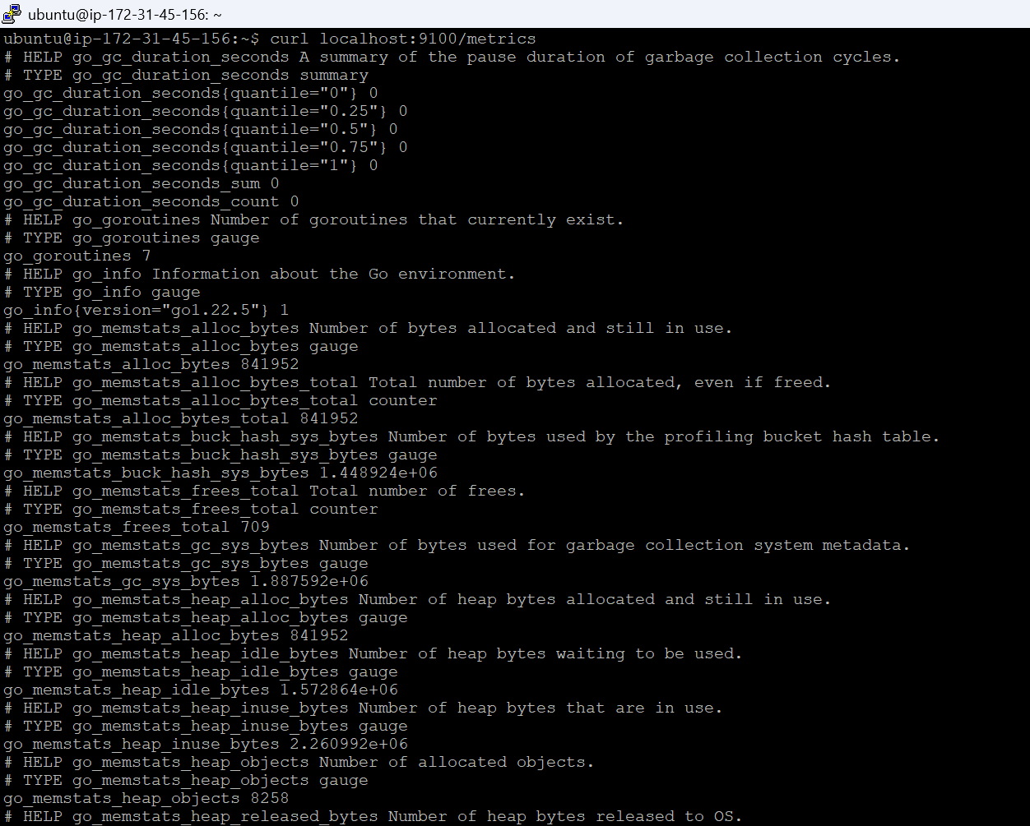
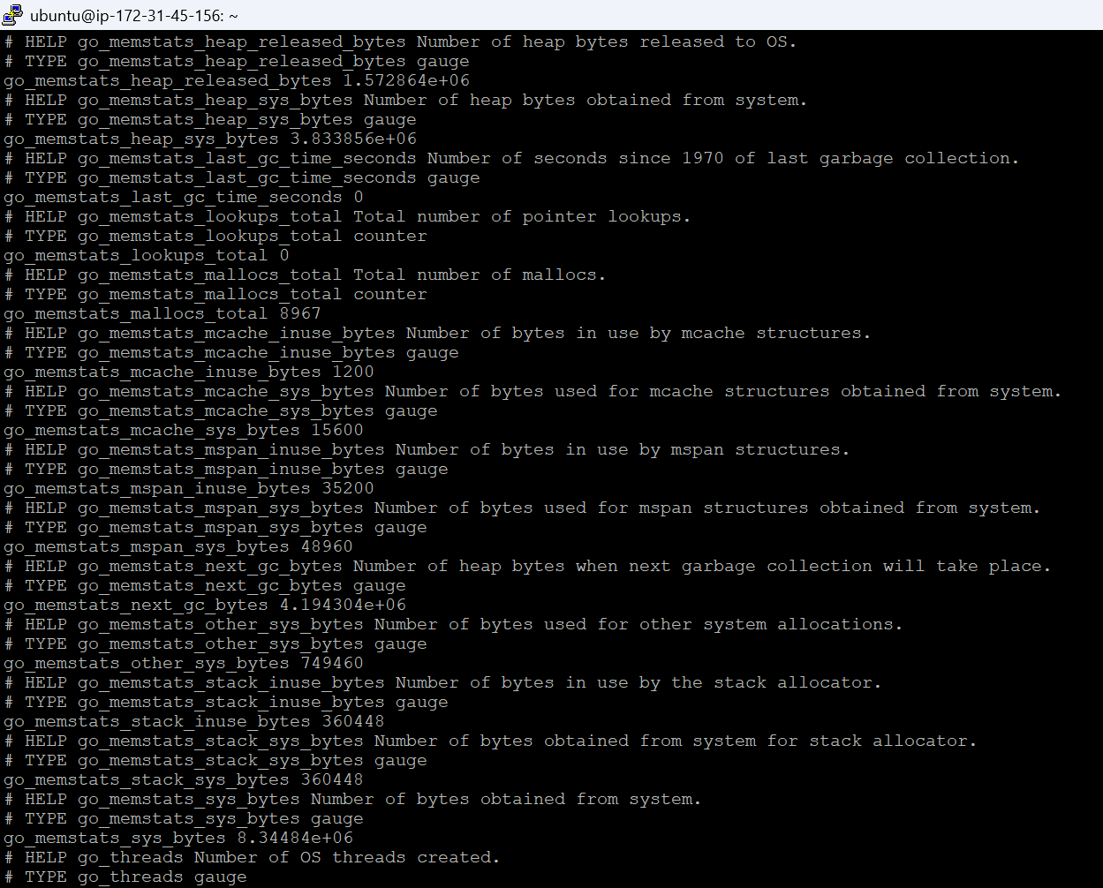
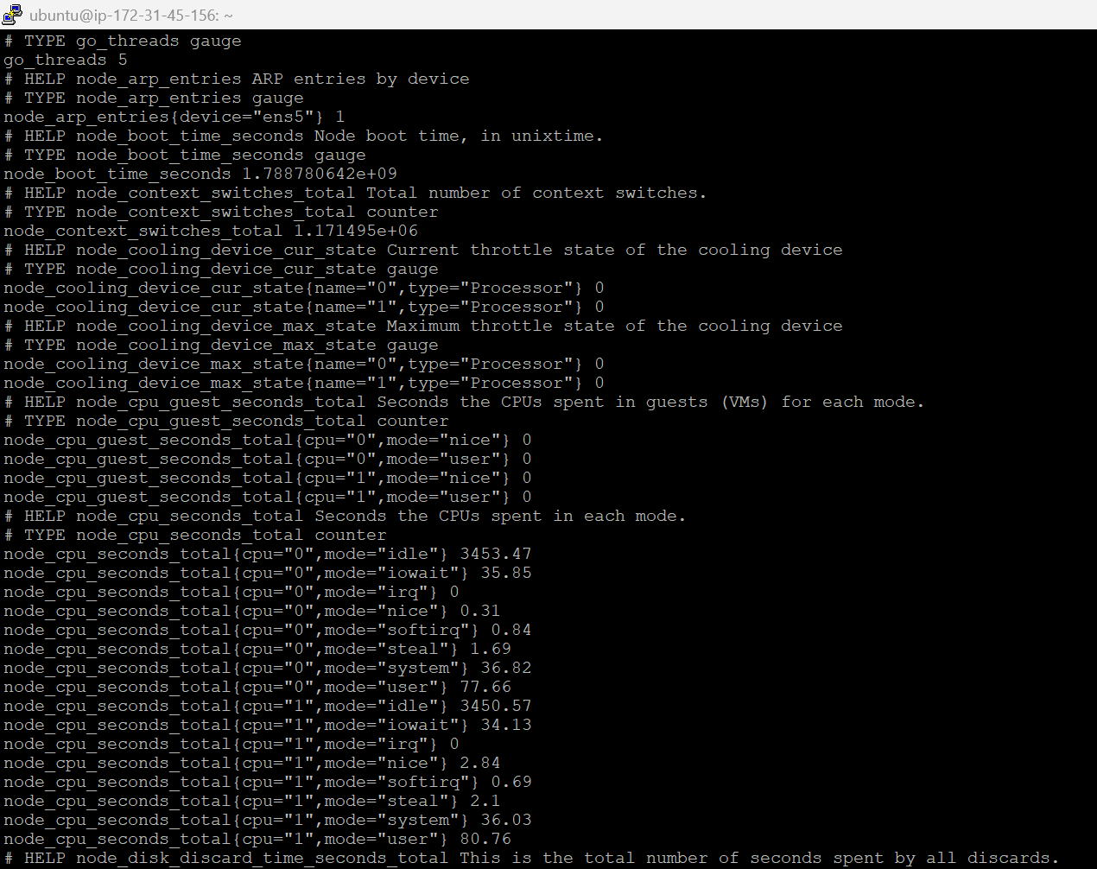

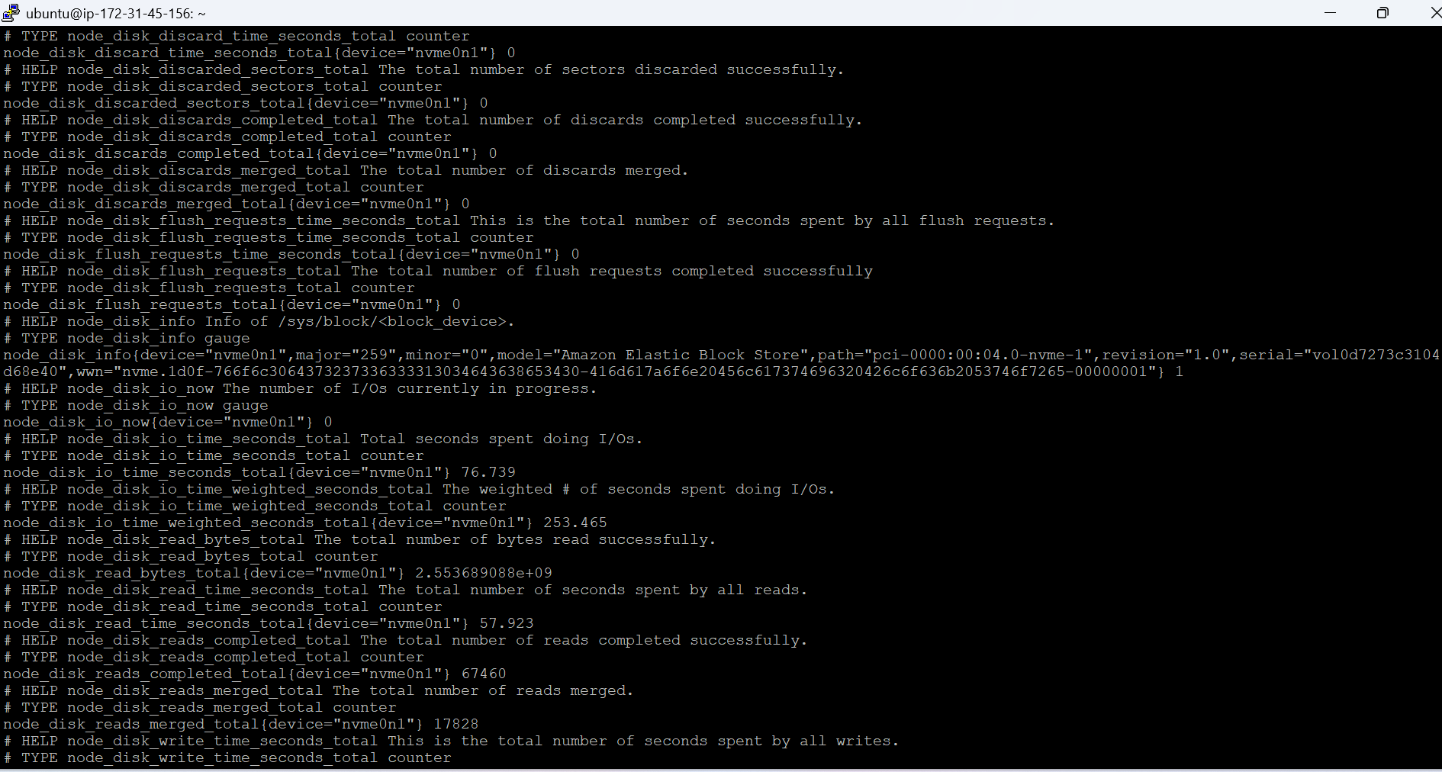
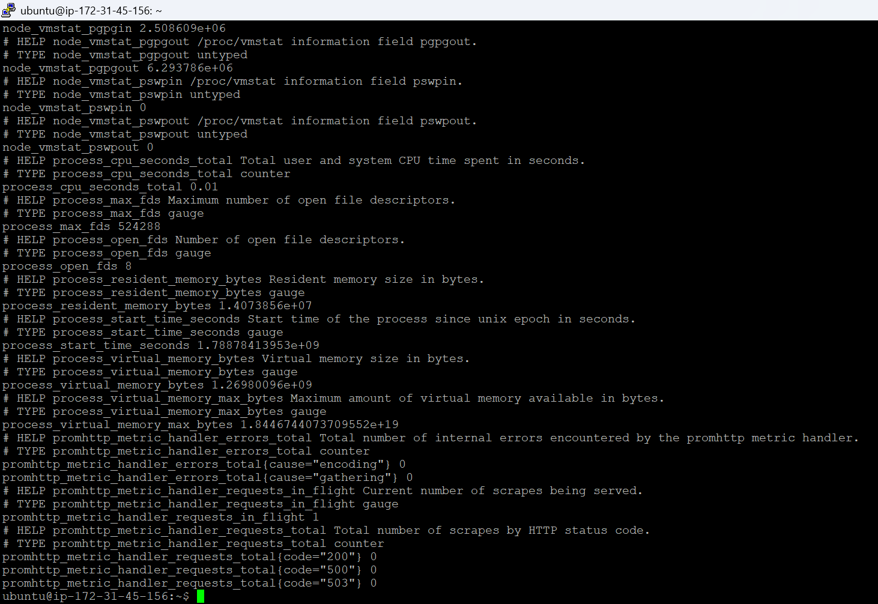

Node Exporter is running and serving metrics correctly.

Now lets wire the Prometheus.yml file so that it can be accessed from a browser

sudo nano /etc/prometheus/prometheus.yml

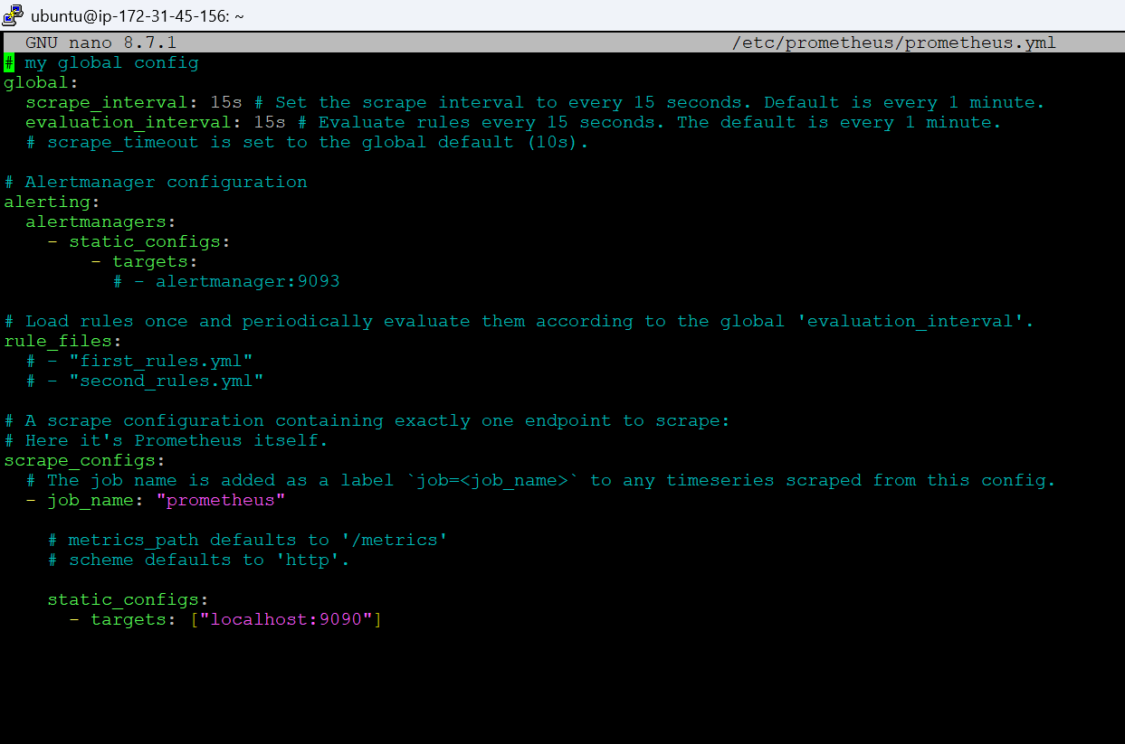

Add the following information to the scrape configs section

- job_name: 'node_exporter'
static_configs:
- targets: ['localhost:9100']
Ctrl+S and Ctrl+X
Now restart the Prometheus so that the changes take effect
sudo systemctl restart prometheus
sudo systemctl status prometheus

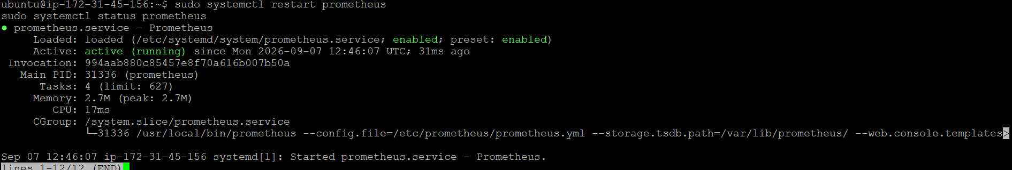

Press q to exit the pager, then check the targets page in our browser

http://<EC2-A-public-ip>:9090/targets which is
http://13.48.43.119:9090/targets

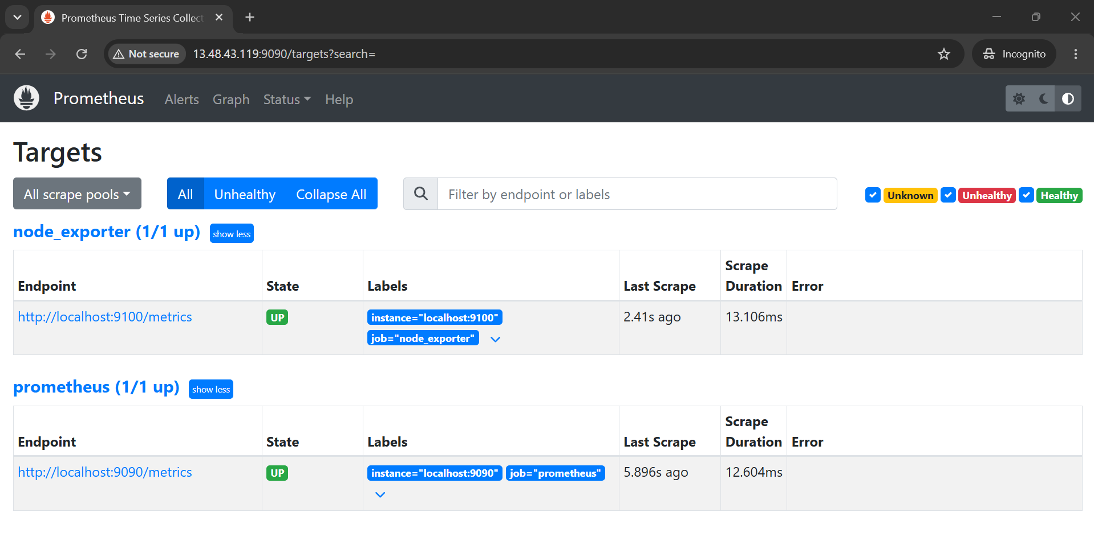

Prometheus installation is completed successfully. Now let’s move on to the Grafana installation on the second EC2 instance.

Grafana Server - EC2 Instance 2
We will use t3.micro and 8 GB Volume of disk space.
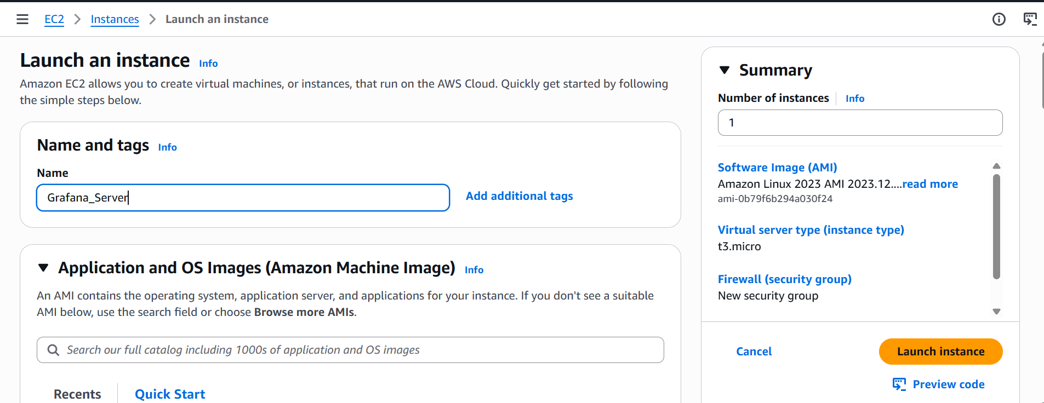

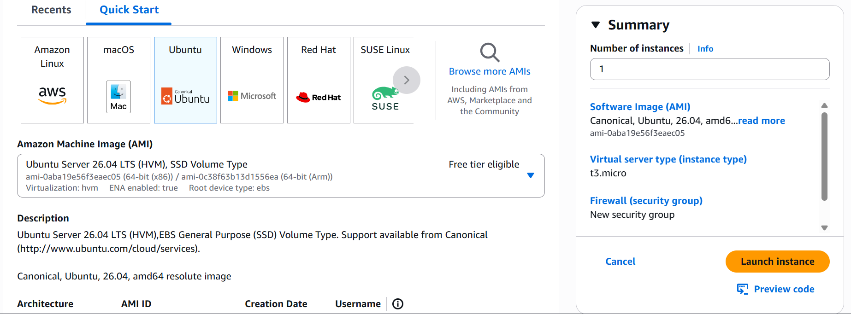

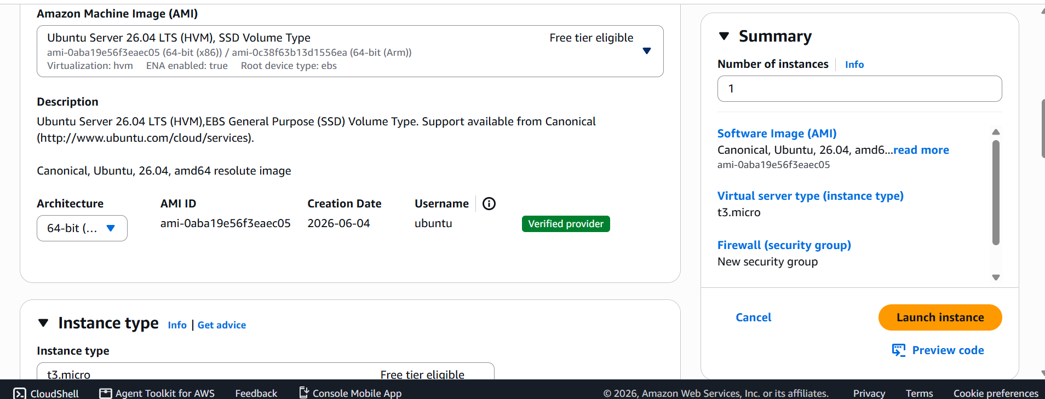

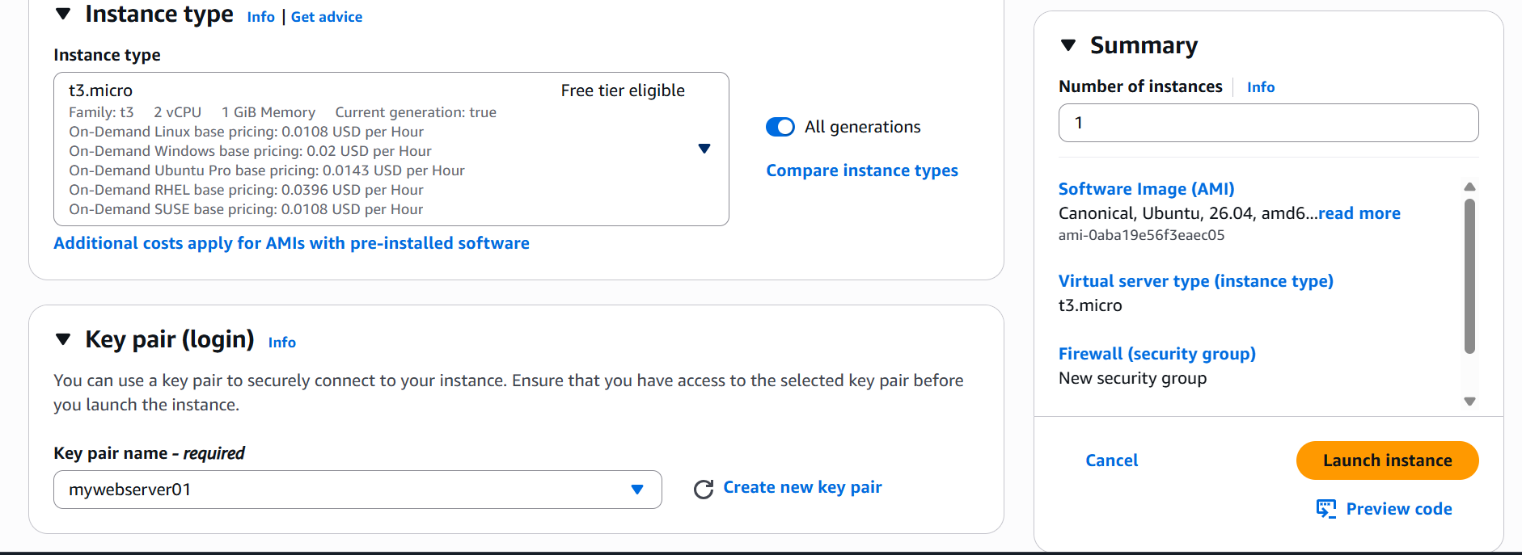

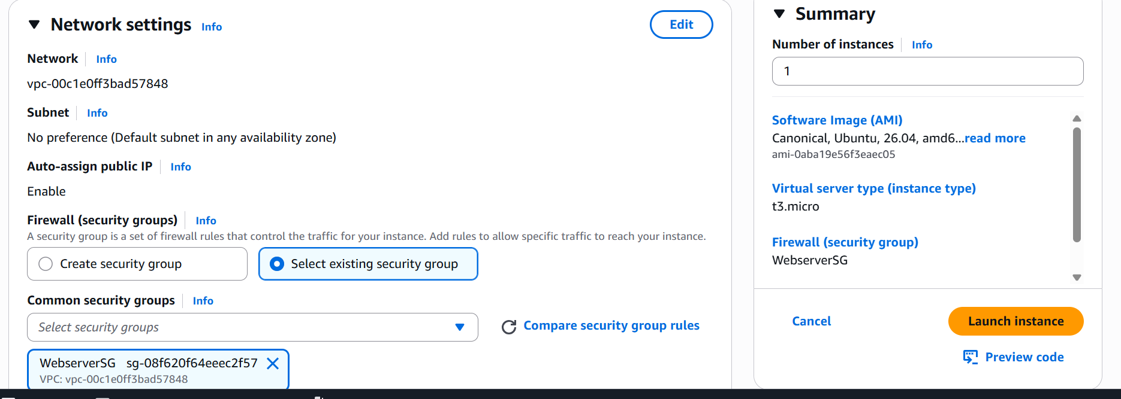

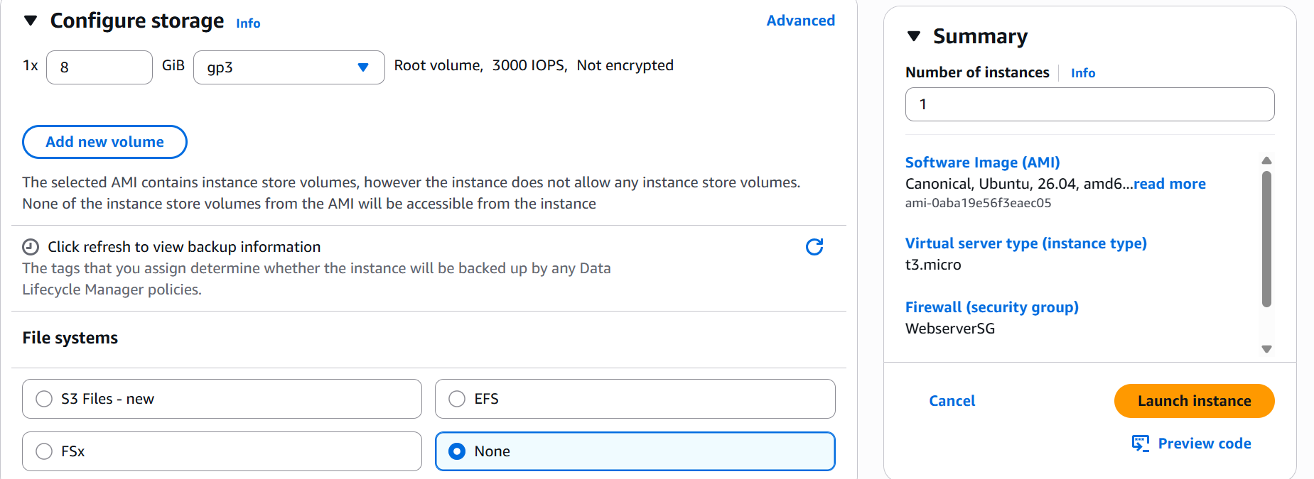

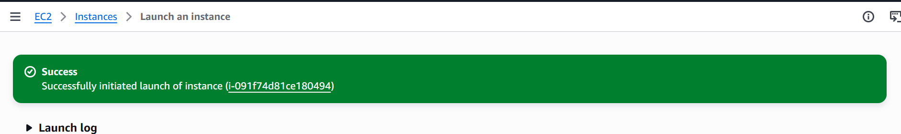

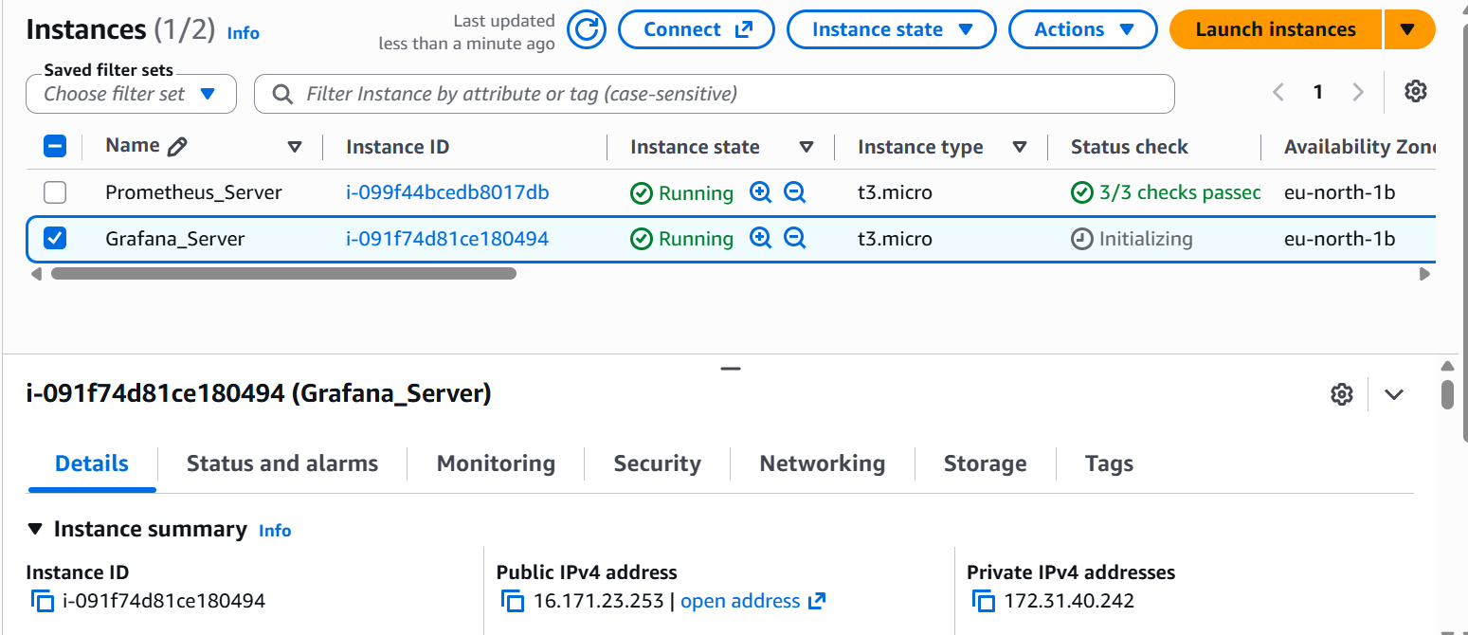

Login to the EC2 instance and then run the following commands for installing Grafana onto it.
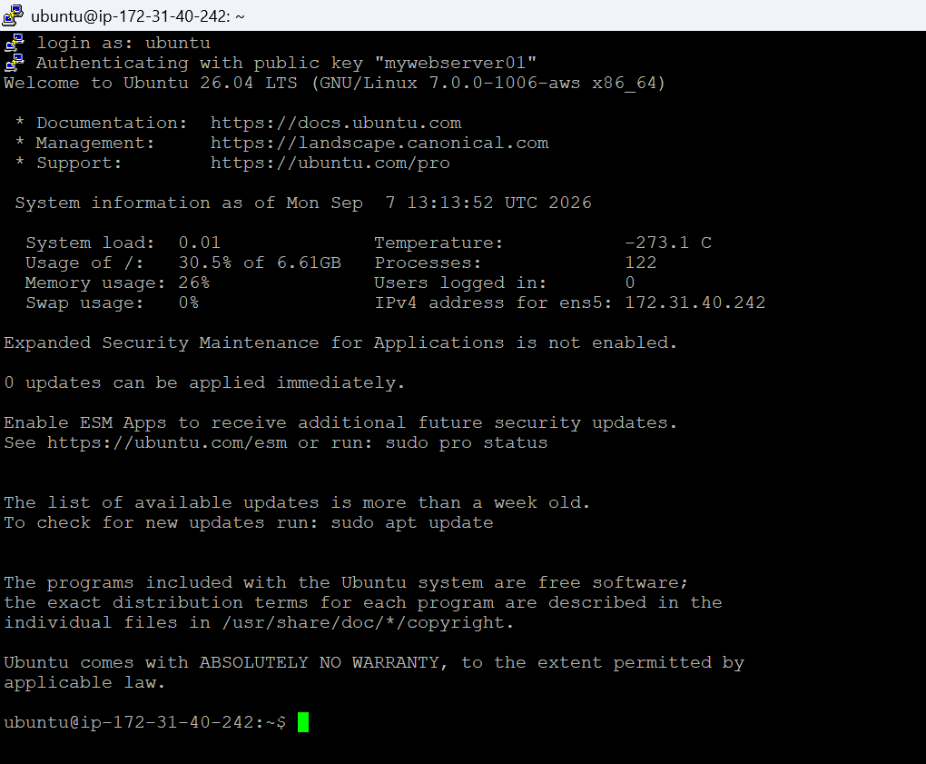

sudo apt-get update
sudo apt-get install -y apt-transport-https software-properties-common wget
sudo mkdir -p /etc/apt/keyrings/
wget -q -O - https://apt.grafana.com/gpg.key | gpg --dearmor | sudo tee /etc/apt/keyrings/grafana.gpg > /dev/null
echo "deb [signed-by=/etc/apt/keyrings/grafana.gpg] https://apt.grafana.com stable main" | sudo tee /etc/apt/sources.list.d/grafana.list

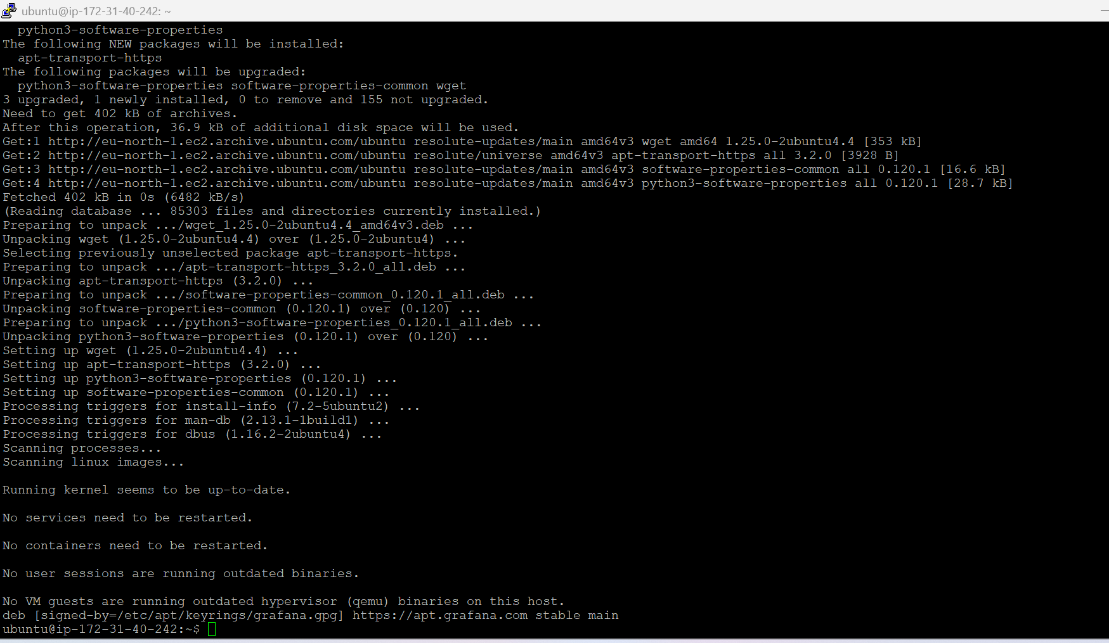

sudo apt-get update
sudo apt-get install -y grafana

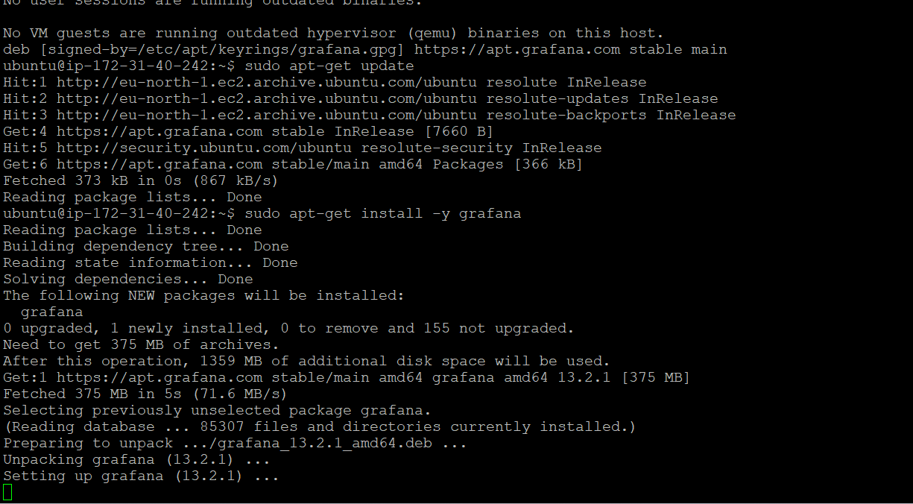

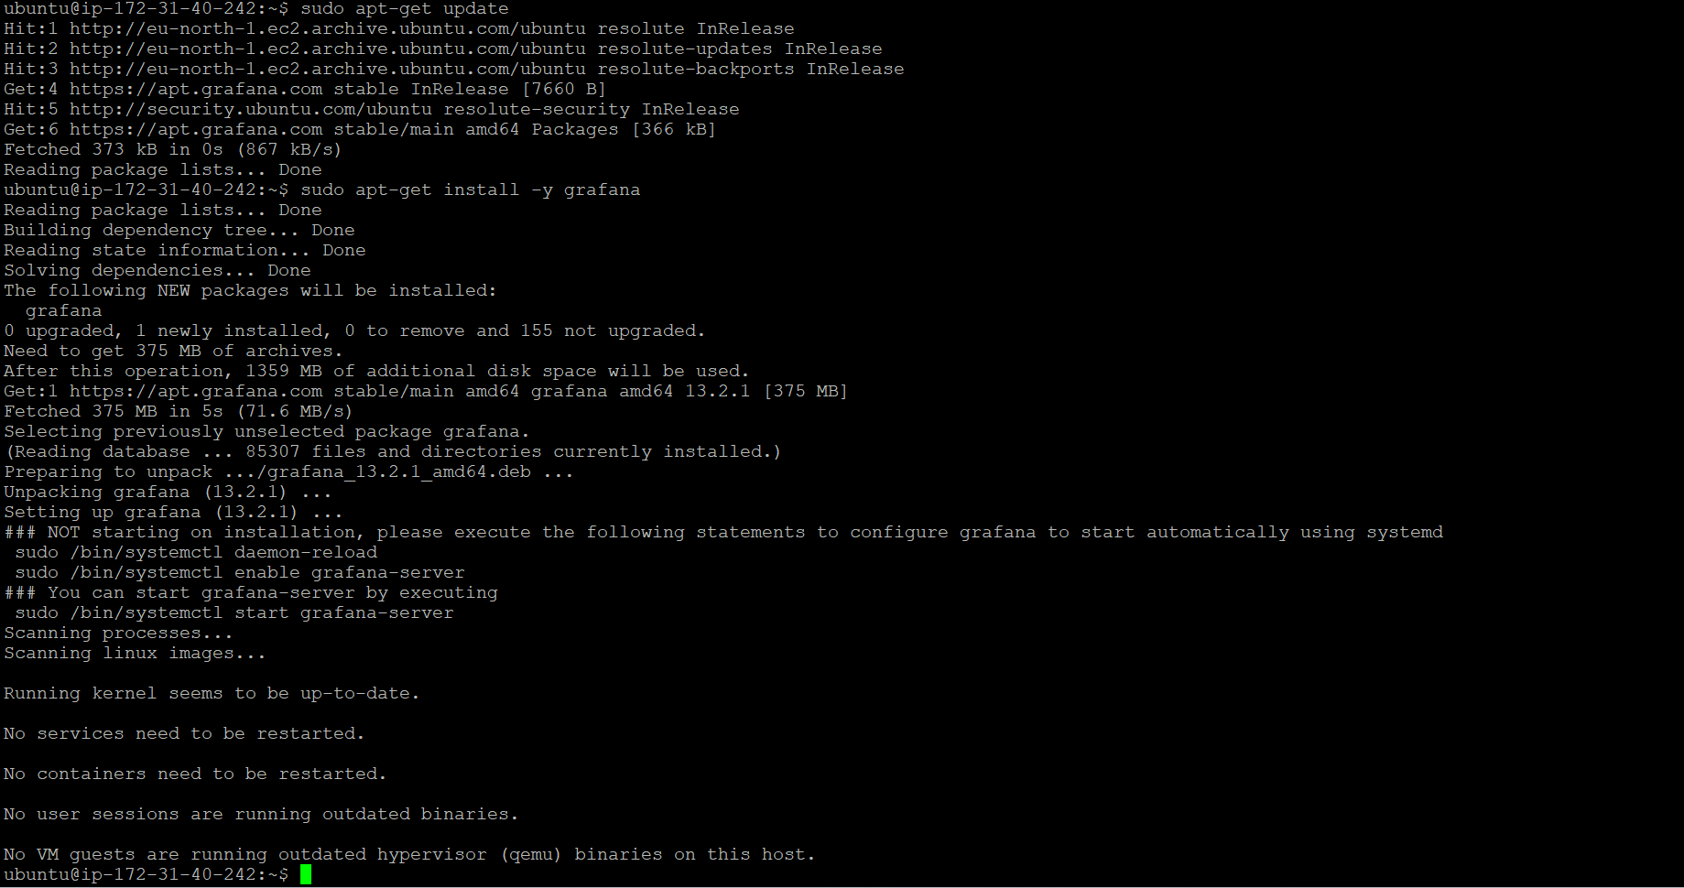

sudo systemctl enable --now grafana-server
sudo systemctl status grafana-server

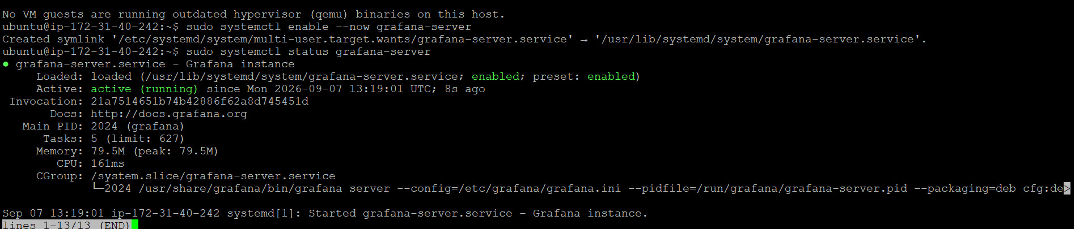

Check whether the Grafana server is accessible via browser

http://<EC2-B-public-ip>:3000 that is
http://16.171.23.253:3000

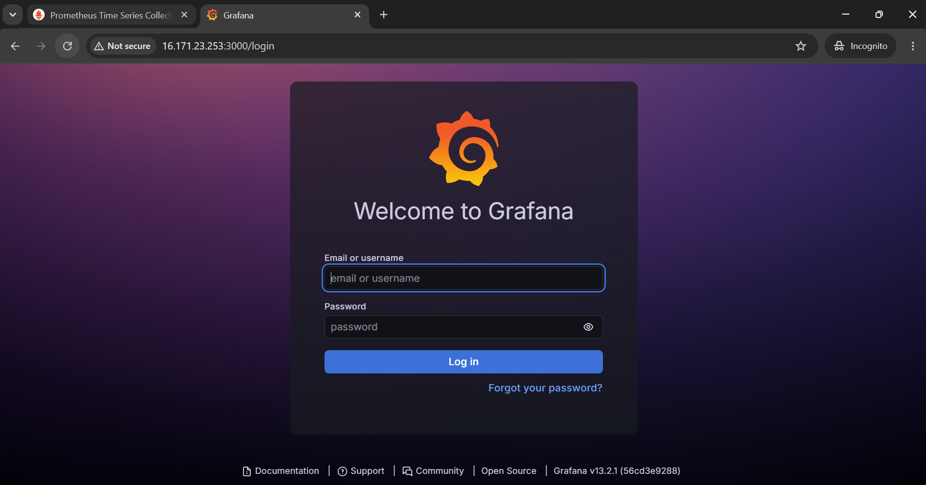

Grafana v13.2.1 is up and serving the login page correctly.

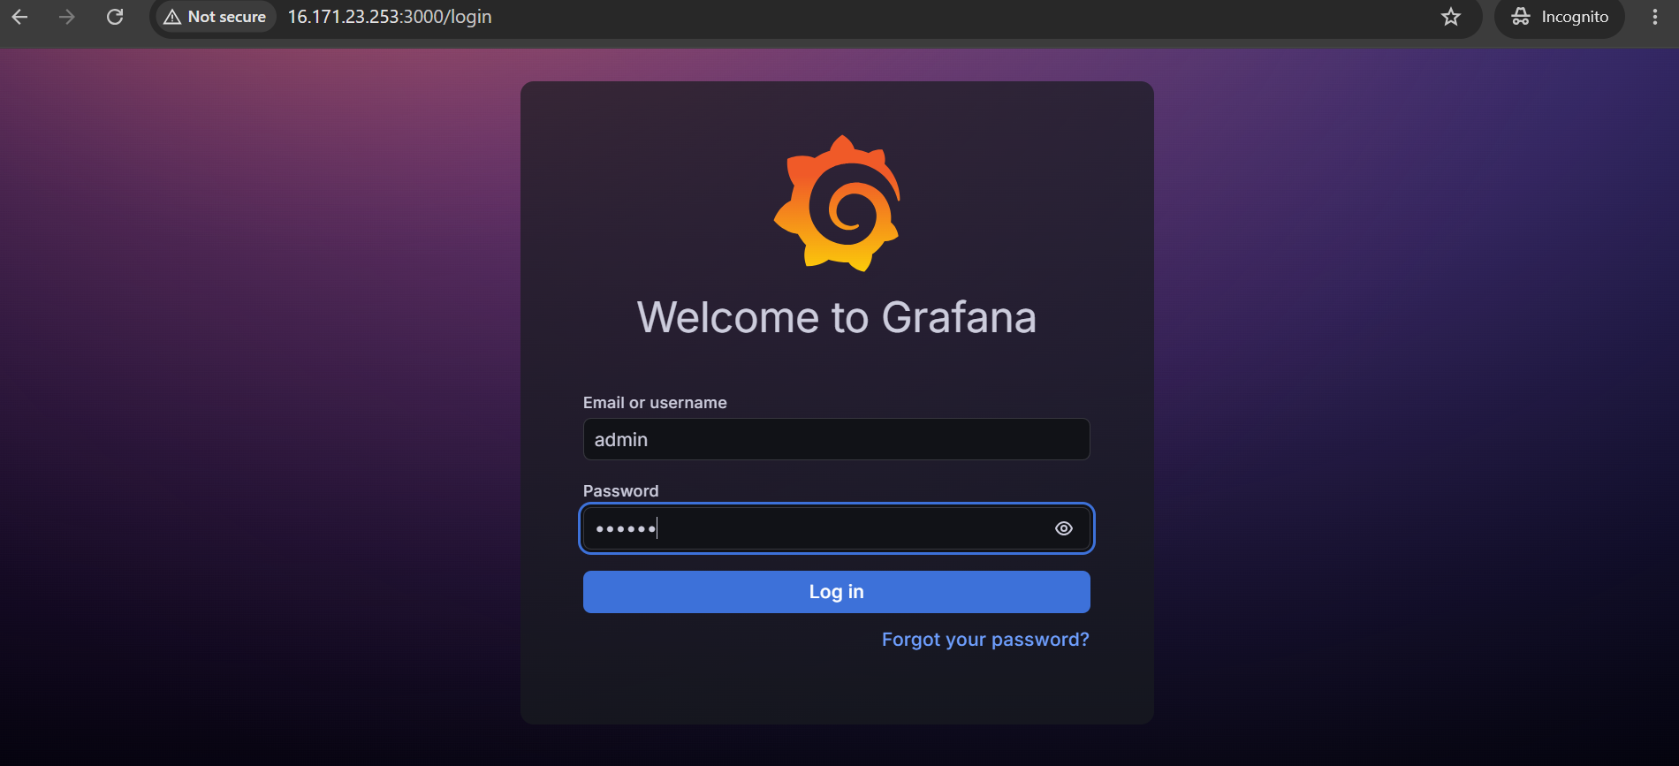

Let’s use “admin” as the username and the password and then we will change the password after login



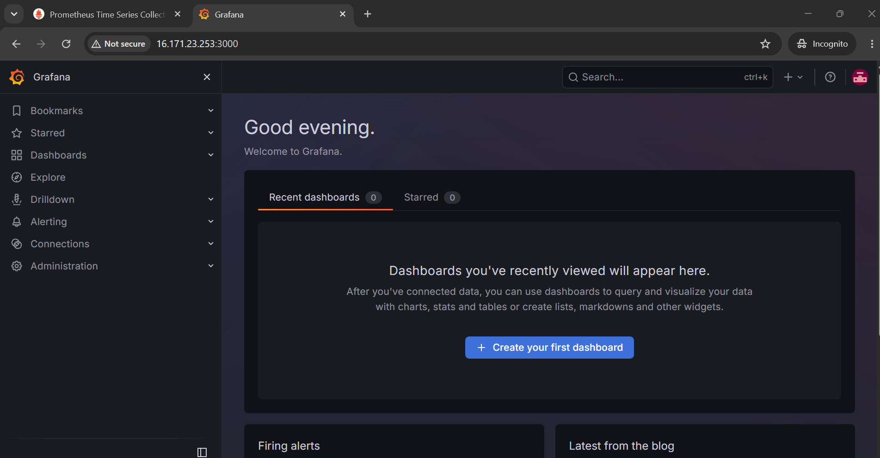

We have successfully logged into the Grafana server.

Now let’s connect this Grafana server with the Prometheus server

In the left sidebar, click Connections
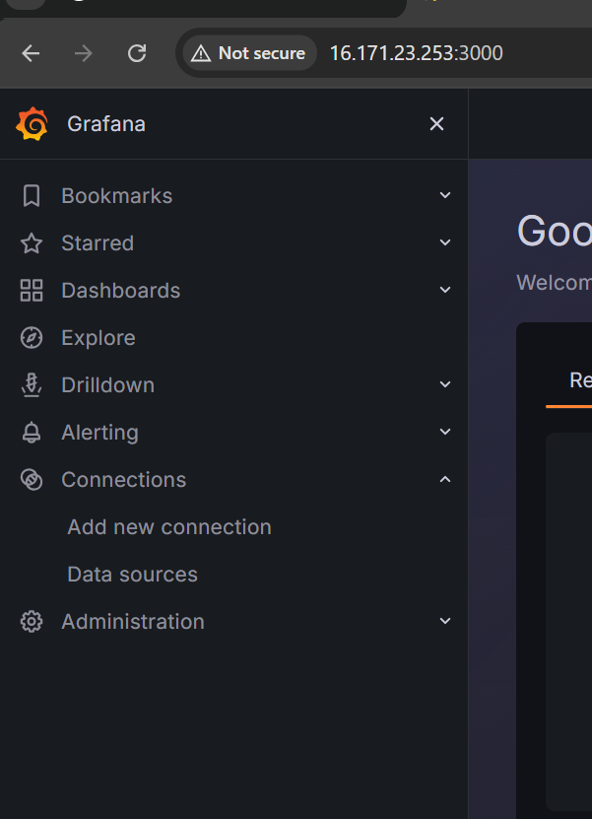
Click Add new connection
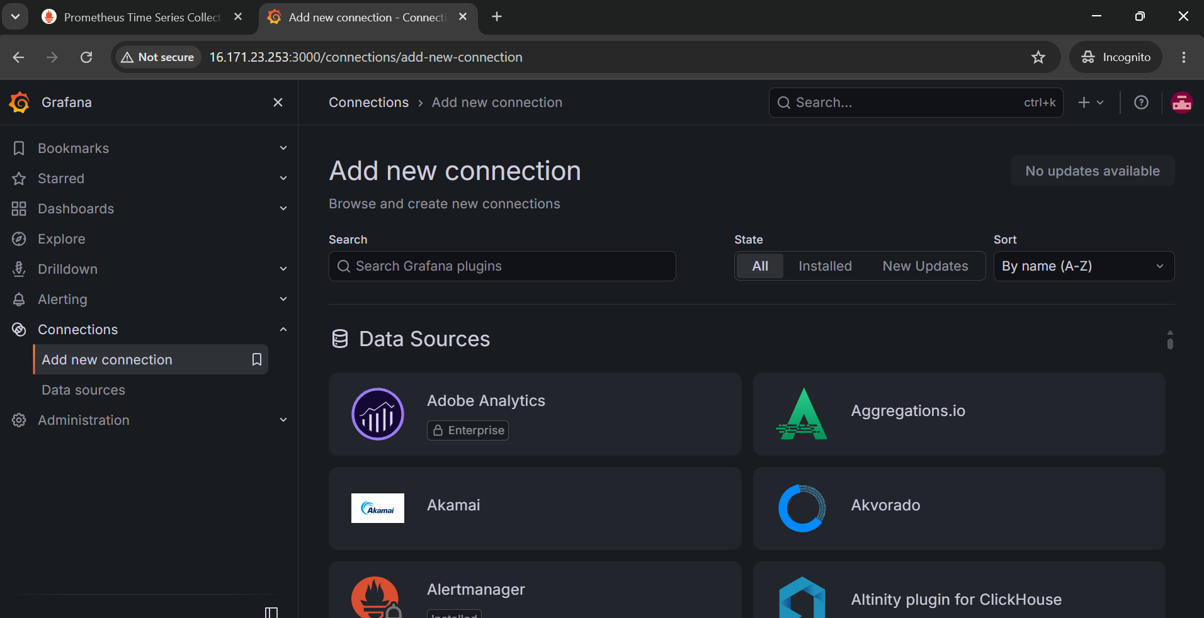
Search for Prometheus and click it

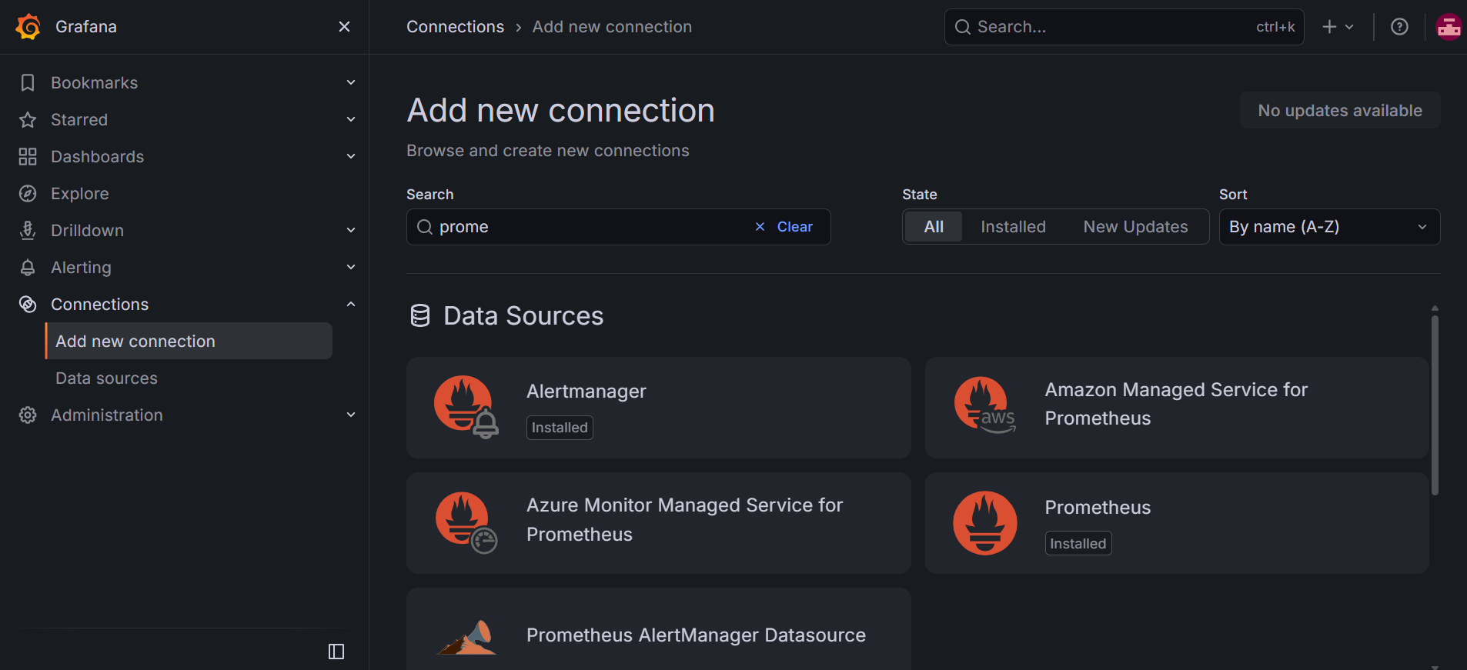
Click Add new data source (top right)
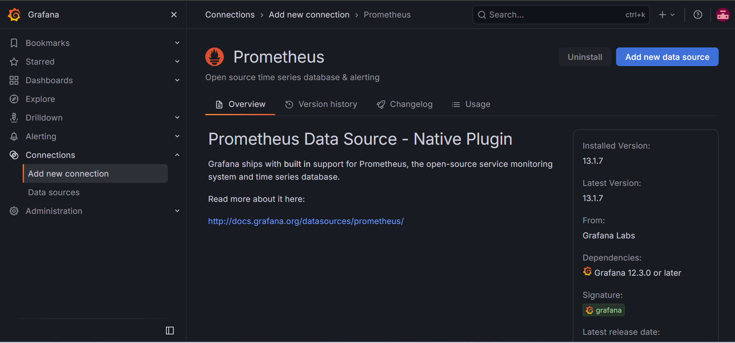

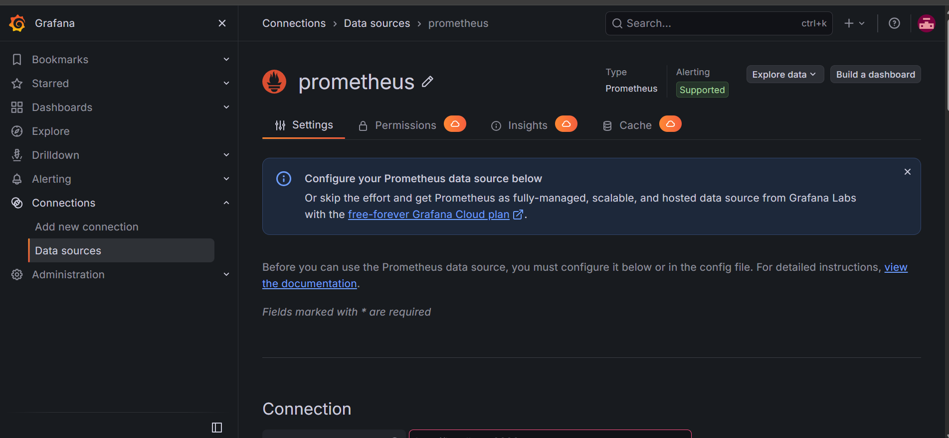
Under Prometheus server URL, enter: http://13.48.43.119:9090
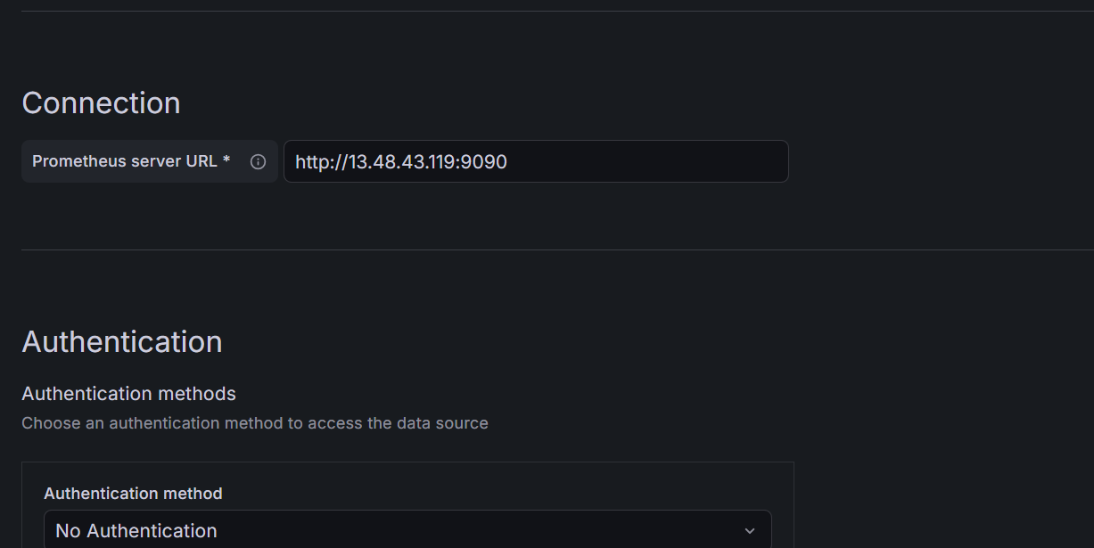

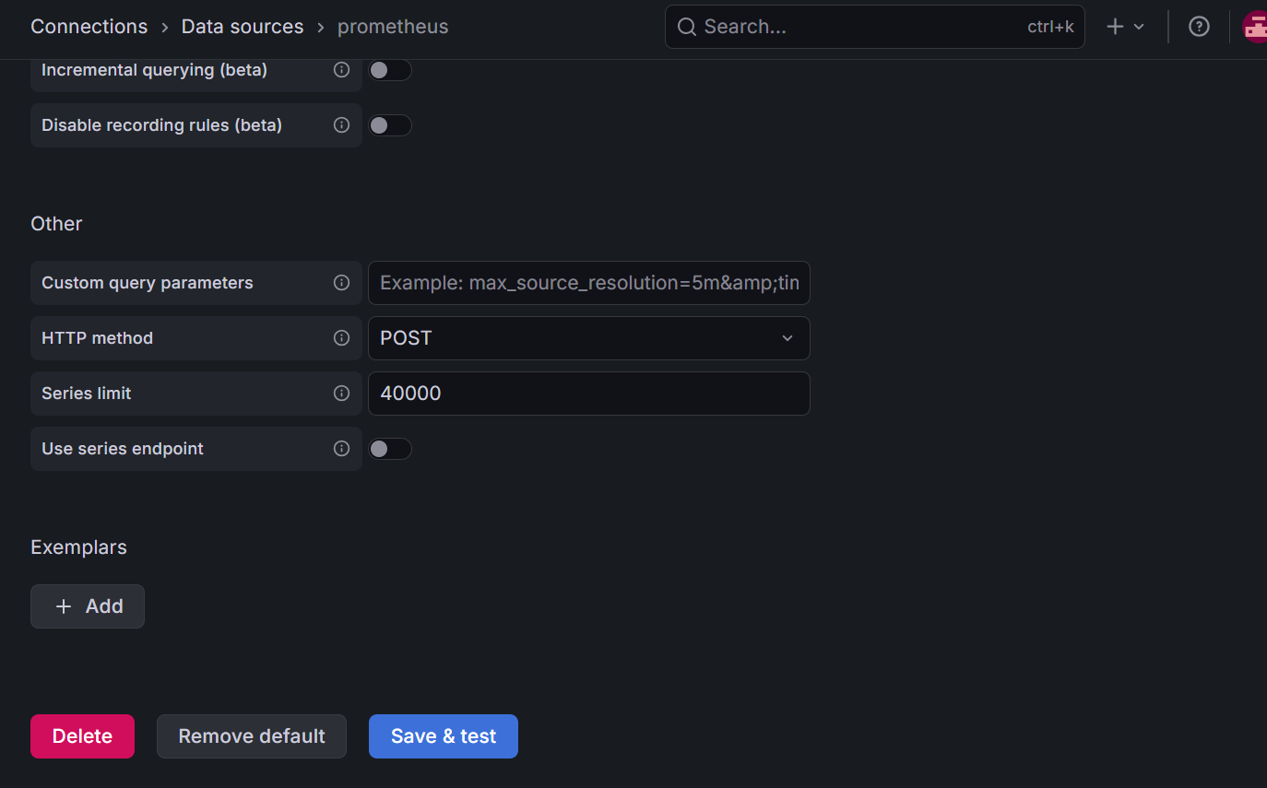

Save and test
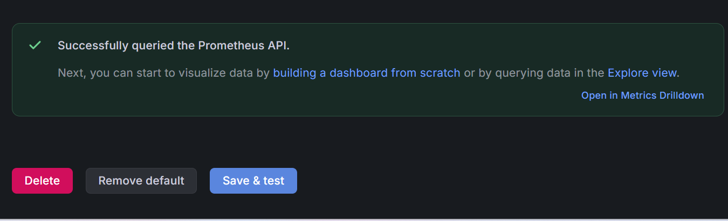

"Successfully queried the Prometheus API" — Grafana on the second EC2 instance is now fully connected to Prometheus on the first EC2 instance. Two-instance setup is complete end to end.

Now let’s build the dashboard

Let’s import the community "Node Exporter Full" dashboard:
- Left sidebar → Dashboards
- Click New (top right) → Import
- In the "Import via grafana.com" field, enter dashboard ID: 1860
- Click Load
- On the next screen, in the dropdown for the Prometheus data source, select the one you just created
- Click Import

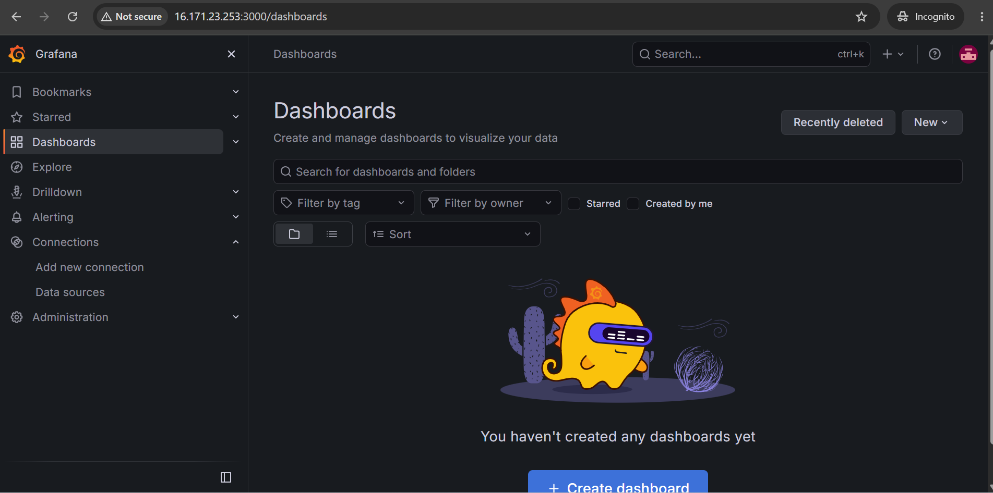

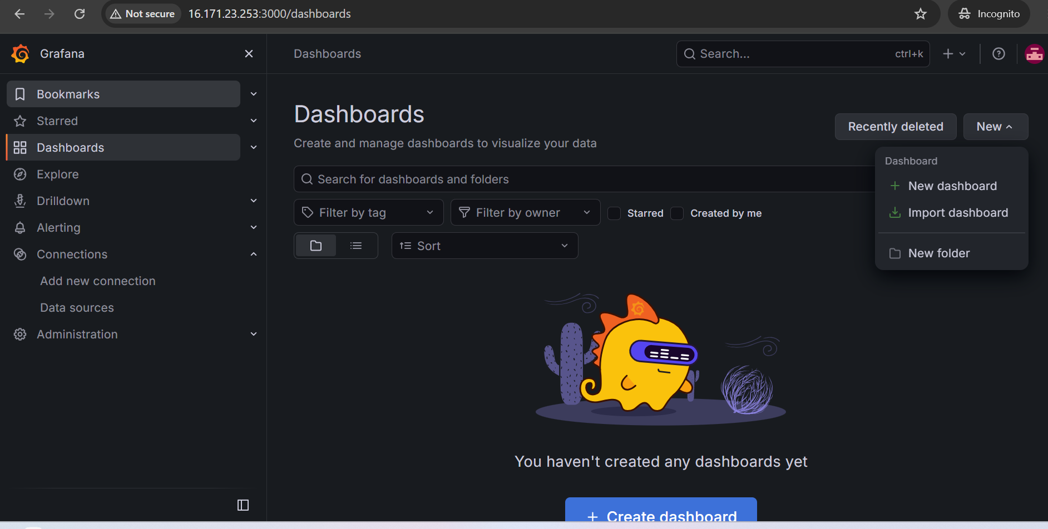

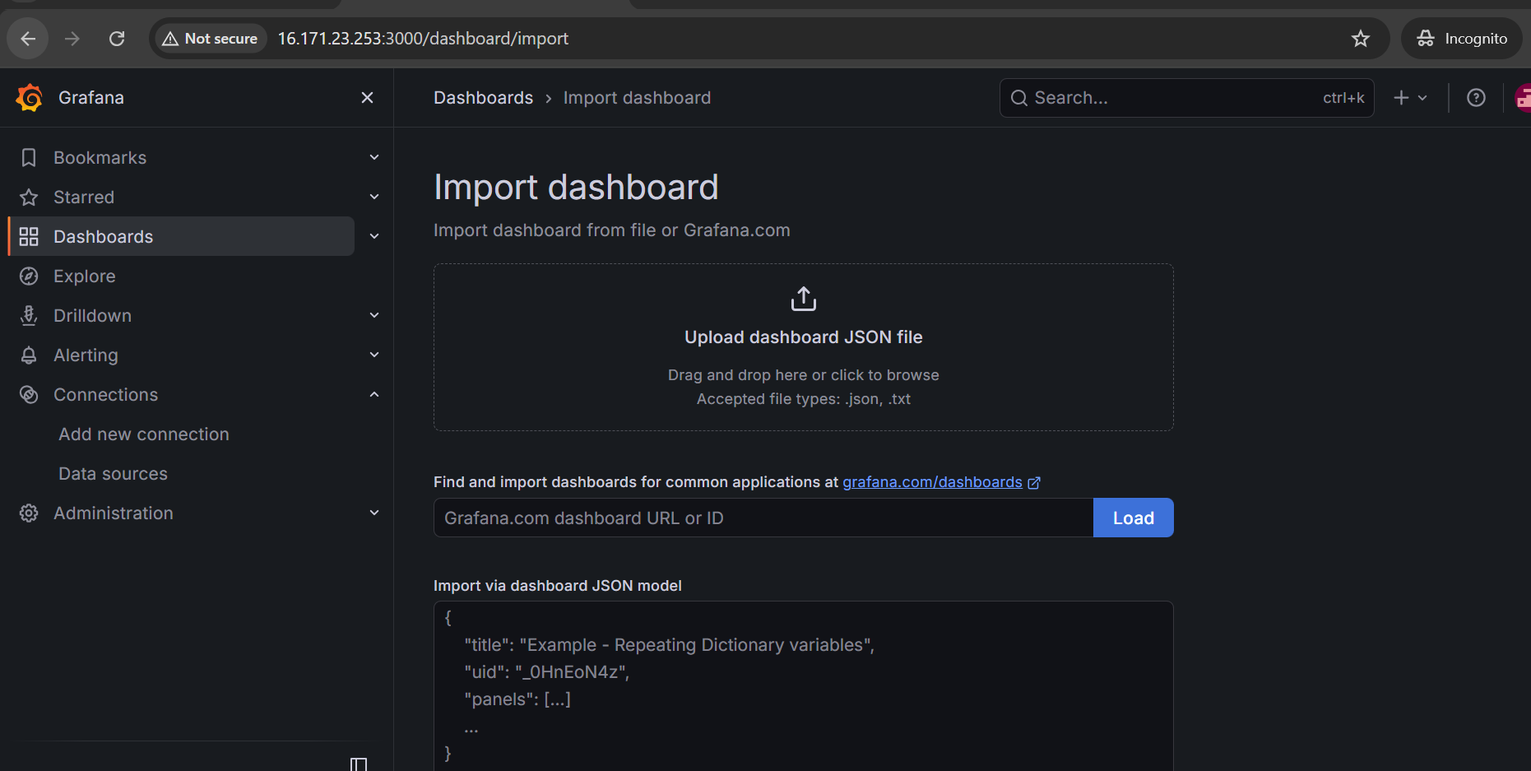

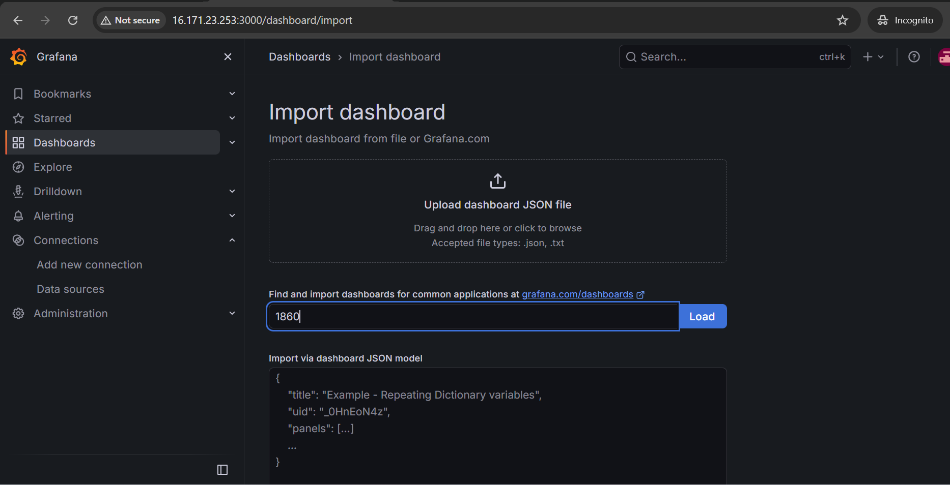

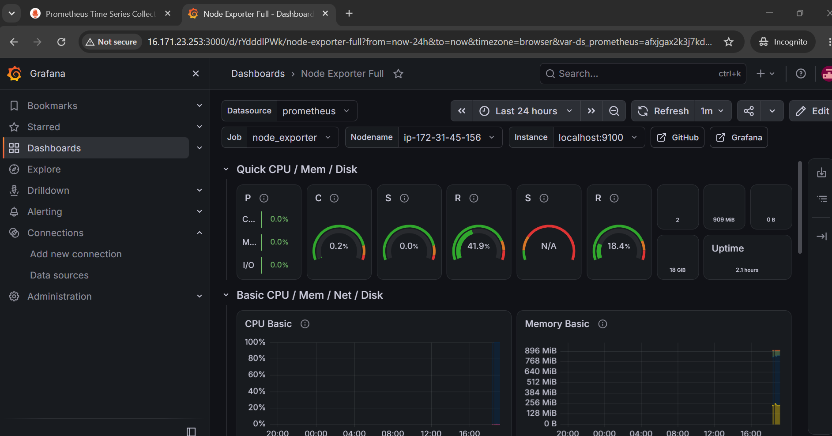

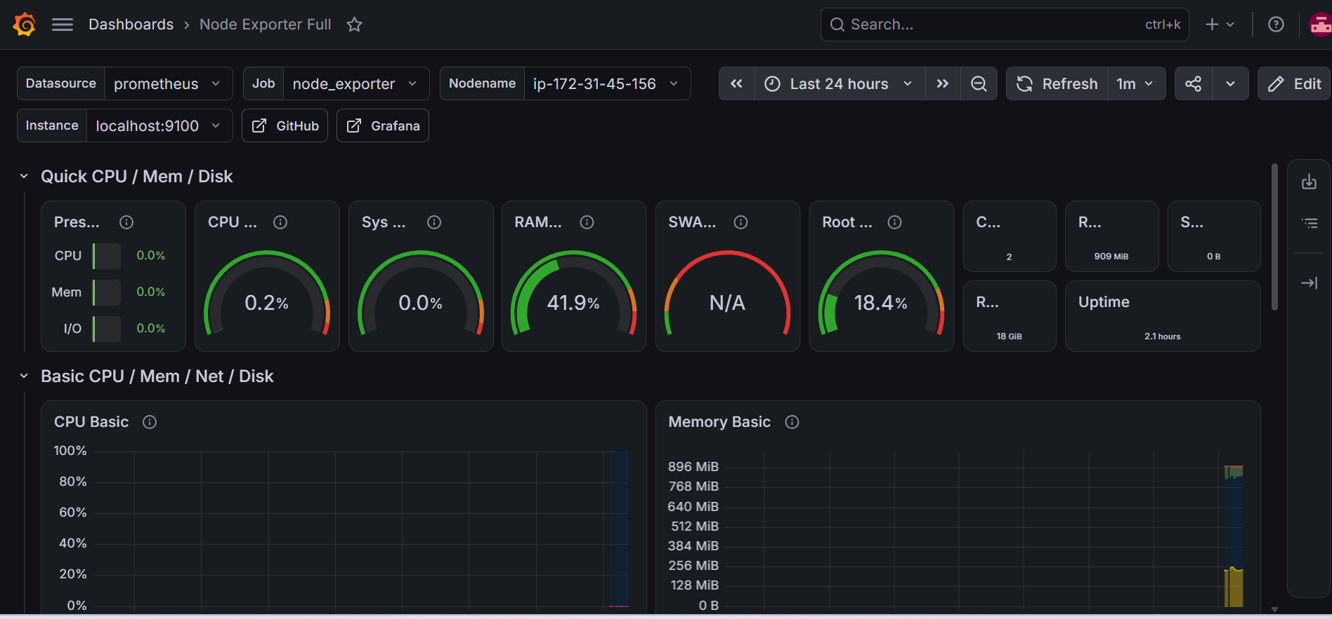

That's a fully working, live dashboard — CPU at 0.2%, RAM at 41.9%, root disk at 18.4%, uptime 2.1 hours, all pulling real-time from EC2 instance 1 Node Exporter via Prometheus, rendered on Grafana running on EC2 instance 2. The whole pipeline is confirmed end-to-end.

We have got the complete two-instance setup working.

EC2 instance 1 (Prometheus + Node Exporter) → scraping local system metrics on localhost:9100, exposing them on 9090 → EC2 instance 2 (Grafana) → querying across the network, rendering the "Node Exporter Full" dashboard with live gauges, charts, and time-series panels.

This concludes our monitoring task.

