Terraform Task

Task Description:
Launch Linux EC2 instances in two regions using a single Terraform file.
Solution:
We are going to launch our EC2 instances in “us-east-1” & “us-east-2”. Hence we need to have two Key pairs. One in each region.
key pair by name “mytfserver02” is created in “us-east-1” region.
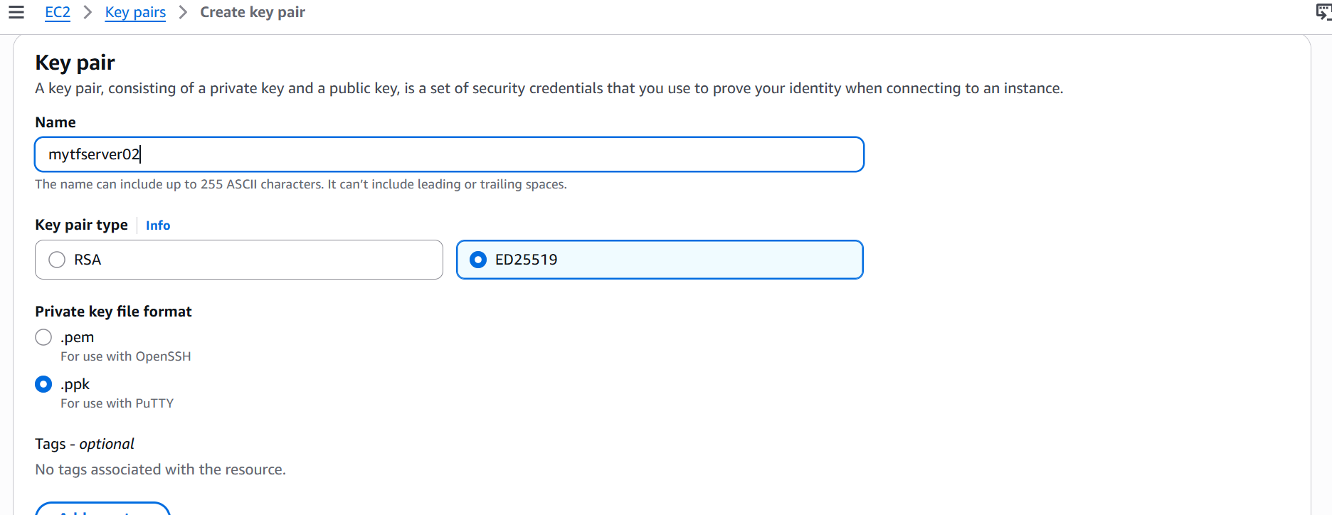
So we will create one key pair in “us-east-2” region now.

Changing the region to “us-east-2” in the aws console
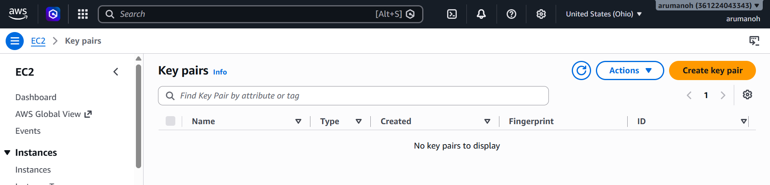

Click key pair
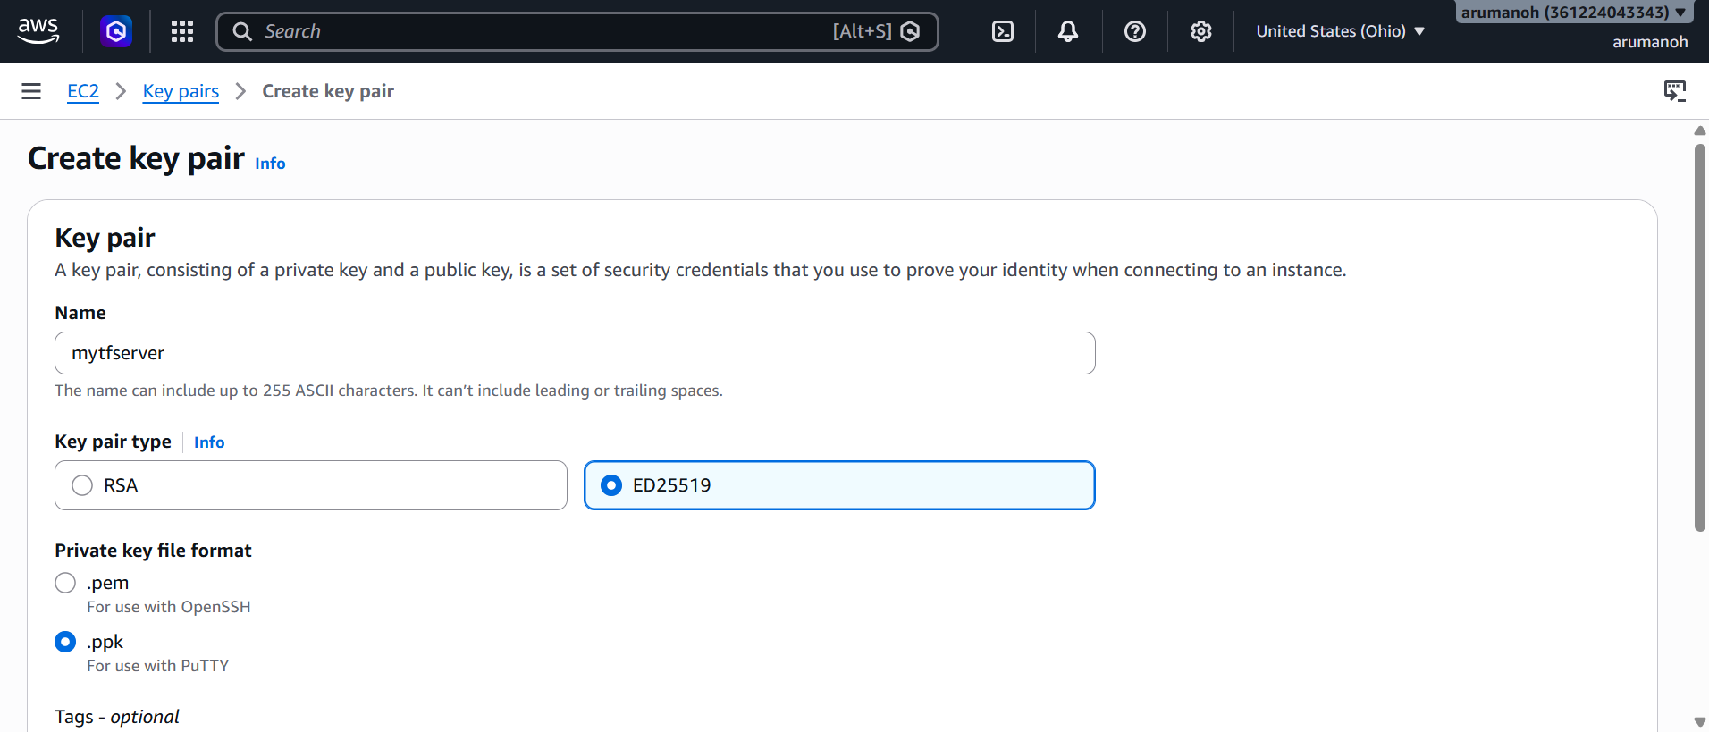
Fill in the details and click on create key pair
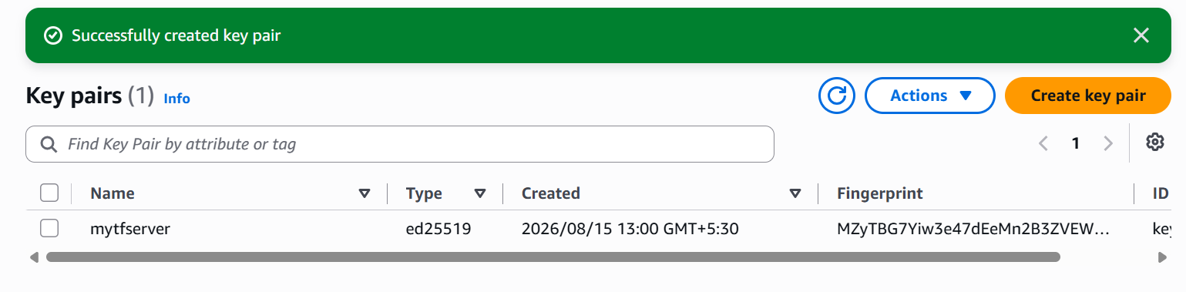
Key pair by name “mytfserver” has been created successfully in “us-east-2” region.
Now let’s create an EC2 instance and install terraform in it.
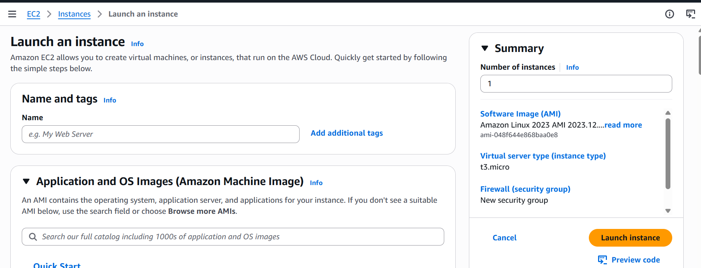

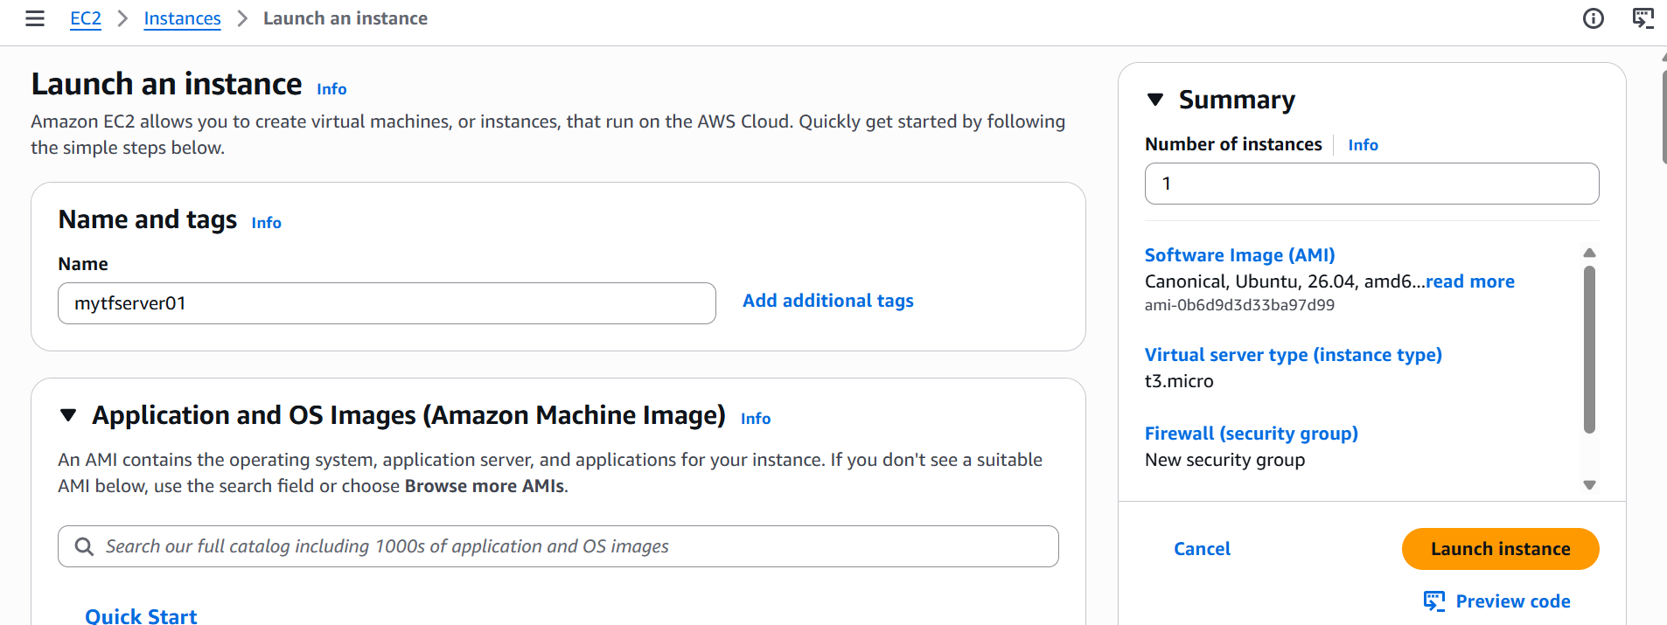

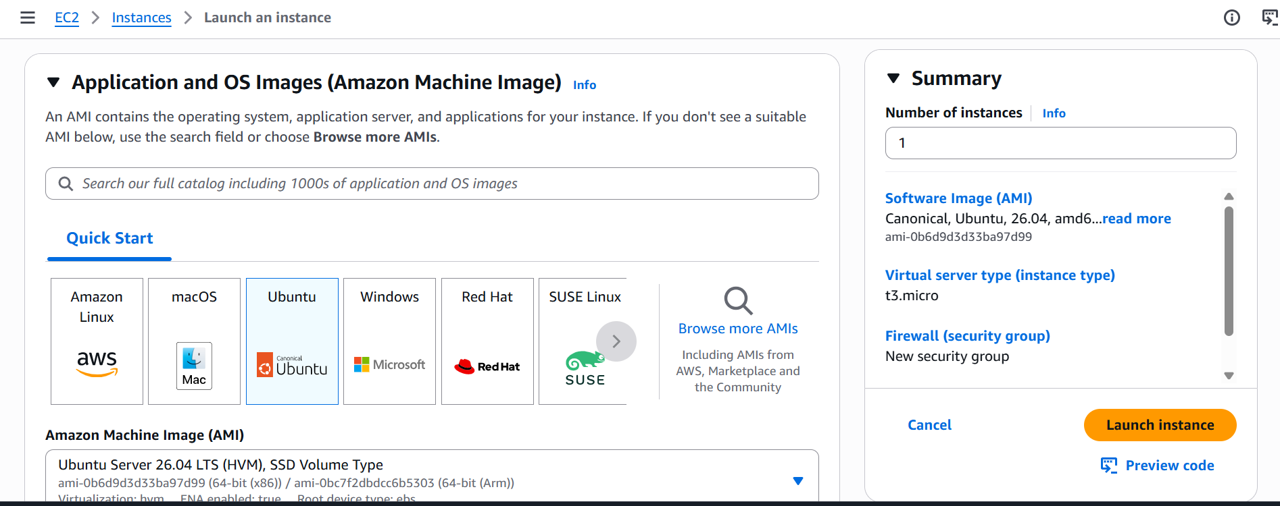

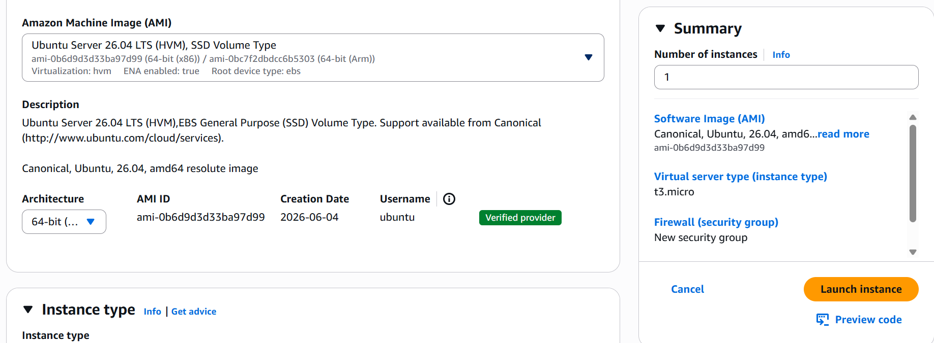

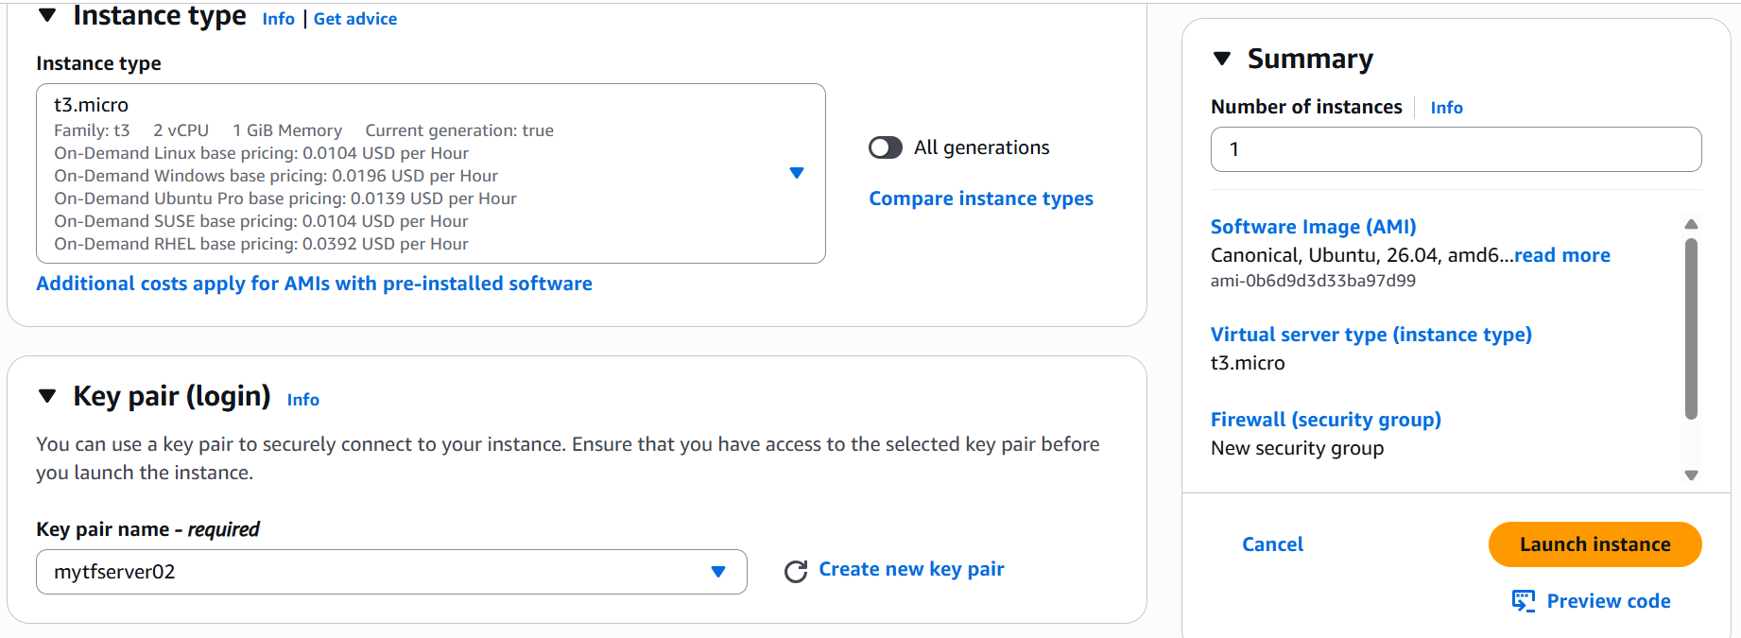
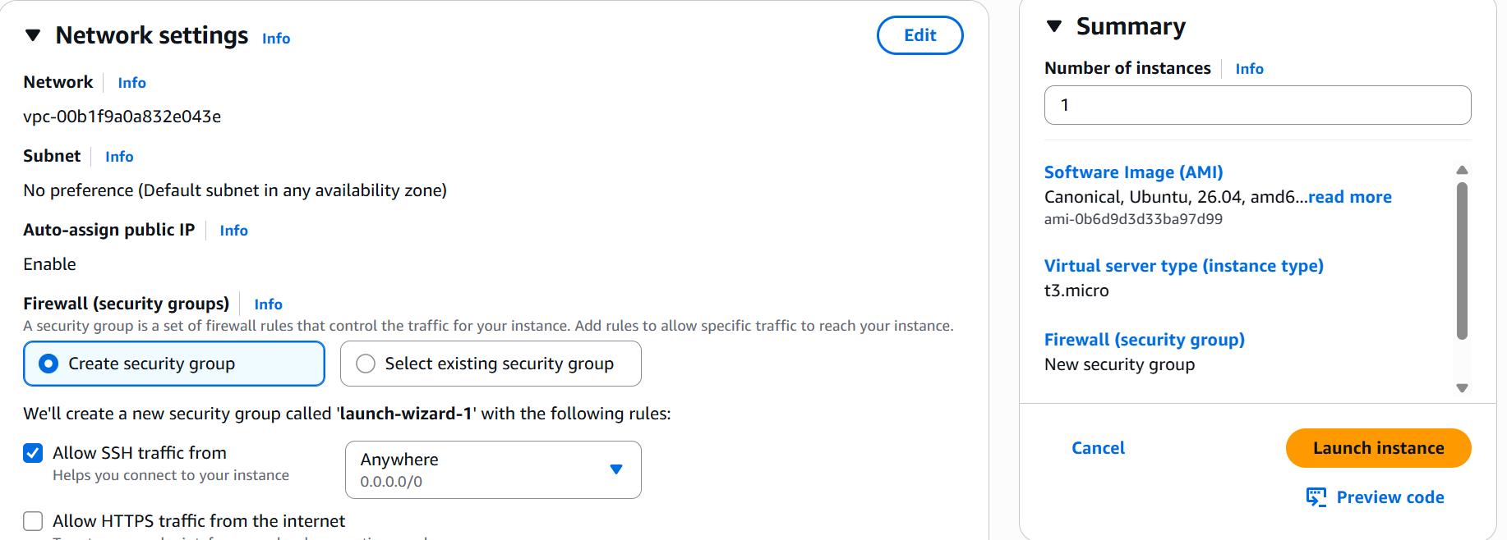

Launch instance
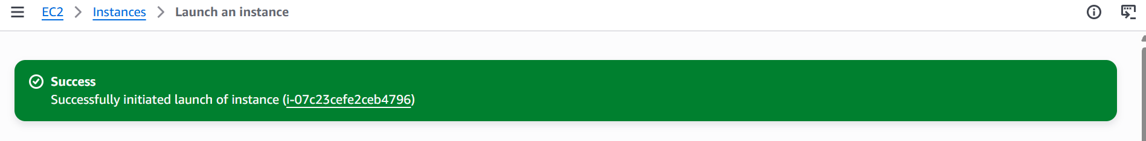
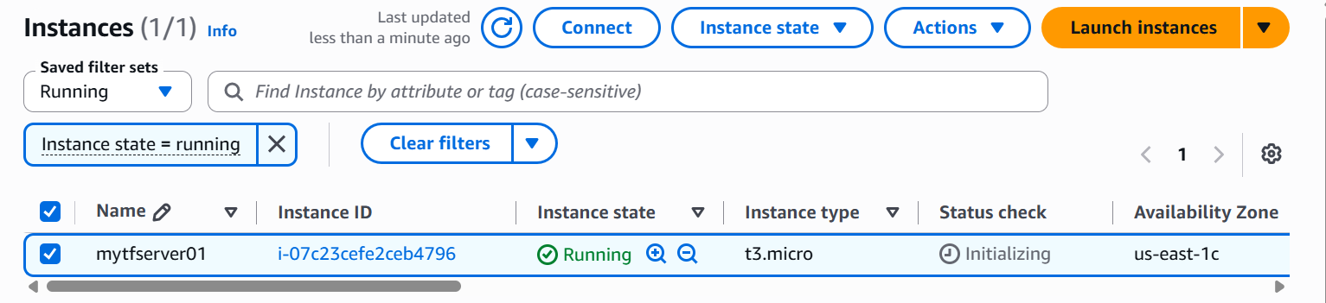
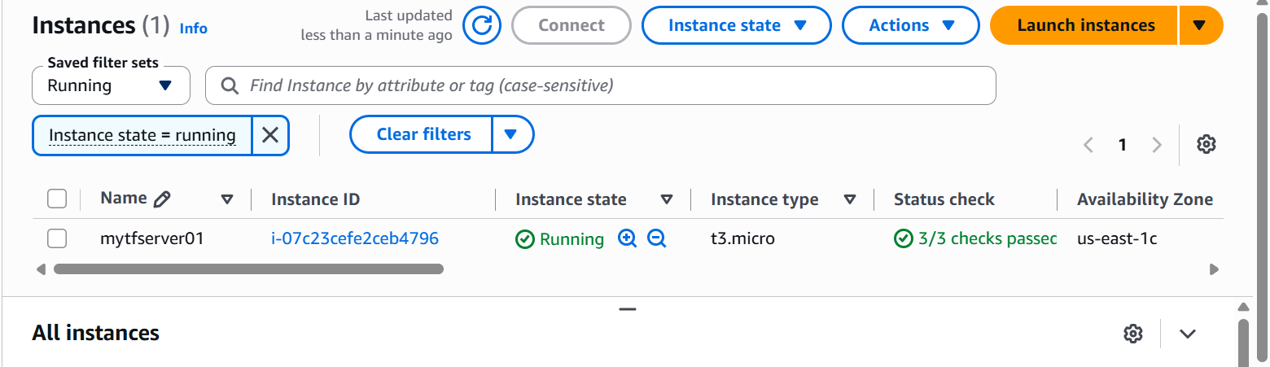
Let’s connect to this Ec2 instance via putty.
The Public IP is 54.167.108.89
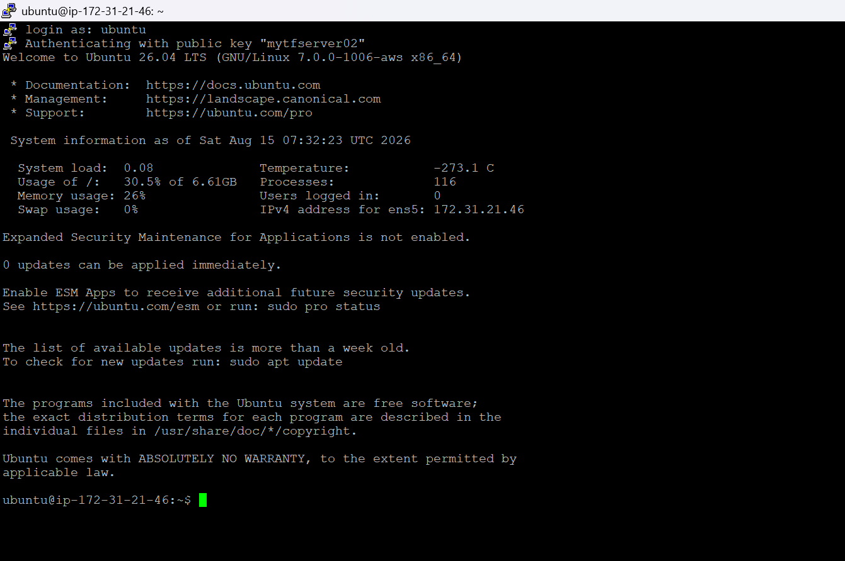
Installing Terraform in this instance
- Update your package list and install prerequisites:
sudo apt update && sudo apt install -y gnupg software-properties-common curl

- Add the official HashiCorp GPG key:
sudo rm -f /usr/share/keyrings/hashicorp-archive-keyring.gpg
curl -fsSL https://apt.releases.hashicorp.com/gpg | sudo gpg --dearmor -o /usr/share/keyrings/hashicorp-archive-keyring.gpg
- Installing Terraform
echo "deb [signed-by=/usr/share/keyrings/hashicorp-archive-keyring.gpg] https://apt.releases.hashicorp.com $(lsb_release -cs) main" | sudo tee /etc/apt/sources.list.d/hashicorp.list
sudo apt update && sudo apt install -y terraform
terraform -version

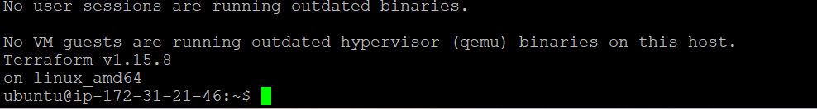

Our Terraform server is ready with version v1.15.8 installed in it.

Now let’s install AWS CLI in our instance

sudo apt install -y unzip curl && curl "https://awscli.amazonaws.com/awscli-exe-linux-x86_64.zip" -o "awscliv2.zip" && unzip awscliv2.zip && sudo ./aws/install.

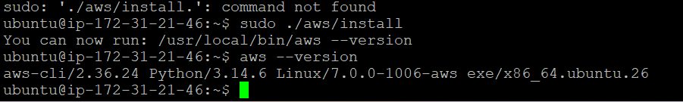

AWS CLI is installed

Now let’s configure AWS

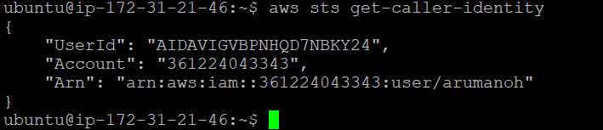

Now let’s create the main.tf file for terraform

nano main.tf

cat > main.tf << 'EOF'
terraform {
required_providers {
aws = {
source = "hashicorp/aws"
version = "~> 5.0"
}
}
}

provider "aws" {
alias = "east1"
region = "us-east-1"
}

provider "aws" {
alias = "east2"
region = "us-east-2"
}

variable "instance_type" {
default = "t3.micro"
}

variable "key_name" {
type = map(string)
default = {
us-east-1 = "mytestserver"
us-east-2 = "mytfserver"
}
}

variable "my_ip" {
type = string
default = "0.0.0.0/0"
}

resource "aws_vpc" "east1" {
provider = aws.east1
cidr_block = "10.0.0.0/16"
enable_dns_support = true
enable_dns_hostnames = true
tags = { Name = "vpc-us-east-1" }
}

resource "aws_subnet" "east1_public" {
provider = aws.east1
vpc_id = aws_vpc.east1.id
cidr_block = "10.0.1.0/24"
availability_zone = "us-east-1a"
map_public_ip_on_launch = true
tags = { Name = "subnet-public-us-east-1" }
}

resource "aws_internet_gateway" "east1" {
provider = aws.east1
vpc_id = aws_vpc.east1.id
tags = { Name = "igw-us-east-1" }
}

resource "aws_route_table" "east1_public" {
provider = aws.east1
vpc_id = aws_vpc.east1.id
route {
cidr_block = "0.0.0.0/0"
gateway_id = aws_internet_gateway.east1.id
}
tags = { Name = "rt-public-us-east-1" }
}

resource "aws_route_table_association" "east1_public" {
provider = aws.east1
subnet_id = aws_subnet.east1_public.id
route_table_id = aws_route_table.east1_public.id
}

resource "aws_security_group" "east1_ssh" {
provider = aws.east1
name = "allow-ssh-us-east-1"
description = "Allow SSH inbound, all outbound"
vpc_id = aws_vpc.east1.id

ingress {
description = "SSH"
from_port = 22
to_port = 22
protocol = "tcp"
cidr_blocks = [var.my_ip]
}

egress {
from_port = 0
to_port = 0
protocol = "-1"
cidr_blocks = ["0.0.0.0/0"]
}

tags = { Name = "sg-ssh-us-east-1" }
}

data "aws_ami" "ubuntu_east1" {
provider = aws.east1
most_recent = true
owners = ["099720109477"]
filter {
name = "name"
values = ["ubuntu/images/hvm-ssd-gp3/ubuntu-noble-24.04-amd64-server-*"]
}
filter {
name = "virtualization-type"
values = ["hvm"]
}
}

resource "aws_instance" "east1" {
provider = aws.east1
ami = data.aws_ami.ubuntu_east1.id
instance_type = var.instance_type
subnet_id = aws_subnet.east1_public.id
vpc_security_group_ids = [aws_security_group.east1_ssh.id]
key_name = var.key_name["us-east-1"]
associate_public_ip_address = true
tags = { Name = "ec2-us-east-1" }
}

resource "aws_vpc" "east2" {
provider = aws.east2
cidr_block = "10.1.0.0/16"
enable_dns_support = true
enable_dns_hostnames = true
tags = { Name = "vpc-us-east-2" }
}

resource "aws_subnet" "east2_public" {
provider = aws.east2
vpc_id = aws_vpc.east2.id
cidr_block = "10.1.1.0/24"
availability_zone = "us-east-2a"
map_public_ip_on_launch = true
tags = { Name = "subnet-public-us-east-2" }
}

resource "aws_internet_gateway" "east2" {
provider = aws.east2
vpc_id = aws_vpc.east2.id
tags = { Name = "igw-us-east-2" }
}

resource "aws_route_table" "east2_public" {
provider = aws.east2
vpc_id = aws_vpc.east2.id
route {
cidr_block = "0.0.0.0/0"
gateway_id = aws_internet_gateway.east2.id
}
tags = { Name = "rt-public-us-east-2" }
}

resource "aws_route_table_association" "east2_public" {
provider = aws.east2
subnet_id = aws_subnet.east2_public.id
route_table_id = aws_route_table.east2_public.id
}

resource "aws_security_group" "east2_ssh" {
provider = aws.east2
name = "allow-ssh-us-east-2"
description = "Allow SSH inbound, all outbound"
vpc_id = aws_vpc.east2.id

ingress {
description = "SSH"
from_port = 22
to_port = 22
protocol = "tcp"
cidr_blocks = [var.my_ip]
}

egress {
from_port = 0
to_port = 0
protocol = "-1"
cidr_blocks = ["0.0.0.0/0"]
}

tags = { Name = "sg-ssh-us-east-2" }
}

data "aws_ami" "ubuntu_east2" {
provider = aws.east2
most_recent = true
owners = ["099720109477"]
filter {
name = "name"
values = ["ubuntu/images/hvm-ssd-gp3/ubuntu-noble-24.04-amd64-server-*"]
}
filter {
name = "virtualization-type"
values = ["hvm"]
}
}

resource "aws_instance" "east2" {
provider = aws.east2
ami = data.aws_ami.ubuntu_east2.id
instance_type = var.instance_type
subnet_id = aws_subnet.east2_public.id
vpc_security_group_ids = [aws_security_group.east2_ssh.id]
key_name = var.key_name["us-east-2"]
associate_public_ip_address = true
tags = { Name = "ec2-us-east-2" }
}

output "east1_public_ip" {
value = aws_instance.east1.public_ip
}

output "east2_public_ip" {
value = aws_instance.east2.public_ip
}
EOF
Ctrl+S and Ctrl+X
Modify the permissions.

Now run the terraform commands.
terraform init
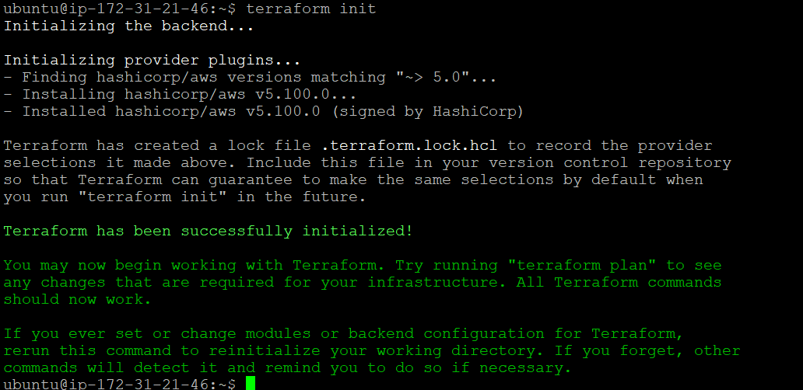

terraform plan
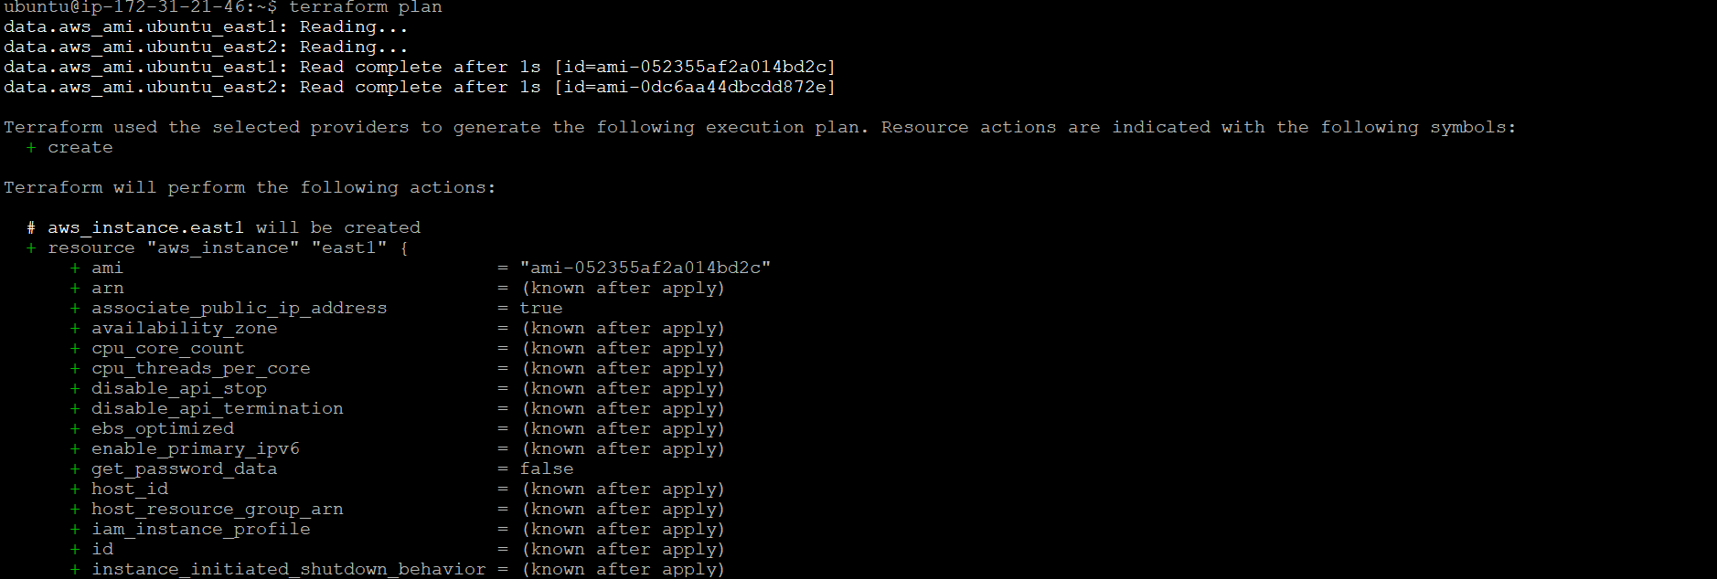

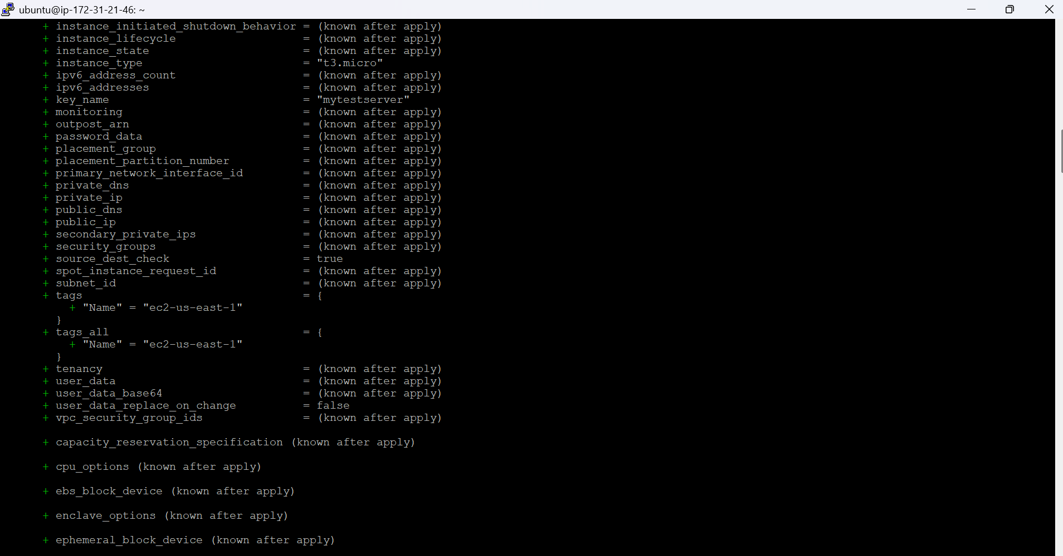

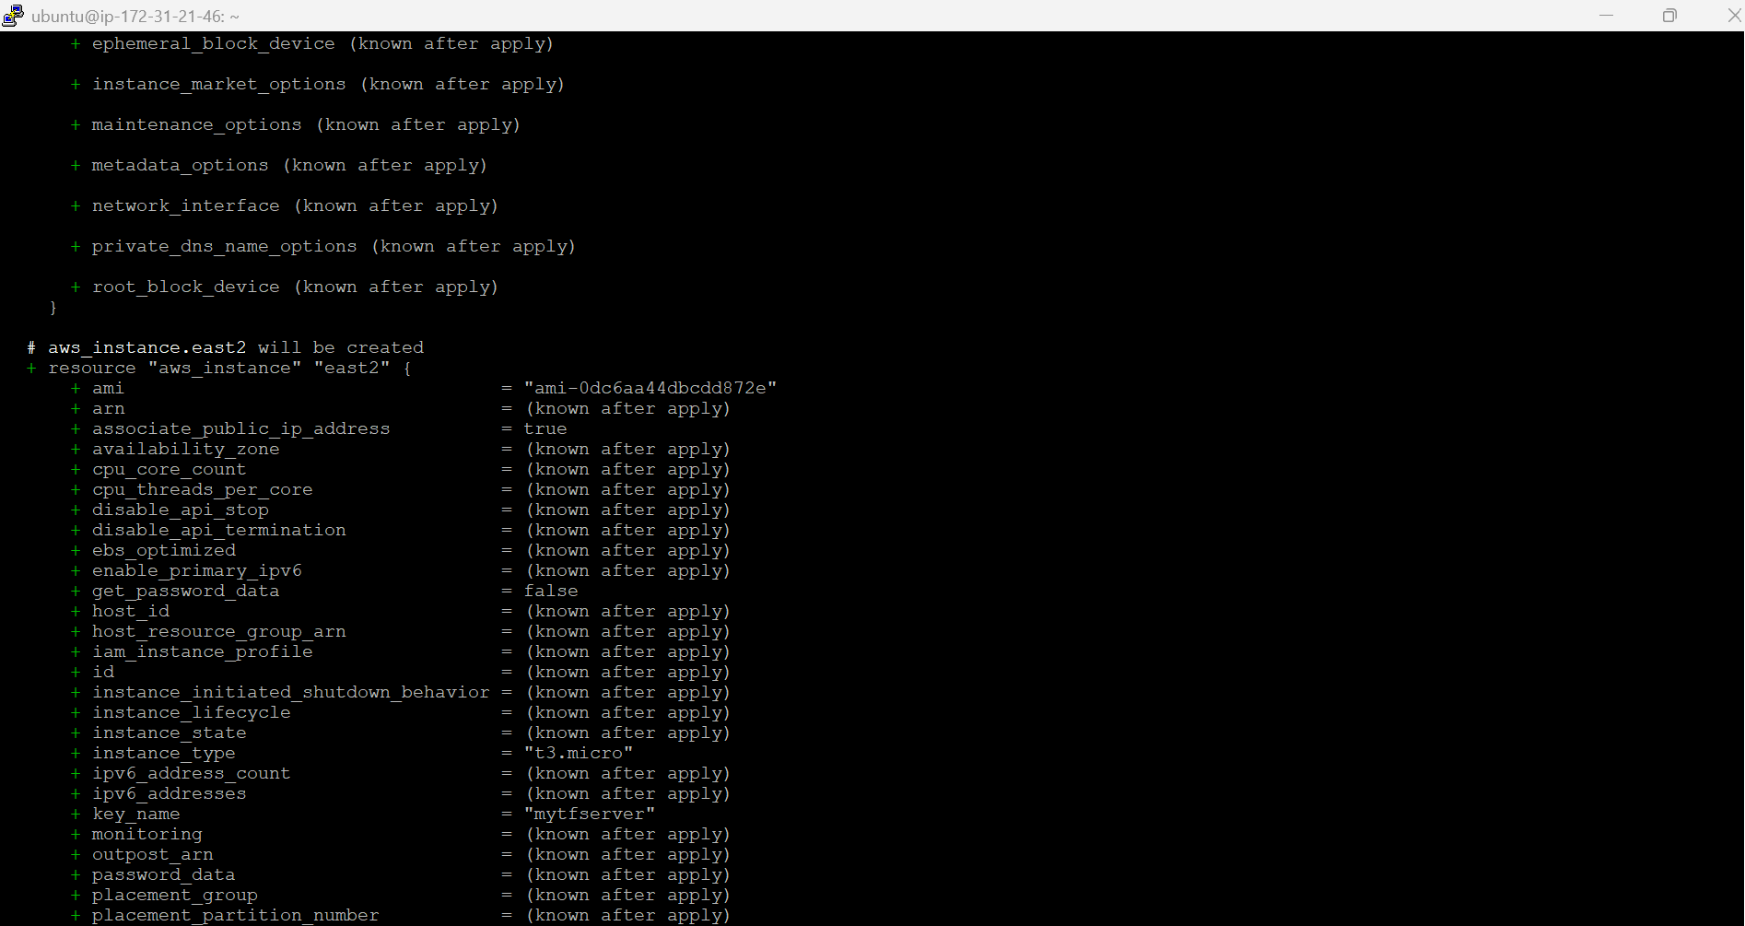

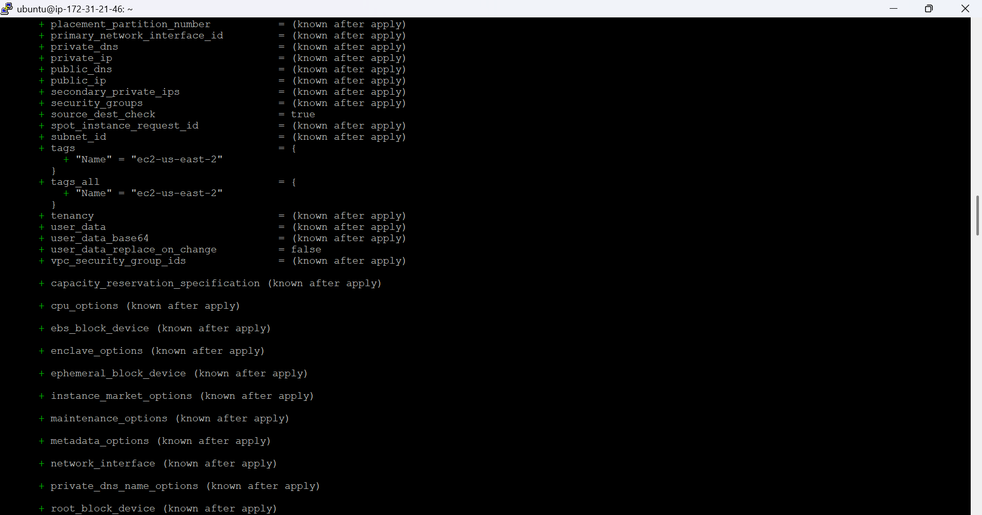

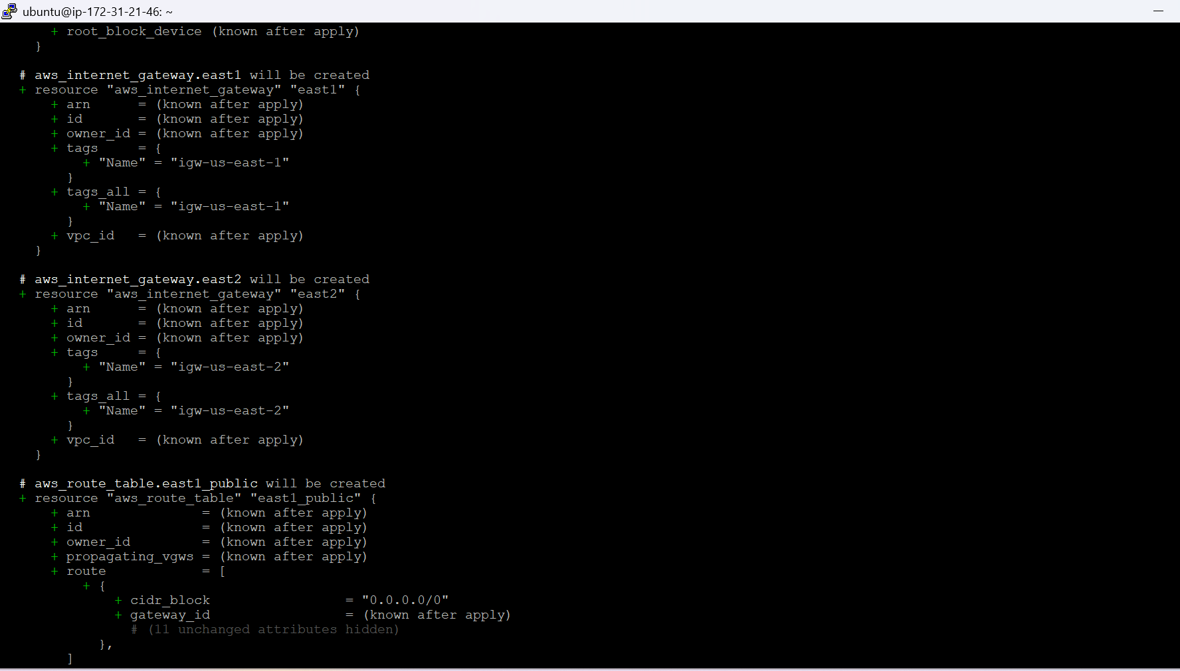

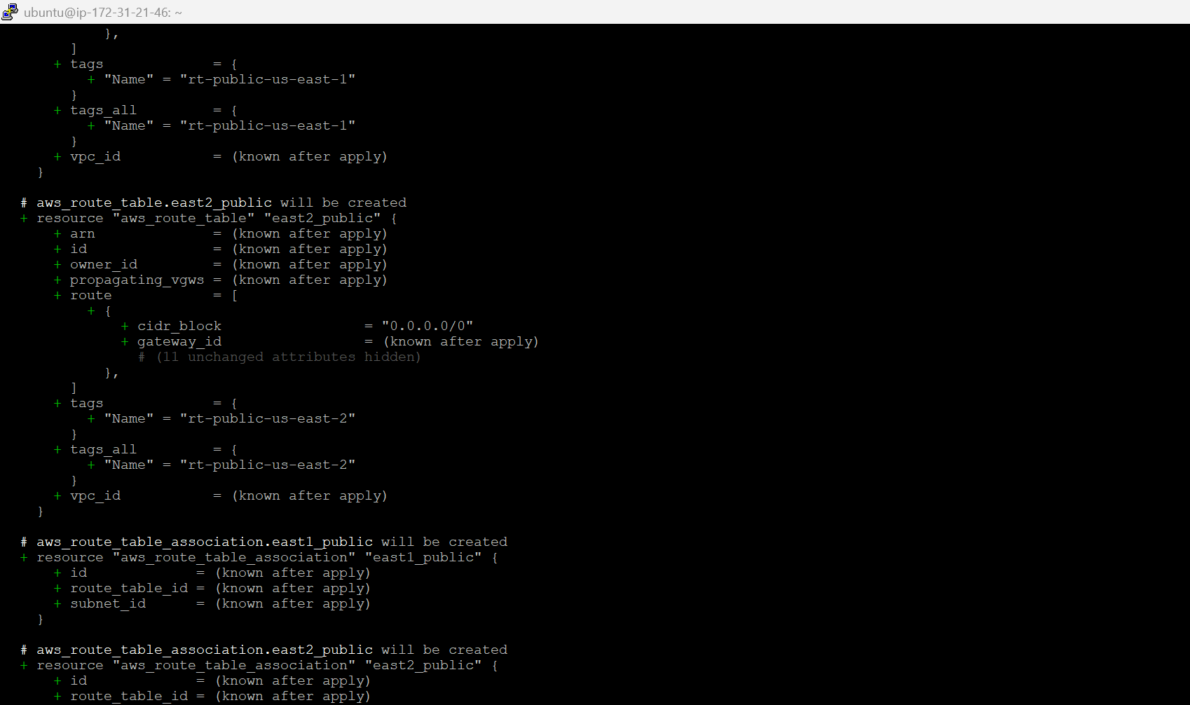

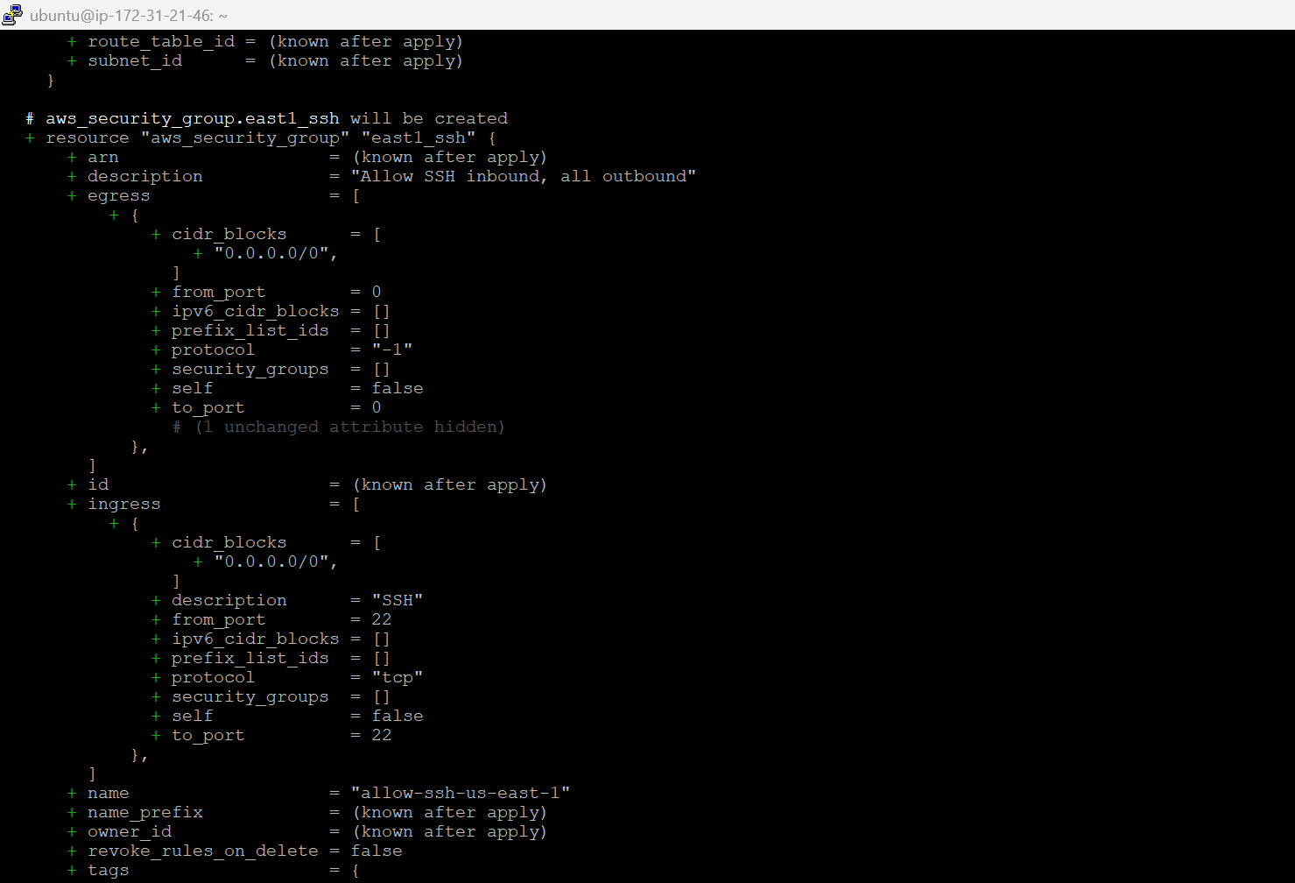

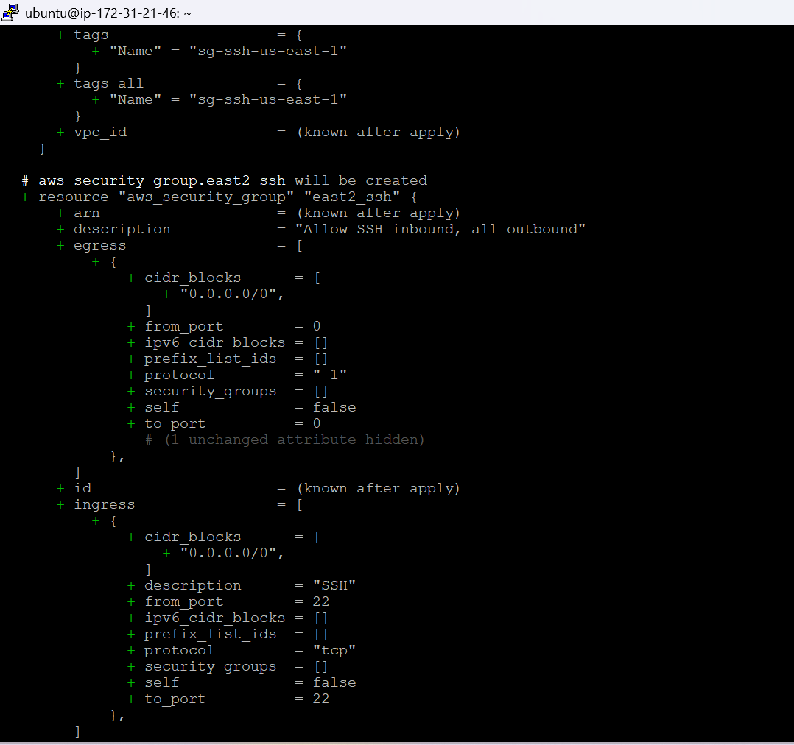

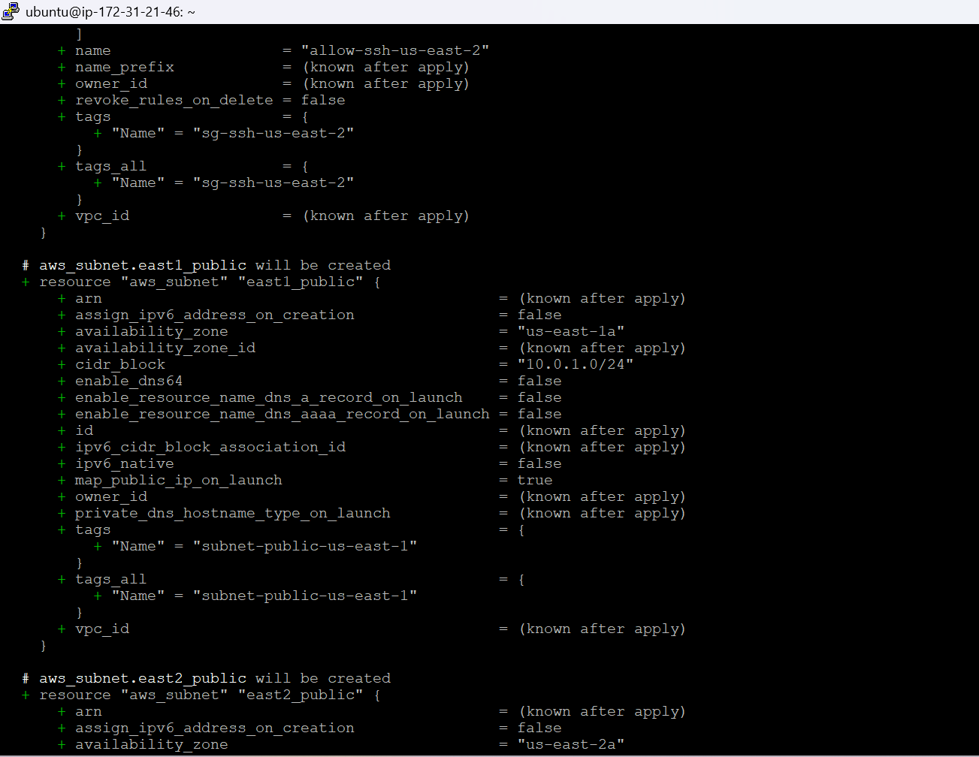

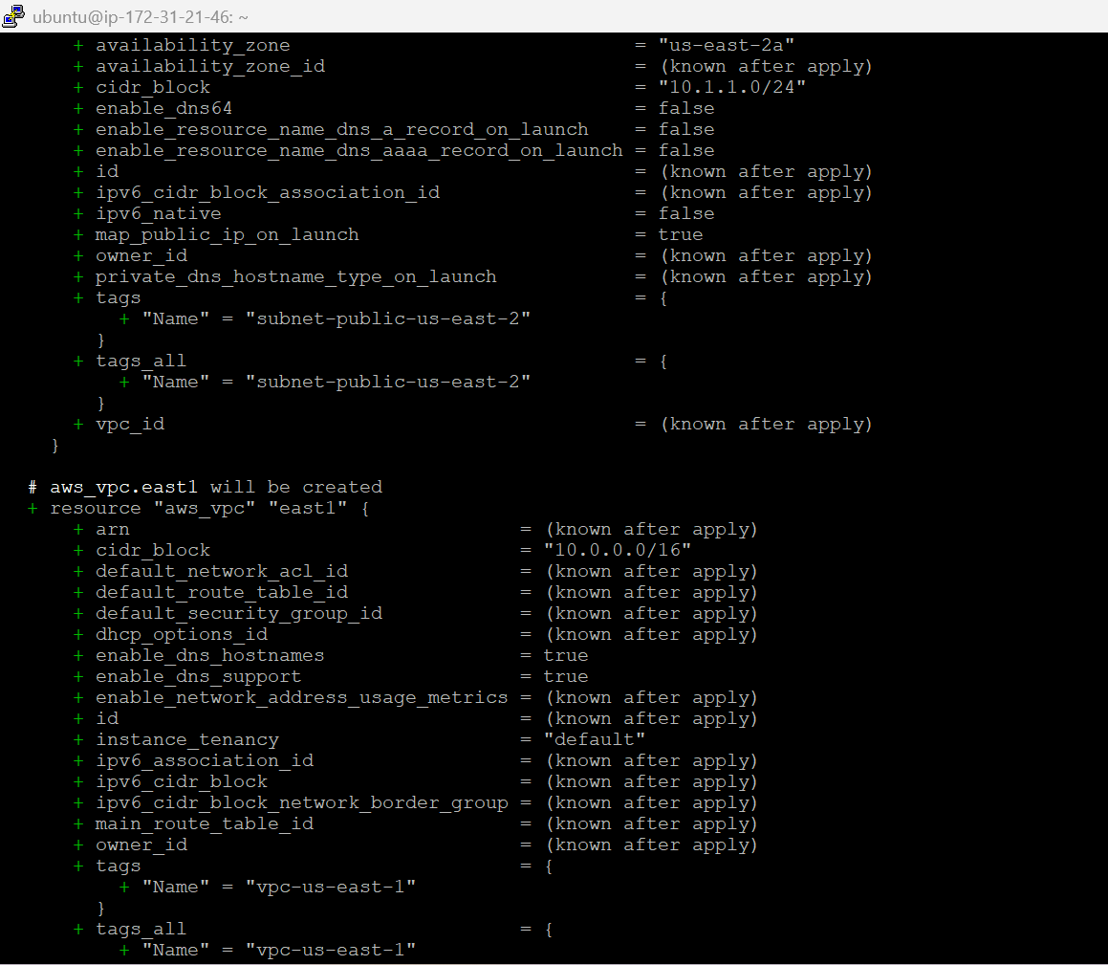

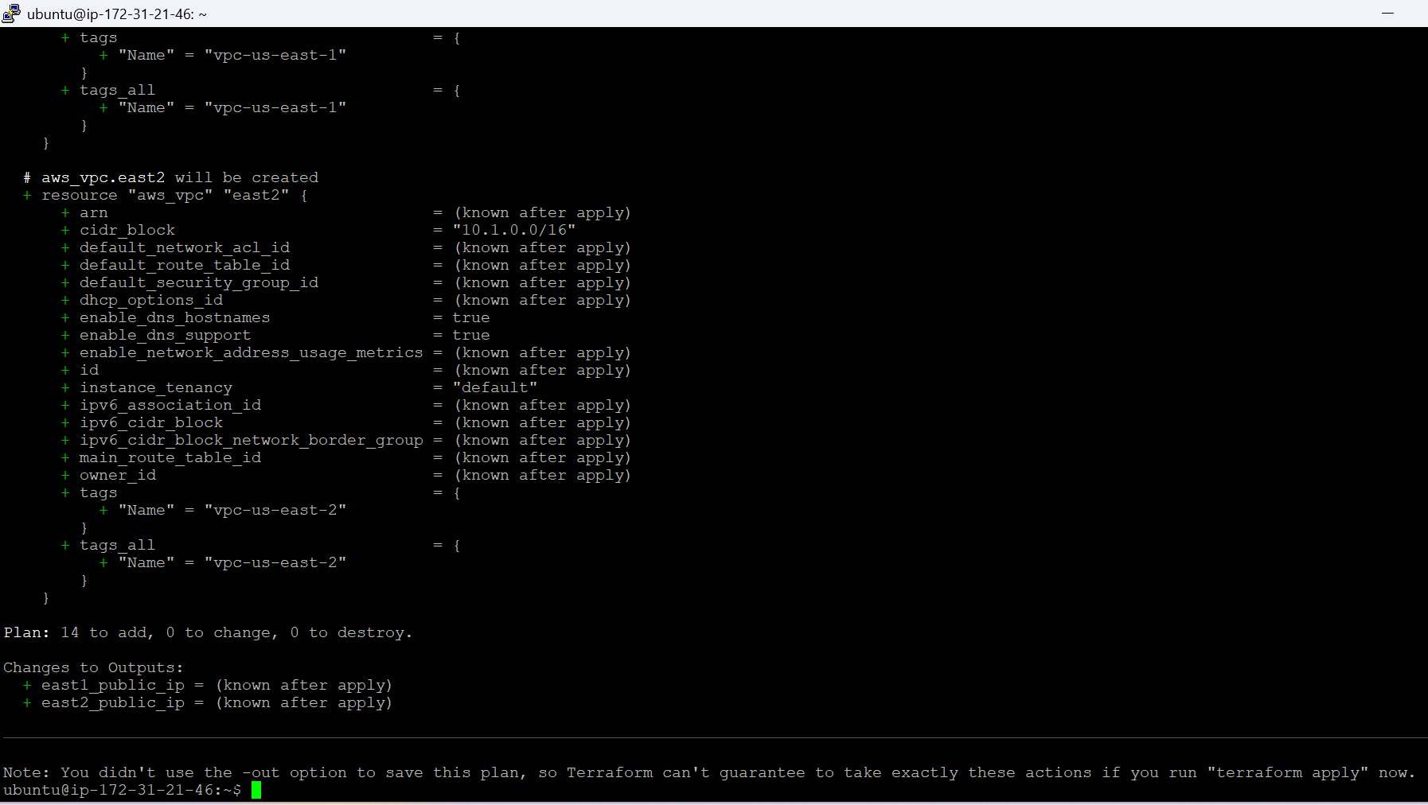

terraform apply

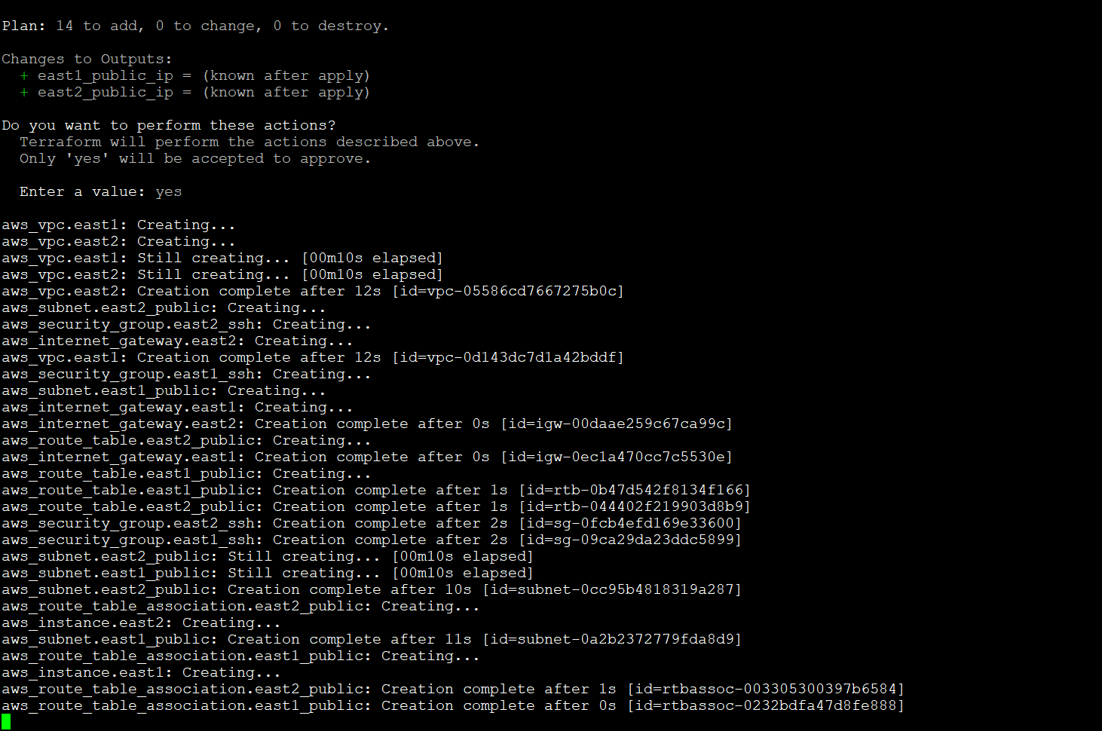

We have successfully applied terraform and the two instances are created in two different regions by terraform.

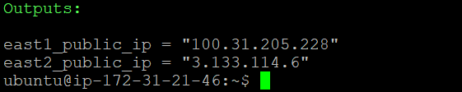

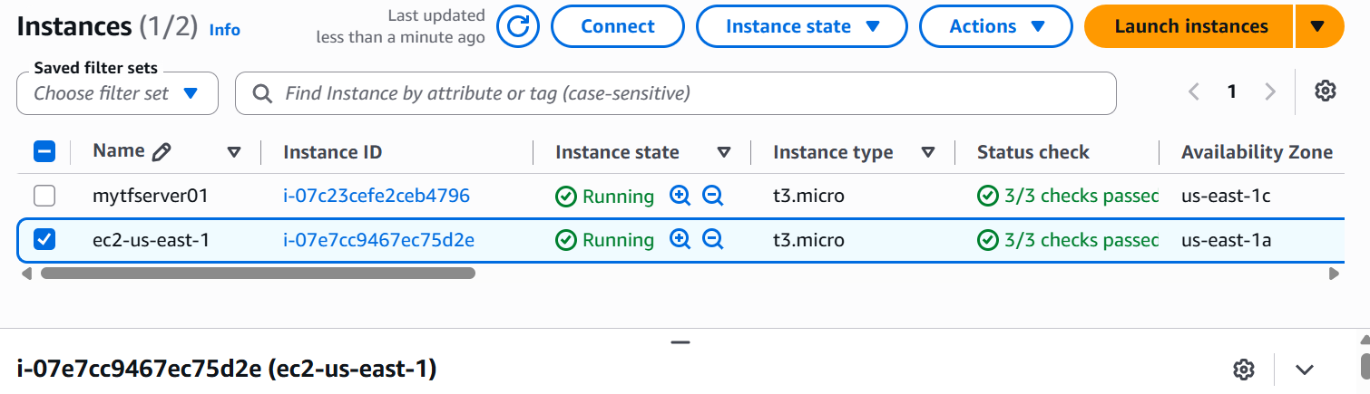

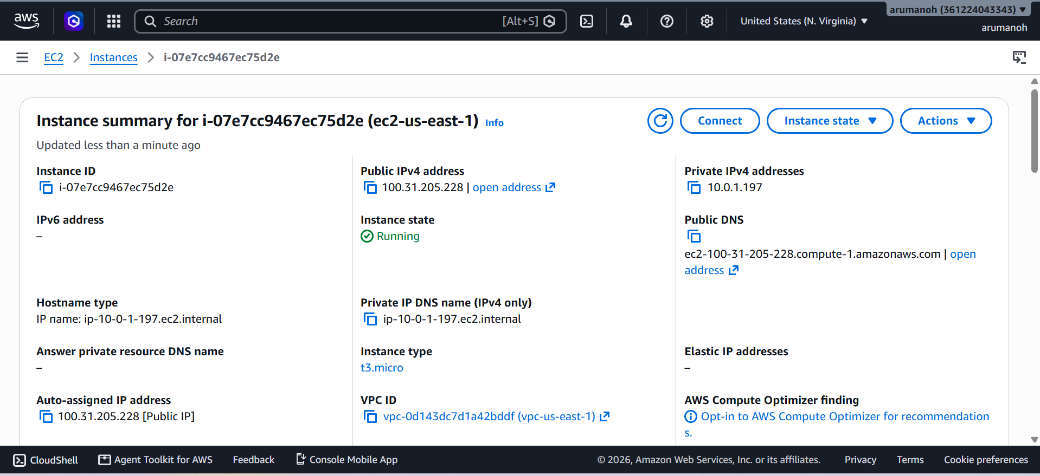

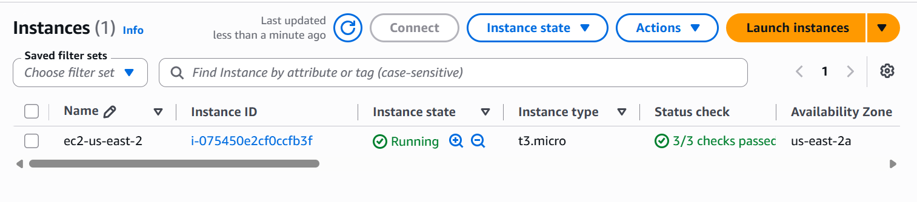

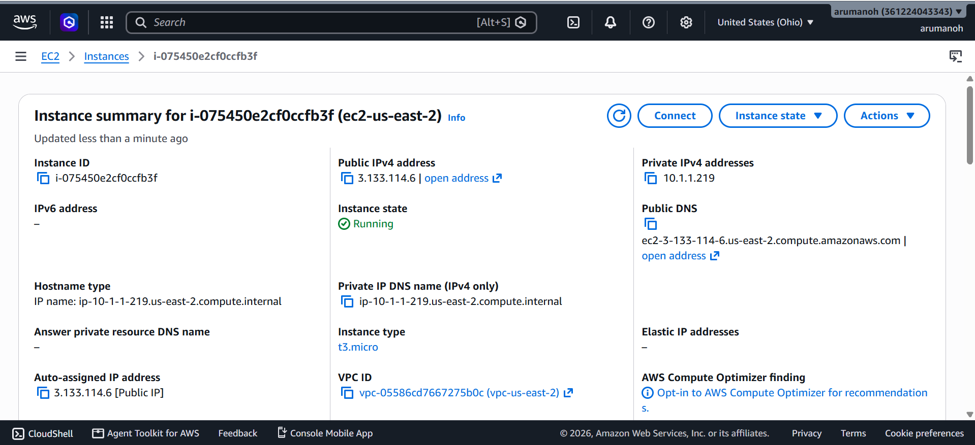

Apart from this we have also created VPC, Subnet, Route table and Internet gateway, Security Groups, in both the regions via terraform.

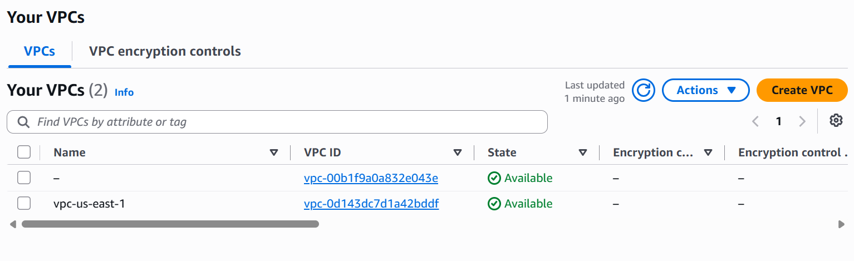
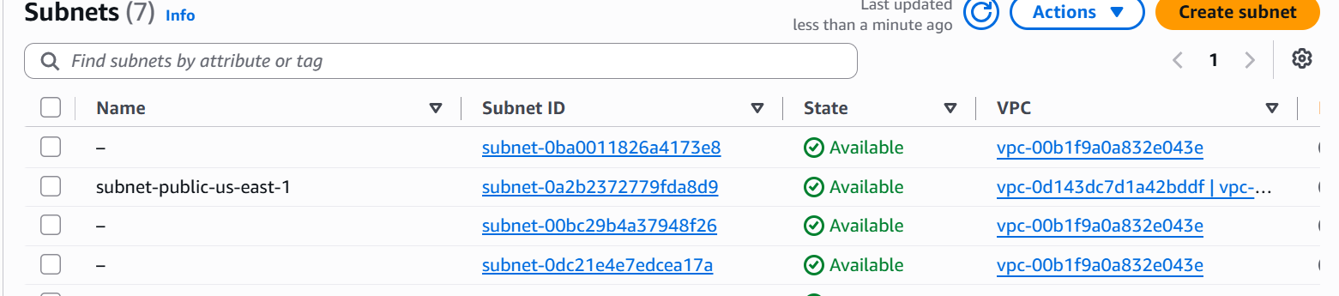
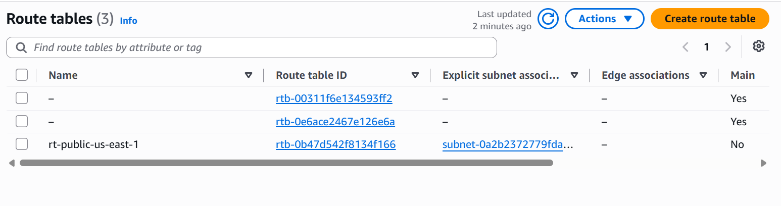
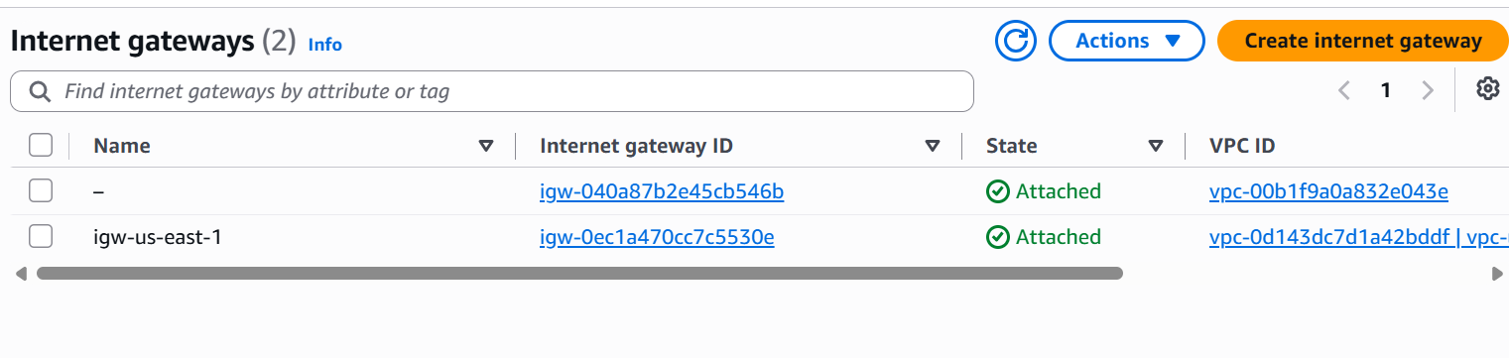
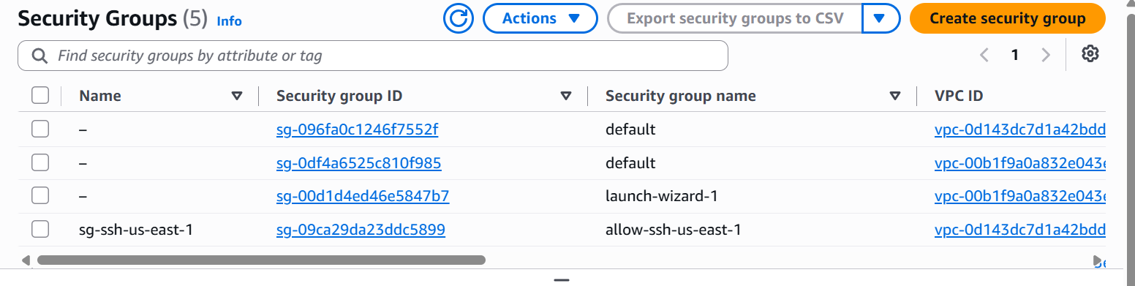

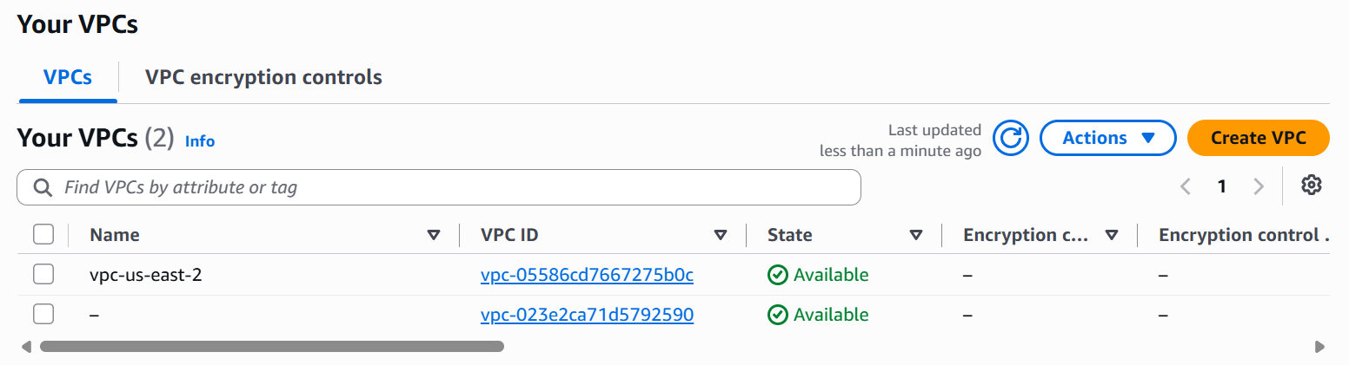

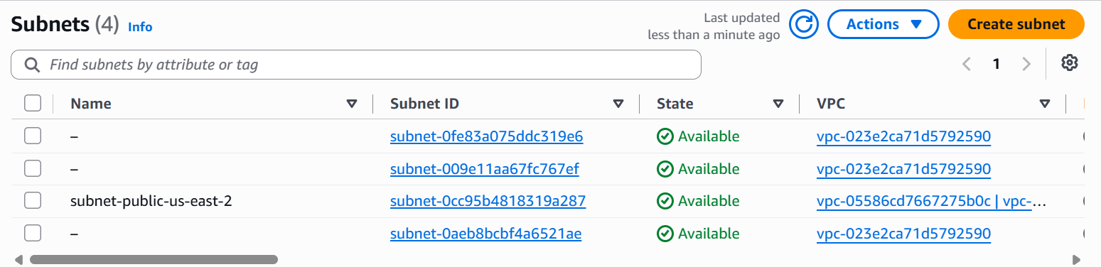
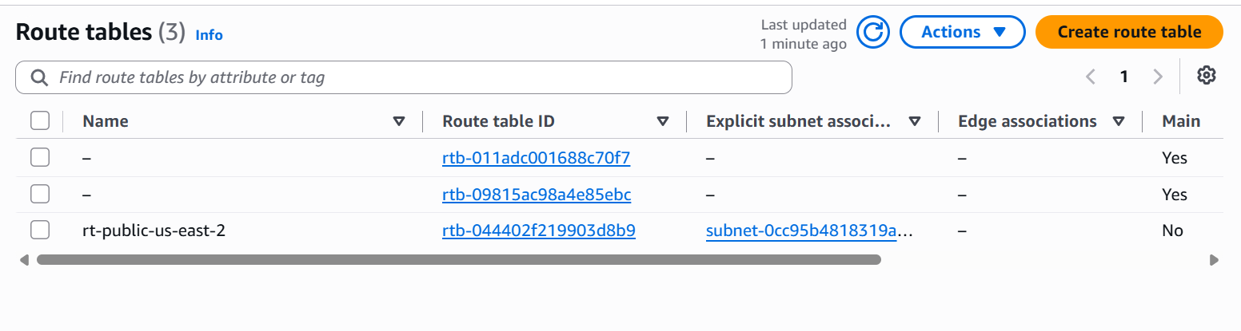
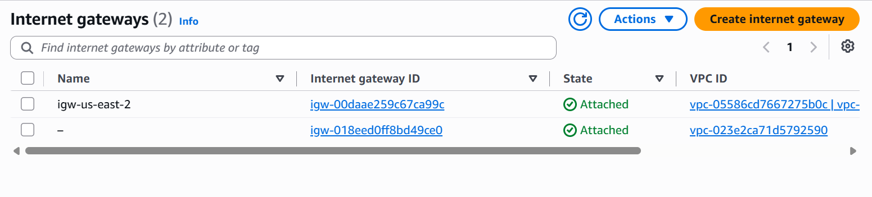
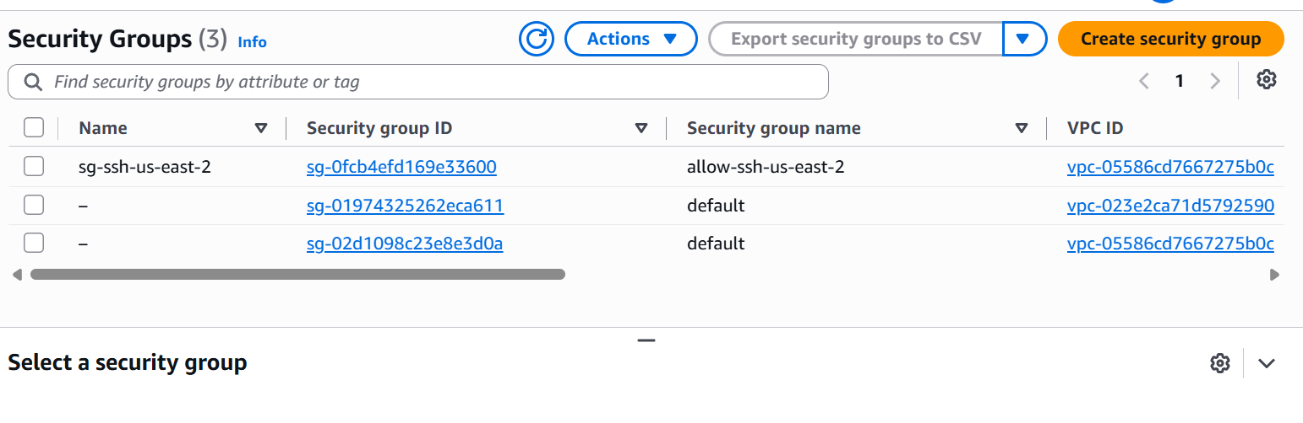
This concludes our task.

