Docker Task -2

Task Description:
Create a dockerfile, docker-compose file which when executed must display your basic details in the website.
First lets create an EC2 instance with Ubuntu OS and then install docker in it.
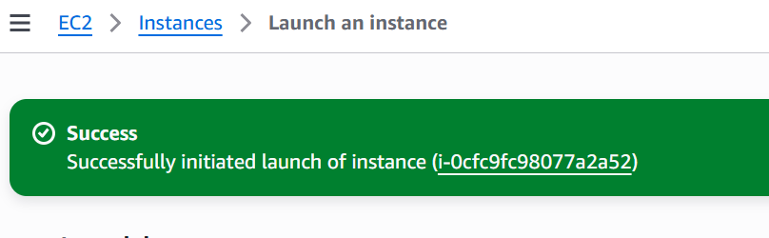

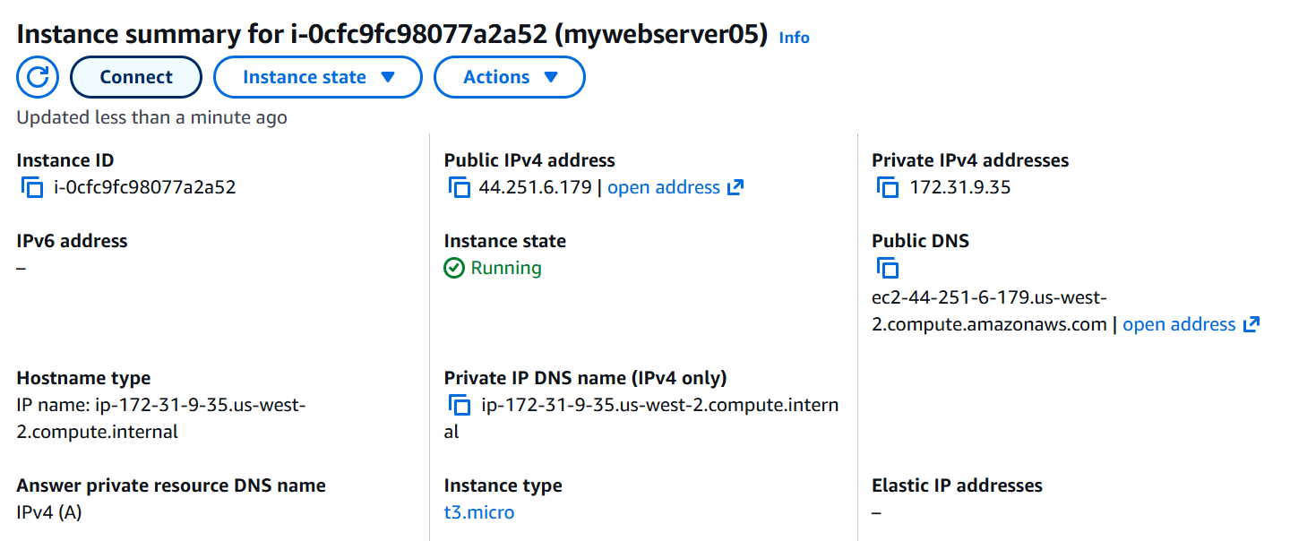

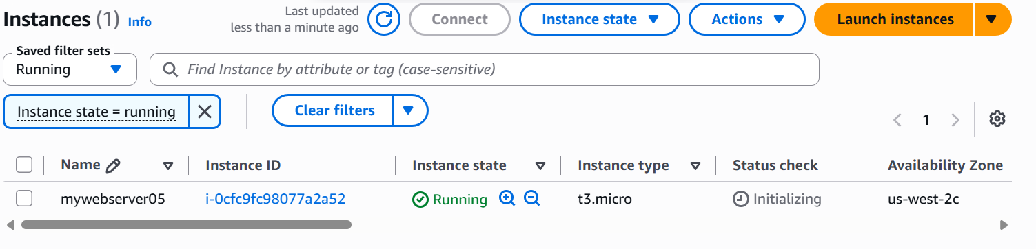
We have logged into the instance via Putty
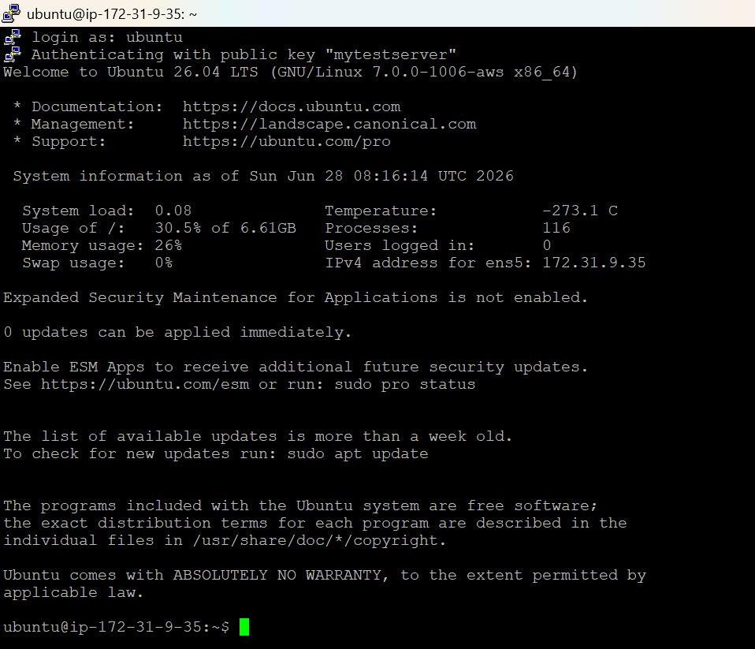
Now lets install docker in this instance.
Uninstalling old packages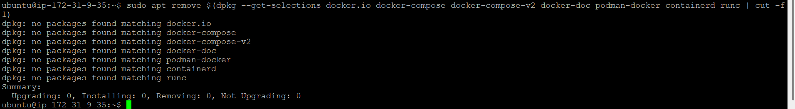
Installing Docker and validating the current Docker version
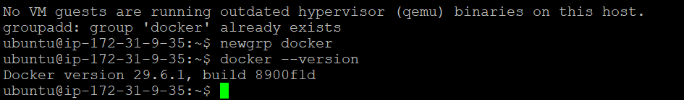
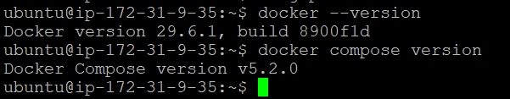
Now lets create a project folder
mkdir docker-info-app
cd docker-info-app

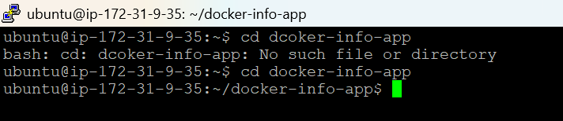

Now lets create 4 files
- Dockerfile
- docker-compose.yml
- app.py
- requirements.txt

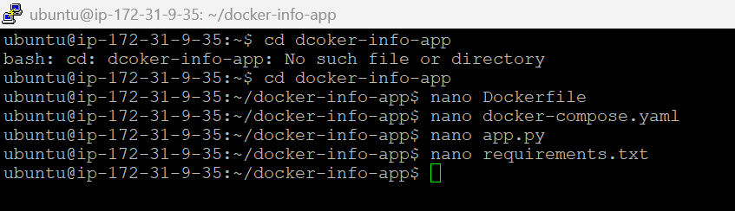

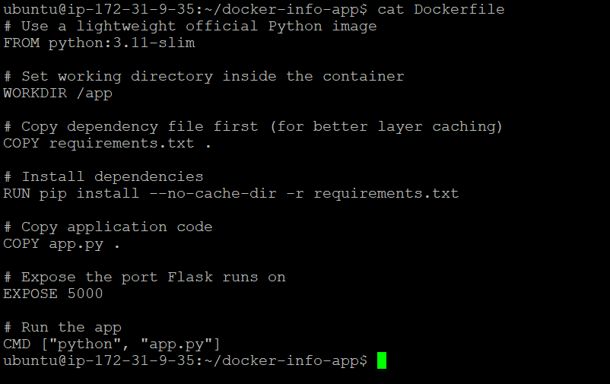

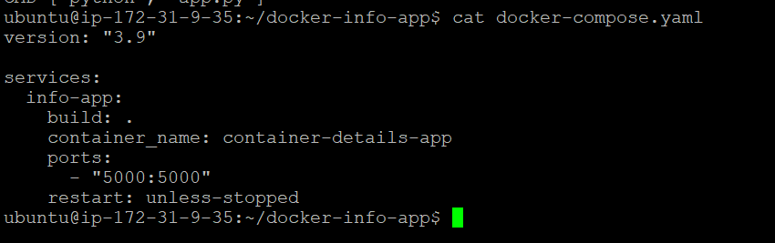

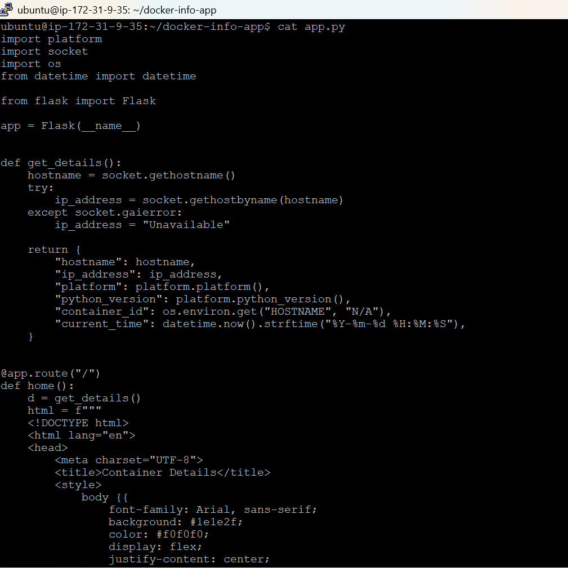

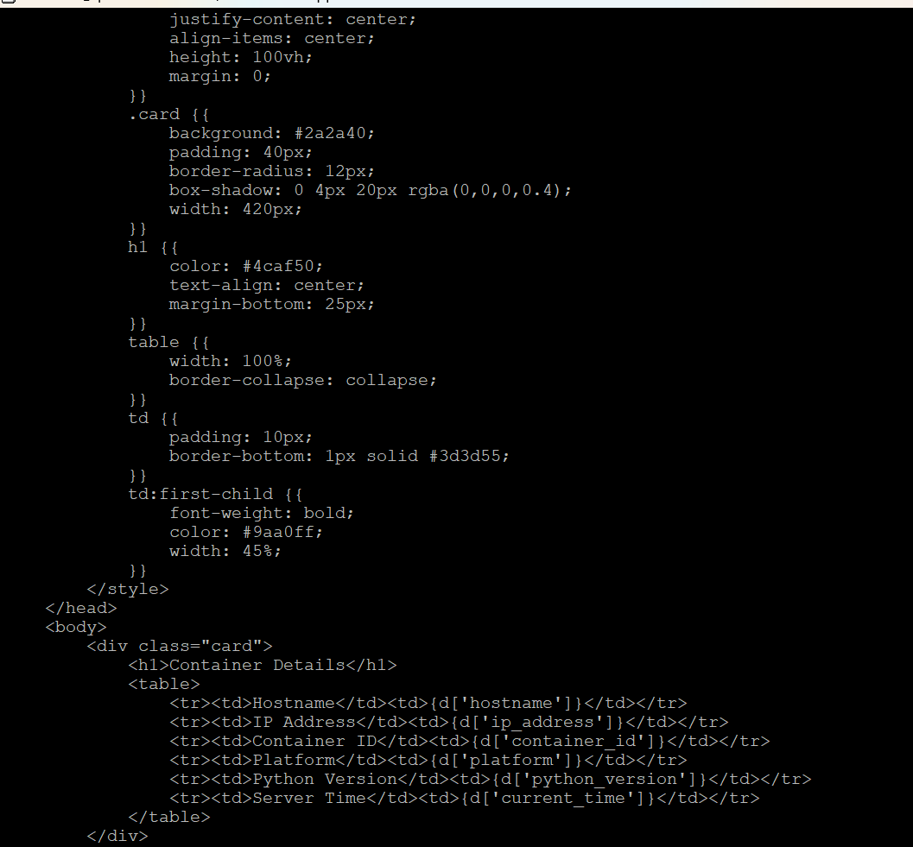
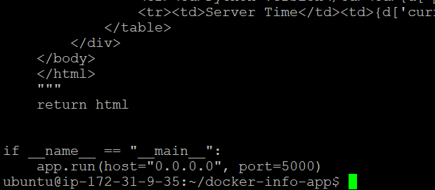
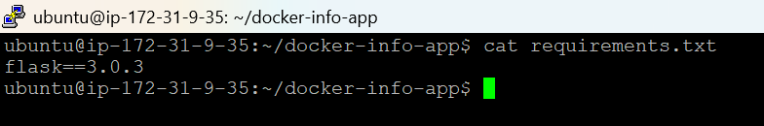
Listing the contents of the folder

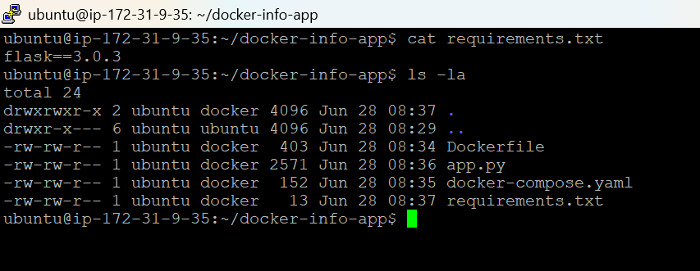

Open port 5000 in our EC2 Security Group

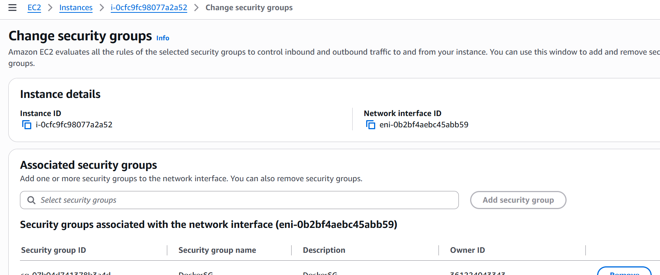

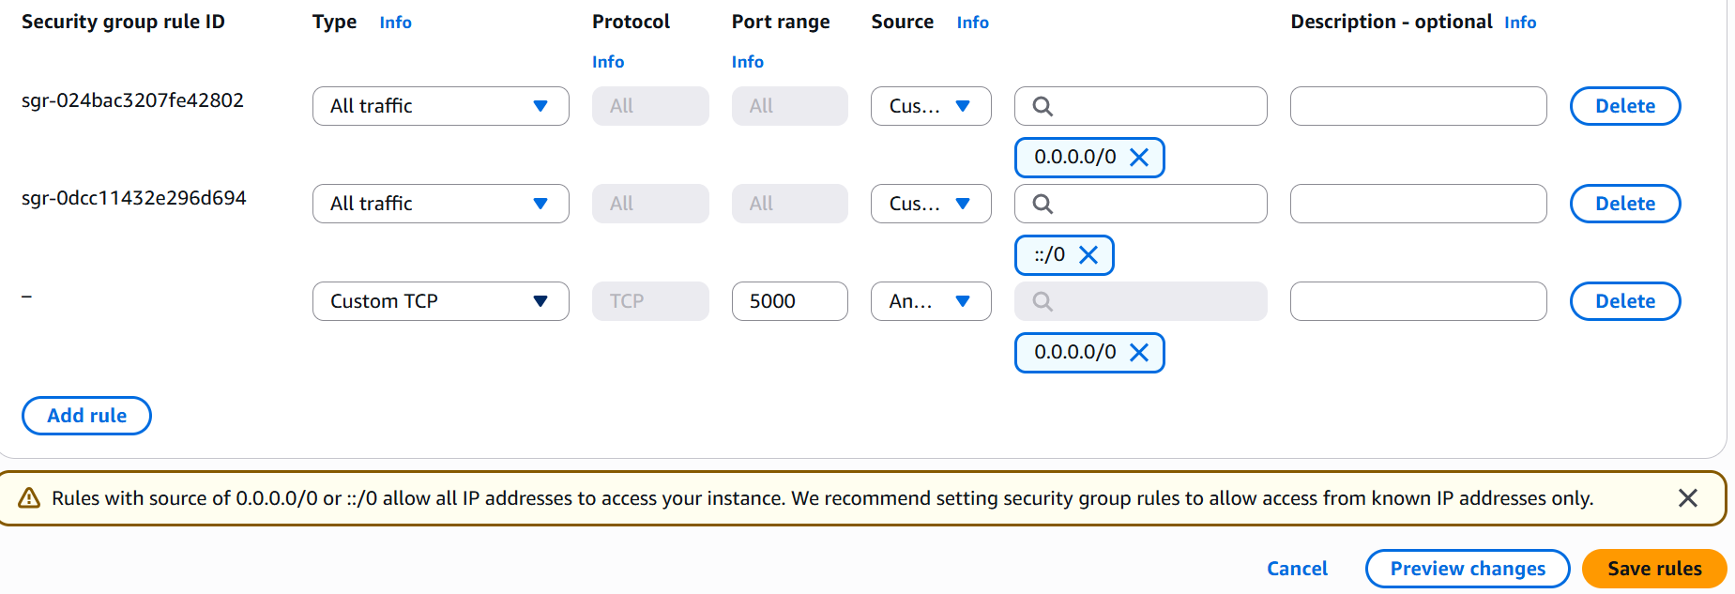

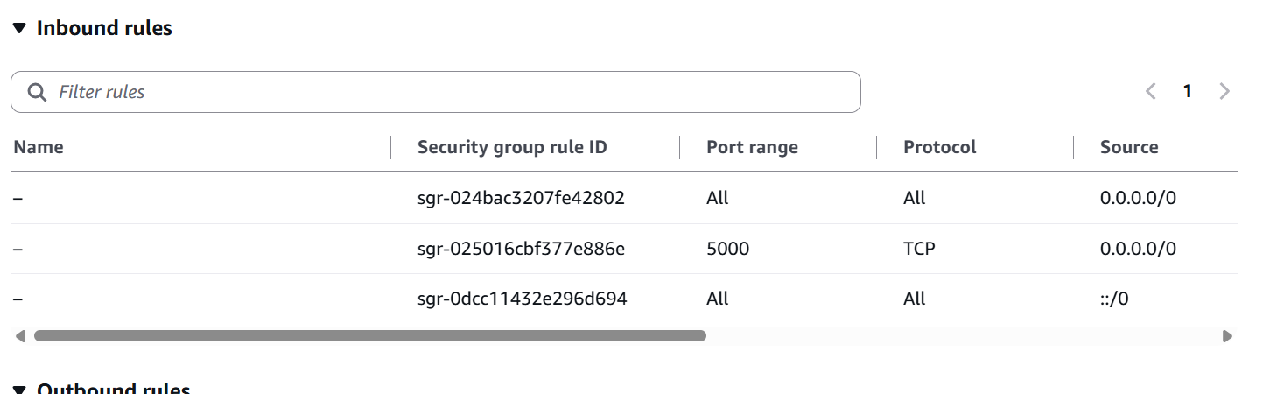

Now we can run the following command to build the image and run the container in detached mode.

docker compose up --build -d

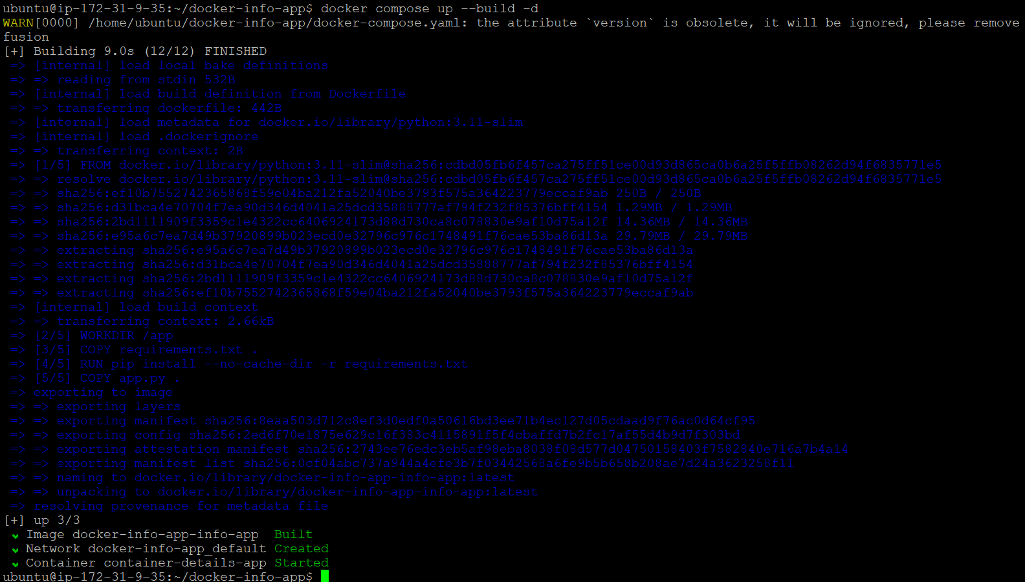

To verify whether the container is running
docker ps

The same can be viewed via the browser
http://44.251.6.179:5000

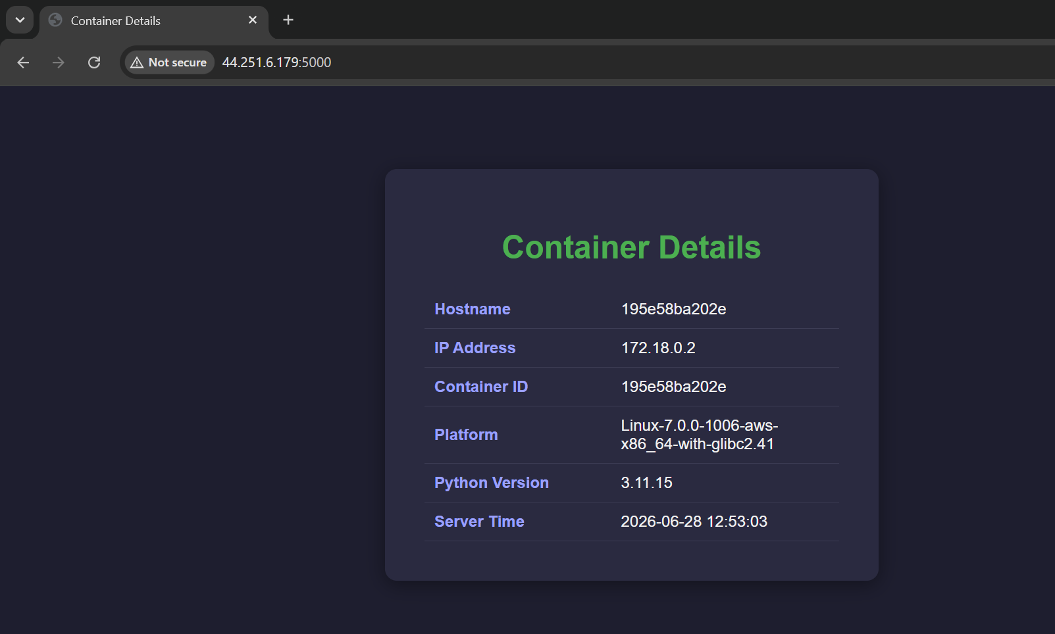

We can stop it once is done.
docker compose down
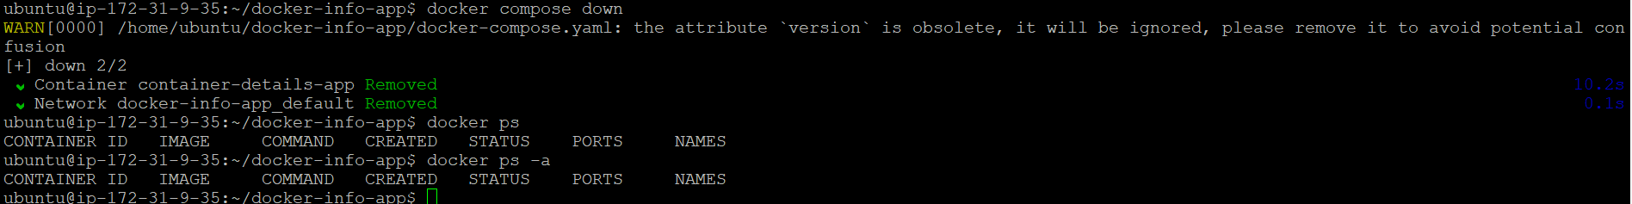

This concludes our task.

