AWS Task-3

Task Description:
- Create a S3 bucket, with no public access and upload files to the bucket & view the logs using cloudwatch for the uploaded files.
S3 bucket has been created with the name “arulbucket010203”
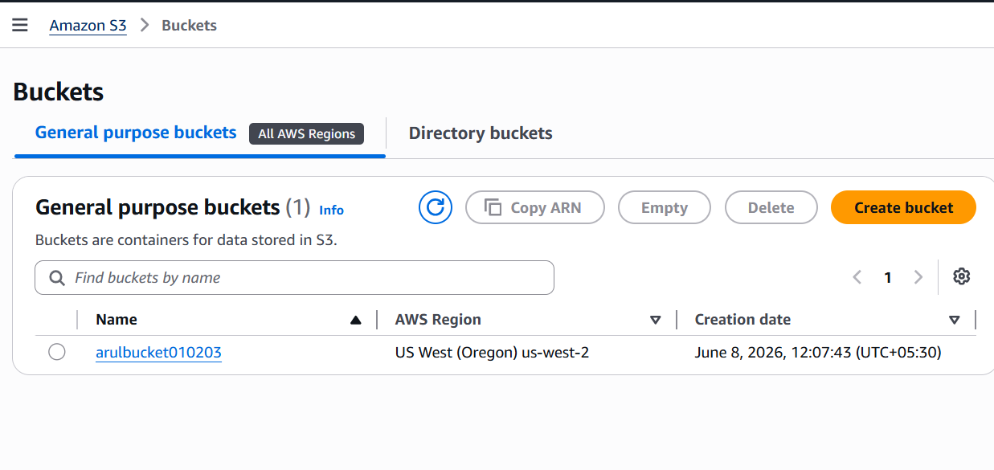
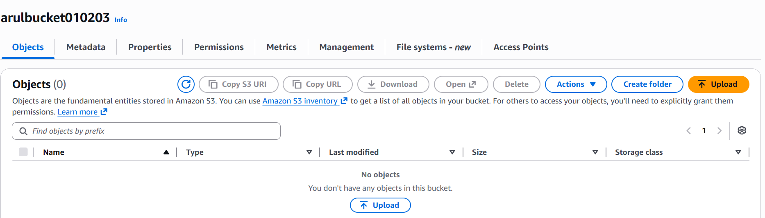
Now a file by name “image_1” has been uploaded into the bucket.
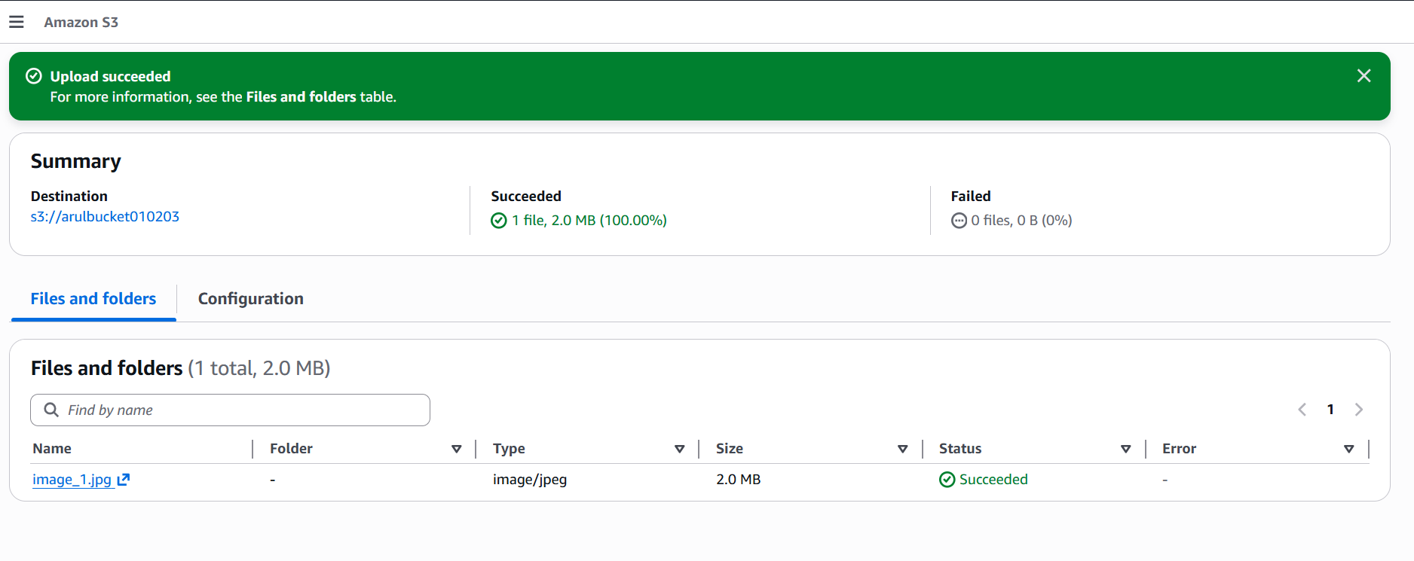
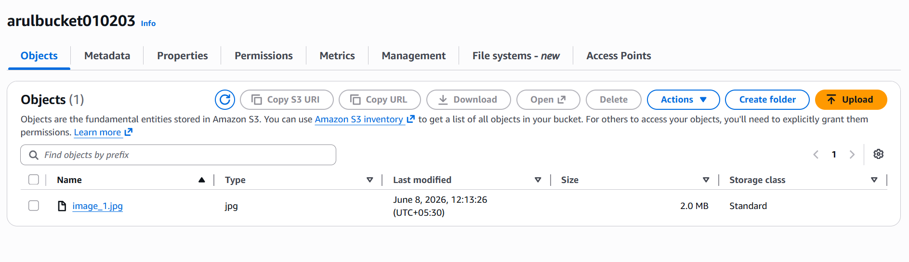
Inorder to view the logs we need to enable CloudTrail with S3 data events.
CloudTrail by name “s3-upload-trail” has been created
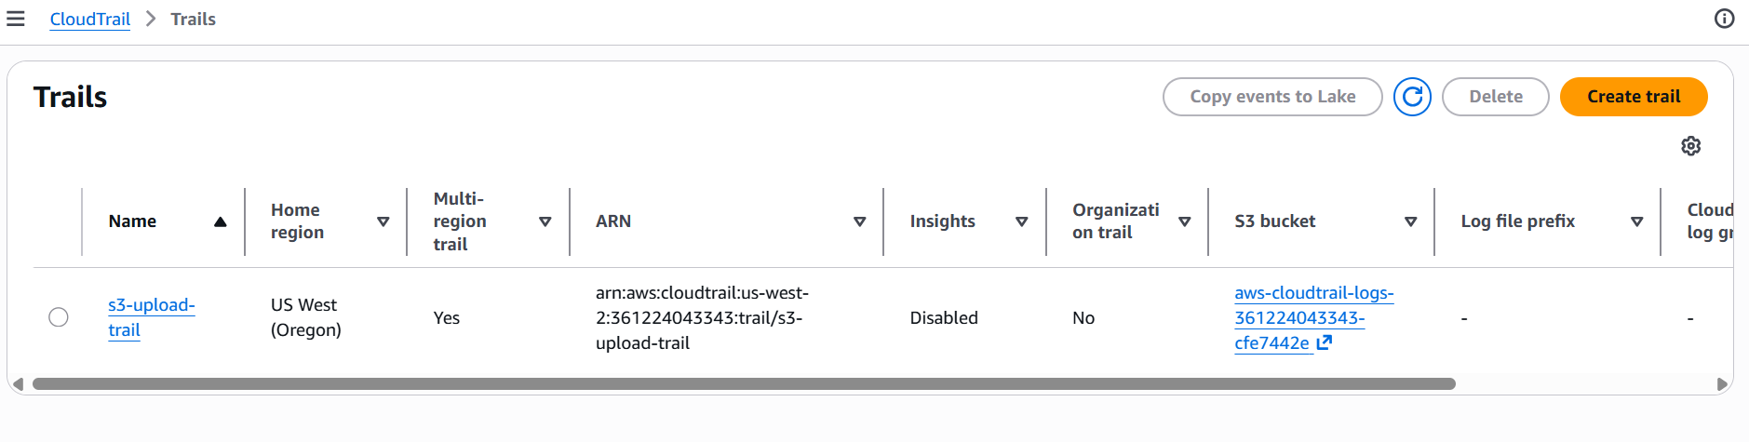
Under Events, I have selected Data Events and the source “S3” has been selected. All “read” and “write” events are logged.
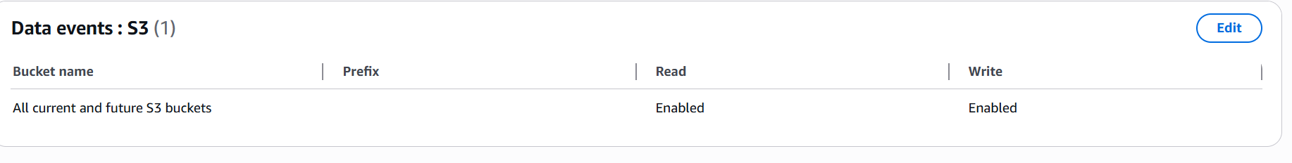
Now we need to connect the CloudTrail to the CloudWatch Log Group
Under CloudWatch Logs, we could see our log group
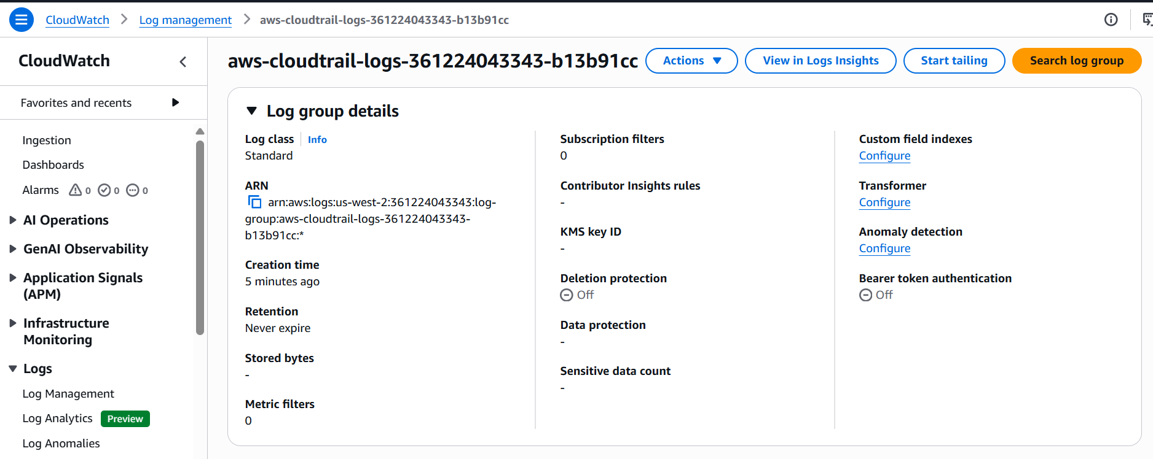
Our Log streams are showing as below
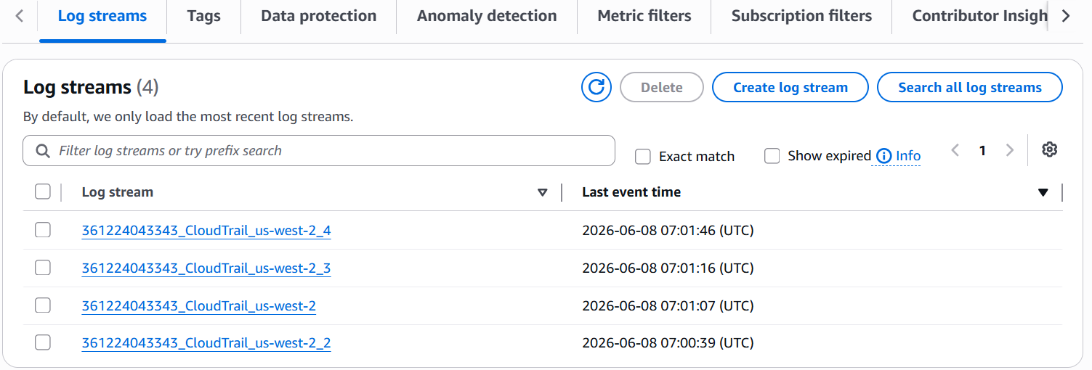
This concludes the first part of this task.

- Launch two ec2-instances and connect it to a application load balancer, where the output traffic from the server must be an load balancer IP address

First lets create the Security Group

Security Group 1 for the App Load Balancer:
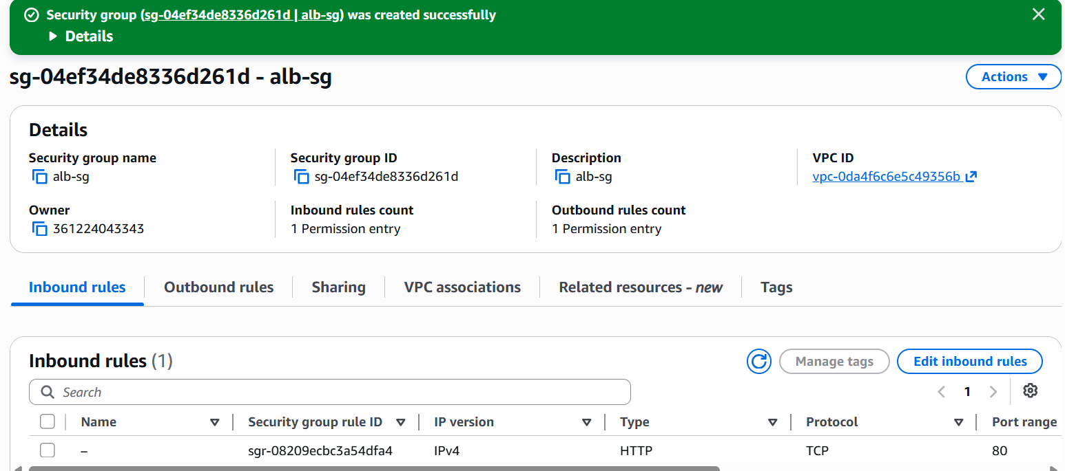

Configure the Inbound rule to allow Http traffic from outside world (Anywhere 0.0.0.0).

Security Group 2 for the EC2 instances:

Configure the Inbound rule to allow Http traffic only the Alb-Sg group alone.

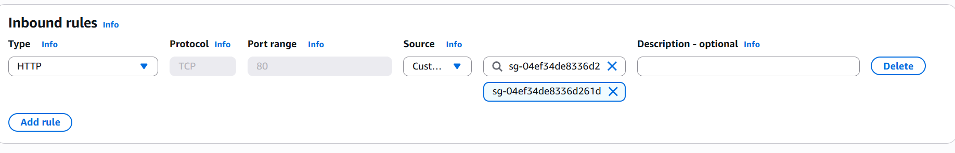
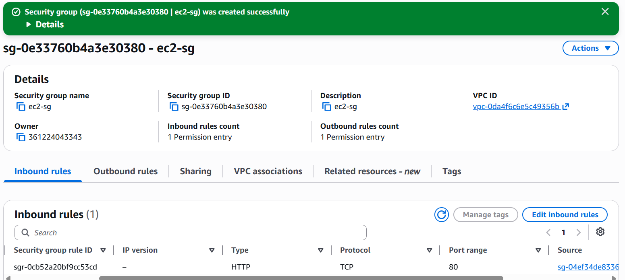
Now lets launch the First EC2 instance.
I am using the default VPC but selecting us-west-2a for this instance.
I am selecting the ec2-sg security group for this instance.

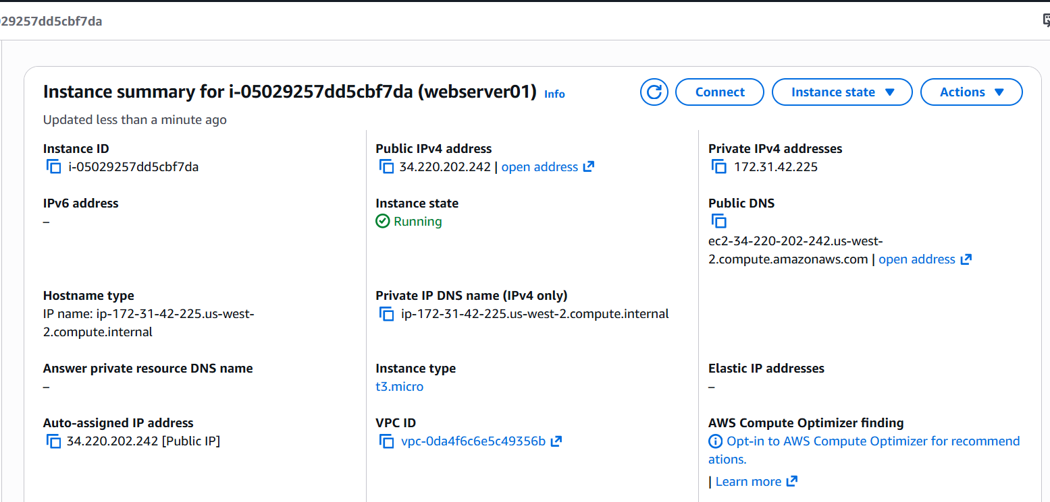

Now lets launch the Second Ec2 instance
This time, I am selecting a different subnet (us-west-2b). All other configurations remain the same.

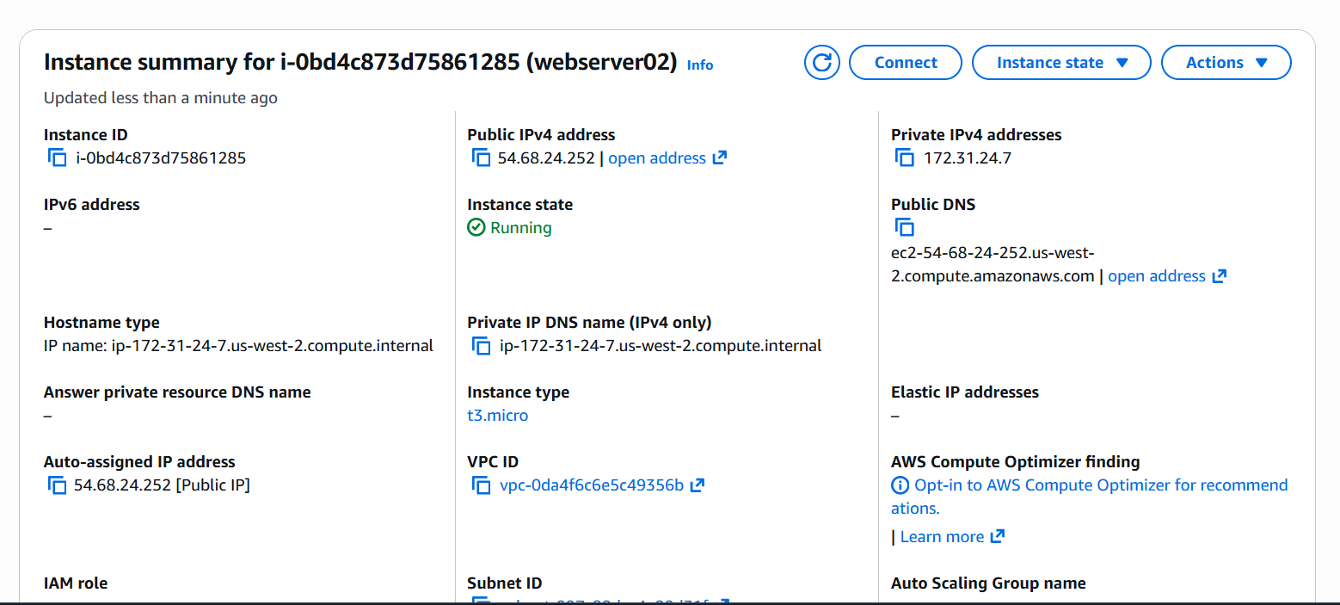

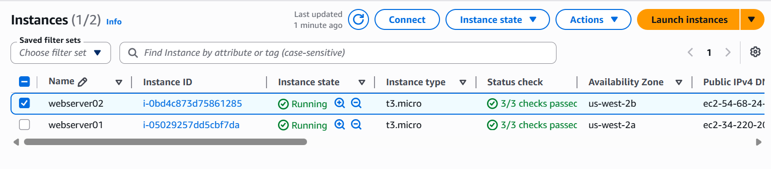
Now lets create a Target Group and then add these two EC2 instances to that group.

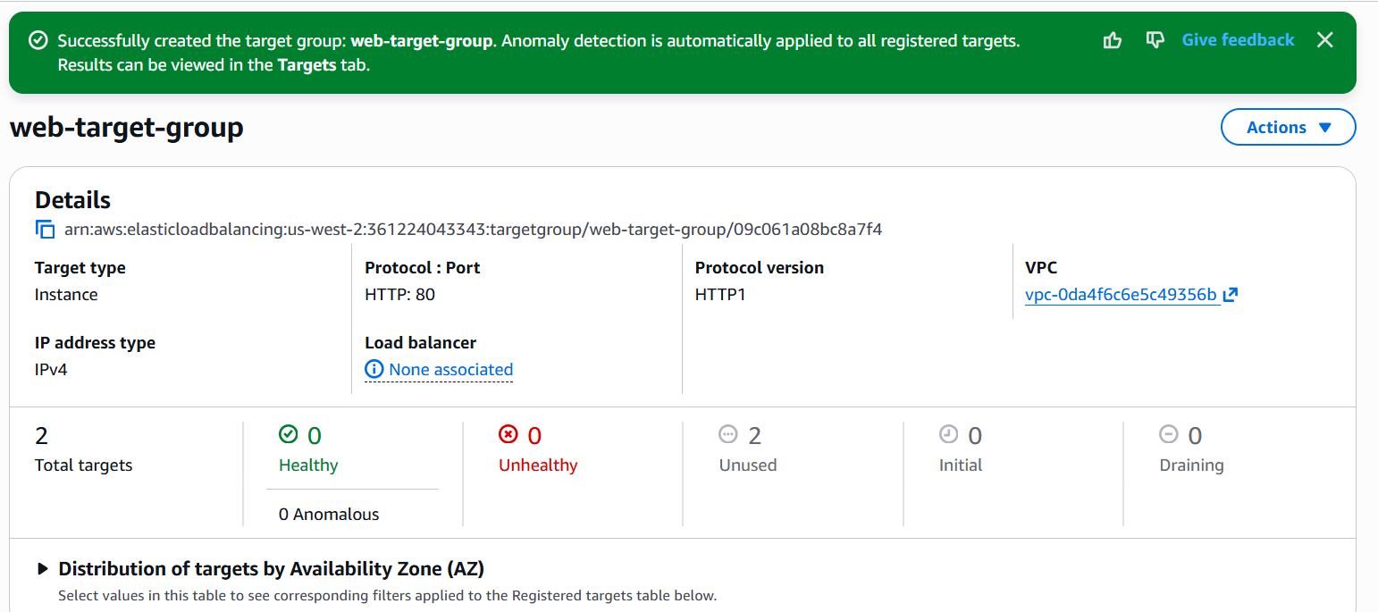

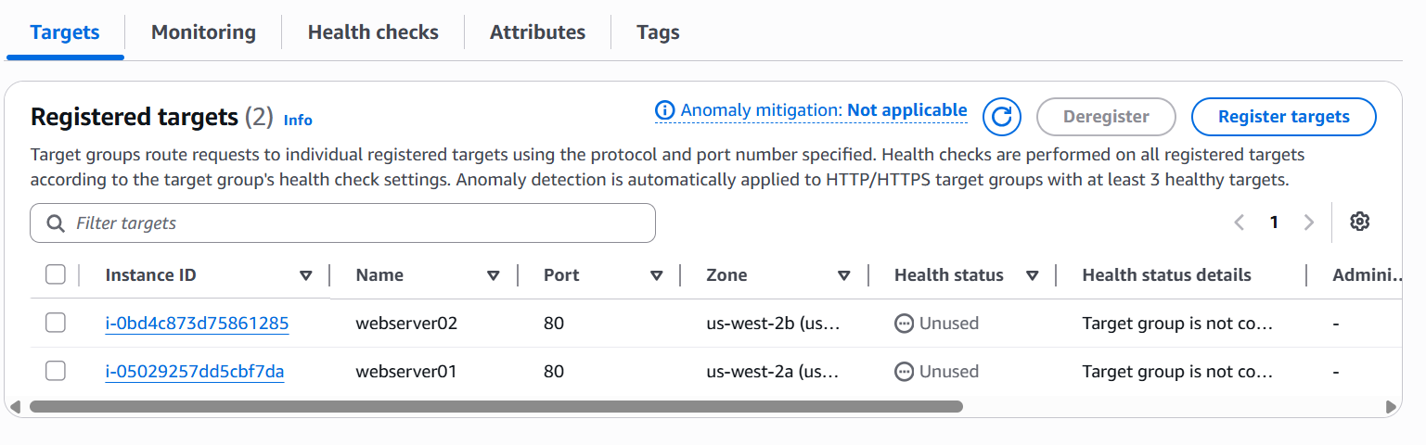

Now lets create an Application Load Balancer

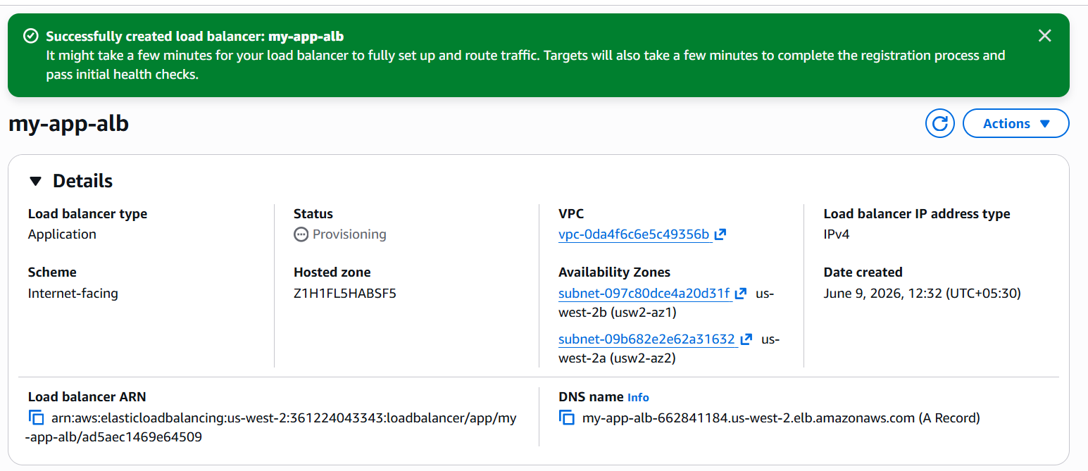

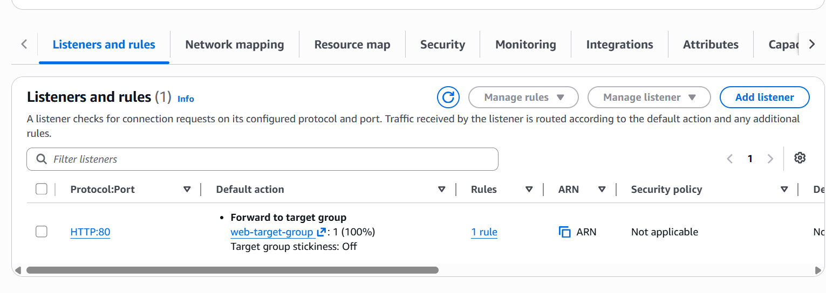
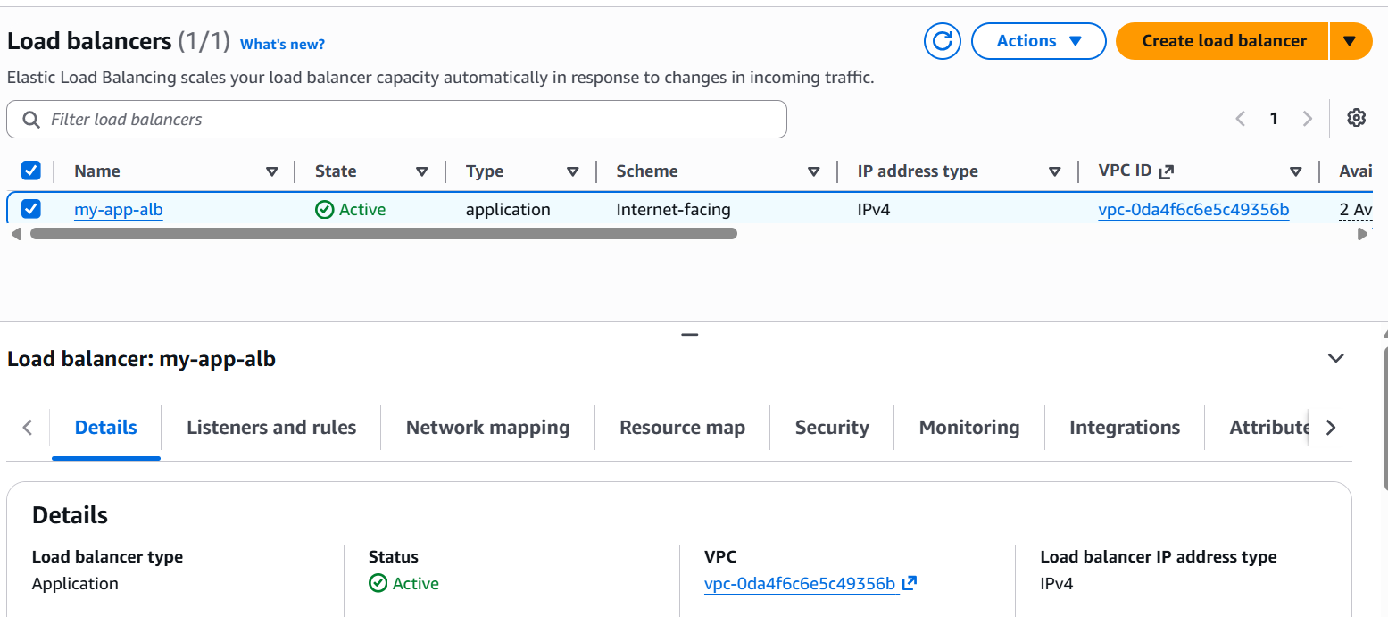

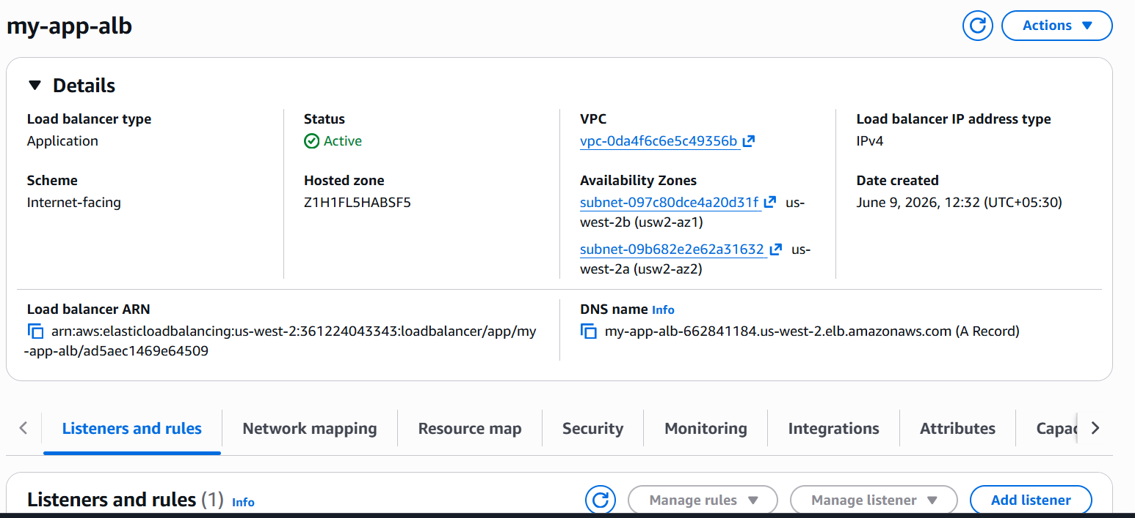

Now lets try copying the DNS name and then paste it into the browser to validate our setup.

First Hit

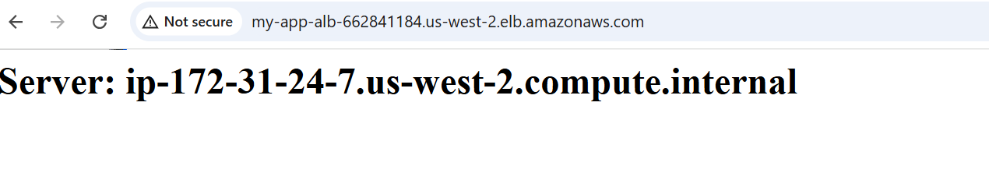

Second Hit
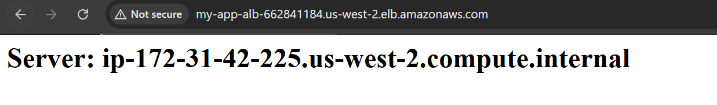
Third Hit
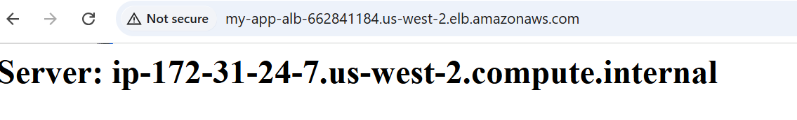
Fourth Hit
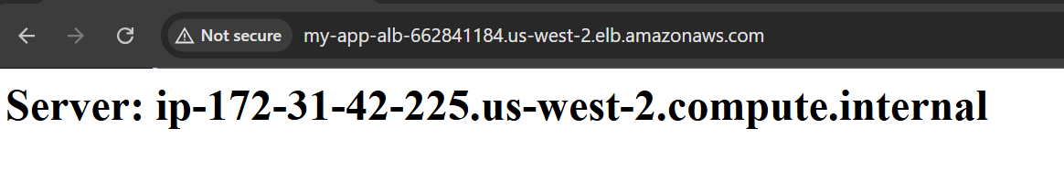
This shows that the Application load balancer is working perfectly. Distributing traffic across the two EC2 instances. Only the ALB Ip’s are visible to the outside world. This concludes the task.

