Task 1: Create a shell script to print the HTTP error code of guvi.in & print, the success/failure message based on the error code response
- I created a script called guviscript.sh and it is shown below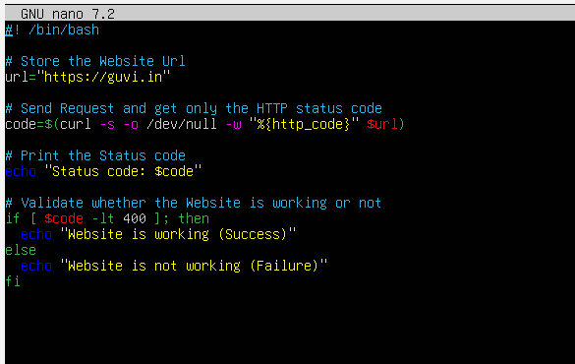low
- I gave executable permission to the owner using the command
“chmod 700 guviscript.sh”

- Then the script was executed
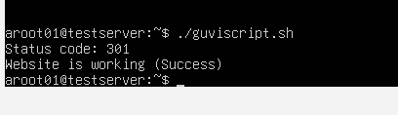

Task 2: Given a file, replace all occurrence of the word "give" with "learning" from 5th line till the end in only those lines that contain the word "welcome"

- I created a file by name file1.txt with the following contents.
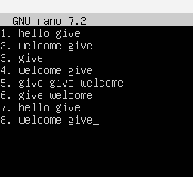

- Then created a script called replace.sh with the following contents.
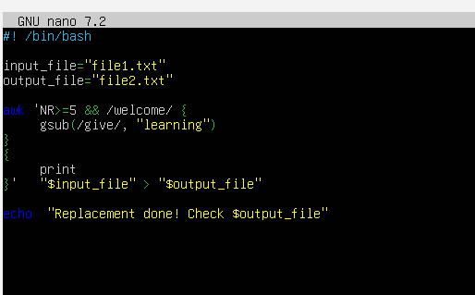

- I am using awk command to redirect the output to new file “file2.txt” which will get automatically created when I execute this script “replace.sh”
- I have also granted executable permission to the owner chmod 700 replace.sh
- When I execute the script
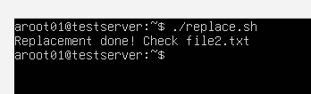

- Now I am opening the “file2.txt” to view the output.
