Network Task

- a) Get me the IP address of a particular domain (guvi.in).
I created a file called guvi.sh
Nano guvi.sh

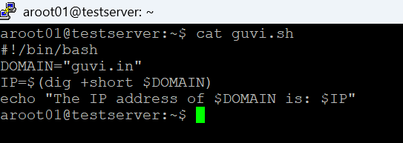

Saved it and then modified the file permission so that it is executable.
chmod 700 guvi.sh
./guvi.sh

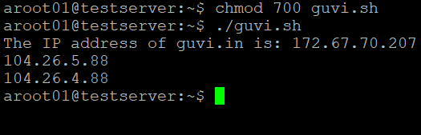

- How do I find my CPU/memory usage of my server ?
This can be done using the “top” command.
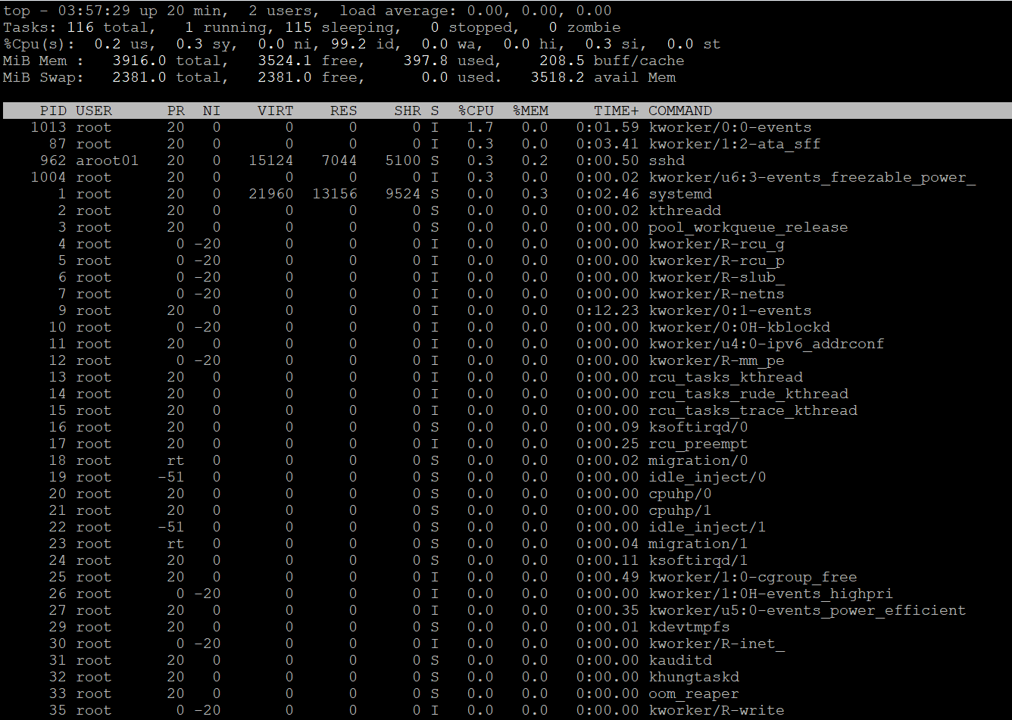

- Test the connectivity between 2 nodes?
This can be done using the Ping command.
Ping guvi.in
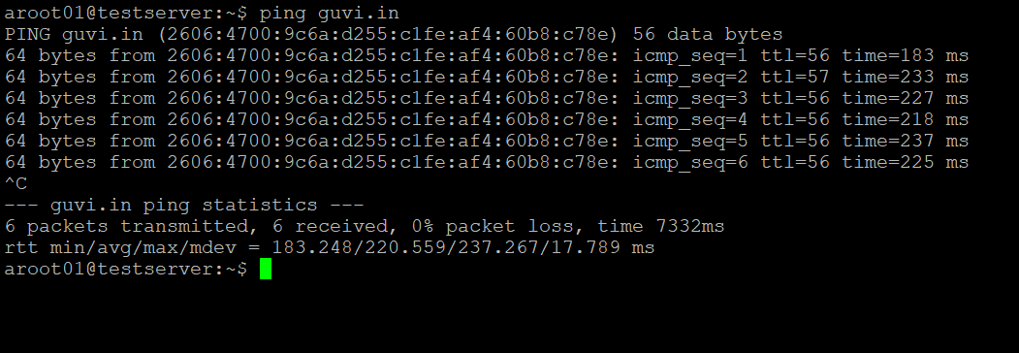
The connectivity between my VM and guvi.in is good.

- I have deployed an application in guvi.com:9000, and logs show my app is running, but I’m unable to view the page. Check whether my port is open or not ?
This can be done using telnet command
telnet guvi.com 9000
Note: If the connection establishes, the port is open. If it fails, the port is blocked or the service isn’t listening.

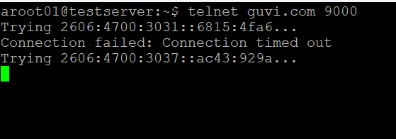

In this case the connection timed out, hence the port 9000 is not open.

