Kubernetes Task

Task Description:
Setup minikube at your local and explore creating namespaces (Go through official documentation).
First let’s spin up a VM using AWS
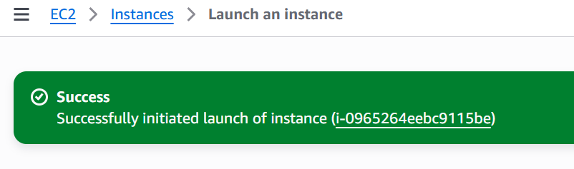
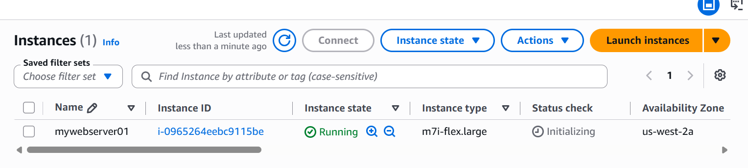
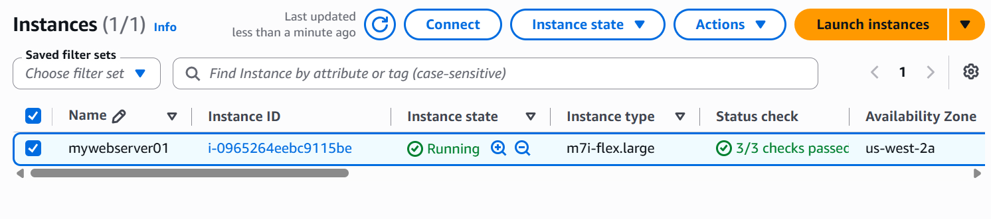
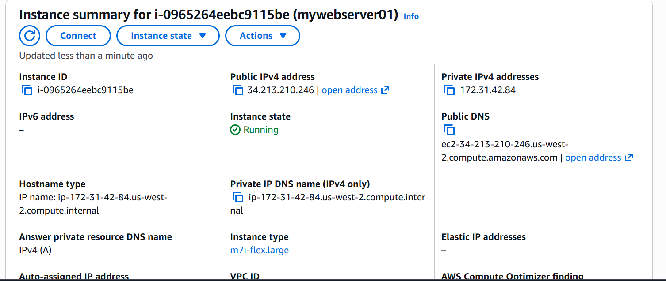

We are able to successfully login to the server via SSH

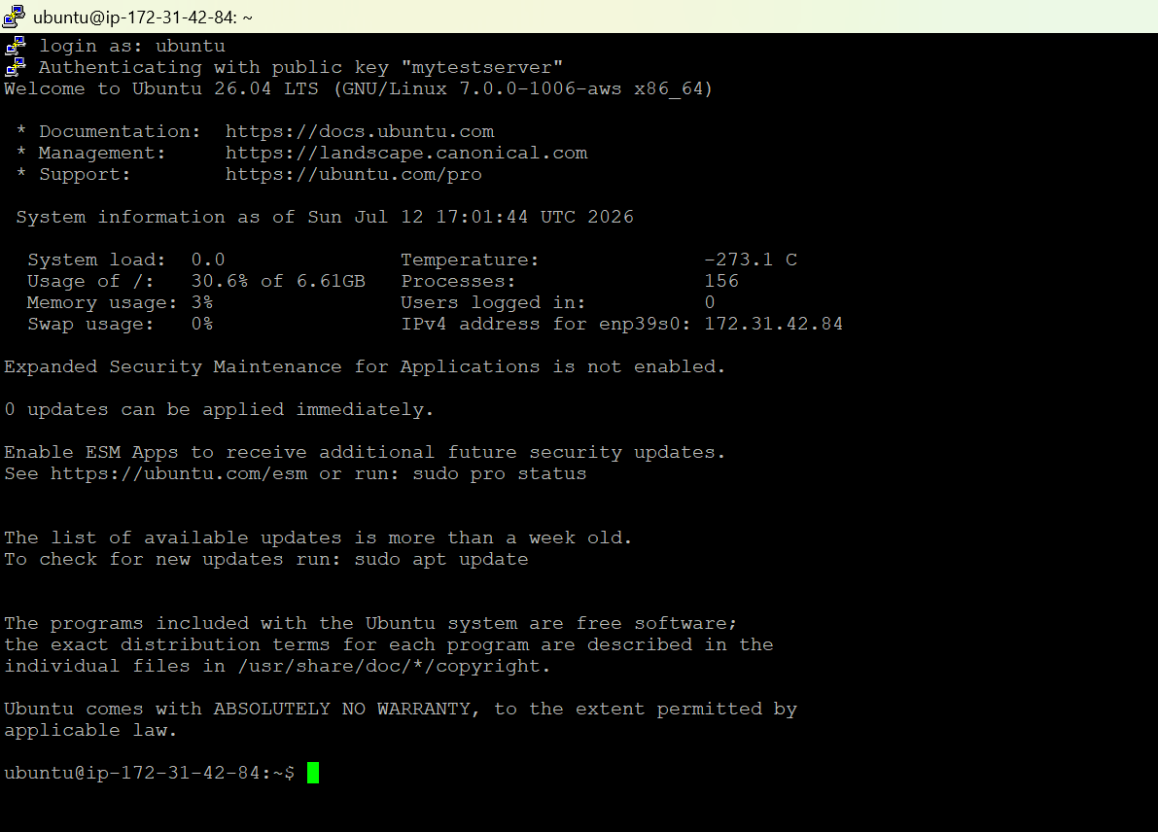

To set up Minikube on Ubuntu, we must install Docker as the container driver, download the Minikube binary, install the kubectl command-line tool, and launch our cluster.
Docker Installation:

- Updating the latest packages.
sudo apt update && sudo apt upgrade -y
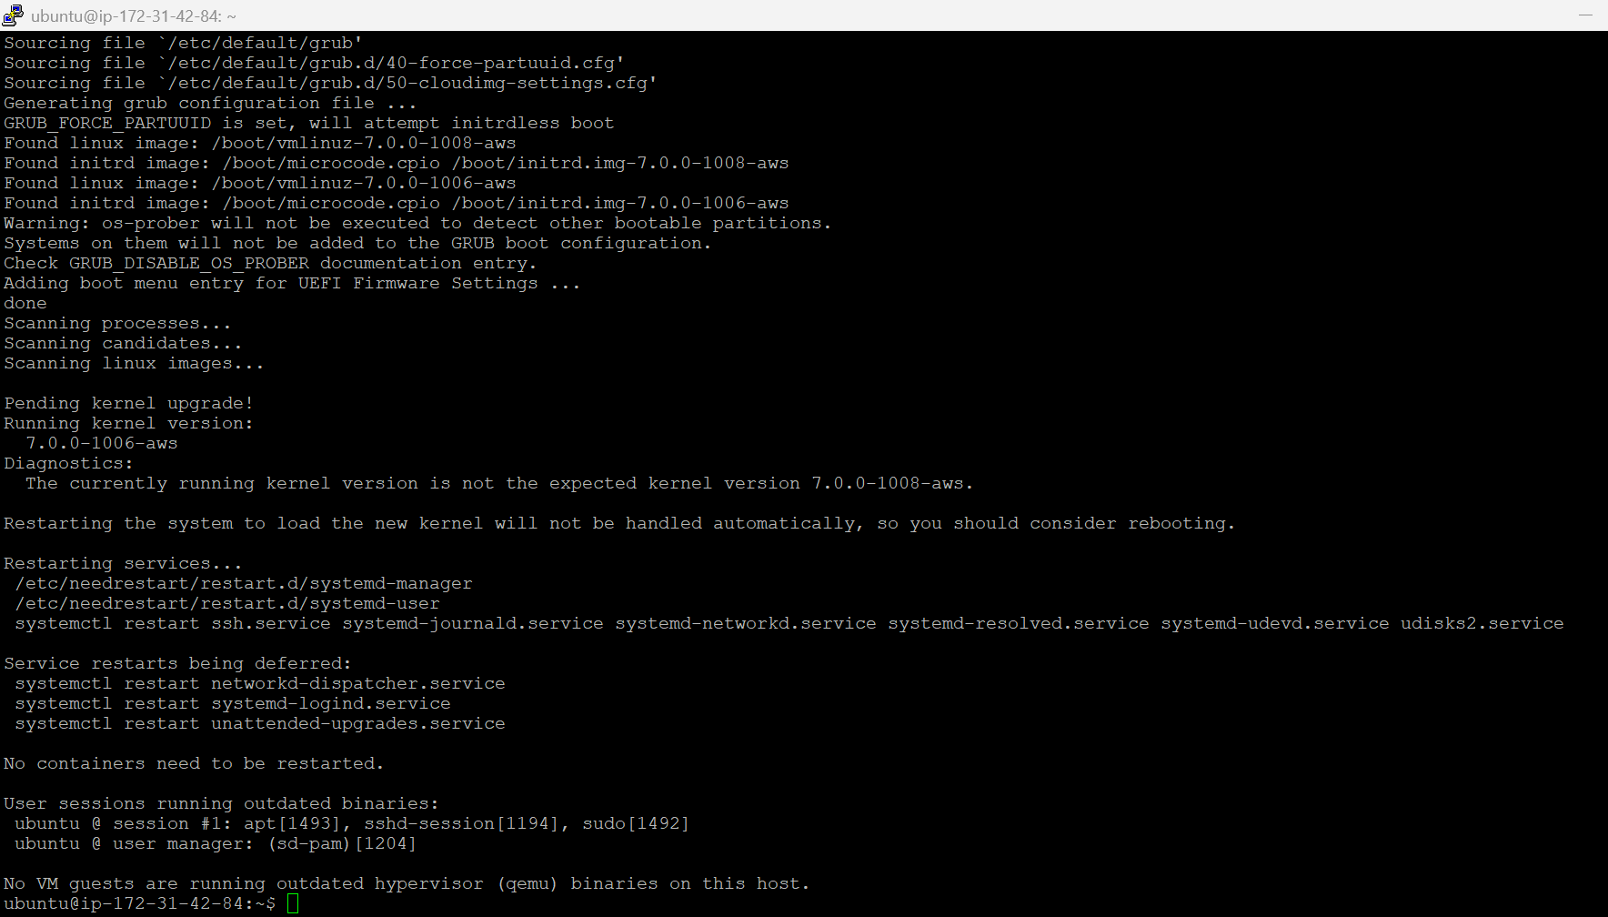
- Installing the necessary system dependencies.
sudo apt install -y curl apt-transport-https ca-certificates
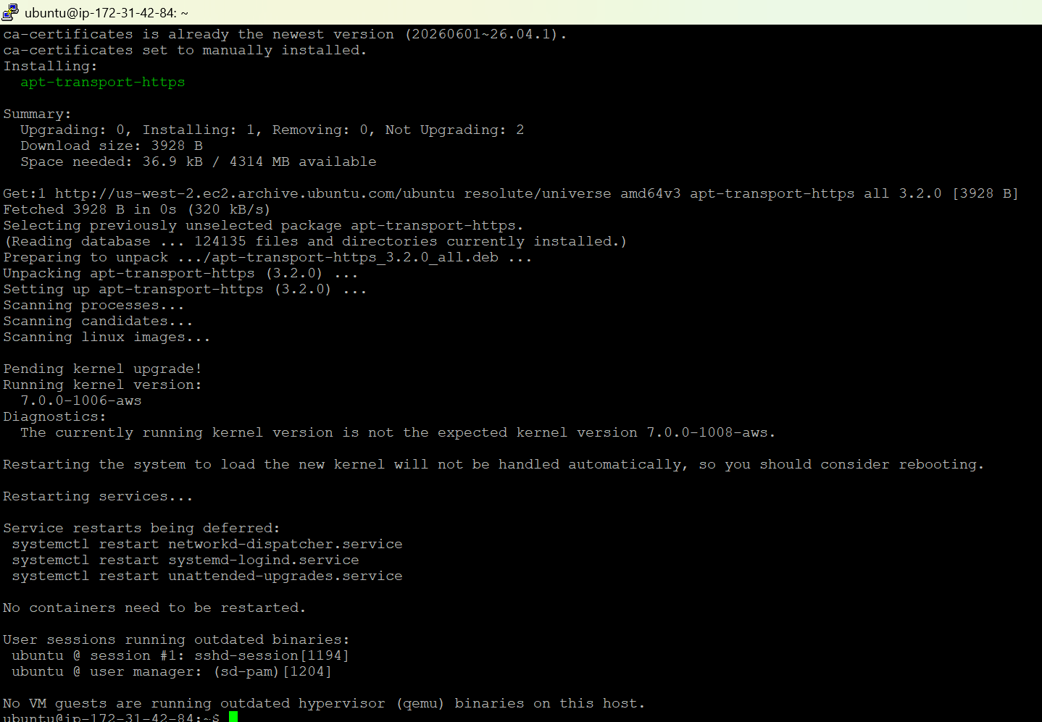
- Install the Docker engine
sudo apt install -y docker.io
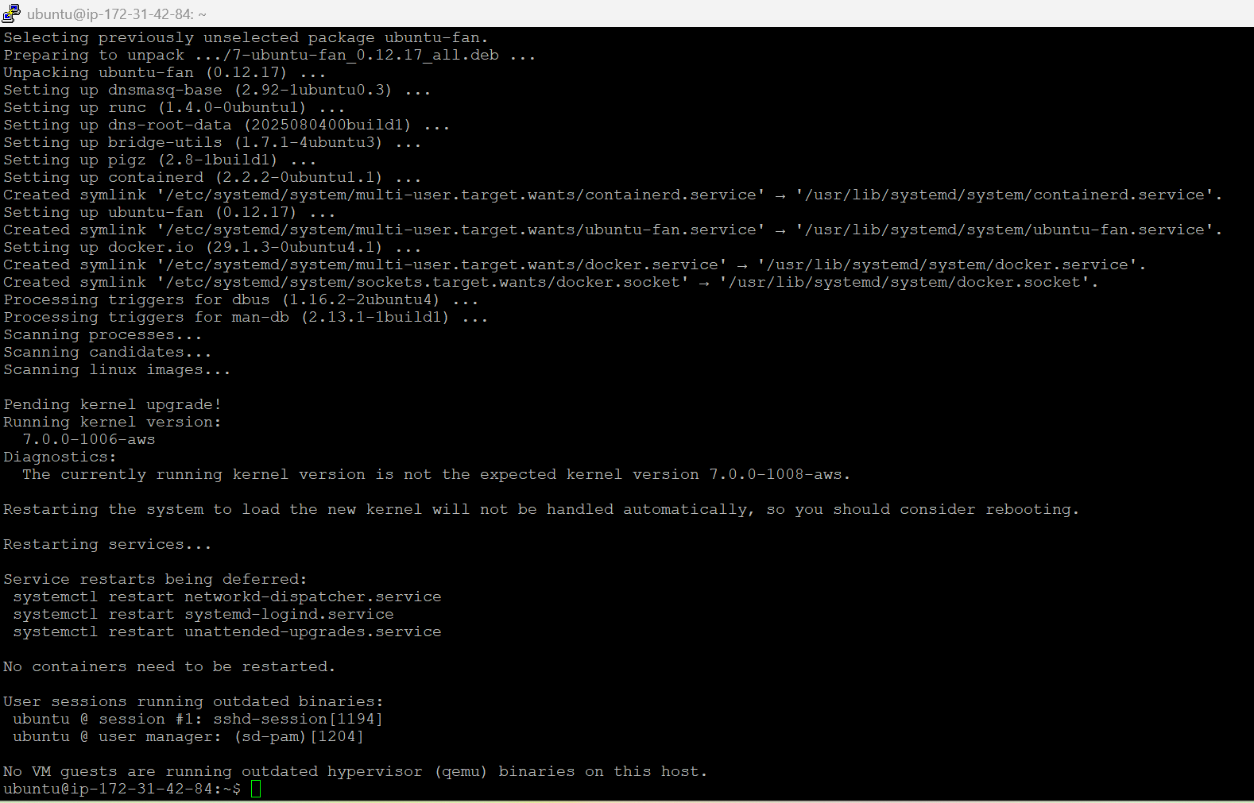
- Adding the current user to the docker group so that the Docker commands can be executed without using sudo
sudo usermod -aG docker $USER && newgrp docker
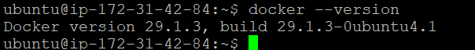

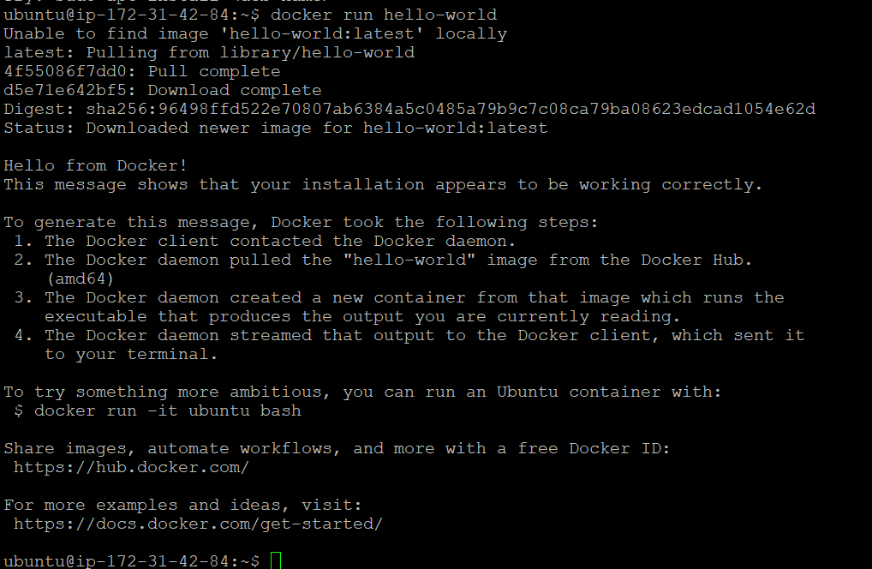

- Now let’s install minikube which is the local Kubernetes focusing on making it easy to learn and develop for Kubernetes.
curl -LO https://github.com/kubernetes/minikube/releases/latest/download/minikube-linux-amd64
sudo install minikube-linux-amd64 /usr/local/bin/minikube && rm minikube-linux-amd64
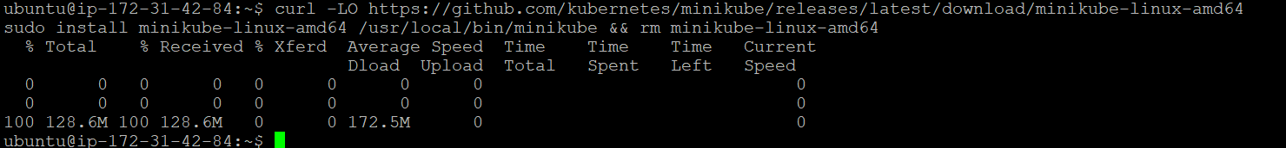
- Starting minikube
minikube start
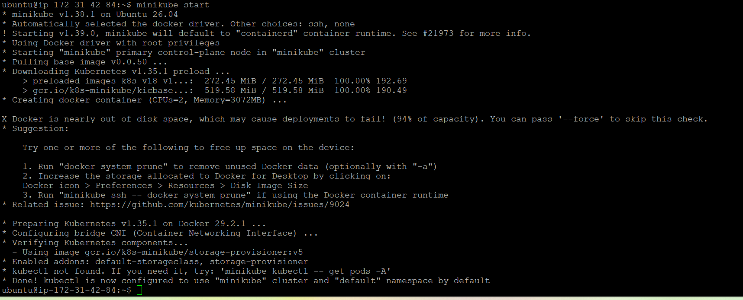

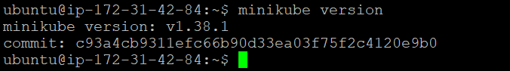

- Kubectl Installation
curl -LO "https://dl.k8s.io/release/$(curl -L -s https://dl.k8s.io/release/stable.txt)/bin/linux/amd64/kubectl"
sudo install -o root -g root -m 0755 kubectl /usr/local/bin/kubectl
kubectl version –client
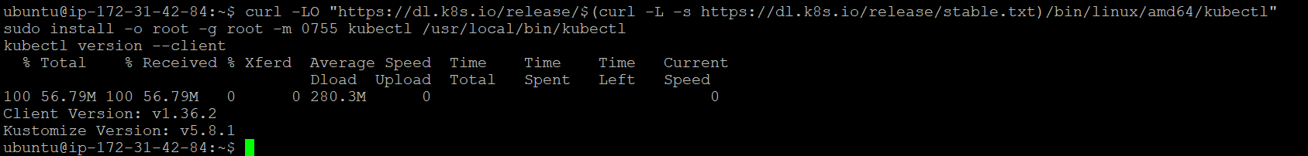

- Starting our cluster
minikube start --driver=docker
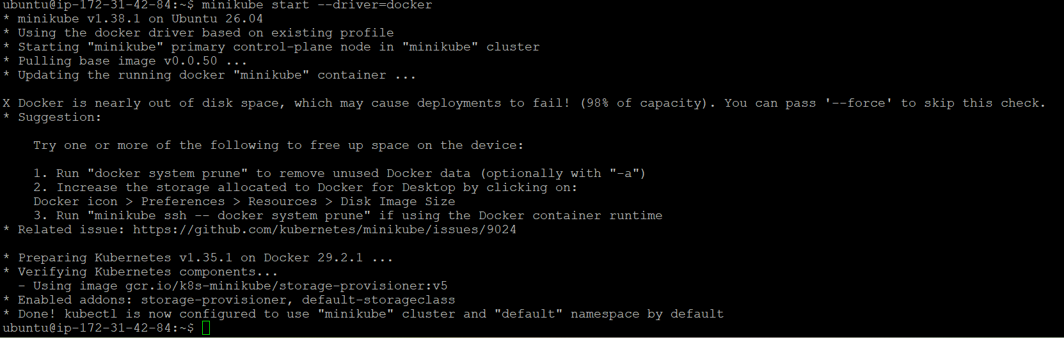
- Check whether it’s up
kubectl get nodes
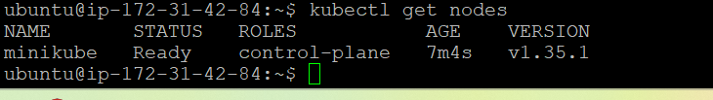
kubectl cluster-info

- Exploring namespaces
kubectl get namespaces
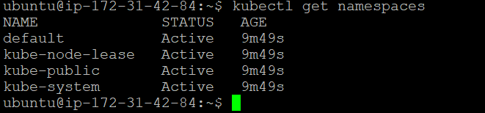
All these are default namespaces.
- Now create two new namespaces.
kubectl create namespace dev
kubectl create namespace staging
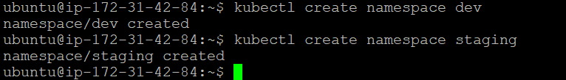
- Verify them
kubectl get namespaces
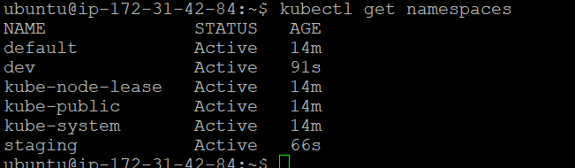
The two namespaces (dev & staging) are present.
- Now let’s run nginx inside the dev namespace.
kubectl run nginx --image=nginx --namespace=dev

kubectl get pods --namespace=dev -w

kubectl get pods --namespace=default

- Delete a namepace called “staging”
kubectl delete namespace staging

kubectl get namespaces
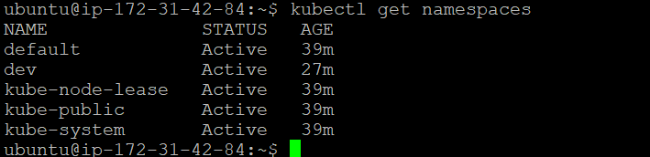

This concludes our task.

