**WEEK-6 REACT HANDS-ON**

**1.ReactJS-HOL**

Create a new React Application with the name “myfirstreact”, Run the application to print “welcome to the first session of React” as heading of that page.

App.js:

import React from 'react';

function App() {

  return (

    <div>

      <h1>Welcome to the first session of React</h1>

    </div>

  );

}

export default App;

**OUTPUT:**

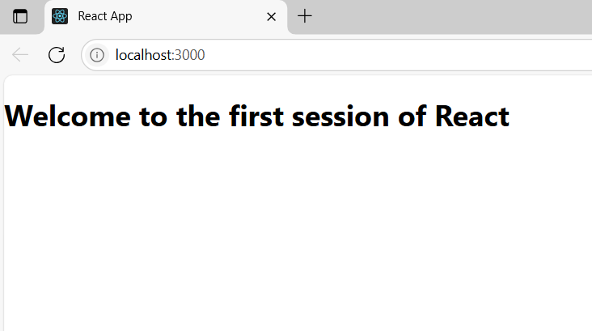

**2.ReactJS-HOL**

Create a react app for Student Management Portal named StudentApp and create a component named Home which will display the Message “Welcome to the Home page of Student Management Portal”. Create another component named About and display the Message “Welcome to the About page of the Student Management Portal”. Create a third component named Contact and display the Message “Welcome to the Contact page of the Student Management Portal”. Call all the three components.

App.js:

import React from 'react';

import Home from './Home';

import About from './About';

import Contact from './Contact';

function App() {

  return (

    <div>

      <h1>Welcome to Student App</h1>

      <Home />

      <About />

      <Contact />

    </div>

  );

}

export default App;

**Home.js:**

import React from 'react';

function Home() {

  return (

    <div>

      <h2>This is the Home Page</h2>

    </div>

  );

}

export default Home;

**About.js**

import React from 'react';

function About() {

  return (

    <div>

      <h2>This is the About Page</h2>

    </div>

  );

}

export default About;

**Contact.js**

import React from 'react';

function Contact() {

  return (

    <div>

      <h2>This is the Contact Page</h2>

    </div>

  );

}

export default Contact;

**OUTPUT:**

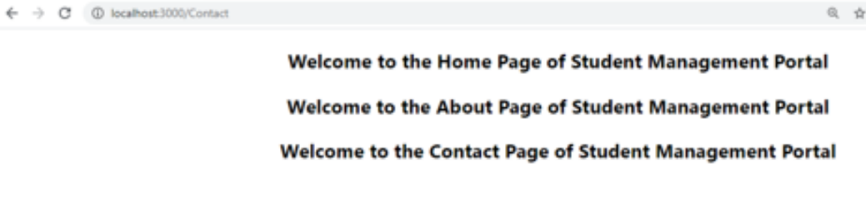

**3.ReactJS-HOL**

Create a react app for Student Management Portal named scorecalculatorapp and create a function component named “CalculateScore” which will accept Name, School, Total and goal in order to calculate the average score of a student and display the same.

App.js

import React from 'react';

import './App.css';

import CalculateScore from './Components/CalculateScore';

function App() {

  return (

    <div className="App">

      <h1>Student Management Portal</h1>

      <CalculateScore name="John" school="Oxford Public School" total={460} goal={5} />

    </div>

  );

}

export default App;

**CalculateScore.js**

import React from 'react';

import '../Stylesheets/mystyle.css';

function CalculateScore(props) {

  const average = props.total / props.goal;

  return (

    <div className="score-container">

      <h2>Student Score Details</h2>

      <p><strong>Name:</strong> {props.name}</p>

      <p><strong>School:</strong> {props.school}</p>

      <p><strong>Total Marks:</strong> {props.total}</p>

      <p><strong>Average Score:</strong> {average.toFixed(2)}</p>

    </div>

  );

}

export default CalculateScore;

**mystyle.css:**

.score-container {

  border: 2px solid #4CAF50;

  padding: 20px;

  margin: 20px auto;

  width: 50%;

  background-color: #f9f9f9;

  border-radius: 10px;

  box-shadow: 0 2px 8px rgba(0, 0, 0, 0.1);

  font-family: Arial, sans-serif;

}

.score-container h2 {

  color: #4CAF50;

  text-align: center;

}

.score-container p {

  font-size: 16px;

  margin: 8px 0;

}

**OUTPUT:**

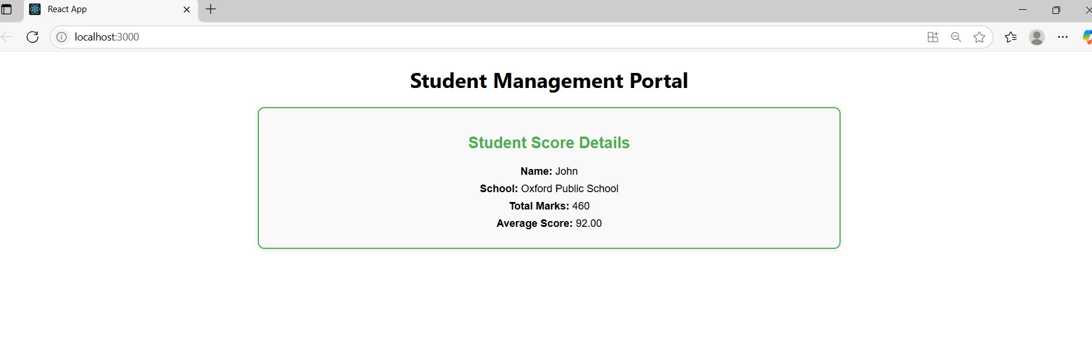

**4.ReactJS-HOL**

* Implement componentDidMount() hook
* Implementing componentDidCatch() life cycle hook.

Post.js:

class Post {

  constructor(userId, id, title, body) {

    this.userId = userId;

    this.id = id;

    this.title = title;

    this.body = body;

  }

}

export default Post;

**Posts.js**

import React, { Component } from 'react';

import Post from './Post';

class Posts extends Component {

  constructor(props) {

    super(props);

    this.state = {

      posts: [],

      hasError: false

    };

  }

  loadPosts = () => {

    fetch('https://jsonplaceholder.typicode.com/posts')

      .then(res => res.json())

      .then(data => {

        const postObjects = data.map(

          post => new Post(post.userId, post.id, post.title, post.body)

        );

        this.setState({ posts: postObjects });

      })

      .catch(error => {

        console.error('Error fetching posts:', error);

        this.setState({ hasError: true });

      });

  };

  componentDidMount() {

    this.loadPosts();

  }

  componentDidCatch(error, info) {

    alert("An error occurred: " + error);

    this.setState({ hasError: true });

  }

  render() {

    if (this.state.hasError) {

      return <h2>Something went wrong.</h2>;

    }

    return (

      <div>

        <h1>Blog Posts</h1>

        {this.state.posts.map(post => (

          <div key={post.id} style={{ marginBottom: '20px' }}>

            <h3>{post.title}</h3>

            <p>{post.body}</p>

          </div>

        ))}

      </div>

    );

  }

}

export default Posts;

**App.js**

import React from 'react';

import './App.css';

import Posts from './Posts';

function App() {

  return (

    <div className="App">

      <Posts />

    </div>

  );

}

export default App;

OUTPUT:

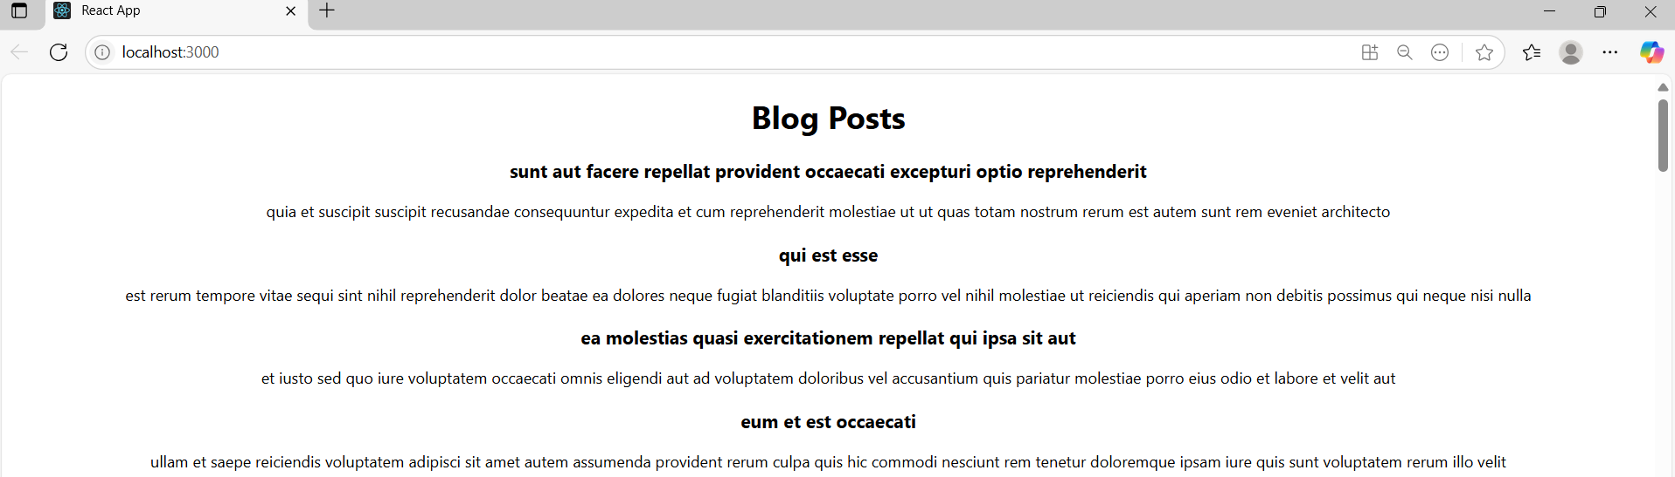

**5.ReactJS-HOL**

My Academy team at Cognizant want to create a dashboard containing the details of ongoing and completed cohorts. A react application is created which displays the detail of the cohorts using react component. You are assigned the task of styling these react components.

**CohortDetails.js:**

import React from 'react';

import styles from './CohortDetails.module.css';

const CohortDetails = ({ cohort }) => {

  const titleStyle = {

    color:

      cohort.status.toLowerCase() === 'ongoing'

        ? 'green'

        : cohort.status.toLowerCase() === 'scheduled'

        ? 'blue'

        : 'black'

  };

  return (

    <div className={styles.box}>

      <h3 style={titleStyle}>{cohort.name}</h3>

      <dl>

        <dt>Started On</dt>

        <dd>{cohort.startedOn}</dd>

        <dt>Current Status</dt>

        <dd>{cohort.status}</dd>

        <dt>Coach</dt>

        <dd>{cohort.coach}</dd>

        <dt>Trainer</dt>

        <dd>{cohort.trainer}</dd>

      </dl>

    </div>

  );

};

export default CohortDetails;

**CohortDetails.module.css:**

.box {

  width: 300px;

  display: inline-block;

  margin: 10px;

  padding: 10px 20px;

  border: 1px solid black;

  border-radius: 10px;

  vertical-align: top;

}

dt {

  font-weight: 500;

}

**App.js:**

import React from 'react';

import CohortDetails from './CohortDetails';

function App() {

  const cohorts = [

    {

      name: 'INTADMDF10 -.NET FSD',

      startedOn: '22-Feb-2022',

      status: 'Scheduled',

      coach: 'Aathma',

      trainer: 'Jojo Jose'

    },

    {

      name: 'ADM21JF014 - Java FSD',

      startedOn: '10-Sep-2021',

      status: 'Ongoing',

      coach: 'Apoorv',

      trainer: 'Elisa Smith'

    },

    {

      name: 'CDBJF21025 - Java FSD',

      startedOn: '24-Dec-2021',

      status: 'Ongoing',

      coach: 'Aathma',

      trainer: 'John Doe'

    }

  ];

  return (

    <div className="App">

      <h1>Cohorts Details</h1>

      {cohorts.map((cohort, index) => (

        <CohortDetails key={index} cohort={cohort} />

      ))}

    </div>

  );

}

export default App;

**OUTPUT:**

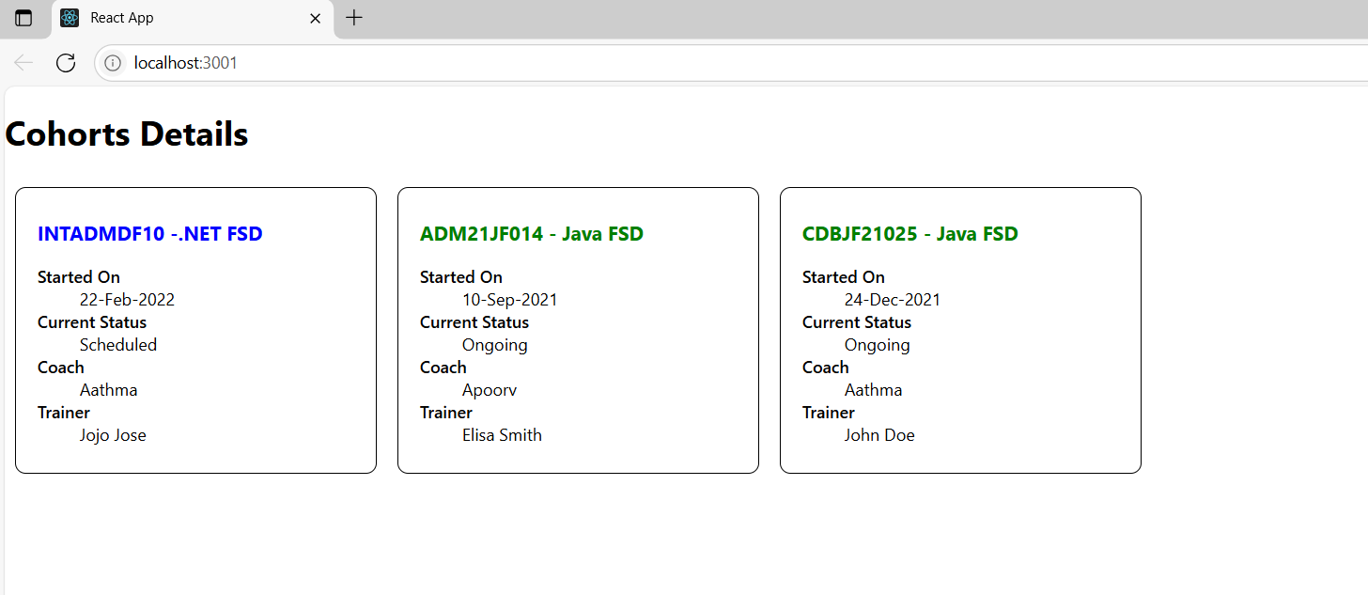

**6.ReactJS-HOL**

Cognizant Academy teams want to maintain a list of trainers along with their expertise in a SPA using React as the technology. You are assigned the task of creating this React app.

The following trainers’ data application will deal.

1. T-ID
2. Name
3. Phone
4. Email
5. Stream
6. Skills

**Trainer.js:**

class Trainer {

  constructor(id, name, email, phone, technology, skills) {

    this.trainerId = id;

    this.name = name;

    this.email = email;

    this.phone = phone;

    this.technology = technology;

    this.skills = skills;

  }

}

export default Trainer;

**TrainersMock.js:**

import Trainer from './Trainer';

const trainers = [

  new Trainer(1, 'Alice', 'alice@example.com', '1234567890', 'Java', ['Spring', 'Hibernate']),

  new Trainer(2, 'Bob', 'bob@example.com', '9876543210', 'Python', ['Django', 'Flask']),

  new Trainer(3, 'Carol', 'carol@example.com', '5551234567', 'JavaScript', ['React', 'Node.js'])

];

export default trainers;

**TrainerList.js**

import React from 'react';

import { Link } from 'react-router-dom';

const TrainersList = ({ trainers }) => {

  return (

    <div>

      <h2>Trainers List</h2>

      <ul>

        {trainers.map(trainer => (

          <li key={trainer.trainerId}>

            <Link to={`/trainers/${trainer.trainerId}`}>{trainer.name}</Link>

          </li>

        ))}

      </ul>

    </div>

  );

};

export default TrainersList;

**Home.js**

import React from 'react';

const Home = () => {

  return (

    <div>

      <h2>Welcome to Cognizant Academy Trainers Portal</h2>

      <p>Click on the Trainers link to view the trainers list.</p>

    </div>

  );

};

export default Home;

**App.js:**

import React from 'react';

import { BrowserRouter as Router, Routes, Route, Link } from 'react-router-dom';

import Home from './Home';

import TrainersList from './TrainerList';

import TrainerDetails from './TrainerDetails';

import trainers from './TrainersMock';

function App() {

  return (

    <Router>

      <div>

        <h1>Trainers App</h1>

        <nav>

          <Link to="/">Home</Link> | <Link to="/trainers">Trainers</Link>

        </nav>

        <Routes>

          <Route path="/" element={<Home />} />

          <Route path="/trainers" element={<TrainersList trainers={trainers} />} />

          <Route path="/trainers/:id" element={<TrainerDetails />} />

        </Routes>

      </div>

    </Router>

  );

}

export default App;

**TrainerDetails.js:**

import React from 'react';

import { useParams } from 'react-router-dom';

import trainers from './TrainersMock';

const TrainerDetails = () => {

  const { id } = useParams();

  const trainer = trainers.find(t => t.trainerId === parseInt(id));

  if (!trainer) return <p>Trainer not found</p>;

  return (

    <div>

      <h2>{trainer.name}'s Details</h2>

      <p><strong>Email:</strong> {trainer.email}</p>

      <p><strong>Phone:</strong> {trainer.phone}</p>

      <p><strong>Technology:</strong> {trainer.technology}</p>

      <p><strong>Skills:</strong> {trainer.skills.join(', ')}</p>

    </div>

  );

};

export default TrainerDetails;

**OUTPUT:**

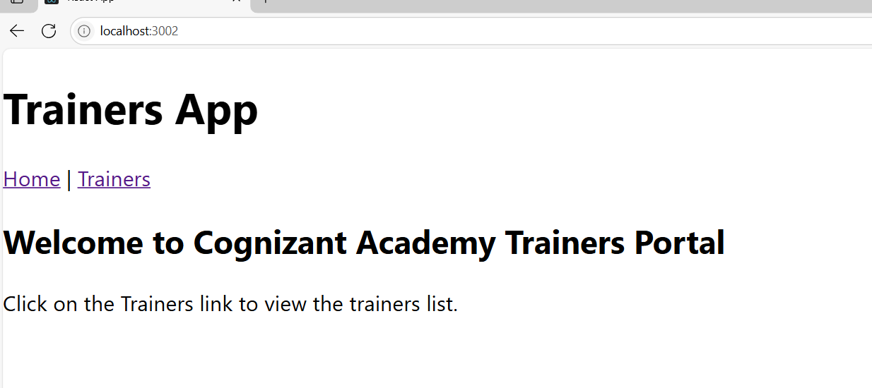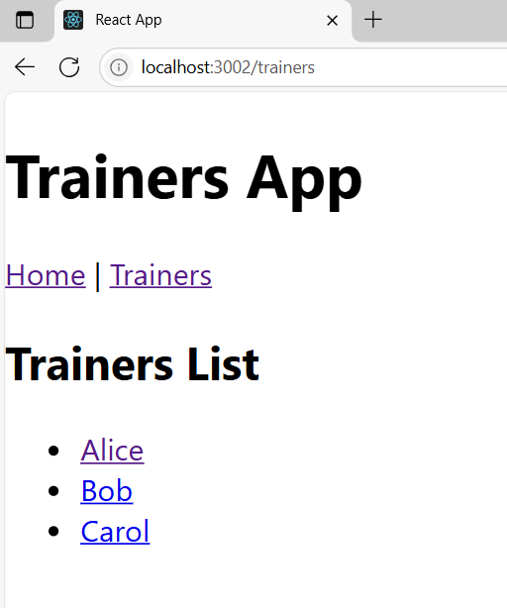

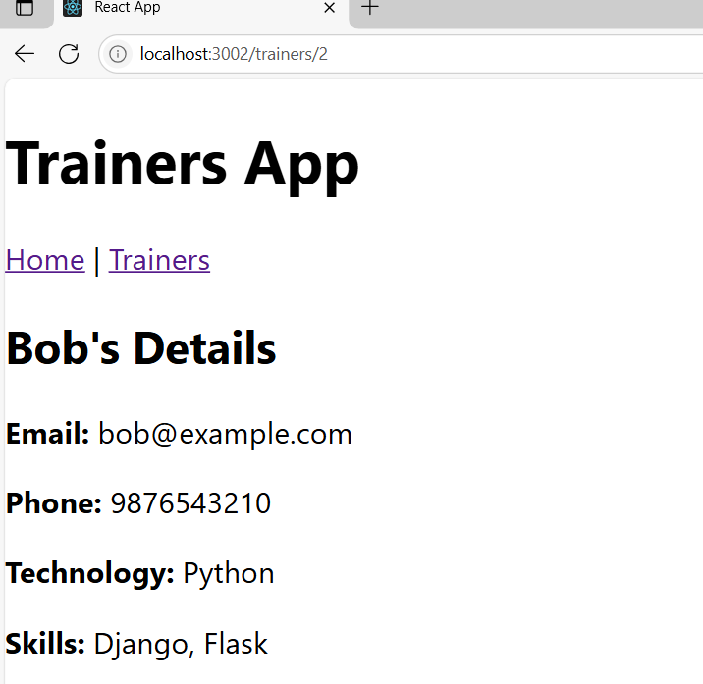

**7.ReactJS-HOL**

Create a React Application named “shoppingapp” with a class component named “OnlineShopping” and “Cart”.

**Cart.js:**

import React from 'react';

class Cart extends React.Component {

render() {

return (

<div style={{ border: '1px solid black', padding: '10px', margin: '10px' }}>

<h3>Item Name: {this.props.itemname}</h3>

<p>Price: ₹{this.props.price}</p>

</div>

);

}

}

Cart.defaultProps = {

itemname: 'Unknown Item',

price: 0

};

export default Cart;

**OnlineShopping.js:**

import React from 'react';

import Cart from './Cart';

class OnlineShopping extends React.Component {

render() {

const items = [

{ itemname: "Laptop", price: 60000 },

{ itemname: "Smartphone", price: 25000 },

{ itemname: "Headphones", price: 2000 },

{ itemname: "Keyboard", price: 1500 },

{ itemname: "Mouse", price: 800 }

];

return (

<div>

<h1>Online Shopping Cart</h1>

{

items.map((item, index) => (

<Cart key={index} itemname={item.itemname} price={item.price} />

))

}

</div>

);

}

}

export default OnlineShopping;

**OUTPUT:**

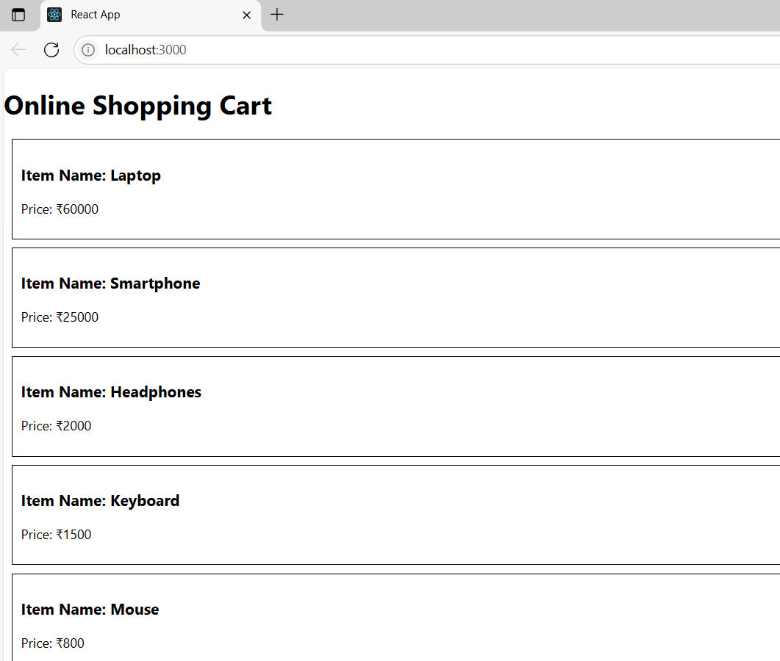

**8.ReactJS-HOL**

Create a React App “counterapp” which will have a component named “CountPeople” which will have 2 methods.

UpdateEntry() à which will display the number of people who entered the mall.

UpdateExit() à which will display the number of people who exited the mall.

**CountPeople.js:**

import React from 'react';

class CountPeople extends React.Component {

constructor(props) {

super(props);

this.state = {

entryCount: 0,

exitCount: 0

};

}

updateEntry = () => {

this.setState((prevState) => ({

entryCount: prevState.entryCount + 1

}));

};

updateExit = () => {

this.setState((prevState) => ({

exitCount: prevState.exitCount + 1

}));

};

render() {

return (

<div style={{ textAlign: 'center', marginTop: '50px' }}>

<h1>People Counter</h1>

<p><strong>Entered:</strong> {this.state.entryCount}</p>

<p><strong>Exited:</strong> {this.state.exitCount}</p>

<button onClick={this.updateEntry} style={{ marginRight: '10px', padding: '10px' }}>

Login

</button>

<button onClick={this.updateExit} style={{ padding: '10px' }}>

Exit

</button>

</div>

);

}

}

export default CountPeople;

**App.js:**

import React from 'react';

import './App.css';

import CountPeople from './CountPeople';OU

function App() {

return (

<div className="App">

<CountPeople />

</div>

);

}

export default App;

**OUTPUT:**

