Smart Farming Platform

Smart Farming Platform is a full-stack agriculture management app built for local development and deployment. It combines a React dashboard with an Express API and SQLite database to help farmers manage farms, track finances, get crop guidance, and use chatbot-assisted workflows.

Project Report Summary

This project focuses on improving farm decision-making through a single digital platform that unifies crop planning, weather awareness, financial tracking, and AI-assisted support. The system is designed for practical daily use by farmers and is implemented with a modular architecture that supports both local deployment and future production scaling.

Problem Statement

Farm operations are often managed using disconnected tools or manual records, which can lead to delayed decisions, poor traceability of expenses and income, and reduced visibility into crop and weather risks.

Objectives

- Provide one dashboard for farm profile, crop support, and financial management.
- Improve decision quality through recommendation and prediction modules.
- Offer an accessible chatbot interface for fast feature discovery and guidance.
- Maintain secure user authentication and protected data access.

Tech Stack

- Frontend: React, TypeScript, Vite, Tailwind CSS
- Backend: Node.js, Express
- Database: SQLite
- Auth: JWT-based authentication

Core Features

- User sign up and sign in
- Farm profile setup and management
- Dashboard modules:
- Weather insights
- Crop recommendations
- Yield prediction
- Financial analytics (expenses and revenue)
- Market prices
- Disease detection workflow
- Admin panel routes and management APIs
- Integrated farming chatbot

System Architecture

Code Block (mermaid)
flowchart LR
U[Farmer / Admin User] --> FE[React Frontend]
FE -->|JWT Auth + API Calls| BE[Express API Server]
BE --> DB[(SQLite Database)]
BE --> AI[Rule-based AI Assistant]
AI --> BE
DB --> BE
BE --> FE
FE --> U

Architecture Notes

- Frontend handles UI rendering, authentication state, and module navigation.
- Backend enforces route protection, business logic, and persistence.
- SQLite stores user, farm, financial, recommendation, and chatbot data.
- Chatbot service is integrated as a backend-assisted feature for consistent responses and persistence.

Data Flow Diagrams (DFD)

DFD Level 0 (Context Diagram)

Code Block (mermaid)
flowchart TB
Farmer[Farmer]
Admin[Admin]
System((Smart Farming Platform))
DataStore[(Farm Database)]

Farmer -->|Register, Login, Farm Data, Expenses, Queries| System
System -->|Recommendations, Analytics, Alerts, Responses| Farmer
Admin -->|Management Requests, Insights Queries| System
System -->|Platform Stats, User Reports| Admin
System <--> DataStore

DFD Level 1 (Major Processes)

Code Block (mermaid)
flowchart LR
U[User] --> P1[1.0 Authentication]
U --> P2[2.0 Farm Profile Management]
U --> P3[3.0 Crop & Yield Services]
U --> P4[4.0 Financial Tracking]
U --> P5[5.0 Chatbot Interaction]

P1 <--> D1[(Farmers)]
P2 <--> D2[(Farms)]
P3 <--> D3[(Crops + Recommendations)]
P4 <--> D4[(Expenses + Payments)]
P5 <--> D5[(Chatbot Queries)]

P2 --> P3
P4 --> P3
P3 --> U
P5 --> U

User Flow Diagram

Code Block (mermaid)
flowchart TD
A[Open App] --> B{Authenticated?}
B -- No --> C[Sign Up / Sign In]
C --> D[Create Farm Profile]
D --> E[Enter Dashboard]
B -- Yes --> E
E --> F[View Overview]
E --> G[Use Crop Recommendation]
E --> H[Check Yield Prediction]
E --> I[Track Expenses / Revenue]
E --> J[Use Disease Detection]
E --> K[Open AI Chatbot]
K --> L[Feature Guidance + Q&A]

Module-Wise Functional Summary

- Authentication Module
- Secure sign-up and sign-in with JWT session handling.
- Route guarding for authenticated dashboard access.

- Farm Setup Module
- Captures farm identity, soil details, and irrigation method.
- Acts as baseline context for recommendations and analytics.

- Crop Recommendation and Yield Module
- Suggests crop options based on available context and season.
- Displays yield estimation workflows to guide planning.

- Financial Analytics Module
- Tracks expenses and payments for farm-level insights.
- Supports profitability understanding through visual summaries.

- Weather and Market Module
- Shows forecast and market-related guidance to support timing decisions.

- Disease Detection Module
- Provides a guided process for identifying crop disease concerns.

- AI Chatbot Module
- Offers proactive, topic-driven help and feature discovery.
- Persists user chatbot interactions for continuity.

Screenshots

1. Dashboard Overview

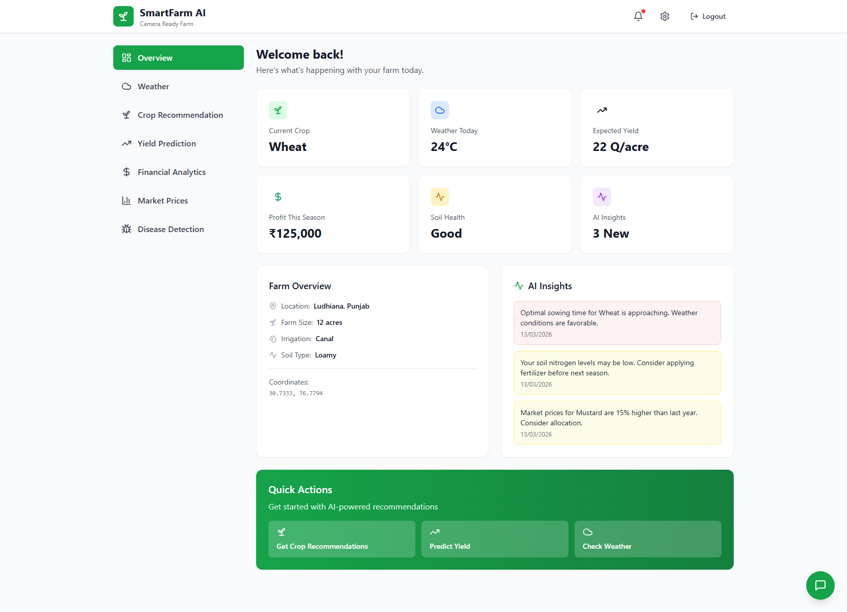
Figure: Dashboard Overview

2. Financial Analytics Scope

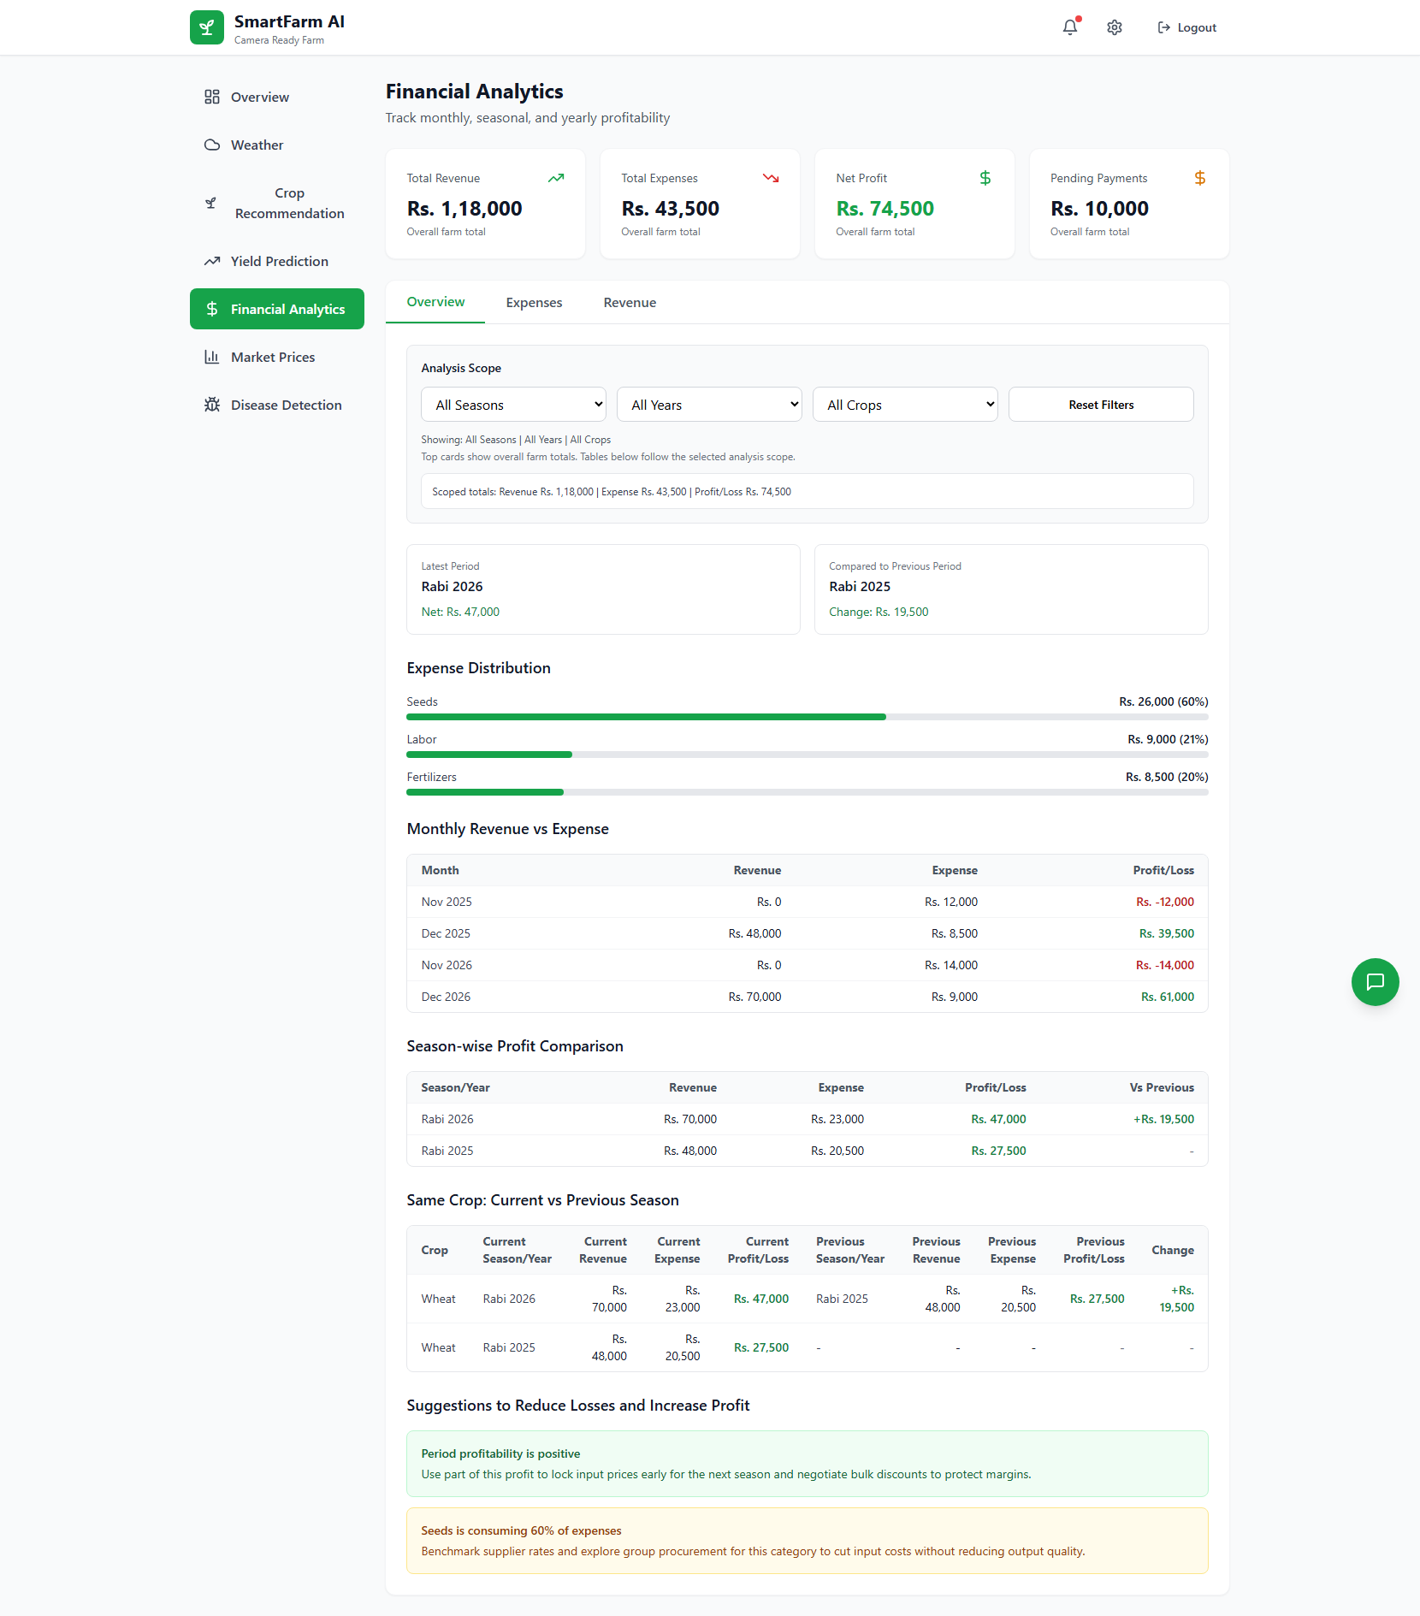
Figure: Financial Scope

3. Same Crop Comparison

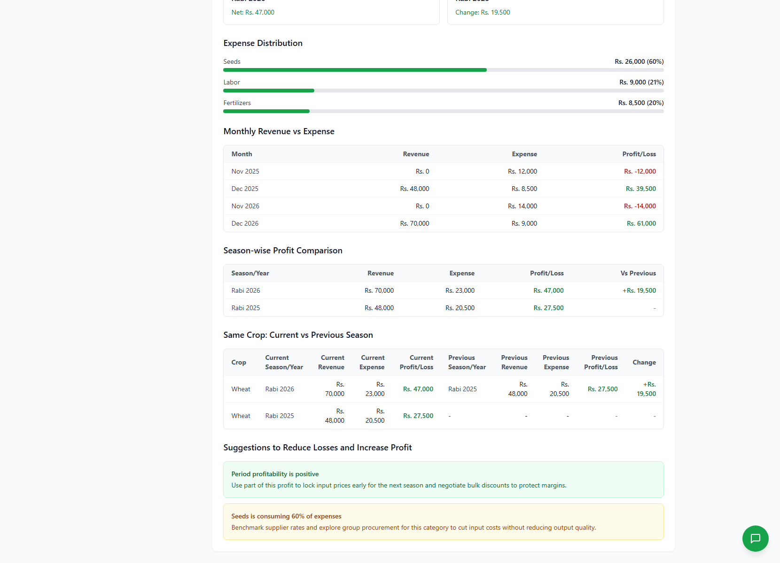
Figure: Same Crop Comparison

4. Edit Workflow

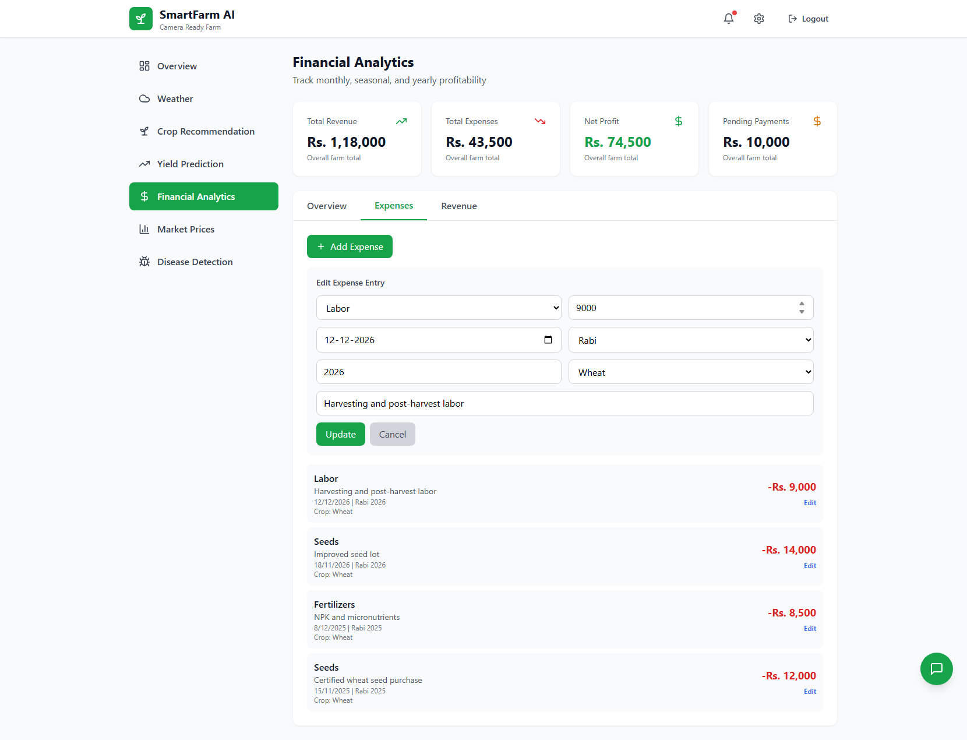
Figure: Edit Workflow

Results and Outcomes

- Unified application flow from onboarding to farm operations.
- Clear separation of frontend, backend, and data layers for maintainability.
- Practical module coverage aligned with common farmer workflows.
- Improved usability through chatbot-led guidance and persistent interaction history.

Limitations and Future Work

- Recommendation and prediction logic can be enhanced with trained ML models.
- External real-time weather and market APIs can replace sample/mock datasets.
- Mobile-first and offline-first workflows can further increase field usability.

Project Structure

Code Block (text)
project/
src/ # Frontend app (React + TypeScript)
server/ # Backend API (Express + SQLite)
supabase/migrations # Initial schema history from earlier setup

Prerequisites

- Node.js 18 or newer
- npm 9 or newer
- VS Code

Install and Run in VS Code

- Clone the repository

Code Block (bash)
git clone https://github.com/arun-19-n/smart-farming-platform.git

- Open the project in VS Code

- Start VS Code
- Go to `File > Open Folder...`
- Select the `project` folder

- Create environment files

Code Block (powershell)
Copy-Item .env.example .env
Copy-Item server/.env.example server/.env

- Install frontend dependencies (from `project`)

Code Block (bash)
npm install

- Install backend dependencies

Code Block (bash)
cd server
npm install
cd ..

- Run the app in two terminals inside VS Code

Terminal 1 (frontend):

Code Block (bash)
npm run dev

Terminal 2 (backend):

Code Block (bash)
npm run server:dev

- Open the app

- Frontend: `http://localhost:5173`
- Backend API health: `http://localhost:3001/api/health`

Useful Scripts

From the root project folder:

- `npm run dev` - start Vite frontend
- `npm run build` - build frontend for production
- `npm run preview` - preview production build
- `npm run lint` - run ESLint
- `npm run typecheck` - run TypeScript type checks
- `npm run server` - run backend server
- `npm run server:dev` - run backend with nodemon

From the project/server folder:

- `npm start` - start Express server
- `npm run dev` - start Express server with nodemon

Notes

- The backend creates `server/farm.db` automatically when needed.
- Keep `.env` and `server/.env` private and do not commit them.
- If port 3001 or 5173 is in use, stop the conflicting process or update your env values.

