***AN AUTOMATED IOT ENABLED FOREST FIRE DETECTION SYSTEM USING SENSOR NETWORK***

1**Senthil G.A 2Geerthik S 3Leonila T***Associate Professor,* *Assistant professor Assistant professor  
Dept. of Information Technology,* *Dept. of information technology Dept. of information technology*

*Agni College of Technology,* *Agni College of technology Agni College of technology*

Chennai, India*.* *Chennai India Chennai India*

[senthilga@gmail.com](mailto:senthilga@gmail.com) [geerthiks@gmail.com](mailto:geerthiks@gmail.com) leo.nila168@gmail.com

4**Saravanan k 5Arun Kumar G** *Student, Student   
Dep. of Information Technology, Dept. of Information technology*

*Agni College of Technology*, *Agni college of technology*

Chennai, India. *Chennai India*

[saravanansven@gmail.com](mailto:saravanansven@gmail.com) [aa7076996@gmail.com](mailto:aa7076996@gmail.com)

*Abstract*— The frequency and severity of forest fires continues to increase worldwide, there is an urgent need for technologies that will improve early detection and rapid response. This paper presents an IoT -based wildfire detection system designed to solve these problems. The system integrates a network of sensor nodes strategically placed in forest areas to create instant monitoring infrastructure. Sensor nodes are equipped with various environmental sensors such as temperature, humidity and smoke detectors to collect information about fire events. The nodes communicate wirelessly with the central IoT gateway, which integrates data and uses an IOT platform for data analysis and to notify. The IOT platform gathers different data’s it helps with the early stages of wildfires. Additionally, the system uses (GSM module) to provide accurate location information, allowing responders to quickly arrive at the emergency in a timely manner. The main goal of our device is to detect a forest fire and issue an alarm using IoT, Neo 6MGPS, and GSM, ESP32. The design of the system is made up of different types of sensors, these sensors play a major role in detecting the forest fire and used to alert the people nearby. Also, we are able to monitor the observed area in real-time via IOT webpage.

Keywords—GSM module, IOT, Neo 6MGPS, ESP32

# **INTRODUCTION**

.Forest fires are a widespread occurrence globally, especially in dry forests during the summer. These fires, varying in severity, annually consume vast expanses of forested areas. They pose a significant threat, causing harm to homes, animal habitats, trees, and natural resources. Additionally, they release toxic pollutants, including carbon dioxide, a major greenhouse gas, into the environment. The impact of forest fires extends beyond immediate damage. They contribute to the greenhouse effect and climate change by elevating atmospheric carbon dioxide levels. The aftermath of fires includes soil nutrient depletion, leading to increased risks of floods and landslides due to soil erosion. Given these challenges, it is crucial to establish a reliable method for detecting forest fires. The proposed solution involves the use of temperature and smoke detection sensors to identify fire signals. When a potential fire is detected, an alert is sent to the user through an IoT cloud server. This system ensures continuous monitoring of the forest, considering factors such as temperature, humidity, and air quality that may indicate potential fire risks. In the event of a fire, the system promptly notifies firefighters and authorities, streamlining the coordination of response efforts. Furthermore, by analysing historical data, the system can identify areas prone to wildfires and predict future outbreaks. This proactive approach enhances overall preparedness and response strategies to mitigate the impact of forest fires. Be cost-effective, covering vast swathes of forest for less than traditional methods like aerial patrols. Protect vital ecosystems and communities by minimizing fire damage and safeguarding wildlife and human settlements. Keep firefighters and rangers safe by giving them a heads-up on approaching flames.

The goal is to find the forest fire as quickly as possible, and pinpointing its exact location and notifying fire units as soon as to take action. The goal is to detect forest fires using various sensors and microcontrollers, and to warn the client through IOT cloud servers and mobile notification, as well as to detect forest fires and alert the fire unit so as they can respond appropriately and avoid any casualties. As a result, the development of an effective forest fire detection technique is required. It uses temperature and smoke detection sensors to detect afire signal and sends a warning to the client via an IOT cloud server. The primary goal of our device is to detect a fire and issue alarm using a buzzer and GSM.

II**. RELATED WORK**

Alexander A. Khamukhin *et.al.*, (2018) proposed a model on the utilization of (UAVs) for efficient forest fire tracking, particularly in large-scale crisis areas. The research explores a comprehensive model for forest fire detection using aerial videos, aiming to showcase its robustness in forest fire surveillance. The identification of fire pixels relies on analysing the colour and motions characteristics associated with fire. Extensive testing is carried out using a diversified database comprising different scene situations in order to evaluate the accuracy of our fire detection algorithm. The research utilizes 49 aerial films totaling 16,898 frames that are devoted to the analysis of forest fires. The outcomes of this study underscore the effectiveness of the proposed forest fire detection model, especially in large-scale crisis areas. By addressing the limitations and introducing a smoke detection stage, the model demonstrates improved accuracy in identifying fire areas, particularly in the presence of thick smoke.

*Evizal Abdul Kadir et.al., (2023*) proposed a model for a major problem and catastrophe in Indonesia due to the country's tropical location and the prevalence of peat land, which poses a high risk of burning, especially during the dry season. Forest fires are frequent in Riau Province, affecting Indonesia's entire length and width. This study proposes the establishment of (WSNs) in Indonesia for the identification of forest fire hotspots, with an emphasis on Riau Province, which is one of the areas with a high risk of forest fire during the dry season. Land sensor systems gather environmental data and report any modifications to a data center for review using WSN technology. Sensors will be installed at a variety of locations, including those that have recently seen a fire and those that are expected to do so in the future. Mathematical simulation is used in this case to model the number of sensors that must be installed as well as the forest's size. The design and development of WSNs has a significant effect and feasibility in solving Indonesia's current forest fire and fire hotspot detection problems. WSNs were used in the development of this system, which are ideal for early warning and detection.

### **III. PROPOSED SYSTEM**

For a forest fire detection system choosing the right sensor technology is essential to guaranteeing accurate and trustworthy data collecting. The proposed fire alarm system comprises temperature, smoke, and fire sensors, all interconnected to facilitate efficient detection of fire outbreaks. These sensors serve as the primary components responsible for monitoring environmental conditions and detecting any deviations indicative of a fire. During a fire event, these sensors can detect various factors that undergo significant changes, such as temperature elevation and smoke presence. The detected data from the sensors are fed into the Arduino Uno, which acts as the central processing unit of the system. The Arduino Uno is tasked with processing the analog inputs received from the sensors, analysing them against predefined threshold values. These threshold values are carefully set to distinguish normal environmental variations from potentially hazardous conditions associated with a fire outbreak. Upon detecting values beyond the established thresholds, the Arduino Uno initiates the warning mechanism of the fire alarm system. In addition to triggering an alarm to alert nearby individuals or occupants, the Arduino Uno utilizes a GPS module to determine the precise location of the sensor detecting the abnormal conditions. This location information is crucial for facilitating swift response measures, enabling responders to quickly pinpoint the source of the fire and take appropriate action.In essence, the Arduino Uno serves as the core component responsible for processing sensor data, evaluating it against predefined thresholds, and initiating timely warnings in the event of a fire outbreak. By integrating the Arduino Uno with temperature, smoke, and fire sensors, along with a GPS module for location tracking, the proposed fire alarm system offers a comprehensive solution for early detection and notification of fire incidents, thereby enhancing overall safety and minimizing potential damage.

**IV METHODOLOGY**

This paper emphasizes the significant role of the IoT in addressing the challenge of early detection of forest fires. The device introduced in this study incorporates multiple sensors and utilizes wireless communication for data transmission to carry out this task. The collected data is then transmitted to a satellite, which relays it to a ground station for analysis. The proposed system, leveraging IoT technology, contributes to the early identification of potential fire threats.

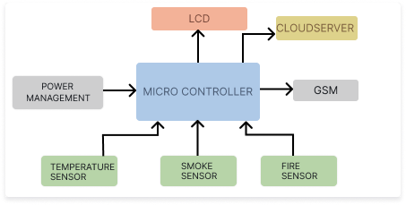

Fig.1. Block Diagram

**4.1 INTERNET OF THINGS**

A network of physical items, including appliances, wearables, and cars, that have sensors, software, communication, selectors, and electronics installed is known as the IoT. These components work together to collect and exchange data, facilitating the monitoring and management of various aspects. In simple terms, IoT allows things, individuals, or communities to share information with a network, enabling communication not only between devices but also involving interactions between people and devices. In our project, we have utilized the Arduino UNO board as the main microcontroller. This board serves as the central hub connecting all the detectors, modules, and other components in our system.

**4.2 ARDUINO UNO**

The name "Uno" originates from the Italian word "uno," meaning "one" or "1." The Arduino Uno microcontroller board is powered by the ATmega328 microcontroller. This board features a total of 14 digital pins, 6 analog pins, a 16-megahertz ceramic resonator, a USB port, and a power input. It comes equipped with all the essential components for initiating microcontroller projects, includes a USB cable for connecting it to a device and an AC-to-DC adapter or battery for power. This comprehensive setup makes it convenient for users to start working with the microcontroller without the need for additional components. The alternate is an unconnected leg that can be used latterly. It has been created a more effective RESET circuit. In place of the 8U2, use a super 16U2 It was chosen as the totem for the Arduino1.0 release. In the future, the Uno and first interpretation of Arduino will be the base model. In our design we've used Arduino UNO board as our base microcontroller which connects all the detectors, modules and other factors. This Arduino UNO board does all the work demanded in the design.

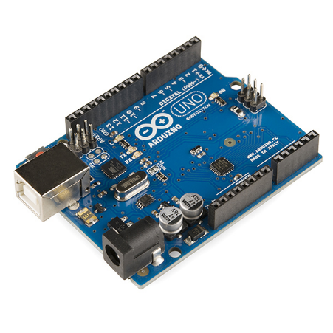

Fig.2.Arduino uno

**4.3** **SENSORS**

Sensors play a crucial role in detecting and monitoring forest fires, helping to provide early warnings and facilitate a rapid response. Various types of sensors can be used in forest fire detection systems. Here are some common types:

**Temperature Sensor** detect infrared radiation to capture heat signatures. They can identify hotspots and areas with increased temperatures, indicating a potential fire. Thermocouples and Thermistors: These sensors measure ambient temperature and can be strategically placed to detect sudden temperature increases.

**Smoke Detector** use light to detect smoke particles in the air. In a forest fire, the presence of smoke can be an early indicator of a potential fire outbreak. Ionization Smoke Detectors: These sensors detect changes in ionization caused by combustion particles present in smoke.

**Fire sensor** detects and reacts to the fire. It sounds the alarm devices, cutting the fuel lines and activating the fire distinguishing systems, responding to the fire blaze. When used in industrial furnaces, their aim is to ensure that the furnace is working properly; they do not take any action other than to warn the operator or control system in these circumstances.

**4.4 FLOW CHART**

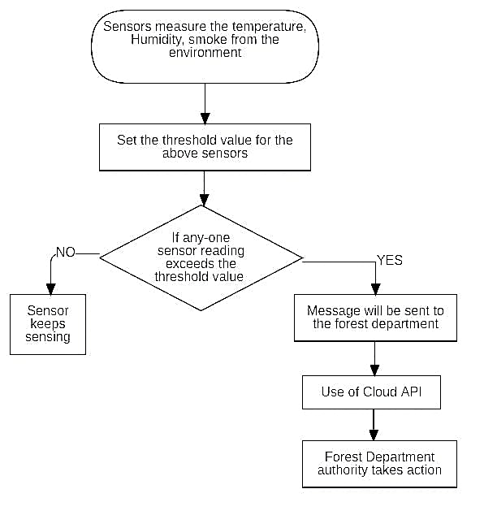

Fig .3. Flow chart

## **3.6. ESP8266 Micro controller**

The NodeMCU project is an IoT platform that is free to users to interact and we have implemented in our work model. It includes firmware for a ESP8266 from Systems, as well as components for the ESP-12 frame. The name "NodeMCU" refers to the framework or the firmware. It is simply written in Lua language, a scripting language. It's built with the Espress if Non-Open-Source Software Development Kit for ESP8266 and is based on the eLua project. The ESP8266, on the other hand, is difficult to navigate and used as a chip. We also program it in low-level computer language such as embedded C, micro python, etc., such that the chip hardware can understand. The NodeMCU integrates the arduino UNO and Raspberry pie for a combined application. It is made up of two main components. 1. An ESP8266 firmware designed on top of a proprietary Software Development Kit from the chip manufacturer. The eLUA is an easy script and has a large developer2. A DEVKIT board with an ESP8266 chip mounted on a regular circuit board. It has an USB that is connected to the board, a reset button, an WIFI chip, LED lights. The ESP8266 board embedded with devkit is shown in below figure community. The Arduino project that we have included builds a portable IoT controller. This setup has a USB port, LEDs, and basic data, similar to NodeMCU. It can interact with sensors and other circuit boards via the inbuilt pins. The Arduino module, unlike the NodeMCU, may have a range of CPU, memory chips for storage, and user interactive environments to interact with it. In reality, the ESP8266 MCU is similar to an Arduino board. Since, the Arduino board lags in many features like WIFI connectivity, USB port connectivity, inbuilt camera, etc. We had preferred the use of ESP8266 microcontroller at the client end to communicate with the Arduino setup without any delay via WIFI connectivity. They perform well unless and until they are under a common subdomain

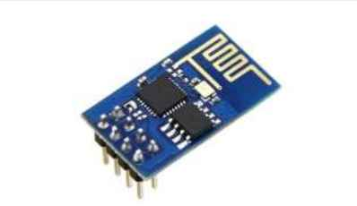

Fig 4 ESP8266 Micro controller

**V IMPLEMENTATION**

The implementation of a Forest Fire Detection system utilizing IoT technology involves a meticulous integration of various components and a systematic approach to ensure its effectiveness in mitigating the risks posed by wildfires. At the core of this system lies the integration of sensors with an Arduino UNO board, specifically calibrated to monitor the environmental conditions prevalent in forested areas. Temperature and smoke sensors are strategically placed to capture vital data that could indicate the presence of a fire.Once integrated, the system continuously acquires data from these sensors, employing programmed algorithms to analyze readings against predefined threshold values. These thresholds serve as indicators of abnormal levels, which could suggest the onset of a forest fire. This proactive monitoring is crucial in enabling timely responses to potential fire outbreaks, thereby minimizing the extent of damage. Upon detecting values beyond the established thresholds, the system initiates an alert mechanism designed to promptly notify relevant parties about the potential fire hazard. This alert mechanism encompasses multiple layers of notification, ensuring comprehensive coverage. Firstly, a GSM module is employed to send SMS notifications to registered mobile numbers, providing detailed information about the detected anomaly. Simultaneously, a local alarm, typically in the form of a buzzer, is activated to alert nearby personnel or inhabitants, enabling immediate action at the site of detection.

In addition to alerting stakeholders, the system incorporates location tracking capabilities facilitated by a GPS module. This enables the precise determination of the fire's location, which is essential for coordinating response efforts effectively. Including location data in mobile notifications ensures that responders can quickly pinpoint the affected area, facilitating a timely and targeted intervention.The IoT connectivity aspect of the system plays a pivotal role in enabling real-time monitoring and data logging. By leveraging IoT protocols, sensor data is transmitted to a cloud server, where it can be accessed remotely by authorized personnel. This centralized data management approach not only facilitates continuous monitoring but also enables historical analysis of trends and patterns, aiding in the refinement of fire detection algorithms over time.Power management is another critical consideration in the design and implementation of the Forest Fire Detection system. Given the remote locations typically associated with forested areas, designing a reliable power supply is imperative. In this context, the integration of renewable energy sources, such as solar panels, offers a sustainable solution to power the system over extended periods, reducing dependence on conventional grid-based electricity.Before deployment in actual forest environments, rigorous testing is conducted to validate the system's functionality and reliability under varying conditions. This testing phase allows for fine-tuning of sensitivity settings and ensures that the system meets the stringent requirements of real-world fire detection scenarios.

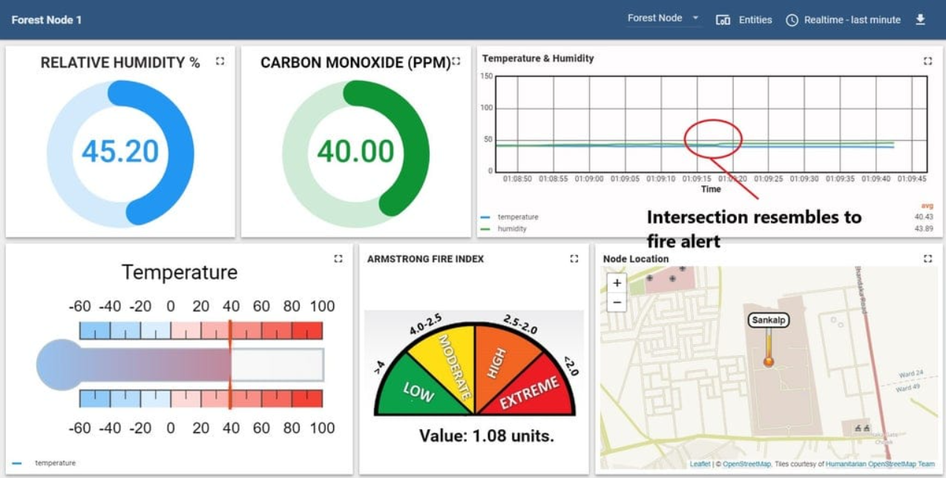

In summary, the implementation of a Forest Fire Detection IoT system involves a comprehensive approach encompassing sensor integration, data acquisition, alert mechanisms, location tracking, IoT connectivity, power management, testing, and maintenance. By addressing each of these components with diligence and attention to detail, the system can effectively detect and respond to forest fires, safeguarding lives and minimizing environmental damage

. 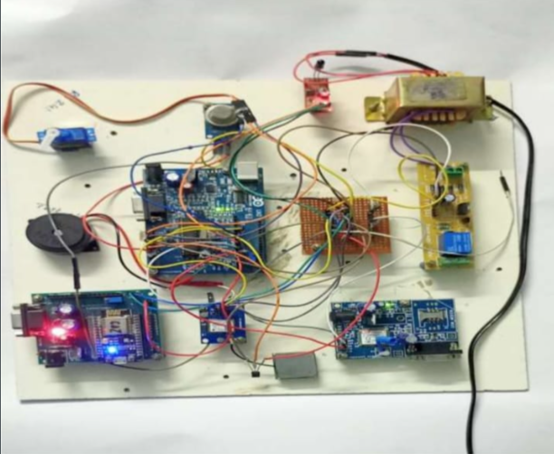

.

**VI RESULTS**

The fire detection system employs three sensors - fire, temperature, and smoke detection sensors, which relay information to the Arduino UNO board upon detecting changes in the surroundings. Once confirmed by the Arduino, connected components including the IOT module ESP8266, GSM module, and a buzzer, are activated for output. The primary alert mechanism utilizes the ESP8266, allowing real-time global monitoring through an internet-connected webpage. The Arduino sends temperature, smoke, and geographic coordinates data to the ESP8266, which uploads it to the webpage. However, internet access is necessary for this feature. A secondary alert via mobile phone notification is facilitated by the GSM module, sending alerts and geographic coordinates to the designated person's mobile number without internet dependency. Additionally, a buzzer is incorporated as a traditional local alert method, sounding when the sensors detect fire-related changes, ensuring notification to those without access to internet or mobile signals. This multi-layered approach enables swift response and coordination in fire emergencies, catering to various communication needs and scenarios.

**VII. CONCLUSION**

The main power of 220 volts will fry out the circuitry so we apply the power to a step-down motor where the current is been step- downed from 220V to 12V. The current from the motor is an interspersing current, the factors majorly used are digital factors. Hence, an Analog to Digital Converter is used to transfigure the interspersing current into direct current. This, Direct Current is fed to all the factors like WIFI module, ESP8266 microcontroller, servo motored.

In forest the input power can be attained from a solar panel setup, where the current is been carried out to all the bias. An Arduino UNO serves as a embedded device that binds the major input sources like temperature detector, fire detector and bank detector. The fire detector detects the infra-red radiation emitted from the thick fire, while the temperature detector detects the rise in temperature over the girding by nonstop monitoring and the bank detector detects the unusual bank caused by the fire. These are the introductory three checksums that are attained to descry the precise timber fire condition.

**VIII.FUTURE WORK**

The improved system can be unfolded for tenementappliances and in industries also. However, the system above is meant for a sincere opinion news only. As a tomorrow aggravation, several-decision company through the IOT landing is study a object and the exploration is being done to effectuate this enormous toil. It is trust that with the technological advancements profitable in instant age scenario, the above rehearse several-opinion correspondence will also be unfold in delay environments

**REFERENCES**

[1] Alexander A. Khamukhin et al: Aerial Forest Fire Surveillance - Evaluation of Forest Fire Detection Model using Aerial Videos,” Future Genre. Compute. Syst., vol. 29, no. 7, pp. 1645–1660, Sep. 2018.

[2] Shixiao Wu et al, “Speculation of Forest Fire Using Spatial and Video Data”, 2019 4th IEEE Conf. Ind. Electron. Appl. ICIEA 2009, pp. 520–523, 2018.

[3] Evizal Abdul Kadir et al, “Modeling of Wireless Sensor Networks for Detection Land and Forest Fire Hotspot,” Int. J. Distrib. Sens. Netw., vol. 2019, no. March, 2019.

[4] The Zettabyte Era-Trends and Analysis. Cisco, May 2013. [Online]. Available: [http://www.cisco.com/en/US/solutions/collateral/ns341/ns52 5/ ns537/ns705/ns827/VNI_Hyperconnectivity_WP.html](http://www.cisco.com/en/US/solutions/collateral/ns341/ns52%205/%20ns537/ns705/ns827/VNI_Hyperconnectivity_WP.html)

[5] T.L. Divya et al: Speculation of Forest Fire Using Spatial and Video Data. 2019

[6] O. Vermesan, M. Harrison, H. Vogt, K. Kalaboukas, M. Tomasella, K.Wouters, K. U. Leuven, S.Gusmeroli, and S.Haller, “Internet of Things strategic research roadmap” in Proc. Eur. Union IoT Cluster Strategic Res. Agenda, pp. 9– 51, 2020. [Online]. Available: [http://www.internetofthingsresearch.eu/pdf/IoT_Cluster_Strategic_Research_Age nda_2011.Pdf](http://www.internetofthingsresearch.eu/pdf/IoT_Cluster_Strategic_Research_Age%20nda_2011.Pdf)

[7] E. De Poorter, I. Moerman, and P. Demeester, “Enabling direct connectivity between heterogeneous objects in the Internet of Things through a network-service-oriented architecture,” EURASIP J. Wireless Commun.Netw., vol. 2021, no. 61, pp. 1–14, Aug. 2020. [Online]. Available: <http://jwcn.eurasipjournals.com/2011/1/61RESEARCHOpen>

[8] S. Farrell, “Security in the Wild,” IEEE Internet Compute., vol. 15, no. 3, pp. 86–91, May/Jun. 2022

[9] ARM targets Internet of Things with New Low-Power Chip. Institute of Nanotechnology. [Online]. Available: http:// www. Instituteofnanotechnology.co.uk/arm-targetsInternet-of-things-withnew- low-power-chip

[10] C. Kao and S. Chang, “An Intelligent Real-Time Fire-Detection Method Based on Video Processing,” IEEE 37th Annu. 2019 Int. Carnahan Conf. On Security Technol. 2019 Proc., 2018.

[11] N. I. Binti Zaidi, N. A. A. Binti Lokman, M. R. Bin Daud, H. Achmad, and K. A. Chia, “Fire recognition using RGB and YCbCr color space,” ARPN J. Eng. Appl. Sci., vol. 10, no. 21, pp. 9786–9790, 2020

[12] J. Apcar, “Routing in the Internet of Things/M2M Networks,” presented at the Ciscolive365.