Early Pest Detection From Crop Using Image Processing And Computational Intelligence

In this project author is using SVM classifier to predict early pest detection as this can help farmer in saving their crop and this early prediction help farmer in deciding suitable quantity of pesticide. Increasing amount of pesticide can cause damage to human or less pesticide cause damage to crop.

In this project author has trained SVM classifier with whitefly and Aphids insects as this insect cause heavy loss to crop.

To implement this project we have trained SVM with 3 different classes such as ['Aphids','Uneffected','Whitefly'] and below is those classes images

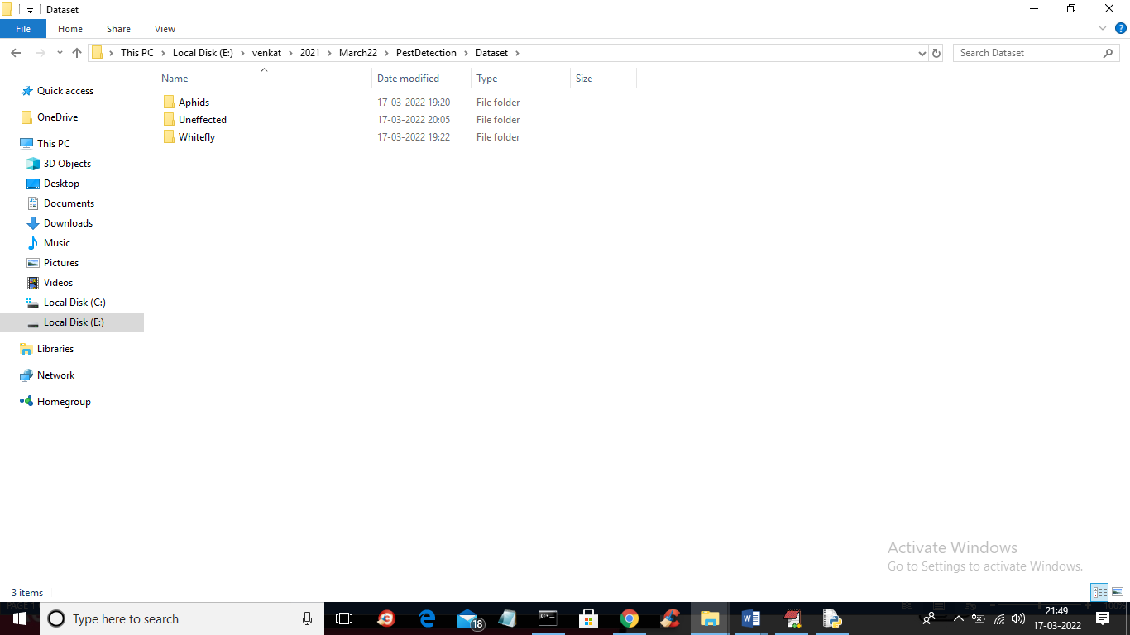

In above screen go inside any folder to see that class images and below is the white fly images

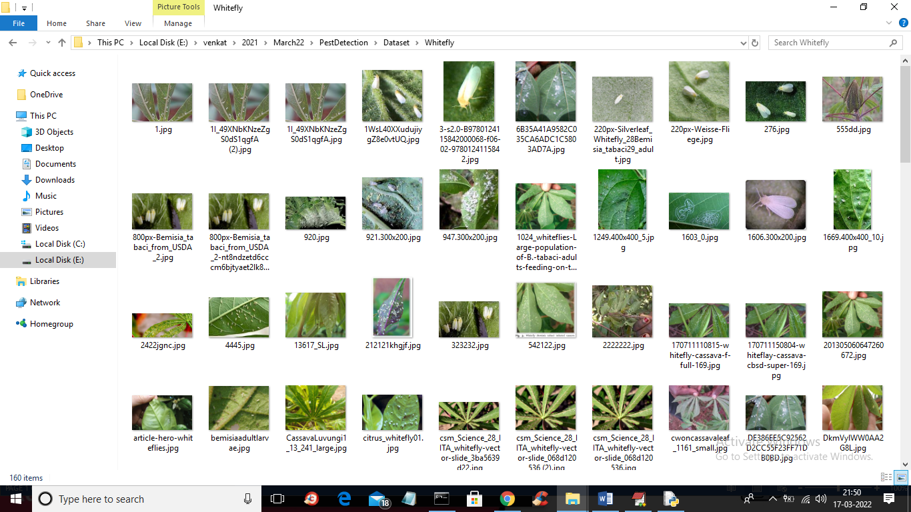

We will use above images to train SVM and we designed following modules

1. Upload Pest Dataset: using this module we will upload dataset to application
2. Preprocess Dataset: using this module we will acquire images from dataset and then filter images to grey colour and then normalize images and then split dataset into train and test part where application use 80% images for training and 20% for testing
3. Run SVM Algorithm: process images will be input to SVM algorithm for training and then calculate its prediction accuracy.
4. Check for Effected from Test Image: using this module we will upload test image and then SVM will predict type of pest as Aphid, White fly or Uneffected.

SCREEN SHOTS

To run project double click on ‘run.bat’ file to get below screen

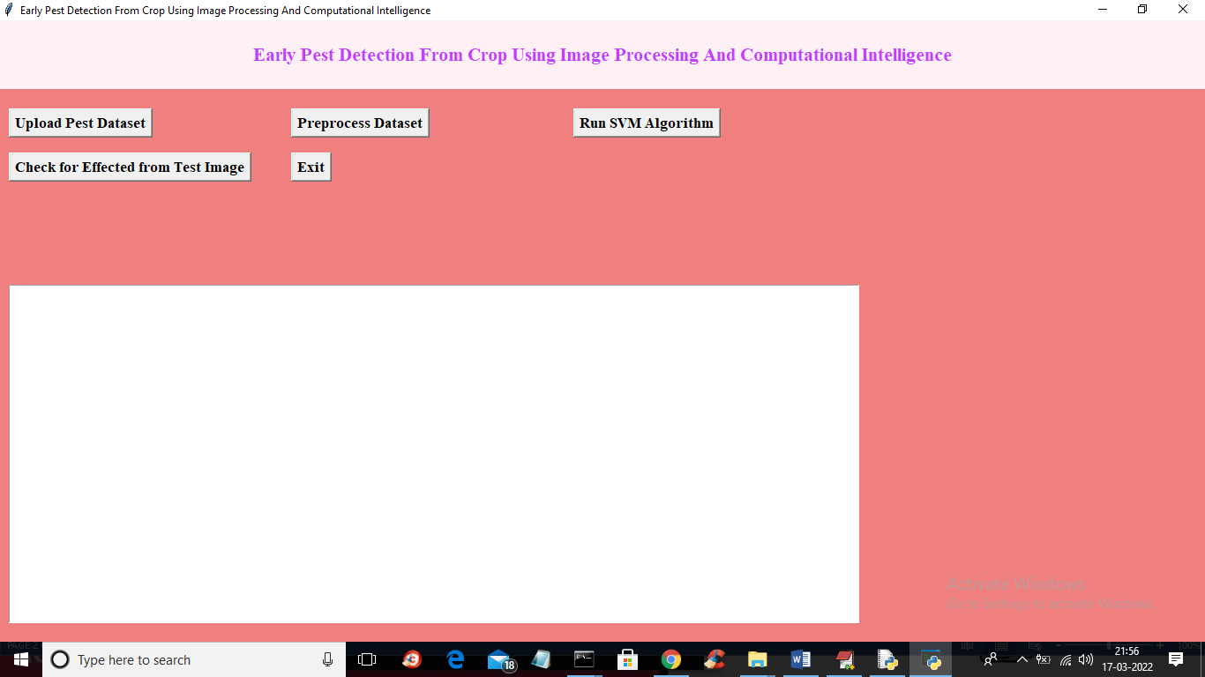

In above screen click on ‘Upload Pest Dataset’ button to upload dataset and to get below screen

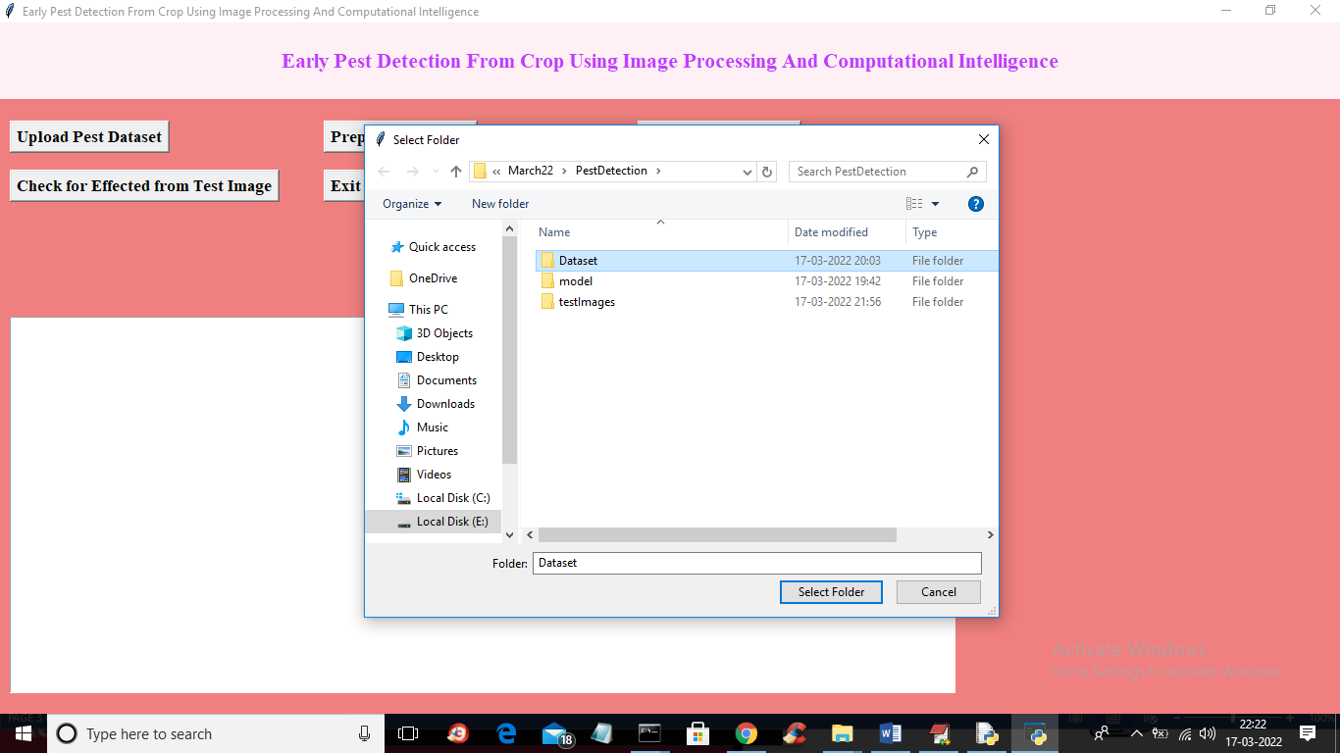

In above screen select and upload ‘Dataset’ folder and then click on ‘Select Folder’ button to load dataset and to get below screen

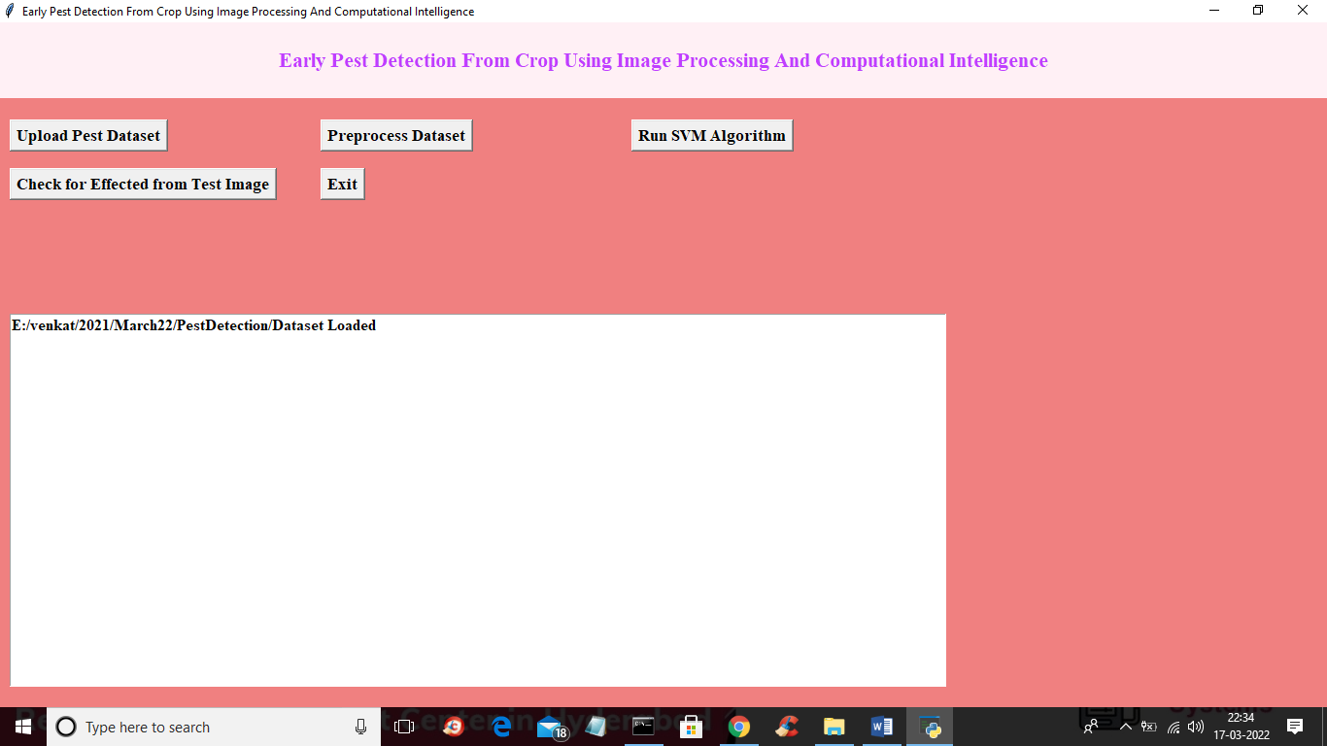

In above screen dataset loaded and now click on ‘Preprocess Dataset’ button to read and normalize images and then split dataset into train and test part.

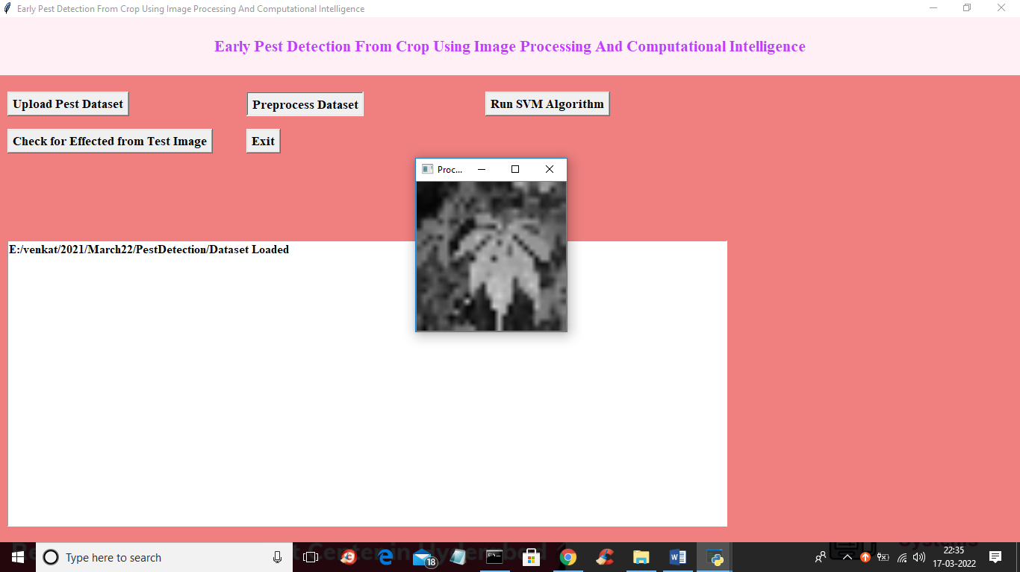

In above screen displaying processed grey image and now close above image to get below screen

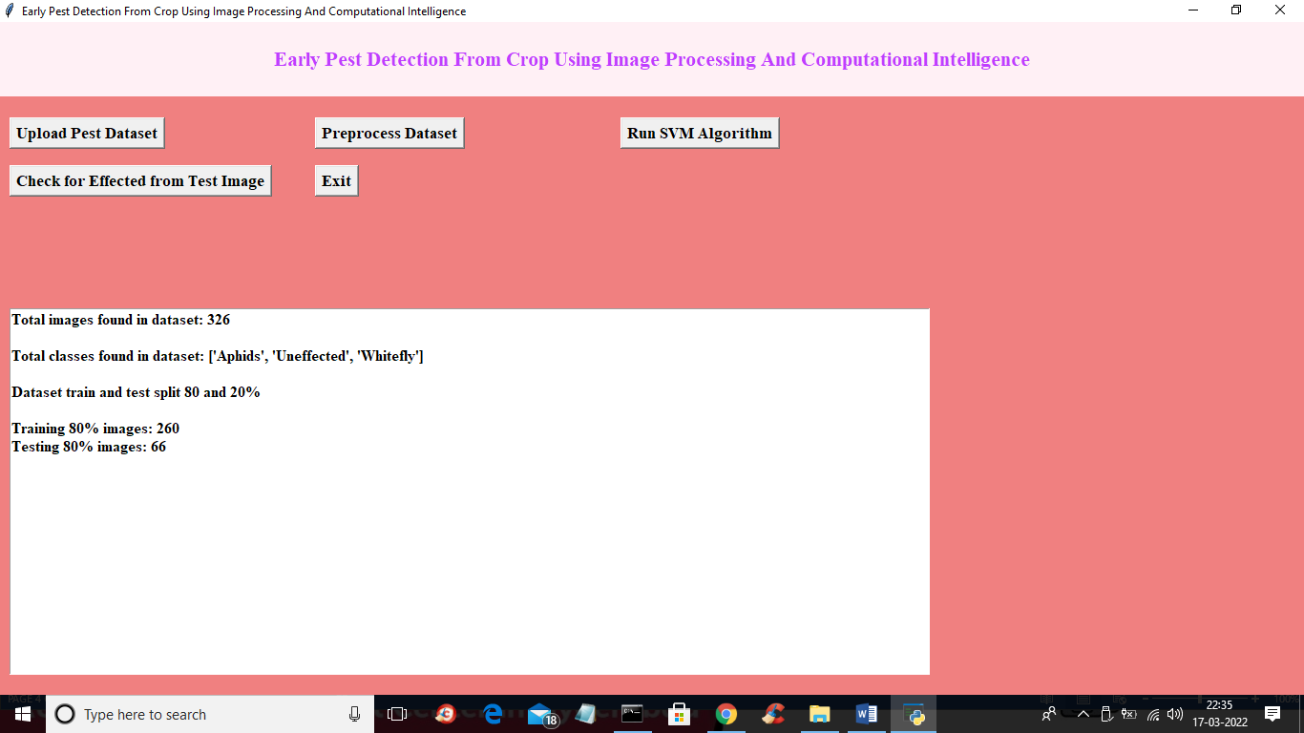

In above screen we can see number of images and classes found in dataset and now click on ‘Run SVM Algorithm’ button train SVM with processed images and then calculate it’s prediction accuracy

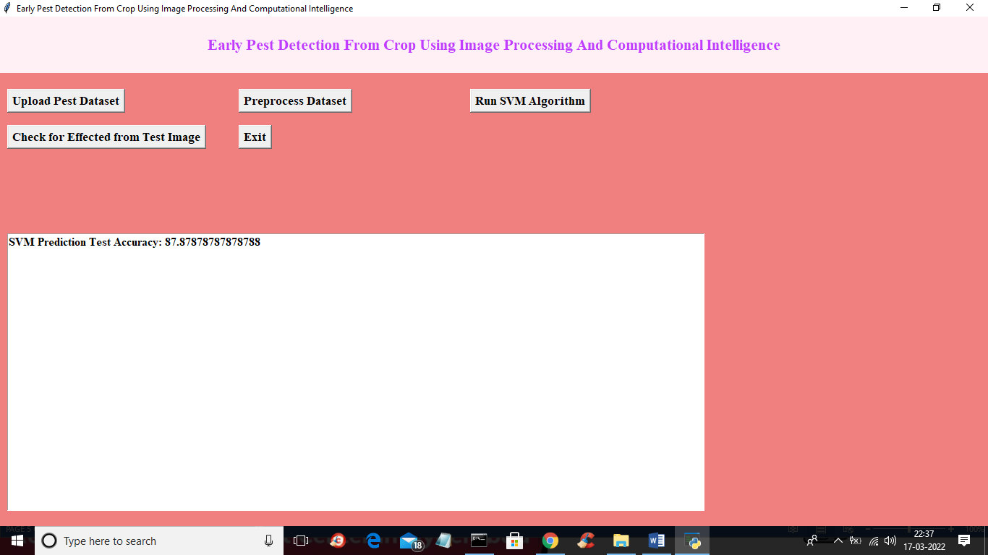

In above screen with SVM we got 87% prediction accuracy and now click on ‘Check for Effected from Test Image’ button to upload test image like below screen

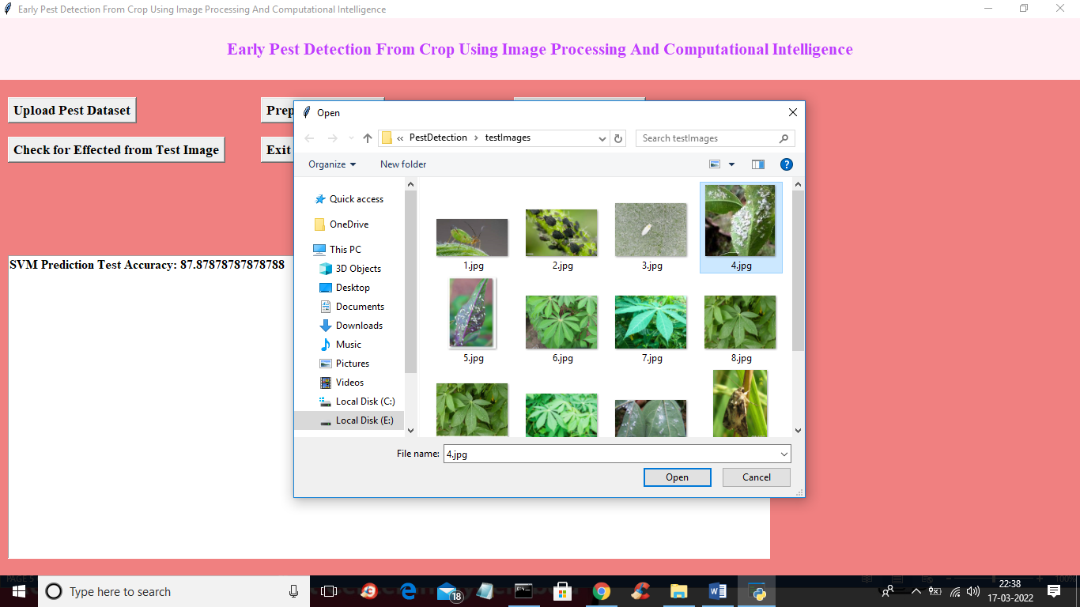

In above screen selecting and uploading 4.jpg file and then click on ‘Open’ button to get below output

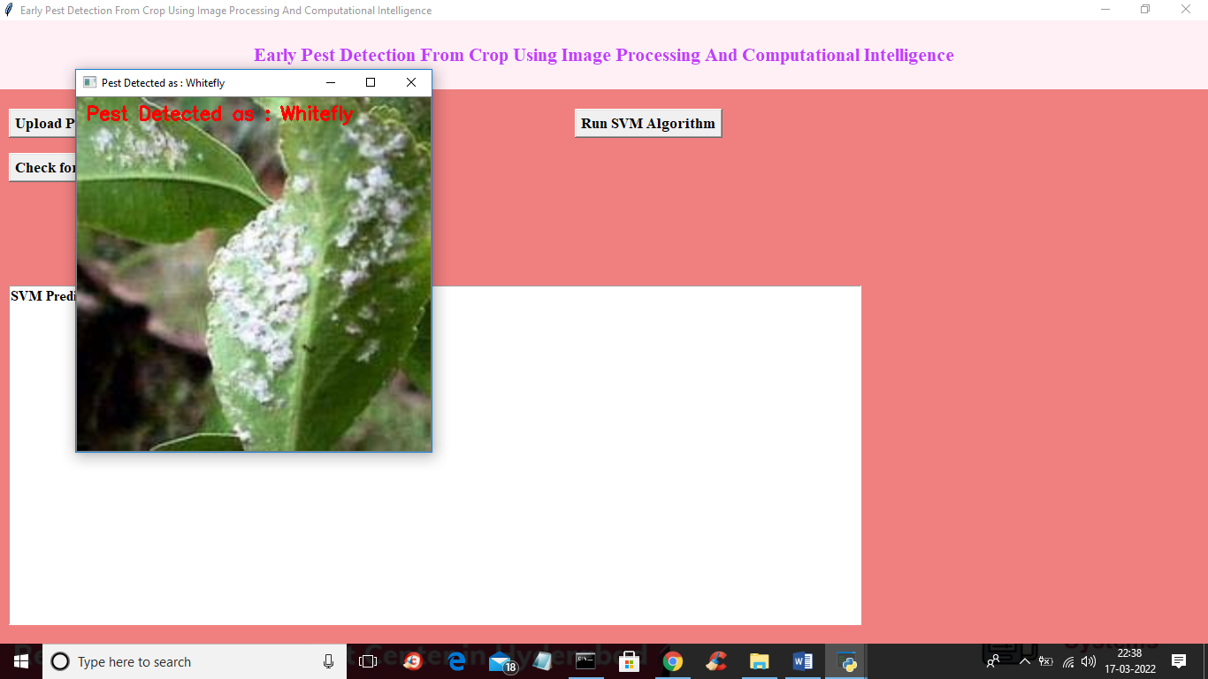

In above screen in red colour text we can see SVM predicted/classified uploaded image as ‘whitefly’ and similarly you can upload and test other images

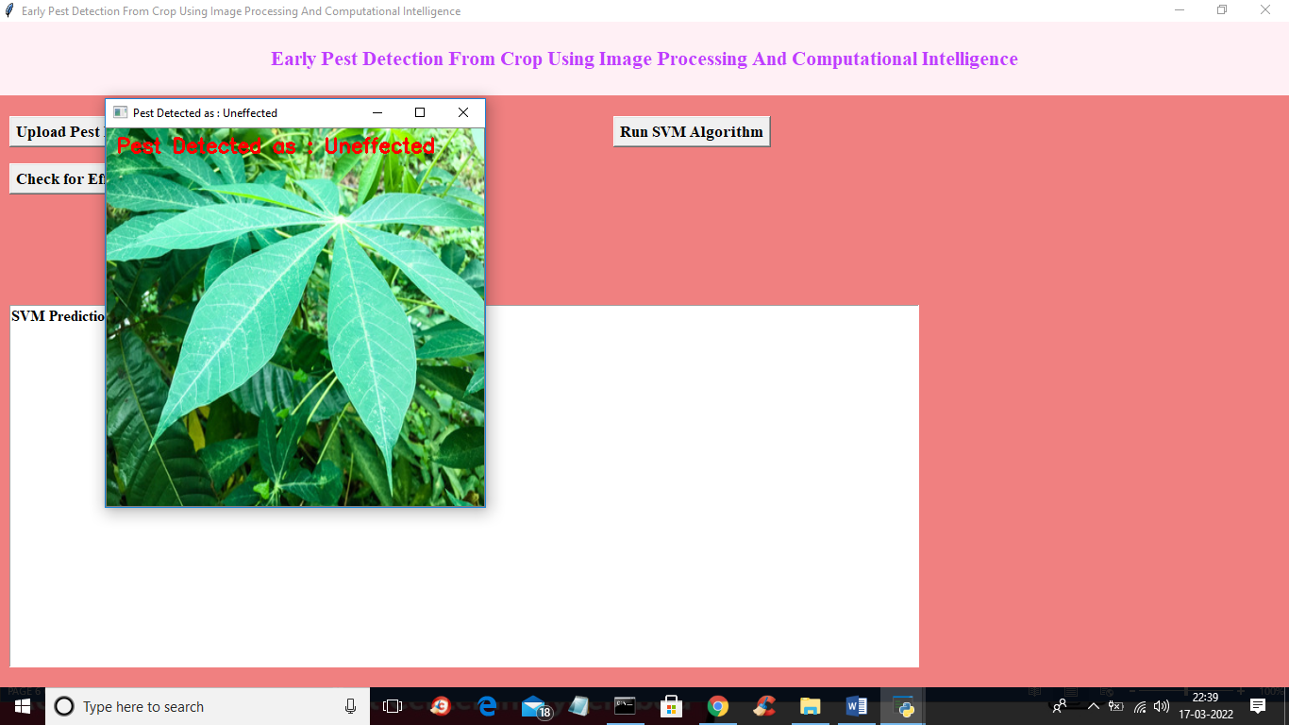

In above screen uploaded image is predicted as ‘Uneffected’ as it not contains any pest.

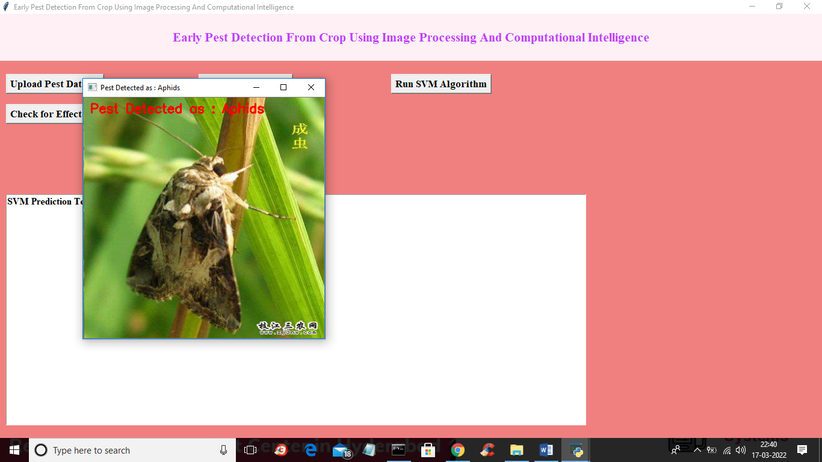

In above screen uploaded image is classifier as ‘Aphids’