# **DATABASE MANAGEMENT SYSTEM**

# **PROJECT NAME :- DECENTRALIZE FILE SYSTEM**

Based on **Blockchain Technology** Powered by **Ethereum**.

Team Members: **Arun Sardar** (Roll No 222123014)

**Vikash Kumar** (Roll No 222123059)

**Project Description**: In this project User can store their personal files, images, documents etc. by connecting Digital Wallet MetaMask. It is secure, transparent and Decentralized way of uploading files into IPFS Network, also can give access to the people so that he/she can only **Read** the files. All the information and transaction will be stored in Smart Contract (Blockchain).

**Tools & Technologies**: 1. Frontend (**ReactJs**)

2. Smart Contract (**Solidity** Language)

3. Test and Deployed on **Hardhat** Node.

4. **IPFS** (**Pinata** as a service)

5. **EtherJs** (to interact with Blockchain)

**Steps of Using project :-**

1. User can connect to the File System by log in to the digital wallet **MetaMask**. All the transaction will take place through MetaMask by Ethereum Crypto Currency.

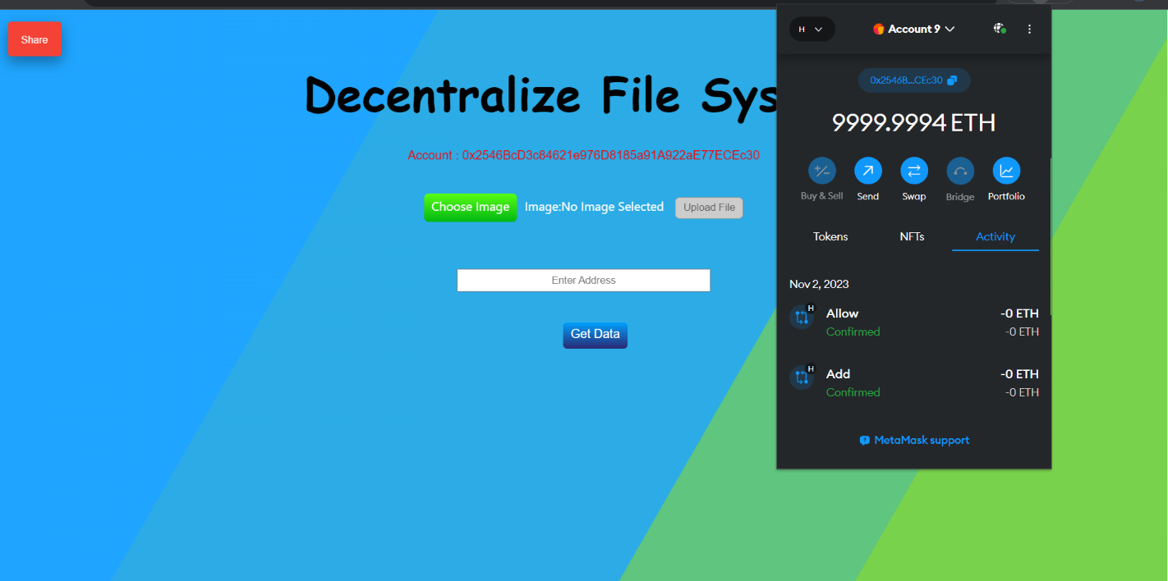

**2.** **To Upload file** - User have to choose file then click **Upload Button**. When file is uploading at the same time transaction will be happen. once transaction confirm it means file uploaded successfully to the **IPFS** (Pinata as a Service) and transaction will be stored in Smart Contract.

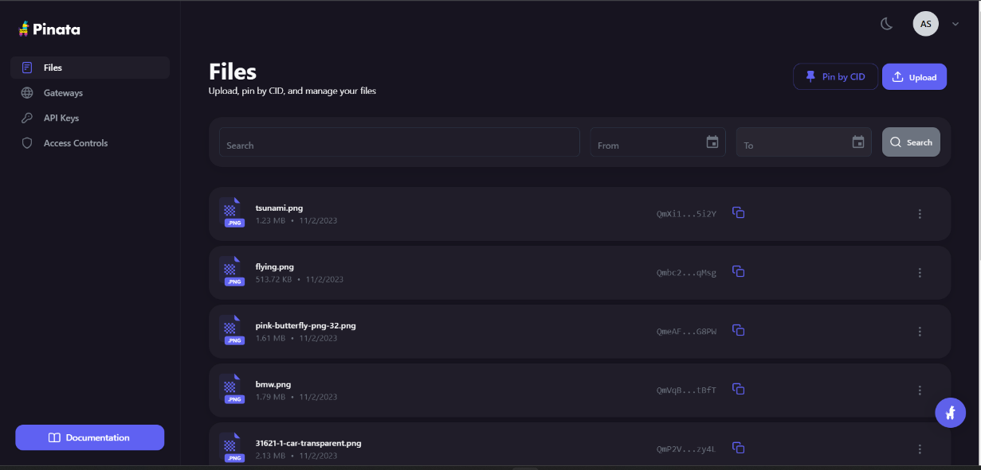

**3. To see Uploaded file** - User have to click Get Data button

then user can see all the file that uploaded by his Account.

**Note:** Only that users can see the files whose account is logged in into the MetaMask and uploaded from his own account. other users can't see images until they get access.

If he/she try to see another account the he/she will get an alert message that “you have not access”.

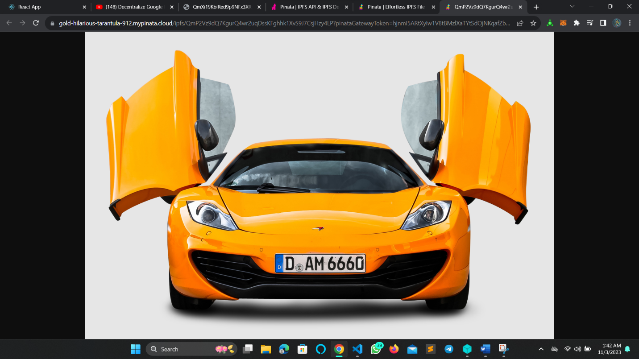

**4. Give access to another users –**

(a). First click **Share button**.

(b). Enter the account of users you want to give access.

(c). Click another **share button**. once share button clicked then MetaMask will be open and transaction will be happen. once transaction done it means you have given access to that user. now that user can see your files by login to the MetaMask.

