DPP – 19
Question 1
Apply Data Validation to restrict Quantity values to only whole numbers between 1 and 10.
Ans : Please follow mentioned steps to achieve the scenario :
- Select the Quantity column
- Go to Data-> Data Validation
- Click on Add Rule.
- Select the range and criteria -> Is between 1 and 10
- In Advance Options select If data is Invalid ->Reject the Input
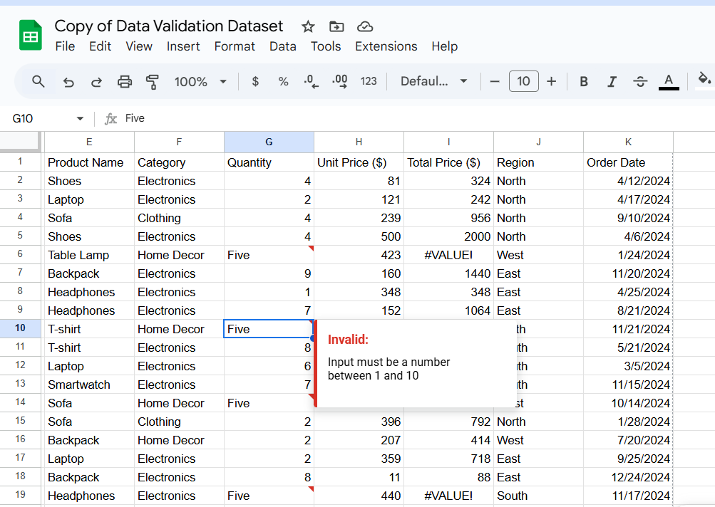

Question 2
Highlight all "Total Price" values greater than $2000 in green using Conditional Formatting.
Ans : Please follow mentioned steps to achieve the scenario :
- Select the Total Price column .
- Select Format -> Conditional Formatting
- In Format Cells if -> Greater than -> 2000
- Formatting style -> Fill with green color
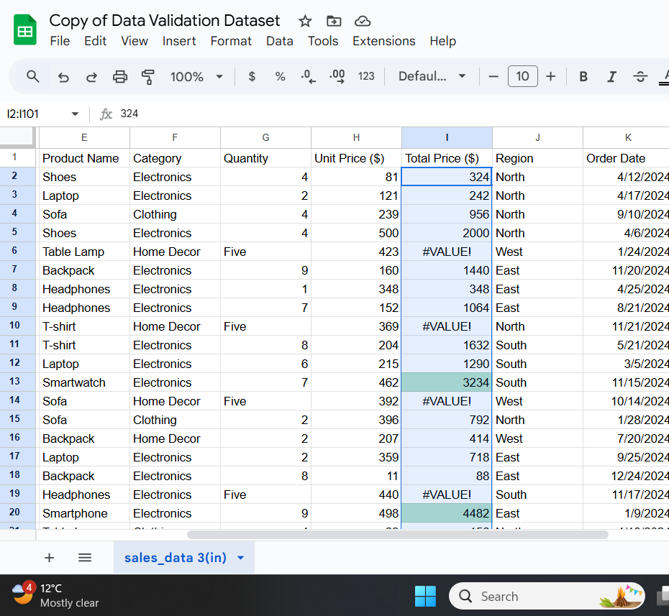

Question 3
Remove duplicate records where "Order ID" is the same.
Ans : Please follow mentioned steps to achieve the scenario :
- Select Order Id column .
- Navigate to Data -> Data Clean Up -> Remove Duplicates
- Duplicates will be removed from the dataset.
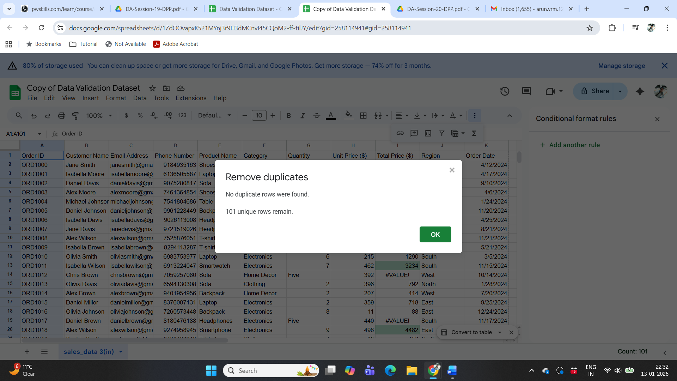

Question 4
The "Customer Name" column contains full names. Split them into "First Name" and "Last Name."
Ans : Please follow below steps:
- Select the Customer name column.
- Click on the Data -> Split text To Columns option
- Select Delimited option, select space option and in destination select the First name column address($C$2) and click Finish button.
- Drag the values to bottom of same column and select the Flash Fill option .
- The first name and last name should be populated successfully.
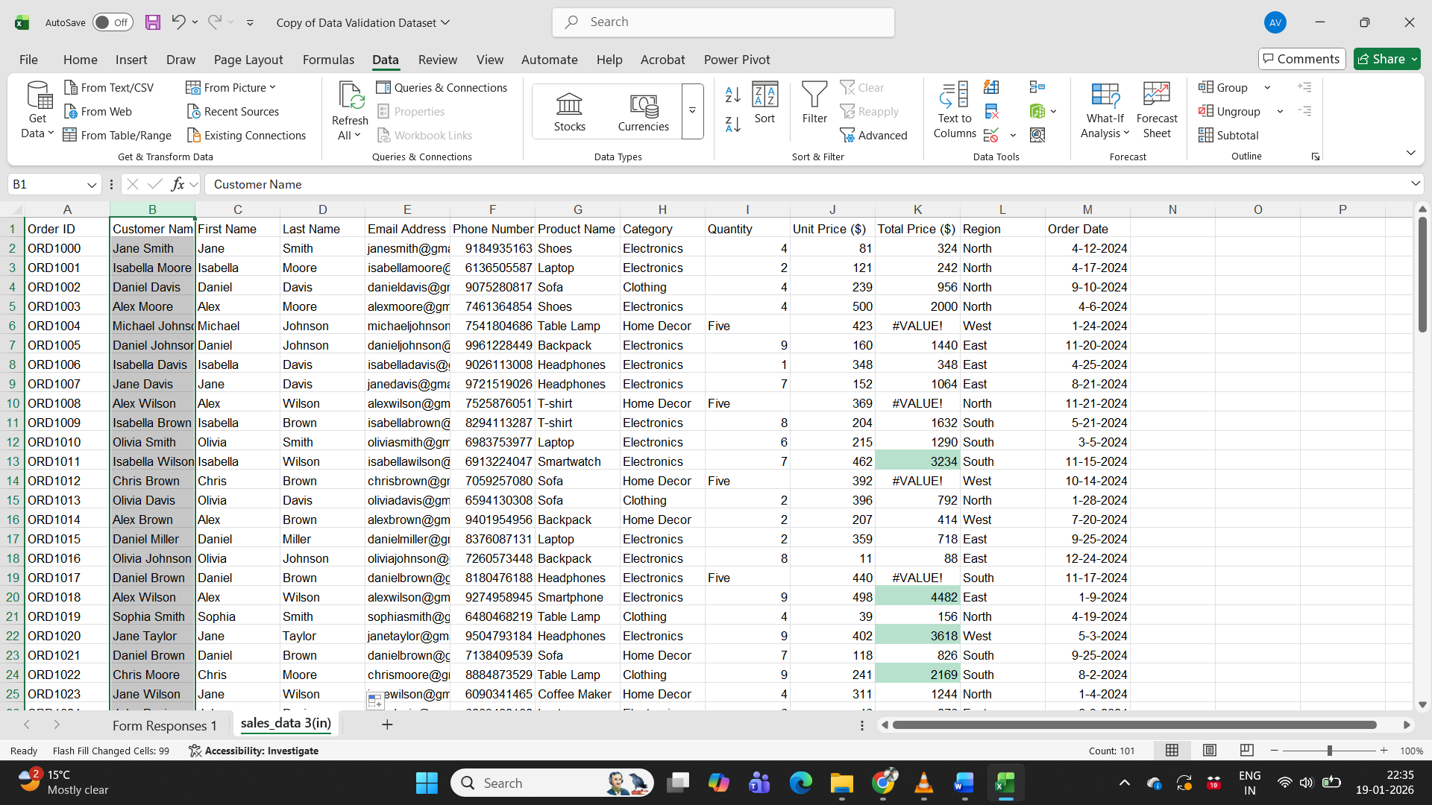
Question 5
Use Conditional Formatting to highlight rows where "Category" is "Electronics" and "Total Price" is greater than $1000.
Ans : Please follow below steps:
- Select the Category column and click on the Conditional Formatting option -> New Rule-> Use formula to determine which cell to highlight
- In the formula tab and write formula =AND($H2=’Electronics’,$K2>1000)
- In the applies to section select the range where the rule has to be applied.
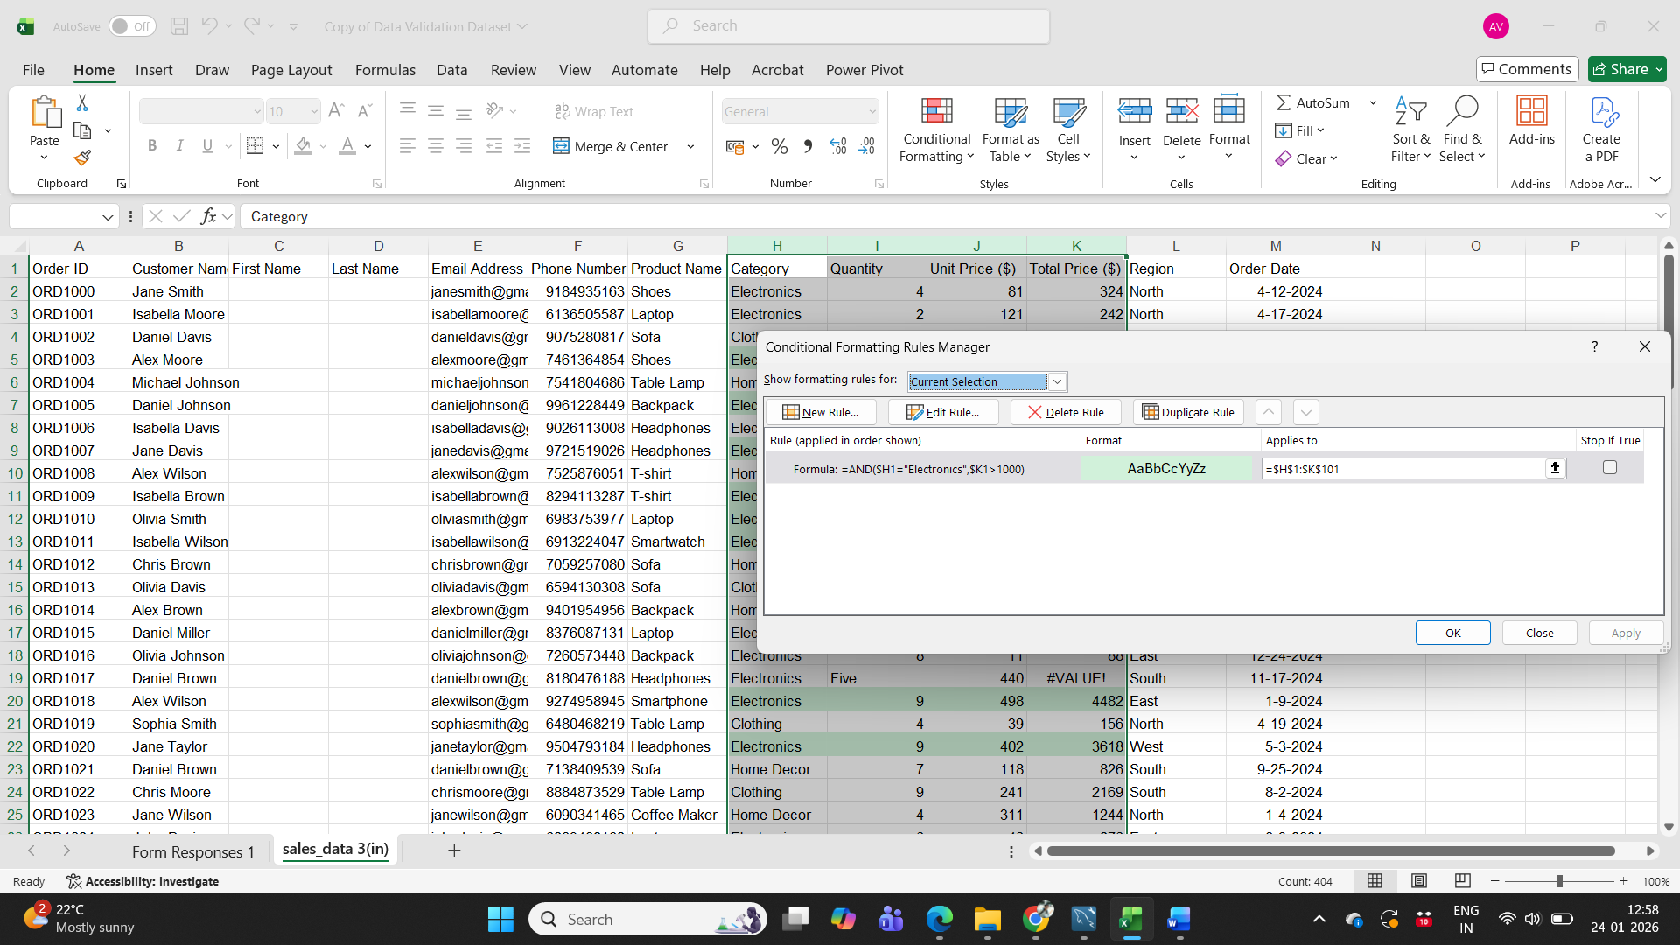

Question 6
Filter the dataset to show only orders from the "North" region.
Ans : Please follow below steps:
- Select the Region column from the dataset and click on the Filter option .
- Now from the filter applied on the Region column select North option.
- Orders from only the North region should be reflected in the dataset.
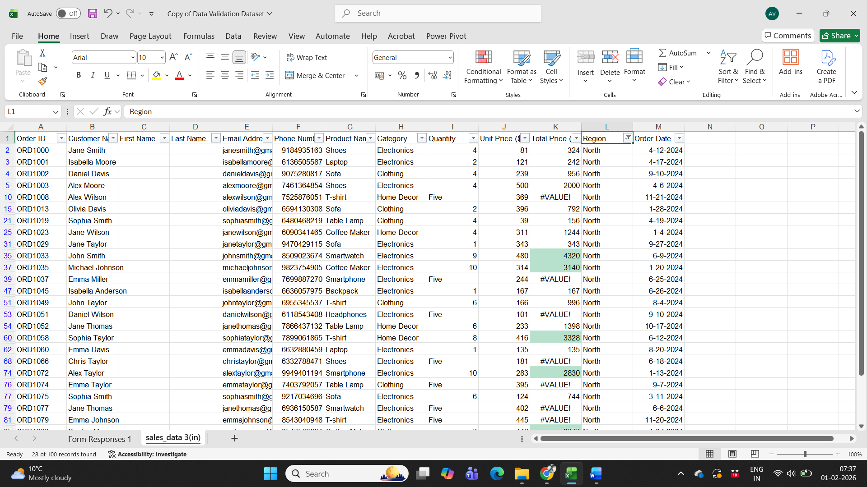

Question 7
Some "Quantity" values contain text (e.g., "Five"). Find and correct these errors.
Ans : Please follow below steps:
- Select the Quantity column from the dataset.
- Click on the Find and Select->Replace option
- Replace Five with 5 and click OK.
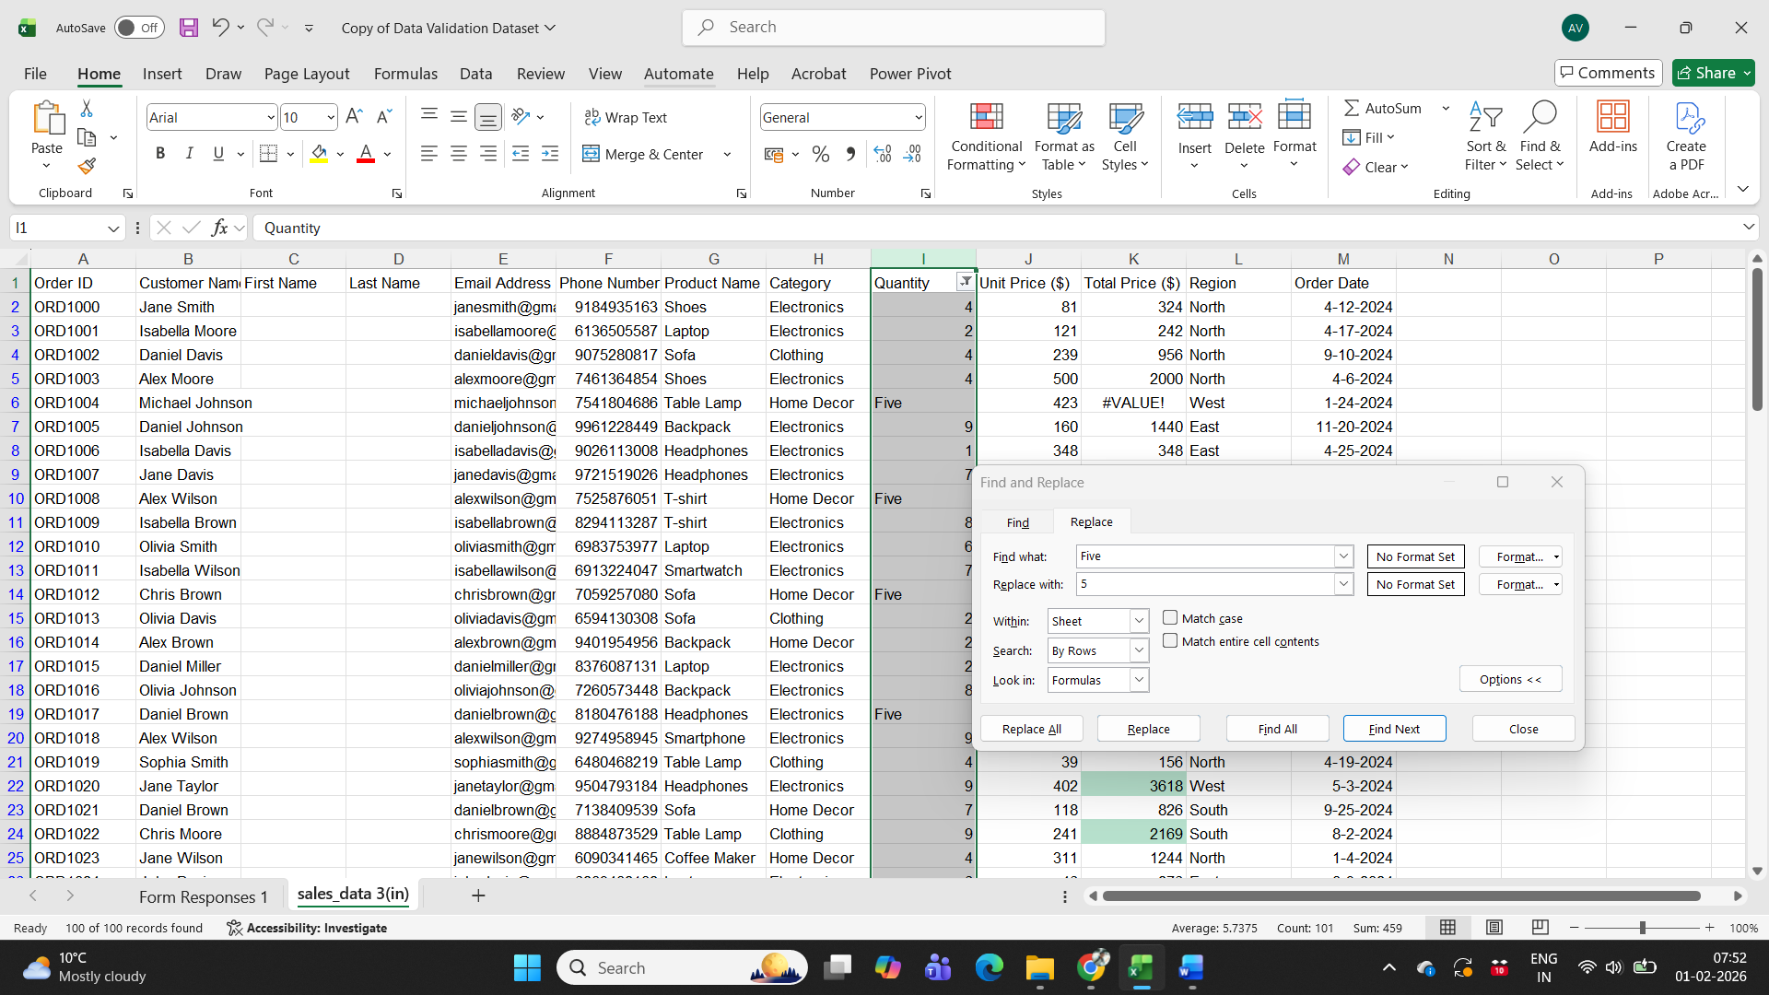
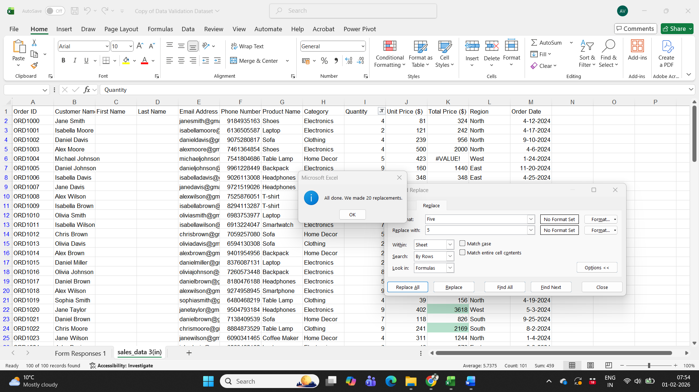

Question 8
Identify customers who placed multiple orders by checking duplicate "Customer Names."
Ans: Please follow below steps:
- Select the Customer name column.
- Select Conditional Formatting -> Highlight cell rules -> Duplicate values
- Duplicate customer name should be highlighted .
