1-intellij
2-wscube

1: https://www.youtube.com/watch?v=nIK2UxECBi0
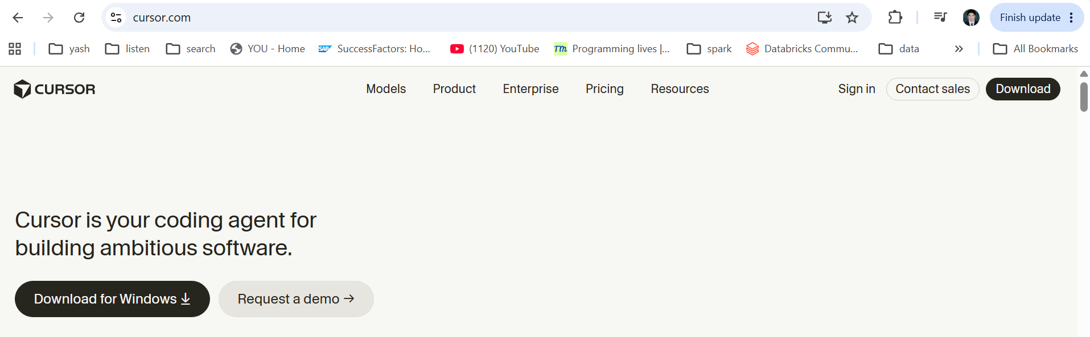

Accept the agrrement:
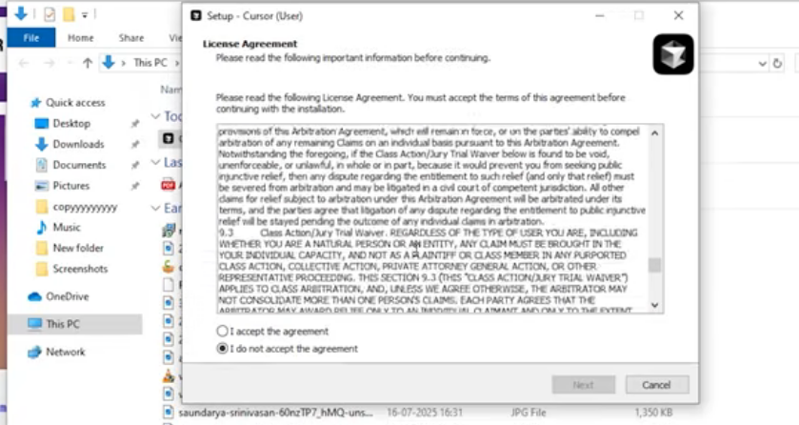

Next:
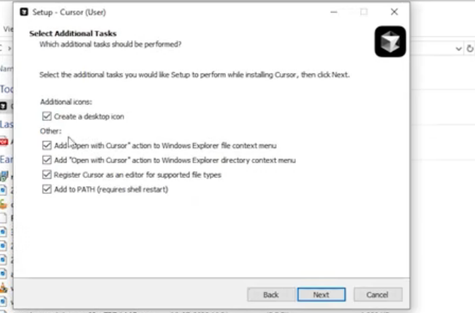
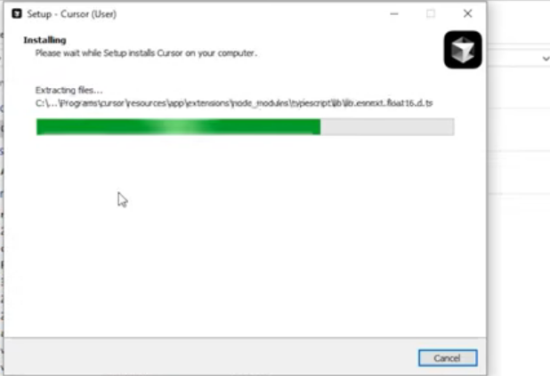
Instalaltio nDone .
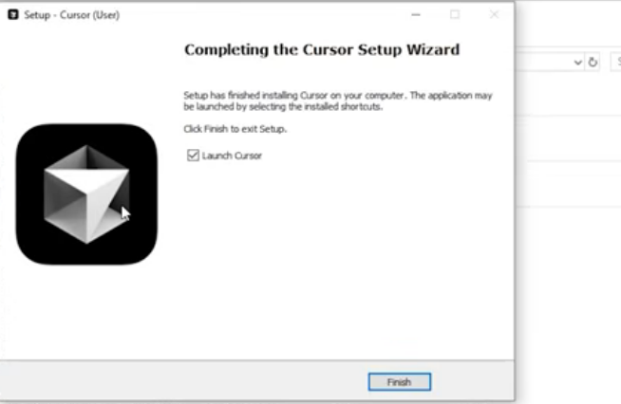

Next : 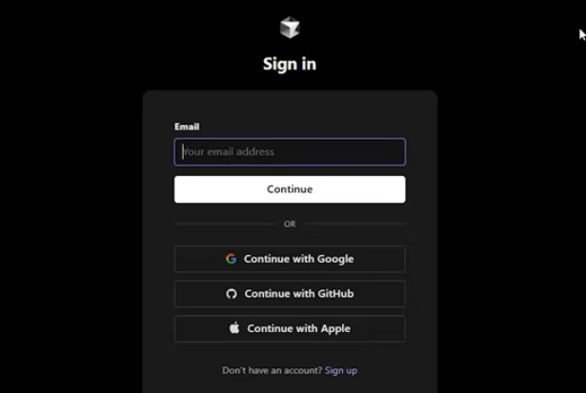

After login it will redirect to this page:
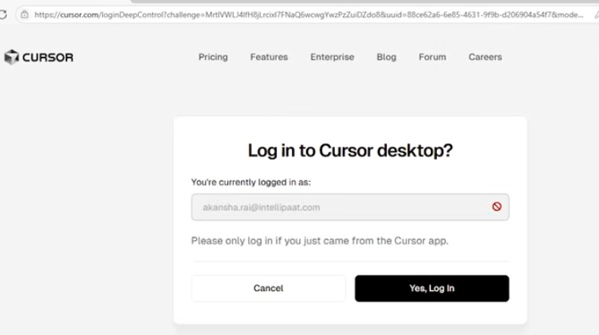

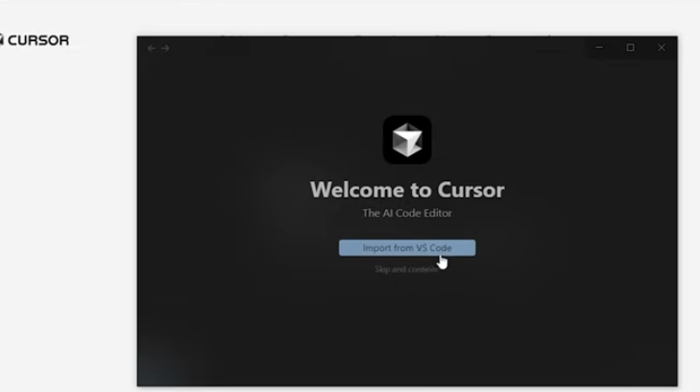

- After downloaf when you open the cursor ai – I will see this interface.
- 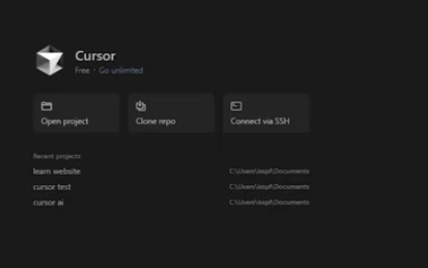
- We have to click open project here.
-But first go to file explorer and create a new file here.
Ecom web folder -> next click on open project and select the folder
And will get this .

But Before starting project let first understand what cursor settigns are and how
They are going help you to increase the productivity.
- So just will go here and click on setting
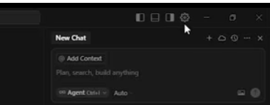

And we see the settings here ,
We can discus setting s here .
Imp – Import settings form vs code. – So if we wants my setting to be similar as
Vs code.
Just directly import s setting from vs code to cursor ai settings .
- Imp – privacy Mode (legacy)- This Privacy mode insure the code is not used to train model or improve the product.
For : ex if you are handling payment gatway , so you don’t want to it visisble any one, you wanted to be confidential.
So you can enable – Privacy Mode over here.

2nd: WE have chat tab:
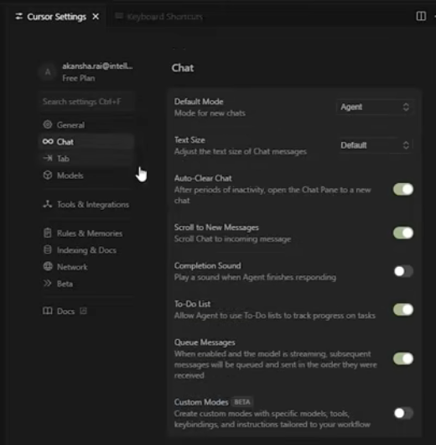

- In chat tab we have default option –
Default Mode: IT set default chat behaviour like –
Agent mode , we have different mode over here.
- Scroll to new messages : this is basically auto scroll to latest reply by ai .
- Completion Sound: You can turn it on like –
You have given short of instruction to this cursor ai and it is
Been generating the code out of it. But you can’t look on the code constantly.
IT is taking lot’s of time to get loaded.
So you can just turn on this completion sound.
When you turn it on, it will play the sound when ai done with the reply.

- Todo – this todo list track the task as todo list.
Like you have created login api. And style checkout.
Queue message – WE have queue message over here .
This basically sends messages one by one during and ai response.

- Custom mdoe – For example you have to make mode that always uses like –
- Tailwind css and next.js
- So you can custom over here.

- Context –

- Wen search tool – for example if you are searching for mstrip pay. Yo ucan directly search over here.

- Auto run Mode: Turn on this it will auto accept the code and will run.

Next: tab
We have cursor -tab
So this cursor tab basically context awair multiline suggestion based on edits.
For ex: while coading of product card component. The cursor might suggest the full
Effect block
- Partial effect – IT suggest one word at a time.
- Import – it will automatically imported the librabries.

Next: Models :

We have diferen-2 models here.
We api keys here. You can just enter your api key here .

Next: WE have toolls and integration here.

We have github and slack over here.
Github – IT will help here bug tracking may be.
To smart suggestion , it will directly take code form github and will give the suggestions
Slack: IT will let you connect cursor agent directly from slack. Usefull from team project or like.
Remote debugging.

Then: We have MCP tolls over here.
- IT will let you plugin your own tool like – formater testing script etc.

NexT: Rules & Memories
Cursor can remember what you like.
And how you code.
Basically based on your previous chat.
Cursor auto learn coading style from your chat.

The n- we have option of docs over here.
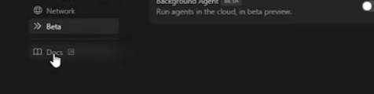
By click on – we can see the cursor. Com has been open.
Everything from installation to core topic to the context.

Now: after seeing the cursor setting let se cursor architecture like how cursor work.

Next- Let see cursor Architecture:
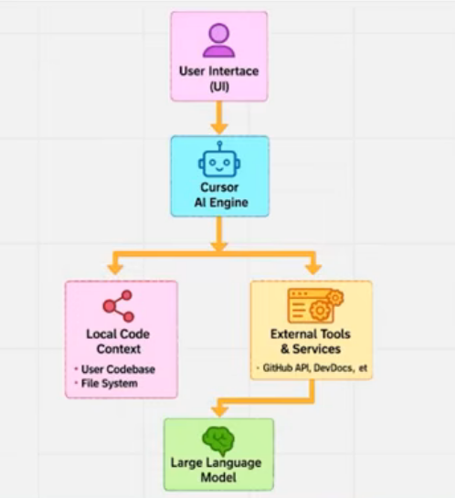

This is the cursor architecture.

*********** ********************
- Smart suggestion
- By pressing the ctlr +k we can add commenct for particular row

- Add to chat
So selec the code – and click o nadd to chat so it will automatically add in chat
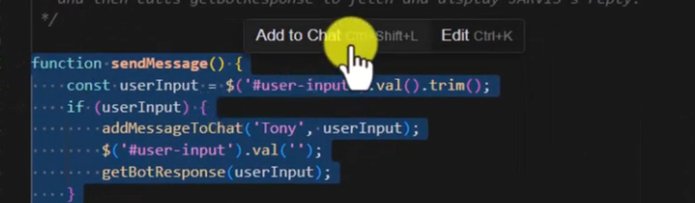
Ask : explain the code
- Add folder and project strucur: by @
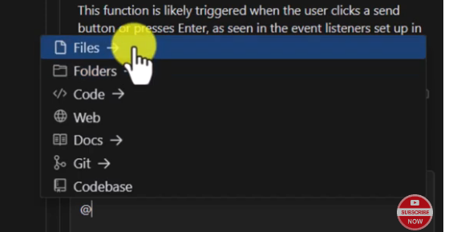
-Whe ni am considerin @ codebase – So al lthe code of this folder it will consider.
Q: what this code all about.

- Fodler – So if you have any specific thing (image) I na folder you can give thelink
- Web : if you want to cursor should visit a web page before generating the code
SO slect @web : and add url here.
- @doc: here you can add documentation here , So cursor will follow that documentation to generate code.

Next: you can import vs code all features
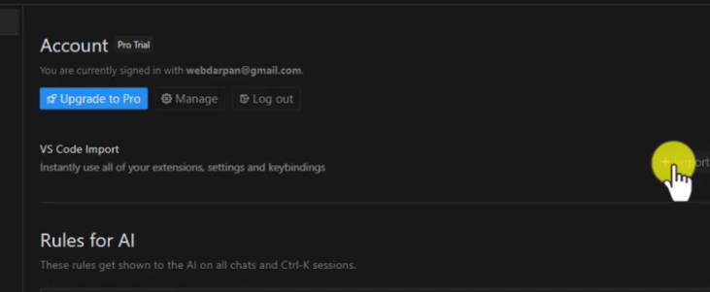

*********** ********************

2- WS cube
https://www.youtube.com/watch?v=Ts4ohUGg63s&t=533s

