**Jenkins Installation Steps on AWS ec2 instance :**

**AWS ec2 Environment Details :**

Operating System : **CentOS-6.5-GA**

AMI-ID : ami-1a013c5f

Security Group Ports : 8888

**Set security group for instance – Go to security Group and add Custom TCP rule to 8888.**

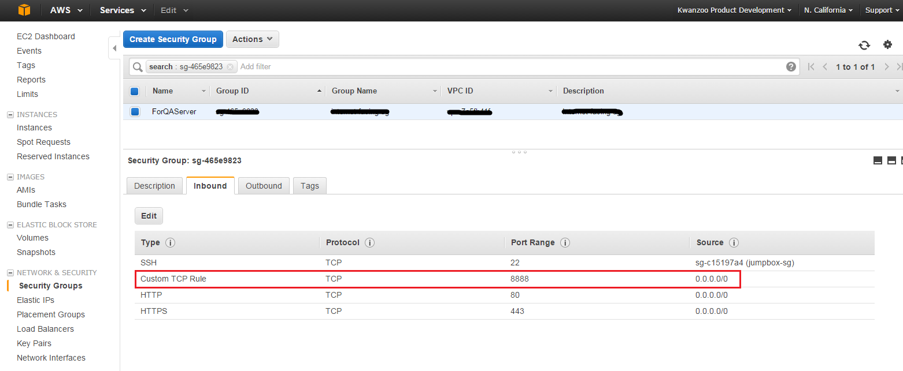

1. Please launch an Amazon Linux instance using Amazon Linux AMI.

2. Login to your Amazon Linux instance.

3. Become root using “sudo su -” command.

4. Update your repositories.

# yum update

5. Get Jenkins repository using below command.

# wget -O /etc/yum.repos.d/jenkins.repo<http://pkg.jenkins-ci.org/redhat-stable/jenkins.repo>

6. Get Jenkins repository key.

# rpm --import<http://pkg.jenkins-ci.org/redhat-stable/jenkins-ci.org.key>

7. Install jenkins package.

# yum install jenkins

By default Jenkins will start on Port 8080. You can change port depend on the requirement. I have changed it to 8888.

Go to **‘vi /etc/sysconfig/jenkins’** file and do the following changes:

JENKINS_PORT="8888"

JENKINS_AJP_PORT="-1"

8. Start jenkins and make sure it starts automatically at system startup.

# service jenkins start

# chkconfig jenkins on

# service jenkins status

9. Open your browser and navigate to http://<Elastic-IP>:8888. You will see jenkins dashboard.

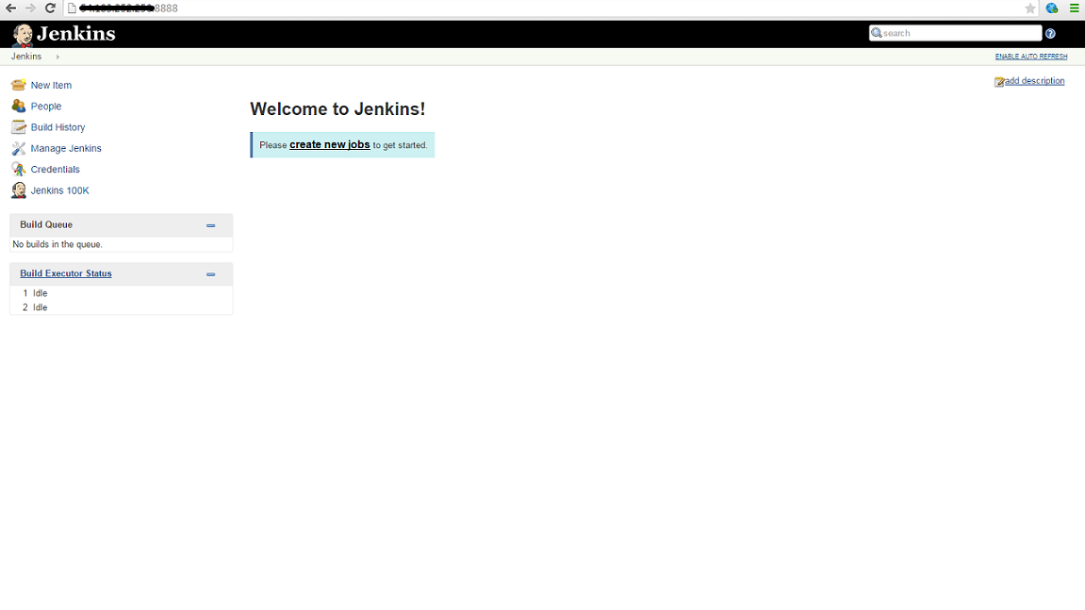

**Before creating any jobs in Jenkins do the following steps in ec2 instance if you want to change the Jenkins User :**

A. To change the jenkins user, open the **/etc/sysconfig/jenkins** (in debian this file is created in /etc/default) and change the **JENKINS_USER** to whatever you want. Make sure that user exists in the system (you can check the user in the **/etc/passwd file** ).

$JENKINS_USER="xxxx"

B. Then change the **ownership of the Jenkins home, Jenkins webroot and logs**.

$ chown -R xxxx:xxxx /var/lib/jenkins

$ chown -R xxxx:xxxx /var/cache/jenkins

$ chown -R xxxx:xxxx /var/log/jenkins

C. Then restarted the Jenkins and check the user has changed.

10. Now that everything is up and running, it's time to **create our first job**. Click the New Job link:

Fill up necessary details: Project name, Description, select **Build Step as Execute shell** and provide command as ‘uptime’.

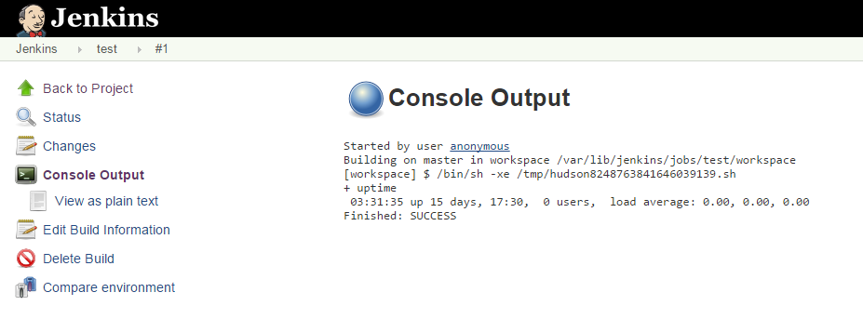

---------------------------------------------second blog----------------------------------------------------

**From Jenkins Build and Deploy code in ec2 instance, ssh to a ec2 instance located in different region and deploy the code. Also configure jenkins to build automatically when code is committed in Github.**

1. First to ssh to any other ec2 instance located in different region do the following steps:

1.a> From Jenkins -> Manage Jenkins -> Manage Plugins -> Install ‘Publish Over SSH Plugin’.

1.b> Now plugin is installed, go to Jenkins -> Manage Jenkins -> Configure System -> Publish over SSH and fill up the details.

Passphrase : Leave it blank, it will take some phrase by its own.

Path to key : Path of your pem file. (Put the pem file in your ec2 instance where jenkins is install -> cd ~/.ssh)

Key : If you give the path no need to put the key.

SSH Server:

Name : Any name you want for the server.

Hostname : Copy the hostname from AWS, it the Public DNS.

Username : Put the username, default is 'root'.

Remote Directory : Leave it blank.

By Clicking **Test Configuration button** you can check if you can ssh to the instance or not.

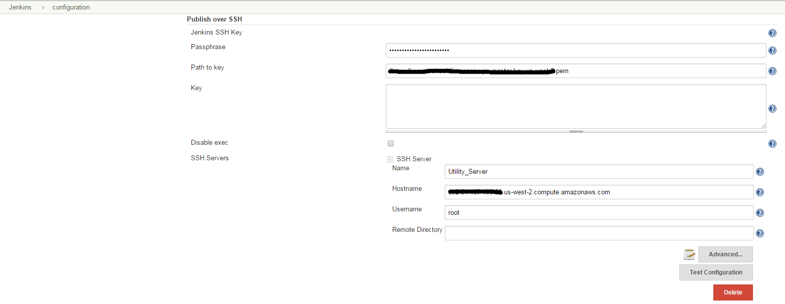

1.c> Now go to the Job and configure as below:

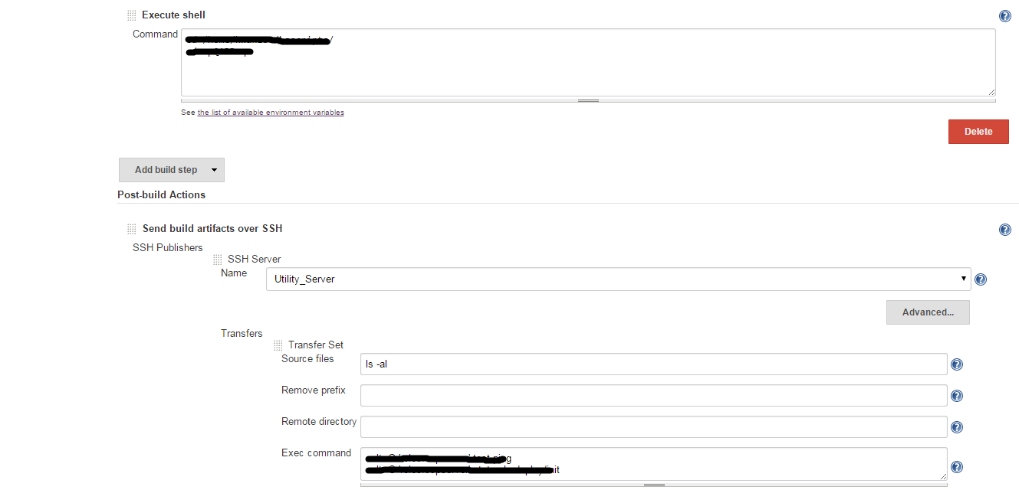

If we run the above job it will execute the shell command in ec2 instance and after finishing it will login to the other ec2 instance (Utility_Server) and execute the command.

**For triggering build automatically when code is committed to github**

1> Jenkins -> Manage Jenkins -> Manage Jenkins (Install git and github Plugin).

2> Configure both of these at **‘Manage Jenkins’ -> ‘Configure System’**. Make sure the path to git is correctly set, and choose **”Manually manage hook URLs”** under the ‘Github Web Hook’ section. (Diagram displayed below).

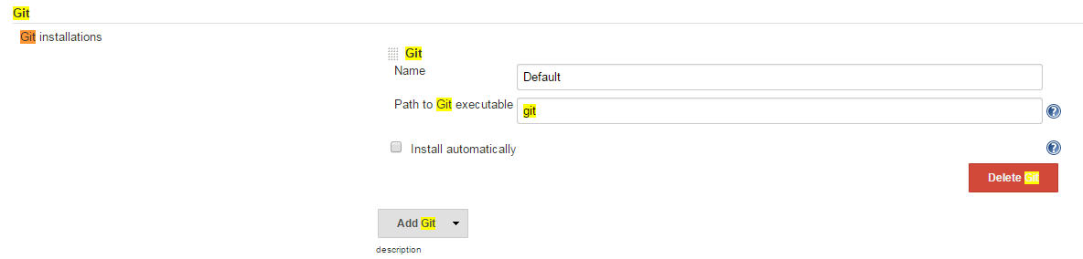

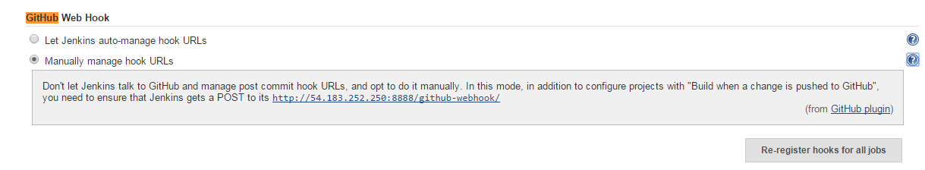

3> Go to Github and do the following changes.

3.a> Click on Settings on right panel.

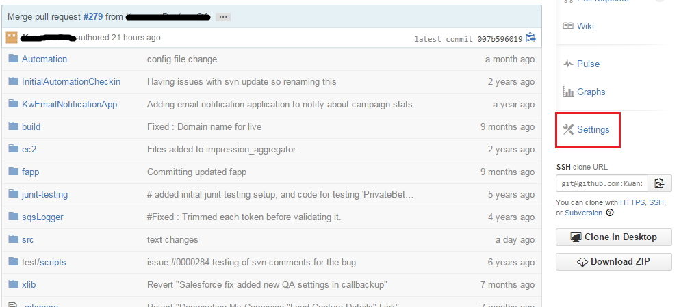

3.b> Select WebHook and Services.

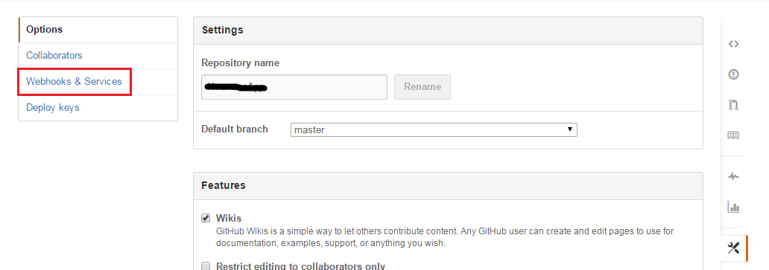

3.c> From Available services drop down select Jenkins (Github Plugin).

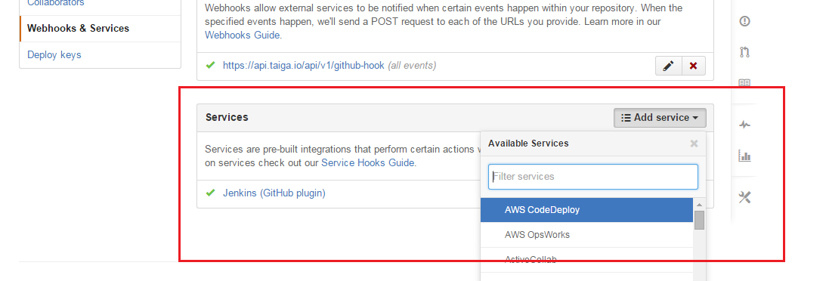

3.d> Add the Jenkins hook url (Url that was mentioned on jenkins Github web hook).

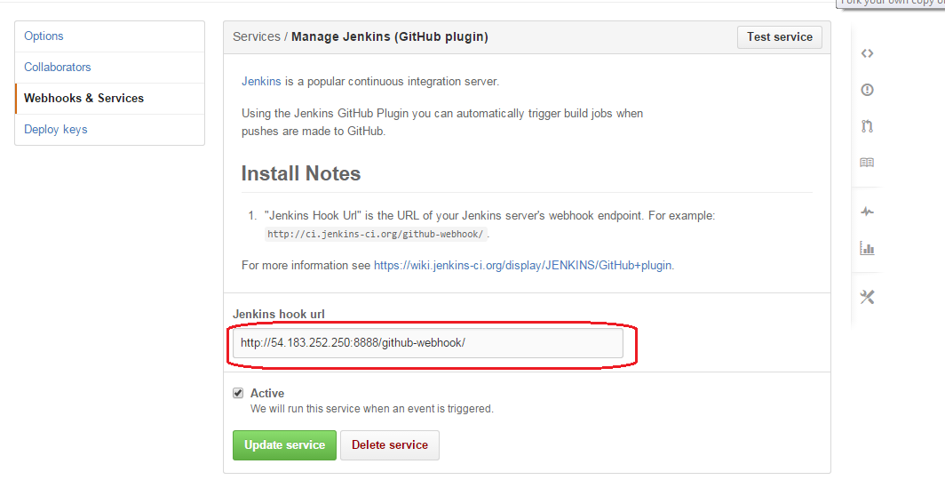

4> Now create a job in jenkins (See diagram below).

4.a> Give github project repo, and git credentials i have use ssh to connect to github.

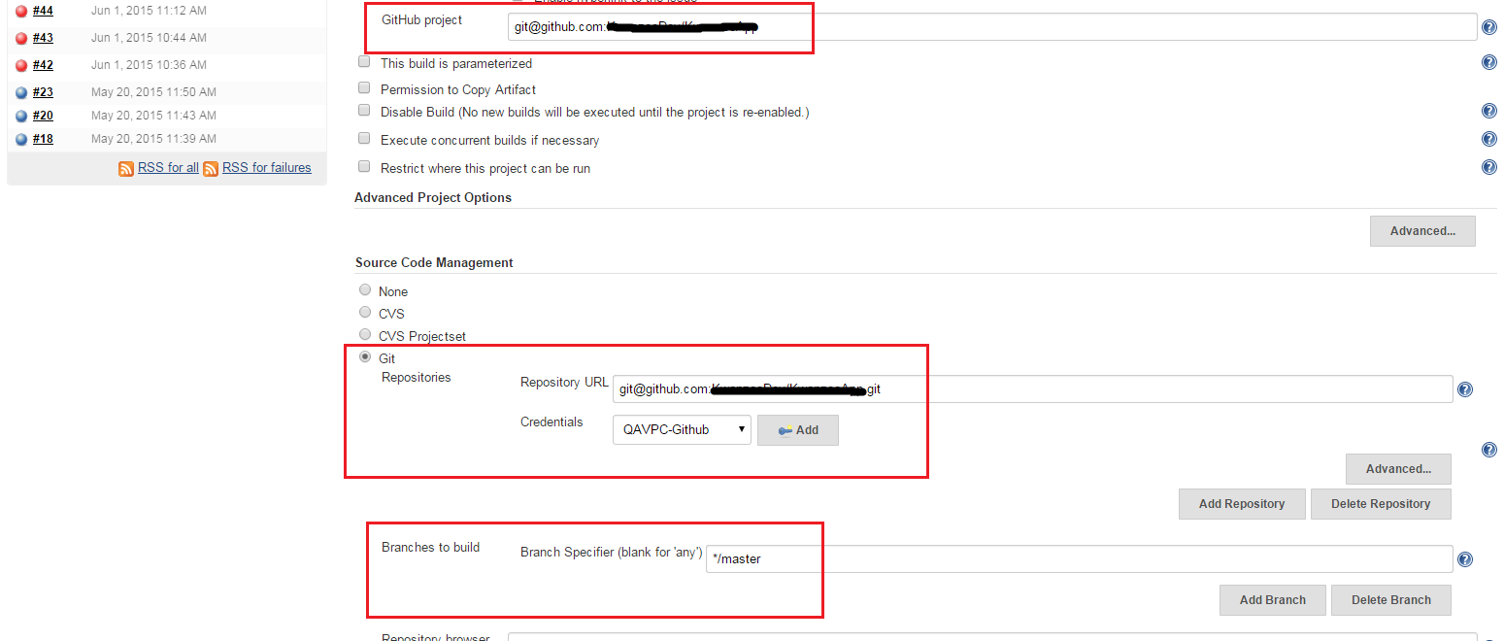

4.b> Select Build Trigger as Build when a change is pushed to Github.

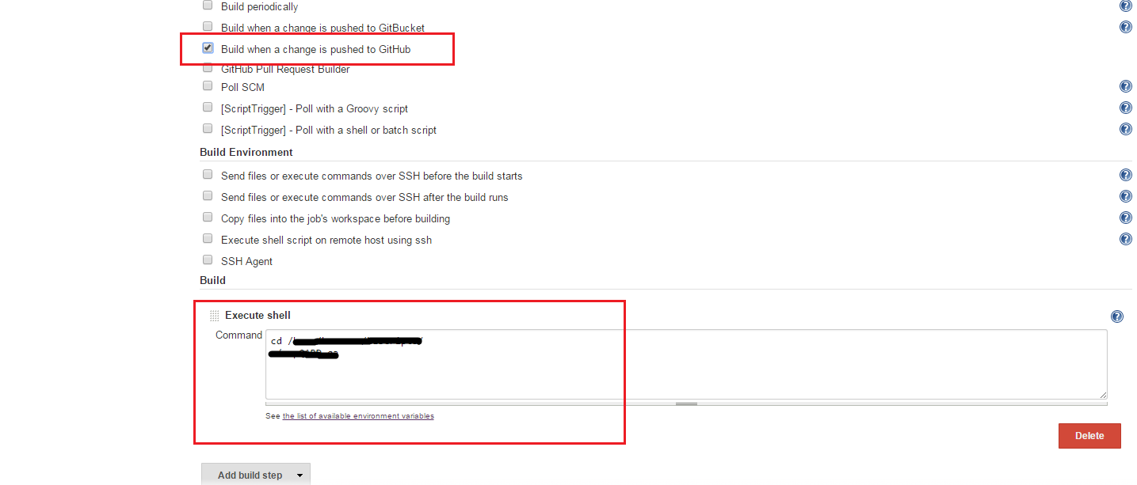

Now Commit any changes on github, it will automatically trigger the build script.