**Adding Jenkins Slave**

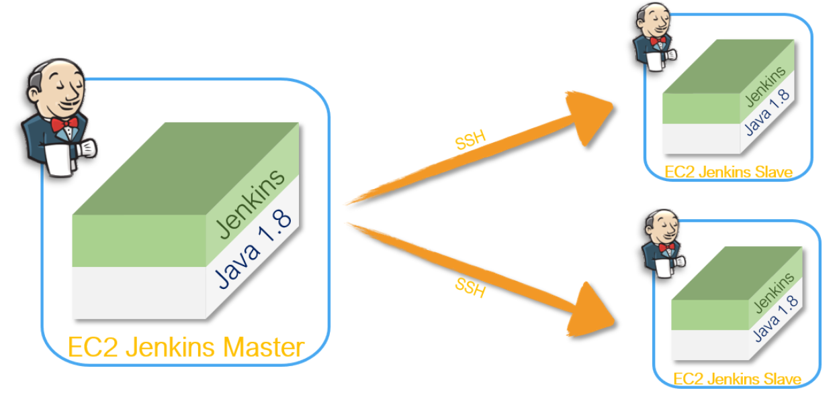

Step 1: Crete A EC2 as Jenkins Slave

1. First create one new EC2 with same key pair which is used in Master EC2 server.
2. Update security inbound security rule

Allow All traffic for this EC2 instance.

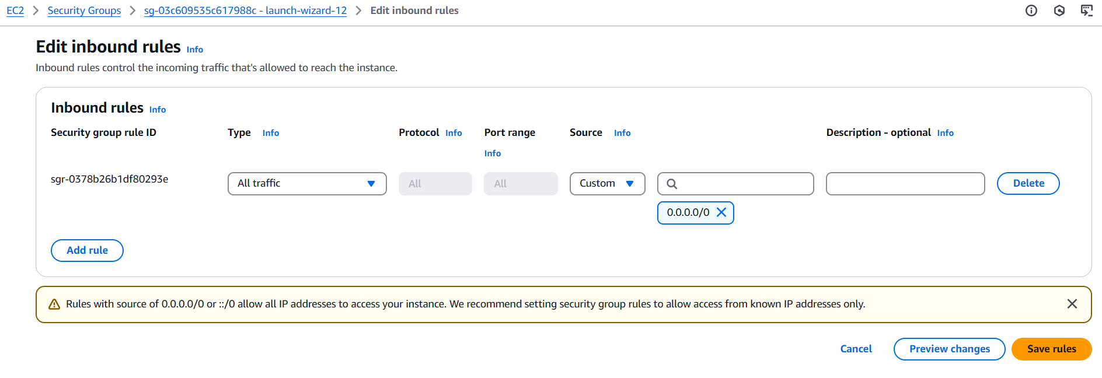

Step 2: Install Java Maven Git on Slave node as well.

yum -y update

yum install -y git

yum install -y java-21-amazon-corretto

yum install -y java-21-amazon-corretto-devel

[root@ip-172-31-41-161 ~]# java --version

openjdk 21.0.5 2024-10-15 LTS

OpenJDK Runtime Environment Corretto-21.0.5.11.1 (build 21.0.5+11-LTS)

OpenJDK 64-Bit Server VM Corretto-21.0.5.11.1 (build 21.0.5+11-LTS, mixed mode, sharing)

[root@ip-172-31-41-161 ~]#

[root@ip-172-31-41-161 ~]#

[root@ip-172-31-41-161 ~]# which java

/usr/bin/java

[root@ip-172-31-41-161 ~]#

[root@ip-172-31-41-161 ~]#

[root@ip-172-31-41-161 ~]# readlink -f /usr/bin/java

/usr/lib/jvm/java-21-amazon-corretto.x86_64/bin/java

cd /opt

sudo wget https://dlcdn.apache.org/maven/maven-3/3.9.9/binaries/apache-maven-3.9.9-bin.tar.gz

sudo tar xvf apache-maven-3.9.9-bin.tar.gz

ls -ltr

cd

echo "export M2_HOME=/opt/apache-maven-3.9.9" >> .bash_profile

echo "export M2=$M2_HOME/bin" >> .bash_profile

echo "export PATH=$M2:$PATH" >> .bash_profile

source ~/.bash_profile

echo $M2_HOME

===========

git --version; java --version; /opt/apache-maven-3.9.9/bin/mvn --version

=============

Step 3 : Login to Jenkins EC2 Slave machine through putty



Run below command on Jenkins Slave

Create user and add the user to wheel group

#useradd jenkins-slave-01

# Create SSH Keys

#sudo su - jenkins-slave-01

#ssh-keygen -t rsa -N "" -f /home/jenkins-slave-01/.ssh/id_rsa

cd .ssh

cat id_rsa.pub > authorized_keys

chmod 700 authorized_keys

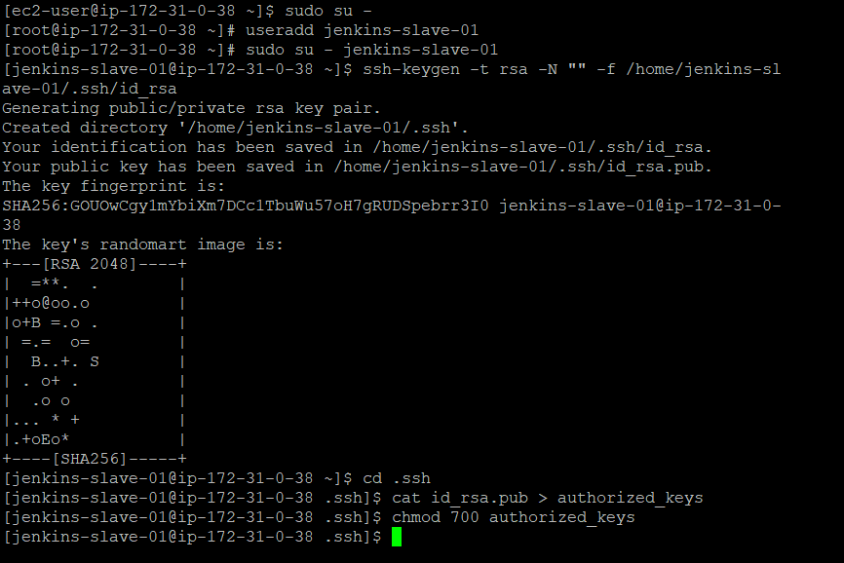

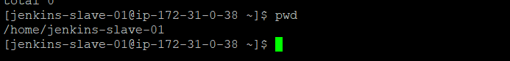

Step 5: Login to Jenkinsmaster and scan the key for jenkinsS

mkdir -p /var/lib/jenkins/.ssh

cd /var/lib/jenkins/.ssh

ssh-keyscan -H private ip of slave server>> /var/lib/jenkins/.ssh/known_hosts

chown jenkins:jenkins known_hosts

chmod 700 known_hosts

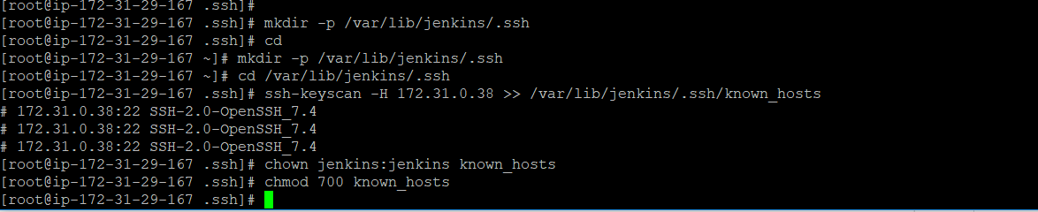

Step 6: Configure the Slave using Manage Jenkins

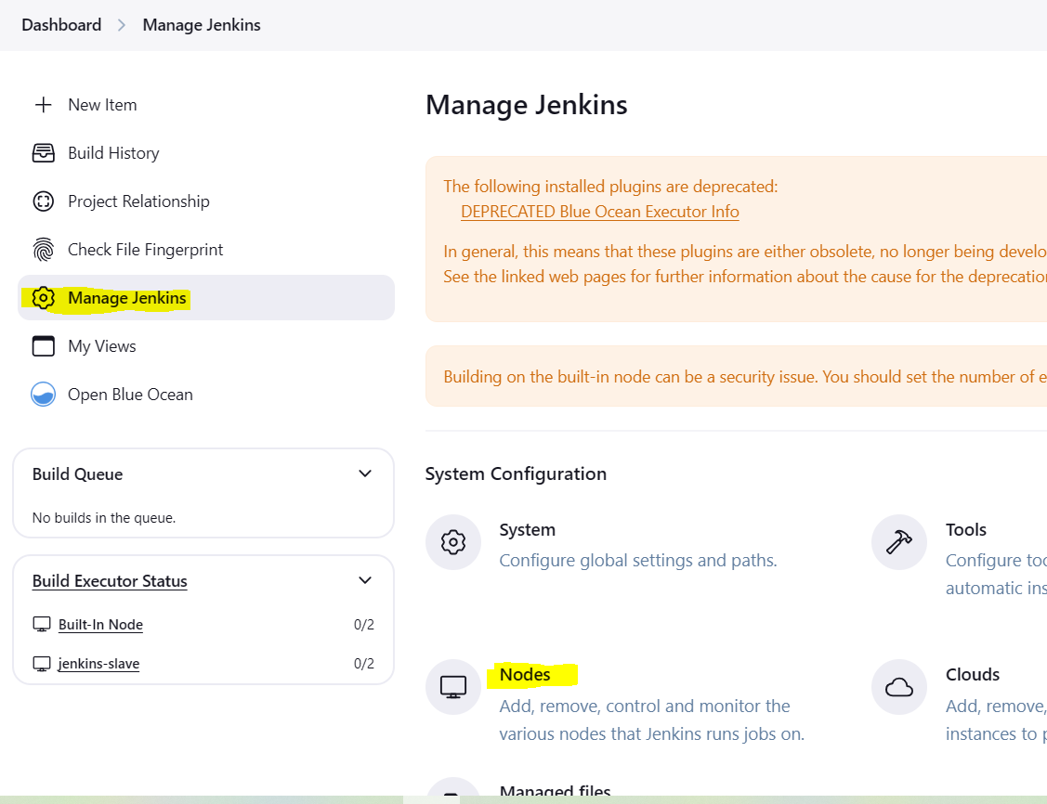

Click on +New Node : to create new node

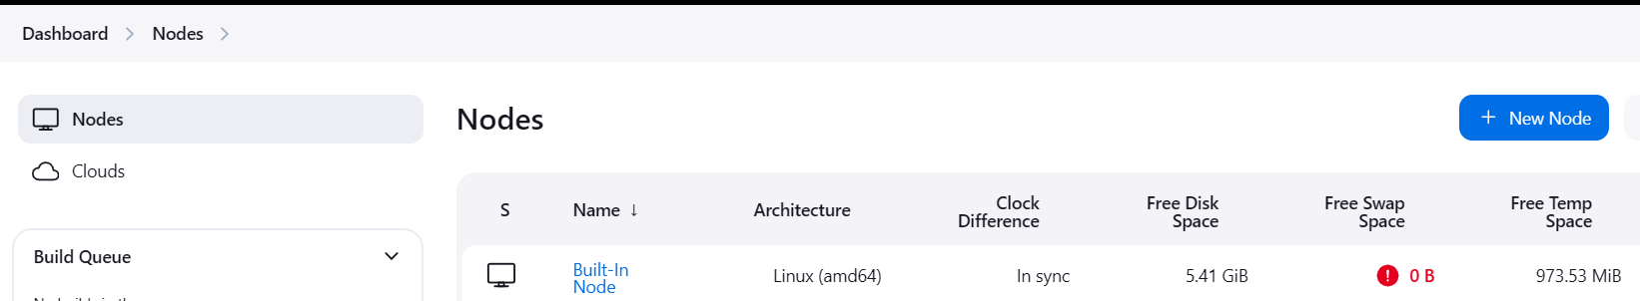

New form will open so we need to fill details

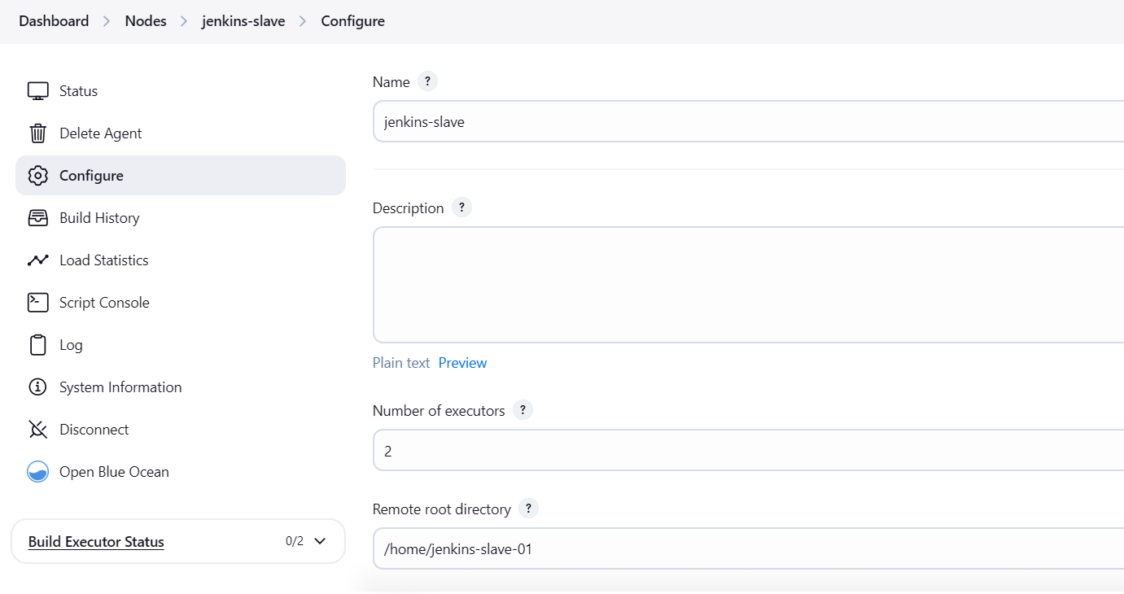

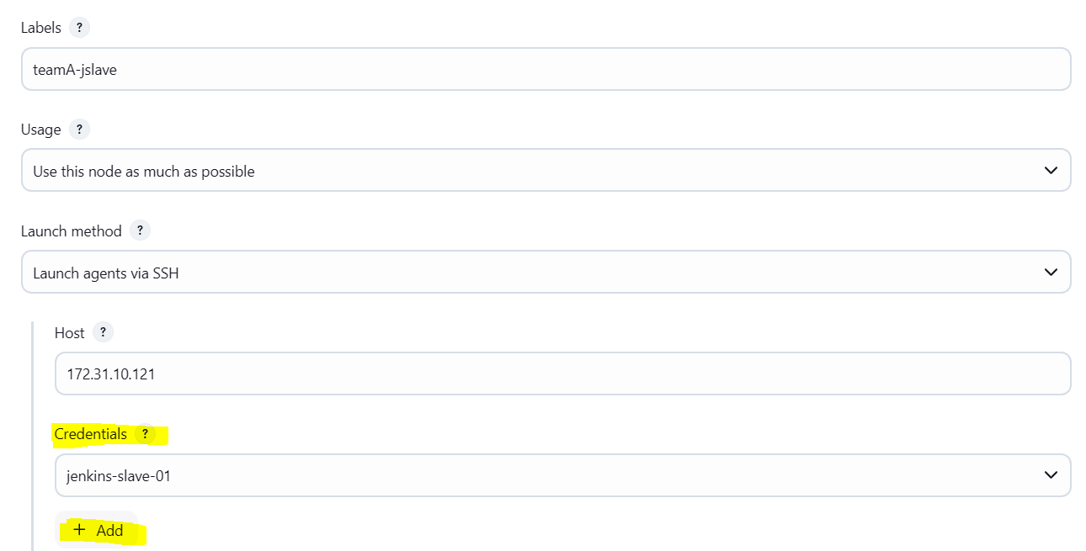

Step 8 : Add the credential’s , Find the key on Jenkins

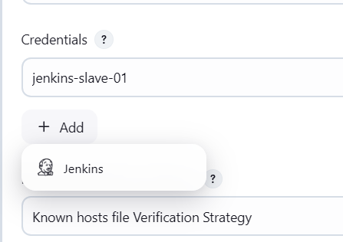

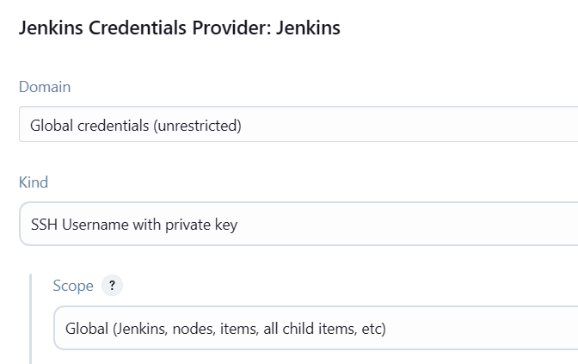

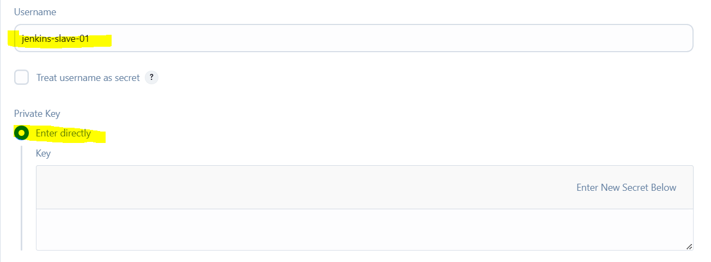

Copy private key from slave server

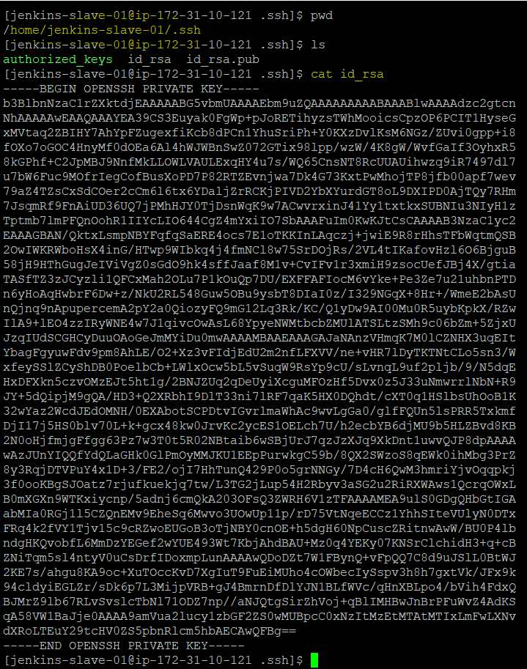

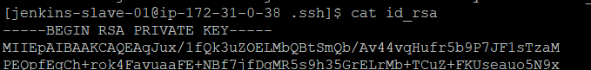

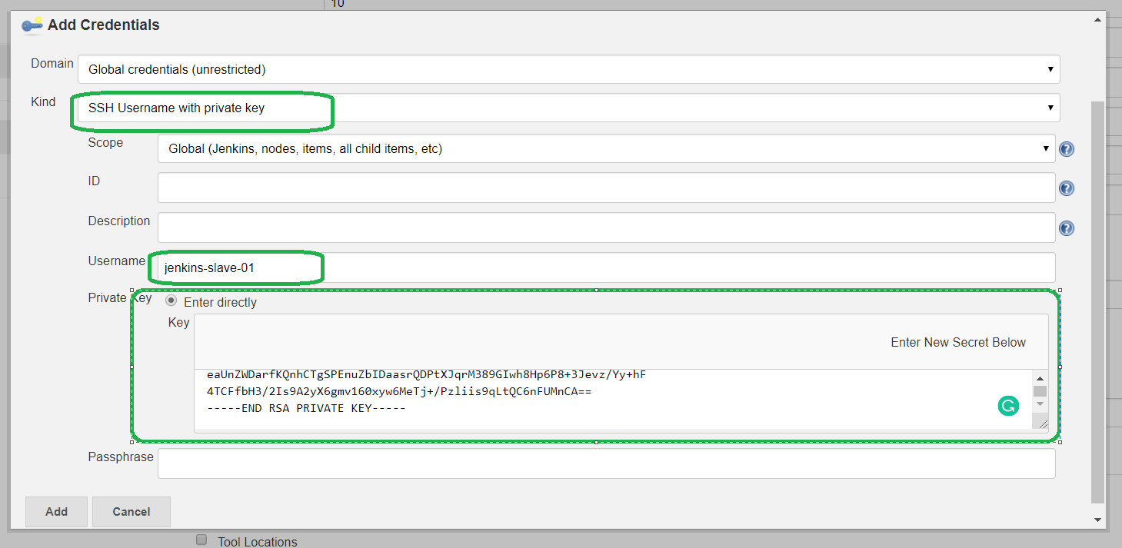

Step 9 : Select the User Id and for password we are using key then save it

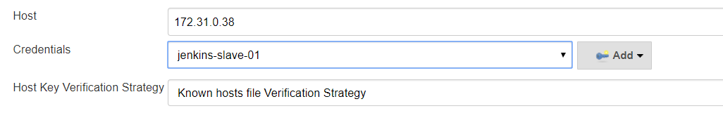

Step 10: Once you save it Jenkins Master will start taking to Jenkins Slave if everything is ok, he will add

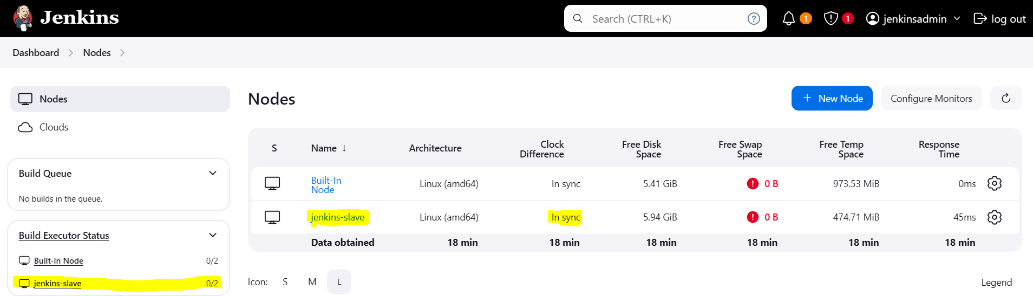

Make some changes in local dev branch and push those changes to remote dev branch.

So master will trigger the job on slave branch.

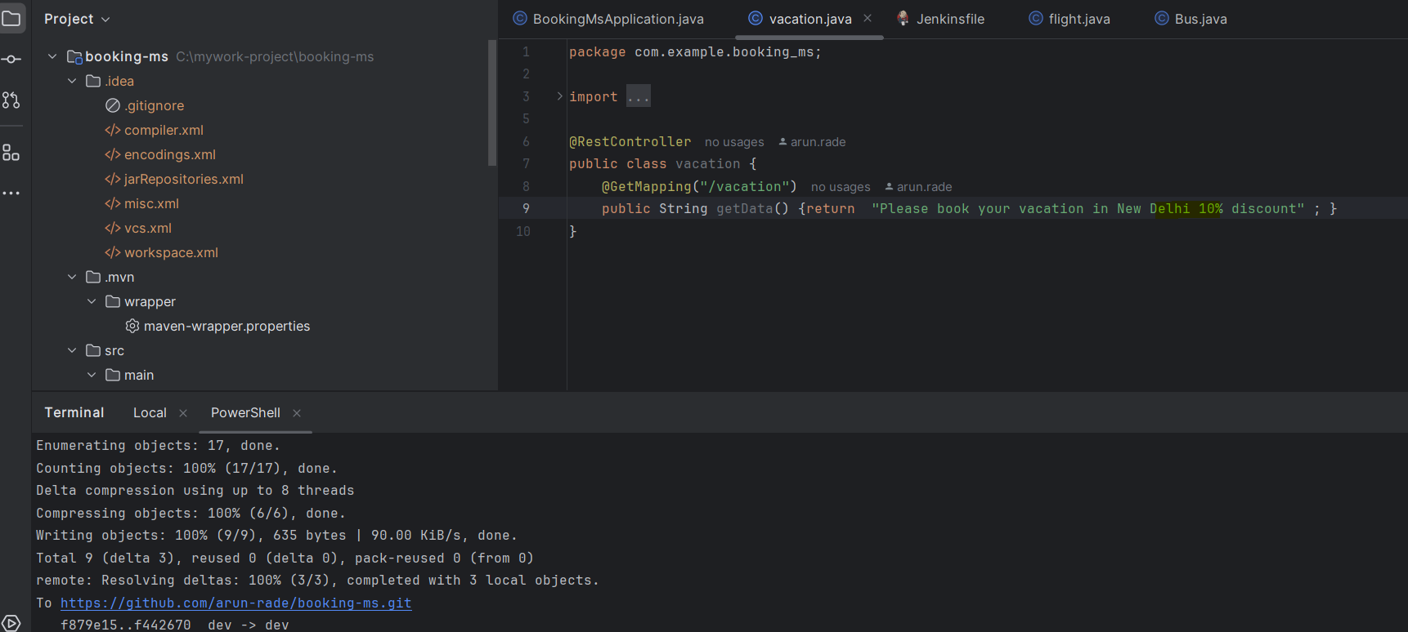

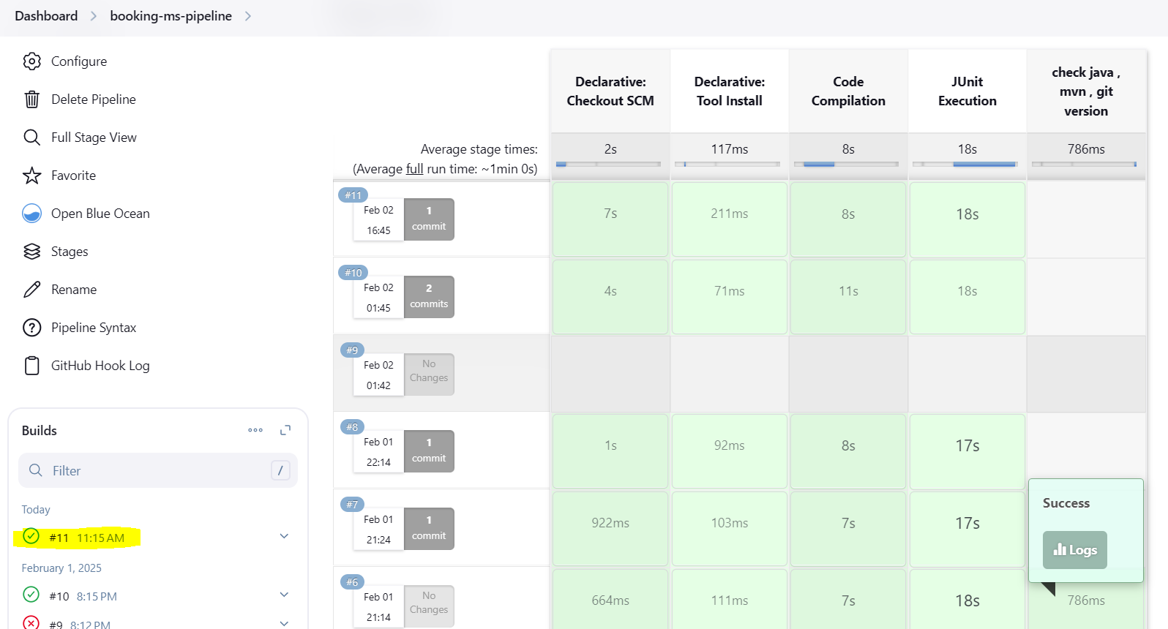

Check console output logs to check the job is running on Jenkins-slave .

