Install Maven on Windows

1. Download Maven latest Maven software from [Download latest version of Maven](http://maven.apache.org/download.cgi)

<http://maven.apache.org/download.cgi>

For example: **apache-maven-3.9.9-bin.zip**

1. Extract the apache maven

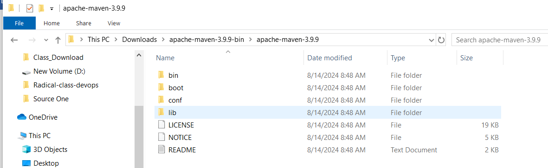

1. Right click on MyComputer -> properties -> Advanced System Settings -> Environment variables -> click new button
2. Now add MAVEN_HOME in variable name and path of maven in variable value. It must be the home directory of maven i.e. outer directory of bin. For example: **C:\Users\Admin\Downloads\apache-maven-3.9.9-bin\apache-maven-3.9.9\bin It** is displayed below:

Search for Environment variable

Select Advanced 🡪 Click on Environment Variables

New window will open 🡪 Click on PATH under System Variables 🡪 Click on Edit

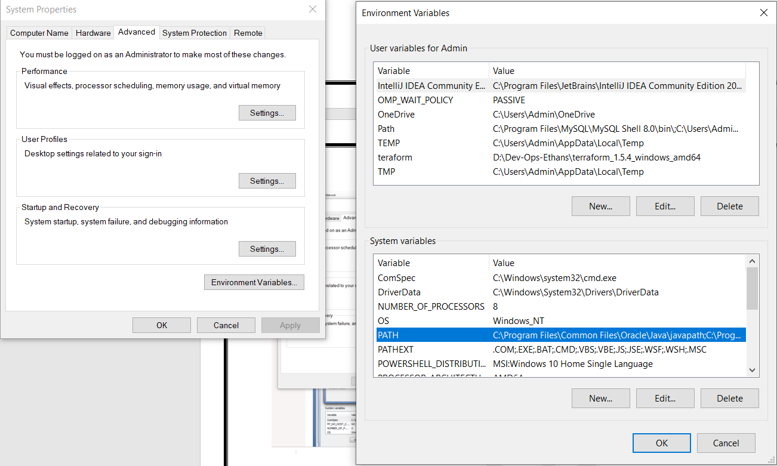

Click on New 🡪 you can see new line at the end and you can add maven path 🡪 Click on OK

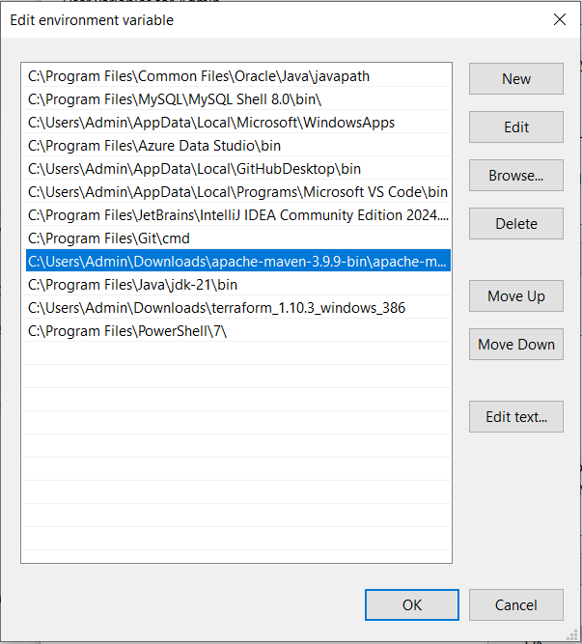

You will come back one step back for Environment variable window 🡪 Click on OK.