UI

1. Reduce the size and check the alignment of below mentioned button

* Higher option request
* Check the alignment of data in application status page()

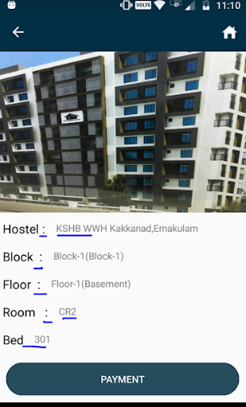

* 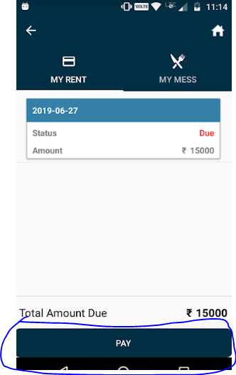Check the alignment of button ‘Pay’(Also Check account page)
* Reduce the size of submit button in nature of complaints page(Camera, audio, video buttons are not working and check the feedback page)

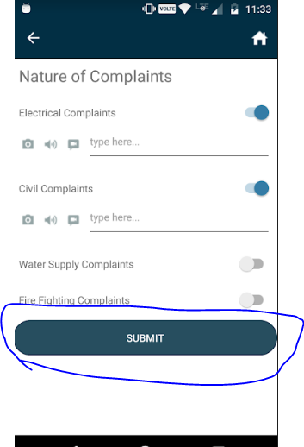

* Check the field ‘address’ in registration page.

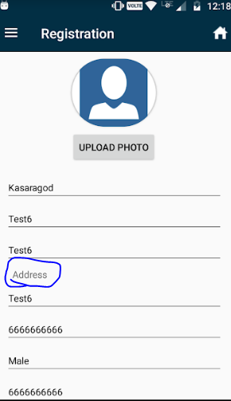

* Check the ‘Next button in Apply Flat page’ and text ‘Ration card’ change as ‘Ration Card No:’
* Check the icon of my agreement

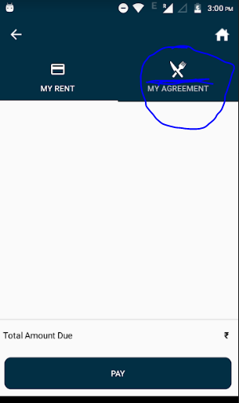

1. Application status page again shows lots of white space.
2. Spelling Mistakes

* Check the sliding menu and correct the spelling of ‘Grievance’.
* Check the job details page and correct the spelling of organisation.
* Check the income page correct the spelling of source.