Requirements  
 Python  
 fbchat  
 icalendar  
 json  
Download   
 You need to download birthday dataset from facebook.   
 Go to home/events/Calendar

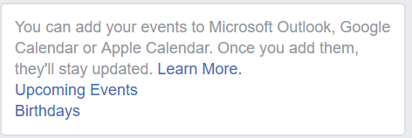

Click on the Birthdays and it will download an .ics file  
 Rename it as birthday.ics  
 and copy to the project directory

Changes  
 In runWishes.py update the username and password and run the code  
  
NOTE:  
 Don’t run the script multiple times. Your account may be locked