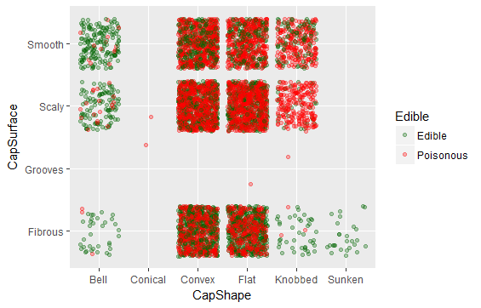

Mushrooms Predictions CapShape Vs CapSurface (Mostly eatable likelihood)

* Bell shaped Cap.
* Cap shape Knobbed and Sunken with Cap Surface Fibrous.

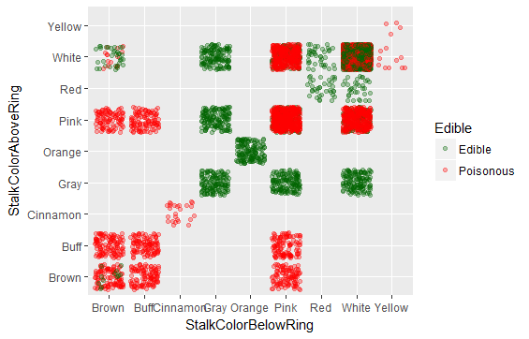

Mushrooms Predictions Stalk Color Above Ring Vs Stalk Color below Ring (Mostly eatable likelihood)

* Stalk Colure in both cases Above and below Ring with Gray , Red and Orange.

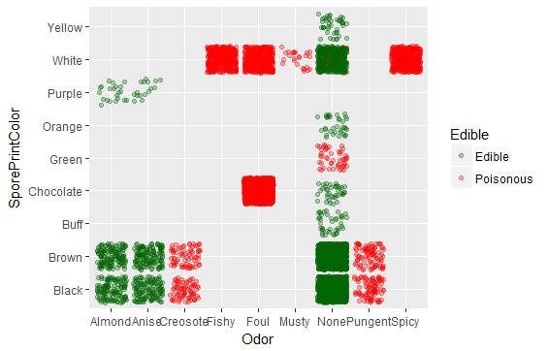

Mushrooms Predictions Spore Print Color Vs Odor (Mostly eatable likelihood)

* Odor with Almond and Anise.
* No Odor but excluding spore print color green.

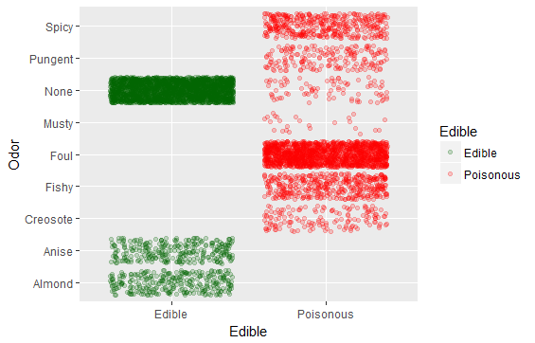

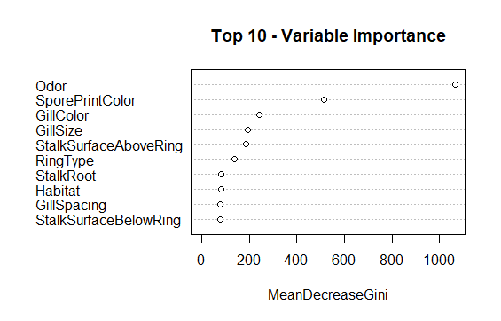

|  |
| --- |
| MeanDecreaseGini Variables  Odor 908.634315 Odor  SporePrintColor 516.449435 SporePrintColor  GillColor 227.720697 GillColor  StalkSurfaceAboveRing 215.169686 StalkSurfaceAboveRing  GillSize 203.893488 GillSize  StalkSurfaceBelowRing 158.840420 StalkSurfaceBelowRing  Population 107.222472 Population  RingType 105.001048 RingType  StalkRoot 96.770750 StalkRoot  Habitat 94.518617 Habitat  Bruises 83.039555 Bruises  StalkColorBelowRing 62.045229 StalkColorBelowRing  StalkColorAboveRing 61.229446 StalkColorAboveRing  GillSpacing 47.297690 GillSpacing  StalkShape 34.606274 StalkShape  CapColor 34.056426 CapColor  RingNumber 32.854662 RingNumber  CapSurface 24.069088 CapSurface  CapShape 12.950087 CapShape  GillAttachment 1.952445 GillAttachment  VeilColor 1.819879 VeilColor  VeilType 0.000000 VeilType |
|  |
| |  | | --- | |  | |

**Confusion Matrix and Statistics**

Reference

Prediction Edible Poisonous

Edible 3130 0

Poisonous 0 2953

Accuracy: 1

95% CI: (0.9994, 1)

No Information Rate: 0.5145

P-Value [Acc > NIR]: < 2.2e-16

Kappa: 1

Mcnemar's Test P-Value: NA

Sensitivity: 1.0000

Specificity: 1.0000

Pos Pred Value: 1.0000

Neg Pred Value: 1.0000

Prevalence: 0.5145

Detection Rate: 0.5145

Detection Prevalence: 0.5145

Balanced Accuracy: 1.0000

'Positive' Class: Edible