
PYTHON PROGRAMMING
ASSIGNMENT 2
REPORT
CO2 Coverage: Control Flow Constructs, String Operations and Functions

Name: ARUN.T
Register Number: 1912260643
Course Name and Code:Python Programming /CSA0806
Faculty Name: Haripriya
Submission Date: 30 October 2026
GitHub Repository Link:https://github.com/arun060308-code/CSA0806-Python-Program/tree/main/Assesment%202

1. Introduction
The objective of this assignment is to apply and analyse Python control-flow constructs, string operations and functions. The tasks cover conditional statements, while and for loops, break and continue, string normalisation and validation, string-building performance, parameter defaults, variable scope, recursion, memoisation and iterative redesign.

2. Learning Objectives
- Use if, if–else and if–elif–else to implement mutually exclusive decisions.
- Use while and for loops, including break, continue, pass and loop–else.
- Manipulate and validate strings using built-in string methods and slicing.
- Compare repeated concatenation, join and formatted string construction.
- Explain function parameters, return values, mutable defaults and variable scope.
- Compare naive recursion, memoisation and iteration using operation counts and complexity.
- Diagnose a limitation, redesign the solution and validate the redesign with evidence.

3. Development Environment
Item | Details
Editor | Visual Studio Code
Language | Python
Python version visible in screenshot | Python 3.12.0
Libraries visible in code | time, sys, functools.lru_cache
Third-party packages | No third-party package is required for the visible programs

Q1 — Decisions with Many Boundaries (6 Marks)

Aim
To implement an electricity subsidy rule and compare separate if statements with an if–elif–else chain.

Rule and test predictions
A household using 100 units or fewer receives a full subsidy. A household using between 101 and 200 units receives a partial subsidy only when it has a ration card. A household using more than 200 units receives a special subsidy only when a member is above 80 years old; otherwise, no subsidy is given.
Units | Ration card | Member over 80 | Expected decision
100 | No | No | Full subsidy
101 | Yes | No | Partial subsidy
200 | Yes | No | Partial subsidy
201 | No | No | No subsidy
80 | Yes | Yes | Full subsidy
150 | No | No | No subsidy
250 | No | Yes | Special subsidy
250 | Yes | No | No subsidy

Implementation and analysis
Separate if statements are checked independently. If their conditions overlap, more than one message can be printed for a single household. An if–elif–else chain selects the first matching branch, so only one branch is executed. Chained comparisons such as 101 <= units <= 200 make the boundary conditions easier to read.
For this rule, an if–elif–else structure is a clear choice because the consumption ranges are mutually exclusive. Nested if statements are useful when a second condition should only be considered inside a particular range; combined Boolean conditions can be concise but may become harder to maintain when the rule grows.

Alternative and complexity
A match–case implementation could first classify the consumption range and then check the ration-card or age condition within the matching case. A lookup list of k upper-limit/decision pairs searched in order takes O(k) time in the worst case and O(k) space for the stored pairs. A fixed if–elif–else chain has O(1) time with respect to a fixed number of rules and O(1) auxiliary space.

Observed evidence
The supplied terminal screenshot shows boundary and mixed-condition examples. It includes cases such as 100 units, 101 units with a ration card, 200 units with a ration card, 201 units with an elderly member, and an 80-unit case. The screenshot demonstrates the difference between the separate-if and chained versions.
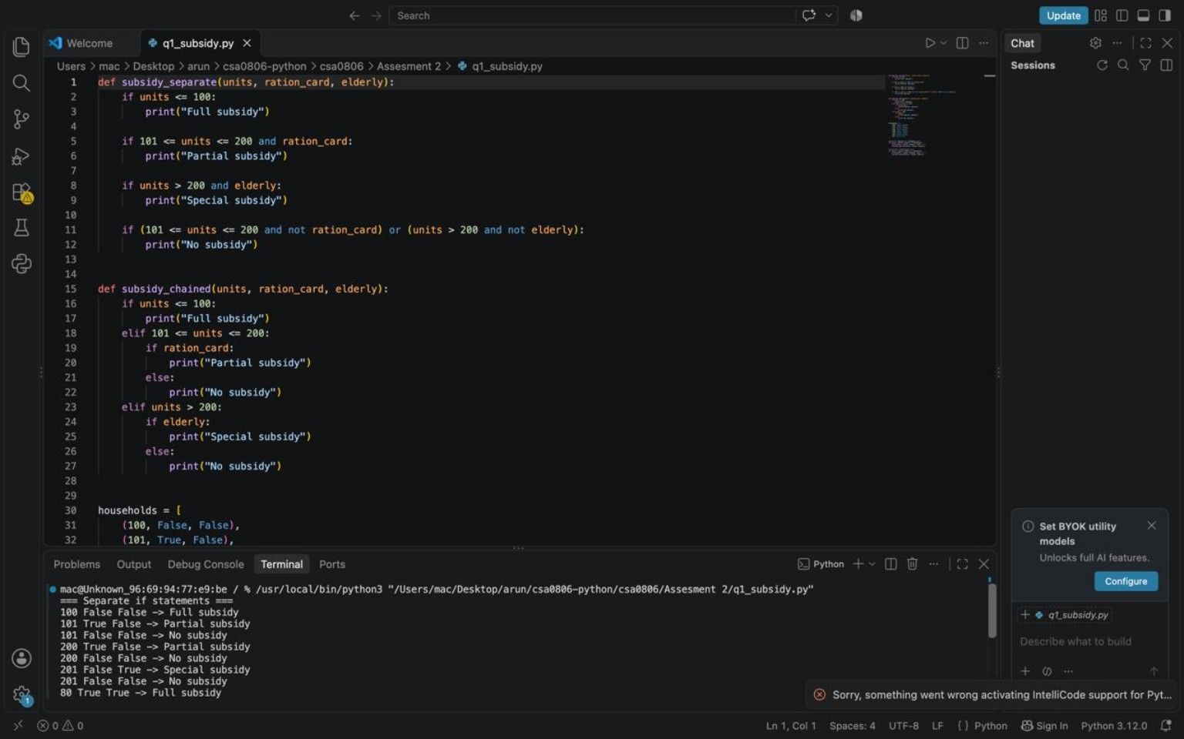
Figure 1. Q1 subsidy conditions and terminal output supplied by the student.

Q2 — Loops that Count Attempts (4 Marks)

Aim
To verify an OTP with a maximum of three counted attempts, while ensuring that a blank entry does not consume an attempt.

Loop behaviour
A while loop is natural when repetition depends on a changing condition such as the number of attempts. A for loop using range(3) is also suitable when the attempt limit is fixed. The attempt counter must be updated only after a non-blank entry; updating it in the wrong place can incorrectly count blank submissions or allow too many attempts.
Construct | Purpose in the OTP program
break | Stops the loop immediately when the OTP is correct.
continue | Skips the remaining statements for a blank entry.
pass | A placeholder statement that performs no operation; it is not needed for the core logic.
Loop else | Runs when the loop completes without break, allowing the lock message after all attempts fail.

Changed condition and alternative
If the security question is answered correctly, the allowed attempt limit can be increased from three to five. The program should check the security-question result before choosing the limit and should still avoid counting blank entries.
A recursive version could accept the remaining attempt count and call itself for the next non-blank attempt. For a attempts, both loop and recursive versions perform O(a) work. A loop uses O(1) auxiliary space, while recursion uses O(a) stack space.

Observed evidence
The supplied terminal screenshot shows a successful OTP verification for 1234, wrong OTP entries, and a blank-entry message. The visible evidence supports the successful, incorrect and blank-input paths.
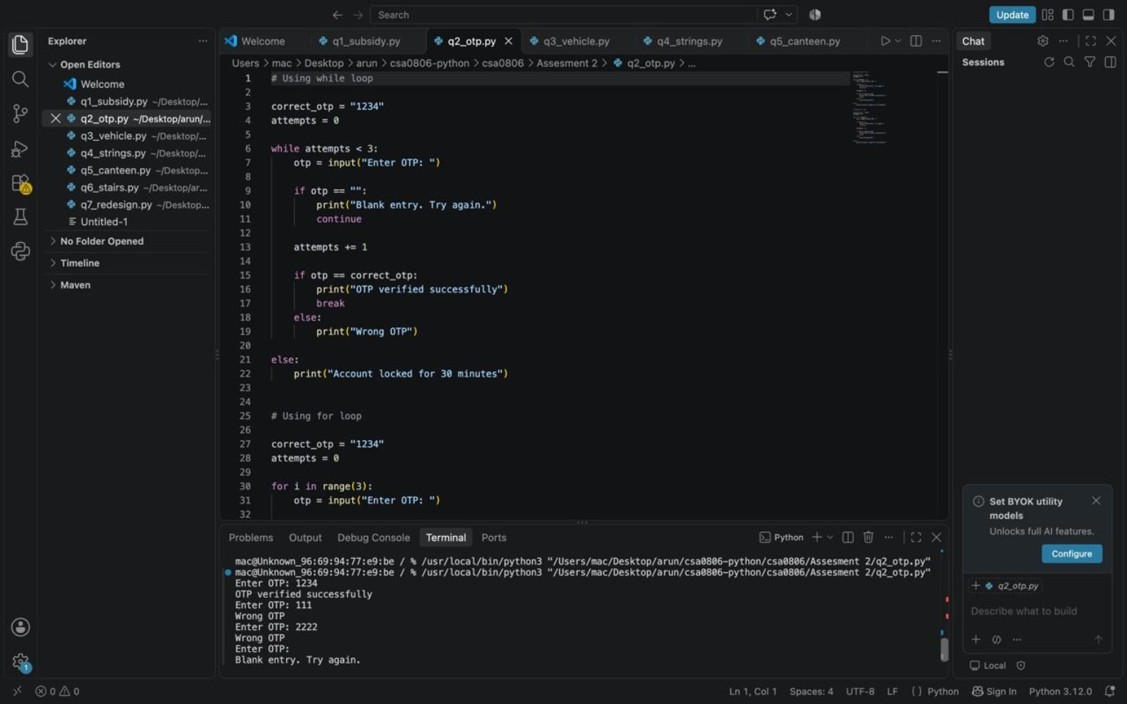
Figure 2. Q2 OTP while/for loop code and terminal evidence supplied by the student.

Q3 — Vehicle Registration Number Validator (6 Marks)

Aim
To normalise vehicle registration strings, validate their structure using string methods and slicing, and format valid registrations for a receipt.

Normalisation and validation
def normalise(text):
text = text.replace(" ", "")
text = text.replace("-", "")
return text.upper()

def is_valid(reg):
if len(reg) not in (9, 10):
return False
if not reg[0:2].isalpha():
return False
if not reg[2:4].isdigit():
return False
if not reg[4:-4].isalpha():
return False
if len(reg[4:-4]) not in (1, 2):
return False
if not reg[-4:].isdigit():
return False
return True

def format_number(reg):
if not is_valid(reg):
return "INVALID"
return f"{reg[:2]} {reg[2:4]} {reg[4:-4]} {reg[-4:]}"

String concepts
Strings are immutable, meaning their characters cannot be changed in place. text.upper() returns a new uppercase string; it does not modify the original variable unless the result is assigned back. For a 9-character string, s[-4:] returns the last four characters and s[4:-4] returns one character. For a 10-character string, the same slices return the last four characters and the two characters between the first four and last four.
A regular expression using re.fullmatch(r"[A-Z]{2}[0-9]{2}[A-Z]{1,2}[0-9]{4}", reg) can express the same pattern compactly. Both methods take O(L) time for a registration string of length L. Slicing is explicit and uses standard string operations, while a regular expression may be more concise for more complex patterns.
Input | Normalised form | Expected result
tn 09 ab 1234 | TN09AB1234 | Valid
KA-01-M-0007 | KA01M0007 | Valid
TN9AB1234 | TN9AB1234 | Invalid
TN 22 1234 AB | TN221234AB | Invalid
MH-12-XY-9876 | MH12XY9876 | Valid
KL 07 CD 4567 | KL07CD4567 | Valid

Observed evidence
The screenshot shows the normalise, is_valid and format_number functions. The terminal includes normalised registrations and valid/INVALID results, including TN9AB1234 as invalid and examples with spaces and hyphens as valid after normalisation.
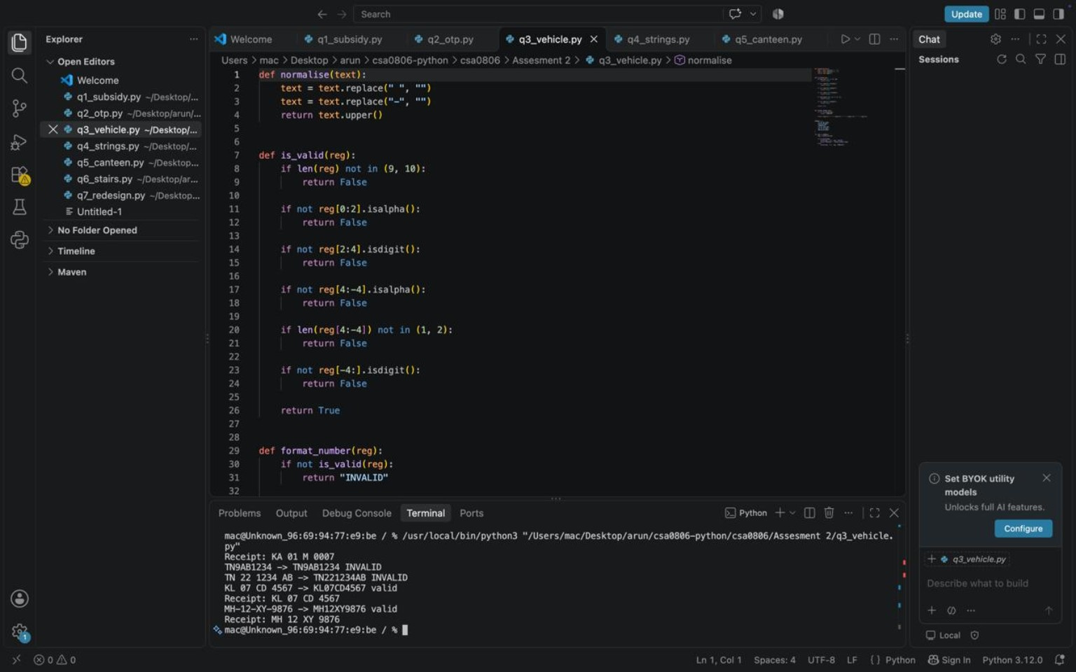
Figure 3. Q3 registration normalisation and validation code with terminal output.

Q4 — Building Long Text: + or join()? (6 Marks)

Aim
To compare repeated += concatenation, str.join() and f-string-based line construction when creating a long statement.

join implementation
def build_join(parts):
return "".join(p + ";" for p in parts)

Complexity and interpretation
Strings are immutable, so concatenation can create new string objects and may copy existing characters repeatedly. Repeated concatenation can have O(N²) worst-case copying for total output size N, although CPython may optimise some += patterns. Building parts and joining them is O(N) in the total output size and requires memory for the parts and the final string. Writing directly to a file or using io.StringIO can be preferable when the complete output should not be held in memory as one large string.

Measured evidence visible in screenshot
Input size | Repeated += time | join time | f-string time | Same output?
200,000 items | 0.0233 s | 0.0328 s | 0.0282 s | True

The visible run reports 200,000 lines/items and an output length of 3,048,890 characters. In this single recorded run, the += method was faster than join and the f-string method. This does not disprove the general complexity guidance: one measurement can be affected by interpreter optimisations, machine load and implementation details. The assignment requests three runs at 1,000, 10,000 and 200,000 items, so the report should include the student's full averages if those measurements are available.
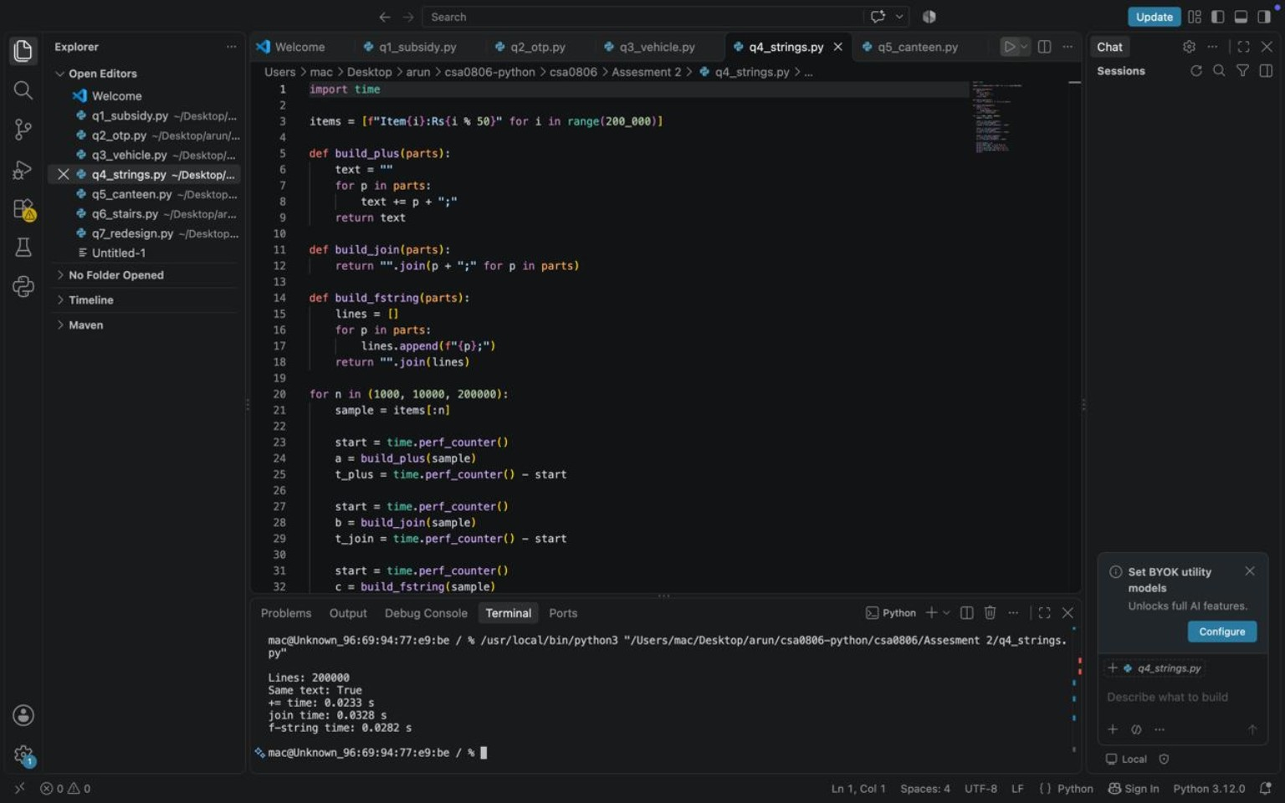
Figure 4. Q4 string-building benchmark code and the visible 200,000-item timing result.

Q5 — Functions, Parameters and Scope (7 Marks)

Aim
To investigate mutable default arguments, independent customer orders, multiple return values and local/global/nonlocal scope.

Corrected function
def add_item(item, order=None):
if order is None:
order = []
order.append(item)
return order

Explanation
A default list in def add_item_buggy(item, order=[]) is created once when the function is defined. Each call that omits order reuses that same list, so items from earlier calls remain in later results. Using None as the default and creating a list inside the function gives each new call its own list.
Positional arguments are matched by position, keyword arguments specify a parameter by name, and default arguments provide a value when the caller omits one. A function can return multiple values using a tuple, for example return total, gst. Local names exist within a function, global names are defined at module level, and nonlocal refers to a name in an enclosing function scope. The global keyword allows reassignment of a module-level name but is often avoided because it creates hidden dependencies between functions.
An alternative is to require the caller to pass an order list explicitly. A closure could also retain an order list inside an enclosing function. Adding one item to the end of a Python list is amortised O(1); each customer's list uses O(m) space for m items.

Observed evidence
The screenshot shows the buggy and corrected functions. The terminal output demonstrates the shared buggy list ['Tea', 'Vada'] appearing in both results, while the corrected calls return separate ['Tea'] and ['Vada'] lists. It also shows a total of 105.0 and GST of 5.0 for an amount of 100.
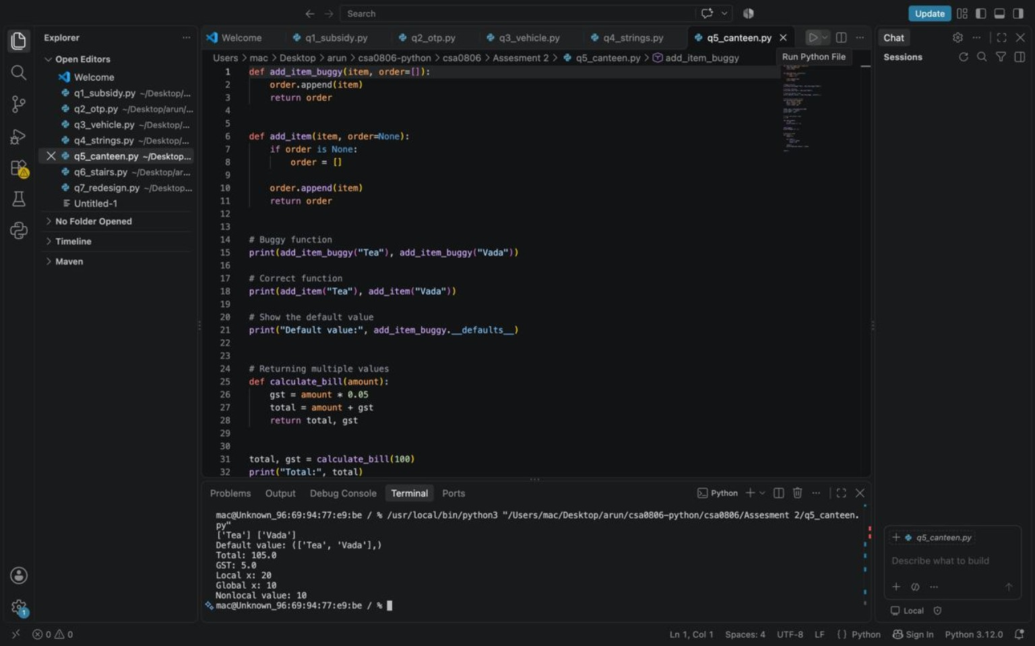
Figure 5. Q5 mutable default argument, corrected function, multiple return values and terminal output.

Q6 — Recursion and Its Limits (8 Marks)

Aim
To count the ways to climb n steps when each move is either one or two steps, and compare naive recursion, memoisation and iteration.

Recurrence and base cases
def ways_naive(n):
if n <= 1:
return 1
return ways_naive(n - 1) + ways_naive(n - 2)

@lru_cache(maxsize=None)
def ways_memo(n):
if n <= 1:
return 1
return ways_memo(n - 1) + ways_memo(n - 2)

def ways_loop(n):
if n <= 1:
return 1
a, b = 1, 1
for _ in range(2, n + 1):
a, b = b, a + b
return b

Answers for small inputs
n | Number of ways
1 | 1
2 | 2
3 | 3
4 | 5
5 | 8
6 | 13

Call-tree explanation
For n = 5, the recursive call begins with ways(5), which calls ways(4) and ways(3). ways(4) calls ways(3) and ways(2), and ways(3) calls ways(2) and ways(1). The same subproblems, such as ways(3) and ways(2), are evaluated repeatedly. Memoisation stores each result the first time it is calculated and reuses it later.

Measured evidence
Method | Input | Result | Function calls / time visible
Naive recursion | n = 25 | 121393 | 242785 calls; 0.021196 s shown in a separate run
Memoisation | n = 25 | 121393 | 26 calls; 0.000013 s shown in a separate run
Loop | n = 25 | 121393 | 0.000005 s shown in a separate run
Memoisation | n = 1000 | RecursionError shown | Python recursion depth reached

The screenshots show that naive recursion and memoisation return the same result for n = 25, but memoisation reduces the function-call count substantially. The screenshot also shows a recursion-depth error for a large input. Increasing the recursion limit can be risky because it may exhaust the interpreter's stack. For n = 1000, an iterative solution is the safer deployment choice.
Complexity: naive recursion takes O(φⁿ) time and O(n) stack space; memoisation takes O(n) time and O(n) cache/stack space; the loop takes O(n) time and O(1) auxiliary space. Python integers grow in size with the answer, so arithmetic cost is not strictly constant for very large n.
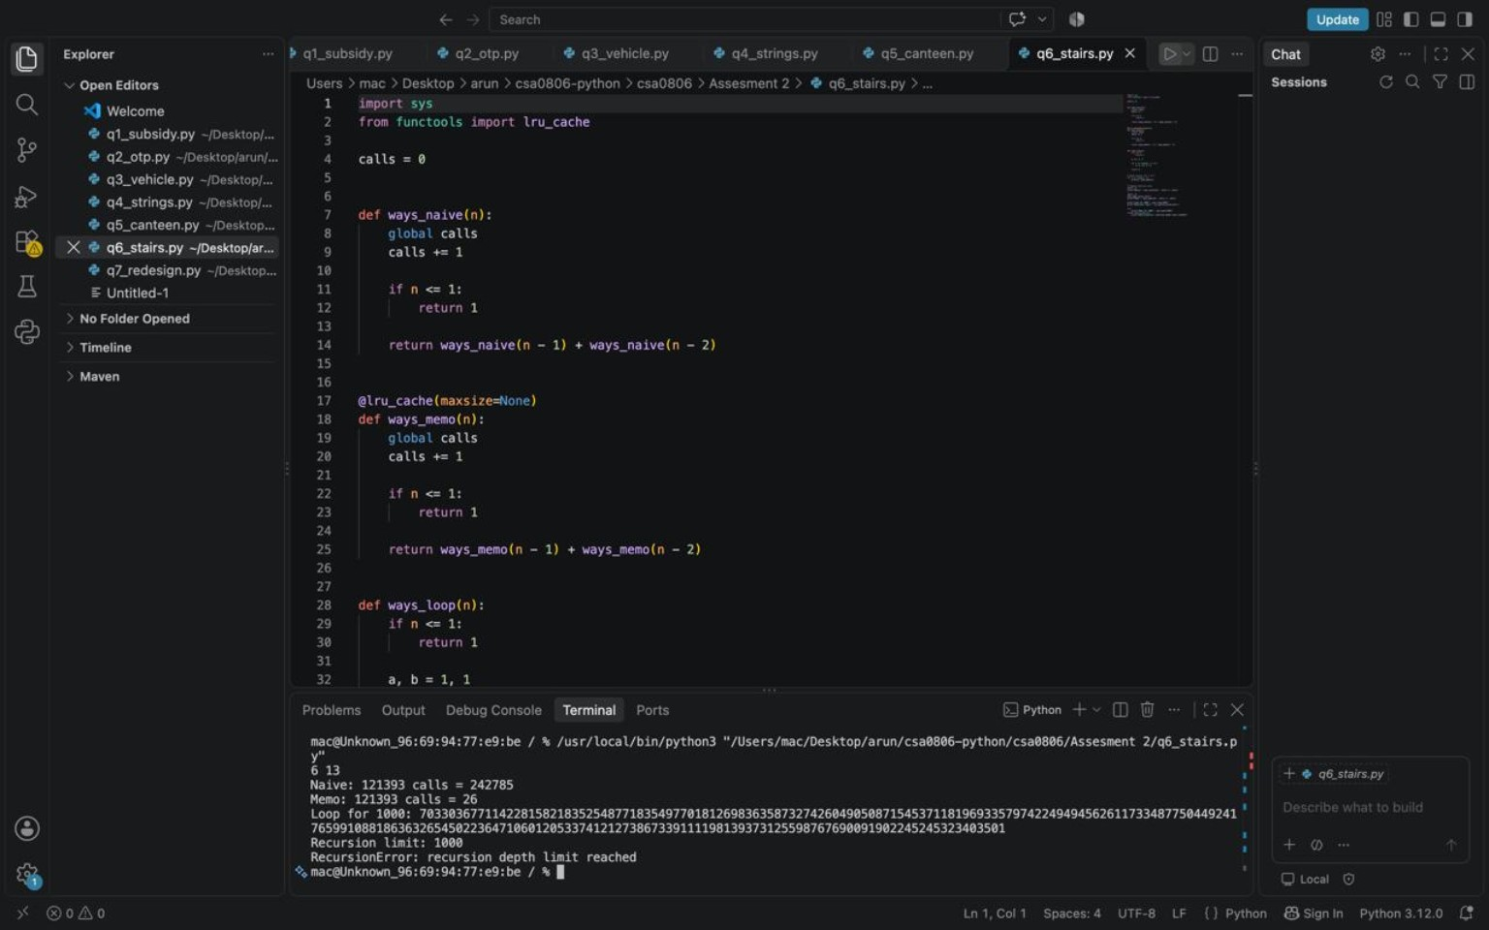
Figure 6. Q6 recursion/memoisation code and terminal output showing the recursion-depth limitation.
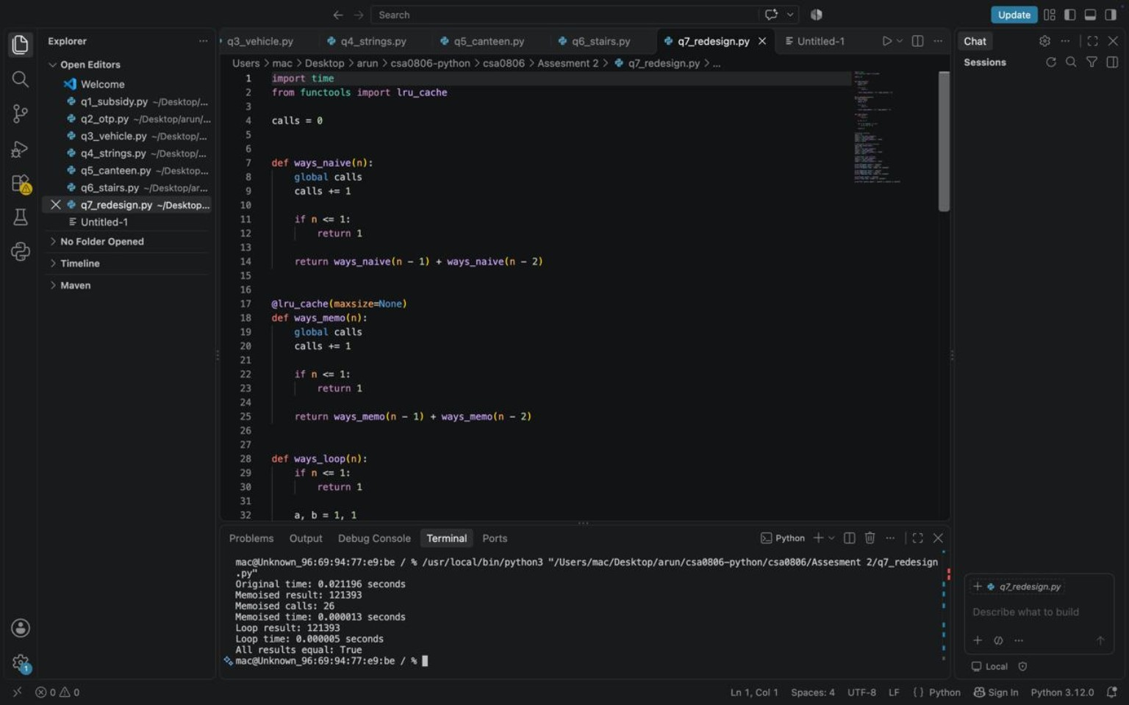
Figure 7. Q7 redesign benchmark screenshot showing equal answers and recorded timings.

Q7 — Diagnose, Redesign and Validate (13 Marks)

A. Diagnose the bottleneck
The staircase program's naive recursive method repeatedly calculates the same subproblems. The evidence for n = 25 shows 242,785 calls for the naive method compared with 26 calls for the memoised method. The growth in repeated calls is the main limitation as n increases.

B. Design objective
The objective is to return the same staircase count while reducing redundant computation and supporting n = 1000 without a recursion-depth error.

C. Revised solution
def ways_loop(n):
if n <= 1:
return 1
previous_two, previous_one = 1, 1
for _ in range(2, n + 1):
previous_two, previous_one = previous_one, previous_two + previous_one
return previous_one

The redesigned solution exploits the recurrence: the current count depends only on the previous two counts. It therefore keeps two variables rather than storing every prior result or building a deep recursive call stack. The trade-off is that the iterative version does not directly mirror the mathematical recursive definition, although it remains simple to implement.

D. Prediction
Before execution, the prediction is that the loop will produce the same answer as both recursive versions, use O(n) time and O(1) auxiliary space, and avoid RecursionError for n = 1000.

E. Validation
Method | Expected/observed result | Evidence
Naive recursion | 121393 for n = 25 | Screenshot shows 242785 calls
Memoisation | 121393 for n = 25 | Screenshot shows 26 calls
Loop | 121393 for n = 25 | Screenshot shows loop result and timing
Loop for n = 1000 | Should complete without recursion-depth error | Run and record the actual result before final submission

The supplied benchmark screenshot reports an original time of 0.021196 seconds, a memoised time of 0.000013 seconds, and a loop time of 0.000005 seconds for the displayed run. These figures are machine- and run-dependent; they should be reported as the recorded run, not as universal performance guarantees.

F. Final evaluation
The redesign is appropriate for large staircases because it eliminates repeated subproblem evaluation and avoids recursion depth limits. The loop is the preferred implementation when low memory use and reliable operation at n = 1000 are priorities. Naive recursion remains useful for teaching the recurrence, and memoisation is useful when the recursive structure is easier to express or many overlapping subproblems are present.

4. Conclusion
This assignment demonstrates how Python decisions, loops, strings, functions and recursion can be applied to practical problems. The key lessons are to make conditional boundaries mutually exclusive where appropriate, handle blank input carefully, normalise strings before validation, avoid mutable objects as default parameter values, and measure performance rather than relying only on assumptions. The staircase experiment shows that memoisation can greatly reduce repeated calls, while an iterative solution is particularly suitable when stack depth and auxiliary memory matter.

