**Face Recognition**

**Attendance System**

Submitted for the Partial Fulfillment of the Requirements for the Degree of

###### Bachelor of Technology

in Computer Science and Engineering

#### J.C. Bose University of Science and Technology, Faridabad

**Submitted By:**

**Arun**

**20020004016**

**Hemant**

**20020004037**



**Under the Guidance of**

**Guided By: (Principal)**

**Dr Deepti Goyal Pawan Bhadana**

**DEPARTMENT OF COMPUTER SCIENCE AND ENGINEERING**

**Satyug Darshan Institute of Engineering and Technology, Faridabad**

**Acknowledgement**

We take this opportunity to thank all those magnanimous persons who rendered their full services at our work.

It’s with great happiness we are expressing gratitude to our guide Faculty Dr Deepti Goyal. CSE Department, for timely and kind help, guidance and providing us with the most essential material required for the completion of this project. We are very thankful to our guide for her indomitable guidance. Her inspiration up to the last moment had made things possible in a planned manner.

We also thank our teaching faculties for the cooperation extended for the successful completion of the project.

Finally, we thank everyone who helped to complete our project work with their cordial support.

**Contents**

Abstract 5

Introduction 6

Motivation 7

Literature Review 8

Keywords and Definition 9

Methodologies 11

Challenges Faced 13

Results 14

Conclusion 18

Future Scope 18



# Abstract

In colleges, universities, organizations, schools, and offices, taking attendance is one of the most important tasks that must be done daily. Most of the time, it is done manually, such as by calling by name or by roll number. The main goal of this project is to create a Face Recognition- based attendance system that will turn this manual process into an automated one. This project meets the requirements for bringing modernization to the way attendance is handled, as well as the criteria for time management. This device is installed in the classroom, where and student's information, such as name, roll number, class, sec, and photographs, is trained. The images are extracted using Open CV. Before the start of the corresponding class, the student can approach the machine, which will begin taking pictures and comparing them to the qualified dataset. The image is processed as follows: first, faces are identified using a Haar**-**cascade classifier, then faces are recognized using the LBPH (Local Binary Pattern Histogram) Algorithm, histogram data is checked against an established dataset, and the device automatically labels attendance. An Excel sheet is developed, and it is updated every hour with the information from the respective class instructor.

# Introduction

Maintaining the attendance record with day-to-day activities is a challenging task. The conventional method of calling the name of each student is time consuming and there is always a chance of proxy attendance. The following system is based on face recognition to maintain the attendance record of students. The daily attendance of students is recorded subject-wise, which is stored already by the administrator. As the time for corresponding subject arrives the system automatically starts taking snaps and then apply face detection and recognition technique to the given image and the recognize students are marked as present and their attendance update with corresponding time and subject id. We have used deep earning techniques to develop this system. Histogram of oriented gradient method is used to detect faces in images and deep learning method is used to compute and compare feature facial of students to recognize them. Our system can identify multiple faces in real time. The main objective of this project is to develop face recognition based automated student attendance system. To achieve better performance, the test images and training images of this proposed approach are limited to frontal and upright facial images that consist of a single face only. The test images and training images must be captured by using the same device to ensure no quality difference. In addition, the students must register in the database to be recognized. The enrolment can be done on the spot through the user-friendly interface.

# Motivation

Applications using facial recognition systems are widespread. They are applied in security systems, authentication systems, verification systems, surveillance systems, etc. We are interacting with face recognition systems without even realizing it. Many Businesses are using facial recognition systems for authentication, verification, and security. There are diverse applications of this system. Countries such as United States, United Kingdom, and Australia are now installing facial recognition technologies in different public spaces such as airports, cafes, shopping areas, factory areas, and government buildings. A large retail company like Alibaba is working on the development of pay-by-face technology. Workspaces use this technology to record the clock in and 6 clock out time of the employees. Law enforcement agencies are installing cameras with facial recognition systems to identify criminals and search for missing persons. As facial recognition technology and algorithms advance, we would see it being implemented more and more in our society.

# Literature Review

Using real time computer vision algorithms in automatic attendance management systems This paper introduces a new approach in automatic attendance management systems, extended with computer vision algorithms. The Proposed system uses real time face detection algorithms integrated on an existing Learning Management System (LMS), which automatically detects and registers students attending a lecture. The system represents a supplemental tool for instructors, combining algorithms used in machine learning with adaptive methods used to track facial changes during a longer period.

Face Recognition-based Lecture Attendance System proposed a system that takes the attendance of students for classroom lectures. The system takes attendance automatically using face recognition. However, it is difficult to estimate the attendance precisely using each result of face recognition independently because the face detection rate is not sufficiently high. In this paper, we propose a method for estimating the attendance precisely using all the results of face recognition obtained by continuous observation.

Automatic Control of students' attendance in Classrooms Using RFID Radio frequency identification (RFID) is one of the automatic identification technologies more in vogue nowadays. There is a wide research and development in this area trying to take maximum advantage of this technology, and in coming years many new applications and research areas will continue to appear**.**

# Keywords and Definition

**Face Recognition:** A technology that identifies or verifies individuals by analyzing and comparing patterns based on facial contours, using characteristics such as the distance between the eyes, nose, and mouth.

**Attendance System:** A system designed to track and record the presence, absence, or arrival of individuals, often used in educational institutions or workplaces for monitoring attendance.

**Biometric Authentication:** A security process that uses unique biological characteristics, like facial features, fingerprints, or iris patterns, to verify and authenticate an individual's identity.

**Facial Features:** Distinctive characteristics of a person's face, such as the size and shape of the eyes, nose, mouth, and other facial attributes, used for recognition purposes.

**Machine Learning:** A subset of artificial intelligence (AI) that enables systems to learn and improve from experience without being explicitly programmed, often used in face recognition systems to enhance accuracy over time.

**Deep Learning:** A type of machine learning that involves algorithms known as neural networks, which can analyze and recognize patterns, widely utilized in complex tasks like facial recognition.

**Liveness Detection:** A technique employed in face recognition systems to ensure that the detected face is from a live person and not a still image or a video recording, preventing spoofing attacks.

**Database Management:** The organization, storage, and retrieval of data related to individuals' facial templates or profiles used for recognition within the system.

**Accuracy Rate:** The measure of how often a face recognition system correctly identifies individuals, often expressed as a percentage.

**Privacy and Security:** Concerns related to the protection of individuals' facial data stored in the system and ensuring that it is not misused or compromised.

**API (Application Programming Interface):** A set of protocols, tools, and definitions that allows different software applications to communicate and share data, often used in integrating face recognition systems with other software or platforms.

**Cloud-Based System:** A system where the storage, processing, and operation of the face recognition system occur on remote servers accessed through the internet, providing scalability and accessibility.

# Methodologies

**Detection of Faces:**

* **Haar Cascades:** This method involves detecting faces by using Haar-like features and a cascade of classifiers to identify regions of interest.
* **Deep Learning-based Detection**: Utilizing Convolutional Neural Networks (CNNs) like SSD (Single Shot MultiBox Detector) or YOLO (You Only Look Once) to detect faces within an image or video stream.

**Feature** **Extraction:**

* **Local Binary Patterns (LBP):** Analyzing patterns in textures to describe facial features, often used for extracting discriminative information from facial regions.
* **Eigenfaces:** A technique using principal component analysis (PCA) to represent facial features based on statistical analysis, reducing the dimensionality of face images for recognition.

**Representation Learning:**

* **Deep Convolutional Neural Networks (CNNs):** Employing architectures like VGG, ResNet, or FaceNet to learn hierarchical representations of facial features directly from raw pixels, enabling robust feature extraction for recognition.
* **Siamese Networks:** Utilizing neural networks that learn to differentiate between pairs of images, used for verification tasks in face recognition.

**Matching and Recognition:**

* **Metric Learning:** Learning a distance metric between faces in a feature space to accurately measure similarities or dissimilarities between faces.
* **One-Shot Learning:** Training models to recognize individuals with limited data, allowing for recognition of new faces with minimal training samples.

**Liveness Detection:**

* **Texture Analysis:** Assessing the dynamic textures of a face to distinguish between live subjects and spoof attempts like photographs or videos.
* **3D Face Reconstruction:** Employing 3D imaging or depth sensors to detect depth cues and verify the presence of a live person.

**Attendance Logging and Management:**

* **Database Management:** Storing and managing facial templates or descriptors securely in a database for quick retrieval and comparison during attendance marking.
* **Real-time Processing:** Processing video streams or live images to mark attendance in real-time, updating records immediately upon face recognition.

**Integration** **and** **Deployment:**

* **API Integration:** Implementing face recognition capabilities through APIs, allowing integration with various applications or platforms for attendance management.
* **Hardware Integration:** Deploying the system on hardware devices like cameras, smartphones, or specialized attendance machines.

# Challenges Faced

**Illumination**

Illumination stands for light variations. The slight change in lighting conditions causes a significant challenge for automated face recognition and can have a significant impact on its results. If the illumination tends to vary, the same individual gets captured with the same sensor and with an almost identical facial expression and pose, the results that emerge may appear quite different.

Illumination changes the face appearance drastically. It has been found that the difference between two same faces with different illuminations is higher than two different faces taken under the same illumination.

**Occlusion**

Occlusion means blockage, and it occurs when one or other parts of the face are blocked and whole face is not available as an input image. Occlusion is considered one of the most critical challenges in face recognition system.

It occurs due to beard, moustache, accessories (goggles, cap, mask, etc.), and it is prevalent in real-world scenario. The presence of such component makes the subject diverse and hence making automated face recognition process a tough nut to crack.

# Results

The results of a face recognition attendance system primarily revolve around the accuracy, efficiency, and usability of the system in accurately identifying individuals and recording their attendance. Here are some key outcomes and benefits:

**Accuracy:**

* **Correct Identification:** The system should accurately recognize individuals, minimizing false positives and negatives in attendance marking.
* **High Precision:** Ensuring the system's ability to precisely match faces even with variations in lighting, angles, or facial expressions.



**Efficiency:**

* **Real-time Tracking:** Marking attendance instantly upon face recognition, allowing for immediate and accurate tracking of individuals' presence.
* **Automated Processes:** Reducing manual attendance tracking efforts, saving time for both administrators and individuals marking attendance.

**Usability:**

* **User-Friendly Interface:** Providing an intuitive interface for users to interact with the system easily, whether for marking attendance or system administration.
* **Scalability:** Being able to handle a growing number of users or attendees without compromising performance.

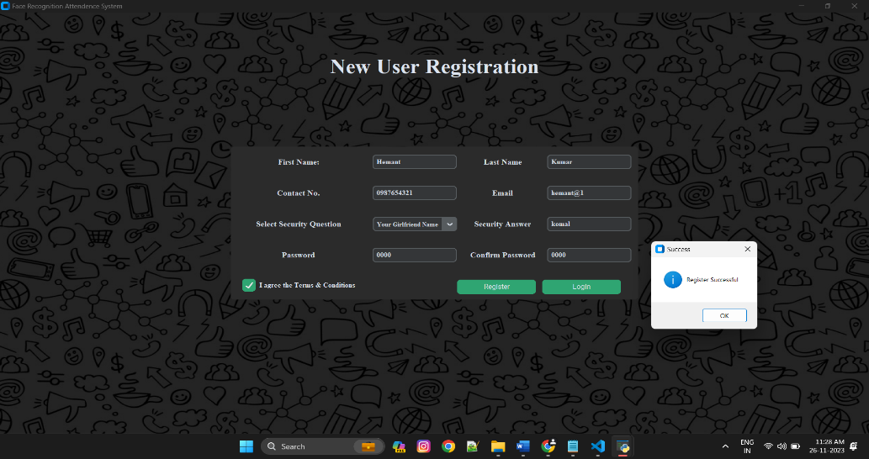

**Data Security and Privacy:**

* **Protection of Facial Data:** Ensuring the stored facial data is secure from unauthorized access or misuse, adhering to privacy regulations and standards.
* **Encryption and Access Control:** Implementing robust encryption methods and access controls to safeguard sensitive facial templates or data.



**Integration and Compatibility:**

* **Compatibility with Systems:** Seamlessly integrating with existing attendance or management systems used in educational institutions or workplaces.
* **API Integration:** Offering APIs for integration with other applications or platforms, providing flexibility in usage.

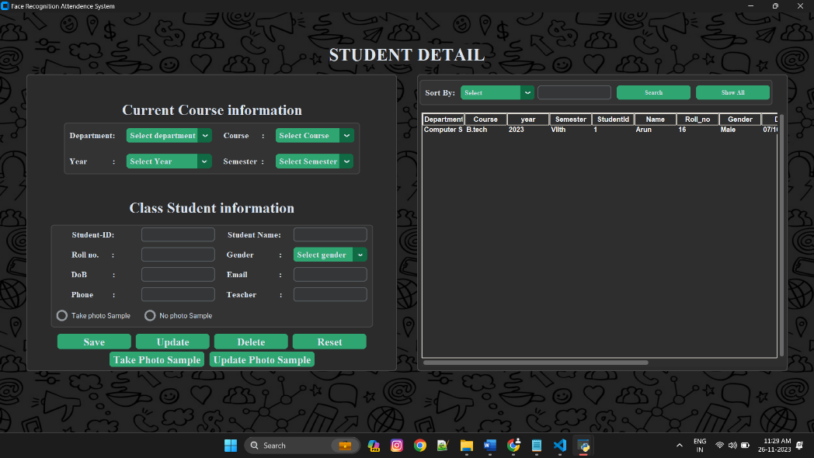

**Reporting and Analysis:**

* **Attendance Reports:** Generating accurate and detailed reports on attendance records, facilitating analysis and decision-making for administrators.
* **Insights and Trends:** Deriving insights from attendance data, such as attendance patterns or trends over time.

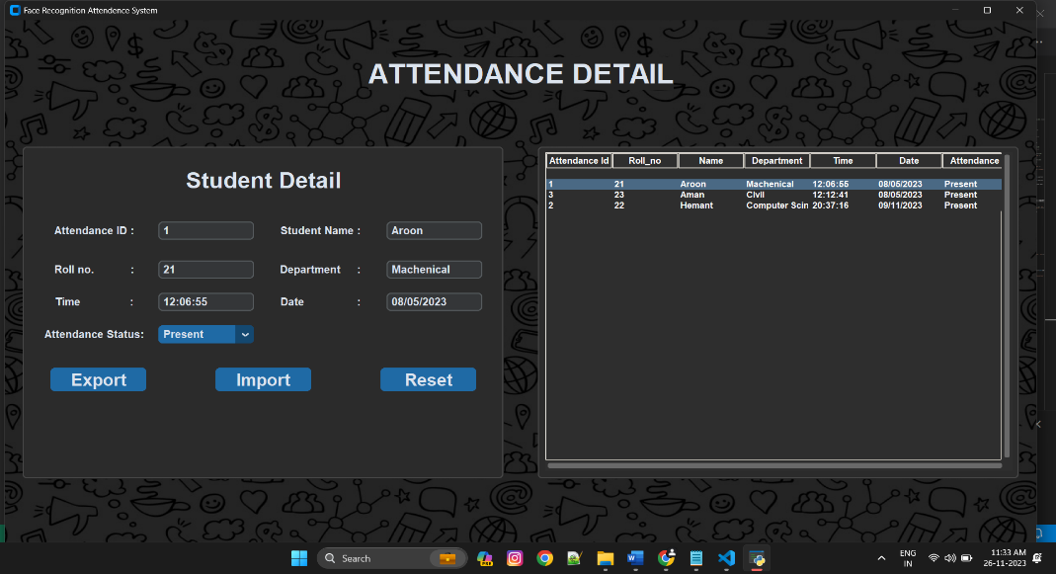

**Liveness Detection and Anti-Spoofing:**

* **Detection of Spoof Attempts:** Successfully identifying and preventing spoofing attempts, ensuring attendance records are based on live face recognition.

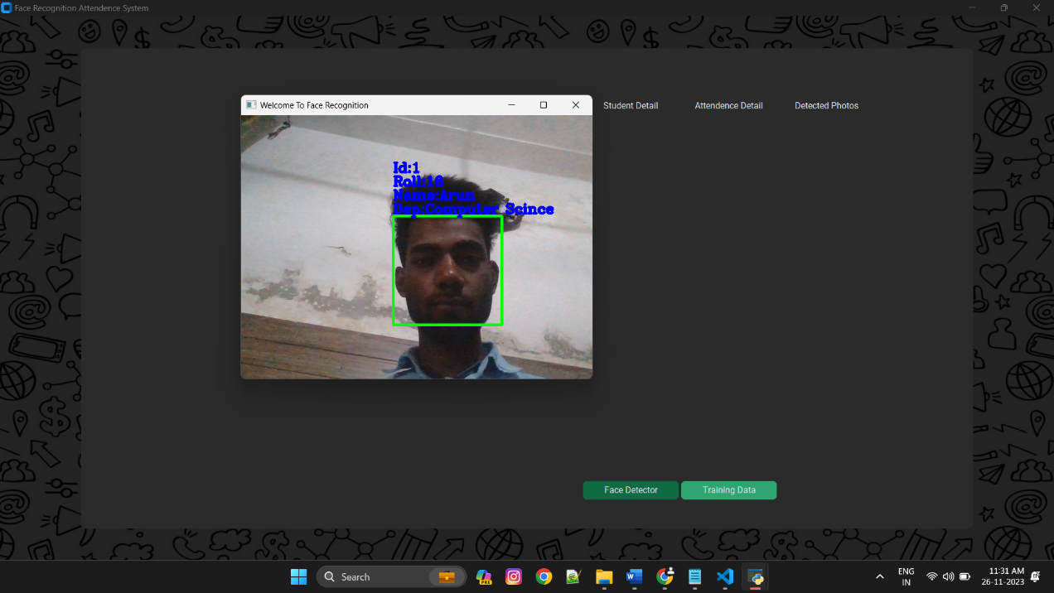

# Conclusion

The goal of the project was to build a facial recognition system for students’ attendance. Concepts of facial recognition and LBPH is heavily discussed in this thesis. Similarly, web development with Django is also discussed, followed by examples of implementation and explanations. The result of the project was a successful prototype of a facial recognition system where the admin can create a teacher account and add students and their information to the database. Teachers then can log in to the system and take attendance of the student. The student's face is detected by a camera and attendance is recorded in the database. Teachers and admin could see the attendance report of the students.

# Future Scope

Face recognition is a futuristic and relatively unexplored field with extensive area of practical applications, including security and criminal cases. Although we can recognize the person from a video. This field has a lot of future building for development and performance in new areas.