Crusource Superadmin — Product Requirements
Status: Draft for designer review
Audience: Product owner and UI/UX designer
Companion: User-facing data flows
Scope: First release of the unified Crusource Superadmin portal for CRM and VMS

Contents
1. Purpose
2. Background and problem
3. Goals and non-goals
4. Vocabulary
5. The most important design requirement: topbar product switcher
6. Users and roles
7. Sign-in, session, and staff access
8. Navigation and screen requirements
9. Screen-by-screen requirements
10. Key interactions
11. States the designer must cover
12. Content, privacy, and data presentation rules
13. First-release scope
14. Reviewable defaults and open questions
15. Designer handoff
16. Acceptance checklist

1. Purpose
Create one internal Crusource portal where Crusource staff can track and manage customer organizations, customer users, subscriptions, requests, and product operations for both CRM and VMS.
• Crusource is the product and portal name.
• CRM and VMS are the two platforms within Crusource.
• Customer administrators continue to use their own CRM or VMS applications. This portal is for Crusource staff only.
• The existing separate per-platform Superadmin portals will be retired once the unified portal has been validated.
This document describes the desired experience. It does not imply that every feature already exists in either application. Placeholder screens are not evidence that a feature works.

2. Background and problem
Today, staff manage each platform through a separate Superadmin portal. This causes several problems:
Problem | Effect on staff
Separate sign-ins and separate navigation | Staff switch between portals and relearn layouts for each platform.
No view of customers that use both platforms | Staff cannot easily see that one organization uses CRM and VMS.
Billing spread across platforms | Staff cannot see an organization's full subscription position in one place.
Different labels and metrics per platform | Numbers are hard to compare and easy to misread.
Separate staff access management | Granting or revoking internal access must be repeated per platform.

The unified portal solves these by giving staff one sign-in, one navigation template, one switcher, common billing, and shared staff access, while keeping each platform's customer data clearly separate.

3. Goals and non-goals
3.1 Goals
1. One place for both platforms: staff manage CRM and VMS from the same portal and the same account.
2. Predictable navigation: every platform screen looks and behaves the same for CRM and VMS; only the data changes.
3. Clear platform context: staff always know which platform's information they are viewing and which platform an action will affect.
4. Common billing: each organization's CRM and VMS subscriptions, invoices, payments, trials, and renewals are visible together.
5. Safe administration: every change states its exact target, requires confirmation and a reason, shows a true result, and is recorded.
6. Trustworthy information: loading, stale, unavailable, and empty states are never confused with real values.
3.2 Non-goals for the first release
• An “All Products” view that mixes CRM and VMS data on platform screens.
• Customer-facing features; customers never use this portal.
• Exposing customer business content (deals, candidates, documents) on summary screens.
• Second-person approval workflows.
• Dark mode and multilingual variants.
• Roles beyond Super Admin and Sub Admin.

4. Vocabulary
Term | Meaning
Platform | CRM or VMS.
Selected platform | The platform chosen in the topbar switcher.
Platform screen | A screen showing selected-platform data: Overview, Organizations, Users, Requests & Feedback, Activity & Security, Product Operations.
Shared screen | A screen unaffected by the switcher: Billing, Pricing & Plans, Staff & Access, or Integrations.
Staff | Internal Crusource employees using this portal.
Customer | An organization or person using CRM, VMS, or both.
Combined profile | One confirmed organization or person, shown once, with separate CRM and VMS memberships.
Platform membership | A customer's role, access status, member count, subscription state, and activity within one platform.
Administrative activity | The record of staff actions: actor, platform, customer, action, result, time, and reason.
Stale information | The last successfully loaded information, shown with its timestamp while a fresh update is unavailable.

5. The most important design requirement: topbar product switcher
Place a prominent CRM / VMS switcher in the topbar on every signed-in screen. Switching changes the platform data; the menu template and equivalent screen remain the same. Billing is common and does not change. Pricing & Plans, Staff & Access, and Integrations are also shared screens. There is no “All Products” option.

5.1 Conceptual layout
Placement and behaviour only — not a prescribed visual design:
🖥️ INTERFACE & NAVIGATION TEMPLATE MOCKUP
CRUSOURCE Product: [ CRM | VMS ] Search Staff profile
^
Always clearly show the selected platform

Menu Selected screen
Overview CRM organizations and CRM users
Organizations Switch to VMS → same screen, VMS data
Users
Billing Common billing for CRM and VMS (Shared)
Pricing & Plans CRM and VMS plan catalog (Shared)
Contact Us Selected-platform inquiries
Requests & Feedback Separate tabs: Demos, Trial Requests, Feedback
Activity & Security
Product Operations
Staff & Access Internal staff for both platforms (Shared)
Integrations Gmail and Google Calendar (Shared)

5.2 Why this matters
Staff frequently move between platforms while investigating the same customer. Keeping the screen and template constant while swapping only the data means staff never lose their place, and comparisons between platforms are straightforward. The switcher must therefore be always visible, always accurate, and never ambiguous.
5.3 Switcher behaviour
Situation | Required behaviour
Overview: CRM → VMS | Stay on Overview; replace CRM metrics with VMS metrics in the same positions.
Organizations: CRM → VMS | Stay on Organizations; show only organizations using VMS.
Users: CRM → VMS | Stay on Users; show only accounts belonging to VMS.
Requests, activity, or operations: CRM → VMS | Stay on the equivalent screen; replace the platform-specific records.
Billing: CRM → VMS | Remain on Billing; keep the same combined billing records.
Staff & Access: CRM → VMS | Keep the same internal staff records; staff serve both platforms.
Organization/user detail exists in both platforms | Keep the same combined profile open; activate the selected platform's section.
Search/filter valid in both platforms | Keep the search, shared filters, and sorting; reset pagination to the first page.

5.4 Loading and accuracy rules
• The selected label changes immediately when staff switch.
• Previous-platform values are cleared at once and replaced with loading placeholders.
• Never display CRM values under a VMS label, or VMS values under a CRM label, even briefly.
• Both switcher options are visible to Super Admin and Sub Admin. Product visibility is shared; permitted actions follow the role and assigned permission profile.
5.5 Accessibility expectations
• The switcher must be operable by keyboard and clearly announce the selected platform.
• The selected state must not rely on colour alone.
• The switcher must remain reachable on narrow screens.

6. Users and roles
The first release has exactly two internal roles.
Role | Who | Responsibility
Super Admin | The first designated owner of the portal | All product and billing actions; invites, manages, and revokes Sub Admins.
Sub Admin | Internal staff, including developers | Views both platforms; administers organizations and users, handles requests, troubleshoots, reads operational summaries.

6.1 Starting permission defaults
Area | Action | Super Admin | Sub Admin
Navigation | See both CRM and VMS | Yes | Yes
Organizations and users | Search and view profiles | Yes | Yes
Organizations and users | Change customer memberships | Yes | Yes
Organizations and users | Suspend or reactivate | Yes | No
Organizations and users | Confirm shared customer links | Yes | No
Billing | Inspect | Yes | Yes
Billing | Extend trials | Yes | Yes
Billing | Plan changes, discounts, refunds, renewals | Yes | No
Requests & Feedback | Assign, resolve, approve, reject | Yes | Yes
Activity & Security | View and export permitted summaries | Yes | Yes
Product Operations | Inspect status and usage | Yes | Yes
Product Operations | Feature changes and provisioning | Yes | As permitted
Support access | Start a support session | Yes | As permitted
Staff & Access | Invite, cancel, re-send, revoke | Yes | No
Staff & Access | Change the Super Admin account | — | No

The Sub Admin column above represents starting grants, not fixed entitlements. The Super Admin configures action permissions through the profiles in section 9.11. Internal access management stays owner-only.
6.2 Role rules
• Customer membership changes never grant internal Superadmin access.
• A Sub Admin cannot alter the Super Admin account.
• No second-person approval is required. Sensitive actions still require confirmation and a reason.
• When an action is not permitted, the portal explains which permission is required rather than hiding the action without explanation.

7. Sign-in, session, and staff access
7.1 Sign-in
• One internal account serves both platforms.
• Sign in using email and password only. No MFA enrolment, challenge, or second verification step is included.
• Include forgot-password/reset-password, session expiry after inactivity, and sign-out from the staff profile menu. Email invitation and password-reset links are account setup/recovery, not additional login factors.
• Invalid details produce a clear error that does not reveal which part was wrong.
• After sign-in, staff land on Overview with their last selected platform (first-time default: CRM).
• Staff accounts and customer accounts must be visibly separate. Customer credentials are never accepted here.
7.2 Session expiry and revocation
• An expired session returns staff to sign-in without completing any pending action.
• Revoked staff lose access to both platforms immediately; any open session ends with an explanation.
• After signing in again, staff return to the screen they were on where practical.
7.3 Staff invitation lifecycle
Status | Meaning | Available actions (Super Admin)
Pending | Invitation sent, not yet activated | Cancel, re-send
Expired | Invitation not used within its validity period | Re-send
Active | Account activated; access to both platforms | Revoke
Revoked | Access removed for both platforms | —
Cancelled | Invitation withdrawn before activation | —

All staff-access changes are recorded in shared staff-access history.

8. Navigation and screen requirements
All items remain in the same order for CRM and VMS. Shared screens carry a clear “Shared across CRM and VMS” label. Colours, icons, detailed spacing, and responsive layouts are the designer's responsibility.
Menu item | Type | Purpose and content | Main actions
Overview | Platform | Same metric layout for the selected platform; attention list and recent activity | Open an organization, user, or request
Organizations | Platform | Selected-platform customers, product badges, account status, owner/contact, member count | Search/filter; open profile; permitted suspension/reactivation
Users (not needed) | Platform | Selected-platform customer accounts, organization, membership role, status, last activity | Search/filter; open combined profile; permitted membership/access changes
Billing | Shared | Common organization billing, CRM/VMS line items, plans, invoices, payment status, renewals, and trials | Review invoices/payments; manage plans, renewals, trials, discounts, and refunds according to role and permission profile
Requests & Feedback | Platform | Selected-platform feedback, demo requests, and trial-extension requests | Inspect, assign, resolve, approve/reject as applicable
Activity & Security | Platform | Selected-platform customer login history and administrative activity | Search/filter; inspect event details; export permitted summaries
Product Operations | Platform | Selected-platform availability, refresh status, administrative usage, and feature settings | Inspect status; permitted feature changes and provisioning
Staff & Access | Shared | Internal staff directory, roles, invitation status, and access status | Super Admin invites, cancels, re-sends, or revokes Sub Admins

Additional navigation items, in the same order under both product selections:
Menu item | Type | Purpose | Main actions
Pricing & Plans (after Billing) | Shared | Dynamic CRM/VMS plan catalog and revisions | Draft, preview, publish, archive with permission
Contact Us (before Requests & Feedback) | Platform plus labelled unassigned queue | General and sales inquiries, separate from feedback | Assign, reply, resolve, create demo request
Integrations (after Staff & Access) | Shared | Gmail and Google Calendar connections and booking defaults | Super Admin connects/configures; permitted staff use

Requests & Feedback has separate Demos, Trial Requests, and Feedback tabs. Staff & Access includes personal staff profiles and reusable permission profiles.
The topbar also includes a search entry point and the staff profile menu (name, role, sign-out).

9. Screen-by-screen requirements
9.1 Overview
Purpose: a quick, trustworthy summary of the selected platform and a starting point for follow-up work.
Metrics — same labels and positions for CRM and VMS:
Metric | Recommended definition
Total and active organizations | Active = enabled for the selected platform; subscription state shown separately
Total and active customer accounts | Active = signed in within the last 30 days
New organizations (last 30 days) | Organizations added to the selected platform in the period
New customer accounts (last 30 days) | Accounts added to the selected platform in the period
Trials ending within seven days | Selected-platform trials ending in the next seven days
Pending requests, by type | Unresolved feedback and demo requests; trial extensions awaiting a decision

Additional content
• Attention list: items needing action, such as trials about to end or pending requests.
• Recent activity: latest administrative actions for the selected platform.
Rules
• Show each metric's period and last-updated time.
• Billing totals belong on the Billing screen.
• Never add CRM and VMS account counts together and label the result as unique people.
• An unavailable metric shows “Unavailable”, never zero.
9.2 Organizations
List columns: organization name, CRM/VMS usage badges, account status for the selected platform, owner/primary contact, member count.
Filters: status, plan or subscription state, created date, and text search. Filters that exist only in one platform are cleared when switching.
Rules: only organizations using the selected platform appear.
9.3 Organization profile
One organization profile with two platform sections is the recommended design.
• Shared header: organization name, customer reference, primary contact, CRM/VMS usage badges, and a link to common billing.
• Detail template (same in both platforms): Summary, Members, Requests, Activity.
• Platform sections: clearly identified CRM and VMS sections. The topbar selection controls which section is active; selecting the other section updates the topbar.
Organization uses | Appears in | Inside the profile
Both | CRM and VMS directories | Two active platform memberships
CRM only | CRM directory only | VMS section shows “Not in use” (not an error)
VMS only | VMS directory only | CRM section shows “Not in use” (not an error)

Rules
• Platform-specific member counts, subscription state, usage, and suspension status remain separate.
• Suspending CRM access must not silently suspend VMS or cancel billing.
• Provisioning the other platform is an explicit, permitted action with its own result.
9.4 Billing (shared)
Recommended design: one organization billing profile with separate CRM and VMS subscription items.
• Billing list: organizations with their CRM and VMS subscription status, payment status, and next renewal or trial end.
• Line-item filter: an optional CRM/VMS filter belonging to Billing. The global switcher does not change this filter or billing results.
• Organization billing profile:
• Separate CRM and VMS subscription items, each with its own plan, status, trial, and renewal date.
• Invoices and payment history. Where supported, an invoice groups both product line items. Existing separate invoices remain visible with their original product and reference.
• Actions: review invoices and payments; manage plans, renewals, trials, discounts, and refunds according to role and permission profile.
Rules
• Common billing does not mean a single combined plan, shared renewal date, or shared trial.
• New amounts, dates, or plans appear only after a successful result.
• If one platform's billing information is incomplete, identify the missing portion and do not present totals as complete.
9.5 Requests & Feedback
Keep Feedback in its own tab, separate from Demos and Trial Requests. Contact Us is a separate navigation item, not a feedback category. See section 9.10 for the demo booking experience.
Request type | Information shown | Actions
Feedback | Message, attachments, organization, submitter, status, assignee | Assign, resolve
Demo request | Contact details, organization, requested time, stage, assignee, notes | Assign, schedule, add notes, update stage
Trial extension | Organization, platform, current end date, proposed end date, reason | Approve or reject

Rules
• Approval extends only the named product's trial for the named organization.
• Rejection records the decision without changing the trial.
• Each action keeps the platform and organization that were displayed when it began.
9.6 Activity & Security
• Customer login history: user, organization, time, result, and context.
• Administrative activity: staff member, platform, customer, action, result, time, and reason.
• Platform-specific actions appear under their platform. Billing history appears on billing profiles; staff-access history appears in Staff & Access. Shared events shown in a platform view are labelled “Shared”.
9.7 Staff & Access (shared)
• Directory of internal staff: name, email, role, assigned permission profile, invitation status, access status, last sign-in.
• Super Admin actions: invite, cancel, re-send, revoke.
• Shared staff-access history.
See section 9.11 for Sub Admin profiles and configurable permissions. The role tables above are starting defaults; the assigned permission profile determines each Sub Admin's allowed actions.
9.8 Pricing & Plans (shared)
Purpose: staff set up and maintain pricing without changing application code or hard-coded price lists.
The catalog covers CRM and VMS, with each plan clearly labelled by platform. It is a shared screen, unchanged by the topbar switcher. Its own CRM/VMS filter is independent of that switcher, just like Billing's line-item filter.
Screen | What the designer should show
Plan catalog | Platform, plan name, currency, billing interval, price, status, current revision, and number of subscribed organizations
Plan editor | Name, description, platform, currency, amount, monthly/annual billing options, billing basis (organization or seat), included features, usage limits, trial rules, and effective date
Preview | Customer-facing plan card, included features and limits, and example billing summary; make the currency and billing interval explicit
Publish review | Changes from the current revision, effective date, and whether the change affects new subscriptions or named existing subscriptions
Revision history | Previous prices and features, author, date, reason, and publication status

Lifecycle: Draft → Published → Archived. Drafts can be edited; changing a published plan creates a new revision. Archived plans cannot be chosen for new subscriptions but remain visible on existing customer billing records.
Rules
• Published plans drive the relevant public pricing, subscription selection, and billing experience. A failed publication leaves the last published revision in use.
• CRM and VMS can have different prices, features, limits, and trial rules. A common catalog does not automatically create a combined bundle.
• Existing subscriptions retain their agreed plan revision by default. Changing their price or benefits requires a separate reviewed action identifying the affected customers and effective date; never silently change existing agreements.
• Prevent deletion of plans referenced by subscriptions or invoices. Archiving does not cancel subscriptions.
• Validate required fields, amounts, intervals, limits, and effective dates before publication. Show a clear free-plan label when the amount is zero.
• Super Admin owns publication by default. An explicitly granted Sub Admin permission may allow drafting, publishing, or archiving separately. Record every publication and subscription migration in activity history.
• Billing links each subscription to its agreed plan revision and shows any scheduled plan change.
9.9 Contact Us (separate from Feedback)
Purpose: handle sales questions, general inquiries, and customer contact messages independently from product feedback.
• List: sender name/email, company or linked organization if known, subject, platform, source, received time, assignee, and status.
• Detail: original message, contact details, conversation history, internal notes, assignment, and status.
• Actions: assign, add an internal note, draft/send a Gmail reply with permission, and resolve/reopen.
• Recommended statuses: New → In progress → Resolved. A reply updates conversation history; it does not automatically resolve the inquiry.
• Offer Create demo request when relevant, retaining a link to the original inquiry. It does not book a meeting or send an email by itself.
• CRM/VMS-tagged inquiries follow the topbar switcher. Inquiries without a platform remain in a clearly labelled Unassigned platform queue within Contact Us, available under either selection; staff can classify them. Do not discard messages from people who are not yet customers.
• Feedback retains its own message/category, submitter, organization if known, status, assignee, and resolution history. Contact and feedback counts remain distinct.
9.10 Demo requests and one-click booking
Within Requests & Feedback → Demos, show requester name/email, company, platform, requested slot and time zone, assignee, status, notes, and linked contact inquiry if any.
Primary action: Book demo. It performs the booking using the saved sender, calendar, duration, meeting location, and confirmation template. The button's nearby summary must show the time, attendee, organizer, and that a customer confirmation will be sent.
• One click is available when a customer-confirmed slot, required details, assigned organizer, current availability, permissions, Gmail connection, and Calendar connection are ready.
• Otherwise show Choose time / Complete details or Reconnect integration, as appropriate. Review the final slot before booking. Never treat an unconfirmed preferred time as an accepted appointment.
• On booking, check availability again, create the Calendar meeting, include a meeting link where configured, send one booking confirmation through Gmail, and record the meeting against the request.
• Coordinate Calendar invitations and Gmail confirmation so the customer does not receive duplicate confirmations. Templates clearly state the platform, date, time zone, duration, organizer, meeting link/location, and rescheduling contact.
• Recommended statuses: New, Awaiting details, Ready to book, Booking, Booked, Confirmation pending, Completed, Cancelled.
• If the Calendar booking fails, do not send a booking-success message. If the meeting exists but email fails, show Booked — confirmation pending and offer Retry confirmation without creating another meeting.
• If the result is unknown, check the existing booking before retrying. Prevent repeated clicks or concurrent staff actions from producing duplicate events/emails.
• A conflicting slot shows Choose another time. Reschedule and cancel are explicit actions with customer notification and activity history; closing a request alone does not cancel its meeting.
9.11 Sub Admin profiles and permissions (shared)
There are still only Super Admin and Sub Admin roles. A permission profile is a reusable set of allowed actions assigned to a Sub Admin; it is not another role. Keep it visually distinct from the staff member's personal profile.
• Staff profile: name, email, role, assigned permission profile, access status, last sign-in, and activity history. Staff can update permitted personal details; they cannot grant themselves permissions.
• Permission profile editor: name, description, and grouped action controls for Organizations, Billing, Pricing & Plans, Contact Us, Feedback, Demos, Activity, Product Operations, Support Access, and integration use.
• Use relevant controls such as view, edit, assign/resolve, approve trial extensions, export, draft/publish/archive plans, send replies, book/reschedule/cancel demos, and support access. Avoid a single unrestricted “Manage everything” checkbox.
• Super Admin creates/edits profiles, assigns one profile when inviting a Sub Admin, and can reassign it later. New profiles start with viewing enabled for administrative summaries and write/export actions disabled until granted.
• Suggested editable starter profiles: Developer, Support, and Billing. They remain Sub Admin accounts, and the owner reviews the actual action grants before assignment.
• Both products and the same navigation remain visible to all staff. Profiles control actions across CRM and VMS; they do not hide either switcher option.
• Show the affected staff count and action changes before saving an edited profile. Changes take effect for active sessions, including permission checks on pending actions, and are recorded in shared history.
• Internal invitations, permission-profile management, access revocation, and managing shared Google connections remain reserved for Super Admin. No profile can grant Super Admin ownership or change/remove the designated owner.
• Restricted actions explain the missing permission and direct staff to the Super Admin.
9.12 Integrations (shared)
Purpose: connect an authorized Crusource work account to Gmail and Google Calendar for contact replies and demo booking.
• Show Gmail and Calendar separately: connected account, connection status, selected sender/calendar, last successful use, and Connect/Reconnect/Disconnect actions.
• Super Admin authorizes connections and sets booking defaults: organizer/calendar, sender, duration, meeting location/link setting, and editable confirmation template. Show a preview before saving a template.
• Staff use integrations only through their assigned permissions. Connection credentials are never displayed in profiles or screens.
• Google account authorization connects these services; it is not portal sign-in. Portal authentication remains email/password without MFA. Google's own authorization experience is external to Crusource.
• Use only the mail/calendar access needed for the chosen features. The portal need not expose the entire Gmail inbox or unrelated calendar event contents.
• Show Disconnected, Connected, Reconnect required, Temporarily unavailable and partial states where only one service works. Keep contact and demo requests available even when booking is blocked.
• Disconnecting blocks new integration actions and clearly explains the impact. Existing sent messages and scheduled meetings are not silently deleted or cancelled.

10. Key interactions
Interaction | Requirements
Trial extension | Show organization, platform, current end date, proposed end date, reason, and decision. Approval updates only the named trial.
Suspension/reactivation | Show the exact organization and platform affected, the impact, and a required reason before confirmation.
Customer membership change | Show the target person, organization, platform, current and proposed role or access. Never grants internal portal access.
Staff invitation | Super Admin enters staff details, assigns a permission profile, and invites a Sub Admin. The invitee activates one internal account for both platforms.
Support access | Requires a permission check, reason, visible support-session banner, time limit, exit action, and recorded activity. Never presented as an ordinary customer login.
Exports | Export the current permitted scope and filters; label the platform and export time. Shared billing exports are explicitly labelled shared.
Feature settings/provisioning | Show the target organization/platform and current state, then confirm the proposed change. Enabling another platform requires an explicit provisioning result.

11. States the designer must cover
State | Expected experience
Loading | Selected platform stays visible; use placeholders rather than misleading values
No customers/results | Explain “No organizations use VMS yet” or “No results match these filters”; offer clear filters where relevant
Platform unavailable | Show unavailable status and retry; other platform and independent shared screens remain usable
Stale data | Label the last successful update and that the data is stale; disable actions needing current data
Permission restriction | Both products remain visible; unavailable actions explain which permission is required
Action in progress | Show progress; prevent duplicate submission
Successful change | Confirm the organization, platform, and completed action
Failed change | Explain the failure and keep entered information; do not show success
Result unknown | Explain that the outcome is unknown; check current state before retrying
Data changed by another staff member | Refresh the current record and ask the user to review before resubmitting
Session expired | Return to sign-in without completing an unauthorized action
Access revoked | End the session and explain that access was removed
Unsupported profile after switch | Return to the equivalent list with an explanation

A CRM problem must not block VMS, and a VMS problem must not block CRM.

12. Content, privacy, and data presentation rules
• Show administrative summaries. Do not expose full customer deals, candidate records, documents, or other business content on overview screens.
• Show only permitted administrative summaries; exporting requires a separate grant in the assigned permission profile.
• Use consistent, unambiguous dates. Identify the time context wherever it affects an expiry, trial, renewal, or audit event.
• Clearly label shared information as shared, and platform information with its platform.
• Never combine CRM and VMS counts in a way that implies unique customers or people.
• Product health reports service availability, not a guarantee that every workflow functions.

13. First-release scope
The first release includes the existing administrative screens plus dynamic Pricing & Plans, separate Contact Us handling, Sub Admin personal and permission profiles, email/password sign-in and recovery, and Gmail/Google Calendar connections with demo booking. These are requirements for the unified portal, not claims of existing implementation.
14. Reviewable defaults and open questions
Recommended defaults for this draft: CRM on first sign-in; remembered product afterward; one reusable permission profile per Sub Admin; Super Admin manages staff access and shared connections; published plan changes apply to new subscriptions unless an explicit existing-customer change is reviewed.
The product owner will confirm exact prices, currencies, billing basis, feature limits, permission-template grants, sender/calendar account, booking duration, and email wording before implementation. No specific commercial values or Google account are assumed here. Portal login is email/password only; MFA is excluded by the product decision.
15. Designer handoff
Keep the CRM/VMS topbar switcher prominent and the menu consistent across both selections. The designer chooses visual layout, colours, and styling. Use the companion flows for the journeys and failure states.
Required additions: plan catalog/editor/preview/history; Contact Us list/detail/reply; Sub Admin personal profile and permission-profile editor/assignment; email/password sign-in and recovery; integration connections/defaults; ready-to-book demo and confirmation-pending state.
16. Acceptance checklist
☐ Topbar contains only CRM and VMS; equivalent platform screens change data without changing the menu template.
☐ Billing, Pricing & Plans, Staff & Access, and Integrations are labelled shared and unaffected by the topbar selection.
☐ Contact Us is separate from Feedback; messages from prospective customers remain available without requiring an organization record.
☐ Plans can be drafted, previewed, published, revised, and archived without editing application code. Existing subscribed prices do not change silently.
☐ Sub Admin profiles control actions without adding roles or hiding either product; current permissions are checked when an action runs.
☐ Portal sign-in uses email/password only and includes recovery; there are no MFA screens.
☐ Google authorization is shown as an integration connection, separate from portal authentication.
☐ A ready demo request can be booked in one click, with visible attendee/time/sender details and customer-notification intent.
☐ Missing details, conflicts, disconnected services, unknown results, and failed confirmations have clear recovery paths without duplicate meetings or emails.
☐ Administrative changes and customer communications show their true outcomes and appear in activity history.

Crusource Superadmin — User-Facing Data Flows
Status: Draft for designer review
Audience: Product owner and UI/UX designer
Companion: Product requirements
Scope: First release of the unified Crusource Superadmin portal for CRM and VMS

Contents
1. How to read this document
2. Vocabulary
3. Who and what is involved
4. Main information flow
5. Topbar product switcher flow
6. Sign-in, session, and internal staff access
7. Overview flow
8. Organization and customer-user discovery
9. Confirming shared customers and users
10. Common billing flow
11. Requests and feedback flow
12. Administrative action flow
13. Support access flow
14. Activity and security flow
15. Product operations flow
16. Export flow
17. Unavailable information and recovery
18. Conflicts, expiry, and interruptions
19. Role and action summary
20. Designer handoff checklist

1. How to read this document
This document explains, step by step, what Crusource staff choose, what information is shown or changed, and what they see next. It is written for people designing the experience, not for people building the infrastructure. It intentionally avoids database, API, and service details.
Each flow section follows the same structure:
Part | What it tells the designer
Purpose | Why staff use this flow.
Starting point | Where in the portal the flow begins.
Diagram | The sequence of choices, decisions, and outcomes.
Step-by-step | A narrative description of each stage.
Information involved | What staff see, what they enter, and what changes as a result.
Rules and edge cases | Behaviour that must be preserved, including failures and restrictions.
Screens to design | The views and states the designer should produce for this flow.

Reading the diagrams
• Rectangles are screens or steps the staff member experiences.
• Diamonds are decisions — either a staff choice or a condition the portal checks.
• Labelled arrows show which path is taken for each outcome.
• Every diagram describes the desired experience. These flows are requirements, not claims that the current CRM or VMS applications already support them.
Recommended defaults (for example, CRM as the first-time platform) match the PRD and can be revised during product review. Portal sign-in uses email and password only, without MFA.

2. Vocabulary
Term | Meaning in this document
Crusource | The product and portal name.
Platform | Either CRM or VMS. There is no “All Products” option.
Selected platform | The platform currently chosen in the topbar switcher. Platform screens show information for this platform only.
Platform screen | A screen whose content depends on the selected platform: Overview, Organizations, Users, Requests & Feedback, Activity & Security, Product Operations.
Shared screen | A screen whose content does not change with the switcher: Billing and Staff & Access. Labelled “Shared across CRM and VMS”.
Staff | Internal Crusource employees who use this portal (Super Admin or Sub Admin).
Customer | An organization or person using CRM, VMS, or both. Customers never use this portal.
Combined profile | One confirmed organization or person, shown once, with separate CRM and VMS platform memberships.
Platform membership | A customer's presence in one platform: its role, access status, member count, subscription state, and activity in that platform.
Administrative activity | The recorded history of what staff did: who, which platform, which customer, what action, result, time, and reason.
Stale information | The last successfully loaded information, shown with its timestamp because a fresh update is currently unavailable.

3. Who and what is involved
3.1 People
Person | Role in these flows
Super Admin | The first designated owner of the portal. Can perform every product and billing action and manages Sub Admin access.
Sub Admin | Internal staff, including developers. Sees both platforms; administers organizations and users, handles requests, troubleshoots.
Invited staff | A person who has received a Sub Admin invitation but has not yet activated it.
Customer (indirect) | Organizations and users whose information is shown. They do not interact with this portal but are affected by staff actions.

3.2 Information areas
These are the conceptual groups of information the portal reads from or changes. They are not a technical design.
Information area | Contents (as seen by staff) | Changes with switcher?
CRM platform information | CRM organizations, users, memberships, requests, login history, availability, feature settings | Yes — shown when CRM is selected
VMS platform information | The same categories for VMS | Yes — shown when VMS is selected
Common billing information | Organization billing profiles, CRM/VMS subscription items, invoices, payments, trials, renewals | No
Internal staff access | Staff directory, roles, permission profiles, invitations, access status | No
Confirmed customer links | Which CRM and VMS records were confirmed as the same organization or person | No
Administrative activity | History of staff actions, labelled by platform or “Shared” | Platform-specific entries change; shared entries are labelled
Staff preferences | The last selected platform for each staff member | Updated by the switcher

3.3 Context diagram
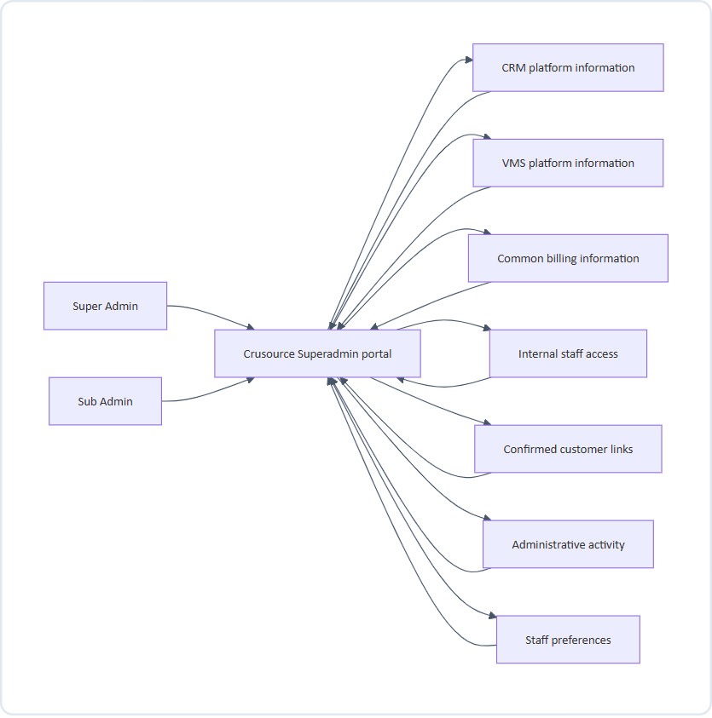
Figure 1: Context Diagram: Crusource Portal & Information Boundaries
What this shows: staff only ever interact with the portal. The portal reads from and writes to separate information areas. CRM and VMS information remain separate; billing, staff access, customer links, and staff preferences are shared.

4. Main information flow
Purpose: give staff a single, predictable place to manage both platforms.
Starting point: a successful sign-in.
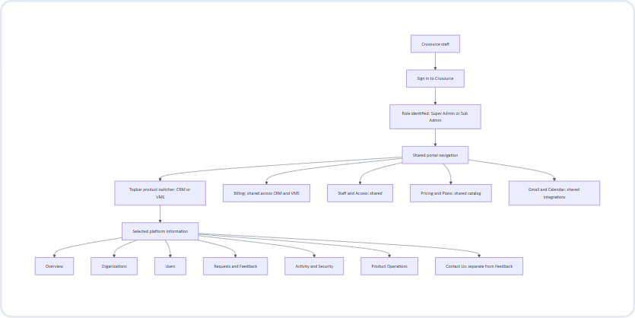
Figure 2: Main Information Flow: End-to-End Navigation Architecture
Step-by-step
1. Staff sign in once with their internal account. The same account serves both platforms.
2. The portal identifies the staff role. The role and assigned permission profile control which actions are allowed, never which platform is visible.
3. The navigation menu appears in a fixed order, identical for CRM and VMS:
Overview → Organizations → Users → Billing → Requests & Feedback → Activity & Security → Product Operations → Staff & Access.
4. The topbar switcher shows the selected platform at all times.
5. Platform screens display information for the selected platform only.
6. Billing, Pricing & Plans, Staff & Access, and Integrations display the same shared information regardless of the switcher.
Information involved
• Shown: the staff member's name and role, the selected platform, the navigation menu, and the content of the chosen screen.
• Changed: nothing, until staff take an action or switch platform.
Rules
• The menu template, item order, and screen layouts are identical for CRM and VMS.
• Shared screens carry a visible “Shared across CRM and VMS” label.
• No screen combines CRM and VMS counts into a single total that could be read as unique customers or people.
Screens to design
• Signed-in shell: topbar with switcher, search, and staff profile; side navigation.
• The shell with CRM selected and with VMS selected, demonstrating that only the data changes.

5. Topbar product switcher flow
Purpose: let staff move between CRM and VMS without losing their place.
Starting point: any signed-in screen.
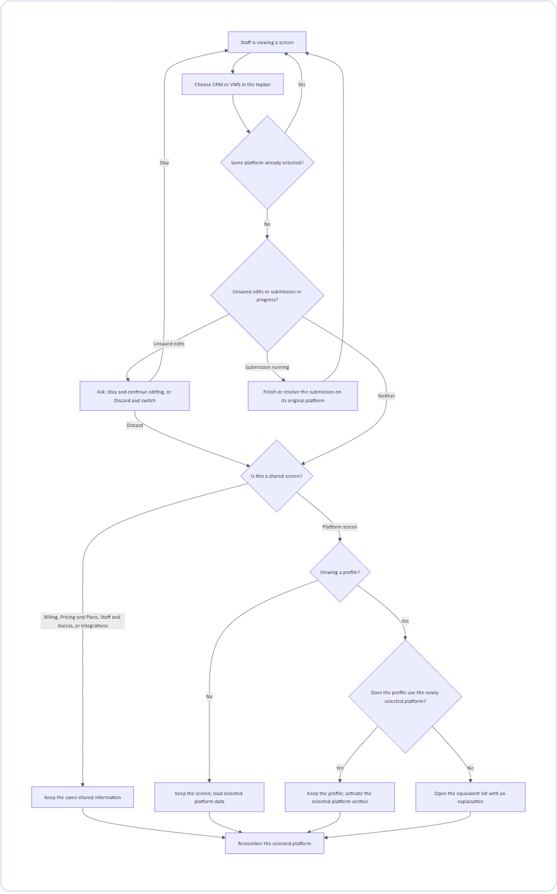
Figure 3: Topbar Product Switcher Flow: Context Retention & Switch Logic
Step-by-step
1. Choice. Staff select the other platform in the topbar. The selected label updates immediately so staff always know which platform they are looking at.
2. Protect work in progress.
• If a form has unsaved edits, staff choose Stay and continue editing or Discard and switch. Edits are never silently lost.
• If a change is being submitted, the switch waits until the submission completes or fails. The submission always targets the platform that was selected when it started.
3. Decide what to show.
• Shared screen: content remains the same. Only the remembered platform changes.
• Platform list or summary screen: the same screen loads the newly selected platform's information.
• Profile that uses both platforms: the same profile stays open; the newly selected platform section becomes active.
• Profile that does not use the new platform: staff are taken to the equivalent list for the new platform with the message “This organization does not use VMS” (or CRM, or “This user…”).
4. Remember. The selection is saved and restored at the next sign-in.
Information involved
• Shown during loading: the new platform label and loading placeholders. Values from the previous platform are cleared immediately and are never displayed under the new platform's label.
• Changed: the staff member's remembered platform.
Search, filters, sorting, and pagination
Item | Behaviour after switching
Search text | Kept.
Filter that exists in both platforms | Kept.
Filter that exists only in the old platform | Cleared, with a short explanation.
Sorting | Kept when valid in the new platform; otherwise reset to the default.
Pagination | Always returns to the first page.

Examples
Before | Staff choice | After
CRM Overview | VMS | VMS Overview; same metric labels and positions
CRM Organizations | VMS | VMS Organizations; same list template
CRM Users | VMS | VMS Users; same list template
CRM Requests & Feedback | VMS | VMS Requests & Feedback; same filters where valid
Organization using both | VMS | Same organization profile; VMS section active
Organization using only CRM | VMS | VMS Organizations list; message explains the customer does not use VMS
Common Billing | VMS | Same billing information; VMS becomes the remembered platform
Staff & Access | VMS | Same staff directory; VMS becomes the remembered platform

Screens to design
• Switcher in its default, hover/focus, and selected states.
• The same screen before and after switching.
• Unsaved-edits confirmation.
• “Submission in progress” waiting state.
• Unsupported-profile redirect with its explanation message.
• Cleared-filter explanation.

6. Sign-in, session, and internal staff access
6.1 Sign-in
Purpose: give staff secure access to one portal for both platforms.
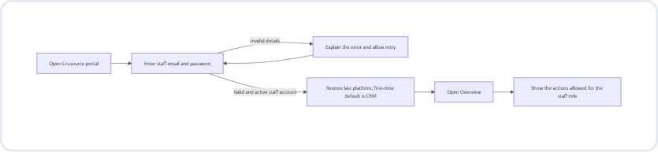
Figure 4: Staff Sign-In & Authentication Workflow
Step-by-step
1. Staff open the portal and enter their internal account details.
2. Invalid details produce a clear, non-revealing error and allow another attempt.
3. An active internal account with valid email/password is signed in directly. No MFA or second verification screen is included.
4. The portal restores the last selected platform; first-time staff start on CRM.
5. Staff land on Overview with the actions permitted for their role.
Rules
• Staff accounts and customer accounts are visibly separate; a customer login is never accepted here.
• Both roles see both switcher options.
• Sessions expire after a period of inactivity. Expiry returns staff to sign-in without completing any pending unauthorized action (see section 18).
• Sign-out is always available from the staff profile menu.
6.2 Staff invitation and lifecycle
Purpose: let the Super Admin control who can access the portal.
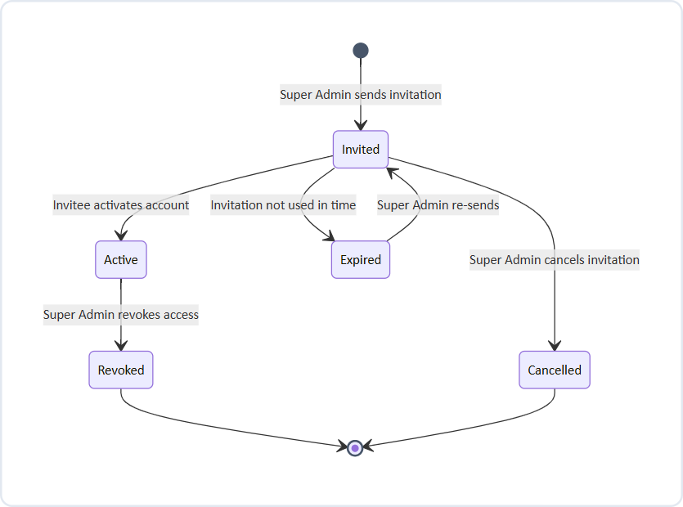
Figure 5: Internal Staff Invitation Lifecycle State Transitions
Step-by-step
1. The Super Admin opens Staff & Access and chooses Invite Sub Admin.
2. The Super Admin enters the staff member's name and email address, assigns a permission profile, and confirms.
3. The invitation appears in the directory as Pending.
4. The invitee follows the invitation, sets their password, and activates the account. Subsequent sign-ins use email and password only.
5. The status changes to Active. The new Sub Admin can now see both platforms.
6. Revoking access ends portal access for both platforms immediately and is recorded in shared staff-access history.
Rules
• Only the Super Admin can invite, cancel, re-send, or revoke.
• A Sub Admin cannot change or remove the Super Admin account.
• Customer membership changes never grant internal portal access.
Screens to design: email/password sign-in, forgot/reset password, error states, staff directory, invitation form, pending/active/expired/revoked statuses, revoke confirmation.

7. Overview flow
Purpose: give staff a quick, trustworthy summary of the selected platform and point them to what needs attention.
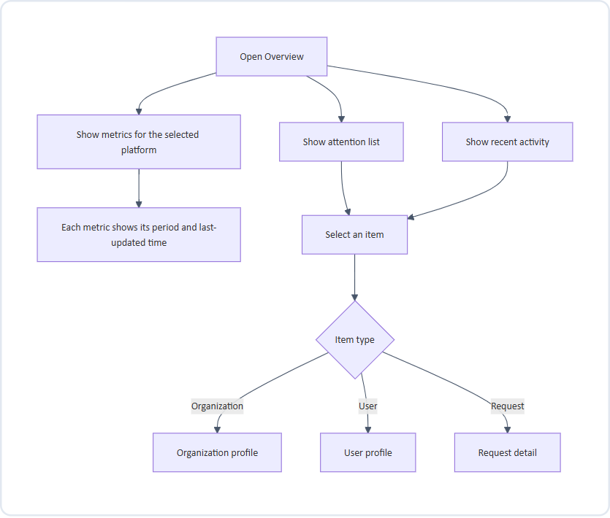
Figure 6: Platform Overview & Attention Metrics Flow
Metrics (same labels and positions for CRM and VMS)
Metric | Recommended definition
Total and active organizations | Active = enabled for the selected platform
Total and active customer accounts | Active = signed in within the last 30 days
New organizations (last 30 days) | Organizations added to the selected platform in the period
New customer accounts (last 30 days) | Accounts added to the selected platform in the period
Trials ending within seven days | Selected-platform trials ending in the next seven days
Pending requests, by type | Unresolved feedback, demo requests, and trial extensions awaiting a decision

Rules
• Show administrative summaries only. Do not display deals, candidate records, documents, or other customer business content.
• Billing totals live on the Billing screen, not on Overview.
• If a metric cannot be loaded, show “Unavailable”, never zero.
Screens to design
Overview for CRM and VMS, loading placeholders, unavailable metric, stale metrics, empty attention list.

8. Organization and customer-user discovery
Purpose: let staff find a customer organization or person and understand their status in the selected platform.
Starting point: Organizations or Users in the navigation.
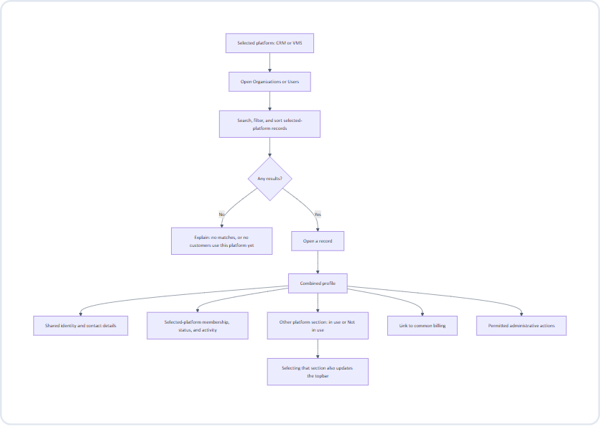
Figure 7: Organization & Customer-User Discovery Workflow
Step-by-step
1. Staff open Organizations or Users. Only customers using the selected platform appear.
2. Staff search and filter. Each row shows enough to decide whether to open it:
• Organizations: name, product badges, account status, owner/contact, member count.
• Users: name, organization, membership role, status, last activity.
3. Staff open a record to see its combined profile.
4. The profile header shows shared details: name, customer reference, primary contact, CRM/VMS usage badges, and a link to common billing.
5. The profile body uses the same tabs in both platforms: Summary, Members, Requests, Activity.
6. The selected platform's section is active. The other platform's section shows its own data, or “Not in use” if the customer does not use it. “Not in use” is not an error.
7. Selecting the other platform's section updates the topbar switcher to match.
Rules
• A combined profile does not mean roles, access, member counts, subscriptions, or suspension status are identical across platforms. Each platform membership is shown and managed separately.
• For a combined user profile, each membership shows its organization, role, access status, and activity. Removing CRM access does not remove VMS access.
• Provisioning the other platform is a separate, explicit action (see section 15).
Screens to design
Organization list, user list, filter panel, empty results, organization profile (both platforms in use, one platform in use), combined user profile with two memberships.

9. Confirming shared customers and users
Purpose: combine CRM and VMS records only when they genuinely belong to the same organization or person.
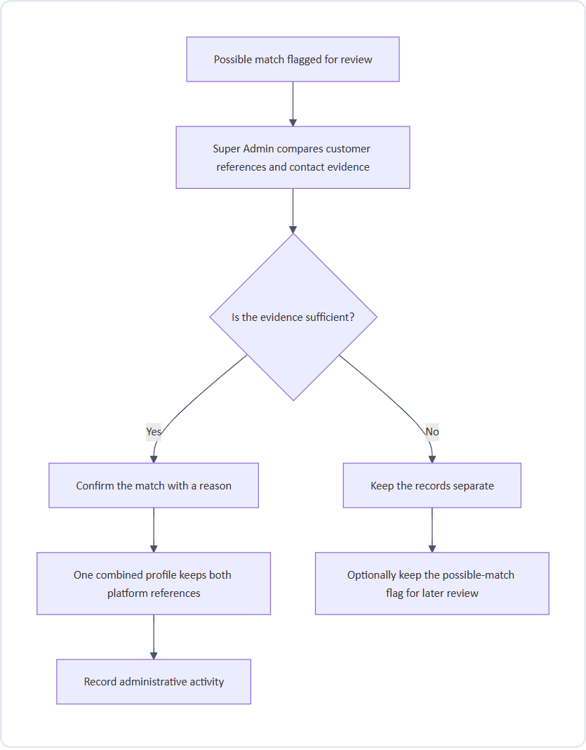
Figure 8: Confirming Shared Customers & Account Linking Flow
Rules
• Similar names alone never establish a match.
• Organizations: the Super Admin confirms the link. Each platform's original customer reference is preserved.
• Users: records are combined only when a shared verified identity is confirmed. Otherwise they remain separate profiles with a possible-match flag.
• Linking does not merge roles, access, subscriptions, or billing; it only presents them together.
Screens to design
Possible-match list, side-by-side comparison, confirmation with reason, “kept separate” outcome.

10. Common billing flow
Purpose: let staff review and manage billing for both platforms in one place.
Starting point: Billing in the navigation, or the billing link on an organization profile.
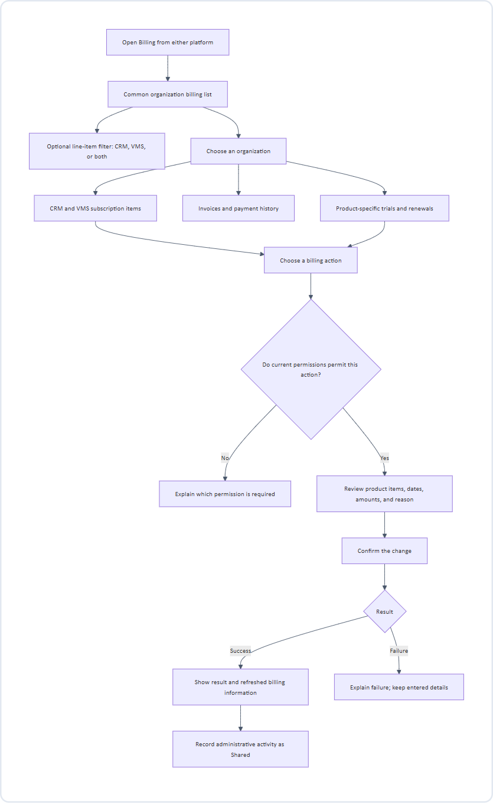
Figure 9: Common Organization Billing & Subscription Flow
Step-by-step
1. Staff open Billing. The topbar switcher does not change these results.
2. A separate, optional line-item filter can narrow results to CRM or VMS items.
3. Staff open an organization's billing profile, which shows:
• Separate CRM and VMS subscription items, each with its own plan, status, trial, and renewal date.
• Invoices and payment history. Existing separate invoices are shown with their original product and reference. Grouped invoices, where supported, keep distinct product line items.
4. Staff choose an action, review exactly what will change, enter a reason, and confirm.
5. The new amounts, dates, or plans appear only after a successful result is confirmed.
Billing actions and recommended role defaults
Action | Super Admin | Sub Admin
Inspect billing | Yes | Yes
Extend a trial | Yes | Yes
Change a plan | Yes | No
Apply a discount | Yes | No
Issue a refund | Yes | No
Change a renewal | Yes | No

Rules
• Common billing does not imply a single combined plan, shared renewal date, or shared trial.
• If one platform's billing information is incomplete, identify the missing portion and do not present totals as complete.
Screens to design
Billing list, line-item filter, organization billing profile, invoice detail, action review, confirmation, success, failure, restricted action.

11. Requests and feedback flow
Purpose: let staff handle customer feedback, demo requests, and trial-extension requests for the selected platform.
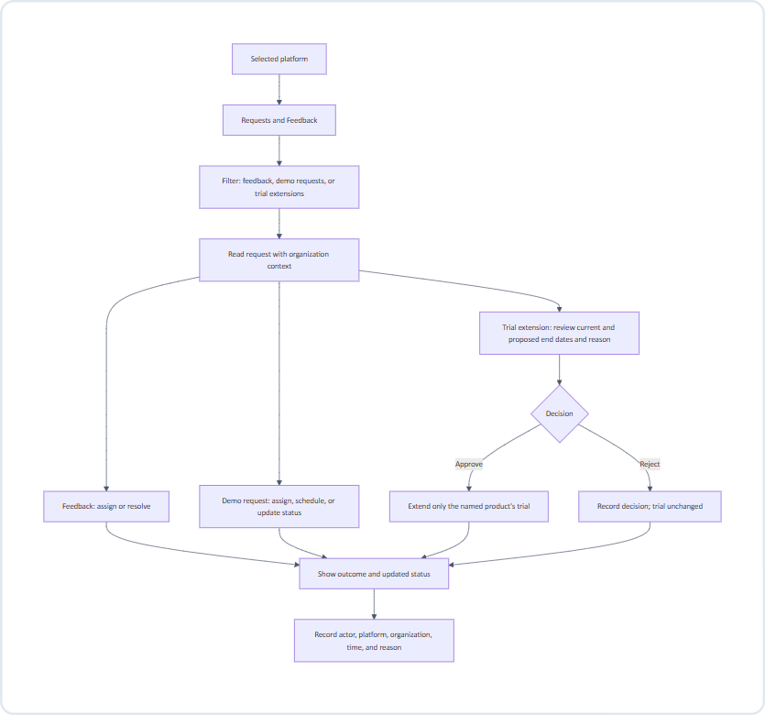
Figure 10: Customer Requests & Feedback Resolution Workflow
Step-by-step
1. Staff open Requests & Feedback and filter by request type, status, or assignee.
2. Opening a request shows its content together with the organization's name, platform, and status.
3. Staff take the appropriate action:
• Feedback: assign to a staff member or mark as resolved.
• Demo request: assign, schedule, add notes, or move between workflow stages.
• Trial extension: compare the current and proposed end dates, read the reason, then approve or reject.
4. The outcome and updated status appear only after the action succeeds.
Rules
• Approval changes only the named product's trial for the named organization.
• Rejection records the decision without changing the trial.
• Each action keeps the platform and organization that were displayed when it began, even if staff switch platform before it completes.
• If another staff member already decided the request, show the current decision and ask staff to review (see section 18).
Screens to design
Request list with filters, feedback detail, demo request detail, trial-extension review, approve/reject confirmation, already-decided state.

12. Administrative action flow
Purpose: make every change to a customer safe, explicit, and traceable.
Applies to: suspension and reactivation, customer membership changes, provisioning, and feature settings.
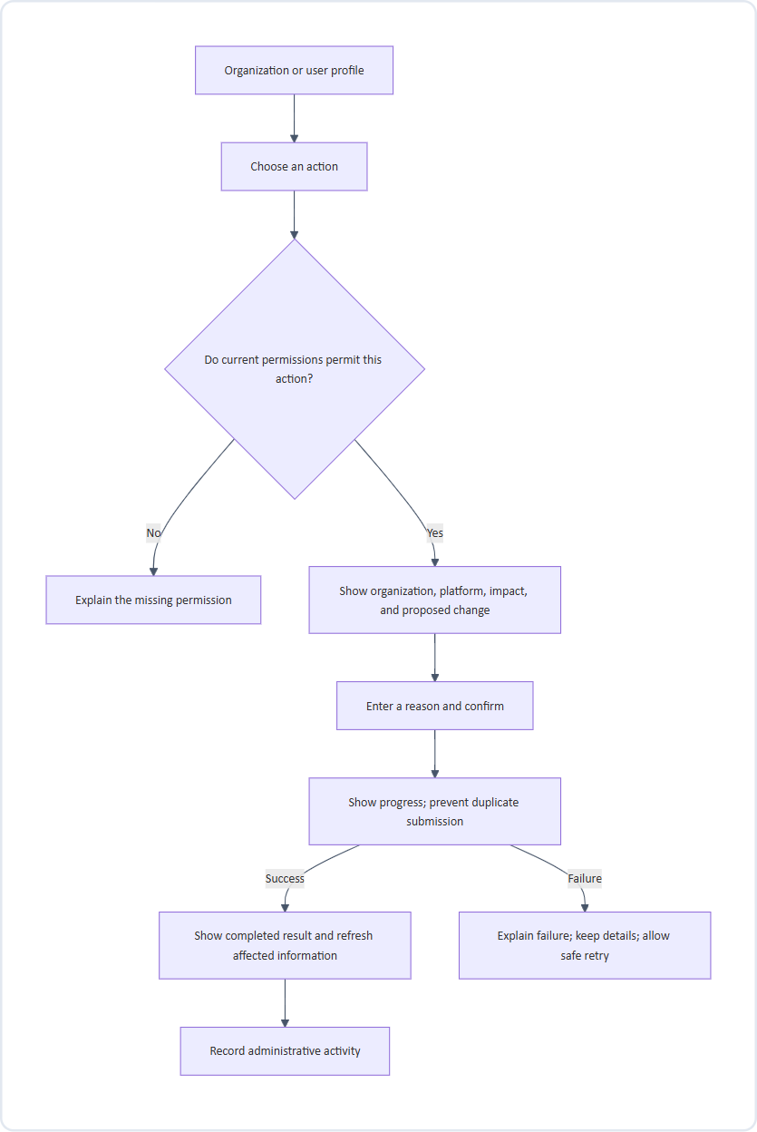
Figure 11: Administrative Action Safety & Confirmation Pattern
Step-by-step
1. Staff choose an action from a profile.
2. If the current permission profile does not permit it, the action explains which permission is required instead of silently disappearing.
3. A review step states exactly which organization or user, which platform, what will change, and the expected impact.
4. Staff enter a reason and confirm.
5. The portal shows progress and blocks duplicate submissions.
6. On success, the result is confirmed and affected information refreshes. On failure, the explanation appears and entered details are kept for a safe retry.
Rules
• Never show success before the action completes.
• Suspending CRM access does not suspend VMS access or cancel any subscription.
• Provisioning a platform has its own explicit result; adding a badge alone is not provisioning.
• Sub Admins may change customer memberships but can never grant internal portal access.
Screens to design
Action menu, restricted action, review/confirmation with reason, in-progress state, success, failure with retry.

13. Support access flow
Purpose: let permitted staff view a customer's experience to troubleshoot, under strict safeguards.
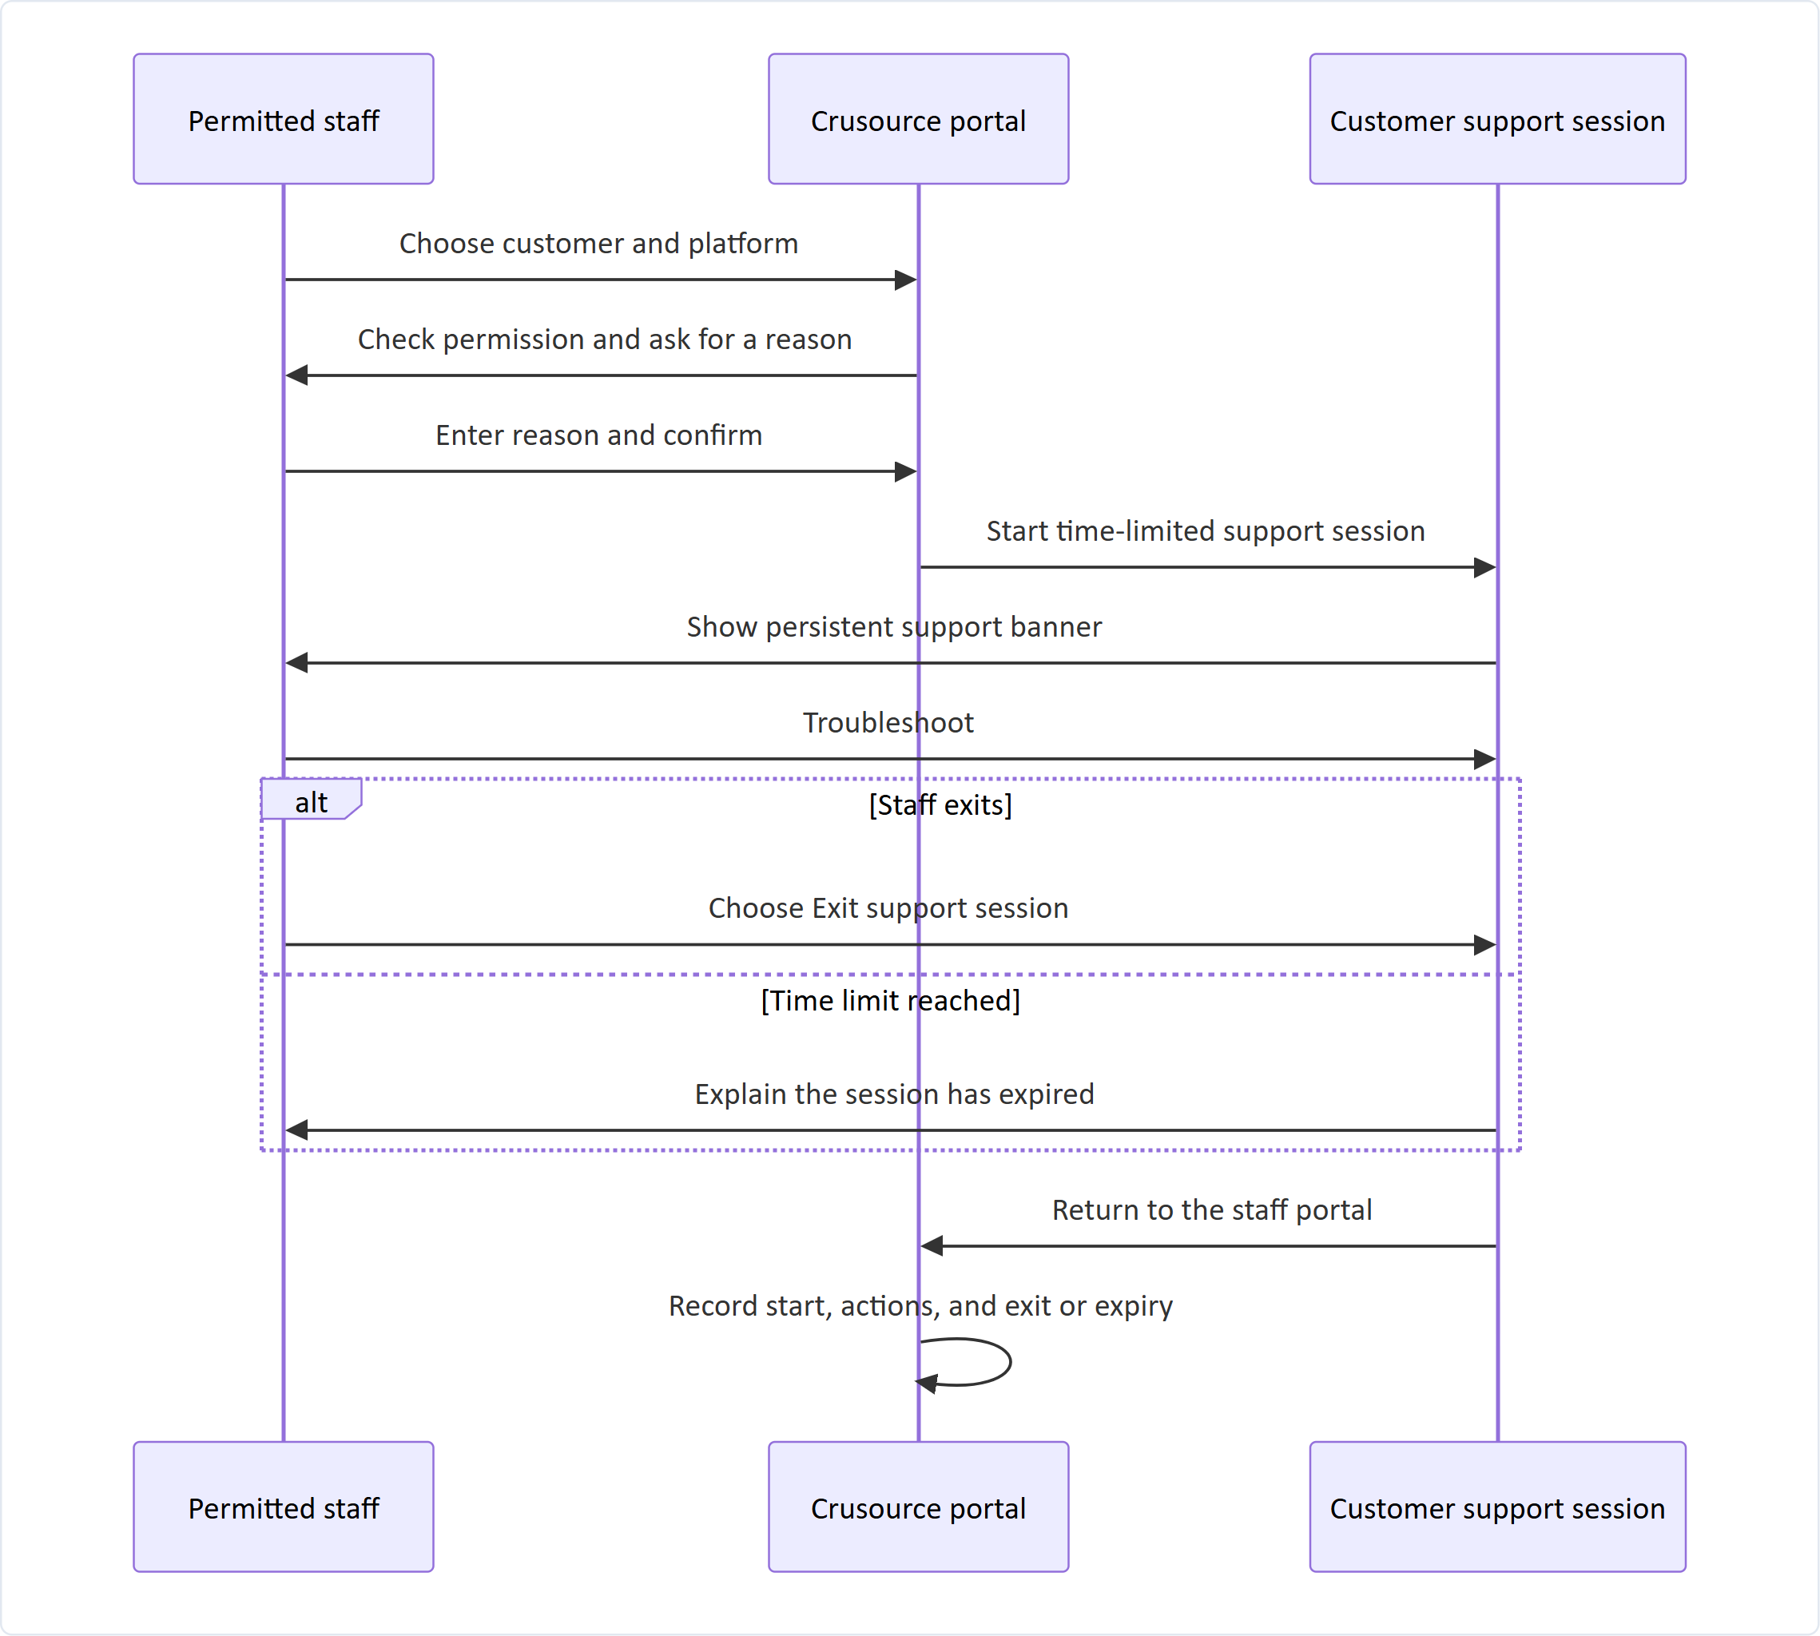
Figure 12: Controlled Customer Support Session Interaction Flow (Sequence)
Rules
• A support session is never presented as an ordinary customer login.
• The banner remains visible throughout and always offers Exit.
• The session ends automatically when the time limit is reached.
• Start, actions taken, and exit or expiry are all recorded.
Screens to design
Start-support confirmation, active support banner, expiry notice, return to portal.

14. Activity and security flow
Purpose: let staff investigate customer sign-ins and staff actions.
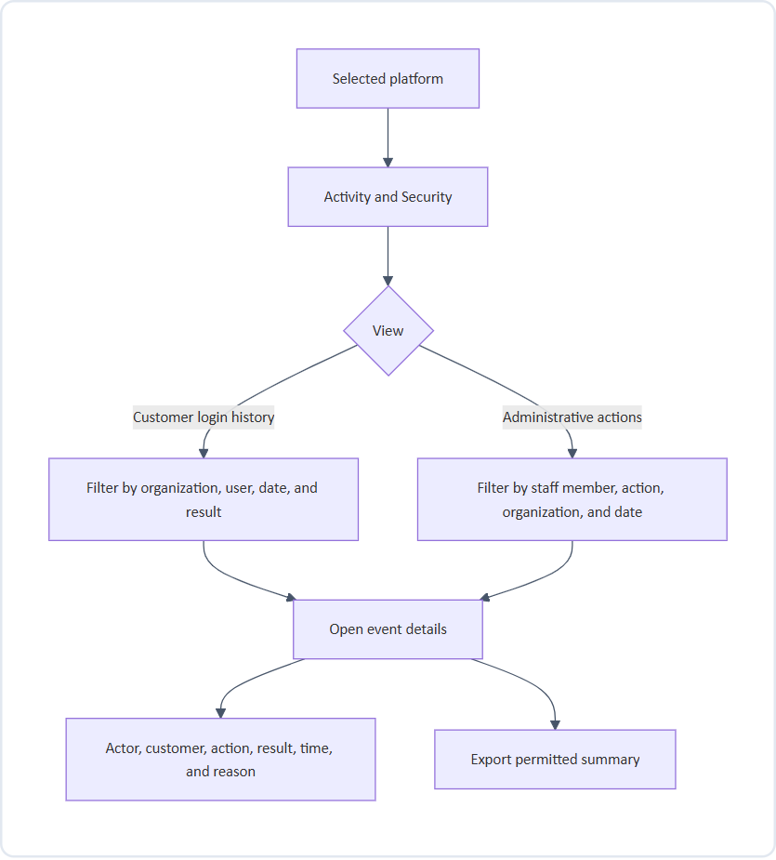
Figure 13: Activity & Security Audit Trail Flow
Where activity appears
Activity type | Where it is shown
Platform-specific actions | Activity & Security for that platform
Billing actions | The organization's billing profile, labelled Shared
Staff access changes | Staff & Access history, labelled Shared
Shared events shown in a platform view | Labelled “Shared”, never presented as platform-specific

Rules
• Times show their time context wherever they affect an audit event.
• Event details are read-only.
Screens to design
Login history list, administrative activity list, filters, event detail, empty results.

15. Product operations flow
Purpose: let staff check platform availability and manage feature settings and provisioning.
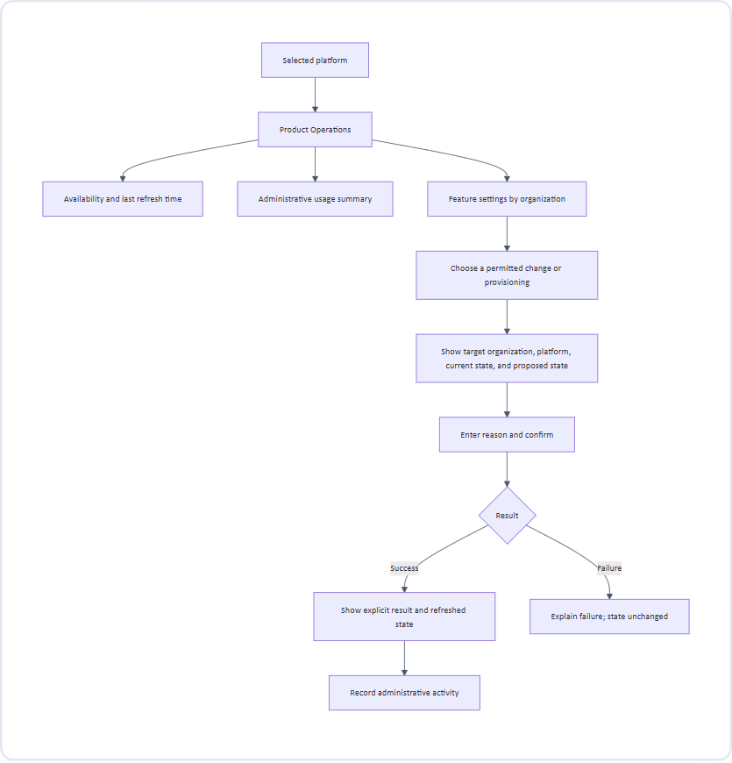
Figure 14: Product Operations, Availability & Provisioning Flow
Rules
• Availability reports service status; it does not promise every customer workflow is functioning.
• Enabling the other platform for an organization requires a provisioning result, not just a badge change.
Screens to design
Availability summary, usage summary, feature settings list, change review, provisioning result.

16. Export flow
Purpose: let staff take permitted information out of the portal in a clearly labelled form.
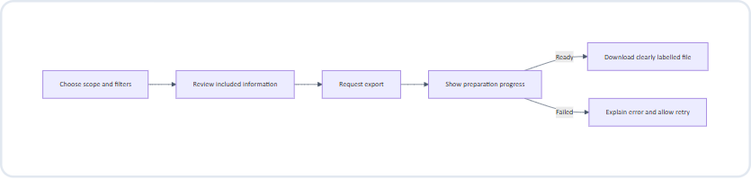
Figure 15: Filtered Data Export Preparation & Delivery Flow
Rules
• Export only information permitted by both viewing and export permissions in the current staff profile.
• Label each file with its platform (or “Shared” for billing) and export time.
• The export reflects the scope and filters that were reviewed.

17. Unavailable information and recovery
Purpose: keep staff informed and safe when information cannot be loaded.
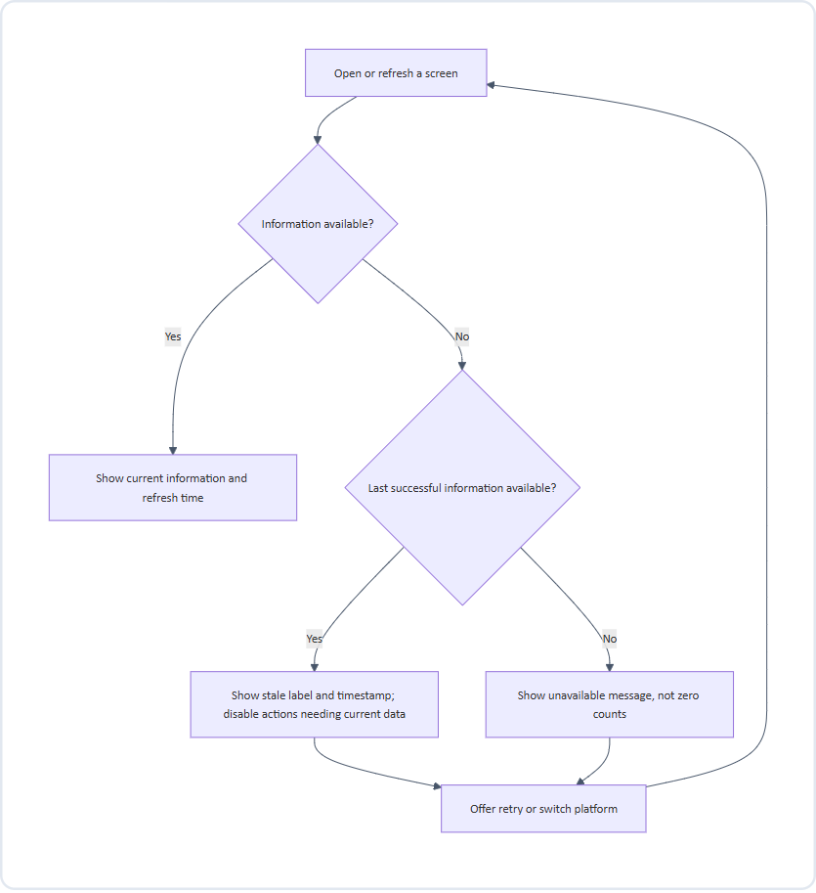
Figure 16: Unavailable Information, Stale Cache & Recovery Flow
Rules
• A CRM problem does not block VMS, and a VMS problem does not block CRM.
• Shared Billing, Pricing & Plans, Staff & Access, and Integrations remain usable whenever their own information is available.
• If shared billing has incomplete product information, identify the missing portion and do not present totals as complete.
States to design
State | Expected experience
Loading | Selected platform stays visible; placeholders instead of misleading values
No results | “No organizations use VMS yet” or “No results match these filters” with clear-filter option
Platform unavailable | Unavailable status and retry; other platform and shared screens remain usable
Stale | Last successful update time and a stale label
Restricted | Actions explain the required role
Successful change | Organization, platform, and completed action confirmed
Failed change | Failure explained; entered information kept

18. Conflicts, expiry, and interruptions
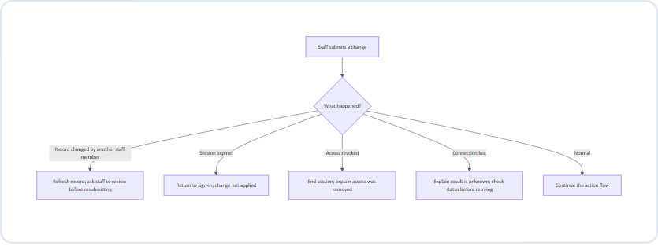
Figure 17: Concurrent Submission Conflicts & Session Expiry Handling
Rules
• A change is never applied after session expiry or access revocation.
• When the result is unknown, staff check the current state before retrying, to avoid duplicate changes.
• After signing in again, staff return to the same screen where practical, with the remembered platform.

19. Role and action summary
Starting defaults, configurable through Sub Admin permission profiles. Internal access and connection management remain Super Admin-only; both products stay visible to everyone.
Area | Action | Super Admin | Sub Admin
Navigation | See CRM and VMS | Yes | Yes
Organizations and users | Search and view profiles | Yes | Yes
Organizations and users | Change customer memberships | Yes | Yes
Organizations and users | Suspend or reactivate | Yes | No
Organizations and users | Confirm shared customer links | Yes | No
Billing | Inspect | Yes | Yes
Billing | Extend trials | Yes | Yes
Billing | Plans, discounts, refunds, renewals | Yes | No
Requests & Feedback | Assign, resolve, approve, reject | Yes | Yes
Activity & Security | View and export permitted summaries | Yes | Yes
Product Operations | Inspect status | Yes | Yes
Product Operations | Feature changes and provisioning | Yes | As permitted
Support access | Start a support session | Yes | As permitted
Staff & Access | Invite, cancel, re-send, revoke | Yes | No
Staff & Access | Change the Super Admin account | — | No

No second-person approval is required in the first release; sensitive actions still require confirmation and a reason.

20. Designer handoff checklist
☐ Show the CRM/VMS switcher prominently in the topbar on every signed-in screen, with no “All Products” option.
☐ Demonstrate the same screen before and after a platform switch.
☐ Show the unsaved-edits confirmation and the submission-in-progress state.
☐ Show the unsupported-profile redirect and its explanation.
☐ Show Billing, Pricing & Plans, Staff & Access, and Integrations as shared and unchanged by the switcher.
☐ Show shared staff access separately from customer users.
☐ Show combined organization and user profiles with separate platform memberships and “Not in use” sections.
☐ Show the shared-customer confirmation flow.
☐ Show the trial-extension review with current and proposed end dates.
☐ Include confirmations with reasons, role restrictions, loading, empty, stale, unavailable, success, and failure states.
☐ Show the support-session banner, exit, and expiry.
☐ Show conflict, session-expired, and access-revoked outcomes.
☐ Show how staff return from a detail, action, or support session.
☐ Keep diagrams and screen annotations understandable without technical infrastructure knowledge.
☐ Show plan editing, revision preview, publication, archiving, and the effect on new versus existing subscriptions.
☐ Show Contact Us separately from Feedback, including unassigned-platform inquiries.
☐ Show staff personal profiles separately from permission-profile editing and assignment.
☐ Show email/password sign-in and recovery without MFA screens.
☐ Show connected, partial, expired, and disconnected Gmail/Calendar states.
☐ Show Book demo, missing details, unavailable slots, and booked-with-confirmation-pending states.

21. Dynamic pricing and plan flow
Starting point: Pricing & Plans, a shared screen with an independent CRM/VMS catalog filter. Switching the topbar does not change the catalog or an open draft.
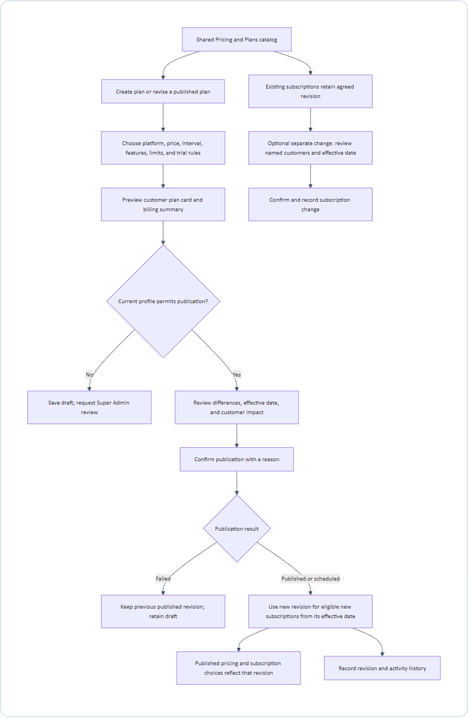
Figure 18: Data Sync and Automated Refresh Pipeline
Information flow: staff-entered plan → draft → published revision → public pricing/subscription selection → customer's agreed billing item. Drafts never appear as live prices. Billing keeps the customer's agreed revision, not simply the latest catalog price.
Archiving stops new selection without cancelling existing subscriptions. Show current and scheduled revisions clearly. A referenced plan cannot be deleted. Public pricing and billing must not display conflicting revisions after publication.
Screens: catalog, plan editor, preview, impact review, publication result, history, archive confirmation, and separate existing-subscription change review.
22. Contact Us and Feedback flows
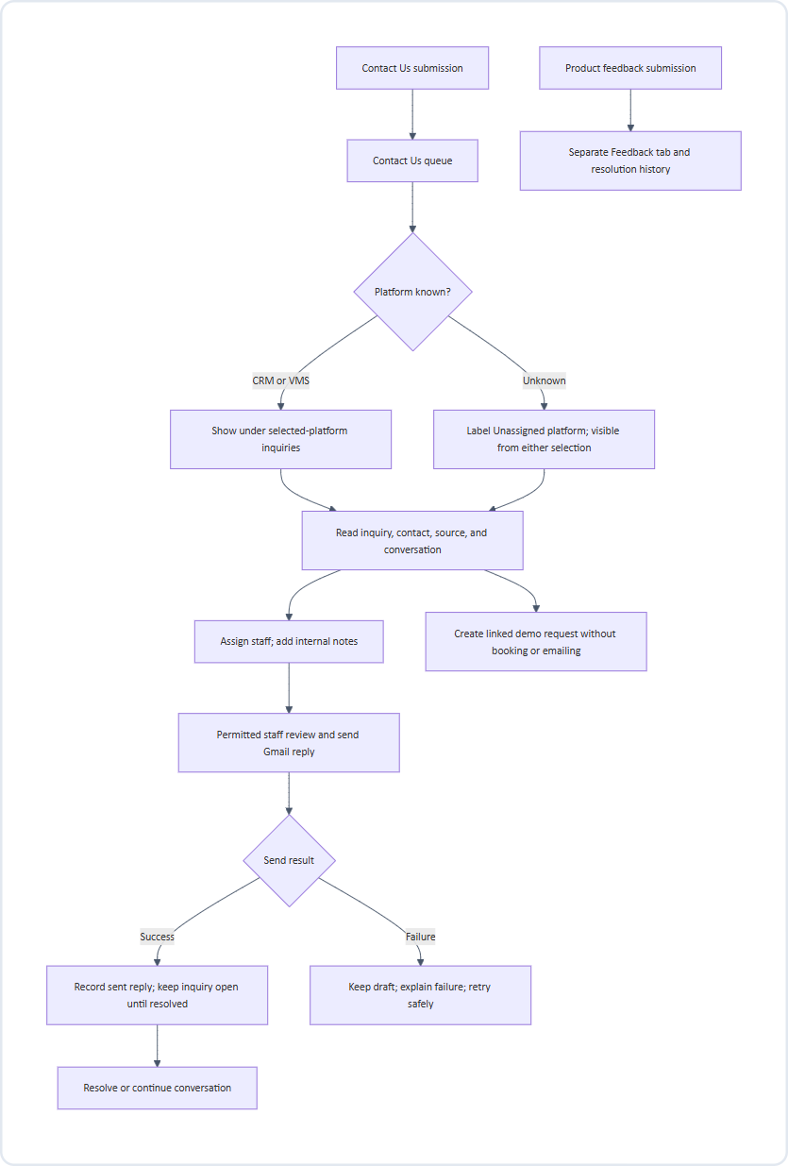
Figure 19: Contact Us and Customer Feedback Intake Workflow
Contact inquiries may come from people without a customer organization; do not invent an organization or discard the message. Classifying an inquiry moves it to the correct platform queue, preserving its history. Feedback does not automatically become a contact inquiry or demo request.
Screens: Contact Us list/detail, unassigned queue, assignment, Gmail reply draft/preview, send result, linked demo request, and a separate Feedback list/detail.
23. Sub Admin profile and permission flow
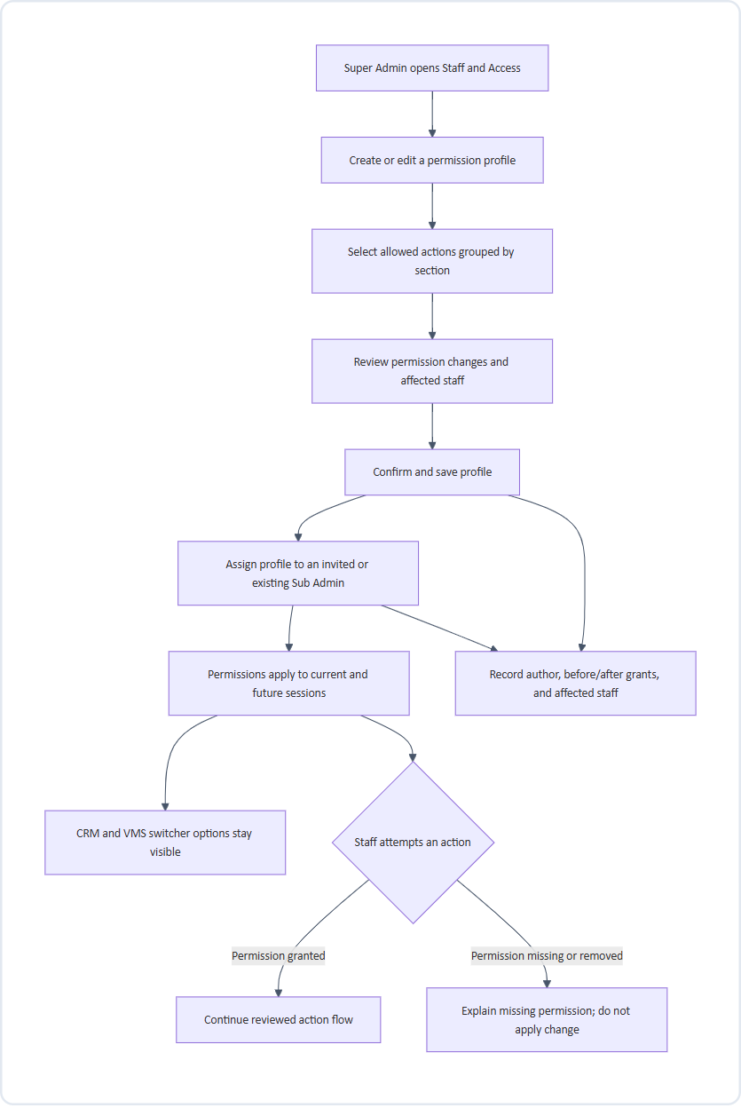
Figure 20: Sub Admin Profile and Permission Management Flow
The staff personal profile holds name, email, role, assigned permission profile, and access status. The reusable permission profile holds action grants. They are different screens and concepts. Developer, Support, and Billing are editable profile suggestions under the Sub Admin role, not additional roles.
Only Super Admin manages invitations, permission profiles, access revocation, and shared Google connections. Profiles cannot promote a Sub Admin to ownership or allow self-escalation. Changing customer memberships never grants portal access. Check current grants when an action is submitted, including after a profile change.
Screens: staff detail, profile list/editor, grouped permission controls, affected-staff preview, profile assignment, history, and restricted-action explanation.
24. Gmail and Google Calendar connection flow
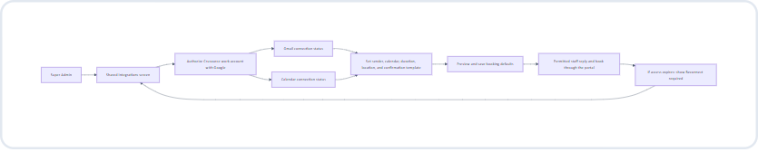
Figure 21: External Integration: Gmail & Google Calendar Authorization
Boundary between services: staff sign in to Crusource with email/password. Separately, Super Admin authorizes Google to let Crusource use the selected mail/calendar services. This connection does not enable Google login or add MFA to the portal.
Only the message recipients/content and booking attendee/time/location information needed for a permitted action cross into the connected services. Contacts and attendee information are private; display connection status and account identity, never connection credentials. General inbox browsing is outside this flow.
Gmail and Calendar have separate status indicators. If either is unavailable, explain which actions are blocked. Disconnecting does not cancel existing meetings or remove sent messages.
Screens: connection cards, external authorization return, sender/calendar/defaults selection, template preview, partial connection, reconnect, and disconnect-impact confirmation.
25. One-click Book demo flow
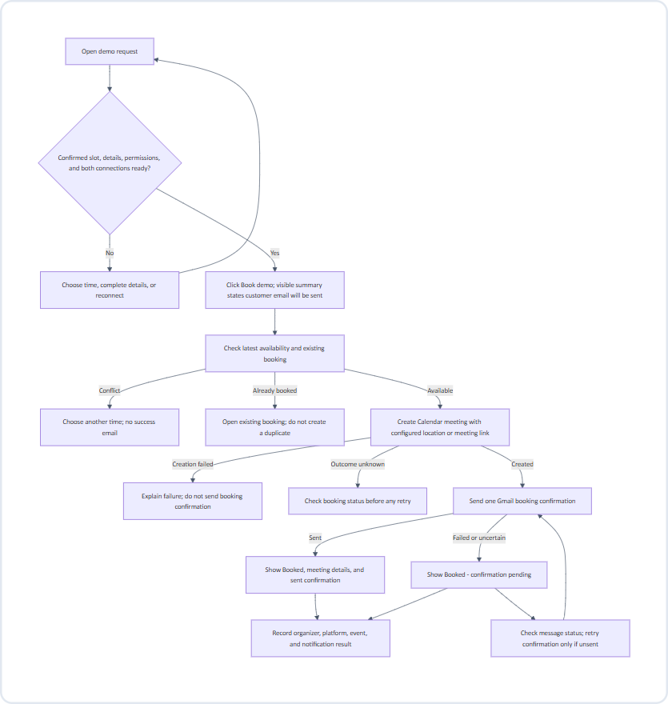
Figure 22: One-Click Public Demo Booking Interaction Flow
One click means: the request already has an agreed slot and booking defaults, so staff do not fill another scheduling form. Requests missing those details need a review step first.
The request sends booking details to Calendar, then meeting details to Gmail for the customer confirmation. Calendar invitations and Gmail messaging must be coordinated to avoid duplicate confirmations. The request stores the booking reference and notification outcome, so retrying a confirmation never creates another meeting.
Show the customer's time zone and organizer's time context when choosing a slot. A preferred slot is not a confirmed appointment. Rescheduling updates the existing booking; cancellation explicitly cancels it and notifies the customer. Resolving an inquiry or changing a request's stage alone never cancels a meeting.
Screens: ready-to-book request, one-click action with booking summary, missing details, slot conflict, progress, booked result, confirmation pending/retry, reschedule, and cancel.

