A sophisticated Railway booking site…

1. I should get option to enter From Station & To Station and Journey Date

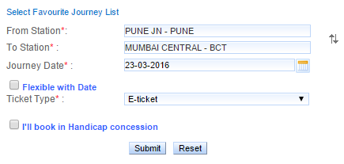

1. Flexible Dates not required immediately
2. Should come up with list of list of trains with details like Train No., From, To, Departure, Arrival, Journey Distance, Journey Time & Number of stops with availability of `Class`.

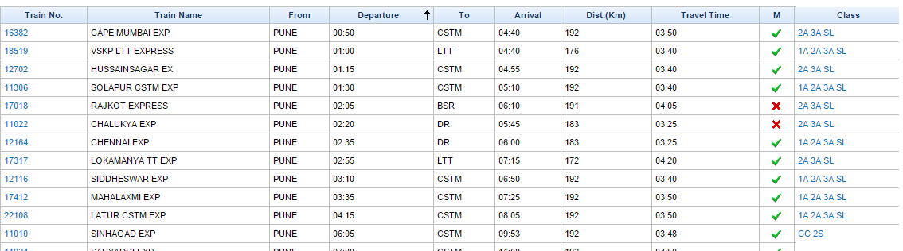

1. I should have option to see available seats by class & its fare.
2. I am starting my business ONLY for General Quota. In FUTURE I may extend my booking for other quotas like

Quotas: Physically Handicapped and Ladies



1. @ the time of booking I should have an option to either board from “From Station” or any of the stops before my last stop.
2. It should accept first name, last name, age & gender @ the time of booking. If I book the ticket then availability of seats should reduce by 1 (if only 1 booking is booked), it should print the ticket (Assume that payment is done & always successful)
3. No WAITING LIST BOOKINGS ARE allowed as my site guarantees the booking.
4. The ticket should print below details: (Ignore formatting, just the details are required, apply 5% service charge)

