# MSc. Project Progress Evaluation Report – 2022

**Liquid Water Path Adjustments to Aerosol Perturbations over BOB:**

**A Machine-Learning Based Analysis**

**Submitted by**

**ARUNKUMAR KL**

**MSc. Atmospheric Sciences**

**Roll-421AS2154**

**Under the guidance of**

**Dr. Jagabandhu Panda**



**Department of Earth and Atmospheric Sciences**

**National Institute of Technology, Rourkela, Odisha-769008**

# Introduction

Aerosols are responsible components in the atmosphere that can act as Cloud Condensation Nucleus (CCN) and the changes in aerosols loading cause changes in the microphysical and optical properties of clouds, which perturb the radiation balance which is defined as the Aerosol Indirect effect. The major source of uncertainty in estimation of the overall anthropogenic radiative forcing appears to be aerosol indirect effects [1,2]. By altering the cloud droplet number concentration (Nd), commonly referred to as the Twomey effect, aerosols have an impact on cloud albedo [3]. The liquid water path (LWP) and cloud fraction may change because of subsequent cloud modifications to aerosol perturbations, further changing the cloud's radiative characteristics. Since LWP is considered the primary determinant of liquid-cloud albedo [4], it is necessary to understand the effect of aerosols on LWP to improve climate model predictions.

This study is done over the Marine boundary layer clouds (MBLC) since it comprises of a large part of global cloud cover as they are present constantly over more than 20% of the Earth’s oceans annually [5]. The purpose of this research is to gain a better understanding of the Nd-LWP relationship in the Bay of Bengal. The structure of the study is as follows:

1. Estimation of cloud droplet number concentrations (Nd) and its spatial analysis over different seasons.
2. Determining the relationship between Nd and liquid water path (LWP) for different seasons
3. Determining the influential factors on LWP using both statistical and Machine Learning based approaches

# Dataset and Methodology

This study is conducted for region in the Bay of Bengal (78° E–96° E and 8°N–23°N), characterized by high aerosol loading as well as dominance of stratocumulus and cumulus clouds, thereby providing ideal conditions for understanding ACI [6]. The study is done seasonally, concentrating majorly on Pre-Monsoon (MAM), Winter (DJF) over a period of last twenty years from 2005.

The MYD08_D3 product which is a level-3 MODIS gridded atmosphere daily global joint product and contains daily 1 x 1 degree grid average values of atmospheric parameters related to atmospheric aerosol particle properties, total ozone burden, atmospheric water vapor, cloud optical and physical properties, and atmospheric stability indices is taken for the estimation of Nd.

Aerosol data were obtained from the Modern-Era Retrospective Analysis for Research and Applications-Version 2 (MERRA-2). MERRA-2 is a multidecadal reanalysis where meteorological and aerosol observations are jointly assimilated into the Goddard Earth Observation System version 5 (GEOS-5) data assimilation system. MERRA2 dataset is used for analysis of Nd.

Nd is estimated based on an adiabatic cloud model [7]:

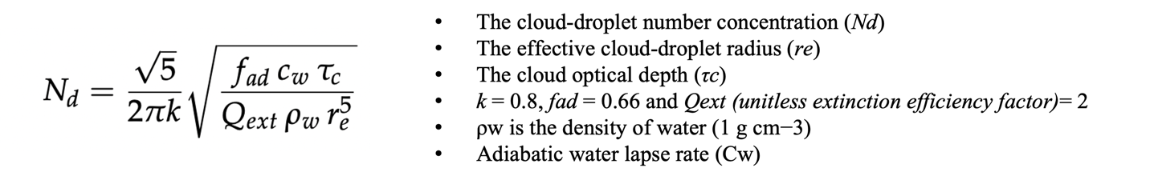

|  |  |  |
| --- | --- | --- |
| **Parameter** | **Data Source** | **Spatial**  **resolution** |
| Effective cloud-droplet radius (*re*)  Cloud optical depth (*τc*)  Cloud-top temperature  Cloud-top pressure | MODIS -AQUA | 1°×1° |
| Total aerosol extinction AOT (550 nm)  Total aerosol Ångström parameter | MERRA-2 | 1°×1° |

Table 1:Summary of various data products used in this study.

# Results and Discussion

## 1. Seasonal spatial variation of Nd, AOD and AI

Figure 1 illustrates the seasonal differences in MERRA- 2 AOD and MODIS Nd over the BOB. In contrast to very less difference in the mean AOD over the period of MAM and DJF, the Nd is varying too much between the two seasons. Nd is highest in the DJF. In the DJF there is a huge increase in the Nd near the coast and lower in the remote sea areas. There is trend of high Nd over Myanmar coast while there is no such hike is found in Indian coasts in both the seasons. The inconsistency of AOD and Nd spatial trend points towards the limitations of AOD as an aerosol proxy. Previous studies have also shown this [8].

The spatial variation of MERRA2 retrieved Aerosol Index is shown in the figure 1(d). It is observed there is increase in the Aerosol index in DJF in comparison with MAM season. The variation is to be important since the MERRA2 AOD spatial variation [figure 1(c)] is not varying over the seasons while AI is changing which make AI more relatable as Nd is concerned. Because it does not provide information about composition and size distribution and is sensitive to relative humidity, AOD is an imperfect CCN proxy variable. Aerosol index (AI) is more closely related to CCN because it partially accounts for aerosol size distribution [9,10]. But it can be observed from the figure 1 that the spatial variation of Nd and AI is not very relatable which indicates that the Aerosol size distribution alone cannot explain the Nd variation.

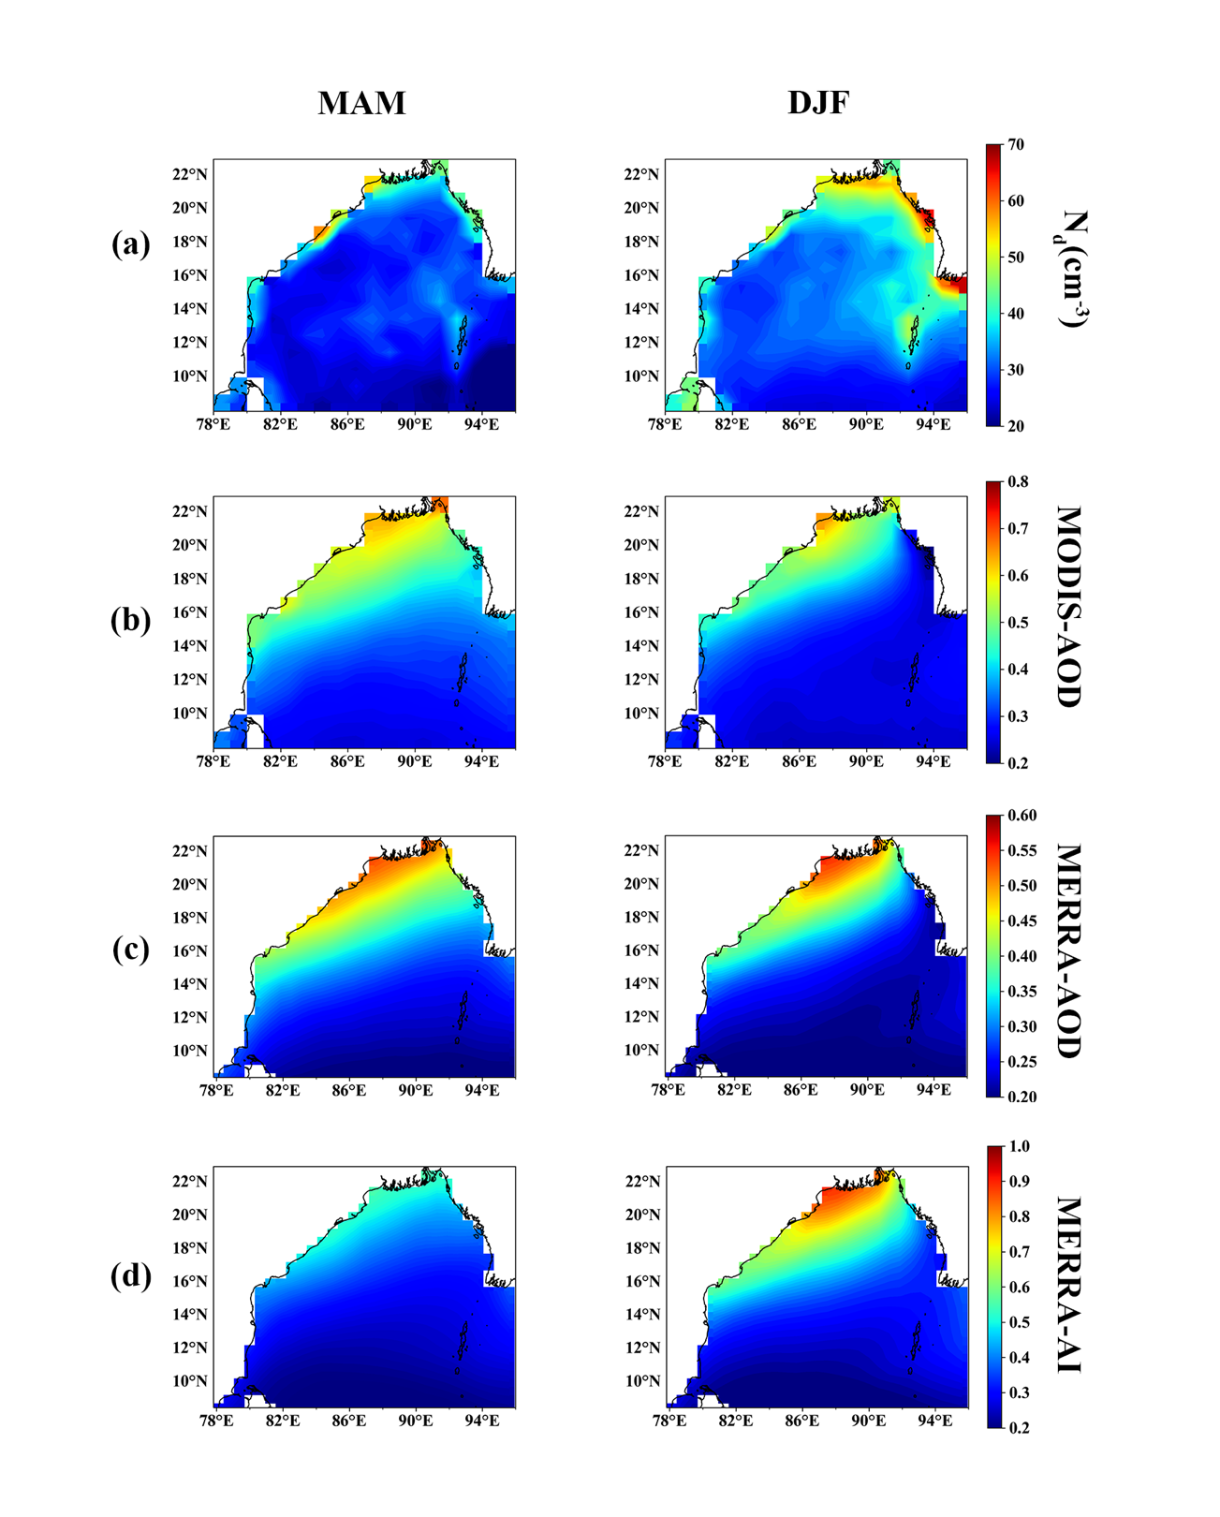

Figure 1: Seasonal spatial maps for (a) cloud drop number concentration (Nd) over the Bay of Bengal (BOB),

(b)MODIS aerosol optical depth (AOD), (c) MERRA-2 aerosol optical depth (AOD), (d) MERRA-2 aerosol index (AI)

## 2. Daily climatology for AOD and Nd on MAM and DJF

The time series of daily averaged Nd and AOD over 20 years is given in the figure 2. For the season of MAM [figure 2(a)] shows no similarity for the trend of AOD and Nd while in the DJF season [figure 2(b)] shows a similar trend which can be because of the more effective conversion of aerosols into CCN in the DJF season than in the MAM. But the inference cannot be confirmed at this point of study and the correlation of AOD-Nd is very low. Further analysis on the same with including various parameters like Composition of Aerosols, Humidity etc. will be done in the further studies for better understanding of the phenomenon.

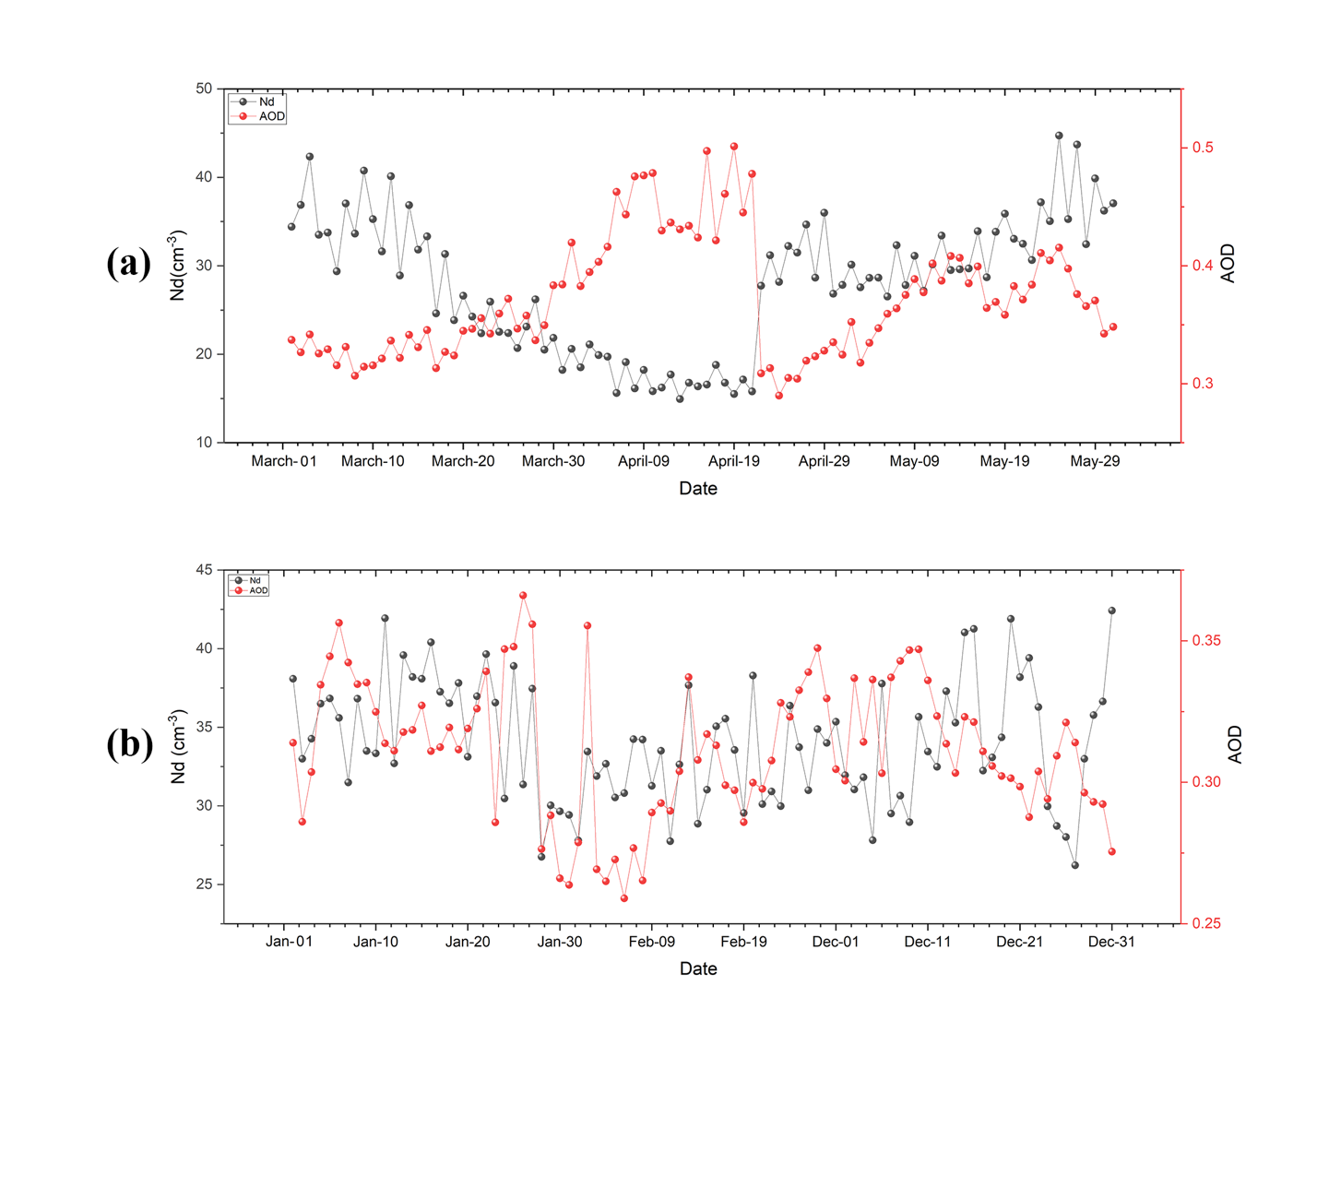

Figure 2: Daily climatology of AOD and Nd over the seasons: (a) Pre monsoon [MAM] and (b) Winter [DJF]

# References

1. Boucher, O., Randall, D., Artaxo, P., Bretherton, C., Feingold, G., Forster, P., Kerminen, V.-M., Kondo, Y., Liao, H., Lohmann, U., Rasch, P., Satheesh, S. K., Sherwood, S., Stevens, B., and Zhang, X. Y.: Clouds and aerosols, in: Climate Change 2013: The Phys- ical Science Basis, Contribution of Working Group I to the Fifth Assessment Report of the Intergovernmental Panel on Climate Change, edited by: Stocker, T. F., Qin, D., Plattner, G.-K., Tig- nor, M., Allen, S. K., Doschung, J., Nauels, A., Xia, Y., Bex, V., and Midgley, P. M., Cambridge University Press, Cambridge, UK, 571–657, 2013.
2. Myhre, G., Shindell, D., Bréon, F.-M., Collins, W., Fuglestvedt, J., Huang, J., Koch, D., Lamarque, J.-F., Lee, D., Mendoza, B., Nakajima, T., Robock, A., Stephens, G., Takemura, T., and Zhang, H.: Anthropogenic and natural radiative forcing, in: Cli- mate Change 2013: The Physical Science Basis, Contribution of Working Group I to the Fifth Assessment Report of the Inter- governmental Panel on Climate Change, edited by: Stocker, T. F., Qin, D., Plattner, G.-K., Tignor, M., Allen, S. K., Doschung, J., Nauels, A., Xia, Y., Bex, V., and Midgley, P. M., Cambridge University Press, Cambridge, UK, 659–740, 2013.
3. Twomey, S. (1977). The Influence of Pollution on the Shortwave Albedo of Clouds, Journal of Atmospheric Sciences, 34(7), 1149-1152. Retrieved Dec 6, 2022, from <https://journals.ametsoc.org/view/journals/atsc/34/7/1520-0469_1977_034_1149_tiopot_2_0_co_2.xml>
4. Gryspeerdt, E., Goren, T., Sourdeval, O., Quaas, J., Mülmenstädt, J., Dipu, S., Unglaub, C., Gettelman, A., & Christensen, M. (2019). Constraining the aerosol influence on cloud liquid water path. In Atmospheric Chemistry and Physics (Vol. 19, Issue 8, pp. 5331–5347). Copernicus GmbH. <https://doi.org/10.5194/acp-19-5331-2019>
5. Wood, R. (2012). Stratocumulus Clouds. In Monthly Weather Review (Vol. 140, Issue 8, pp. 2373–2423). American Meteorological Society. <https://doi.org/10.1175/mwr-d-11-00121.1>
6. <https://ui.adsabs.harvard.edu/abs/2018EGUGA..20..477S/abstract>
7. Grosvenor, D. P., Sourdeval, O., Zuidema, P., Ackerman, A., Alexandrov, M. D., Bennartz, R., Boers, R., Cairns, B., Chiu, J. C., Christensen, M., Deneke, H., Diamond, M., Feingold, G., Fridlind, A., Hünerbein, A., Knist, C., Kollias, P., Marshak, A., McCoy, D., … Quaas, J. (2018). Remote Sensing of Droplet Number Concentration in Warm Clouds: A Review of the Current State of Knowledge and Perspectives. In Reviews of Geophysics (Vol. 56, Issue 2, pp. 409–453). American Geophysical Union (AGU). https://doi.org/10.1029/2017rg000593
8. Stier, P.: Limitations of passive remote sensing to constrain global cloud condensation nuclei, Atmos. Chem. Phys., 16, 6595–6607, https://doi.org/10.5194/acp-16-6595-2016, 2016.
9. Deuze, J. L., Breon, F. M., Devaux, C., Goloub, P., Her- man, M., Lafrance, B., Maignan, F., Marchand, A., Nadal, F., Perry, G., and Tanre, D.: Remote sensing of aerosols over land surfaces from POLDER-ADEOS-1 polarized measurements, J. Geophys. Res.-Atmos., 106, 4913–4926, https://doi.org/10.1029/2000jd900364, 2001.
10. Nakajima, T., Higurashi, A., Kawamoto, K., and Penner, J. E.: A possible correlation between satellite-derived cloud and aerosol microphysical parameters, Geophys. Res. Lett., 28, 1171–1174, https://doi.org/10.1029/2000gl012186, 2001.
11. Dadashazar, H., Painemal, D., Alipanah, M., Brunke, M., Chellappan, S., Corral, A. F., Crosbie, E., Kirschler, S., Liu, H., Moore, R. H., Robinson, C., Scarino, A. J., Shook, M., Sinclair, K., Thornhill, K. L., Voigt, C., Wang, H., Winstead, E., Zeng, X., … Sorooshian, A. (2021). Cloud drop number concentrations over the western North Atlantic Ocean: seasonal cycle, aerosol interrelationships, and other influential factors. In Atmospheric Chemistry and Physics (Vol. 21, Issue 13, pp. 10499–10526). Copernicus GmbH. <https://doi.org/10.5194/acp-21-10499-2021>
12. Zipfel, L., Andersen, H., & Cermak, J. (2022). Machine-Learning Based Analysis of Liquid Water Path Adjustments to Aerosol Perturbations in Marine Boundary Layer Clouds Using Satellite Observations. In Atmosphere (Vol. 13, Issue 4, p. 586). MDPI AG. https://doi.org/10.3390/atmos13040586