**Initial Login page –**

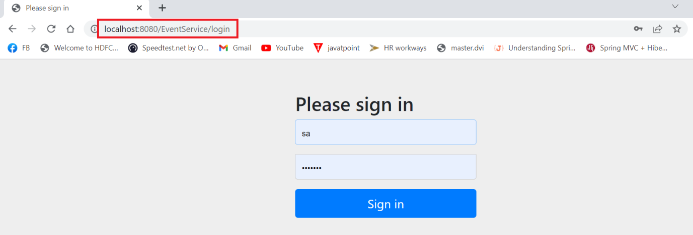

**Event_db database – table data loaded through data.sql**

**Roles table –**

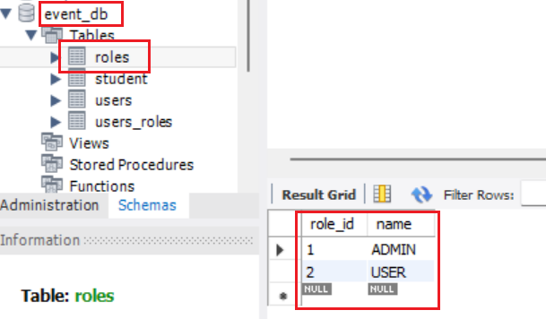

**Users table –**

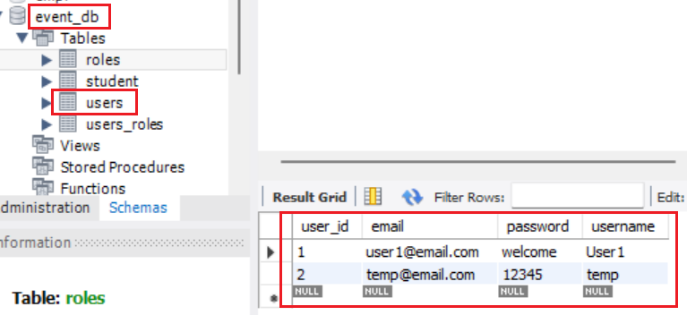

**Student table –**

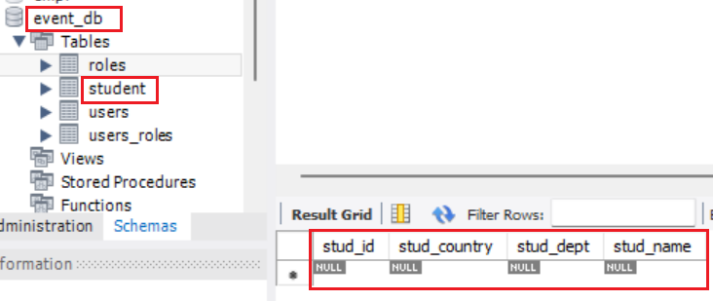

1. **Login as ADMIN – User1**

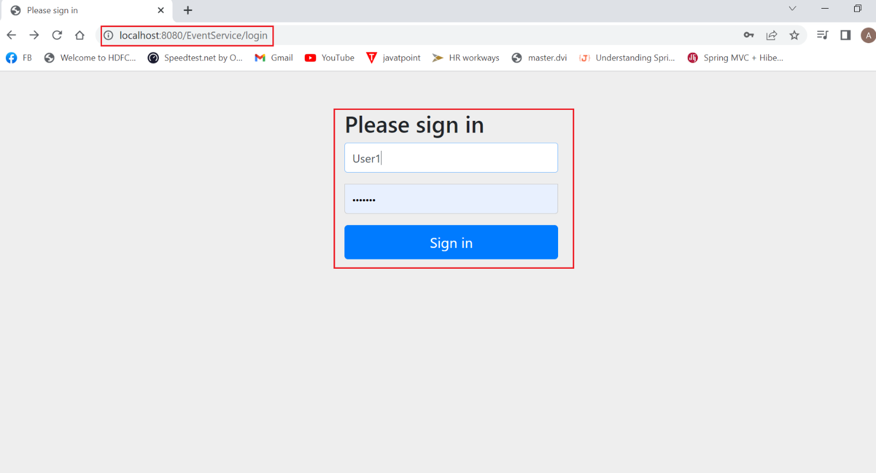

**Hit Sign In and will be routed to the Event Registration – MAIN page**

**Main page –**

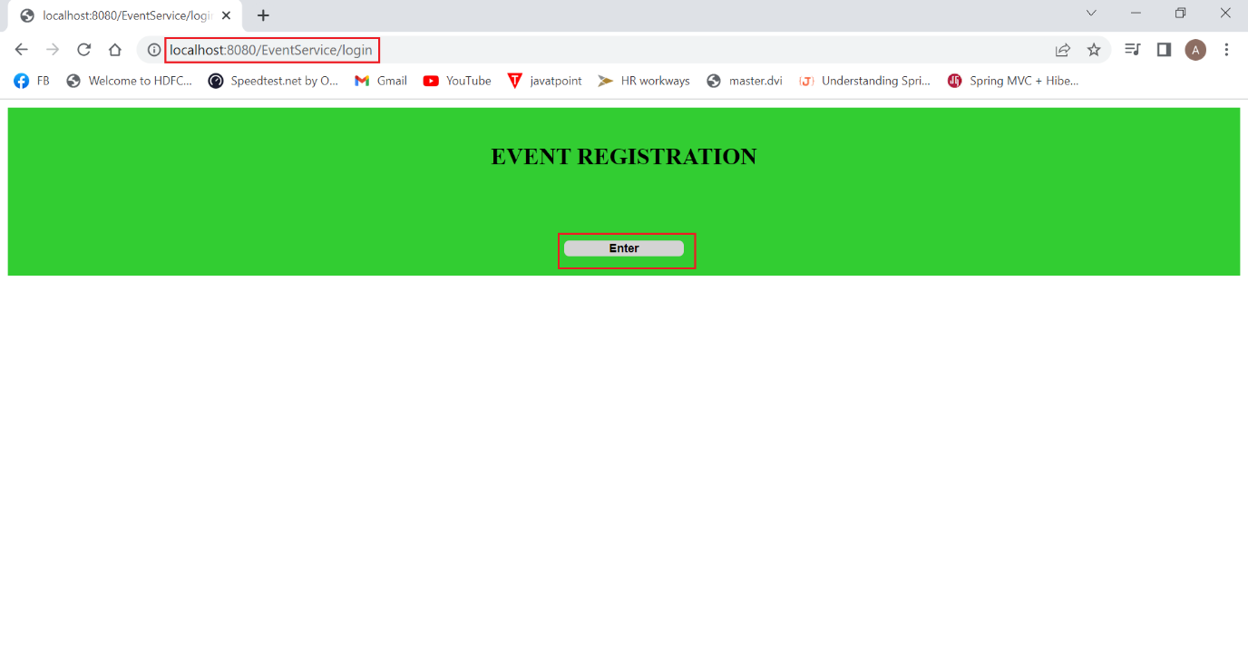

**Hit ENTER – No Students registered and hence blank page**

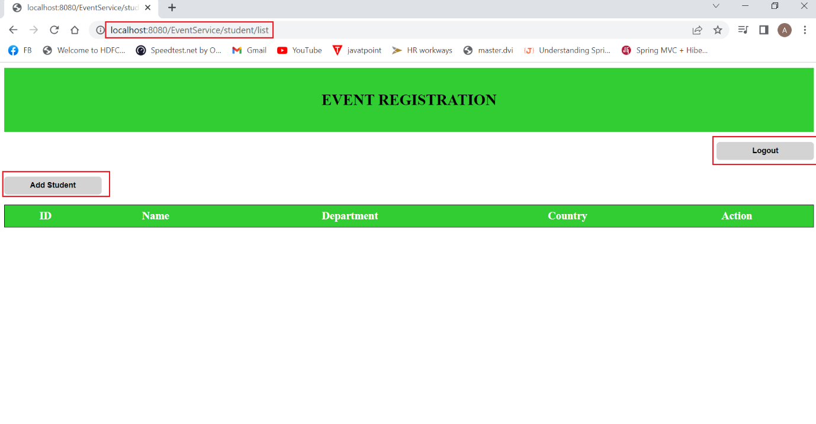

**Add Student –**

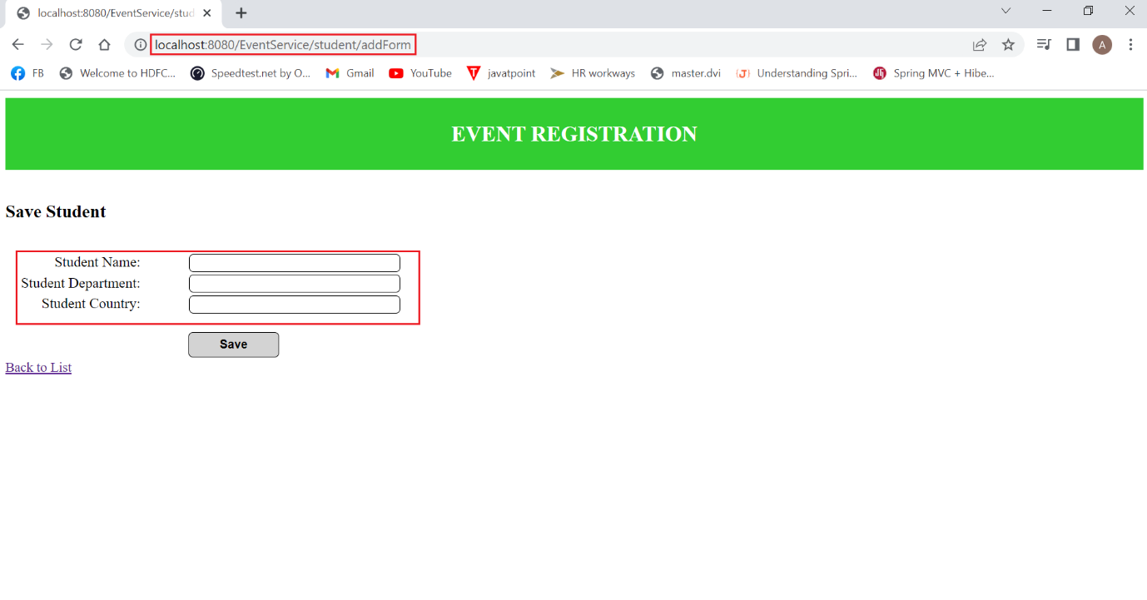

**Add Student details –**

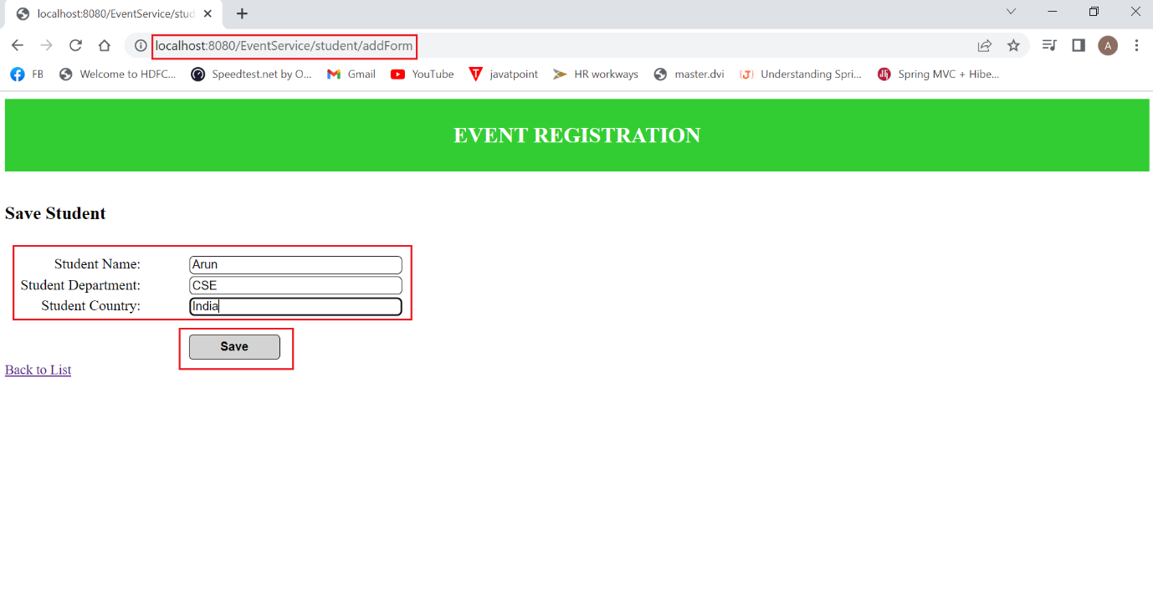

**On Clicking – SAVE**

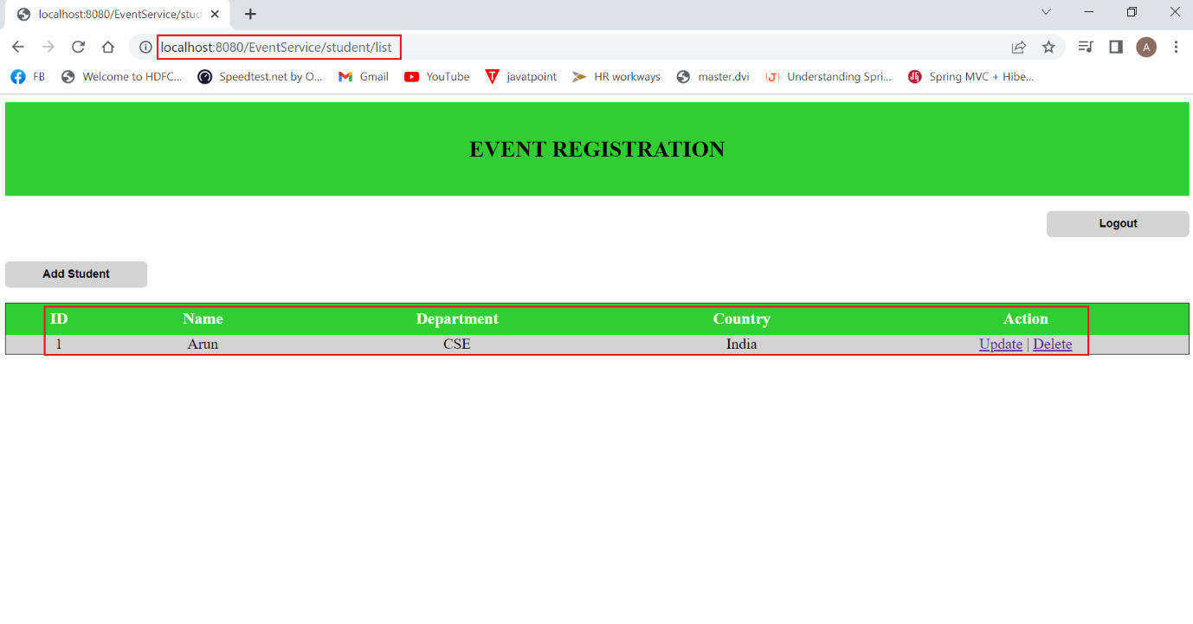

**After adding more Students –**

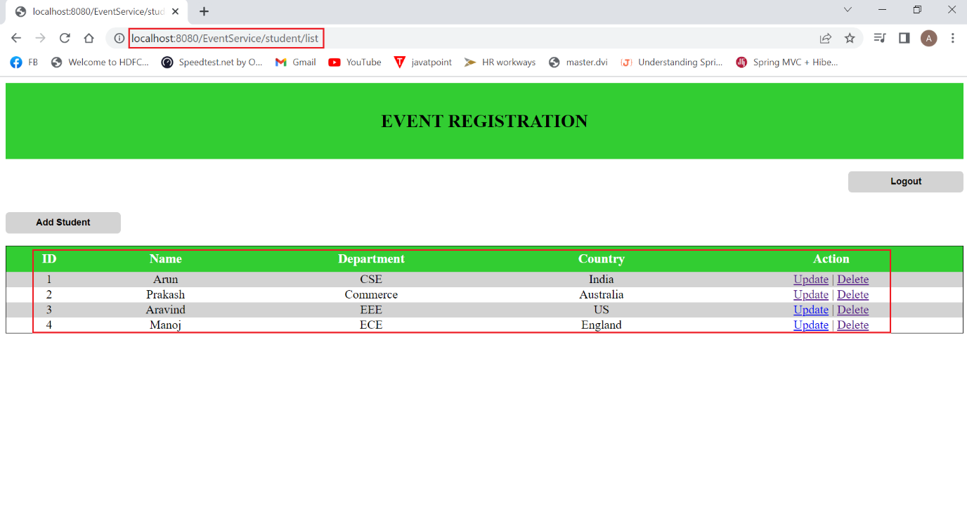

**Table in MySql –**

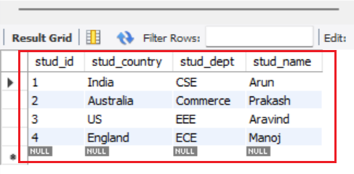

**Update –**

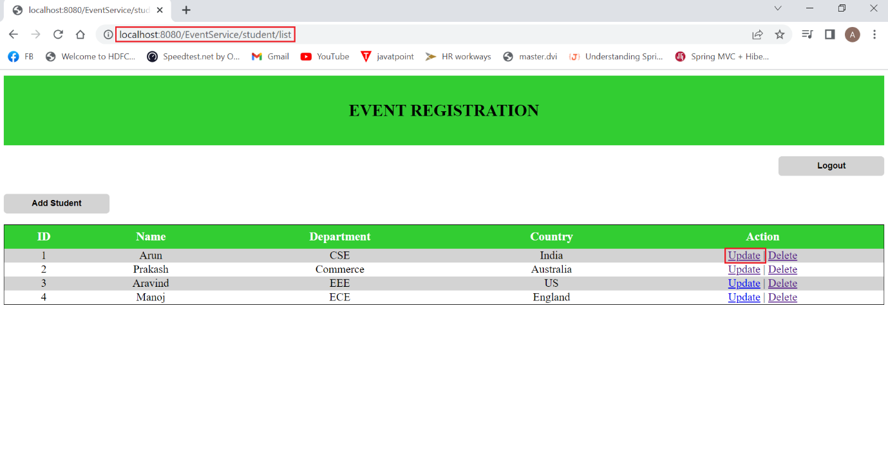

**On Clicking Update option –**

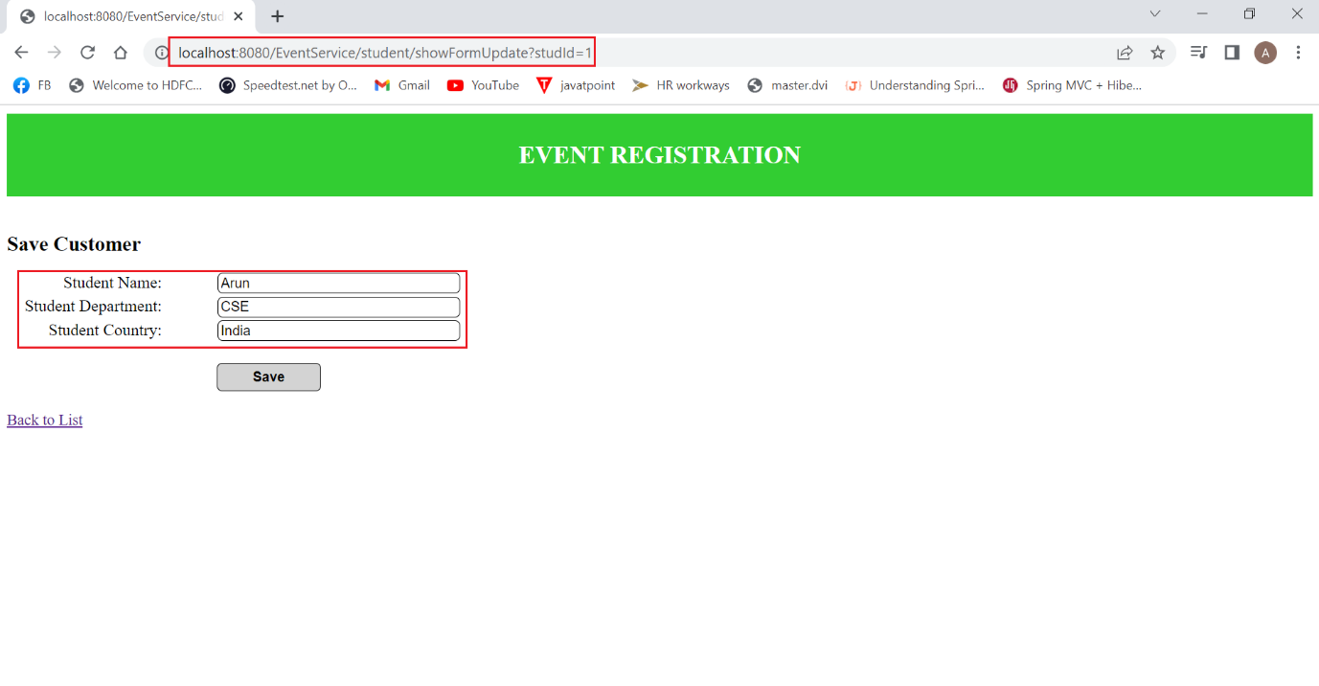

**Changing Name - “Arun” to “Sriram”**

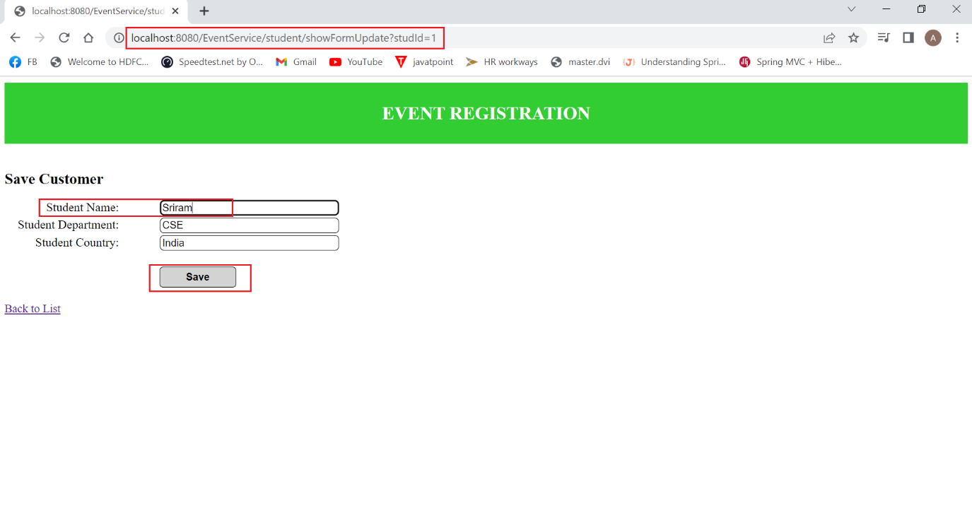

**On Clicking SAVE –**

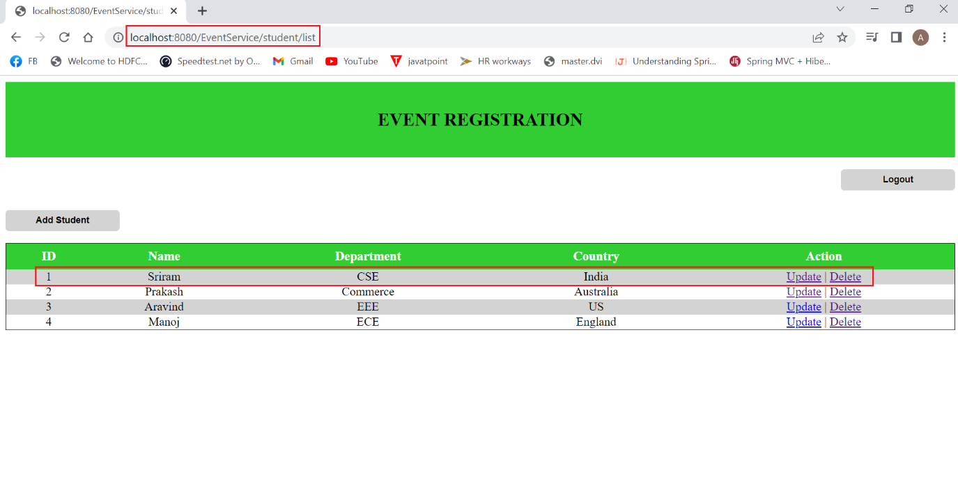

**Delete –**

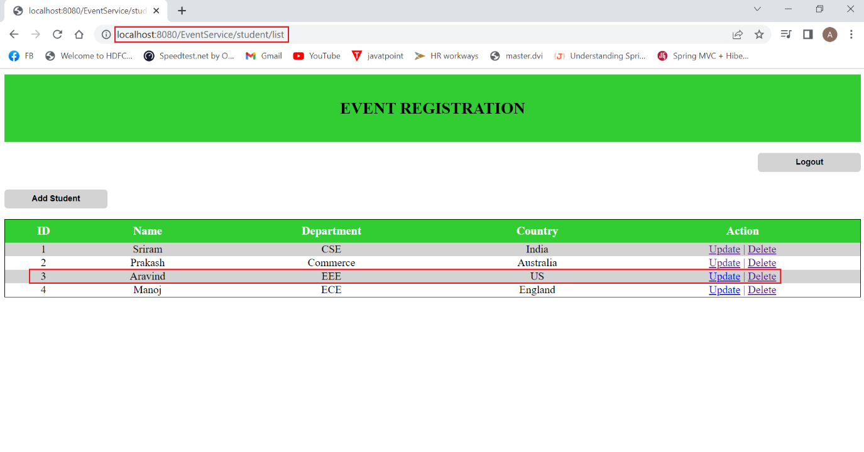

**On Clicking Delete option**

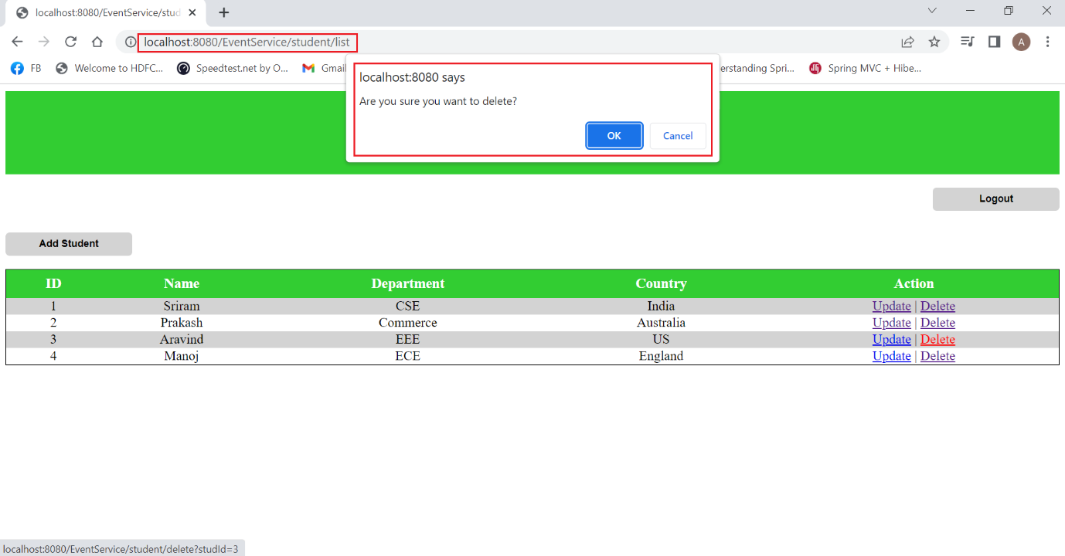

**On Clicking OK –**

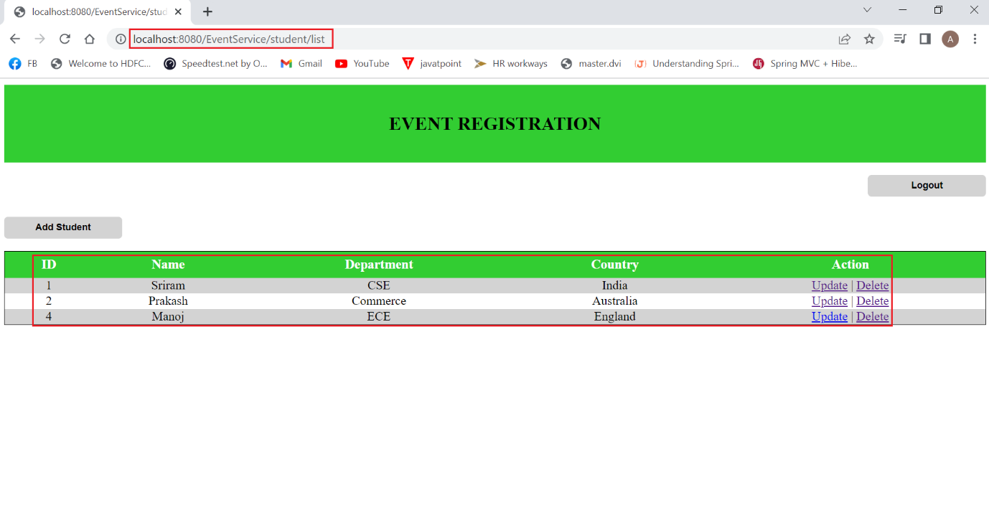

**Clicking “Add Student”**

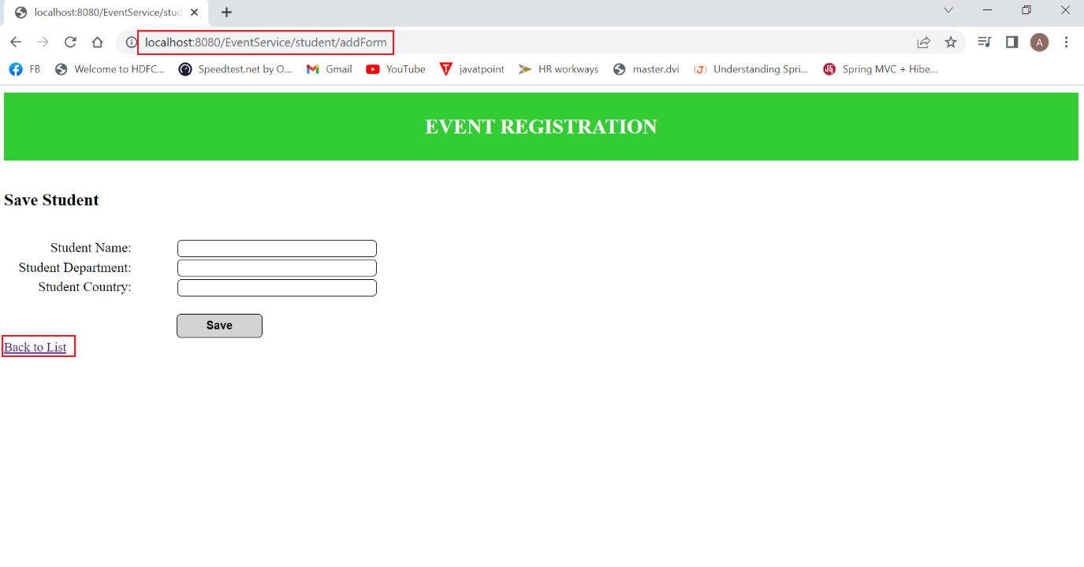

**On Clicking BACK TO LIST –**



1. **Login as USER – User2**

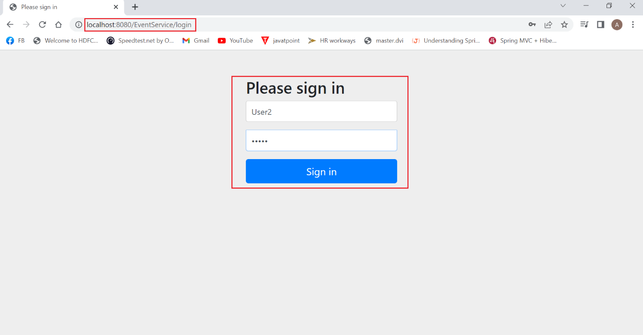

**Data already present in Student table –**

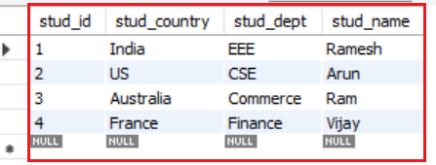

**On Clicking Sign in –**



**User2 able to view Students details –**

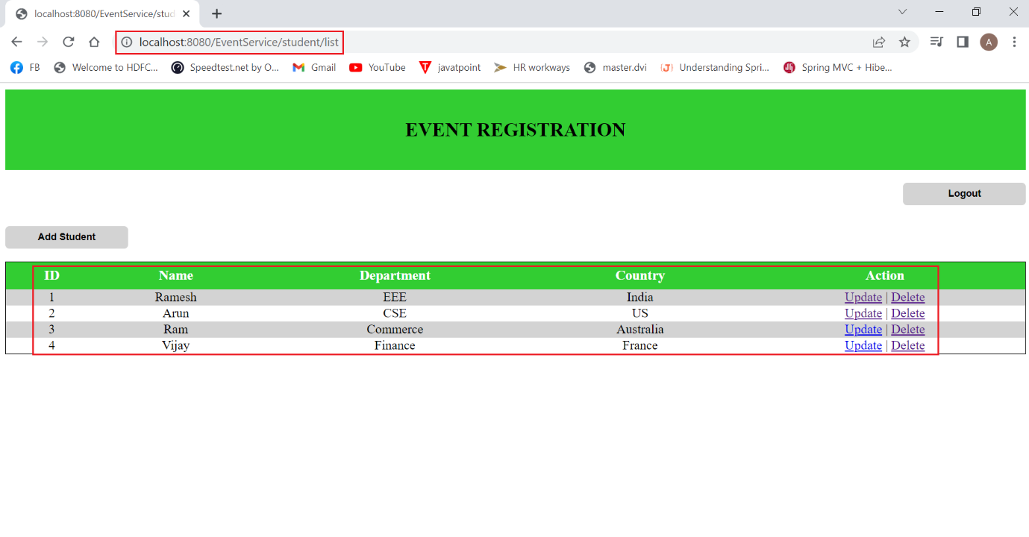

**User2 – Trying to add new entry –**

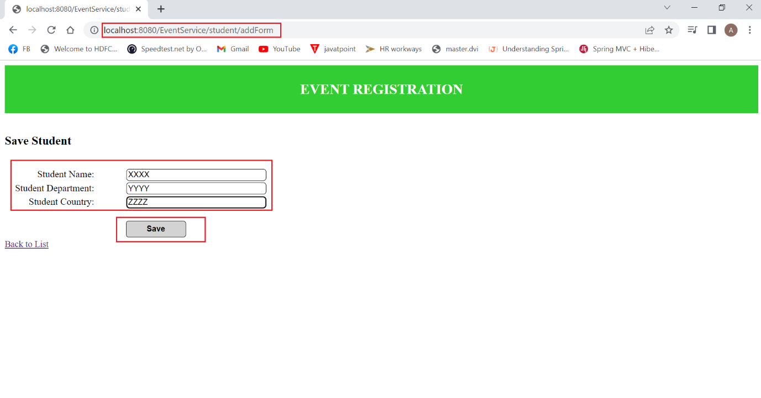

**On Clicking SAVE –**

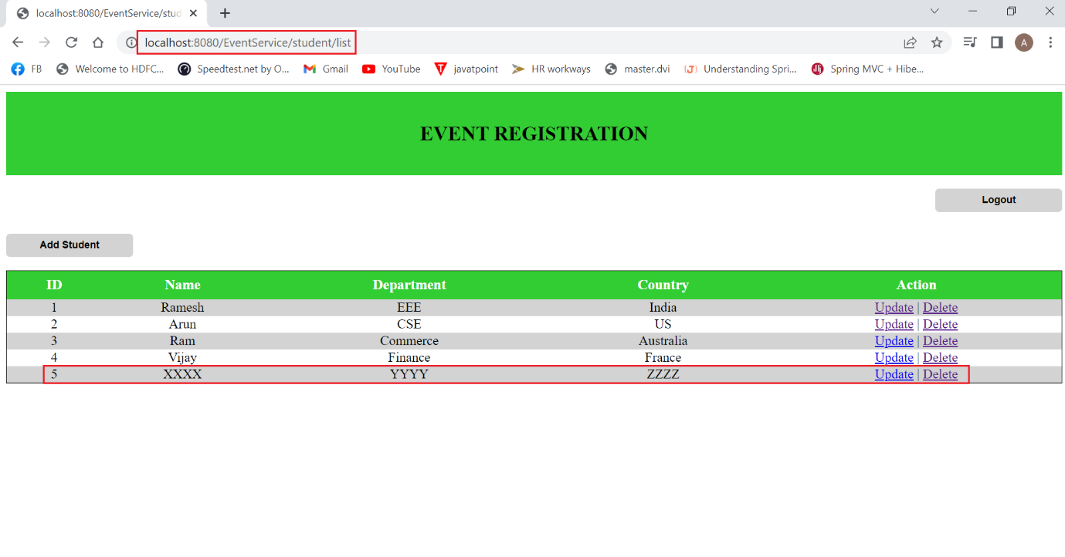

**User2 – Trying to update details – Changing Name -> “Ramesh” to “Arun”**

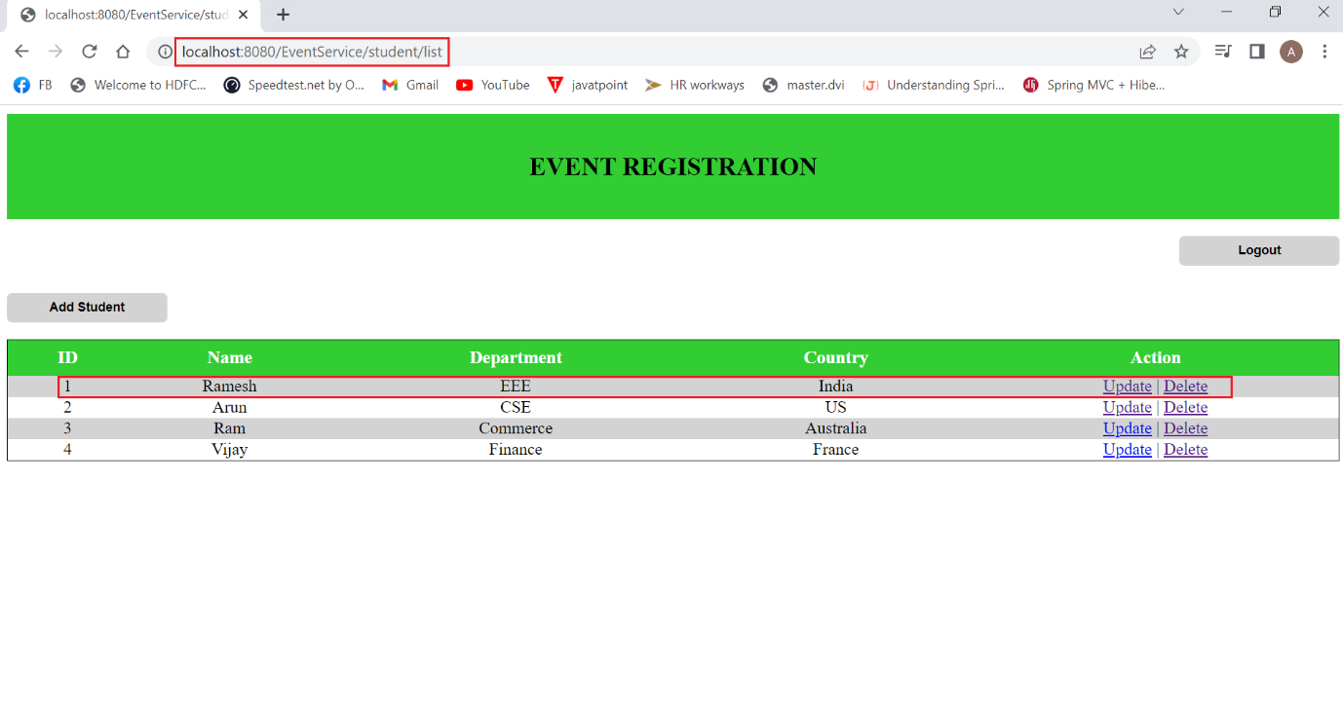

**On Clicking Update –**

**Trying to update the name**

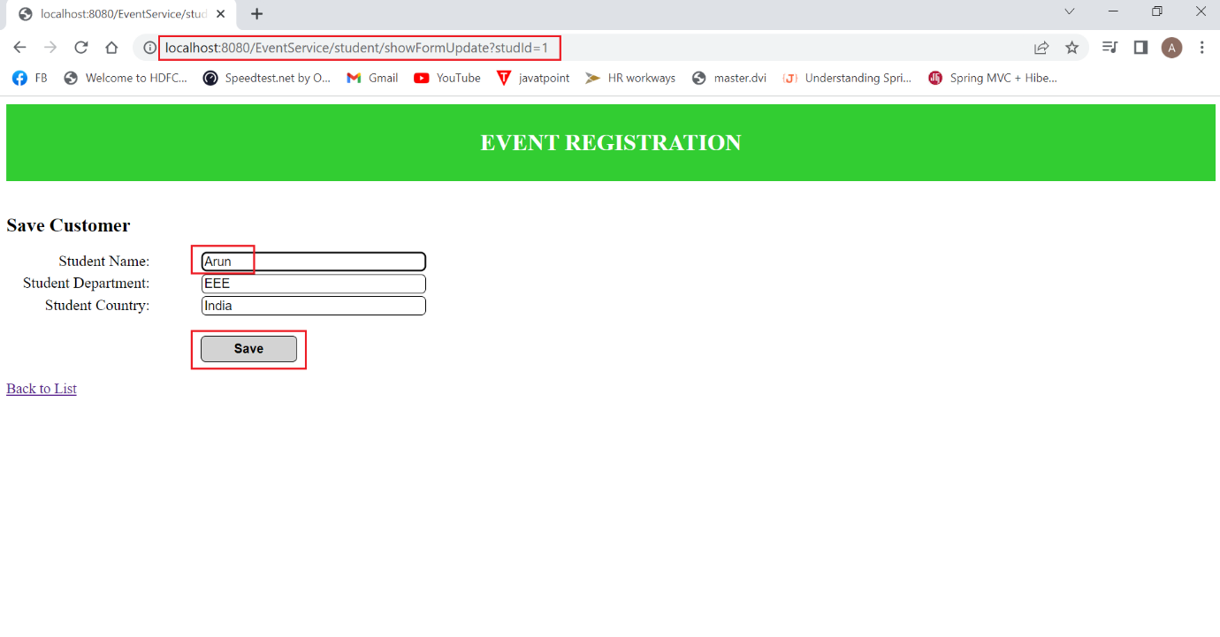

**On Clicking SAVE –**

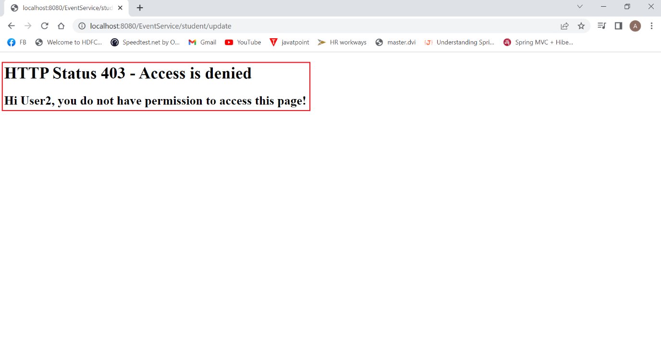

**User2 – Trying to delete a record – Id – 1**

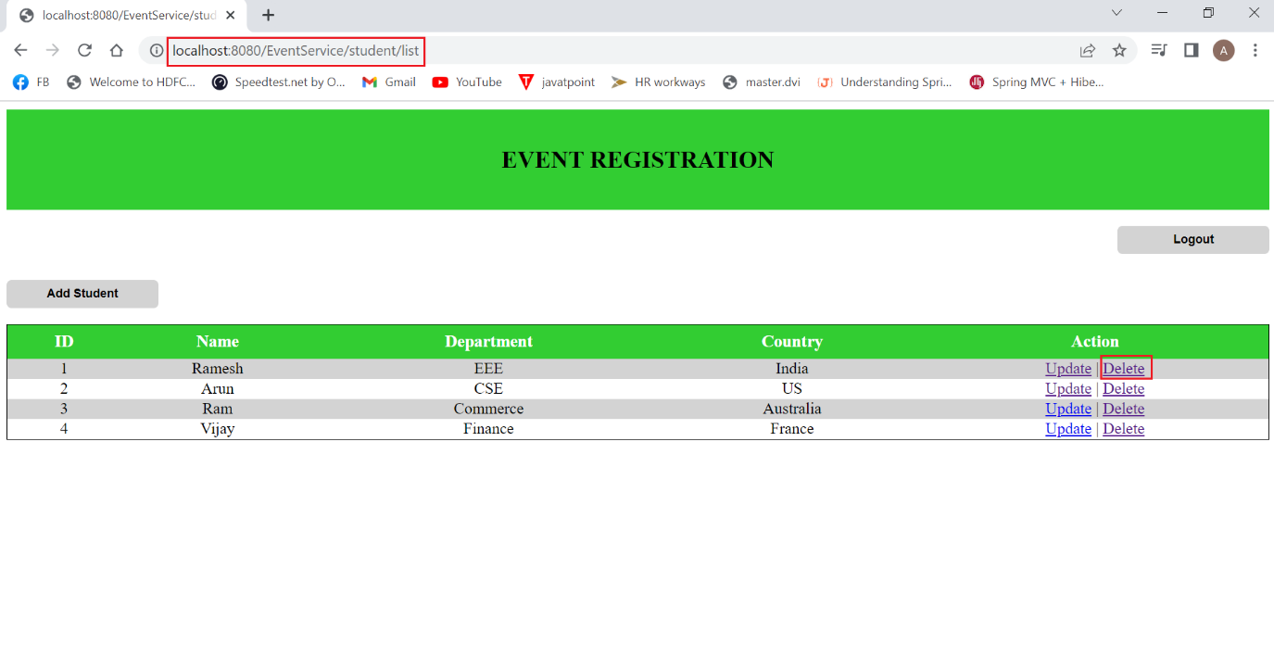

**User2 is prompted for record deletion**

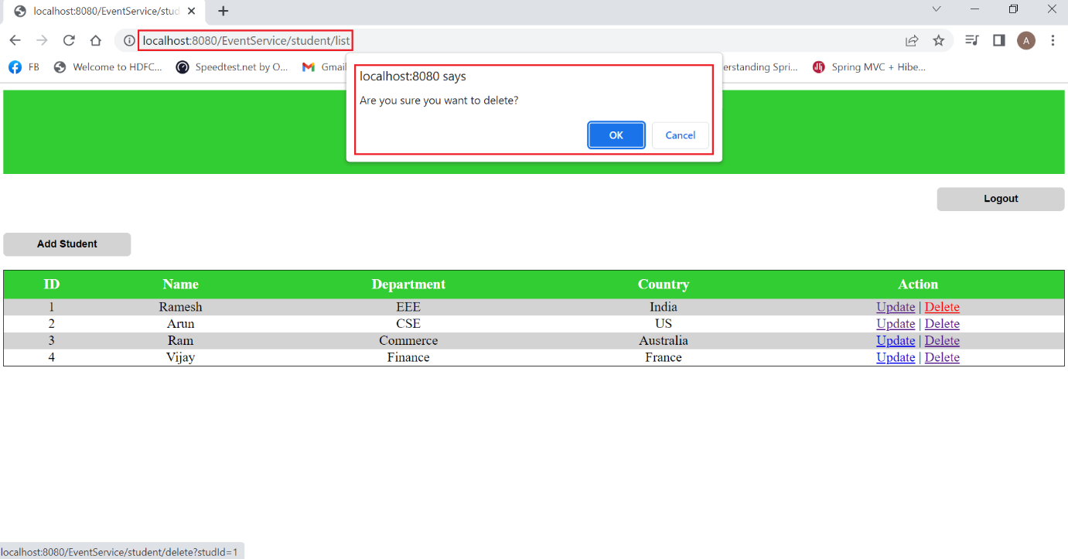

**On Clicking OK –**

