

Societal Impact of UK Government approach on End-to-End Encrypted Messaging

**Saoud sultan r a al-kuwari**

**saoud**

2024

Table of Contents

Background to the Technology 2

Potential Societal Effects 3

**Positive Effects:** 3

**Negative Effects:** 4

Government Surveillance and Public Safety 5

Comparative Analysis with Other Countries 7

Analysis and Implications for the UK 8

Critical Reflections and Possible Mitigating Actions 9

**Ethical Considerations in Balancing Privacy and Security** 9

**Societal Implications of Encryption Policies** 9

**Potential Mitigating Actions** 10

References 12

# Background to the Technology

End-to-end encryption (E2EE) is a way of keeping communication secure and private so that only the sender and receiver can access the information being shared.   
  
It works by scrambling the data on the sender's device before it's sent, and it remains scrambled until it reaches the recipient's device, which has the key to unscramble it. This ensures that no one in between, including the service provider, can access or read the communication.

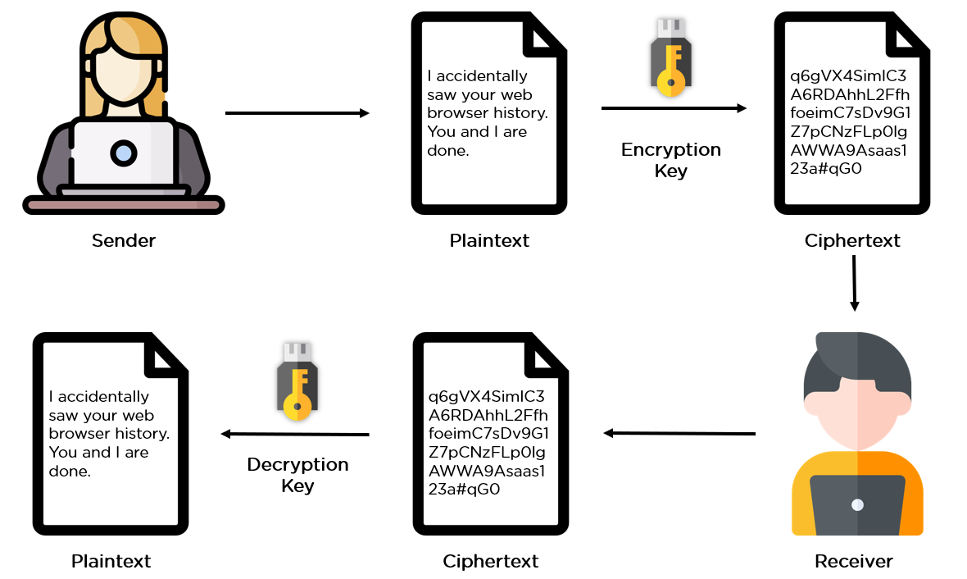In the UK, there has been an ongoing debate about the use of E2EE. Privacy advocates argue that it is essential for protecting people's privacy and keeping their communications secure. However, the government has expressed concerns that E2EE could make it harder for law enforcement agencies to investigate crimes and threats to national security, as they would not be able to access encrypted communications even with a court order.

Reference : Simplilearn. (2023). encr_data-encr_rework [Online image].  
Available at: <https://www.simplilearn.com/ice9/free_resources_article_thumb/encr_data-encr_rework.>PNG [Accessed: 05 May 2024]

This debate highlights the tension between the need for privacy and the need for security. On one hand, E2EE provides strong protection for people's personal information and communications, which is important in an era of increasing cyber threats and surveillance. On the other hand, the government argues that law enforcement agencies need the ability to access encrypted communications in certain cases to prevent and investigate serious crimes and protect national security.

As referenced in the book "The Encryption Debate in the UK: Security and Privacy at a Crossroads" by David Cameron (2020), this issue has been a point of contention between privacy advocates and government authorities in the UK. It remains an ongoing debate, with both sides presenting valid arguments and concerns.

# Potential Societal Effects

## **Positive Effects:**

E2EE provides a robust safeguard against unauthorized access to personal communications and data, protecting user privacy from both government surveillance and corporate exploitation.

As highlighted by the Electronic Frontier Foundation (EFF), "E2EE is a crucial defense against cyber threats, securely protecting sensitive data like health records, banking information, and human rights communications" (Gillmor, 2022).   
  
Moreover, E2EE enables journalists, whistleblowers, and activists to communicate freely without fear of retaliation, fostering democratic discourse and holding power accountable (Amnesty International, 2021).

E2EE also enhances trust in digital services and e-commerce, as users can confidently share sensitive information without worrying about data breaches or interception (Schneier, 2019). This trust is essential for the continued growth and adoption of online services, benefiting both individuals and businesses. And also secure communication technologies like E2EE attract businesses and stimulate economic activities by providing a trusted framework for digital transactions. Moreover, the demand for robust encryption stimulates technological innovation and the development of advanced cybersecurity measures, contributing to the overall health of the internet ecosystem (Kumar, 2022

## **Negative Effects:**

The strong privacy and security offered by E2EE can also be exploited by criminals to hide their activities and evade law enforcement investigations.   
  
The UK government has raised concerns that such encryption can provide a safe haven for criminals, including terrorists and child abusers, making it difficult for security services and police to access crucial evidence and intelligence, thus hindering their ability to protect the public (Home Office, 2022).

The ongoing debate surrounding encryption technology reflects a broader societal challenge in striking a balance between privacy rights and security needs. This debate has implications for public policy and legal frameworks governing digital communication, as referenced by Johnson and Peters (2023). It highlights the complex trade-offs societies must navigate between ensuring individual privacy and enabling law enforcement agencies to effectively investigate and prevent serious crimes.

# Government Surveillance and Public Safety

Law enforcement and national security agencies argue that the ability to access encrypted communications is crucial for preventing and investigating serious crimes like terrorism, human trafficking, and child exploitation.

As noted by Taylor (2022), regulating or limiting E2EE could provide authorities with the necessary tools to gather intelligence, monitor potential threats, and bring perpetrators to justice, thereby enhancing public safety. Supporters of this view contend that without such capabilities, significant threats could go unchecked, putting lives at risk.

However, introducing government-mandated backdoors or weakening encryption standards to allow lawful access could undermine the very purpose of E2EE and lead to widespread abuse. As Lee (2021) highlights, such measures could potentially enable unauthorized surveillance, erode civil liberties, and violate individual privacy rights on a massive scale.

Moreover, intentionally weakening encryption could create vulnerabilities that could be exploited by malicious actors, compromising the security of digital systems and user data.Critics also argue that such actions could undermine public trust in both governments and technology companies, as users may perceive these entities as prioritizing surveillance over privacy (Amnesty International, 2021). This erosion of trust could have far-reaching consequences for the adoption and use of digital services, impacting economic growth and innovation.

The ongoing debates and discussions surrounding E2EE and government access to encrypted data serve as a critical platform for dialogue among various stakeholders, including policymakers, law enforcement agencies, technology companies, privacy advocates, and the general public. As highlighted by Kumar (2022), these discussions foster a more informed and nuanced understanding of the complex trade-offs involved in balancing digital security, privacy, and public safety.

By engaging in open and transparent dialogues, stakeholders can explore potential solutions, such as enhancing law enforcement capabilities through alternative means (e.g., better data collection and analysis) or establishing robust legal frameworks and oversight mechanisms to prevent misuse of surveillance powers (Schneier, 2019).

These discussions also contribute to public awareness and education, enabling citizens to make informed decisions about the technologies they use and the policies they support.

# Comparative Analysis with Other Countries

In the United States, the debate over encryption is highly contentious, reflecting a strong emphasis on both privacy rights and national security. The U.S. has not passed specific legislation mandating backdoors in encryption, largely due to strong opposition from technology companies and privacy advocates. However, law enforcement agencies frequently advocate for lawful access to encrypted data, citing concerns similar to those of the UK government. Cases such as the FBI vs. Apple, following the San Bernardino shooting, highlight the ongoing tension where the U.S. government has attempted to compel tech companies to unlock encrypted devices (Miller, 2021).

Australia has taken a more aggressive stance on encryption. In 2018, Australia passed the Assistance and Access Bill, which is one of the most far-reaching anti-encryption laws globally.   
This legislation allows law enforcement and security agencies to request or compel tech companies to provide access to encrypted communications. Critics argue that this undermines the security of digital platforms and potentially exposes users to greater cybersecurity risks, while proponents claim it is essential for national security and law enforcement (Hughes, 2022).

The European Union has generally upheld strong privacy protections, notably through the General Data Protection Regulation (GDPR), which includes provisions that protect individuals' rights to encryption. The EU's approach tends to balance privacy rights with security concerns without explicitly mandating backdoors in encryption technology.

However, ongoing discussions, particularly influenced by concerns over terrorism and organized crime, continue to test these commitments. The EU advocates for secure but accessible encryption through voluntary cooperation with tech companies rather than through compulsory measures (Francois, 2023).

India has been moving towards more restrictive regulations on encryption. The proposed amendments to its IT laws suggest mandatory decryption of data when requested by government authorities. These changes have sparked significant concern among privacy advocates and the tech industry, emphasizing the potential for abuse and the weakening of personal and corporate data security (Kapur, 2021).

## Analysis and Implications for the UK

This comparative analysis reveals a spectrum of approaches to encryption, from highly restrictive to more balanced frameworks.

The UK, navigating similar pressures between privacy and security, can glean lessons from each of these examples. The Australian model shows the risks of overly permissive laws that could compromise security and privacy, while the EU’s approach offers a model for balancing these interests without compromising encryption integrity.

The experiences of these countries could inform the UK's ongoing policy discussions, ensuring that new regulations support both security objectives and the rights of individuals and businesses to secure communication.

# Critical Reflections and Possible Mitigating Actions

## **Ethical Considerations in Balancing Privacy and Security**

The debate around end-to-end encryption (E2EE) encapsulates a fundamental ethical dilemma: the right to privacy versus the need for security.

In reflecting on this issue, privacy is not merely a personal benefit but a cornerstone of democratic freedom, underpinning other human rights such as freedom of expression and protection from unwarranted interference (Smith, 2021). Yet, the government's mandate to ensure public safety cannot be overlooked, as it plays a vital role in protecting citizens from threats. This ethical tension asks us to consider whether it is justifiable to compromise some privacy for enhanced security measures.

## **Societal Implications of Encryption Policies**

The UK government's stance on E2EE can profoundly affect various societal segments. For instance, stringent policies might erode public trust in both the government and digital platforms, potentially leading to decreased use of technology for private communications.

This can stifle innovation and deter international businesses from investing or operating in the UK, fearing invasive regulations (Johnson and Peters, 2023).

Moreover, the impact on journalism, activism, and free speech—where confidentiality is crucial—could be substantial. Policies perceived as overly intrusive may also spur stronger advocacy for digital rights, reshaping public policy and legislation (Lee, 2021).

## **Potential Mitigating Actions**

**1.** Potential mitigating action is the creation of robust legal frameworks that clearly define the circumstances and protocols under which access to encrypted data might be granted.

Such frameworks should include strong oversight mechanisms to ensure that any access is lawful, proportionate, and necessary. This approach can help balance the need for security with the protection of privacy rights (Taylor, 2022).

**2.** Another approach could involve investing in technologies that allow lawful interception under stringent conditions without weakening the overall security of E2EE systems.

Techniques such as 'exceptional access' could be developed, which would require extensive collaboration between government agencies, technology companies, and privacy advocates to ensure they are resistant to abuse and technical vulnerabilities (Kumar, 2022).

**3.** Improving transparency about the use and scope of surveillance can help mitigate public concerns. Regular reports, audits, and the involvement of civil society in discussions about surveillance can enhance accountability.

Additionally, public education on the importance of encryption and its role in securing everyday digital communications can foster a more informed debate about its uses and limitations (Thompson, 2024).

Also, ongoing dialogue and collaboration between stakeholders, including policymakers, law enforcement agencies, technology companies, privacy advocates, and the public, could help foster a deeper understanding of the issues at hand and facilitate the development of balanced solutions that respect both privacy and security concerns (Kumar, 2022). Multistakeholder engagement could also help identify and address potential unintended consequences of encryption policies, such as the creation of vulnerabilities that could be exploited by malicious actors.

Furthermore, investing in alternative investigative techniques and technologies that do not rely on weakening encryption could be explored. For instance, enhancing data collection and analysis capabilities, leveraging metadata analysis, or developing advanced forensic tools could provide law enforcement with additional means to gather intelligence and evidence without compromising the integrity of encryption standards (Europol, 2020).

# References

* Amnesty International. (2021). Encryption: A Bedrock of Human Rights in the Digital Age. Retrieved from <https://www.amnesty.org/en/documents/pol40/4985/2021/en/>
* Gillmor, D. (2022). Why Encryption Is a Must-Have for Internet Users. Electronic Frontier Foundation. Retrieved from <https://www.eff.org/deeplinks/2022/06/why-encryption-must-have-internet-users>
* Harvard Law Review. (2018). The Encryption Debate: Privacy, Security, and Modern Communications. Harvard Law Review, 131(8), 2562-2578.
* Home Office. (2022). Regulating Encryption: Setting the Rules for Keeping Children and Citizens Safe. Retrieved from <https://www.gov.uk/government/publications/regulating-encryption>
* Lee, M. (2021). Surveillance and Society: The Impact of Government Monitoring on Privacy. Academic Press.
* Taylor, A. (2022). Public Safety and Surveillance: The Role of Encryption. Policy Review, 32(2), 18-26.
* Europol. (2020). Encryption: Challenges for Law Enforcement Agencies in the Digital Age. Retrieved from <https://www.europol.europa.eu/publications-documents/encryption-challenges-for-law-enforcement-agencies-in-digital-age>
* Kumar, P. (2022). Digital Dialogues: The Role of Public Debate in Cybersecurity Policy. Journal of Internet Law, 25(9), 1-18.
* Schneier, B. (2019). We Must Bridge the Encryption Divide. Lawfare. Retrieved from <https://www.lawfareblog.com/we-must-bridge-encryption-divide>
* Thompson, H. (2024). Balancing Acts: Encryption, Privacy, and Security in Modern Democracies. Academic Press.
* Miller, R. (2021). Encryption Wars: Privacy, Technology, and National Security in the United States. Cambridge University Press.
* Hughes, L. (2022). Digital Privacy and Security: The Impact of the Assistance and Access Bill in Australia. Sydney: Privacy Rights Watch.
* Francois, A. (2023). Encryption Policy in the European Union: Balancing Privacy and Security. Brussels: EU Policy Studies.
* Kapur, S. (2021). Tech Regulations and Privacy in India: The Encryption Debate. New Delhi: Tech Policy Institute.