**Literary Criticism Final paper analysis on The Old Man and The Sea**

Tamader AlQahtani

202105204

Literary Criticism L52

Professor Yasser Khan

Department of English Literature and Linguistics

**Analysis of theme - Friendship as the Core of Resilience**

**First Passage: (Pg 2.)**

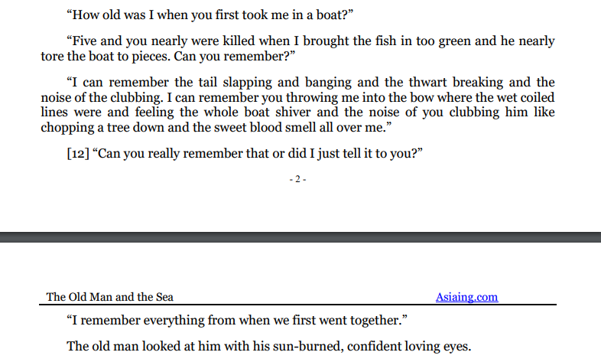

At the outset of The Old Man and the Sea, I see Santiago and the boy and the relationship between them is already strong. The first passage, is from the start of the story shows the old man and the boy talking about when the boy was very young and first went fishing with him. This shows how long their friendship goes back and how it started very early. The boy was only five and the old man took him fishing, this shows that their bond began long ago. They share memories of hardship and danger but also care and trust as said in the story “I remember everything from when we first met.” Meaning all the experiences he had with the old man teaching him how to fish, urging them to be even closer to each other regardless of their age gap and also how the old man is still a mento to him notwithstanding his struggles in finding fish to catch, he is still a great man to Manolin. It shows how their first meeting evokes a feeling of nostalgia in the boy. “…first took me…” and “...when we first went together.” the boy here recalls these specific moments suggests that there is something strong or a strong bond that does not get influenced by the old man, Santiago’s struggles and hardship. The old man looks at the boy with loving eyes. The way they remember their first fishing experience shows that friendship is a big theme right from the start. Friendship here is connected to teaching passing knowledge from older to younger and sharing life lessons. The old man and boy form a strong bond and it does not depend on success, it says here “five and you were nearly killed when I brought the fish in too green and he nearly tore the boat to pieces. Can you remember?” A difficult encounter with a fish that nearly destroyed the boat but that memory is precious because it belongs to them together, how the old man saving him shows how much he evokes trust filled emotions in the boy. This theme of friendship also connects to resilience and dignity which are central to the story. Santiago and the boy support each other emotionally and that friendship gives Santiago strength even when the boy is not with him physically. The beginning sets the theme that human dignity and hope often come from connections between people.

**Second Passage: (Pg 16.)**

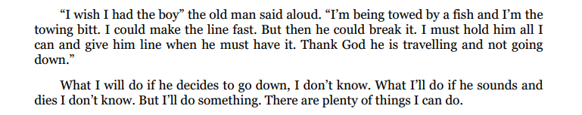

In the middle of the story Santiago is out alone at sea He hooks a great marlin and struggles with it for days. Here Santiago is alone but he thinks about the boy. He wishes he had the boy with him This tells us that the friendship theme is so important that even when the boy is absent Santiago feels his presence in memory, He wants the boy not only for physical help but also for moral support. The friendship gives him mental strength When he says I wish I had the boy it shows that human bonds give courage and comfort. He is not just an old man fighting a fish. He is also a teacher and a friend and in remembering the boy he finds strength to keep going. His will to keep fighting is partly inspired by the boy who believes in him. This shows that friendship is a source of hope in isolation.

**Third Passage: (Pg 46.)**



And, at end of story the old man returns defeated in a physical sense because the sharks have eaten the big marlin. He brings home only the skeleton. He is exhausted. the boy still cares deeply about the old man, “the boy saw to old man was breathing and then saw the old man’s hands and he started to cry.” In this passage i can see that the roles have shifted, although the old man was always Manolin’s protector and wise man, manolin takes over that role when he sees the old man’s hand in pain, he sheds tears for him which means that he not only cares about him but is willing to protect him too. His tears show the depth of their friendship, he cries because he understands the old man’s suffering and struggle. Not only that but also feels relieved when he saw him breathing “ the boy saw the old man breathing and then he saw the old man’s hand and he started to cry” his relief soon transforms into sarrow and empathy as he notices the condition of the old mans hand. His love for the old man was mixed with anguish from seeing him in pain. He sees the old mans wounded hands and realizes what the old man has gone through and how fragile he became to be. The friendship does not end with the loss of the fish. In fact it grows stronger because now the boy understands the price Santiago paid. The boy will bring him coffee and comfort and they will remain close, its something they used to do a lot “he went out very quickly to go to bring some coffee…” This final passage shows that even in loss the friendship endures and that human dignity grows from love and understanding between friends. The boy is moved by the old mans effort and is proud of him, making the theme of friendship central to understanding the old mans struggle. He never truly fights alone. The memory of the boy in the middle sustained him and at the end the boy returns to weep for him and help him. This theme is linked to resilience and dignity because Santiago never surrenders his honor and his friendship is not based on success but on mutual respect and care.

When I look at the three passages in the story, I see how the theme of friendship grows and changes. At the start, the bond between Santiago and the boy is already strong. It began long ago when the boy was very young, and the old man taught him how to fish. It starts as a long established bond built from early childhood experiences. In the middle of the story, Santiago is alone at sea. But even when he is alone, he thinks about the boy. He remembers the boy’s kindness and wishes he was there with him. This shows that the friendship is not just about being together physically. It continues as a memory and source of strength at sea and in the end it is reaffirmed by the boys compassion and devotion. Friendship here is not just a side note. It is a core part of why Santiago can face hardship with dignity and resilience. At the end of the story, the boy is there for Santiago again. He sees the old man’s struggle and understands his pain. The boy shows his love and respect by caring for Santiago. This proves that their friendship does not depend on success or catching a fish. It grows stronger because it is built on understanding and compassion. Santiago’s dignity and resilience come from this connection. Friendship is not just part of the story, it is what helps Santiago face challenges and find hope. It shows how human connections are more important than winning or losing.

**Analysis of character: Santiago’s Strength** (Pg 8.)

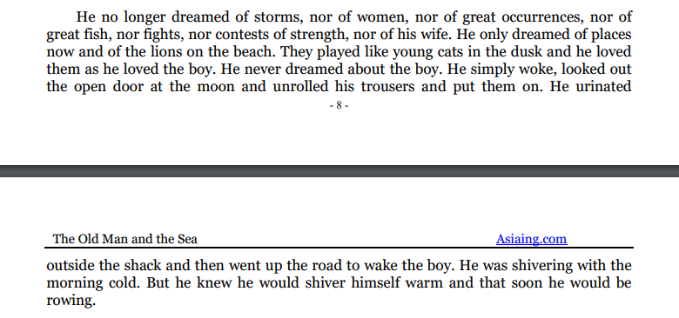

The characters in The Old Man and the Sea are shown through what they do and think. Santiago is wise and also strong as he keeps fishing even when it is very hard. I feel respect and admiration for him because he never gives up. The characters are knowable because I understand their feelings and see what they go through but sometimes they are a bit elusive because I do not see everything about them. The way author describes them is connected to the themes of friendship and struggle, the plot of fishing and battling the sea, the mood of determination and hope and the imagery of the ocean and the lions. This makes the characters feel real and their stories meaningful because their inner strengths help them face challenges. Focusing on Santiago as a character, the para shows Santiago as a simple man who holds his dignity in quiet ways. "He no longer dreamed of storms, nor of women, nor of great occurrences, nor of great fish, nor fights, nor contests of strength, nor of his wife." He no longer chases big dreams of wonder or heroism, he dreams only of lions which symbolize youth strength and freedom. “He loves the lions like he loves the boy”, the lions remind him of something pure and eternal inside him he once had, like his potency possessiveness and strength. He does not dream of the boy which may seem odd, however, he lives the friendship with the boy in real life, which makes ironic to dream of him because it’s reality. The lions in his dreams stand for a deeper spiritual strength that he carries from his youth. He accepts his old age his simple life and his routine. He is connected to nature. To wake before dawn and go fishing is part of who he is. He trusts that he can warm himself by his own effort. This shows resilience and dignity. He does not complain and faces cold and hunger with calm acceptance. Also, Santiago is practical and self reliant. This character detail connects to the theme of friendship and resilience because even though he is old and unlucky he has the boy “He urinated outside the shack and then went up the road to wake the boy.” He has love and care and the boy admires him. He admires the lions and the memory of his youth. He is not broken by hardship. He lives a life guided by a quiet inner strength Santiago as a character is defined by perseverance humility and a deep moral code. His dreams and actions show that he draws power from nature and memory. This supports the theme of dignity and resilience and the importance of friendship because the boy is always near him in reality and he cherishes that bond quietly Character is shown here as someone who stands firm in a harsh world without losing grace or heart.

**Analysis of atmosphere and setting: The Sea, A Reflection of Struggle and Connection**

**(Pg 10.)**

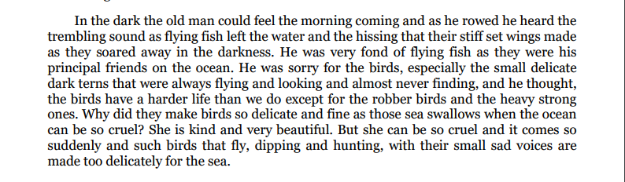

Now analyzing at how atmosphere and setting reflect Santiago’s isolation and connection to nature. Here the setting is the ocean at dawn and its creatures. The old man feels the coming of morning in the dark He moves quietly in a world that is both beautiful and dangerous. The flying fish and the birds show how life in the sea is full of struggle and delicate balance. The old man calls the flying fish his friends. This is important because it shows that his sense of friendship goes beyond just human relationships. He feels connected to other creatures. He cares about the delicate terns. He wonders why they are made so fragile in a cruel sea. This thought process shows that he respects life around him and understands hardship in a broad sense. The atmosphere is calm and mysterious .The darkness the soft sounds of flying fish the quiet hissing of their wings all create a setting where the old man feels both alone and yet not alone .He is isolated but among friends of a different kind .The cruelty and sudden danger of the ocean remind us that the old man lives at the mercy of nature. He respects that. He does not curse it. He admires its beauty and accepts its cruelty . He is kind toward the animals .He shares a bond of sympathy with them This atmosphere makes us see that Santiago’s dignity comes from understanding his place in nature. He does not fight nature blindly. He lives within it and respects it .The atmosphere and setting help show that he is never truly alone because he carries empathy and respect for other creatures .The ocean is both a challenge and a friend and that shapes his moral code.

The haecceities in this book are the unique details about the sea and old man. For instance the descriptions about the flying fish the quiet morning and the lions in his dreams make the story special. These details help to create a strong atmosphere that shows the beauty and the struggle of the sea.  
  
The haecceities interact in a way that they support each other and make the atmosphere feel real. The peaceful morning contrasts with the tough battle with the fish but they work together to show Santiago’s journey. These elements are resonant because they highlight both the calm and the challenges he faces which makes the setting more meaningful.

This setting shows that dignity can exist even in a dangerous world if one approaches it with respect and understanding.

**Structure analysis:**

For narrative structure, I consider how the story comes whole circle and how friendship and resilience shape the conclusion The questions given to consider are about the theme of friendship and how it is related to the fish and what brings the old man and the boy together and how it remains central even when the boy is missing at sea also what is unique about their friendship. At the end the old man returns with the marlin’s skeleton. He has lost the fish but proven himself . The boy cries at his wounded hands and brings him coffee. The narrative starts with them talking about fishing and ends with them reunited. The cycle of going out and coming back shows that the friendship does not depend on catching a fish. It depends on understanding and caring.

I believe the narrator in The Old Man and the Sea keeps a near distance from the story. It feels like the narrator is watching the characters closely and telling us what they are doing and feeling. The story is told in third person which means the author is talking about the characters from outside. The narrator does not talk to us directly but shows us the thoughts and actions of Santiago and the boy. This makes us feel connected to them and understand their struggles. The way the narrator is close helps us care about what happens in the story.

The way the story is told shows clearly that friendship is a central theme. The relationship between the old man and the boy is not based on luck or material success. Instead, it is built on respect, trust, and deep care for each other. From the start of the story, I see their bond through their conversations and shared memories. The boy looks up to the old man, and the old man treasures the boy’s loyalty and kindness. This relationship gives meaning to their lives and helps them face hardships. The old man and boy share a bond formed long ago when the old man taught the boy how to fish. This bond was not broken even though the boy’s parents made the boy go with a luckier boat. They were brought together by fishing but what keeps them together is deeper than just fishing, It is respect love and shared experiences. The old man might be old and unlucky but the boy admires him greatly because he is courageous honest and full of skill. The uniqueness of their friendship comes from the difference in their ages and from the fact that the old man is like a mentor and father figure to the boy While at sea alone Santiago misses the boy and wishes for his presence. This shows that even in isolation friendship is present in his mind. Also , When the old man returns and is sleeping the boy comes and sees him and cries. This shows that the narrative structure returns to the human connection that started the story. The fish they caught or lost does not really define their bond. The really the treasure is the understanding they share. The old man might have lost the fish but he has gained a stronger confirmation of his dignity and the boys devotion. The narrative structure is shaped so that i start with their friendship and i see it tested by separation and hardship and in the end i return to that friendship renewed and more profound. The old man and boy stand together again planning future fishing trips. The cycle shows that life goes on The struggle was not for nothing It strengthened their bond and proved what is important in life.

The story begins and ends with their relationship making friendship one of the main pillars that support the old mans dignity and resilience.