|  |  |
| --- | --- |
|  | **2011** |
|  | Web Development service  WEI.WENBO 11304767 Arun Jayaraj 11044942 |

|  |
| --- |
| **[Bart website]** |
| Arun jayaraj and Wei wenboo |

Contents

Introduction 3

Objectives 3

Work flow diagram 4

Search timetable by Trip 4

Search timetable by station name 5

Calculate fare 5

Application functionality 6

Installation 10

# Introduction

This document contains the brief report on BART website functionality process and technologies implemented in the website. BART website main functionalities are display the timetable of based on trip and station, calculate fare and display map using google map interface. The contents of website are mainly based on XML document. XML document are retrieved from the provide URL and different technologies are used to retrieve information. The website are heavily influenced on DOM parser which processes the XML document and display information to human readable. Each webpage uses different approaches to retrieve the XML document. RESTful webservice and WSDL are used to retrieve the XML documents. The website uses the main technology java server page to display the processed XML document on html webpage and uses TOMCAT webserver to display the website on browser lively. Every webpage has search functionality to display the result accurately. The website is time efficient and limits user interaction by provide enhanced solutions. The website design is supported by Cascading Style Sheet which improves our website appearances. The website most of the functionalities is heavily influenced on XML DOM parser with java technology. The website is built using the Eclipse IDE tool which has made this BART website possible.

# Objectives

• Display route with color

• Display trip and service

• Filter the trip result by the service eg. Saturday, Weekdays

• Display trip timetable with arrival and departure, Route name.

• Show the map and URL link to selected station.

• Show Station timetable with stop time, departure time and trip name.

• Calculate the fare by selecting the destination and source station to get the fare price.

**Technologies**

Eclipse IDE tool is used to contrast and test our website.

Javascript code is also used for design purpose.

The website is based on Java server page.

XML document are processed using XML DOM parser with java technology.

HTML a essential part of website development and the html is supported by CSS file to improvise the appearance of the website.

WSDL (Web Services Description Language) is used to describe the functionality for fare calculator web service.

RESTful webservice is used to retrieve the XML document from the provide URL. XML values are then passed to DOM parsing again.

# Work flow diagram

## Search timetable by Trip

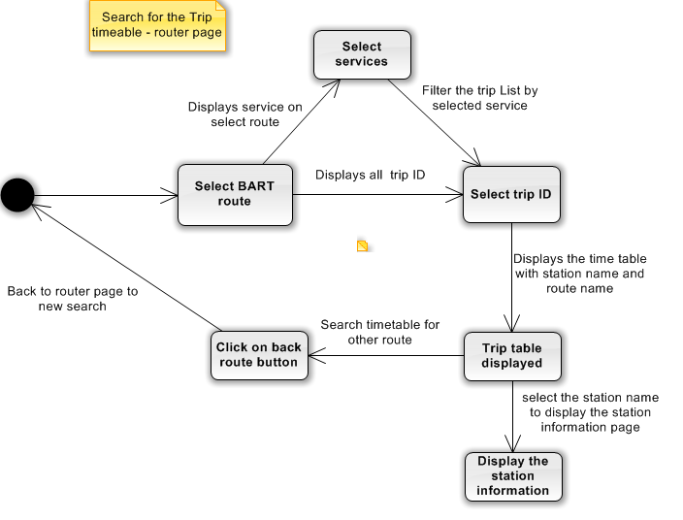

## Search timetable by station name

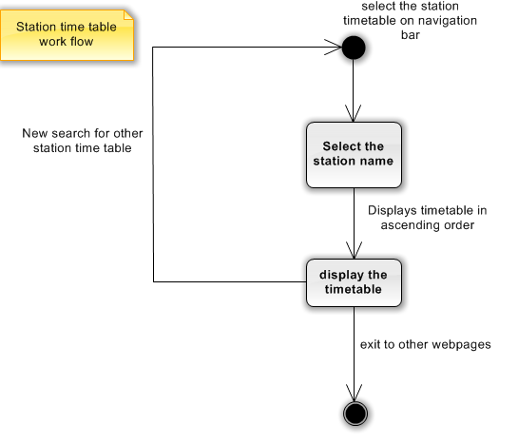

## Calculate fare

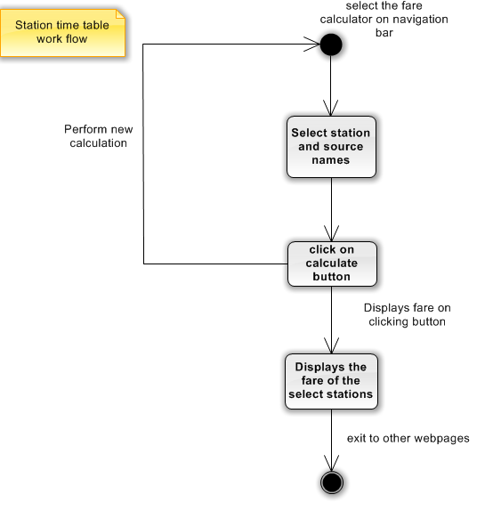

# Application functionality

**Route Page**

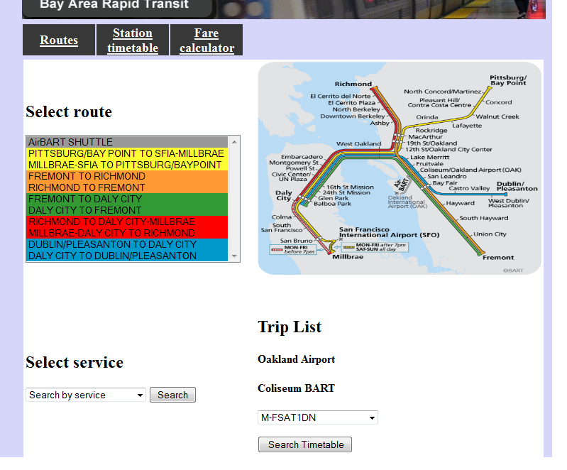

Router page: This page is using for showing the routes, selecting service and listing the trips.

1. Users select the route they want at the route table.
2. Choose a current service at the ‘Select Service’ drop-down box and click the search button which after the drop-down box. Then the ‘Trip List’ change as the selected service.
3. At another station drop-down box, users select the station which they need and click the ‘Search Timetable’, then the page will change to another page for listing stations.

**Trip timetable**

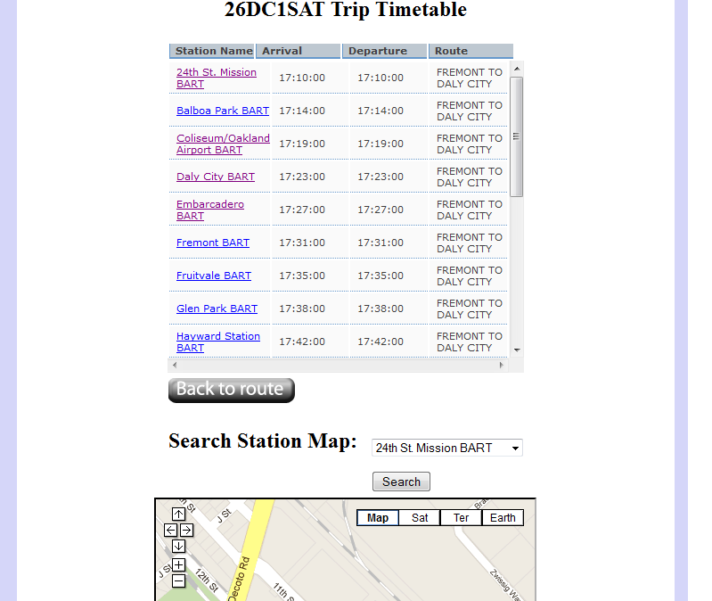

Trip timetable page: This page shows all the stations and the stop and departure time.

Fare calculation page

1. All the stations full name and arrival and departure time will be list in a table under the trip name which users select before at the route page.
2. Users can click the ‘Go Back’ button to change another route or trips. Then the page will go back to the station page.
3. Select the station name below the timetable list to search for the Map location of the station.

**Fare calculator page**

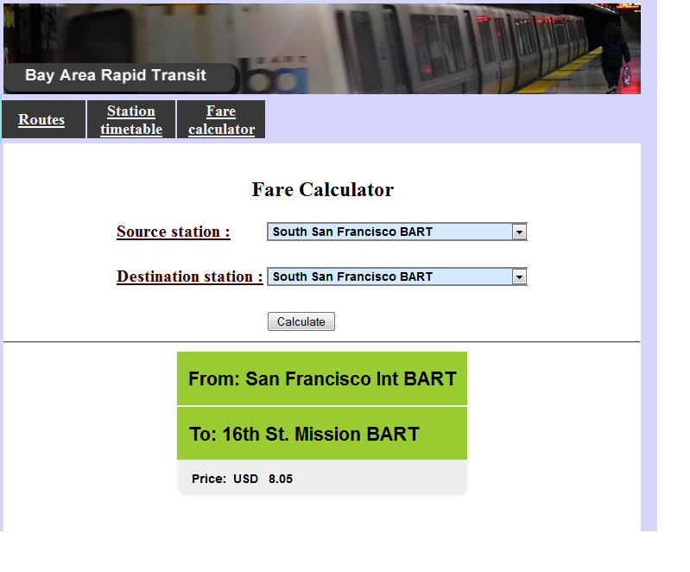

Fare calculation page: This page is using to calculate the whole tripe tickets fare.

1. Users select a station in the ‘Source Stations’ drop-down box, which station is the start station.
2. Select another station in the ‘Destination Stations’ drop-down box, which station is the end station.
3. Click the ‘Calculate’ button
4. The start station and end station will show at the center of the page and the whole of the tickets price will be auto calculated and shown.

**Station timetable**

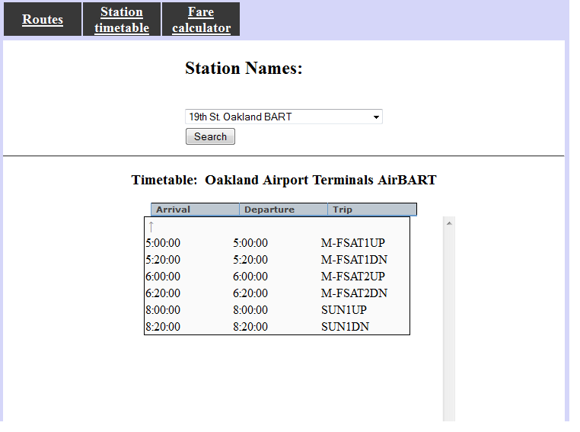

Station time table: This page shows stations full name and the stop and departure time.

Fare calculation page

1. Users select one of the stations name at the drop-down box and click the ‘Search’ button.
2. Then the station`s full name is display above the timetable. Timetable displays the arrival time, departure time and trip ID

# Installation

The Website is Zipped and it has manual instruction to use the website functionality. Unzip the folder to extract the folder. Create the dynamic web project and copy the folder website into the webcontent folder. Next create the package in java Resource/src and create the package client and dca.tranlist. Copy java class of client into the client package and dca.tranlist java class to dca translist

**Conclusion**

The BART website is the customer information website which has enhanced search function and display the result in order. This website provides the search functionality to provide trip names, station names and they timetable results. It also covers the enhanced functions for user support to display the MAP of the station using google map and URL link. This website uses java technology and XML DOM is implemented based on java. Java server page web technology we are using to implement the website. RESTful web service is used to retrieve the xml document and WSDL are used to retrieve SOAP web service functions. Hence website cover support based on XML document from the remote server and DOM, RESTful, WSDL and Java server page are technologies are used to implementing BART website.

**Reference**

<http://www.codeproject.com/KB/scripting/sorttable.aspx>

<http://www.robertdenton.org/reference/css-tables-tutorial.html>

<http://www.roseindia.net/jsp/parsing-xml.shtml>

[www.**w3schools**.com/](http://www.w3schools.com/)