Setup Installer -Beta v0.1

**1. Setup file of installer**

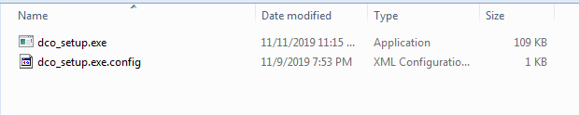

**2. Start setup installer**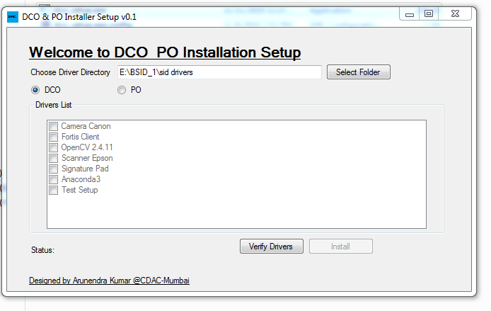

**3. Choose drivers folder**

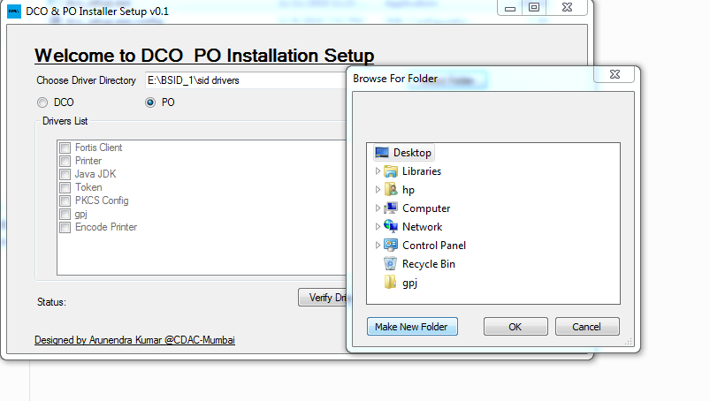

**4. Drivers folder structure**

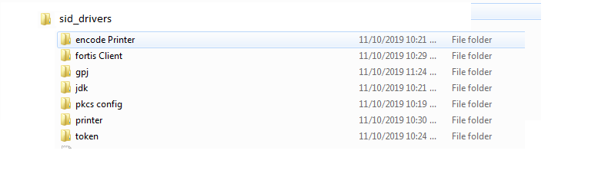

**5. Click on Verify**

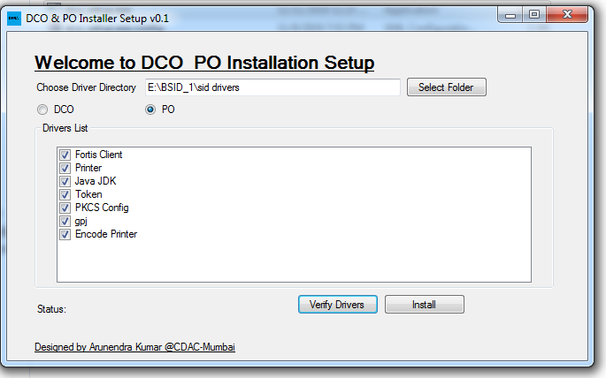

**6. Click on Install**

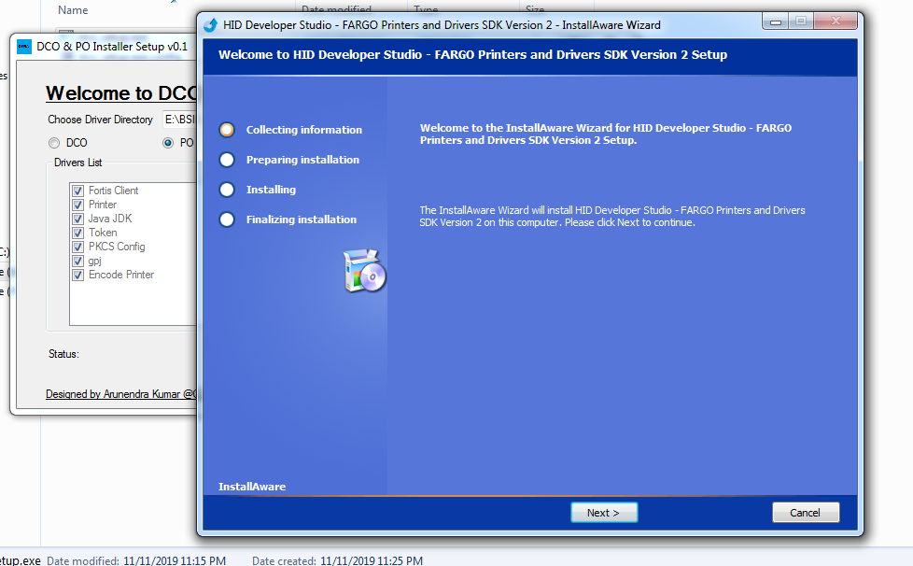

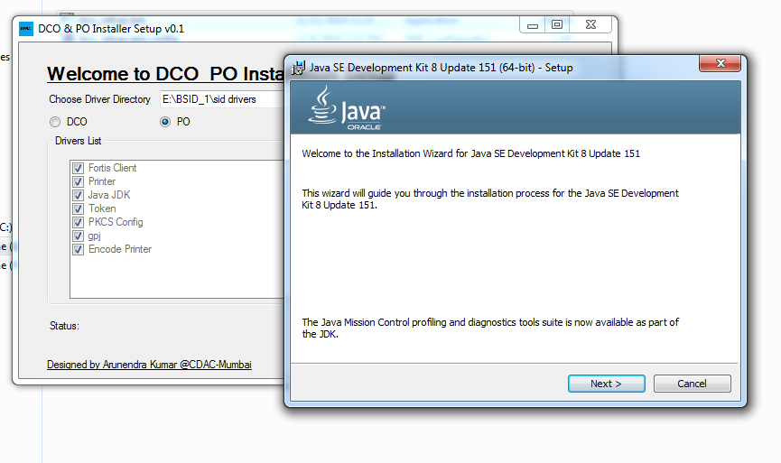

**7. After all drivers successful installation**

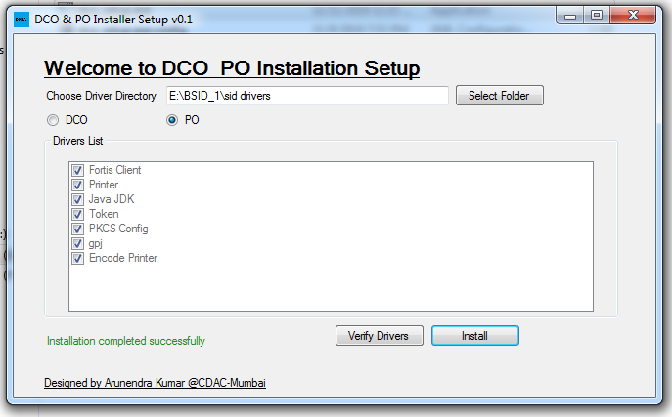

**8. Errors**

