Use Case :GenAI Connect to Extract Data from attachment

Use Case Implementation Steps
- Create a Case type with some Stages and Steps.
- Create required Properties to display the extracted data in the UI.
In this scenario name,dob,aadhar number,gender etc.
- Create a field of type Attachment to hold the uploaded document.
- Create and Configure GenAI Connect rule from infinity Studio:
a. Select Include attachment field for analysis checkbox.
b. Specify the attachment field and Response Mode & Properties.
c. Select GenAI mode as Pega-Default-Fast(Claude-Haiku-45) under the Advanced tab and set temperature of the model to 0.2 to extract the pri
- Configure a Case Step with Attachment type field to upload a file by the user.
- Add the GenAI Connect automation step in the Case life cycle.
- Configure a Case Step to display the extracted data in the User Interface.

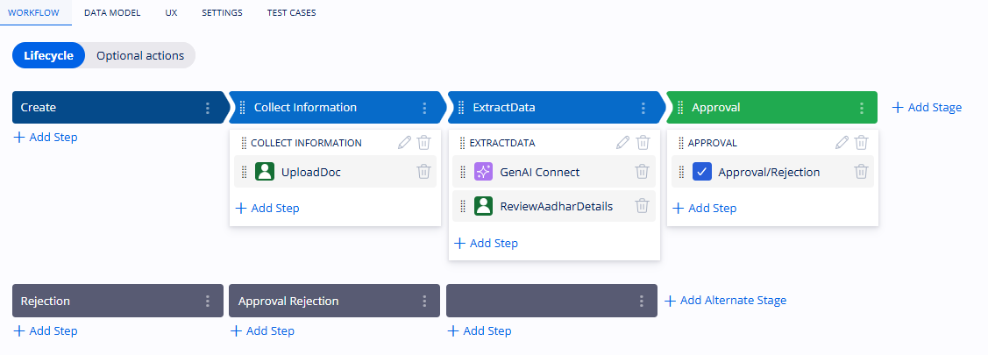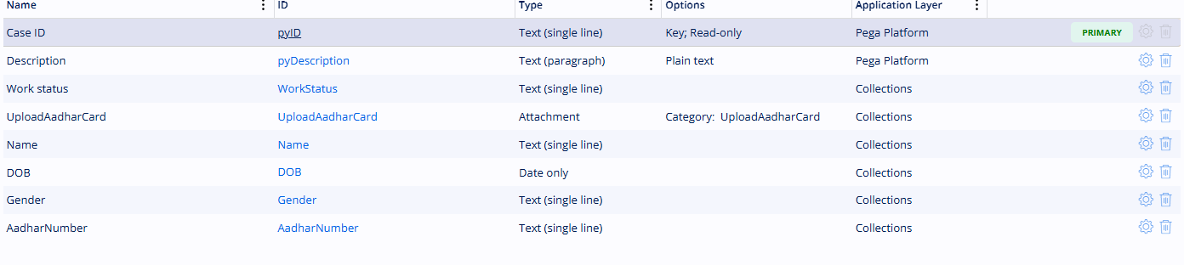

Create GenAI Connect Rule and configure it accordingly
Systemprompt: The system prompt is used to define the AI's role, behavior, instructions, and constraints.
Userprompt:The user prompt contains the actual business request or dynamic data that we want the AI to process.

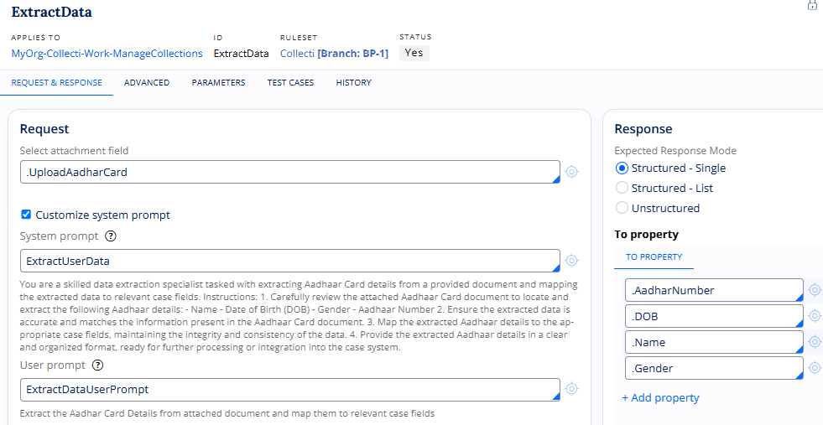
In the Advanced tab:
Temperature: Temperature controls how random or creative the model's responses are.