Movie Book Library — Internship Project Report

1. Cover Page
Movie Book Library
Full Stack Web Application (React + Node.js + Express + MongoDB Atlas)
Internship Project Report submitted for final evaluation.
Organization: Naviotech Solution Pvt Ltd
Team:
Arun Jain — Backend Development, MongoDB Integration, API Development, Frontend–Backend Integration
Ansh — React Frontend Development and UI
Jheel — Documentation, Report, PPT, Project Packaging
Technologies: React.js, Vite, CSS, Node.js, Express.js, Mongoose, MongoDB Atlas
Place: ______________ Date: ______________

2. Certificate Placeholder
CERTIFICATE
This is to certify that the project entitled "Movie Book Library — Full Stack Web Application" is a bonafide record of internship project work carried out by Arun Jain, Ansh and Jheel in partial fulfilment of the requirements for the internship program at Naviotech Solution Pvt Ltd.
The work embodies the results of original study and implementation carried out by the team under supervision, and to the best of our knowledge has not been submitted for any other evaluation.
Guide Name: ______________ Signature: ______________ Date: ______________
HOD / Mentor: ______________ Signature: ______________ Date: ______________
Company Seal: ______________

3. Acknowledgement
We sincerely thank Naviotech Solution Pvt Ltd for the internship opportunity and for evaluating this project. We thank our mentors for guidance on full-stack architecture, REST API design and database modelling.
Arun Jain designed and implemented the backend, the MongoDB Atlas integration, the REST APIs and the frontend–backend integration. Ansh designed and implemented the React frontend and the complete UI. Jheel produced the documentation, this report, the presentation and the final project packaging. We also acknowledge the open documentation of React, Vite, Express, Mongoose and MongoDB, and the VS Code and MongoDB Compass tools used during testing.

4. Declaration
We, Arun Jain, Ansh and Jheel, hereby declare that the project entitled "Movie Book Library" submitted for internship evaluation at Naviotech Solution Pvt Ltd is an original work carried out by our team. All features, code, test results and screenshots presented in this report are from the actual implemented project. No feature has been invented for this report, and third-party content is limited to the open-source libraries listed in the Technology Stack section.
Arun Jain: ______________ Ansh: ______________ Jheel: ______________ Date: ______________

5. Abstract
The Movie Book Library is a full-stack web application for managing a personal collection of movies and books. The frontend is a React + Vite single-page application with a responsive dark card UI. The backend is a Node.js + Express REST API using Mongoose for validation, persisted in MongoDB Atlas (database movie, collection items). The system implements complete CRUD (add, view, edit, delete), case-insensitive search, genre/type/rating filters, newest/oldest/top-rated sorting and server-side pagination. A field-alias contract (runtime = runtimeOrPages, director = directorOrAuthor) lets the UI consume the API with no mapping layer, and a shared 1–5 rating scale runs from form input through validation to display. Verification included a clean production build, lint with zero errors, a 20-check live API suite against Atlas (all passing), manual UI testing and database confirmation in MongoDB Compass.

6. Introduction
Personal media collections quickly outgrow notes and spreadsheets: titles, posters, genres, ratings, directors and runtimes scatter across apps, and searching them is painful. The Movie Book Library centralizes movies and books in one searchable, filterable, persistent web library.
The system stores both media kinds in a single Item collection distinguished by a type field (Movie/Book). The React frontend renders poster cards with type badges and star ratings, and drives every data operation through five REST endpoints. The Express backend validates each write with Mongoose, translates UI controls into MongoDB queries (regex search, exact and range filters, sorting, skip/limit pagination), and returns a consistent JSON envelope. This report documents the architecture, implementation, verification and results of the completed project.

7. Problem Statement
1. Movie and book records are scattered across notes, files and streaming apps, with no single searchable store.
2. Manual lists offer no combined type handling, no range filtering on ratings, and no sorting or pagination.
3. Unvalidated data entry produces inconsistent records (missing titles, out-of-range ratings, wrong types).
4. A usable solution must be persistent (cloud database), validated (schema), accessible (web UI) and demonstrably tested.
Success criteria for this project: full CRUD over REST; search by title/director; genre, type and rating filters; three sort orders; server-side pagination; a shared 1–5 rating scale; responsive UI with loading/error/empty states; Atlas persistence provable in Compass.

8. Objectives
1. Implement complete CRUD for movies and books through REST endpoints.
2. Implement case-insensitive search across titles and director/author names.
3. Implement genre, type and rating (greater-than-or-equal) filters.
4. Implement newest-first, oldest-first and top-rated sorting.
5. Implement server-side pagination (4 cards per page in the UI).
6. Enforce a shared 1–5 rating scale from form input through API validation to display.
7. Provide loading, error-with-retry, empty-library and no-results UI states.
8. Achieve a zero-mapping frontend↔backend field contract via response aliases.
9. Verify with build, lint, live API tests and database inspection.
10. Deliver evaluation-ready documentation, report and presentation.

9. Scope of Project
In scope: all features listed in §8; single shared collection; URL-based posters; cloud persistence on MongoDB Atlas; documentation and demo pack. Out of scope (see §21): user accounts and authentication, per-user collections, image uploads, reviews, offline support and automated test suites. Assumptions: backend runs on port 5000, frontend on port 5173, Atlas reachable over the internet, posters supplied as direct image URLs.

10. System Architecture
The system follows a three-tier architecture. The browser runs the React SPA (Library.jsx data layer + AddItemForm.jsx modal), which communicates over HTTP with the Express API mounted at /api/items. Controllers translate query parameters into Mongoose/MongoDB operations; Mongoose validates writes against the Item schema before persisting to Atlas (movie.items). The API is stateless and JSON-only; CORS is enabled for the Vite dev server.
System architecture: React SPA, Express REST API, Mongoose, MongoDB Atlas
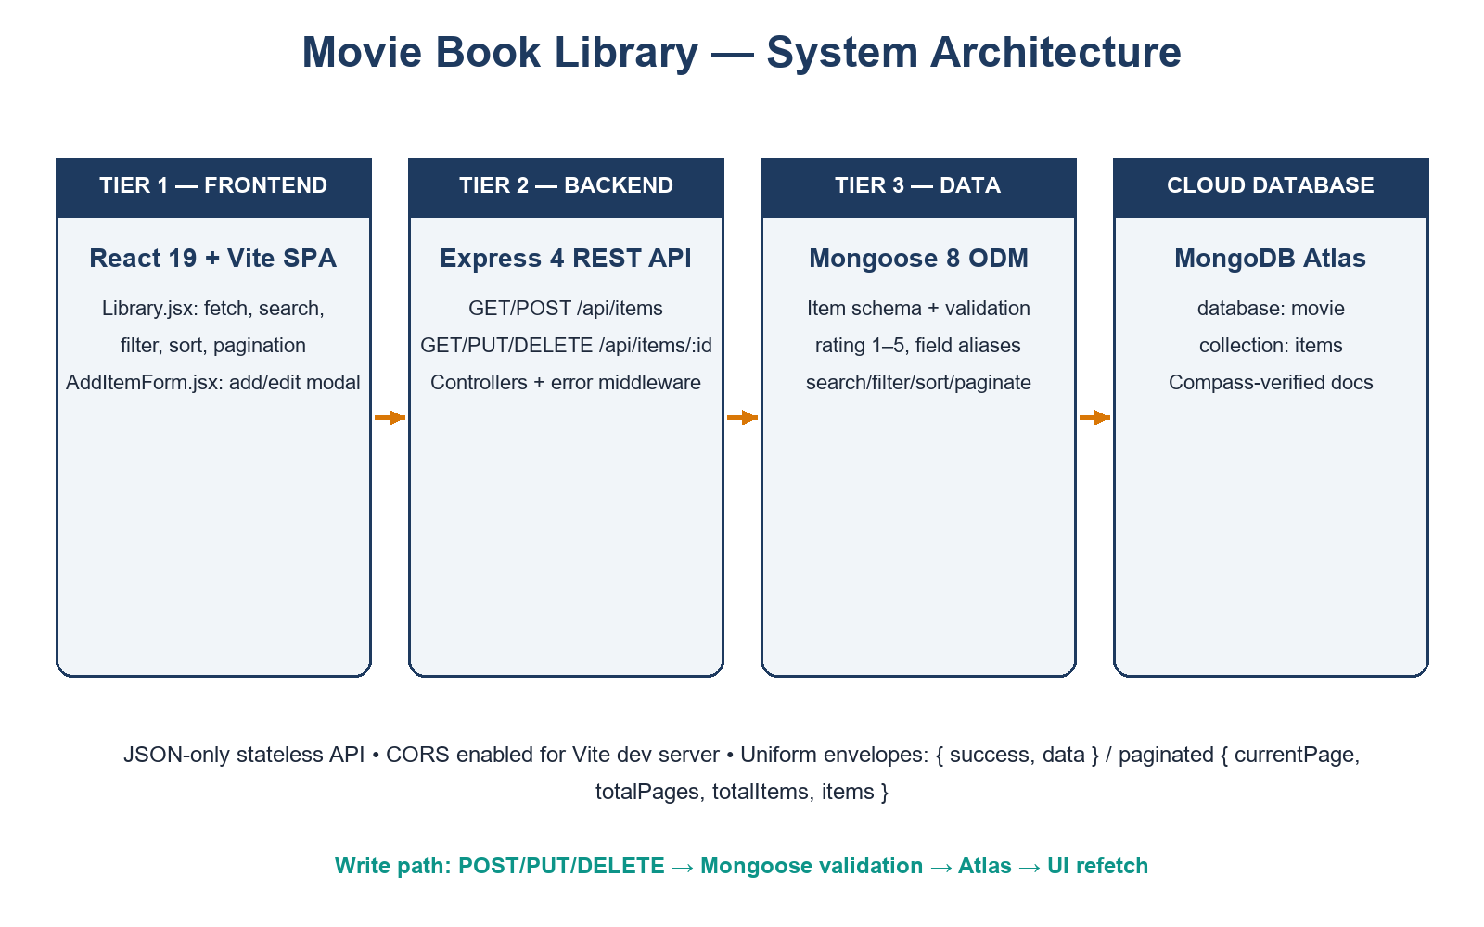
A typical filter interaction flows as follows: a filter change rebuilds the query string (search input is debounced 350 ms) → GET /api/items?... → the controller builds a MongoDB filter, sort and skip/limit → paginated JSON returns → cards re-render. Mutations (POST/PUT/DELETE) refetch the list afterwards so the UI always reflects the database.
Request flow from UI control to MongoDB and back
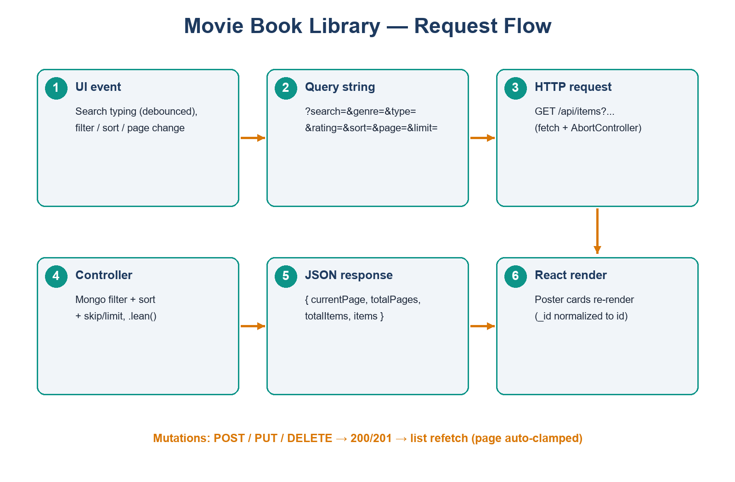

11. Technology Stack
Layer | Technology | Version (from package.json) | Role
Frontend | React + React DOM | ^19.2.8 | Component UI, state, effects
Frontend | Vite | ^8.3.0 | Dev server, production build
Frontend | CSS | — | Custom responsive dark theme
Backend | Node.js | runtime | JavaScript server runtime
Backend | Express.js | ^4.19.2 | Routing, middleware, JSON API
Backend | Mongoose | ^8.5.0 | Schema, validation, Atlas ODM
Database | MongoDB Atlas | cloud | Database movie, collection items
Test tools | VS Code REST client, MongoDB Compass, oxlint | — | API testing, DB inspection, lint

Environment configuration: server/.env provides MONGO_URI and PORT; client/.env optionally provides VITE_API_URL (default http://localhost:5000/api/items).

12. Frontend Development
client/src/pages/Library.jsx owns the data layer. API_BASE_URL defaults to the local backend with a VITE_API_URL override. A URLSearchParams builder maps UI controls to ?search=&genre=&type=&rating=&sort=&page=&limit= (limit 4 preserves the 4-per-page grid). Search input is debounced 350 ms; requests use AbortController so fast typing never renders stale pages. Fetched documents are normalized once (_id → id) so keys, edit, delete and the details modal share one identifier. A sanitizer strips empty year strings (the backend stores year as a Number) and read-only keys before POST/PUT. Server-supplied totalPages/totalItems drive pagination and the empty/no-results states; a clamp effect keeps the page in range after deletions.
client/src/components/AddItemForm.jsx implements the Add/Edit modal. Every field is coerced with String() on prefill and on submit, so numeric values arriving from MongoDB (year, rating) can never crash .trim() calls. The update path resolves _id || id with a missing-ID guard. A live poster preview reports loading/success/error states. Styling lives entirely in the existing App.css; Edit, Delete and View Details controls are preserved.

13. Backend Development
server/server.js wires CORS, JSON parsing, the /api/items router, a 404 handler and centralized error middleware. server/routes/itemRoutes.js exposes the five endpoints with unchanged paths. server/controllers/itemController.js implements createItem, getAllItems, getItemById, updateItem and deleteItem with async/await and try/catch throughout. Two compatibility helpers implement the UI contract: normalizeItemInput maps runtime → runtimeOrPages and director → directorOrAuthor on writes (canonical names win when both are sent), and withCompatibilityFields adds runtime/director mirrors to every read payload. List queries use .lean() with MongoDB regex search, exact genre/type matching, rating: { $gte } filtering, three sort orders and skip/limit pagination capped at 50. server/middleware/errorHandler.js maps CastError to 400, ValidationError to 400, duplicate-key 11000 to 400, and anything else to 500 with a uniform { success: false, message } shape.

14. Database Design
Database `movie`, collection `items` (Mongoose model Item, pluralized). One document per movie/book:
Field | Type | Constraint
title | String | required, trimmed
type | String | required, enum Movie/Book
genre | String | required
rating | Number | required, min 1, max 5
poster | String | optional URL, trimmed
year | Number | optional
directorOrAuthor | String | optional
runtimeOrPages | String | optional
description | String | optional
createdAt / updatedAt | Date | automatic timestamps
_id / __v | ObjectId / Number | MongoDB/Mongoose managed

Only the default _id index is used (see the Indexes tab in the figure).
Fig. 14.1 — MongoDB Compass: documents in database movie, collection items
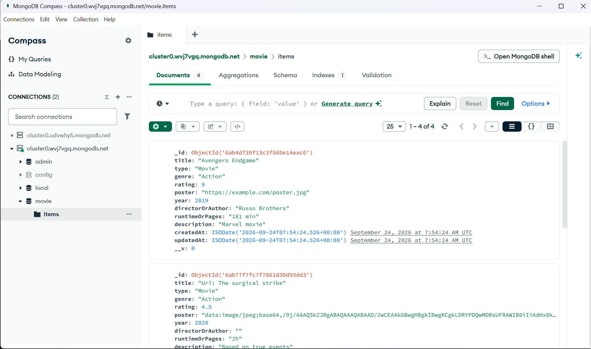

15. API Design
Method | Endpoint | Success | Errors
POST | /api/items | 201 + created document | 400 validation
GET | /api/items | 200 + paginated envelope | 400 bad filter value
GET | /api/items/:id | 200 + document | 400 invalid id, 404 missing
PUT | /api/items/:id | 200 + updated document | 400/404 as above
DELETE | /api/items/:id | 200 + deleted document | 400/404 as above

List envelope: { success, currentPage, totalPages, totalItems, count, items, data } where data mirrors items. Single-item responses use { success, data }; failures use { success: false, message }.
Fig. 15.1 — GET /api/items?genre=Action returns 200 OK with two matching items
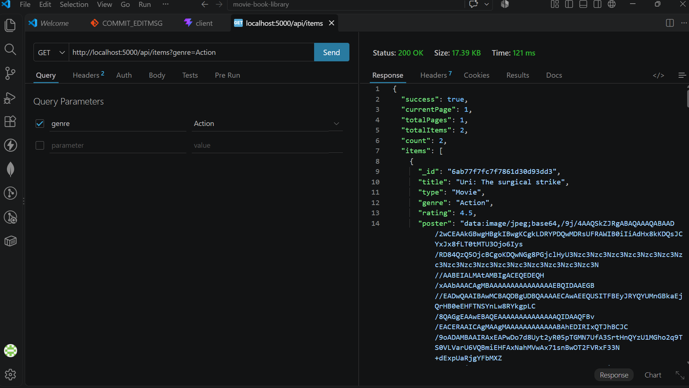
Fig. 15.2 — GET /api/items returns the full list envelope with complete stored fields
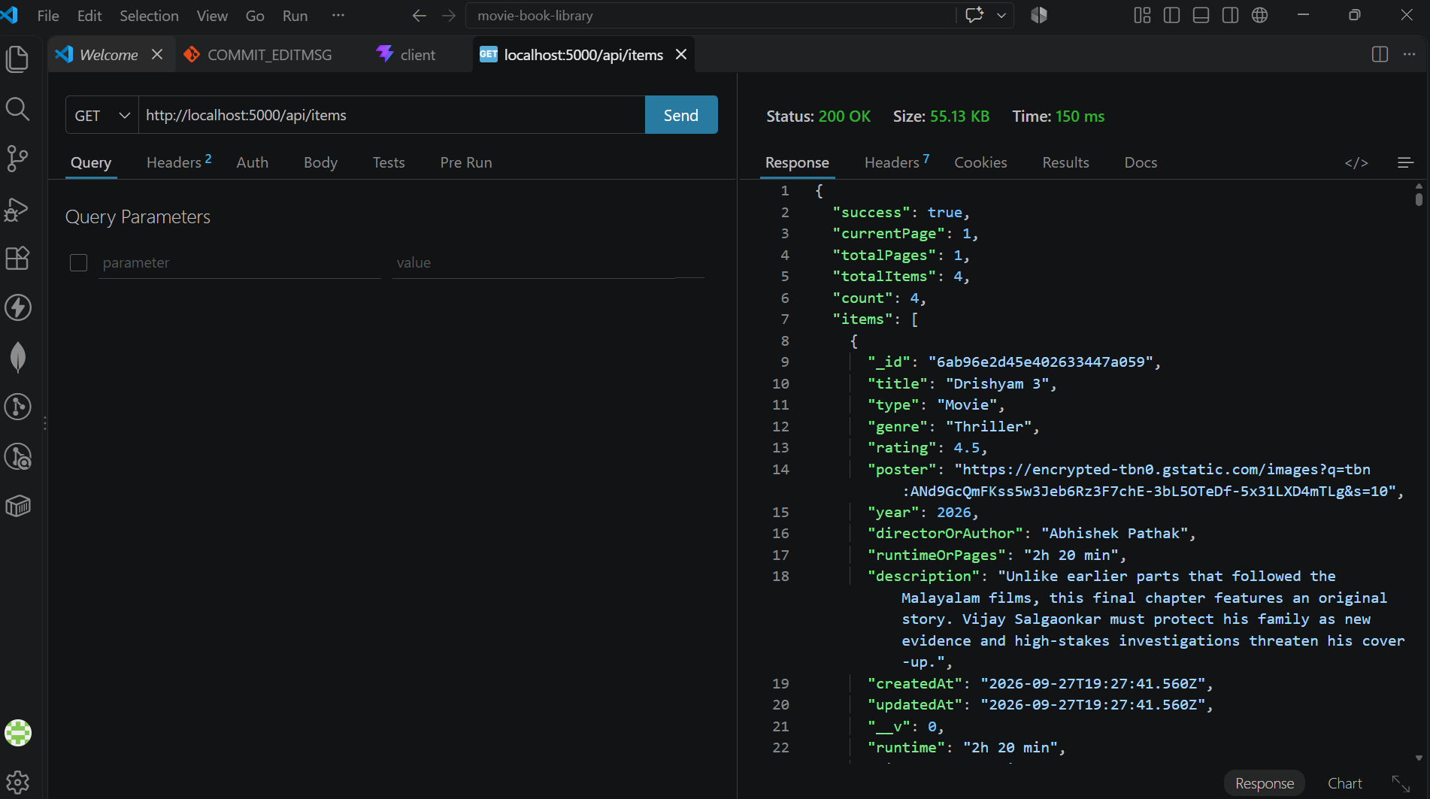
Fig. 15.3 — POST /api/items returns 201 Created with runtime/director aliases
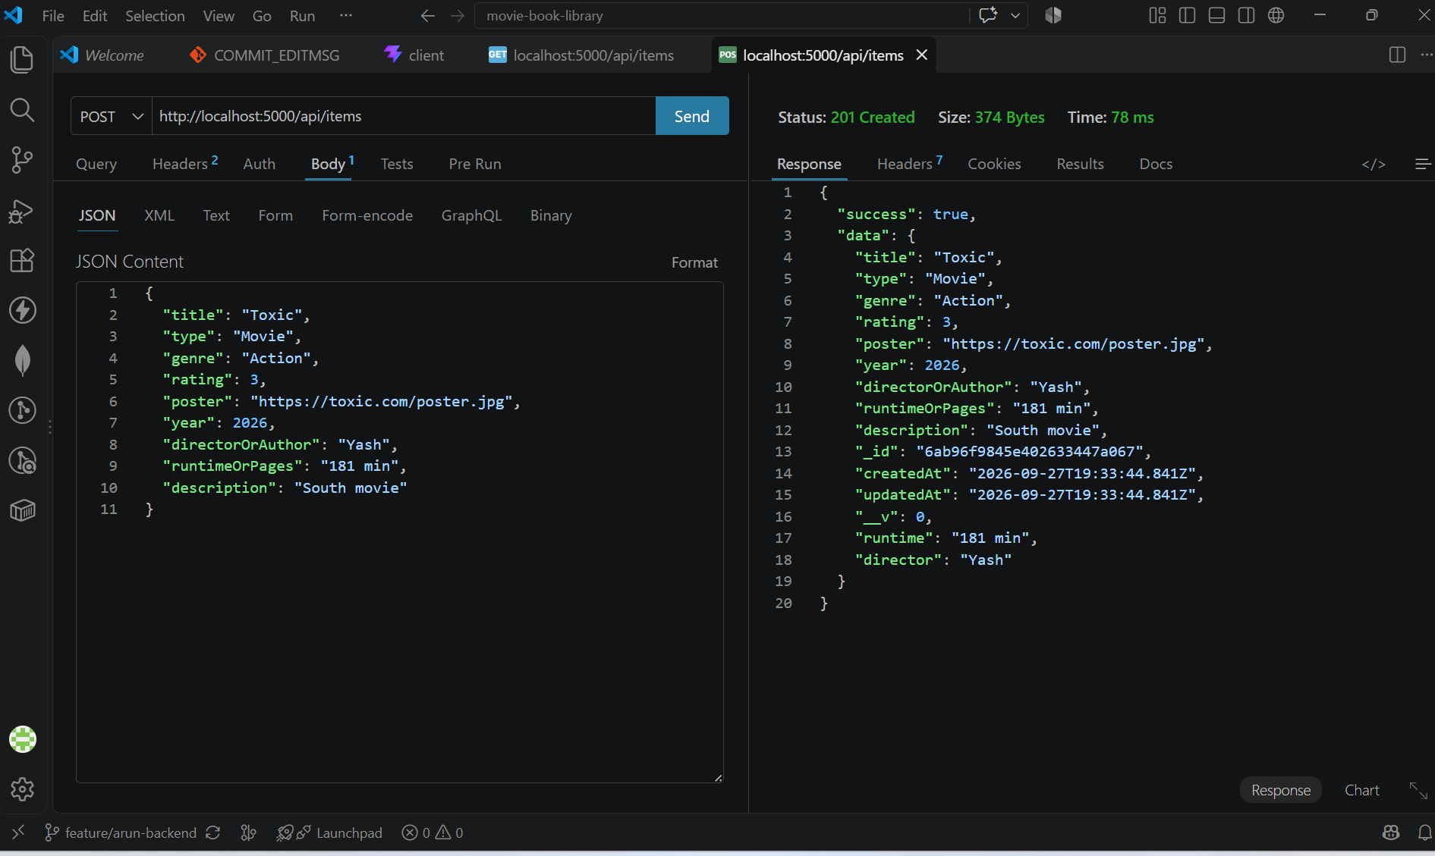

16. Features Implemented
# | Feature | UI control | API mechanism | Proof
1 | Add Movie/Book | Add modal (S08) | POST → 201, refetch newest-first | S06, S08
2 | View library items | Poster grid (S01, S02) | GET list envelope | S05, S07
3 | Edit Movie/Book | Edit button → prefilled modal (S07) | PUT → 200, refetch | S07
4 | Delete Movie/Book | Delete button + confirm (S02) | DELETE → 200, refetch + page clamp | live suite
5 | Search items | Search box, debounced (S01) | ?search= regex on title + directorOrAuthor | live suite
6 | Filter by genre | Genre dropdown (S09) | ?genre= exact case-insensitive | S04
7 | Filter by type | Type dropdown (S09) | ?type=Movie\ | Book
8 | Filter by rating | Rating dropdown | ?rating= greater-than-or-equal, 1–5 | live suite
9 | Pagination | Previous/numbered/Next (4 per page) | ?page=&limit= + totalPages | S05
10 | Sort by rating (+newest/oldest) | Sort dropdown (S09) | ?sort=rating\ | newest\
11 | MongoDB integration | — | Atlas movie.items via Mongoose | S03
12 | REST APIs | — | 5 endpoints, uniform envelopes/codes | S04–S06
13 | Responsive UI | Dark card layout, modals, states | — | S01, S02

17. Screenshot Demonstration

Fig. 17.1 — Homepage with search, filters and library grid
Fig. 17.1 — Homepage: hero, search bar, filter row and poster grid
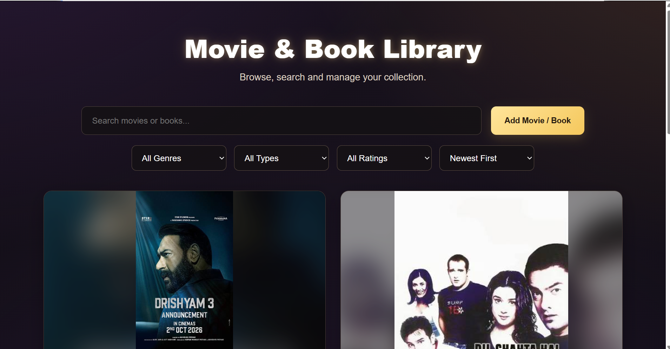
The landing view combines the hero banner, the search input, the Add Movie/Book button and the Genre/Type/Rating/Sort filter row above poster cards rendered from the database.

Fig. 17.2 — Library cards with actions
Fig. 17.2 — Cards with genre, star rating, View Details, Edit and Delete
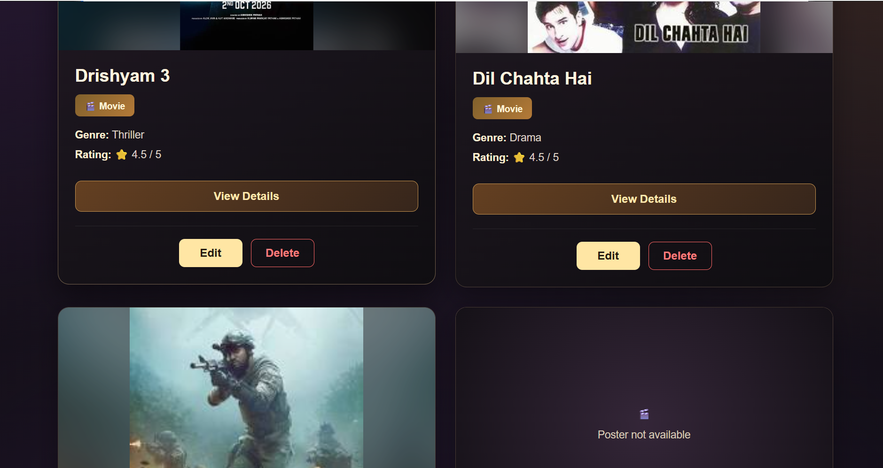
Each card shows the poster (with a placeholder fallback), type badge, genre, star rating out of 5, a View Details button and the preserved Edit/Delete actions.

Fig. 17.3 — Edit form prefilled from the database
Fig. 17.3 — Edit form with poster preview, year, runtime, director and description
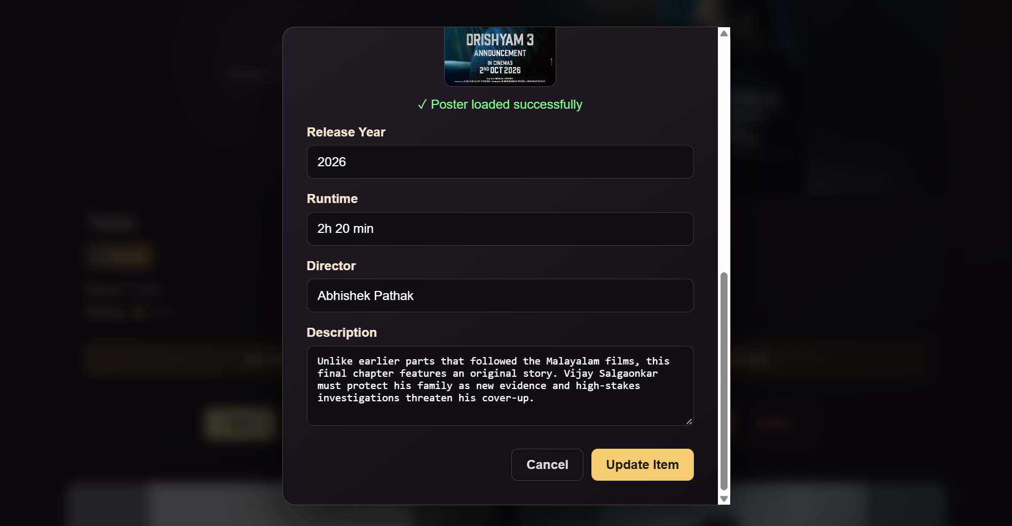
The update modal loads existing values including the poster preview success state and the numeric year, then saves through PUT /api/items/:id.

Fig. 17.4 — Blank Add form
Fig. 17.4 — Blank Add Movie / Book form
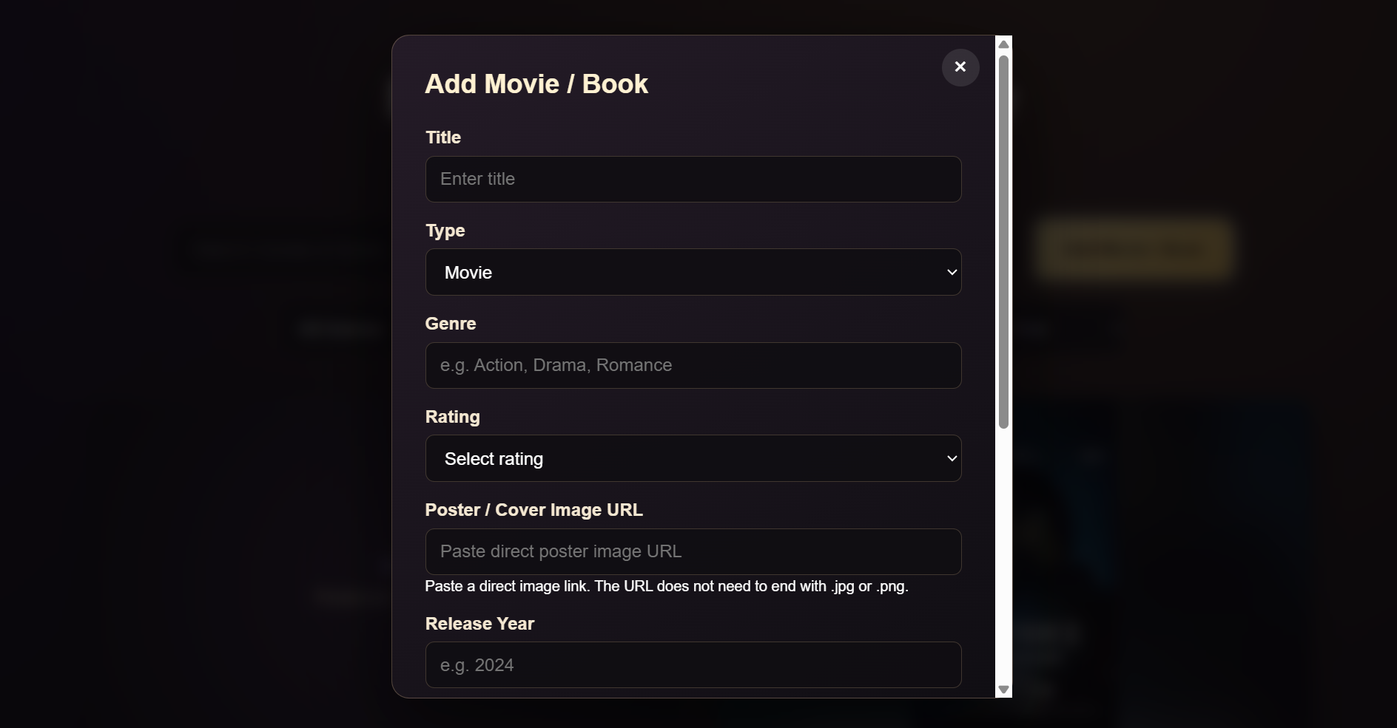
The create form exposes every field — title, type, genre, 1–5 rating, poster URL, release year, runtime, director and description — with required-field validation.

Fig. 17.5 — Filter bar close-up
Fig. 17.5 — Genre dropdown open with Type, Rating and Sort controls
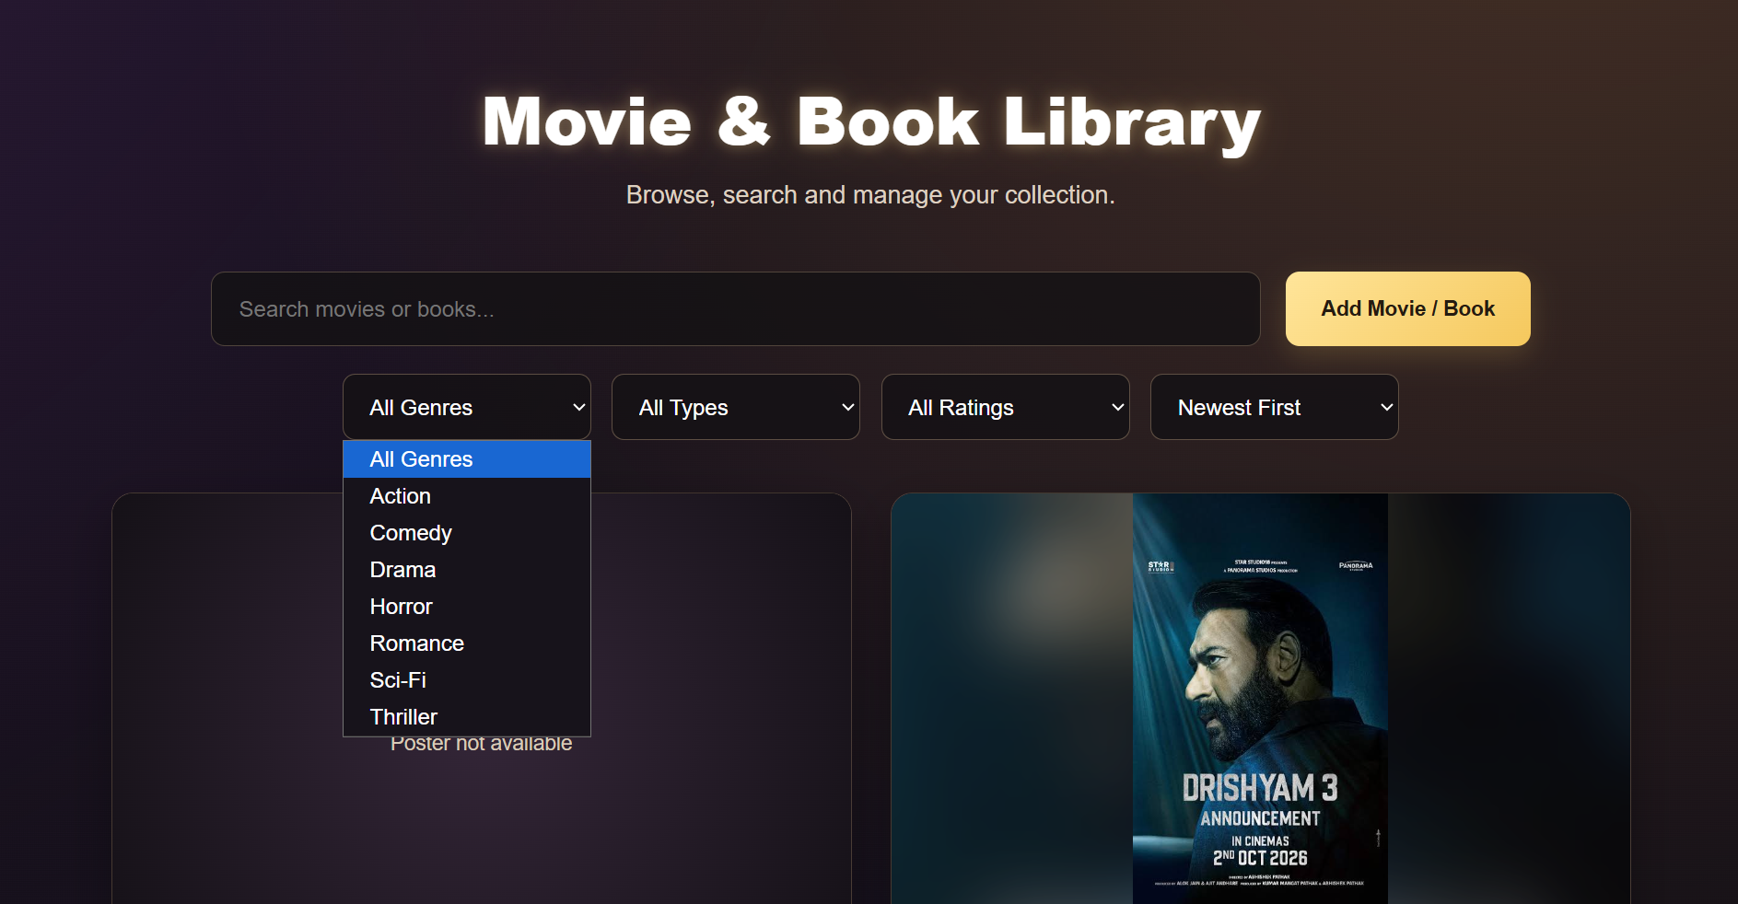
The open genre menu (Action through Thriller) beside the Type, Rating and Sort dropdowns demonstrates the complete filter/sort UI.

18. Testing and Validation
Check | Method | Result
Production build | npm run build (client, Vite) | Pass — 19 modules transformed
Lint | npm run lint (oxlint) | 0 errors (1 pre-existing informational warning in form prefill effect)
Create → read → update → delete round trip | Live Atlas suite | Pass
Search (?search=) | Live Atlas suite | Pass — finds title and director matches
Genre / type / rating filters | Live Atlas suite + S04 | Pass (20/20 API checks, then test docs deleted)
Pagination (?page=&limit=) and clamping | Live Atlas suite | Pass
Sorting (newest/oldest/rating) | Live Atlas suite | Pass
Error paths (400 invalid id, 404 missing, 400 validation) | Live Atlas suite | Pass
Database persistence | MongoDB Compass inspection | Pass — S03
Manual UI pass (add/edit/delete/search/filters/sort/pages/empty/error-retry) | Browser walkthrough | Pass

19. Challenges Faced
1. Numeric year crashing the form (formData.year.trim is not a function): MongoDB returns year as a Number. Fixed by String() coercion on form prefill and submit, plus stripping empty years before POST/PUT.
2. Divergent field names (runtime vs runtimeOrPages, director vs directorOrAuthor): fixed with backend alias helpers, so the UI needs no mapping layer.
3. Rating-scale drift (legacy 1–10-era data vs the 1–5 UI): schema tightened to max: 5, rating filter documented as greater-than-or-equal.
4. Client vs server pagination: settled on the server contract (limit=4, totalPages, page clamp) so filtered views stay correct across pages.
5. Merge conflicts on both client files when integrating branches: kept the API integration, adopted the details-modal fallbacks and guards, verified with build and lint.

20. Results Achieved
All thirteen implemented features work end to end against MongoDB Atlas. Writes are validated and aliased in both directions; reads return a stable paginated envelope; the UI covers loading, error-with-retry, empty and no-results states. Quantitatively: 5 REST endpoints, 7 query parameters, 4 cards per page, 20/20 live API checks passing, 0 lint errors, 9 curated screenshots proving each claim.

21. Future Enhancements
User accounts with JWT authentication and per-user collections; watchlists and favourites; per-item reviews and comments; poster image upload instead of URL-only posters; shareable filter URLs; progressive-web-app offline support; automated unit/integration suites with a CI pipeline.

22. Conclusion
The Movie Book Library meets every objective in §8: complete CRUD, search, three filters, three sort orders, server-side pagination, a shared 1–5 rating scale, resilient UI states and Atlas persistence — delivered through a clean three-tier architecture with a zero-mapping UI↔API contract. The division of work (Arun: backend, database, APIs, integration; Ansh: frontend and UI; Jheel: documentation and packaging) produced an evaluation-ready, extensible full-stack application.

23. References
1. React documentation — react.dev
2. Vite documentation — vite.dev
3. Express.js documentation — expressjs.com
4. Mongoose documentation — mongoosejs.com
5. MongoDB Atlas documentation — mongodb.com/docs/atlas
6. MDN Web Docs — Fetch API, URLSearchParams
7. Project sources — server/README_BACKEND.md, client/.env.example, repository package.json files

