**What is Database?**

A database is an organized collection of data, stored and retrieved digitally from a remote or local computer system.

### What is DBMS?

DBMS stands for Database Management System. DBMS is a system software responsible for the creation, retrieval, updating, and management of the database. It ensures that our data is consistent, organized, and is easily accessible by serving as an interface between the database and its end-users or application software.

### What is the difference between SQL and MySQL?

SQL is a standard language for retrieving and manipulating structured databases. On the contrary, MySQL is a relational database management system,

### What are Constraints in SQL?

Constraints are used to specify the rules concerning data in the table.

### What is a Primary Key?

The PRIMARY KEY constraint uniquely identifies each row in a table. It must contain UNIQUE values and has an implicit NOT NULL constraint.

### What is a Foreign Key?

A FOREIGN KEY comprises of single or collection of fields in a table that essentially refers to the PRIMARY KEY in another table. Foreign key constraint ensures referential integrity in the relation between two tables.

Joins read from ppt

What is full outer join

A **FULL JOIN** (or **OUTER JOIN**) in a relational database retrieves all records from both tables being joined, and fills in NULL values for columns where there is no match in either the left or right table.

When the statement says "where there is a match in either the left or right table," it means that the **FULL JOIN** includes records from both the left and right tables, regardless of whether there is a matching record in the other table. If there is a match in the left table, the corresponding columns from the right table will be included, and vice versa. If there is no match in one of the tables, the result will still include that table's columns with NULL values in place of the missing data.

**What are UNION, MINUS and INTERSECT commands?**

The **UNION** operator combines and returns the result-set retrieved by two or more SELECT statements.  
The **MINUS** operator in SQL is used to remove duplicates from the result-set obtained by the second SELECT query from the result-set obtained by the first SELECT query and then return the filtered results from the first.  
The **INTERSECT** clause in SQL combines the result-set fetched by the two SELECT statements where records from one match the other and then returns this intersection of result-sets.

Certain conditions need to be met before executing either of the above statements in SQL -

* Each SELECT statement within the clause must have the same number of columns
* The columns must also have similar data types
* The columns in each SELECT statement should necessarily have the same order

**Drop delete and truncate**

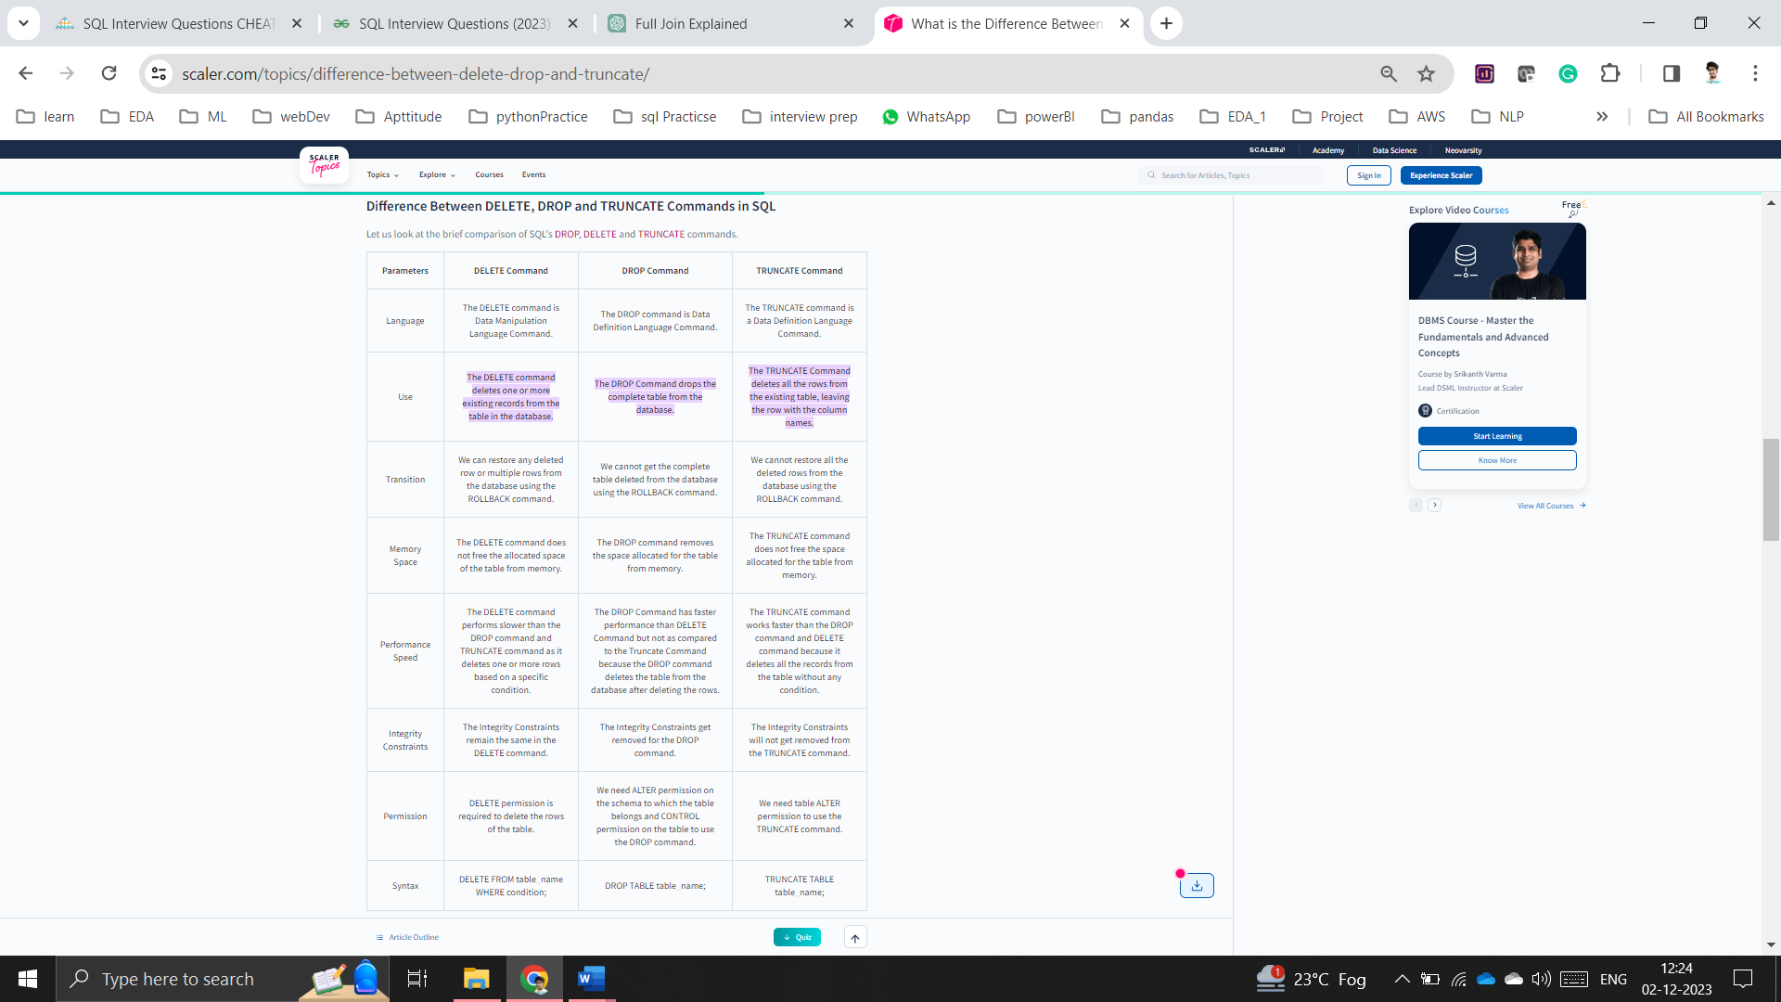

### 7. What is the difference between CHAR and VARCHAR2 datatype in SQL?

Both of these data types are used for characters, but varchar2 is used for character strings of variable length, whereas char is used for character strings of fixed length. For example, if we specify the type as char(5) then we will not be allowed to store a string of any other length in this variable, but if we specify the type of this variable as varchar2(5) then we will be allowed to store strings of variable length. We can store a string of length 3 or 4 or 2 in this variable.

**Data Definition Language (DDL):**

* DDL commands are used for defining the structure of the database, such as creating, altering, and deleting database objects (tables, indexes, etc.).
* Common DDL commands include:
  + **CREATE**: Used to create a new database object (table, view, index, etc.).
  + **ALTER**: Used to modify the structure of an existing database object.
  + **DROP**: Used to delete a database object (table, view, index, etc.).
  + **TRUNCATE**: Used to remove all rows from a table but retains the table structure.
  + **COMMENT**: Used to add comments to the data dictionary.

**Data Control Language (DCL):**

* DCL commands are used to control access to data within the database. They include commands related to granting or revoking permissions.
* Common DCL commands include:
  + **GRANT**: Used to provide specific privileges to database users.
  + **REVOKE**: Used to revoke previously granted privileges.

Data Manipulation Language (DML):

DML commands are used for manipulating data stored in the database, such as inserting, updating, and deleting records.

Common DML commands include:

SELECT: Used to retrieve data from one or more tables.

INSERT: Used to add new records to a table.

UPDATE: Used to modify existing records in a table.

DELETE: Used to remove records from a table.

### What is the difference between primary key and unique constraints?

The primary key cannot have NULL values, the unique constraints can have NULL values. There is only one primary key in a table, but there can be multiple unique constraints. The primary key creates the clustered index automatically but the unique key does not.