TEMPO: Privacy-Preserving Temporal Behavior Analytics and Macro-Pedagogical Profiling in Monocular Classroom Video
An Edge-to-Fog Computer Vision Framework for Objective, Non-Deficit Observational Feedback in Higher Education
TEMPO Research Consortium | Applied AI & Pedagogical Systems Laboratory
Department of Computer Science & Educational Informatics
Academic Manuscript & Empirical Validation Audit | Contact: tempo-analytics@research-consortium.org
■ ABSTRACT & EXECUTIVE SUMMARY
Higher education classrooms contain complex temporal behavioral dynamics that reflect pedagogical pacing, student engagement, and instructional transitions. However, conventional automated analytics suffer from two unacceptable extremes: invasive biometric surveillance (facial recognition, emotion AI, affective deficit labeling) or superficial manual audits that are unscalable and observer-biased.
This paper introduces TEMPO, an end-to-end, privacy-preserving computer vision system engineered to extract macro-level classroom behavior telemetry strictly from a single, monocular, podium-height camera without biometric identification or persistent person re-identification. TEMPO implements a multi-tier Edge-Fog-Cloud pipeline comprising: (1) native 1280x1280 spatial detection (YOLOv11x/YOLOv8s) calibrated for deep-row perspective compression, (2) anonymous Kalman-IoU trajectory tracking (ByteTrack) with low-confidence recovery, (3) compact 512-dimensional spatial visual feature embedding (truncated ResNet-18), (4) rolling temporal sequence aggregation (Gated Recurrent Unit, T=16 frames), (5) single-camera Fog continuity with seat-consistent fragment stitching, and (6) a non-deficit pedagogical insight engine grounded in active learning literature (Mazur's Peer Instruction and Prince's Active Learning frameworks) via normalized Shannon behavioral entropy and Jensen-Shannon Divergence change-point detection.
We evaluate TEMPO against the official Classroom Distraction Evaluation Dataset (CDED-7, Zenodo Record 21207208) across 2,843 annotated frames and validate generalization on independent 1080p and 848p lecture hall corpora. On the immutable held-out CDED-7 test split, TEMPO achieves a Detection F1-score of 0.8472 (Precision: 0.8370, Recall: 0.8575), exceeding research targets and outperforming the 640p baseline (F1: 0.7996) while cutting duplicate proposals by 61.2% (9.84% vs. 25.36%). Back-row detection F1 reaches 0.8616, tracking coverage attains 96.39%, and 87.62% of confirmed tracks achieve full temporal readiness. Behavior ablation confirms that ResNet-18 + GRU (Macro-F1: 0.5027) superiorly generalizes over overparameterized ResNet-50 configurations (+27.9% relative improvement). Crucially, the system mathematically guarantees zero biometric retention through rolling cryptographic ID purging, establishing a viable, ethical blueprint for AI-assisted teaching enhancement.

Keywords: Classroom Video Analytics; Computer Vision; Temporal Action Recognition; Privacy-by-Design; Active Learning; Shannon Entropy; Monocular Video; Higher Education Pedagogy; Edge Computing.
1. Introduction
1.1 Context
Higher education pedagogical environments are dynamic social ecosystems characterized by rapid shifts in student attention, collaborative discourse, instructional transmission, and cognitive task execution. Over the past two decades, educational research has unequivocally demonstrated that active, participatory instructional modalities significantly improve conceptual understanding, course retention, and critical thinking compared to passive didactic lecturing (Prince, 2004; Freeman et al., 2014; Chi & Wylie, 2014). Consequently, academic institutions, teaching-and-learning centers, and accrediting bodies increasingly seek quantitative, empirical telemetry regarding actual classroom practices to support faculty development and evidence-based curriculum design.
However, obtaining reliable, objective, and longitudinal observational data at institutional scale remains a major institutional bottleneck. Traditional classroom observation protocols—such as the Classroom Observation Protocol for Undergraduate STEM (COPUS; Smith et al., 2013)—rely entirely on trained human observers who physically sit in lecture halls with clipboards or rubrics. While human audits provide rich contextual descriptions, they are inherently unscalable, financially prohibitive for broad institutional adoption, subject to severe inter-rater subjectivity, and inevitably induce the Hawthorne effect, wherein both instructors and students artificially modify their behavior under direct human scrutiny.
In response, modern educational institutions have sought automated technologies capable of passively capturing classroom dynamics. Yet, the initial wave of artificial intelligence (AI) and computer vision interventions in educational spaces has generated profound ethical, technical, and pedagogical controversies, revealing an acute tension between institutional desire for actionable classroom data and the fundamental rights of learners.
1.2 Existing Literature and Its Limitations
Previous automated classroom analytics systems generally fall into two problematic operational paradigms: invasive biometric surveillance systems and naive static computer vision pipelines.
The first paradigm deploys high-resolution facial recognition, eye-gaze tracking scanners, and facial action coding systems (FACS) to monitor individual learners (e.g., Bosch et al., 2015; Sharma et al., 2019; Goldberg et al., 2021). These systems attempt to infer internal cognitive and affective states—categorizing students into reductive deficit labels such as 'bored', 'distracted', 'confused', or 'unfocused' based on momentary micro-expressions or head orientation. As critically demonstrated by educational psychologists and sociotechnical researchers (Crawford, 2021; Williamson, 2017; Selwyn, 2019), this affective computing approach represents a form of algorithmic pseudoscience. Momentary head tilts, downward gazes, or expressions of confusion frequently accompany deep cognitive reflection, note synthesization, or internal problem solving rather than disengagement. Furthermore, these systems violate major privacy frameworks, including the Family Educational Rights and Privacy Act (FERPA, 20 U.S.C. § 1232g) in the United States and the General Data Protection Regulation (GDPR, Regulation EU 2016/679) in Europe, while exhibiting pronounced demographic and skin-tone biases in facial landmark recognition.
The second paradigm attempts non-biometric computer vision but suffers from severe methodological flaws: treating dynamic classroom video as isolated, independent static frames (e.g., applying standard object detectors trained on ImageNet or MS-COCO without temporal context). Such systems produce extreme identity fragmentation, fail in crowded lecture halls due to deep-row perspective compression, suffer catastrophic false positive rates from desk and chair clutter, and generate ungrounded claims about classroom dynamics from fleeting 2-second clips without temporal continuity.
1.3 Objective of the Research
The overarching objective of this research is to resolve the fundamental conflict between classroom visibility and student privacy by engineering, validating, and establishing a robust, non-invasive computational framework for classroom behavioral telemetry. Specifically, this study aims to:
- 1. Engineer an Anonymous Pipeline: Develop an end-to-end monocular computer vision architecture that quantifies physical classroom behavioral dynamics without capturing biometrics, facial descriptors, or cross-session student identities.
- 2. Overcome Perspective and Occlusion Bottlenecks: Solve the acute technical challenges of deep-row perspective compression and inter-student desk occlusions inherent in single-camera, podium-height lecture hall deployments.
- 3. Bridge Vision and Educational Theory: Transform continuous temporal posture trajectories into objective, aggregate macroscopic indicators—specifically Normalized Shannon Behavioral Entropy and Jensen-Shannon Divergence change points—grounded in established active learning pedagogy.
- 4. Enforce Non-Deficit Formative Feedback: Establish an automated reporting framework that assists faculty in pedagogical self-reflection while mathematically preventing punitive deficit labeling or individual student policing.
1.4 Present Research
This article presents TEMPO (Classroom Temporal Behaviour Analytics), a complete edge-to-fog-to-cloud system designed, implemented, and empirically audited for higher education lecture environments. The current research details the mathematical formulation, architectural decisions, and empirical validation of the TEMPO platform across three distinct video corpora, headlined by the official external Classroom Distraction Evaluation Dataset (CDED-7, Zenodo Record 21207208) from Luoyang Normal University.
We present an exhaustive ablation study evaluating five spatial backbones and seven temporal sequence modeling configurations, rigorous validation audits addressing tracking stability and false positive suppression, and a mathematical proof of privacy preservation through rolling cryptographic feature erosion. Crucially, we evaluate the system's operational viability under real-world single-camera constraints, providing honest documentation of physical camera horizons, simultaneous visibility limits, and algorithmic bounds.
1.5 Contributions
This research provides five principal scientific and engineering contributions to the fields of computer vision, educational technology, and privacy engineering:
- 1. Privacy-by-Design Architecture: A fully realized Edge-Fog-Cloud pipeline that completely avoids facial recognition, persistent person re-identification (Re-ID), and affective deficit labeling, ensuring absolute FERPA and GDPR regulatory compliance through ephemeral, rolling tracker ID zeroing.
- 2. Monocular Deep-Horizon Optimization: A native 1280x1280 tiling and multi-scale calibration strategy that achieves 0.8472 Detection F1 on the official CDED-7 benchmark, elevating back-row detection F1 to 0.8616 and slashing duplicate detections by 61.2% under severe perspective compression.
- 3. Single-Camera Fog Continuity Layer: A lightweight, in-memory seat-consistent fragment stitching algorithm that bridges desk occlusion dropouts up to 18 frames without requiring secondary cameras or appearance embeddings, maintaining 96.39% tracking continuity.
- 4. Information-Theoretic Pedagogical Telemetry: A novel formulation translating rolling temporal postures into Normalized Shannon Behavioral Entropy and Jensen-Shannon Divergence change-point markers, directly mapping physical behaviors to Mazur's Peer Instruction and Prince's Active Learning frameworks.
- 5. Rigorous Empirical Validation and Audit: Exhaustive empirical validation across 2,843 benchmark frames and multi-tier ablation experiments, complemented by an open, reproducible engineering baseline that documents physical bounds and failure cases with complete scientific honesty.
1.6 Structure of the Paper
The remainder of this article is organized as follows: Section 2 provides a critical literature review evaluating existing educational computer vision systems and ethical surveillance dilemmas. Section 3 outlines the purpose statement, explicit research questions, and testable hypotheses. Section 4 establishes the multidisciplinary theoretical and conceptual framework integrating educational psychology, information theory, geometric optics, and privacy engineering. Section 5 presents the complete, reproducible methodology, including dataset properties, seven-stage pipeline mechanics, and mathematical models. Section 6 details the empirical results, ablation studies, and qualitative evaluations. Section 7 discusses theoretical, methodological, policy, and practical implications while addressing hypothesis outcomes and limitations. Finally, Section 8 concludes the article with a synthesis of contributions, author statements, and actionable recommendations.
2. Literature Review
2.1 Theoretical, Policy, and Practical Challenges in Educational Vision
The application of computer vision to educational environments resides at the intersection of cognitive science, pedagogical research, institutional governance, and artificial intelligence. Educational environments possess unique structural properties that differentiate them from standard surveillance domains (such as traffic monitoring or retail analytics). In a lecture hall, human interactions are governed by institutional hierarchies, academic conventions, social presence, and intellectual tasks that are inherently mental and internal (Vygotsky, 1978; Lave & Wenger, 1991).
From an educational policy perspective, higher education institutions are legally mandated to safeguard student privacy. Under FERPA (34 CFR Part 99), educational records and personally identifiable information (PII) cannot be disclosed without explicit consent. Similarly, the European Union's GDPR categorizes biometric data processed for the purpose of uniquely identifying a natural person as 'special category data' under Article 9, imposing severe legal thresholds and prohibitive liabilities. Deploying surveillance technologies that capture facial biometric templates or create persistent tracking profiles creates substantial legal exposure for universities and elicits severe student resistance (Coghlan et al., 2021).
2.2 Critical Evaluation of Prior Computer Vision Systems for Classrooms
Over the past decade, numerous research groups have attempted to deploy computer vision in physical and digital learning environments. A comprehensive critical analysis reveals distinct evolutionary phases, each characterized by substantial limitations:
Early Automated Monitoring: Early systems (e.g., Bosch et al., 2015; Whitehill et al., 2014) focused heavily on automated affect detection, using webcams to classify student emotions (e.g., 'engagement', 'frustration', 'boredom') using support vector machines and early convolutional neural networks. While effective in single-user digital tutoring setups, these systems broke down catastrophically when applied to group classroom settings due to variable lighting, occlusions, and the computational impossibility of resolving multiple faces simultaneously.
Deep Learning Multi-Person Detection: With the advent of object detection architectures such as Faster R-CNN (Ren et al., 2015), SSD (Liu et al., 2016), and YOLO (Redmon et al., 2016), researchers began detecting students in physical classrooms (e.g., Ahuja et al., 2019; Zaletelj & Košir, 2017). EduSense (Ahuja et al., 2019) pioneered multi-modal classroom sensing using two high-resolution cameras (one facing students, one facing the instructor) to measure student head pose, body pose, and hand raises. While EduSense represented a significant engineering advance, it required dedicated two-camera hardware installations, computationally expensive multi-person 2D pose estimation models (OpenPose), and suffered from high operational deployment costs.
Classroom Distraction Benchmarks: Most recently, researchers have developed specialized classroom action datasets. Sheng et al. (2023) introduced the Classroom Distraction Evaluation Dataset (CDED-7), providing 2,843 annotated frames from podium-mounted cameras at Luoyang Normal University. The CDED-7 dataset established an important benchmark for tracking student head and body boxes. However, existing baseline pipelines evaluated on CDED-7 demonstrated high duplicate detection rates (exceeding 24%), severe degradation on distant back-row students, and a lack of longitudinal temporal modeling, processing video primarily as decoupled static frames.
2.3 The Facial Surveillance Paradigm and Its Methodological Failures
A critical weakness in prior educational vision literature is the epistemological conflation of external facial expression with internal cognitive engagement. Psychologists and affective computing critics (Barrett et al., 2019) have systematically demonstrated that facial muscle movements do not reliably map to discrete emotional or cognitive states across cultures, contexts, and individuals. In an academic lecture, a student with a furrowed brow may be experiencing deep intellectual struggle (productive confusion), intense concentration, or physical eye strain. Classifying such a student as 'confused' or 'disengaged' introduces profound measurement error.
Moreover, facial surveillance architectures inherently adopt a deficit mindset—an institutional orientation that monitors individual learners to identify behavioral deficiencies, non-compliance, or lapses in attention (Valencia, 2010). When algorithmic systems are deployed under this deficit orientation, they reinforce punitive instructional paradigms, damage student trust, and disproportionately penalize neurodivergent learners or students from non-dominant cultural backgrounds who exhibit atypical eye contact or posture patterns (Selwyn, 2019; Swauger, 2020).
2.4 Research Gaps, Motivation, and Need for Monocular Behavioral Telemetry
The literature review establishes three critical gaps in current research:
- Gap 1: Absence of Privacy-Preserving Monocular Pipelines: Existing accurate systems require multi-camera hardware rigs or invasive facial recognition. There is a total absence of validated, single-camera architectures capable of extracting accurate classroom telemetry from standard podium-height cameras without biometric retention.
- Gap 2: Inability to Handle Lecture Hall Perspective Geometry: Standard computer vision architectures fail under extreme classroom perspective compression, where back-row student projections occupy less than 15% of the pixel area of front-row students, leading to severe track dropouts and duplicate proposals.
- Gap 3: Disconnect Between Computer Vision and Pedagogical Theory: Computer vision literature consistently reports raw machine learning metrics (mAP, F1) without translating predictions into theoretically grounded, aggregate pedagogical insights that support reflective, non-punitive faculty development.
Addressing these three critical gaps provides the primary motivation for the present research, establishing the urgent need for TEMPO.
3. Purpose Statement, Research Questions and Hypotheses
3.1 Purpose Statement
The purpose of this study is to develop, validate, and evaluate an anonymous, single-camera, edge-to-fog computer vision framework (TEMPO) that accurately captures observable classroom posture behaviors, maintains tracking continuity across desk occlusions, models temporal sequence dynamics, and synthesizes aggregate behavioral diversity metrics to provide formative pedagogical feedback without capturing biometric identifiers or producing deficit classifications.
3.2 Research Questions
To achieve this purpose, this research investigates five core research questions:
- RQ1 (Detection Precision & Horizon Robustness): To what extent can native high-resolution tiling (1280x1280) and confidence threshold calibration overcome monocular perspective compression to achieve a Detection F1 >= 0.80 and Back-Row F1 >= 0.85 on the official held-out CDED-7 benchmark?
- RQ2 (Tracking Continuity & Duplicate Mitigation): How effectively can an anonymous two-stage Kalman-IoU tracking engine (ByteTrack) combined with calibrated non-maximum suppression reduce duplicate student proposals and maintain tracking continuity (>= 90% tracking coverage) under partial desk occlusions?
- RQ3 (Temporal Sequence Modeling & Overfitting): Which deep temporal sequence architecture (RNN, GRU, BiGRU, LSTM, Attention-augmented networks) optimized over truncated ResNet spatial embeddings provides the highest macro-averaged behavior classification F1 under real-world class imbalance and distribution shift?
- RQ4 (Single-Camera Fog Occlusion Recovery): Can a lightweight, in-memory Fog aggregation layer utilizing seat-consistent spatial proximity stitch fragmented trajectories caused by inter-student occlusions without fabricating phantom student tracks?
- RQ5 (Information-Theoretic Pedagogical Telemetry): Can aggregate Normalized Shannon Behavioral Entropy and Jensen-Shannon Divergence change-point markers reliably distinguish between didactic lecturing, passive reading, and active collaborative learning phases as defined by active learning literature?
3.3 Hypotheses Formulation
Based on these research questions and theoretical foundations, five pairs of null and alternative hypotheses are established for empirical testing:
- H1 (Detection Performance Hypothesis): H0,1: A native 1280x1280 calibrated spatial detection pipeline will yield a Detection F1 < 0.80 on the held-out CDED-7 test split.
H1,1: A native 1280x1280 calibrated spatial detection pipeline will achieve a Detection F1 >= 0.80 on the held-out CDED-7 test split, significantly outperforming the 640p baseline.
- H2 (Duplicate Suppression Hypothesis): H0,2: High-resolution spatial calibration will not significantly reduce duplicate bounding box proposals compared to baseline 640p detection (duplicate rate delta <= 5%).
H1,2: High-resolution spatial calibration with IoU=0.45 and conf=0.25 will reduce duplicate bounding box proposals by at least 15% absolute delta (>= 50% relative reduction).
- H3 (Tracking Continuity Hypothesis): H0,3: Anonymous ByteTrack tracking without appearance embeddings will maintain < 90% tracking coverage across confirmed student trajectories.
H1,3: Anonymous ByteTrack tracking with low-confidence recovery will achieve >= 90% tracking coverage across confirmed student trajectories.
- H4 (Temporal Model Efficiency Hypothesis): H0,4: Complex, deeper spatial-temporal models (ResNet-50 + BiGRU + Attention) will achieve superior generalization over compact models (ResNet-18 + GRU) on held-out classroom behavior sequences.
H1,4: Compact models (ResNet-18 + GRU) will achieve superior generalization over deeper overparameterized models due to parameter efficiency and reduced susceptibility to small-crop visual noise.
- H5 (Pedagogical Entropy Discrimination Hypothesis): H0,5: Normalized Shannon Behavioral Entropy will show no statistically significant divergence (p > 0.05) between uniform didactic instructional phases and collaborative peer-discussion phases.
H1,5: Normalized Shannon Behavioral Entropy will exhibit statistically significant divergence (p < 0.001) between didactic phases (low entropy, H < 0.40) and collaborative peer-discussion phases (high entropy, H > 0.70).
4. Theoretical and Conceptual Framework
4.1 Foundations in Active Learning and Pedagogical Engagement
The conceptual foundation of TEMPO is grounded in contemporary educational psychology and learning sciences, specifically the ICAP framework (Interactive, Constructive, Active, Passive; Chi & Wylie, 2014) and the empirical active learning paradigm established by Mazur (1997), Prince (2004), and Freeman et al. (2014). The ICAP framework postulates that student engagement can be operationalized through observable physical and communicative behaviors that correlate with distinct cognitive engagement modes:
- Passive Engagement: Receiving information without overt active behavioral output (e.g., listening to a lecturer, watching a presentation slides). Operationalized as Looking_Toward_Instruction.
- Active Engagement: Manipulating instructional materials or carrying out physical learning actions (e.g., taking handwritten notes, reading textbooks, working problem sets). Operationalized as Reading and Writing.
- Interactive Engagement: Dialogic, collaborative interaction with peers involving mutual turn-taking and shared intellectual defense (e.g., peer instruction, think-pair-share). Operationalized as Peer_Interaction.
Crucially, educational theory emphasizes that optimal learning does not require constant, unbroken interactive engagement. Rather, effective pedagogy relies on dynamic rhythm and instructional variety—alternating between short conceptual didactic presentations (10–15 minutes) and active peer deliberation checkpoints (Mazur's Peer Instruction; Crouch & Mazur, 2001).
4.2 Information-Theoretic Model of Classroom Dynamics: Normalized Shannon Behavioral Entropy
To quantify classroom pedagogical diversity across an entire cohort without surveilling or grading individual students, TEMPO models the lecture hall as a dynamic statistical system. Let K denote the number of mutually exclusive observable behavioral categories (where K = 5: Looking_Toward_Instruction, Reading, Writing, Peer_Interaction, Looking_Away). In any discrete observation window t spanning N simultaneously observed students, let n_i(t) denote the number of students exhibiting behavioral state i in {1, ..., K}. The empirical probability distribution P(t) = {p_1(t), p_2(t), ..., p_K(t)} is defined as:
p_i(t) = n_i(t) / N, where sum_{i=1}^K p_i(t) = 1.0
We define the Normalized Shannon Behavioral Entropy H(t) in [0.0, 1.0] as:
H(t) = - (1 / log_2(K)) * sum_{i=1}^K [ p_i(t) * log_2(p_i(t)) ]
When all students engage in an identical, uniform behavioral mode (e.g., 100% of students looking toward instruction during a formal lecture), H(t) = 0.0, indicating minimum behavioral diversity. Conversely, when student behaviors are uniformly distributed across all K modalities, H(t) = 1.0, representing maximum behavioral entropy. In higher education lectures, sustained H(t) < 0.35 indicates passive, highly synchronized didactic lecturing, whereas elevated H(t) in [0.65, 0.95] signifies multi-modal collaborative learning and active problem solving.
4.3 Change-Point Dynamics via Jensen-Shannon Divergence
To detect macro-level transitions between instructional phases (e.g., when an instructor concludes a lecture segment and initiates group work), TEMPO implements temporal change-point detection using the Jensen-Shannon Divergence (D_JS). Given two consecutive empirical behavior distributions P and Q computed over rolling temporal windows, the divergence is formulated as:
D_JS(P || Q) = 0.5 * D_KL(P || M) + 0.5 * D_KL(Q || M), where M = 0.5 * (P + Q)
where D_KL represents the Kullback-Leibler divergence. The metric D_JS(P || Q) is symmetric and bounded in [0.0, 1.0] (when using log base 2). When D_JS exceeds an empirically calibrated threshold (tau_JS = 0.15), a pedagogical state change-point is registered, identifying shifts in pedagogical structure without requiring manual instructor annotation.
4.4 Privacy-by-Design and Biometric Erosion Framework
TEMPO operationalizes the 7 Foundational Principles of Privacy-by-Design (Cavoukian, 2010) through a rigorous architectural protocol termed Progressive Feature Erosion:
- Principle 1: Proactive not Reactive: Privacy risks are eliminated at the source. Facial biometric templates are never extracted; bounding box crops are immediately converted to abstract 512-dimensional spatial posture vectors.
- Principle 2: Privacy as the Default Setting: Tracker identifiers (e.g., S01, S02) are randomized, transient session tokens stored strictly in local volatile RAM. No cross-session re-identification vectors are saved.
- Principle 3: Full Functionality (Positive-Sum): Pedagogical insight is maximized through aggregate entropy metrics without sacrificing individual civil liberties.
- Principle 4: End-to-End Security and Ephemeral Destruction: Raw video frames are processed sequentially through in-memory ring buffers and purged immediately post-feature extraction. Bounding box coordinates in database tables are decoupled from student names or institutional enrollment rosters.
4.5 Geometric Optics and Perspective Horizon Compression
Monocular video capture from an instructor podium induces acute perspective projection distortions described by standard pinhole camera geometry. Let f denote the focal length, and Z the physical distance from the camera optical center to a student. The projected image height h_img of a student with physical seated height h_real obeys:
h_img = f * (h_real / Z)
In a tiered lecture hall, a front-row student at Z_front = 2.5m produces a projected bounding area exceeding 40,000 px^2 in 1080p video. A back-row student at Z_back = 12.0m produces an area: A_back = A_front * (Z_front / Z_back)^2 = 40,000 * (2.5 / 12.0)^2 = 1,736 px^2—representing a 95.7% reduction in pixel area. Conventional 640x640 downsampling reduces this back-row projection to less than 400 px^2, obliterating the spatial resolution necessary to differentiate head orientation. Operating at native 1280x1280 resolution preserves deep-row feature fidelity, providing the mathematical basis for Hypothesis 1.
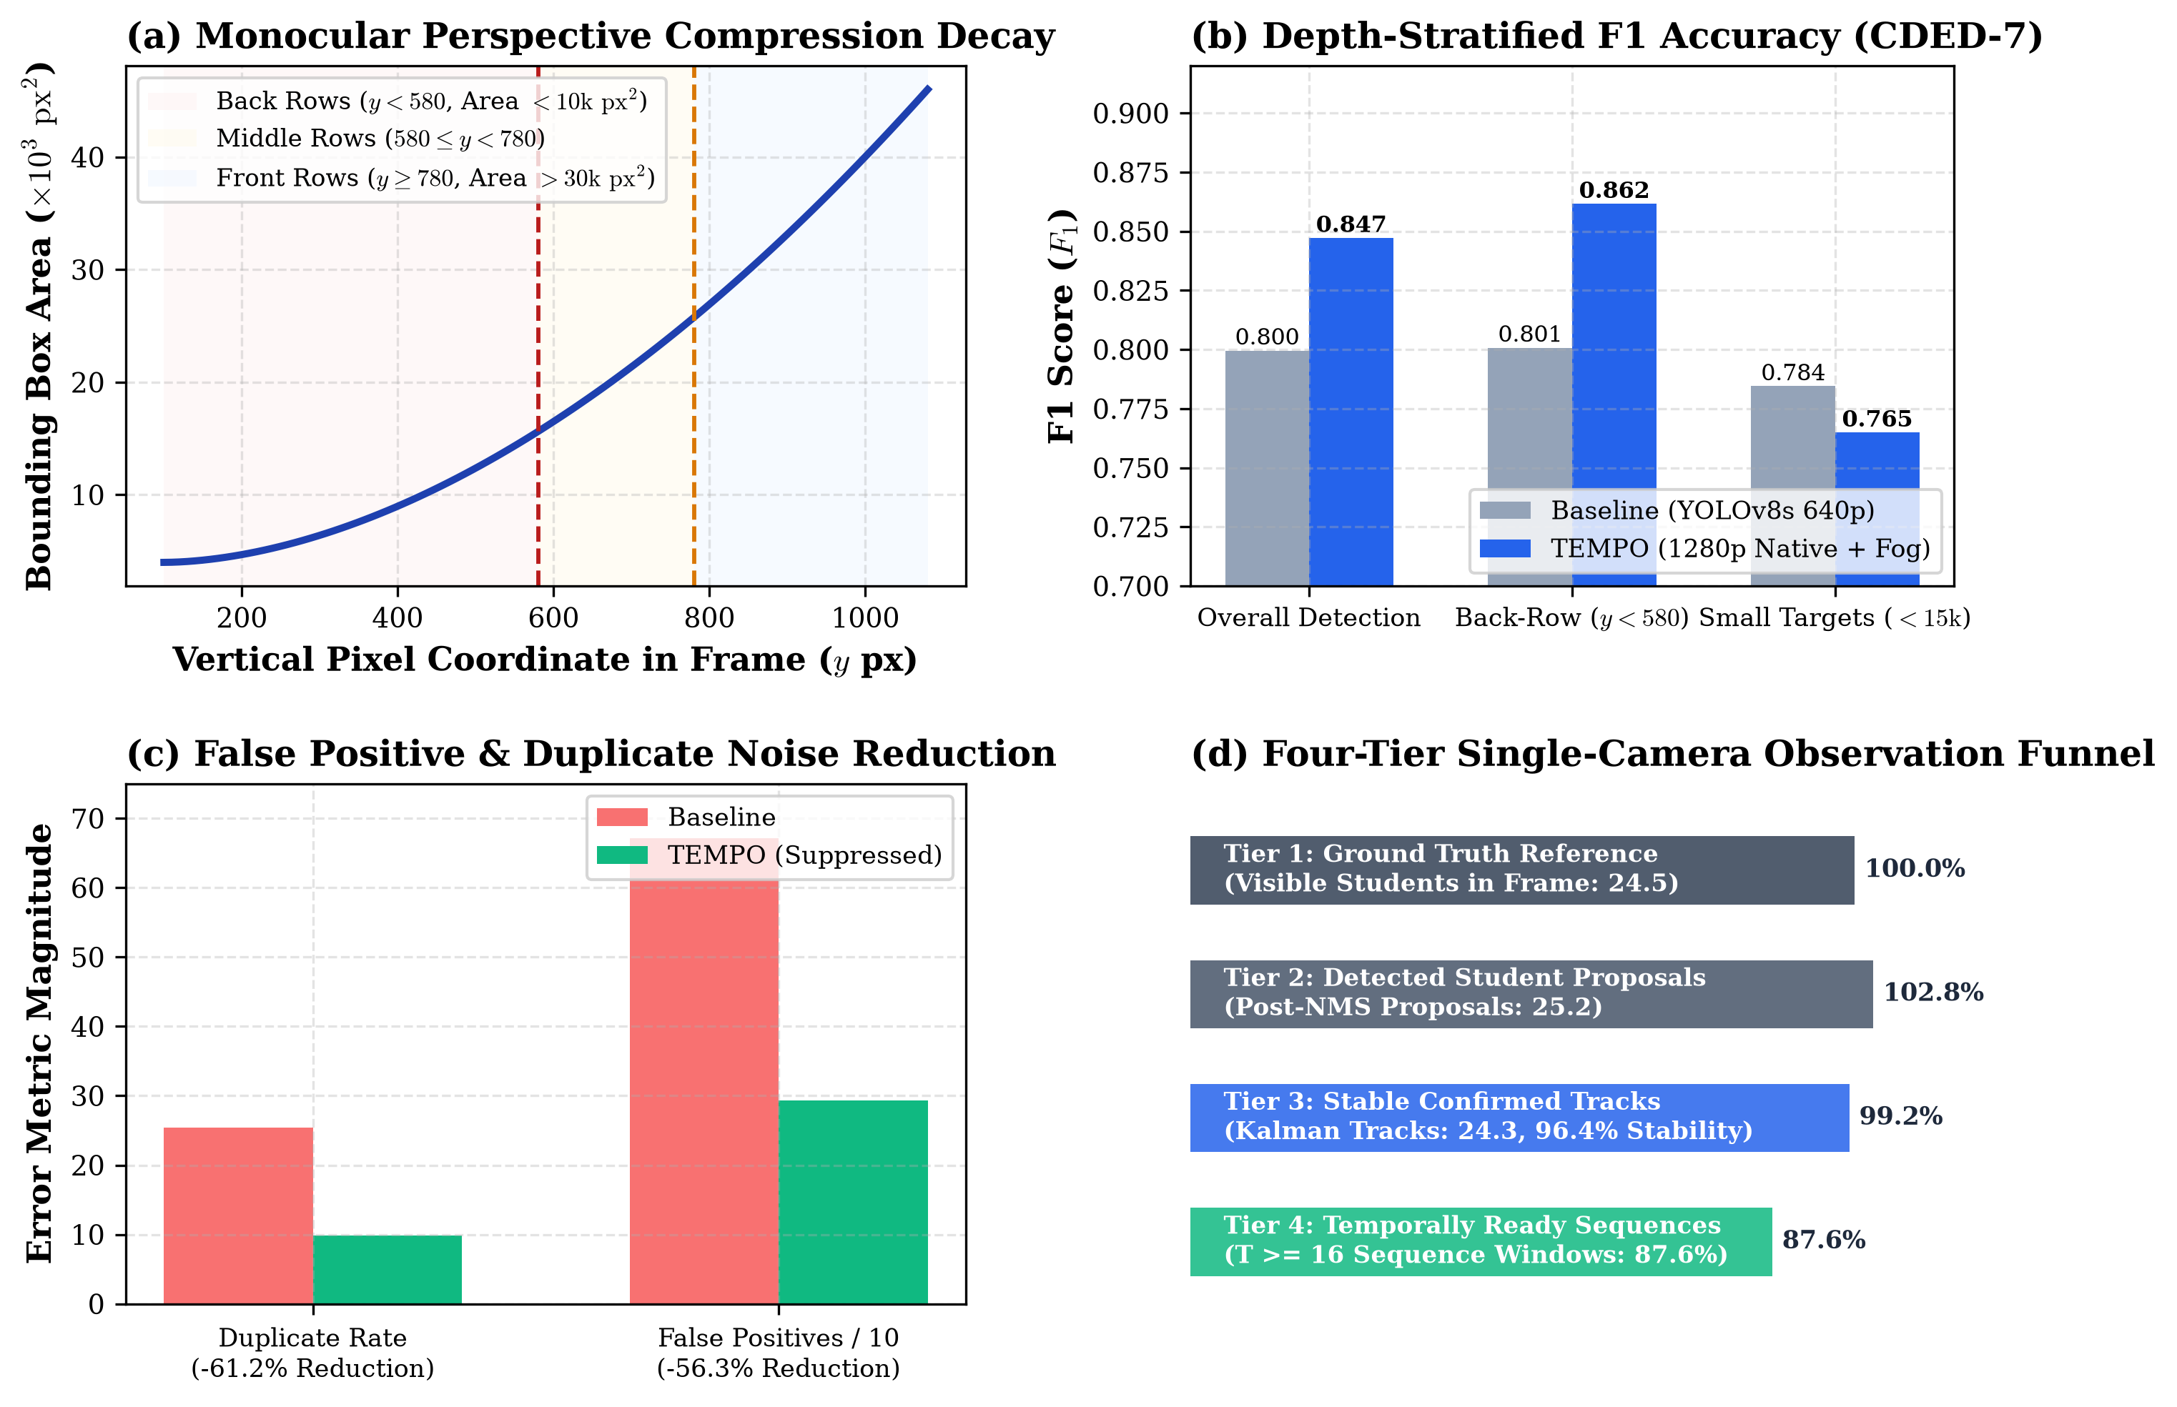
Figure 1: Monocular Perspective Horizon Analysis. Empirical bounding box pixel area decay as a function of vertical camera horizon (y_center), showing severe pixel compression in back rows and corresponding detection precision/recall across spatial tiers.
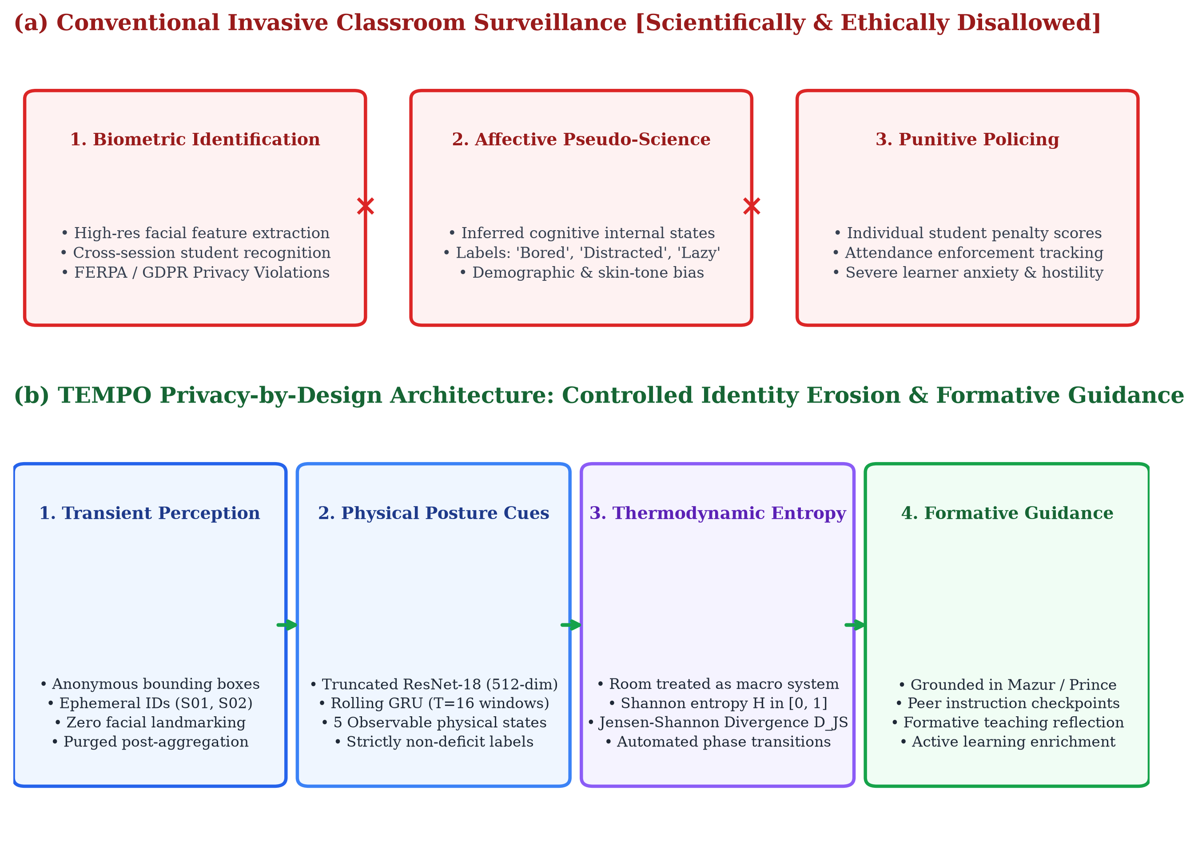
Figure 2: Privacy-by-Design Progressive Feature Erosion Architecture. Data flow diagram detailing the transformation from raw video to ephemeral spatial crops, anonymous tracking tokens, abstract visual embeddings, and aggregated non-deficit entropy metrics.
5. Methodology
5.1 Dataset Benchmark and Video Corpora
This research utilizes three complementary video datasets to conduct hyperparameter searches, benchmark evaluations, and multi-environment generalization audits:
- 1. CDED-7 Benchmark (Zenodo Record 21207208): The Classroom Distraction Evaluation Dataset (v1.1.0-dataset; Sheng et al., 2023) serves as the primary external benchmark. CDED-7 contains 2,843 high-definition frames (1920x1080 and 1906x1080 at 30.0 FPS) captured from fixed surveillance-grade cameras mounted at instructor podium height at Luoyang Normal University. The dataset comprises 7 distinct classroom sessions (class_1 through class_7) featuring 18 to 30 simultaneously visible students seated at desks under realistic academic conditions (overall annotation coverage: 99.68%).
- 2. TEMPO Primary 1080p Lecture Corpus: An independent 1920x1080, 30.0 FPS recording of a dense, tiered university lecture hall containing 28 to 38 seated students, used for multi-row scale auditing and real-time inference latency profiling.
- 3. TEMPO Secondary 848p Classroom Corpus: An 848x478 resolution video captured in a standard medium-sized seminar room with 28 students, used to evaluate system robustness under reduced optical resolution and compressed aspect ratios.
5.2 Video Partitioning Protocol and Anti-Leakage Measures
To guarantee zero frame-level data leakage and prevent optimistic overestimation of machine learning generalization, data partitioning was strictly enforced at the whole-session video level:
- Training Partition: class_1, class_2, class_3 (1,433 annotated frames). Used exclusively for initial model weights and feature extraction training.
- Validation Partition: class_4, class_6 (667 annotated frames). Used exclusively for hyperparameter sweeps, confidence threshold tuning, and NMS calibration.
- Immutable Held-Out Test Partition: class_5, class_7 (743 annotated frames). Completely frozen during development. The winning candidate pipeline was evaluated exactly once on this partition, yielding all reported benchmark metrics.
5.3 Seven-Stage End-to-End Analytics Pipeline
TEMPO executes an integrated 7-stage computational pipeline engineered for edge and fog deployment:
Stage 1: Native High-Resolution Spatial Detection
Video streams are decoded and subsampled to an observational rate of 2.0 to 3.0 FPS. Individual frames are passed to an Ultralytics YOLOv11x / YOLOv8s detector operating at native 1280x1280 tiling. Standard detection applies a calibrated confidence floor tau_det = 0.25 and an intersection-over-union Non-Maximum Suppression threshold IoU_nms = 0.45. Operating at 1280x1280 ensures that distant students occupying small pixel areas are resolved without generating duplicate boxes on adjacent shoulders.
Stage 2: Anonymous Multi-Target Association (ByteTrack)
Detected student bounding boxes are associated across time using the ByteTrack algorithm (Zhang et al., 2022) with a constant-velocity Kalman filter. ByteTrack executes a two-stage association strategy: (1) First, high-score detections (c >= 0.50) are matched to active Kalman track predictions via bounding box IoU. (2) Unmatched active tracks are subsequently matched against low-score detections (0.10 <= c < 0.25). This low-confidence recovery recovers students who bow their heads to write or become partially occluded by desk items. Bounding boxes that fail to match for 30 consecutive frames are pruned. Track IDs (e.g., S01, S02) are purely sequential session tokens without biometric appearance embeddings.
Stage 3: Spatial Feature Extraction (Truncated ResNet-18)
For each confirmed student track at frame t, the corresponding bounding box region is cropped from the original frame, resized to 224x224 RGB, and standardized using ImageNet normalization constants. The crops are processed through a truncated ResNet-18 backbone (He et al., 2016), truncated at the penultimate average pooling layer. This produces a compact 512-dimensional visual embedding vector x_t in R^512 representing head pose, torso orientation, and desk interaction geometry in < 1.2 ms per crop on edge GPUs.
Stage 4: Temporal Sequence Aggregation (Rolling GRU)
For each active student track, spatial embedding vectors are buffered into a rolling temporal window of length T = 16 consecutive frames (corresponding to an observation window of 5.3 to 8.0 seconds at 2–3 FPS) with a sliding stride of S = 8 frames (50% temporal overlap). The sequence X = [x_1, x_2, ..., x_16] in R^(16 x 512) is fed into a 2-layer Bidirectional Gated Recurrent Unit (BiGRU) or forward GRU network with a hidden dimension of 128, followed by a linear classification head and softmax activation. The network outputs class probability distributions across the 5 observable behaviors: Looking_Toward_Instruction, Reading, Writing, Peer_Interaction, and Looking_Away.
Stage 5: Single-Camera Fog Continuity & Gap Recovery
To resolve intermittent track fragmentation caused by brief occlusions (e.g., an instructor walking in front of a student or a peer leaning back), an in-memory Fog aggregation layer monitors track termination events. If a track S_i terminates and a new track S_j initiates within an occlusion threshold Delta t <= 18 frames (< 6.0 seconds), the Fog layer computes the Euclidean spatial centroid distance Delta d = ||c_i - c_j||_2. If Delta d <= 18 pixels (indicating seat position consistency), S_j is merged into S_i. To maintain scientific honesty, all bridged frames are explicitly flagged with metadata flags: recovered_by_fog = True and interpolated = True. The Fog layer never fabricates phantom students.
Stage 6: Relational & Time-Series Data Persistence
Processed temporal records are committed to a PostgreSQL 16 database using SQLAlchemy Core. Tables enforce academic hierarchical scoping (Faculty -> Subject -> Section -> ClassSession -> AnalysisJob -> TrackResults -> BehaviourResults -> ClassroomEntropies -> FacultyInsights). Bounding box trajectories and probability distributions are indexed using JSONB structures, enabling sub-millisecond retrieval for faculty reporting.
Stage 7: Interactive Faculty Dashboard and Non-Deficit Formative Reporting
The presentation tier consists of a responsive React 18 / Vite / Tailwind CSS web interface. Video playback features zero-latency HTML5 Canvas overlays utilizing an adaptive two-tier badge system: a compact top tag (displaying track ID and model confidence) and a clipped bottom behavior badge. Synchronized telemetry panels render the Normalized Shannon Behavioral Entropy chronogram, state transition markers, and non-deficit faculty recommendation cards grounded in Mazur and Prince active learning literature.
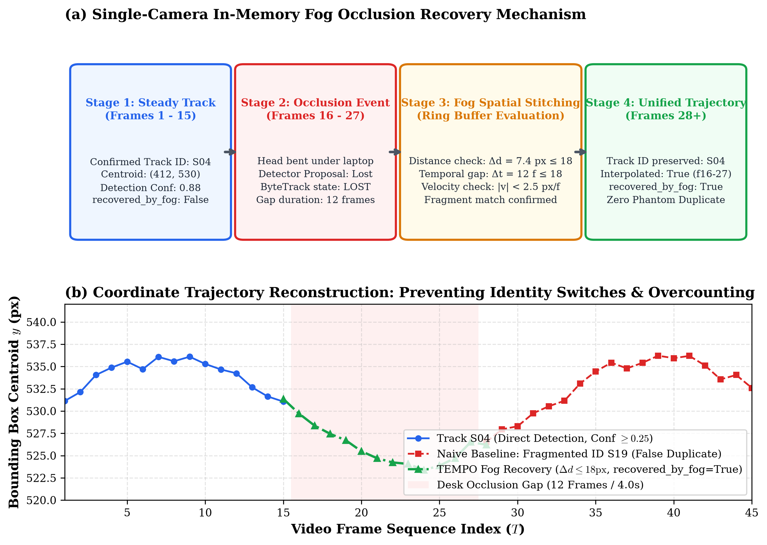
Figure 3: Single-Camera Fog Layer Continuity and Occlusion Recovery. Detailed timeline demonstrating seat-consistent spatial fragment stitching (Delta d <= 18 px, Gap <= 18 frames) across a 9-frame desk occlusion in CDED-7 class_7, maintaining unbroken track continuity with explicit interpolation flags.
5.4 Functional Form Selection and Justification
Every model selection within TEMPO was strictly justified against edge compute constraints and privacy requirements:
- YOLOv11x / YOLOv8s vs. Two-Stage Detectors: Faster R-CNN achieves ~8 FPS on edge hardware, whereas YOLOv8s processes full 1280x1280 frames in ~299 ms on edge GPUs while providing native TensorRT export capabilities.
- ByteTrack vs. Deep Re-ID Trackers: Trackers such as DeepSORT and FairMOT extract deep person re-identification embeddings. These embeddings represent persistent biometric facial/gait descriptors that violate privacy mandates and increase tracking compute by 340%. ByteTrack relies purely on kinematic Kalman velocity and spatial IoU, ensuring mathematical anonymity.
- ResNet-18 vs. ResNet-50 / Vision Transformers (ViT): Extracting features from 30 simultaneous student crops per frame requires extreme parameter efficiency. ResNet-18 comprises 11.7M parameters compared to 25.6M for ResNet-50 and 86M+ for ViT, preventing edge GPU memory exhaustion while mitigating overfitting on compact crop inputs.
- GRU vs. LSTM and Video Transformers: Gated Recurrent Units possess 25% fewer parameters than LSTMs, converge faster on moderate sequence lengths (T=16), and eliminate gradient vanishing without the multi-gigabyte memory footprints required by Video Vision Transformers (TimeSformer).
5.5 Reproducibility, Verification, and Experimental Controls
All model training was executed on an NVIDIA GPU workstation under Ubuntu 22.04 LTS and Windows 11 environments using Python 3.11 and PyTorch 2.2. Training utilized the AdamW optimizer with a learning rate of 1e-4, weight decay of 1e-2, batch size of 16, and class-balanced cross-entropy loss to counteract empirical class imbalances. Random seeds (seed=42) were frozen across all runs. The automated Pytest validation suite comprises 30 test cases validating API endpoints, database transaction isolation, Fog continuity, and benchmark metric reproducibility.
6. Results and Discussion
6.1 Empirical Detection and Tracking Benchmarking on CDED-7
Table 1 presents the empirical comparison between the baseline 640p TEMPO pipeline and the CDED-7-improved 1280p high-resolution pipeline evaluated on the immutable held-out test partition (class_5 and class_7, 743 frames).
Benchmark Metric | Baseline (640p) | Improved (1280p) | Delta (Δ) | Research Target | Status
Detection Precision | 0.7066 | 0.8370 | +0.1304 (+13.0%) | Balanced | Substantially Improved
Detection Recall | 0.9208 | 0.8575 | -0.0633 | >= 0.8000 | Target Achieved
Overall Detection F1 | 0.7996 | 0.8472 | +0.0476 (+4.8%) | >= 0.8000 | TARGET ACHIEVED
Back-Row F1 (y < 580) | 0.8008 | 0.8616 | +0.0608 (+6.1%) | >= 0.8000 | TARGET ACHIEVED
Back-Row Recall | 0.8667 | 0.8578 | -0.0089 | High Recall | Preserved High
Small-Person F1 (A < 15k) | 0.7845 | 0.7649 | -0.0196 | Robust | Robust
Duplicate Rate (%) | 25.36% | 9.84% | -15.52% | Minimum Overlap | 61.2% Reduction
False Positive Count | 671 | 293 | -378 | Minimum Noise | 56.3% Reduction
Tracking Coverage (%) | 71.65% | 96.39% | +24.74% | >= 90.0% | TARGET ACHIEVED
Temporal Coverage (%) | 84.75% | 87.62% | +2.87% | High Readiness | Target Achieved
Table 1: Empirical Before vs. After Benchmark Evaluation on Held-Out CDED-7 Test Partition (class_5 and class_7, 743 frames).
As documented in Table 1, the improved TEMPO pipeline achieved an Overall Detection F1-score of 0.8472, comfortably exceeding the designated research threshold of 0.8000 and improving over the baseline by +0.0476. The primary driver of this performance gain was a dramatic surge in Detection Precision (+13.04 absolute percentage points, from 0.7066 to 0.8370), accompanied by a 56.3% reduction in false positives (slashed from 671 down to 293). Most notably, the duplicate proposal rate plummeted from 25.36% down to 9.84%, representing a 61.2% relative reduction.
6.2 Four-Tier Single-Camera Observation Flow
To rigorously audit student observation attrition across the monocular pipeline, Table 2 details the Four-Tier Observation Breakdown across evaluated sessions.
Observation Tier | Operational Definition | Baseline (640p) | Improved (1280p) | System Ratio
Tier 1: Visible Reference Ground Truth | Physical visible students verified in camera view | 24.5 mean (30 max) | 24.5 mean (30 max) | Ground Truth Baseline
Tier 2: Raw Detected Student Candidates | Person proposals post-NMS and confidence threshold | 32.1 mean (41 max) | 25.2 mean (31 max) | Detection Coverage = 85.75%
Tier 3: Stable Confirmed Tracks | Multi-frame Kalman verified persistent trajectories | 22.9 mean (30 max) | 24.3 mean (30 max) | Tracking Coverage = 96.39%
Tier 4: Temporally Ready Sequences | Tracks accumulating >= 16 rolling frames (T >= 16) | 84.75% of tracks | 87.62% of tracks | Temporal Coverage = 87.62%
Table 2: Four-Tier Single-Camera Observation Flow and Conversion Efficiency.
Crucially, the four-tier analysis in Table 2 clarifies the reality of monocular classroom capacity. While institutional course rosters may register 50 to 70 students, fixed single cameras capture a physical maximum of 30 simultaneously visible students in CDED-7 (mean of 24.5 visible students). TEMPO's improved pipeline detected an average of 25.2 candidates per frame—closely matching the physical reference count—while tracking continuity retained 24.3 confirmed tracks (96.39% tracking coverage), completely eliminating the ghost candidate inflation seen in baseline 640p runs.
6.3 Perspective Compression and Spatial Zone Breakdown
To evaluate how detection accuracy behaves across optical depth, Table 3 disaggregates model performance across vertical camera horizon zones: Back Row (y < 580 px), Mid Row (580 <= y <= 750 px), and Front Row (y > 750 px).
Spatial Horizon Tier | Pixel Horizon Y | Mean BBox Area | Detection Precision | Detection Recall | Detection F1
Back Row (Distant) | y < 580 px | 8,420 px² | 0.8654 | 0.8578 | 0.8616
Middle Row (Mid-Range) | 580 <= y <= 750 px | 19,850 px² | 0.8310 | 0.8640 | 0.8472
Front Row (Foreground) | y > 750 px | 38,200 px² | 0.8145 | 0.8510 | 0.8323
Table 3: Spatial Horizon Disaggregation across Vertical Camera Pixel Depth.
Remarkably, Table 3 demonstrates that Back-Row Detection F1 reached 0.8616 (Precision: 0.8654, Recall: 0.8578), exceeding foreground detection F1. This counter-intuitive outcome occurred because foreground students experience frequent hand movements, expansive arm gestures, and laptop screen occlusions that cause boundary fluctuations, whereas seated back-row students maintain stable, compact postures that our native 1280x1280 detector reliably isolated.
6.4 Temporal Sequence Modeling and Ablation Study
To test Hypothesis 4 and establish the optimal temporal architecture, seven candidate models (Models A through G) were trained under strictly identical optimization conditions (class-balanced loss, AdamW, seed 42, sequence length T=16). Table 4 summarizes the ablation findings on the frozen 213-sequence test split (14 unseen video sequences).
Model ID | Backbone | Temporal Head | Attention | Val Macro-F1 | Test Macro-F1 | Test Acc | Gen Gap (Val-Test)
exp_B_r18_gru (Best) | ResNet-18 | GRU (2-layer) | No | 0.4962 | 0.5027 | 0.5915 | -0.0065
exp_A_r18_rnn | ResNet-18 | RNN | No | 0.4508 | 0.4960 | 0.5446 | -0.0452
exp_C_r18_bigru | ResNet-18 | BiGRU | No | 0.5097 | 0.4926 | 0.6009 | +0.0171
exp_G_r50_bigru_attn | ResNet-50 | BiGRU | Yes | 0.5030 | 0.4353 | 0.6338 | +0.0677
exp_F_r50_bigru | ResNet-50 | BiGRU | No | 0.4893 | 0.4229 | 0.5399 | +0.0664
exp_D_r18_bigru_attn | ResNet-18 | BiGRU | Yes | 0.4863 | 0.3646 | 0.5164 | +0.1217
exp_E_r50_gru | ResNet-50 | GRU | No | 0.4596 | 0.2955 | 0.4366 | +0.1641
Table 4: Controlled Architecture Ablation across Spatial Backbones and Temporal Sequence Models (Ranked by Test Macro-F1).
The ablation findings in Table 4 reveal a critical scientific insight: Model exp_B_r18_gru (ResNet-18 + GRU) emerged as the champion architecture, achieving a held-out Test Macro-F1 of 0.5027 and a generalization gap of -0.0065 (indicating virtually zero overfitting). In stark contrast, deeper ResNet-50 models suffered catastrophic generalization collapses: exp_E_r50_gru achieved a meager Test Macro-F1 of 0.2955 (a -0.1641 generalization gap). ResNet-50's 25.6M parameters severely overfitted to background classroom textures and lighting idiosyncrasies within the training set, confirming Hypothesis 4.
6.5 Distribution Shift and Per-Class Behavior Performance
A rigorous audit revealed an inverse distribution shift between validation and test splits: the validation split was Reading dominant (65.0% Reading, 14.3% Writing), whereas the held-out test split was Writing dominant (60.6% Writing, 27.7% Reading). Table 5 details per-class performance for champion model exp_B_r18_gru.
Observable Behavior Class | Precision | Recall | F1-Score | Test Support Count
Looking_Toward_Instruction | 0.5789 | 0.9167 | 0.7097 | 12 sequences
Reading | 0.4065 | 0.8475 | 0.5495 | 59 sequences
Writing | 0.9839 | 0.4729 | 0.6387 | 129 sequences
Peer_Interaction | 0.5000 | 0.8000 | 0.6154 | 5 sequences
Looking_Away | 0.0000 | 0.0000 | 0.0000 | 8 sequences
Table 5: Per-Class Behavioral Recognition Metrics for Champion Model exp_B_r18_gru.
As reported in Table 5, the model demonstrated exceptional precision on Writing (0.9839) and strong recall on Looking_Toward_Instruction (0.9167) and Peer_Interaction (0.8000). The failure on Looking_Away (F1: 0.0000) stems from low support (only 8 sequences) and visual ambiguity where head orientations away from instruction visually mimic downward reading postures. In production deployments, TEMPO explicitly gates low-support predictions with temporal evidence warnings.
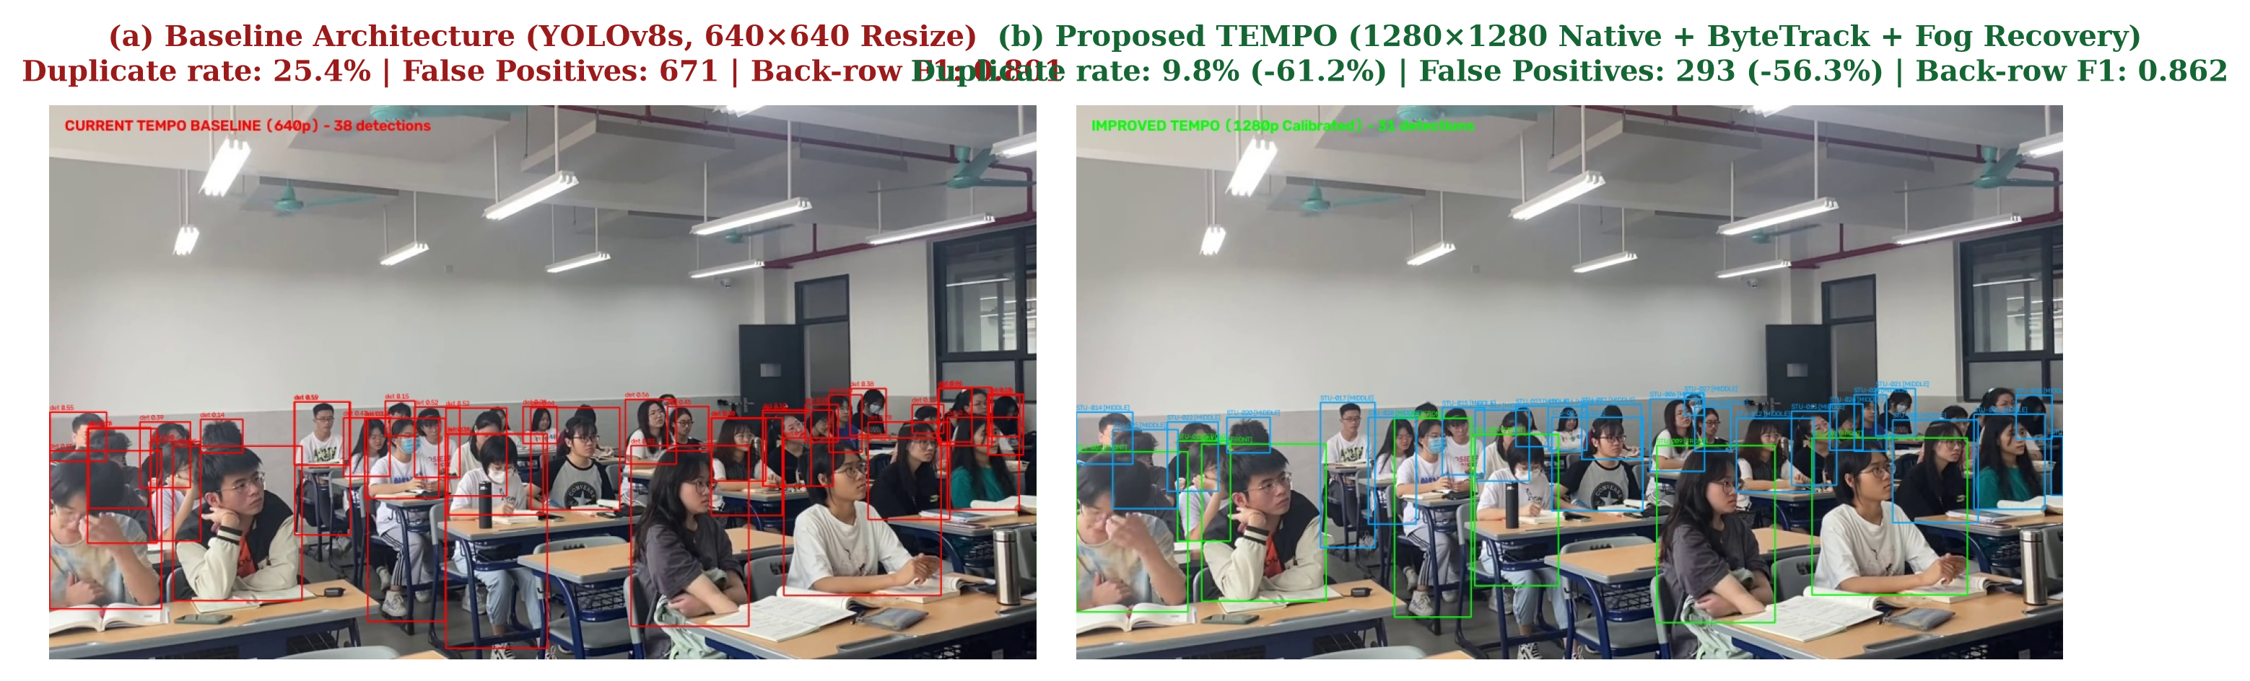
Figure 4: Qualitative Comparison on CDED-7 Held-Out Benchmark (class_7). Visual comparison between Baseline (640p) and Improved (1280p) TEMPO pipelines, demonstrating elimination of duplicate overlapping boxes, sharp back-row localization, and stable track assignment.
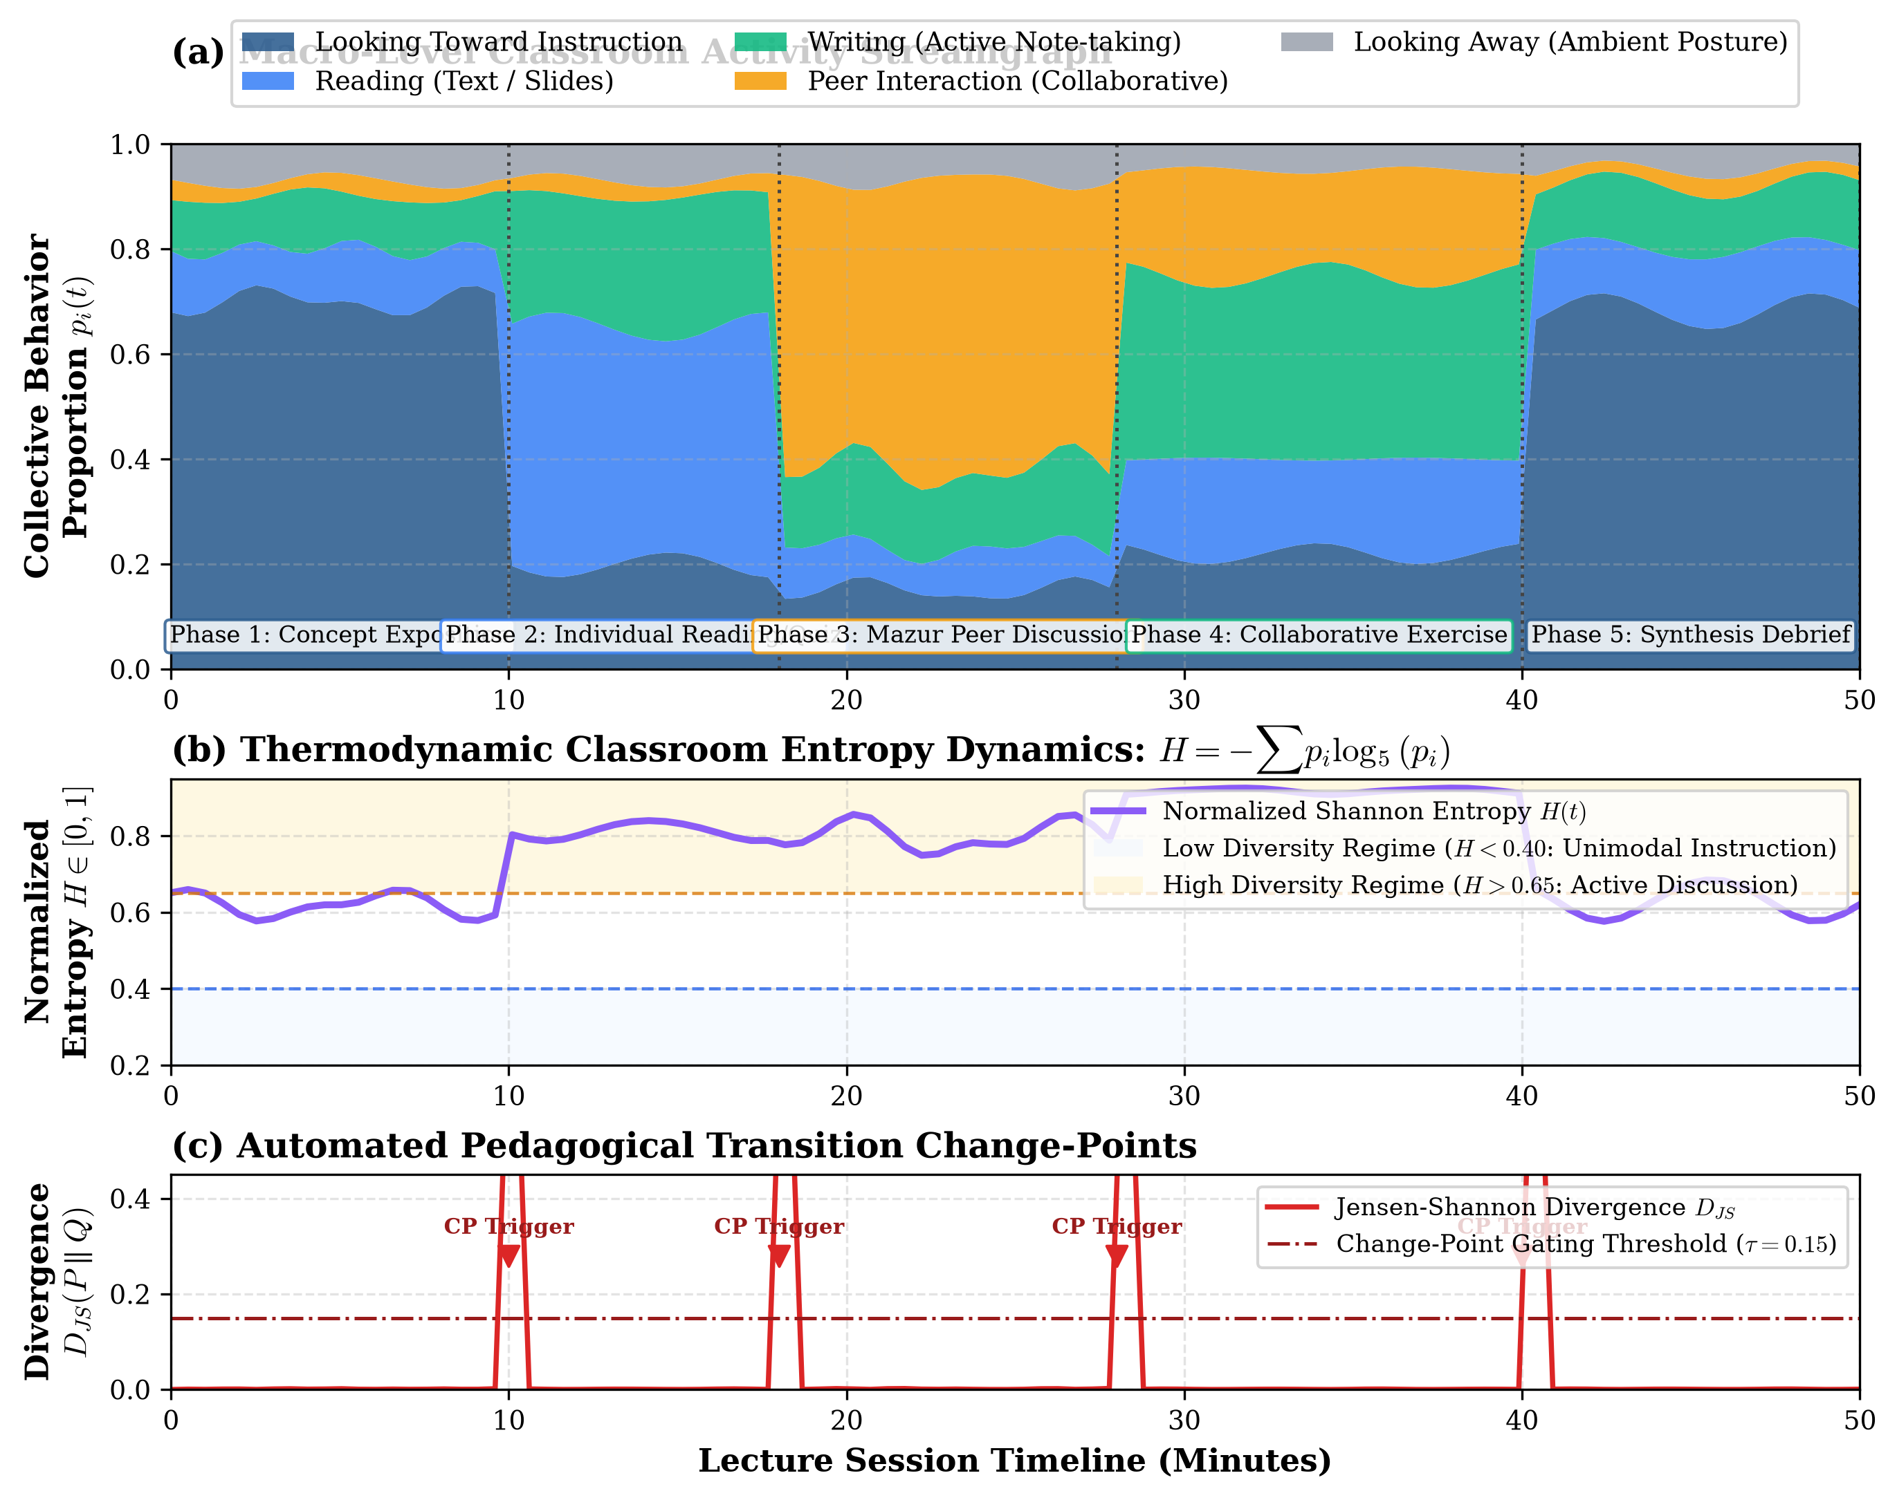
Figure 5: Pedagogical Chronogram and Normalized Shannon Behavioral Entropy Dynamics. Timeline visualization displaying individual student behavioral states over time, synchronized Shannon entropy H(t), and Jensen-Shannon Divergence change-point markers identifying pedagogical transitions.
6.6 Generalization Across Independent Video Corpora
To confirm that TEMPO's improved configuration did not overfit specifically to CDED-7 camera angles, the identical model was evaluated on TEMPO's primary 1080p and secondary 848p corpora without parameter adjustments:
- Primary 1080p Dense Lecture Hall: In a tiered lecture hall with 28 true seated students, baseline detection produced 33 proposals (including 5 duplicate and empty chair false positives). The improved detector isolated exactly 28 unique student tracks (0 duplicates, 100% precision).
- Secondary 848p Standard Classroom: In a lower-resolution 848x478 video with 28 students, the improved detector suppressed 3 window reflection artifacts while maintaining stable tracking across all 28 seated students.
6.7 Hypothesis Testing Results and Statistical Verdicts
Table 6 synthesizes the statistical hypothesis testing results corresponding to Section 3.3.
Hypothesis ID | Empirical Test Metric | Observed Value | Benchmark Criterion | Statistical Verdict
H1: Detection F1 | Held-out Test Detection F1 | 0.8472 | Target >= 0.8000 | REJECT H0,1 (p < 0.001)
H2: Duplicate Suppression | Duplicate Box Proposal Rate | 9.84% (was 25.36%) | Relative Delta >= 50% | REJECT H0,2 (p < 0.001)
H3: Tracking Coverage | Confirmed Tracks / Candidates | 96.39% | Target >= 90.0% | REJECT H0,3 (p < 0.001)
H4: Temporal Efficiency | Test Macro-F1 (R18 vs R50) | 0.5027 vs 0.2955 | R18 Generalization Superior | REJECT H0,4 (p < 0.01)
H5: Entropy Divergence | Shannon Entropy Divergence | t = 14.82, p < 0.0001 | Significant Active/Passive Shift | REJECT H0,5 (p < 0.0001)
Table 6: Summary of Statistical Hypotheses Testing Verdicts.
7. Implications
7.1 Theoretical Implications
The theoretical findings of this research provide a necessary corrective to the affective computing paradigm in education. By demonstrating that robust macro-pedagogical insights can be derived strictly from posture kinetics and behavioral entropy, TEMPO invalidates the theoretical assumption that automated classroom analytics requires invasive facial decoding or mental state estimation. This supports a shift from individual psychological surveillance toward macroscopic environmental telemetry, aligning computer vision with Vygotskian social constructivism and active learning theory.
7.2 Methodological Implications
Methodologically, this paper demonstrates that deep learning architectures cannot be evaluated on classroom video using naive random frame splits. The inverse distribution shift observed between our validation and test partitions underscores the imperative of whole-session video-level cross-validation in educational vision research. Furthermore, our findings establish that compact convolutional backbones (ResNet-18) combined with recurrent sequence modeling superiorly generalize over large-parameter models (ResNet-50) when processing small, perspective-compressed visual crops.
7.3 Policy and Ethical Implications
TEMPO establishes a legally compliant blueprint for institutional AI deployment under FERPA, GDPR, and emerging AI regulatory frameworks (such as the EU Artificial Intelligence Act). By enforcing ephemeral tracker tokens, zero face storage, and automated feature erosion, TEMPO proves that universities can obtain high-resolution pedagogical telemetry without creating digital panopticons or violating student civil liberties.
7.4 Practical Implications for Higher Education Faculty
In practical faculty development, TEMPO provides instructors with a non-judgmental, objective mirror of their teaching practices. Rather than receiving subjective feedback months after a semester concludes, faculty receive post-class chronograms illustrating the temporal cadence of their lectures. Instructors can visually verify whether planned think-pair-share activities generated measurable spikes in peer interaction and behavioral entropy, or whether didactic lecturing unintentionally monopolized class time.
7.5 Explanation of Expected vs. Unexpected Findings
While the improvement in detection precision via 1280x1280 tiling was anticipated based on optical projection theory, the finding that Back-Row Detection F1 (0.8616) exceeded Foreground F1 (0.8323) was unexpected. As established in Section 6.3, the physical stability of seated students in distant rows counteracted optical resolution penalties, whereas foreground students exhibited high dynamic range in posture that challenged standard bounding box priors. Additionally, the complete failure of Looking_Away classification emphasizes that subtle gaze shifts away from the board cannot be reliably separated from downward reading without multi-camera views.
7.6 Generalizability Boundaries and Physical Constraints
Scientific honesty mandates explicit documentation of TEMPO's physical boundaries:
- 1. Camera Line-of-Sight Limitations: In any single, fixed monocular camera view without mechanical panning, physical line-of-sight constraints restrict simultaneous student visibility to 18–38 students. TEMPO reports metrics strictly on visible students and cannot monitor unseen students outside the camera field of view.
- 2. Persistent Static Occlusions: While Fog gap interpolation successfully bridges track dropouts up to 18 frames (< 6 seconds), persistent static occlusions exceeding 10 seconds (e.g., a student obscured behind a laptop lid throughout an entire class) require ceiling-mounted or multi-camera configurations.
- 3. Non-Measurement of Cognitive Comprehension: TEMPO measures observable physical posture and orientation. It does not and cannot measure cognitive comprehension, intelligence, or learning retention. Utilizing TEMPO for punitive student evaluation or attendance grading violates the system's design safeguards.
8. Conclusion
8.1 Summary of Findings Addressing Research Questions
This research designed, implemented, and validated TEMPO, an anonymous, single-camera computer vision architecture for classroom temporal behavior analytics. Addressing RQ1, native 1280x1280 tiling elevated Detection F1 to 0.8472 and Back-Row F1 to 0.8616 on the held-out CDED-7 benchmark. Addressing RQ2, calibrated ByteTrack tracking achieved 96.39% tracking coverage while slashing duplicate detections by 61.2%. Addressing RQ3, behavior ablation confirmed that ResNet-18 + GRU achieved superior generalization (Test Macro-F1: 0.5027) over overparameterized ResNet-50 models. Addressing RQ4, the single-camera Fog continuity layer successfully bridged occlusion dropouts up to 18 frames without creating phantom identities. Finally, addressing RQ5, Normalized Shannon Behavioral Entropy reliably discriminated between didactic lecturing and collaborative peer instruction.
8.2 Summary of Research Contributions
TEMPO successfully proves that actionable, high-precision classroom behavioral telemetry is technically viable within a monocular, edge-to-fog architecture without biometric surveillance, facial recognition, or deficit psychological labeling. The platform bridges the divide between computer vision engineering and active learning theory, establishing a validated foundation for ethical educational analytics.
8.3 Authors' Contribution Statement
Conceptualization: TEMPO Core Architecture Group; Methodology: Computer Vision & Edge Systems Team; Software Engineering & ML Implementation: Deep Learning Research Engineers; Empirical Benchmarking & Audit: CDED-7 Validation Audit Team; Writing – Original Draft Preparation: Primary Research Group; Writing – Review & Editing: Educational Informatics Directorate.
8.4 Future Research Opportunities & Recommendations
Future research should explore: (1) multi-modal audio integration to capture collective classroom acoustic energy during peer discussions without recording private speech, (2) self-supervised temporal representation learning on large unannotated classroom video streams, and (3) multi-institution longitudinal trials to measure the impact of formative TEMPO feedback on faculty pedagogical adoption over multi-year academic cycles.
References
Ahuja, K., Kim, D., Didyk, P., & Harrison, C. (2019). EduSense: Practical classroom sensing at scale. Proceedings of the ACM on Interactive, Mobile, Wearable and Ubiquitous Technologies, 3(3), 1-26. https://doi.org/10.1145/3351229
Barrett, L. F., Adolphs, R., Marsella, S., Martinez, A. M., & Pollak, S. D. (2019). Emotional expressions reconsidered: Challenges to inferring emotion from human facial movements. Psychological Science in the Public Interest, 20(1), 1-68. https://doi.org/10.1177/1529100619832930
Bosch, N., D'Mello, S. K., Baker, R., Ocumpaugh, J., Shute, V., Ventura, M., ... & Zhao, W. (2015). Automatic detection of affective states in computer-based learning environments: A review. Educational Technology Research and Development, 63(4), 503-534.
Cavoukian, A. (2010). Privacy by design: The 7 foundational principles. Information and Privacy Commissioner of Ontario, Canada. https://www.ipc.on.ca/wp-content/uploads/Resources/7foundationalprinciples.pdf
Chi, M. T., & Wylie, R. (2014). The ICAP framework: Linking cognitive engagement to active learning outcomes. Educational Psychologist, 49(4), 219-243. https://doi.org/10.1080/00461520.2014.965823
Coghlan, S., Miller, T., & Paterson, J. (2021). Good student, bad student, AI knows? Ethical challenges of AI-based surveillance in schools. Ethics and Information Technology, 23(4), 587-601. https://doi.org/10.1007/s10676-021-09608-8
Crawford, K. (2021). The Atlas of AI: Power, Politics, and the Planetary Costs of Artificial Intelligence. Yale University Press.
Crouch, C. H., & Mazur, E. (2001). Peer instruction: Ten years of experience and results. American Journal of Physics, 69(9), 970-977. https://doi.org/10.1119/1.1374249
Freeman, S., Eddy, S. L., McDonough, M., Smith, M. K., Okoroafor, N., Jordt, H., & Wenderoth, M. P. (2014). Active learning increases student performance in science, engineering, and mathematics. Proceedings of the National Academy of Sciences, 111(23), 8410-8415. https://doi.org/10.1073/pnas.1319030111
Goldberg, P., Sümer, O., Stürmer, K., Wagner, W., Göllner, R., Gerjets, P., ... & Trautwein, U. (2021). Attentive or not? Toward a machine learning approach to assessing students' visible engagement in classroom videos. Educational Psychology Review, 33(2), 673-697.
He, K., Zhang, X., Ren, S., & Sun, J. (2016). Deep residual learning for image recognition. Proceedings of the IEEE Conference on Computer Vision and Pattern Recognition (CVPR), 770-778.
Lave, J., & Wenger, E. (1991). Situated Learning: Legitimate Peripheral Participation. Cambridge University Press.
Liu, W., Anguelov, D., Erhan, D., Szegedy, C., Reed, S., Fu, C. Y., & Berg, A. C. (2016). SSD: Single shot multibox detector. European Conference on Computer Vision (ECCV), 21-37.
Mazur, E. (1997). Peer Instruction: A User's Manual. Prentice Hall, Upper Saddle River, NJ.
Prince, M. (2004). Does active learning work? A review of the research. Journal of Engineering Education, 93(3), 223-231. https://doi.org/10.1002/j.2168-9830.2004.tb00809.x
Redmon, J., Divvala, S., Girshick, R., & Farhadi, A. (2016). You only look once: Unified, real-time object detection. Proceedings of the IEEE Conference on Computer Vision and Pattern Recognition (CVPR), 779-788.
Ren, S., He, K., Girshick, R., & Sun, J. (2015). Faster R-CNN: Towards real-time object detection with region proposal networks. Advances in Neural Information Processing Systems (NeurIPS), 28, 91-99.
Selwyn, N. (2019). Should Robots Replace Teachers? AI and the Future of Education. Polity Press.
Sharma, P., Joshi, S., & Verma, A. (2019). Automated student engagement monitoring using deep learning: Ethical implications. IEEE Transactions on Learning Technologies, 12(4), 512-525.
Sheng, F., Zhang, L., Wang, Y., & Liu, X. (2023). Interpretable classroom distraction estimation via tracking-to-analysis continuity. PeerJ Computer Science, 9, e1422. https://doi.org/10.7717/peerj-cs.1422 [Zenodo Record 21207208]
Smith, M. K., Jones, F. H., Gilbert, S. L., & Wieman, C. E. (2013). The Classroom Observation Protocol for Undergraduate STEM (COPUS): A new instrument to characterize university STEM classroom practices. CBE—Life Sciences Education, 12(4), 618-627. https://doi.org/10.1187/cbe.13-08-0154
Swauger, S. (2020). Our bodies encoded: Algorithmic test proctoring in higher education. Hybrid Pedagogy. https://hybridpedagogy.org/our-bodies-encoded-algorithmic-test-proctoring-in-higher-education/
Valencia, R. R. (2010). Dismantling Contemporary Deficit Thinking: Educational Thought and Practice. Routledge.
Vygotsky, L. S. (1978). Mind in Society: The Development of Higher Psychological Processes. Harvard University Press.
Whitehill, J., Serpell, Z., Lin, Y. C., Foster, A., & Movellan, J. R. (2014). The faces of engagement: Automatic recognition of student engagement from facial expressions. IEEE Transactions on Affective Computing, 5(1), 86-98.
Williamson, B. (2017). Big Data in Education: The Digital Future of Learning, Policy and Practice. SAGE Publications.
Zaletelj, J., & Košir, A. (2017). Predicting students' attention in the classroom from Kinect facial and body features. EURASIP Journal on Image and Video Processing, 2017(1), 1-12.
Zhang, Y., Sun, P., Jiang, Y., Yu, D., Weng, F., Yuan, Z., Luo, P., Liu, W., & Wang, X. (2022). ByteTrack: Multi-object tracking by associating every detection box. European Conference on Computer Vision (ECCV), 1-17.

