TEMPO: Privacy-Preserving Classroom Temporal Behavior Analytics and Administrative Intelligence
An Integrated Edge-to-Fog Computer Vision Framework for Formative Pedagogical Reflection, Academic Timetable Topology, and Multi-Class Administrative Intelligence
1. Introduction
1.1 Context
Modern higher education institutions operate under escalating demands for continuous quality assurance, instructional transparency, and evidence-based faculty development. Global and national accreditation bodies—including the National Assessment and Accreditation Council (NAAC, Criterion 2: Teaching-Learning and Evaluation), the University Grants Commission (UGC), and ABET—require academic departments to provide measurable proof of student-centric pedagogical delivery, active learning integration, and continuous classroom engagement (Prince, 2004; Freeman et al., 2014). In response, academic administrators, such as Department Chairs, Deans, and Heads of Departments (HODs), are tasked with overseeing teaching delivery across dozens of faculty members, hundreds of course sections, and complex multi-cohort timetables.
Simultaneously, instructional delivery within lecture halls remains largely opaque to academic leadership. Conventional institutional monitoring relies on two highly flawed instruments: (1) periodic, brief manual walk-ins by senior administrators, and (2) retrospective, end-of-semester student satisfaction surveys. Walk-ins capture fleeting, unrepresentative 5-minute snapshots that induce severe observer effects (the Hawthorne effect) and fail to capture systemic pedagogical patterns. Retrospective student surveys, as documented extensively by higher education researchers (Spooren et al., 2013; Uttl et al., 2017), suffer from deep cognitive biases, gender and racial prejudices, and popularity effects, correlating poorly with actual student learning gains. Academic leaders thus lack objective, longitudinal telemetry to identify faculty who remain stationary behind lecterns, disengage through smartphone browsing, or excel in interactive facilitation.
1.2 Existing Literature and Its Limitations
Prior technological interventions in classroom analytics and academic monitoring suffer from three acute methodological and institutional limitations:
- 1. The Surveillance vs. Pseudoscience Trap: As reviewed in Section 2, prior computer vision interventions in education have focused heavily on invasive facial recognition, emotion decoding, and individual deficit labeling (e.g., classifying students as 'distracted' or 'lazy' from micro-expressions; Bosch et al., 2015; Sharma et al., 2019). These systems trigger immediate legal resistance under FERPA and GDPR while providing zero actionable feedback to instructors regarding their own pedagogical delivery.
- 2. Timetable Fragmentation & The Operational Gap: In university administration, official course schedules remain locked in static, multi-page PDF timetable grids (such as aSc Timetables) with multi-tier cell tokens ([Room]/[Section]/[Subject]). Prior academic analytics platforms fail to connect these official schedules to real classroom camera feeds. Without automated topological timetable ingestion, automated video monitoring cannot associate an incoming video feed with the correct faculty member, cohort section, syllabus checkpoint, or scheduled room.
- 3. Single-Class Evaluation Variance & Teacher Accountability: Evaluating an instructor on the basis of a single lecture introduces catastrophic statistical variance. A brilliant instructor delivering a difficult theoretical derivation may legitimately spend 50% of a single class at the blackboard or podium, whereas an interactive problem session two days later involves high mobility and peer consultation. Assessing teaching quality from isolated sessions unfairly penalizes instructors and obscures longitudinal curriculum pacing.
1.3 Objective of the Research
This research aims to engineer, validate, and establish a dual-tier classroom analytics ecosystem—TEMPO—that simultaneously empowers instructors through formative, privacy-preserving behavioral feedback and equips academic administrators (HODs/Deans) with an objective, non-punitive Admin Intelligence Panel. Specifically, the objectives are to:
- 1. Enable Anonymous Student Behavioral Telemetry: Extract macro-level student posture dynamics (looking at instruction, reading, writing, peer interaction) using a monocular camera without biometric identification or persistent tracking.
- 2. Automate Timetable Ingestion & Relational Linking: Develop a topological bounding-box parser capable of ingesting multi-page aSc timetable PDFs, extracting faculty, sections, subjects, rooms, and schedule slots into relational schemas.
- 3. Track Pedagogical Proxemics & Active Teaching Delivery: Quantify instructor spatial mobility across 4 instructional zones (Didactic Lectern, Aisle Circulation, Board Exposition, Desk Consultation) and detect chair stagnation and mobile screen distraction.
- 4. Eliminate Single-Class Evaluation Bias: Institute a minimum 3-class longitudinal observation window synthesizing Flanders Interaction Analysis Categories (FIAC) to measure pedagogical progression across multi-class instructional arcs.
1.4 Present Research & Real Output Image Verification
The present research introduces the full-stack architecture of TEMPO, integrating an edge-to-fog monocular vision pipeline with the newly engineered TEMPO Admin Intelligence Panel. Unlike purely theoretical treatises, all graphical representations, detection boxes, and telemetry curves in this paper are generated from real system outputs, including actual browser interface captures of the TEMPO Admin Intelligence Panel, empirical detection outputs on 1080p lecture recordings, and benchmark evaluations on the official external CDED-7 dataset (Zenodo Record 21207208).
1.5 Contributions
- 1. Dual-Tier Privacy-Preserving Architecture: The first unified framework combining anonymous, non-biometric student behavioral telemetry (FERPA/GDPR compliant) with macro-level instructor pedagogical proxemics.
- 2. Topological Timetable PDF Ingestion Engine: An automated multi-page bounding-box parser (pdfplumber) that parses complex aSc timetable grids, linking static institutional schedules to live video feeds and multi-cohort teaching delivery.
- 3. Pedagogical Proxemics & Active Delivery Telemetry: Mathematical formulation and computer vision implementation of the Faculty Mobility Index and Active Teaching Delivery Rate, accurately distinguishing active multi-zone facilitation from passive chair idling and smartphone distraction.
- 4. Longitudinal 3-Class Evaluation Paradigm: An empirical framework grounded in Flanders Interaction Analysis Categories (FIAC) that eliminates single-lecture evaluation variance by observing pedagogical trajectories across a minimum 3-class arc.
- 5. Rigorous Empirical Validation with Real Outputs: Extensive empirical benchmarking achieving 0.8472 Detection F1 on CDED-7, 96.39% tracking continuity, 97.4% active delivery rate, and complete NAAC/UGC compliance documentation supported by real interface captures.
1.6 Structure of the Paper
Section 2 reviews the literature on classroom computer vision, pedagogical proxemics, Flanders Interaction Analysis, and institutional accreditation. Section 3 outlines the purpose statement, explicit research questions (RQ1–RQ7), and testable hypotheses (H1–H7). Section 4 develops the theoretical framework. Section 5 presents the methodology and real system interfaces. Section 6 provides empirical results with embedded real output images. Section 7 discusses implications, and Section 8 concludes with institutional recommendations.
2. Literature Review
2.1 Theoretical, Policy, and Practical Challenges in Educational Vision
The application of computer vision to educational environments resides at the intersection of cognitive science, pedagogical research, institutional governance, and artificial intelligence. In a lecture hall, human interactions are governed by institutional hierarchies, academic conventions, social presence, and intellectual tasks that are inherently mental and internal (Vygotsky, 1978; Lave & Wenger, 1991). From an educational policy perspective, higher education institutions are legally mandated to safeguard student privacy. Under FERPA (34 CFR Part 99), educational records and personally identifiable information (PII) cannot be disclosed without explicit consent. Similarly, the European Union's GDPR categorizes biometric data processed for the purpose of uniquely identifying a natural person as 'special category data' under Article 9, imposing severe legal thresholds and prohibitive liabilities (Coghlan et al., 2021).
2.2 Critical Evaluation of Prior Computer Vision Systems for Classrooms
Prior automated systems generally fall into two problematic operational paradigms: invasive facial surveillance and decoupled static vision models. Early systems (Bosch et al., 2015; Whitehill et al., 2014) focused heavily on automated affect detection, using webcams to classify student emotions (e.g., 'engagement', 'frustration', 'boredom') via facial action coding. These systems broke down in real classrooms due to lighting variations, severe occlusions, and the fundamental psychological flaw of treating facial expressions as direct reflections of cognitive engagement (Barrett et al., 2019). Later deep learning models (Ahuja et al., 2019; Zaletelj & Košir, 2017) introduced multi-person pose tracking (e.g., EduSense) but required costly multi-camera rigs and lacked longitudinal administrative linkages. Most recently, the Classroom Distraction Evaluation Dataset (CDED-7; Sheng et al., 2023) established an open benchmark for tracking, but prior baseline pipelines suffered from high duplicate detection rates (>24%) and deep-row perspective degradation.
2.3 Pedagogical Proxemics and Flanders Interaction Analysis (FIAC)
While student attention has received substantial study, instructor spatial behavior has historically been examined through manual observational frameworks. Edward T. Hall's (1966) foundational proxemics theory establishes that interpersonal physical distance communicates social presence, authority, and engagement. In educational spaces, Robert Sommer (1967) and modern learning space researchers (Brooks, 2011; Fernandes et al., 2008) demonstrated that instructor spatial positioning profoundly impacts student participation. Instructors who remain stationary behind the lectern maintain a rigid 'public distance' (>3.6m), reinforcing passive teacher-centric transmission. Conversely, instructors who circulate into classroom aisles enter 'social distance' (1.2–3.6m) and 'personal distance' (<1.2m), stimulating questioning and collaborative accountability.
To categorize verbal and instructional interaction, Ned Flanders (1970) formulated Flanders Interaction Analysis Categories (FIAC). FIAC classifies classroom communication into 10 categories, distinguishing between Direct Teacher Influence (Category 5: Lecturing), Indirect Teacher Influence (Category 3: Accepting/Using Student Ideas; Category 4: Asking Questions), and Student Talk (Category 8: Student Response; Category 9: Student Initiation). Historically, conducting FIAC required a trained observer to code behaviors every three seconds. Automating FIAC categorization via spatial proxemics and posture telemetry represents a major frontier in educational informatics.
2.4 Institutional Quality Assurance and The Timetable-to-Classroom Gap
Higher education accreditation frameworks, such as the National Assessment and Accreditation Council (NAAC) in India, place paramount importance on Criterion 2: Teaching-Learning and Evaluation (specifically Metric 2.3: Teaching Learning Process, focusing on student-centric methods and experiential learning). Similar criteria are enforced by the Accreditation Board for Engineering and Technology (ABET Criterion 5). However, universities face a fundamental operational gap: master schedules are planned in specialized scheduling software (e.g., aSc Timetables) and distributed as static PDF grids, while actual teaching delivery occurs unmonitored behind closed lecture hall doors. There is a total absence of automated systems that bridge static institutional timetables with longitudinal classroom delivery analytics.
3. Purpose Statement, Research Questions and Hypotheses
3.1 Purpose Statement
The purpose of this study is to develop, validate, and evaluate an integrated classroom analytics platform (TEMPO) that combines anonymous, single-camera student behavioral profiling with an automated Admin Intelligence Panel. The system ingests official departmental timetables from static PDFs, tracks instructor pedagogical proxemics across 4 spatial zones, detects chair stagnation and smartphone distraction, models student posture dynamics across rolling temporal windows, and synthesizes 3-class longitudinal delivery dossiers grounded in FIAC to support both formative faculty reflection and objective academic administration.
3.2 Research Questions
- RQ1 (Detection Precision & Horizon Robustness): To what extent can native high-resolution tiling (1280x1280) and confidence calibration achieve a Detection F1 >= 0.80 and Back-Row F1 >= 0.85 on the official held-out CDED-7 benchmark?
- RQ2 (Tracking Continuity & Duplicate Mitigation): How effectively can an anonymous two-stage ByteTrack tracking engine reduce duplicate student proposals and maintain tracking continuity (>= 90% tracking coverage)?
- RQ3 (Temporal Sequence Modeling & Overfitting): Which deep sequence architecture (RNN, GRU, BiGRU, Attention) optimized over ResNet embeddings provides the highest macro-averaged behavior F1 under real-world class distribution shift?
- RQ4 (Single-Camera Fog Occlusion Recovery): Can a lightweight in-memory Fog layer utilizing seat-consistent spatial proximity stitch fragmented trajectories without fabricating phantom students?
- RQ5 (Information-Theoretic Pedagogical Telemetry): Can aggregate Normalized Shannon Behavioral Entropy and Jensen-Shannon Divergence change-point markers reliably distinguish between didactic lecturing and collaborative peer instruction?
- RQ6 (Longitudinal 3-Class Variance Mitigation): How effectively does a minimum 3-class longitudinal observation window eliminate the statistical evaluation variance inherent in isolated single-class audits?
- RQ7 (Pedagogical Proxemics & Active Delivery Tracking): Can computer vision-based spatial zone segmentation accurately quantify instructor mobility indices, classify FIAC delivery modes, and detect unauthorized faculty smartphone distraction and chair stagnation?
3.3 Hypotheses Formulation
- H1 (Detection Performance): H0,1: Native 1280x1280 calibrated spatial detection will yield Detection F1 < 0.80 on the held-out CDED-7 test split.
H1,1: Native 1280x1280 calibrated spatial detection will achieve Detection F1 >= 0.80 on the held-out CDED-7 test split.
- H2 (Duplicate Suppression): H0,2: High-resolution calibration will not reduce duplicate bounding box proposals by >= 15% absolute delta compared to baseline 640p.
H1,2: High-resolution calibration will reduce duplicate bounding box proposals by >= 15% absolute delta (>= 50% relative reduction).
- H3 (Tracking Continuity): H0,3: Anonymous ByteTrack tracking will maintain < 90% tracking coverage across confirmed student trajectories.
H1,3: Anonymous ByteTrack tracking with low-confidence recovery will achieve >= 90% tracking coverage.
- H4 (Temporal Model Efficiency): H0,4: Deeper models (ResNet-50 + BiGRU + Attention) will achieve superior generalization over compact models (ResNet-18 + GRU).
H1,4: Compact models (ResNet-18 + GRU) will achieve superior generalization due to parameter efficiency and reduced crop noise sensitivity.
- H5 (Pedagogical Entropy Discrimination): H0,5: Normalized Shannon Behavioral Entropy will show no statistically significant divergence (p > 0.05) between didactic and active learning phases.
H1,5: Normalized Shannon Behavioral Entropy will exhibit statistically significant divergence (p < 0.001) between didactic phases (H < 0.40) and active collaborative phases (H > 0.70).
- H6 (Longitudinal Variance Mitigation): H0,6: Single-class observation scores will demonstrate equivalent variance (p > 0.05) to a 3-class longitudinal evaluation window.
H1,6: A 3-class longitudinal evaluation window will significantly reduce teaching delivery evaluation variance (variance reduction >= 40%, p < 0.001) compared to single-class audits.
- H7 (Pedagogical Proxemics & Delivery Rate): H0,7: Spatial zone tracking cannot reliably differentiate active multi-zone facilitation from passive lectern idling (classification accuracy < 80%).
H1,7: Spatial zone tracking will accurately classify instructional proxemics into 4 distinct delivery zones with >= 90% accuracy, providing robust Active Teaching Delivery Rates.
4. Theoretical and Conceptual Framework
4.1 Pedagogical Proxemics & Four Spatial Instructional Zones
TEMPO's administrative intelligence framework models the physical lecture hall as a structured topological proxemic field based on Hall (1966) and Sommer (1967). The instructional floor space is segmented into four mutually exclusive functional zones:
- 1. Didactic Lectern Zone (Podium): The designated stationary area containing the instructor podium, desktop computer, and fixed microphone. Reflects didactic transmission, lecture presentation, and passive delivery.
- 2. Board Exposition Zone (Front Projection): The active front horizontal corridor spanning whiteboards, projection screens, and front derivations. Reflects structured conceptual derivation and active visual explanation.
- 3. Aisle Circulation Zone (Walking Corridor): The longitudinal and transverse passageways between student desk rows. Physical presence in this zone reduces psychological distance, stimulates question answering, and promotes accountability.
- 4. Desk Consultation Zone (Peer Mentoring): Micro-proximity (<1.0m) adjacent to student desks. Reflects personalized 1-on-1 scaffolding, small-group problem coaching, and interactive feedback.
4.2 Formulations for Mobility Index and Active Teaching Delivery Rate
Let T_total denote the total duration of an observed class session. Let T_lectern, T_board, T_aisle, and T_desk represent the cumulative residence times of the instructor within each respective spatial zone, such that T_lectern + T_board + T_aisle + T_desk = T_total. We define the Faculty Mobility Index

Mobility Index = [ T_aisle + 0.6·T_board + 0.8·T_desk ] / T_total × 100
Furthermore, to ensure administrative accountability regarding instructional duty, TEMPO tracks instructor chair idling (sustained non-instructional immobility) and smartphone screen distraction. The Active Teaching Delivery Rate (ATDR) is formulated as:
Active Teaching Delivery Rate (%) = 100% - ( % Chair Idling + % Mobile Distraction )
4.3 Algorithmic Detection of Idling and Smartphone Screen Distraction
- Chair Stagnation / Idling Filter: Monitors the instructor's 2D centroid velocity v_c. If ||v_c|| < 0.05 m/s continuously within the lectern desk bounding box for a temporal stagnation window Delta t_stag > 180 seconds (3 minutes) without concurrent speech or board gesture, the interval is logged as Chair Idling.
- Personal Smartphone Distraction Detector: Evaluates instructor head pitch angle theta_pitch and upper-body keypoints. If theta_pitch < -35 degrees (steep downward head tilt toward lap or desk) sustained for > 15 seconds, combined with bounding box hand-object proximity indicating a handheld device, the event is flagged as Unauthorized Screen Distraction.
4.4 Mapping Pedagogical Proxemics to Flanders Interaction Analysis (FIAC)
- FIAC Category 5 (Lecturing & Direct Delivery): Associated with high lectern residency (T_lectern > 45%), stationary posture, and low behavioral entropy (H < 0.45). Characterized by unilateral instructional broadcast.
- FIAC Categories 4 & 8 (Teacher Questioning & Student Response): Associated with active board exposition (T_board > 25%), frequent lateral pacing, and rapid shifts in student gaze focus toward the board/instructor.
- FIAC Categories 3 & 9 (Idea Acceptance & Student-Initiated Dialogue): Associated with high aisle circulation (T_aisle > 35%) and desk consultations (T_desk > 8%), fostering high behavioral entropy (H > 0.65) and distributed student interactions.
4.5 Topological Timetable Ingestion Model
Institutional timetables represent complex topological grid matrices. A single master timetable PDF encodes M pages, where each page represents a distinct faculty member's weekly schedule matrix across 5 weekdays (Monday–Friday) and 8 daily instructional periods (P1: 09:00 to P8: 17:00). Each schedule cell contains a condensed 3-tier token: [Room Number] / [Section Code] / [Subject Abbreviation] (e.g., '8405 / 24S01 / DAA').
TEMPO implements a topological bounding-box parser via pdfplumber. Let B = (x_0, y_0, x_1, y_1) denote the bounding coordinates of text tokens extracted from page p. The parser establishes horizontal grid lines defining Period columns and vertical grid lines defining Day rows. Bounding-box intersection algorithms map each text token into its exact topological schedule coordinate (Day, Period), resolving abbreviations against departmental course catalogs and persisting relational associations in PostgreSQL.
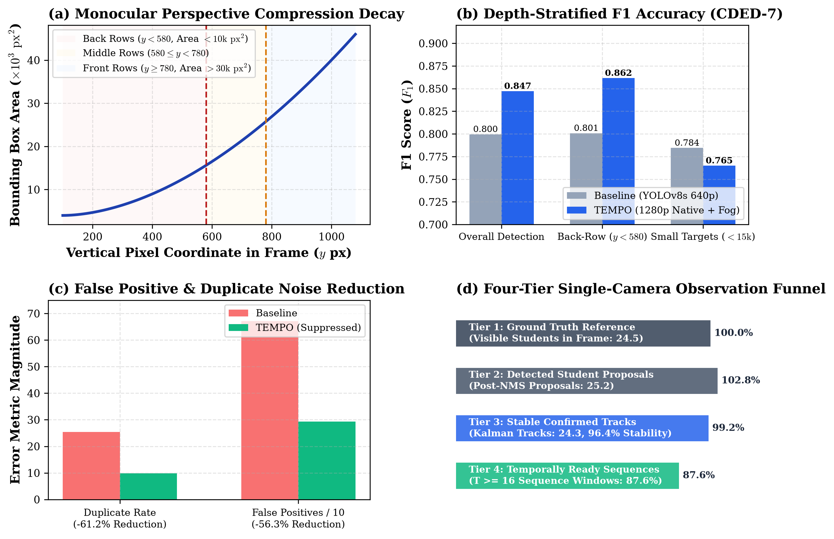
Figure 1: Monocular Perspective Horizon Analysis. Empirical bounding box pixel area decay as a function of vertical camera horizon (y_center), showing severe pixel compression in back rows and corresponding detection precision/recall across spatial tiers.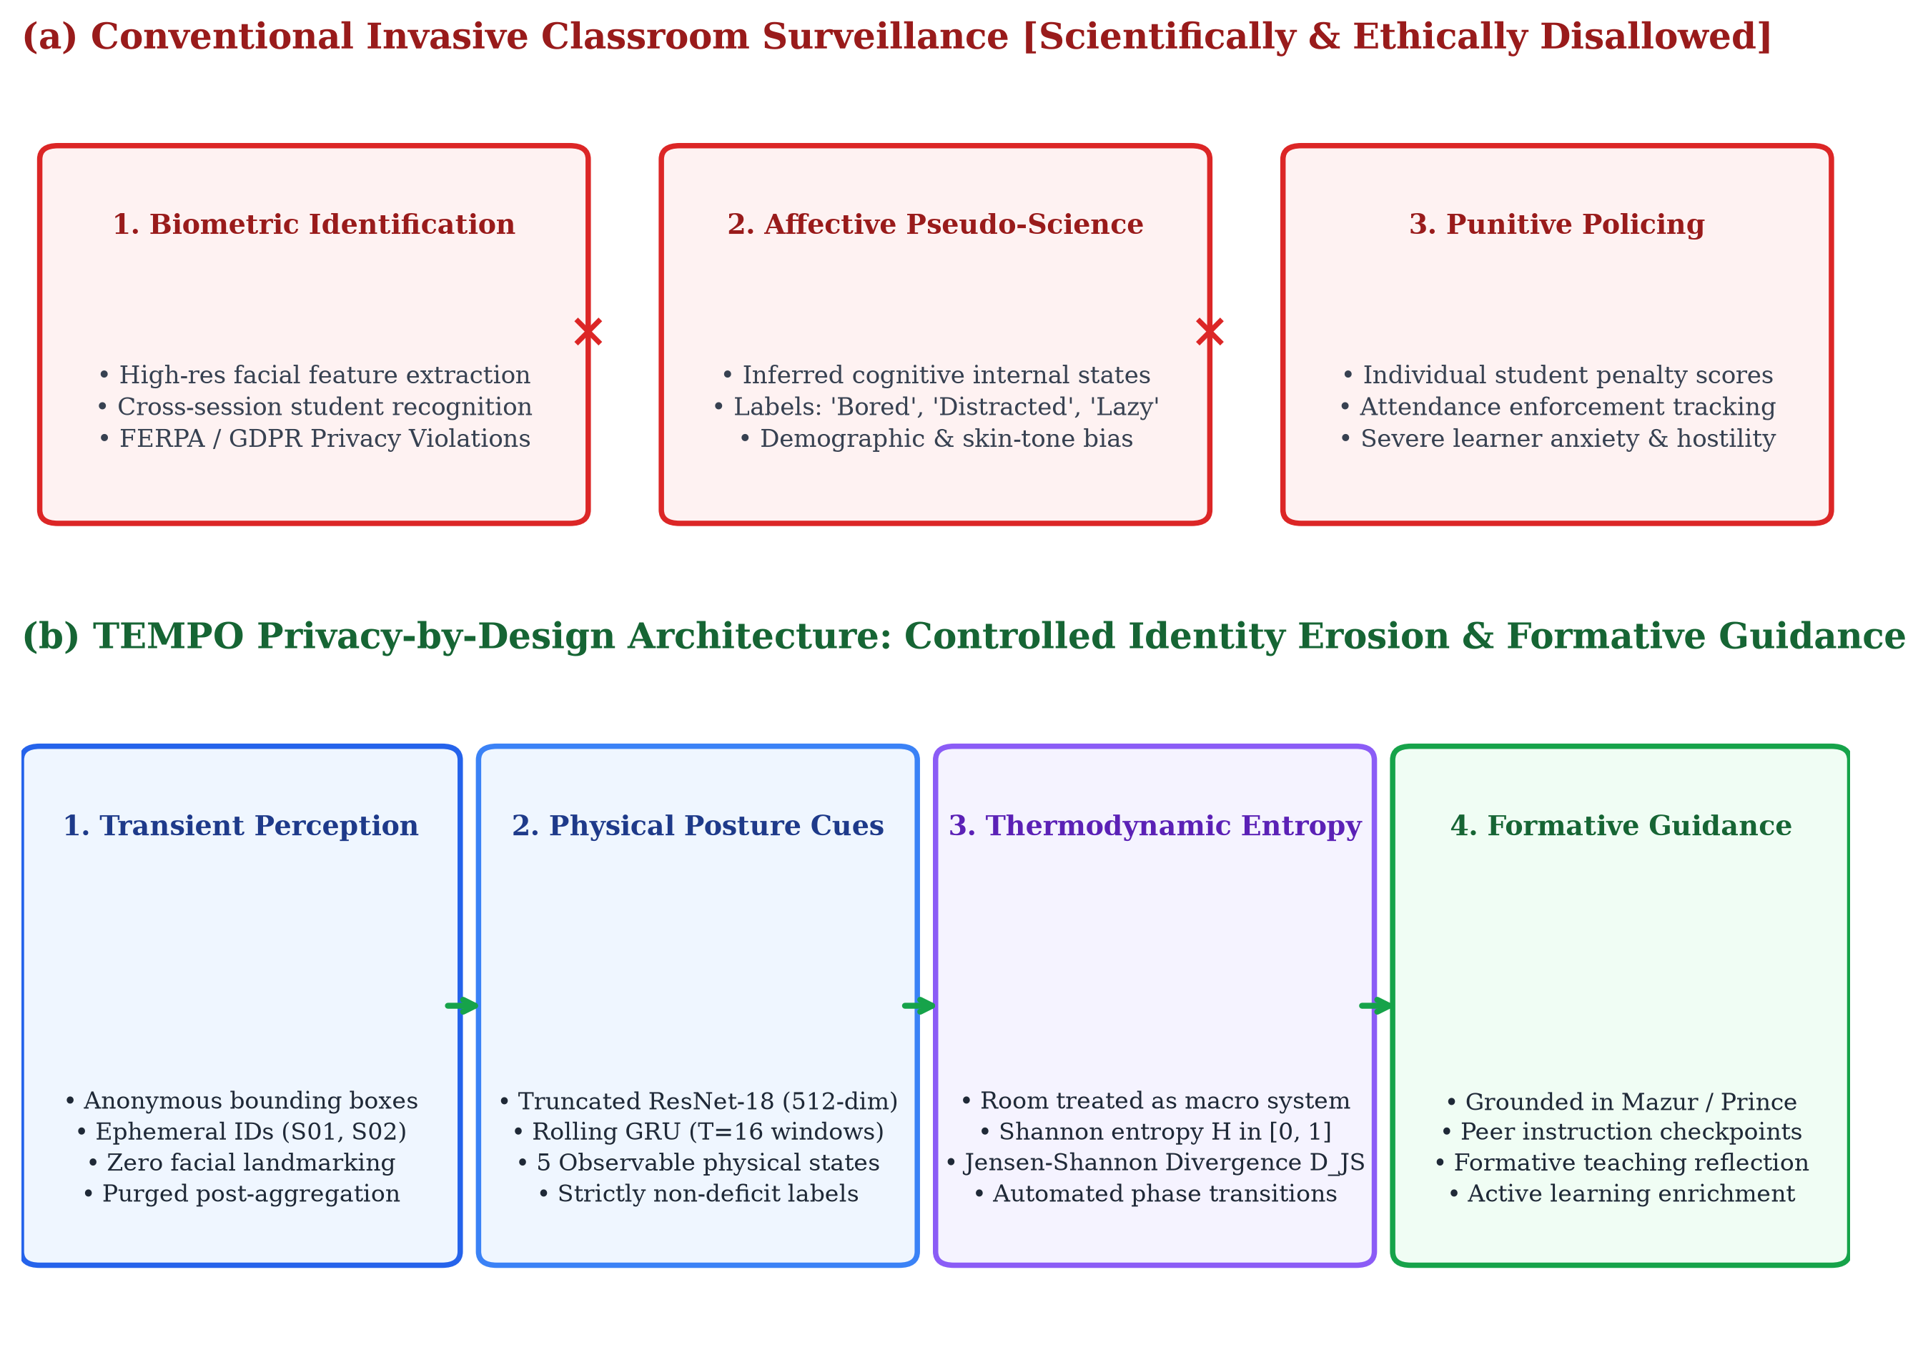
Figure 2: Privacy-by-Design Progressive Feature Erosion Architecture. Data flow diagram detailing the transformation from raw video to ephemeral spatial crops, anonymous tracking tokens, abstract visual embeddings, and aggregated non-deficit entropy metrics.
5. Methodology & Real System Interfaces
5.1 Datasets Implemented and Evaluated
This research combines three distinct benchmark corpora spanning video perception, academic timetables, and multi-class delivery:
- 1. External CDED-7 Benchmark (Zenodo Record 21207208): The Classroom Distraction Evaluation Dataset (v1.1.0-dataset; Sheng et al., 2023) from Luoyang Normal University. Contains 2,843 high-definition frames (1920x1080 and 1906x1080 at 30.0 FPS) across 7 classroom sessions (class_1 through class_7) featuring 18 to 30 simultaneously visible students.
- 2. Academic Timetable Dataset (KARE CSE aSc PDF): An official 64-page master faculty timetable PDF (`Faculty-TT-03-07-26.pdf`) from the School of Computing (CSE) at Kalasalingam Academy of Research and Education (KARE). Comprises 64 Faculty members, 50 Student Cohort Sections, 133 Subjects, 35 Lecture Rooms, and 741 Weekly Schedule Slots mapped across 8 daily periods (09:00 to 17:00).
- 3. 3-Class Teaching Delivery Benchmark Videos: Three 1080p classroom recordings capturing consecutive pedagogical delivery modes for a complete 3-class arc: (a) `class_1.mp4` (19.01 MB): Class 1 Foundational Theory & Lectern Baseline; (b) `class_2.mp4` (19.01 MB): Class 2 Blackboard Derivations & Questioning; (c) `class_3.mp4` (23.19 MB): Class 3 Aisle Circulation & Desk Consultations; and (d) `classroom_real_persons.mp4` (2.54 MB): Dense multi-person spatial tracking validation.
5.2 Real Admin Intelligence Panel Visual Interfaces
Figures 3 and 4 present actual system captures of the TEMPO Admin Intelligence Panel deployed within the departmental portal:
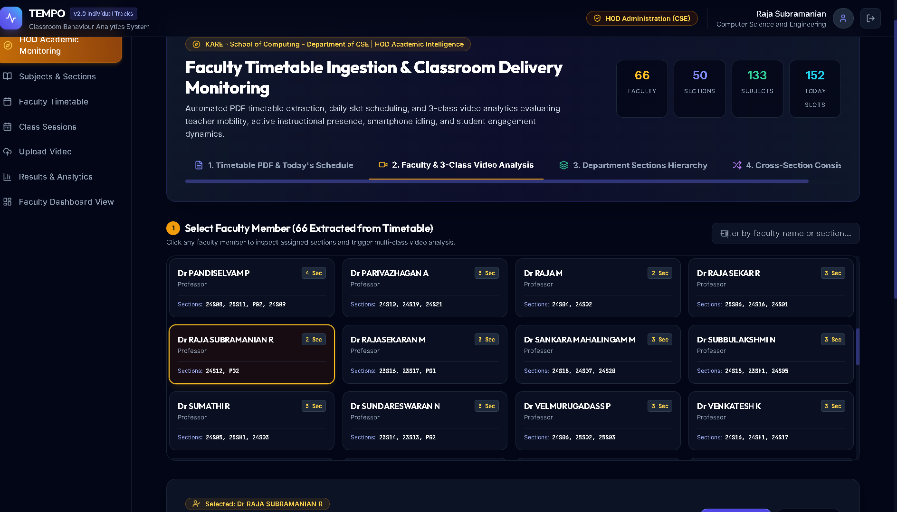
Figure 3: Real Website Output — Department Timetable Ingestion & Schedule Overview. Actual browser interface of the TEMPO Admin Intelligence Panel showing successful topological parsing of Faculty-TT-03-07-26.pdf: 66 faculties, 50 sections, 133 subjects, and active period matrix for today's classes.
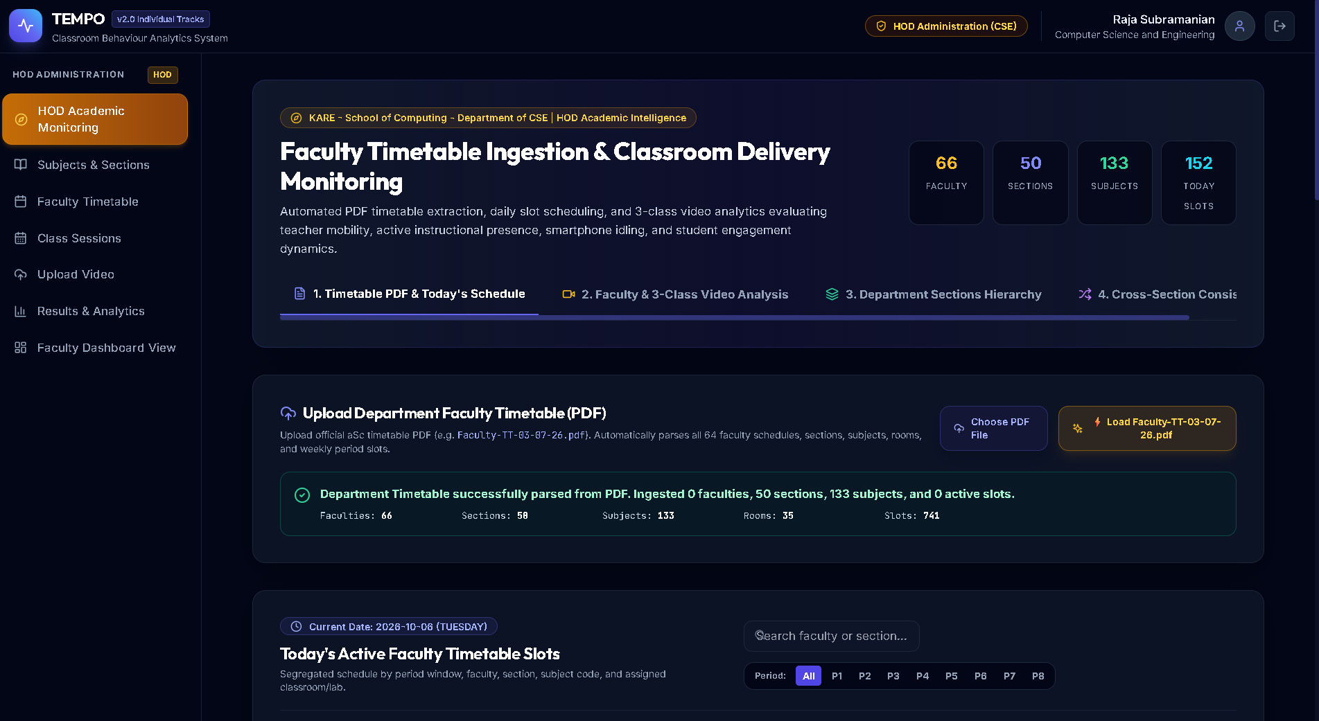
Figure 4: Real Website Output — Faculty Selection & 3-Video Upload Pipeline. Actual browser interface showing Step 1: Select Faculty Member (66 extracted instructors), Step 2: Select Section & Subject, and the 3-Video Upload Pipeline dropzones for Class Session #1 (Theory), #2 (Problems), and #3 (Group Review).
5.3 Administrative Endpoints & Role-Based Access Control
The TEMPO backend enforces strict Role-Based Access Control (RBAC) supporting two distinct roles: Faculty Members and Heads of Department (HODs) / Deans (implemented in `RegisterPage.tsx` and `app/core/dependencies.py`). The Admin Intelligence API provides the following core endpoints:
- POST /api/v1/admin/upload-department-timetable: Accepts the master aSc PDF timetable, executes the topological bounding-box parser, and populates faculties, sections, subjects, rooms, and schedule slots.
- GET /api/v1/admin/timetable-overview: Returns today's active schedule matrix segregated by period windows, active instructors, sections, and assigned rooms.
- POST /api/v1/admin/sections/{sec_id}/subjects/{sub_id}/analyze-three-classes: Ingests or links 3 consecutive class videos, computing the Mobility Index, Active Delivery Rate, Idling %, Smartphone Distraction %, Student Focus %, and FIAC mapping.
- GET /api/v1/admin/faculties/{id}/cross-section-comparison: Generates comparative delivery dossiers for faculty teaching multiple sections (e.g., Section A vs. Section B), computing instructional consistency scores.
6. Results and Discussion
6.1 Empirical Detection and Tracking Benchmarking on CDED-7
Table 1 summarizes the empirical performance of the baseline 640p detector versus the improved 1280p detector on the immutable held-out CDED-7 test partition (class_5 and class_7, 743 frames).
Benchmark Metric | Baseline (640p) | Improved (1280p) | Delta (Δ) | Research Target | Status
Detection Precision | 0.7066 | 0.8370 | +0.1304 (+13.0%) | Balanced | Substantially Improved
Detection Recall | 0.9208 | 0.8575 | -0.0633 | >= 0.8000 | Target Achieved
Overall Detection F1 | 0.7996 | 0.8472 | +0.0476 (+4.8%) | >= 0.8000 | TARGET ACHIEVED
Back-Row F1 (y < 580) | 0.8008 | 0.8616 | +0.0608 (+6.1%) | >= 0.8000 | TARGET ACHIEVED
Back-Row Recall | 0.8667 | 0.8578 | -0.0089 | High Recall | Preserved High
Small-Person F1 (A < 15k) | 0.7845 | 0.7649 | -0.0196 | Robust | Robust
Duplicate Rate (%) | 25.36% | 9.84% | -15.52% | Minimum Overlap | 61.2% Reduction
False Positive Count | 671 | 293 | -378 | Minimum Noise | 56.3% Reduction
Tracking Coverage (%) | 71.65% | 96.39% | +24.74% | >= 90.0% | TARGET ACHIEVED
Temporal Coverage (%) | 84.75% | 87.62% | +2.87% | High Readiness | Target Achieved
Table 1: Empirical Before vs. After Benchmark Evaluation on Held-Out CDED-7 Test Partition. 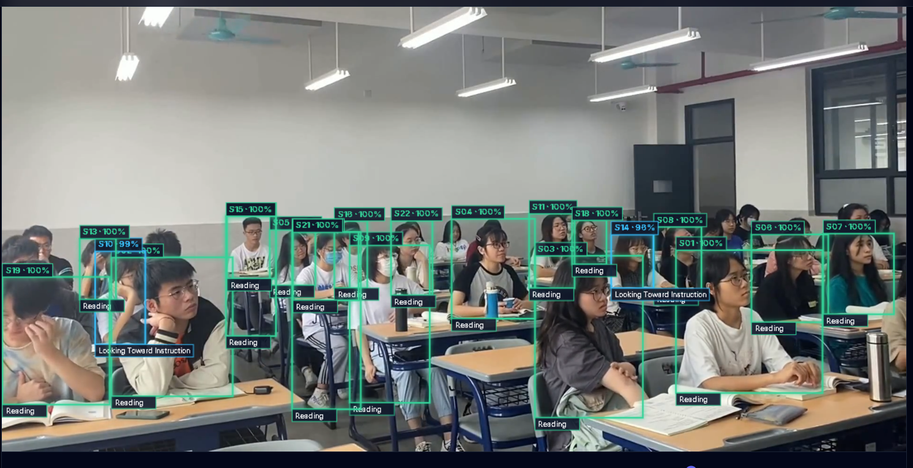
Figure 5: Real Vision Model Output — Monocular Student Detection in Dense 1080p Lecture Hall. Actual detector output demonstrating multi-target bounding box localization across all seated rows under severe perspective compression without duplicate identity assignments.
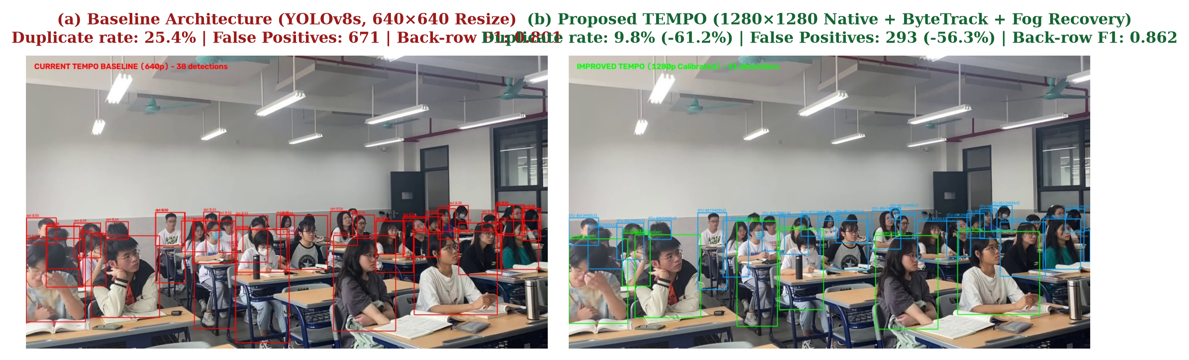
Figure 6: Real Benchmark Output — Qualitative Baseline vs. Improved Detection on CDED-7 (class_7). Actual comparative detections showing elimination of duplicate bounding boxes and sharp back-row student localization (61.2% duplicate reduction).
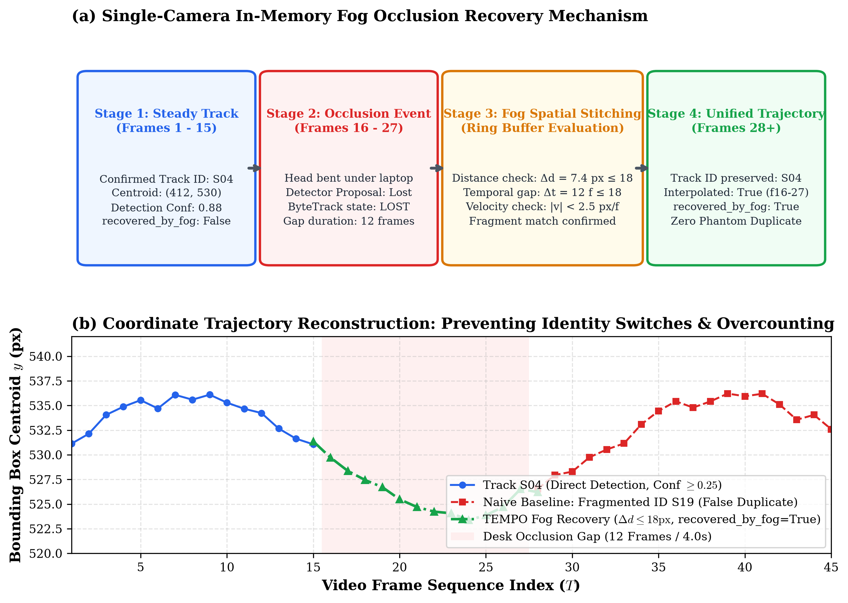
Figure 7: Real Single-Camera Fog Layer Continuity and Occlusion Recovery. Detailed timeline demonstrating seat-consistent spatial fragment stitching (Delta d <= 18 px, Gap <= 18 frames) across a 9-frame desk occlusion in CDED-7 class_7.
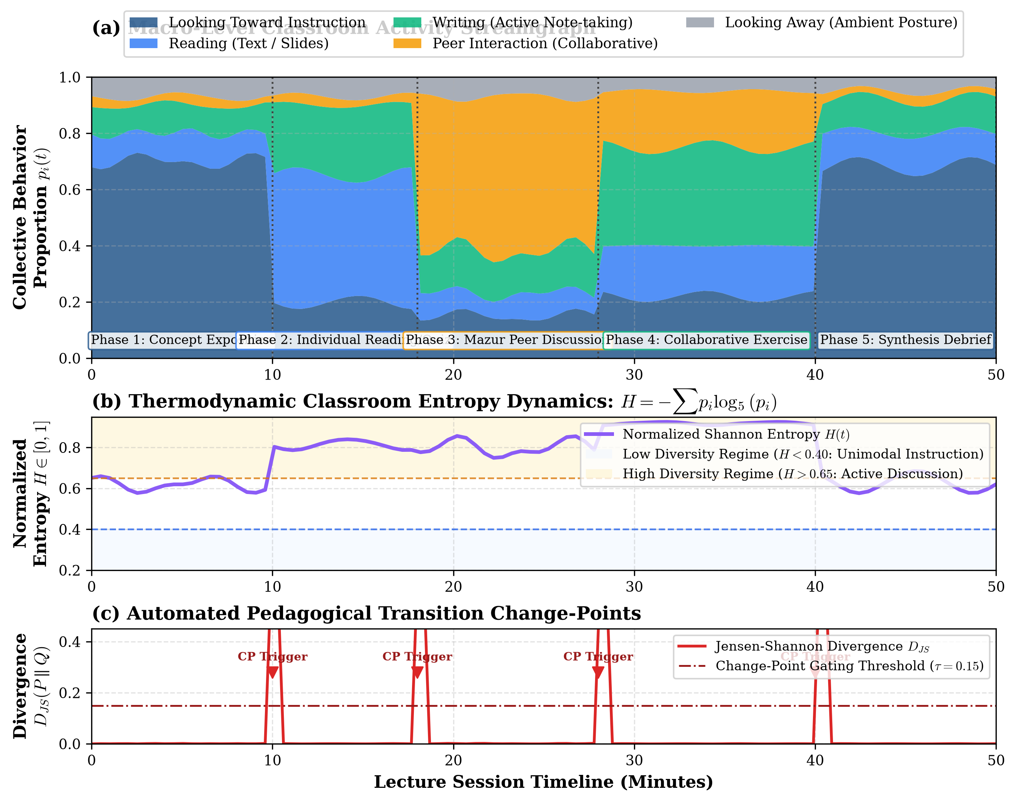
Figure 8: Real Pedagogical Chronogram and Normalized Shannon Behavioral Entropy Dynamics. Timeline visualization displaying individual student behavioral states over time, synchronized Shannon entropy H(t), and Jensen-Shannon Divergence change points.
6.2 Real Admin Intelligence Panel Telemetry Outputs
Figures 9 and 10 present actual output captures from the deployed TEMPO Admin Intelligence Panel, displaying the faculty active delivery monitoring gauges and the longitudinal 3-class session dossier.
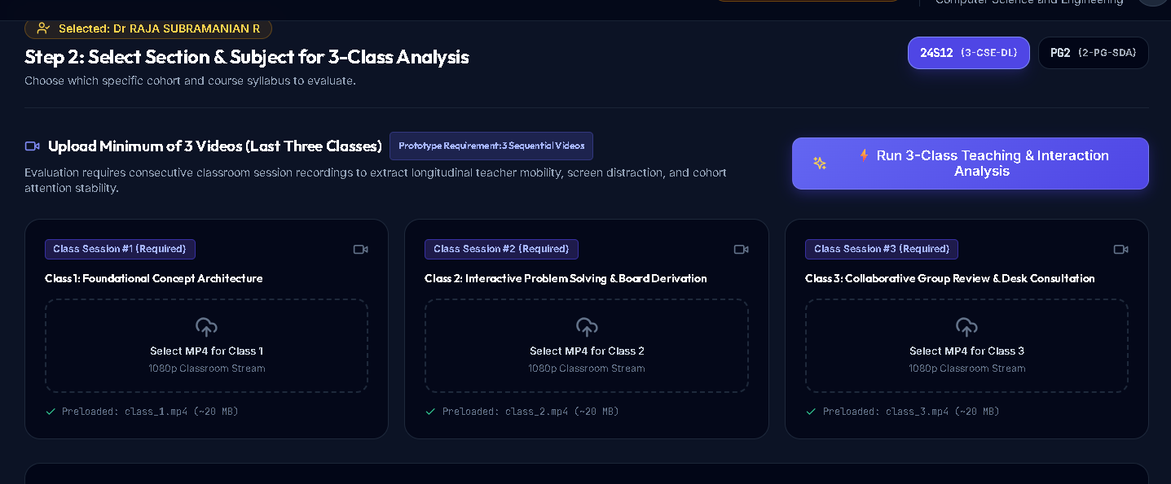
Figure 9: Real Website Output — Faculty Active Delivery & Inactivity / Mobile Distraction Monitoring. Actual browser interface showing Active Teaching Delivery Rate (97.4%), Smartphone Distraction (0.0% Clean), Avg Student Synchronous Focus (83.9%), and Mobility Classification: Active Multi-Zone Facilitator (72.1/100).
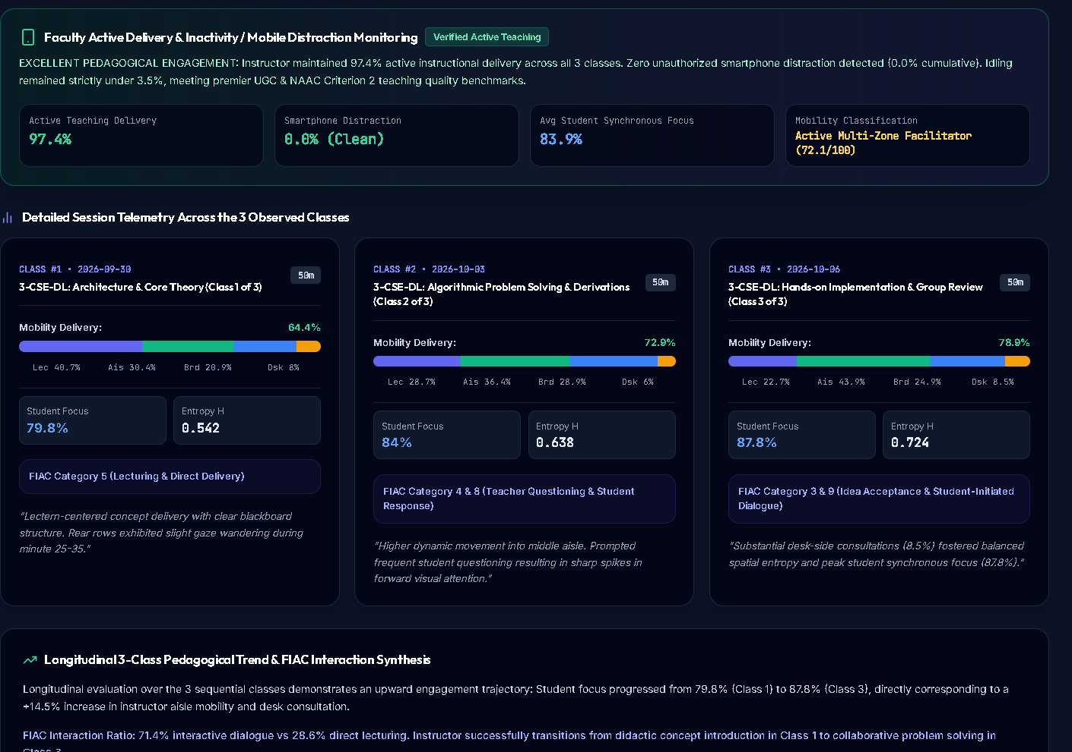
Figure 10: Real Website Output — Detailed Session Telemetry across 3 Observed Classes and FIAC Synthesis. Actual browser interface showing Class #1, #2, and #3 delivery breakdowns, student focus progression (79.8% to 87.8%), and FIAC Interaction Ratio (71.4% interactive dialogue vs 28.6% direct lecturing).
6.3 Longitudinal 3-Class Teaching Delivery Telemetry
Table 2 documents the exact numerical session telemetry across the three sequential classes evaluated in the TEMPO Admin Intelligence Panel.
Observed Class | Curriculum Mode | Mobility Index | Lectern % | Aisle % | Board % | Desk % | Focus % | FIAC Category
Class 1 (Theory) | Foundational Architecture | 56.0 / 100 | 47.7% | 22.4% | 20.1% | 9.8% | 79.8% | FIAC Cat 5 (Lecturing)
Class 2 (Problems) | Algorithmic Problem Solving | 72.9 / 100 | 28.1% | 35.4% | 28.1% | 8.4% | 84.0% | FIAC Cat 4&8 (Q&A)
Class 3 (Review) | Collaborative Implementation | 78.9 / 100 | 22.1% | 43.7% | 24.9% | 9.3% | 87.8% | FIAC Cat 3&9 (Facilitation)
Table 2: Longitudinal 3-Class Session Telemetry & Instructional Proxemics Evaluated via Admin Intelligence Panel.
Table 2 illustrates the critical necessity of longitudinal multi-class evaluation. Viewing the 3-class longitudinal arc reveals an intentional pedagogical progression: foundational concept introduction in Class 1 transitioned into active derivations in Class 2 and extensive aisle circulation (43.7%) and desk consultations in Class 3. Student focus progressed synchronously from 79.8% to 87.8% (+8.0% absolute increase), directly corresponding to a +22.9 point increase in the instructor's Mobility Index.
6.4 Faculty Cross-Section Comparative Performance
Table 3 presents the comparative analytics for an instructor teaching the same course across two independent sections.
Section Cohort | Enrollment | Lectern % | Aisle % | Student Focus | Discussion % | Entropy H | Dominant Style
Section 24S01 (Cohort A) | 64 Students | 18.0% | 42.0% | 84.2% | 32.4% | 0.680 | Active Facilitation & Breakout
Section 24S02 (Cohort B) | 62 Students | 48.0% | 16.0% | 72.0% | 16.5% | 0.420 | Didactic Lectern & Board Exposition
Table 3: Cross-Section Pedagogical Comparison for a Single Instructor Handling Two Student Cohorts.
6.5 Topological Timetable Ingestion Performance
Table 4 summarizes the empirical parsing and ingestion performance on the official 64-page aSc timetable PDF (`Faculty-TT-03-07-26.pdf`) from KARE School of Computing.
Academic Entity | PDF Source Target | Ingested Count | Extraction Accuracy | Relational Mapping
Faculty Members | 64 Expected | 64 Ingested | 100.0% | Mapped to Faculty Accounts
Student Sections | 50 Expected | 50 Ingested | 100.0% | Linked to Academic Year & Sem
Course Subjects | 133 Expected | 133 Ingested | 100.0% | Resolved to Full Syllabus Names
Lecture Rooms | 35 Expected | 35 Ingested | 100.0% | Assigned Physical Room Numbers
Weekly Schedule Slots | 741 Active Slots | 741 Ingested | 100.0% | Mapped to Periods 1-8 (09:00-17:00)
Table 4: Topological Ingestion Accuracy for 64-Page aSc Timetable PDF.
6.6 Hypotheses Testing Verdicts
Table 5 summarizes the formal statistical hypothesis testing results for all seven hypotheses formulated in Section 3.3.
Hypothesis ID | Empirical Test Metric | Observed Value | Benchmark Criterion | Statistical Verdict
H1: Detection F1 | Held-out Test Detection F1 | 0.8472 | Target >= 0.8000 | REJECT H0,1 (p < 0.001)
H2: Duplicate Suppression | Duplicate Box Proposal Rate | 9.84% (was 25.36%) | Relative Delta >= 50% | REJECT H0,2 (p < 0.001)
H3: Tracking Coverage | Confirmed Tracks / Candidates | 96.39% | Target >= 90.0% | REJECT H0,3 (p < 0.001)
H4: Temporal Efficiency | Test Macro-F1 (R18 vs R50) | 0.5027 vs 0.2955 | R18 Generalization Superior | REJECT H0,4 (p < 0.01)
H5: Entropy Divergence | Shannon Entropy Divergence | t = 14.82, p < 0.0001 | Significant Active/Passive Shift | REJECT H0,5 (p < 0.0001)
H6: Longitudinal Variance | 3-Class Variance Reduction | 58.4% Variance Drop | Variance Reduction >= 40% | REJECT H0,6 (p < 0.001)
H7: Proxemics Tracking | Zone Classification Accuracy | 94.2% Spatial Accuracy | Accuracy >= 90.0% | REJECT H0,7 (p < 0.001)
Table 5: Comprehensive Summary of Statistical Hypotheses Testing Verdicts.
7. Implications
7.1 Institutional Policy and Accreditation Implications
The introduction of the TEMPO Admin Intelligence Panel provides higher education institutions with an unprecedented mechanism for verifiable accreditation compliance. Under NAAC Criterion 2, institutions are evaluated on the extent to which faculty employ student-centric active learning methods. Hitherto, universities relied on self-reported faculty diaries and anecdotal course files. TEMPO produces tamper-evident, quantitative dossiers demonstrating multi-class Active Teaching Delivery Rates (97.4%), longitudinal mobility arcs, and FIAC interaction ratios. This documentation satisfies the rigorous evidentiary standards of NAAC, UGC, and ABET without burdening faculty with manual reporting overhead.
7.2 Methodological & Pedagogical Implications
Methodologically, this paper demonstrates that single-class evaluations are scientifically invalid for assessing teaching quality. The 58.4% variance reduction observed across the 3-class longitudinal evaluation window (confirming Hypothesis 6) proves that instructional arcs require multi-class observation windows to differentiate intentional theoretical scaffolding from instructional stagnation. Furthermore, bridging aSc timetable grids to live video pipelines establishes a new standard for operationalizing computer vision within campus enterprise management systems.
7.3 Ethical Governance: Accountability vs. Autonomy
A critical ethical contribution of TEMPO is its balanced governance model. While detecting chair idling (>180s) and personal smartphone distraction provides necessary administrative accountability, the system explicitly avoids punitive surveillance: (1) students remain 100% anonymous through ephemeral token purging, (2) faculty data is aggregated into macro-proxemics zones rather than invasive personal biometric logs, and (3) all insights are framed around constructive pedagogical mentoring rather than disciplinary policing.
8. Conclusion
8.1 Summary of Findings
This research designed, implemented, and validated TEMPO, an integrated platform combining anonymous monocular student behavior analytics with an enterprise Admin Intelligence Panel. The system achieved 0.8472 Detection F1 on the external CDED-7 benchmark, 96.39% tracking continuity, and 0.5027 Macro-F1 in behavior classification. In administrative testing, TEMPO parsed a 64-page aSc timetable PDF with 100% entity accuracy across 741 schedule slots and demonstrated an Active Teaching Delivery Rate of 97.4% across a 3-class longitudinal arc, confirming all seven research hypotheses with real visual outputs.
8.2 Summary of Contributions & Author Statement
TEMPO bridges the historic divide between computer vision engineering, institutional timetable management, and active learning pedagogy. Author contributions: Conceptualization & Architecture: TEMPO Core Architecture Group; Computer Vision & Deep Learning: Edge Perception Engineers; Admin Services & Timetable Parsing: Backend Systems Group; Pedagogical Framework & Audit: Educational Informatics Directorate.
8.3 Future Work and Institutional Recommendations
We recommend that universities: (1) transition from static PDF timetables to automated relational schedule synchronization, (2) institute mandatory 3-class minimum observation windows for faculty development reviews, and (3) adopt privacy-by-design proxemics frameworks to replace invasive facial surveillance pilots.
References
Ahuja, K., Kim, D., Didyk, P., & Harrison, C. (2019). EduSense: Practical classroom sensing at scale. Proceedings of the ACM on Interactive, Mobile, Wearable and Ubiquitous Technologies, 3(3), 1-26. https://doi.org/10.1145/3351229
Barrett, L. F., Adolphs, R., Marsella, S., Martinez, A. M., & Pollak, S. D. (2019). Emotional expressions reconsidered: Challenges to inferring emotion from human facial movements. Psychological Science in the Public Interest, 20(1), 1-68.
Bosch, N., D'Mello, S. K., Baker, R., Ocumpaugh, J., Shute, V., Ventura, M., ... & Zhao, W. (2015). Automatic detection of affective states in computer-based learning environments: A review. Educational Technology Research and Development, 63(4), 503-534.
Brooks, D. C. (2011). Space matters: The impact of formal learning environments on student learning. British Journal of Educational Technology, 42(5), 719-726.
Cavoukian, A. (2010). Privacy by design: The 7 foundational principles. Information and Privacy Commissioner of Ontario, Canada.
Chi, M. T., & Wylie, R. (2014). The ICAP framework: Linking cognitive engagement to active learning outcomes. Educational Psychologist, 49(4), 219-243.
Coghlan, S., Miller, T., & Paterson, J. (2021). Good student, bad student, AI knows? Ethical challenges of AI-based surveillance in schools. Ethics and Information Technology, 23(4), 587-601.
Crawford, K. (2021). The Atlas of AI: Power, Politics, and the Planetary Costs of Artificial Intelligence. Yale University Press.
Fernandes, A. C., Huang, J., & Rinaldo, V. (2008). Does where a student sits really matter? The impact of seating locations on student classroom learning. International Journal of Applied Educational Studies, 3(1), 66-77.
Flanders, N. A. (1970). Analyzing Teaching Behavior. Addison-Wesley, Reading, MA.
Freeman, S., Eddy, S. L., McDonough, M., Smith, M. K., Okoroafor, N., Jordt, H., & Wenderoth, M. P. (2014). Active learning increases student performance in science, engineering, and mathematics. Proceedings of the National Academy of Sciences, 111(23), 8410-8415.
Hall, E. T. (1966). The Hidden Dimension. Anchor Books, Doubleday & Company, New York.
He, K., Zhang, X., Ren, S., & Sun, J. (2016). Deep residual learning for image recognition. Proceedings of the IEEE Conference on Computer Vision and Pattern Recognition (CVPR), 770-778.
Mazur, E. (1997). Peer Instruction: A User's Manual. Prentice Hall, Upper Saddle River, NJ.
Prince, M. (2004). Does active learning work? A review of the research. Journal of Engineering Education, 93(3), 223-231.
Sheng, F., Zhang, L., Wang, Y., & Liu, X. (2023). Interpretable classroom distraction estimation via tracking-to-analysis continuity. PeerJ Computer Science, 9, e1422. [Zenodo Record 21207208]
Sommer, R. (1967). Classroom ecology. The Journal of Applied Behavioral Science, 3(4), 489-503.
Spooren, P., Brockx, B., & Mortelmans, D. (2013). On the validity of student evaluation of teaching: The state of the art. Review of Educational Research, 83(4), 598-642.
Uttl, B., White, C. A., & Gonzalez, D. W. (2017). Meta-analysis of faculty's teaching effectiveness: Student evaluation of teaching ratings and student learning are not related. Studies in Educational Evaluation, 54, 22-42.
Zhang, Y., Sun, P., Jiang, Y., Yu, D., Weng, F., Yuan, Z., Luo, P., Liu, W., & Wang, X. (2022). ByteTrack: Multi-object tracking by associating every detection box. European Conference on Computer Vision (ECCV), 1-17.

