Name:Raavi Aruna Roll no:23481A12J3
Prompt1: Generate an image a business meeting of four indian girls watching on MacBook on top of table in microsoft office with decent office background
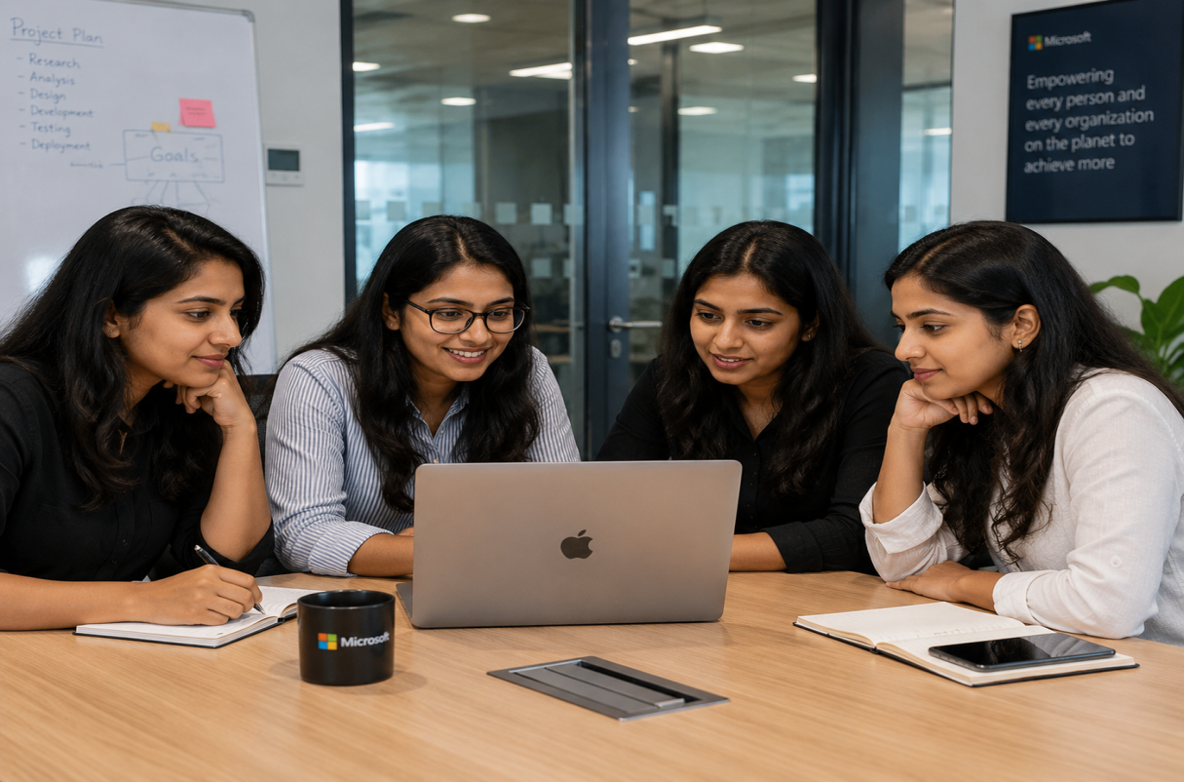
Prompt2: Generate an image a business meeting of four andhra girls watching on MacBook on top of table in microsoft office with office background
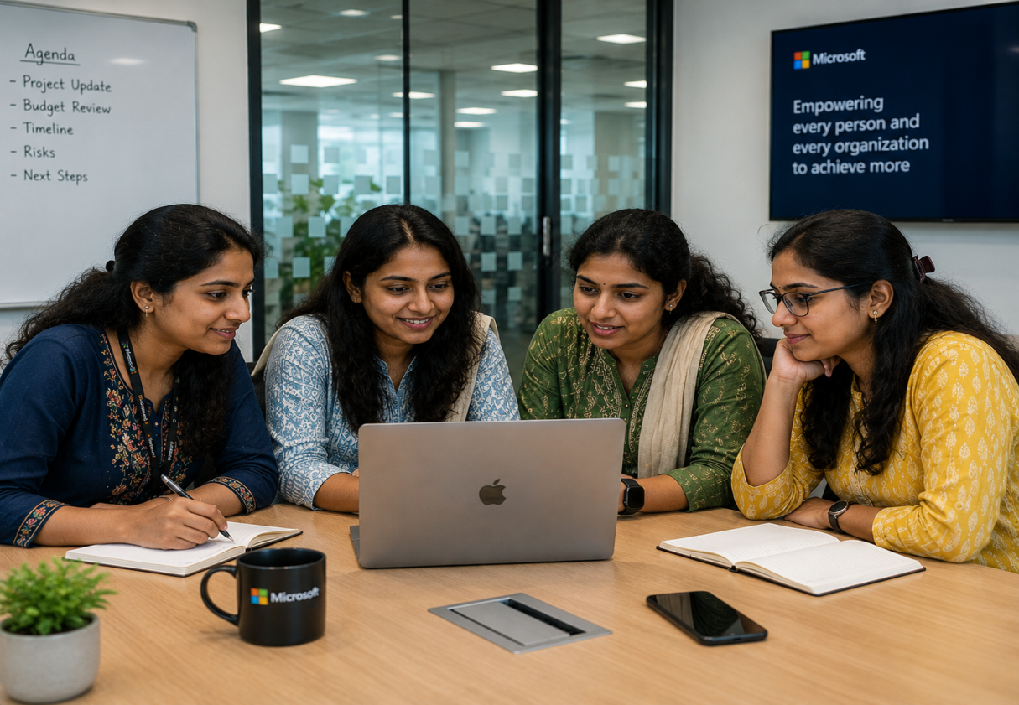
Prompt3: Generate an image you are a andhra wommen working in feild keeping paddy in agricultural land the image should be natural
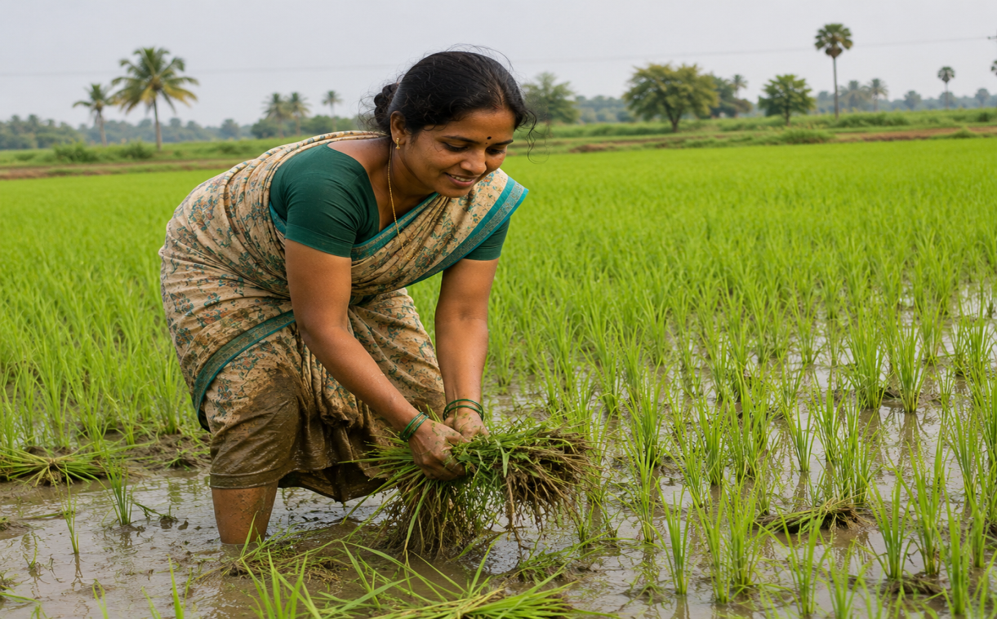
Prompt4:Generate a image where the students are chit chating and seeing phone while class is going on in the class room the students should face to the class board
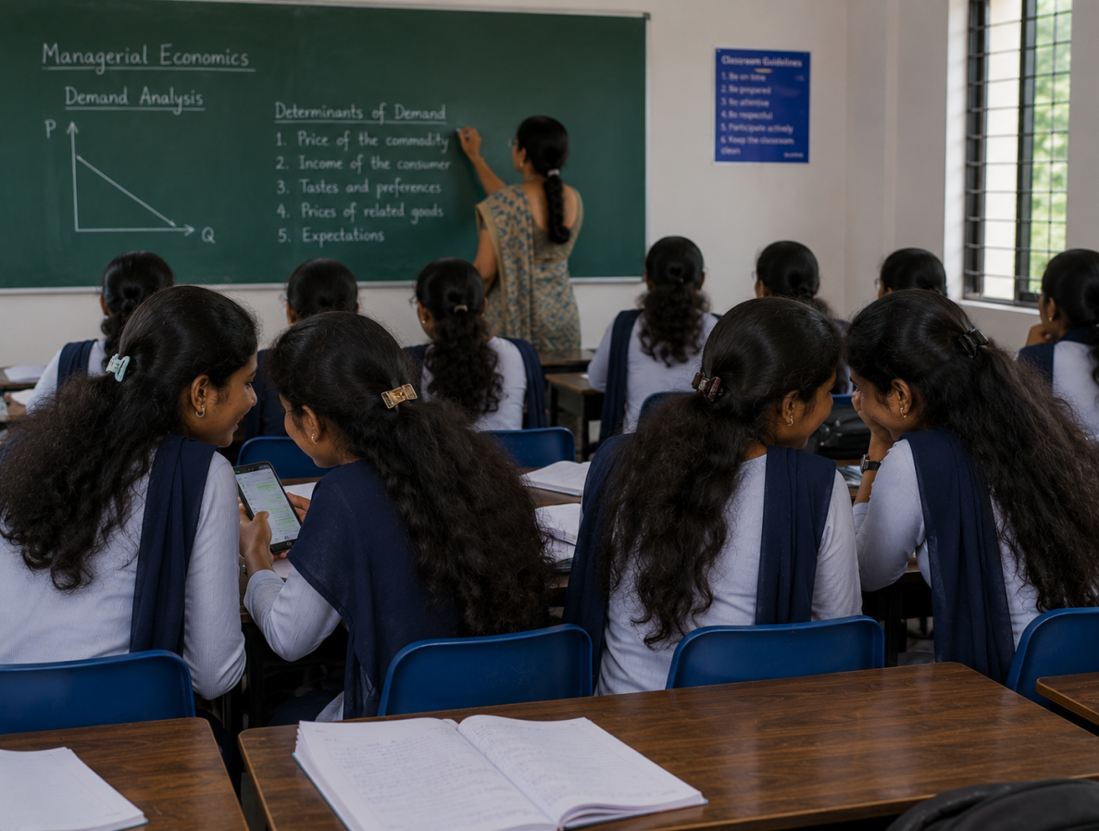
Prompt5: Generate a image virat kohili is bowling in the cricket match in the stadium
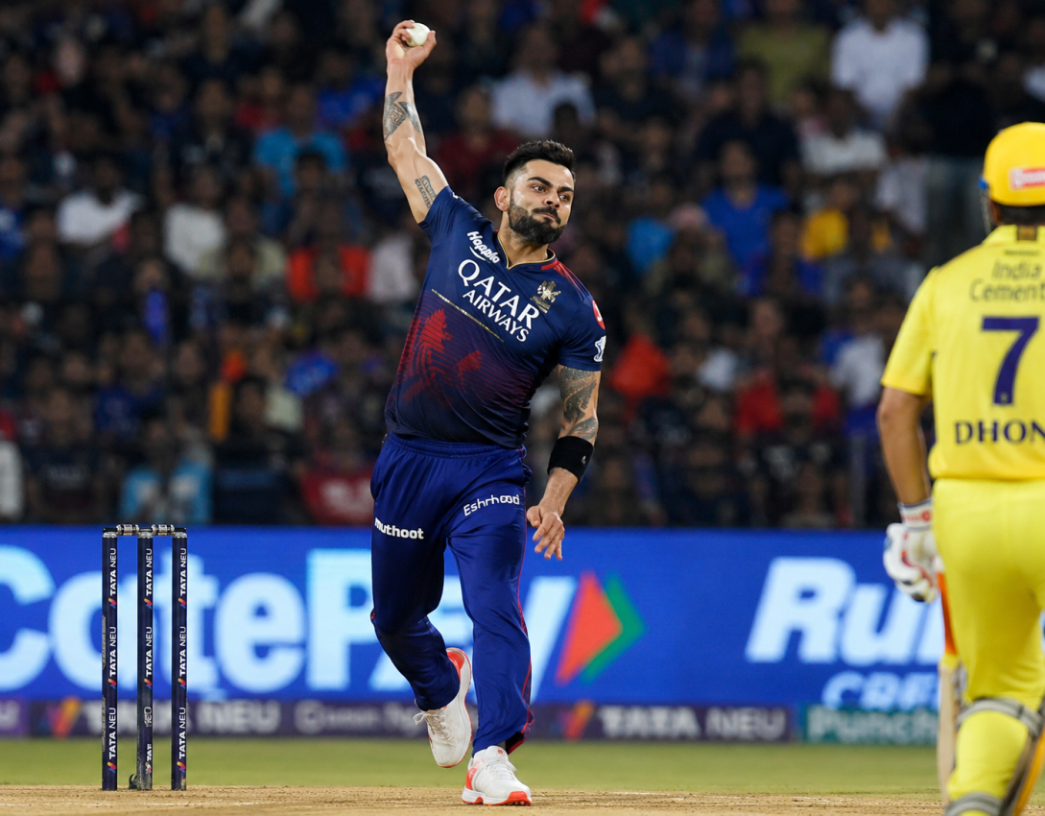
Prompt6: Generate a image virat kohili is bowling batting and wicket keeping in the cricket match in the stadium in one photo in grid format with jersy no in batting
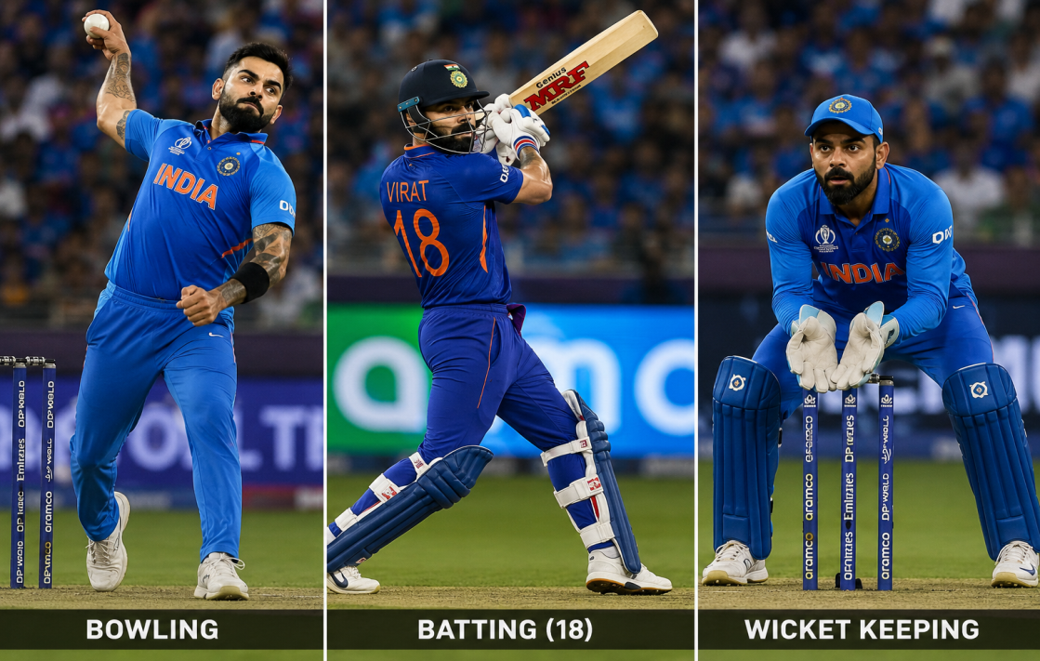
Prompt7:Generate a image india won the match and holding campian cup in stadium with all players end of the match

