Arunabha Majumder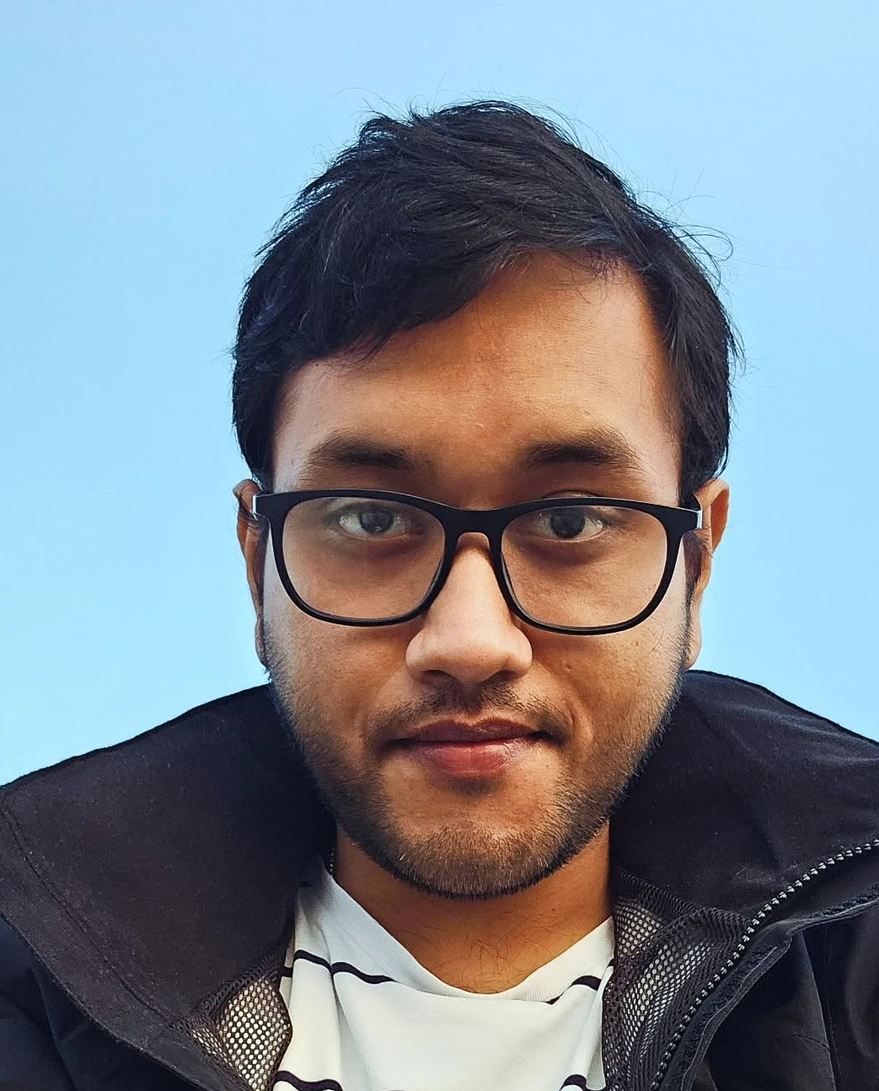
Mechanical Engineer | Mechanical Design, SolidWorks, Prototyping and Testing
+45 71 62 24 00 | Aalborg, Denmark
somrkmv1997@gmail.com | 97arunabhasit027@gmail.com
Portfolio: arunabha22.github.io/arunabha-majumder
LinkedIn: linkedin.com/in/arunabha-majumder-681264107
PROFILE
Mechanical engineer who designs, builds and tests mechanical systems, with a focus on saving energy. My main project is a hybrid shoulder exoskeleton that uses a spring to carry most of the load so a small motor is enough, cutting energy use by more than 25%. I work in SolidWorks from hand sketch to drawings, build prototypes and test rigs, and check designs with real measurements. PhD in Mechatronics and Robotics at Aalborg University (thesis expected March).
CORE SKILLS
- CAD: SolidWorks (CSWA): parts, assemblies, 2D technical drawings, Design for Assembly
- Prototyping: 3D printing (Bambu Lab, Ultimaker Cura), iterative prototypes, custom test rigs, troubleshooting
- Integration: Motor, encoder and force sensor integration; Arduino; MATLAB/Simulink
- Testing: Qualisys motion capture and data acquisition, Forsentec force/torque sensors, user trials
- Sketching and visuals: Hand sketching of concepts, technical illustrations (Adobe Illustrator, Photoshop, Procreate)
PROFESSIONAL EXPERIENCE
Research Engineer, Shoulder Exoskeleton (PhD project VIEXO) | 2023 - Present
Aalborg University, Aalborg, Denmark
- Came up with and designed a hybrid shoulder exoskeleton where a spring carries most of the arm load and a small 6 Nm motor adds the rest; it cut energy use by more than 25% (Best Paper Award, IFToMM ISRM 2026).
- Owned the mechanical design from hand sketches to SolidWorks models and drawings, then 3D printed and rebuilt parts many times to improve fit, strength and ease of assembly.
- Integrated the motor, encoder and force sensors into the frame and worked with control and software colleagues to get it running as one system; built custom test rigs.
- Collected data from 12 participants (EMG with the Qualisys data acquisition system and motion capture).
- Worked in a team of 3 on an Assist-as-Needed controller (my part: equations such as the Fourier fit, and defining how the GUI should behave); muscle effort dropped by more than 15%.
- Estimated tip force on a 5-bar parallel robot from its variable-stiffness actuators (within 10% RMS error vs a force sensor), so no extra sensor was needed; built an Arduino-based trigger to sync robot motion with Qualisys cameras for arm impedance tests (6 participants).
- Taught university courses and supervised Bachelor's students (2023 - 2025).
MTech Researcher, Pneumatic Artificial Muscles (Master's thesis) | 2020 - 2022
CSIR-Central Mechanical Engineering Research Institute (CMERI), Durgapur, India
- Fabricated and assembled pneumatic muscles to an existing lab design, collected test data on the lab's setup and used it to design the outer PID loop of a gain-scheduled controller (0.3-0.78% position error, IEEE CONECCT 2022).
Bachelor's Capstone, Upper-Limb Rehabilitation Exoskeleton | 2018 - 2019
Siddaganga Institute of Technology, Tumakuru, India
- Led CAD design, machining, assembly and testing; Best Major Project Award and an INR 100,000 TATA Technologies Innovation Grant.
- Student teams: built a Go-Kart (2017) and an Efficycle hybrid vehicle (2018).
EDUCATION
PhD, Mechatronics and Robotics (defence expected in 2027) | 2023 - Present
Aalborg University, Department of Materials and Production, Denmark
Study abroad, National University of Singapore (NUS), Sep - Nov 2025
MTech, Mechatronics | 2020 - 2022
AcSIR - CSIR-CMERI, Durgapur, India
BTech, Mechanical Engineering | 2015 - 2019
Siddaganga Institute of Technology (VTU), India
Diploma in Fine Arts (Painting)
Bangiya Sangeet Parishad, India
AWARDS AND PUBLICATIONS
- Best Research Paper Award, 9th IFToMM ISRM (2026); Certified SolidWorks Associate (CSWA); Best Major Project Award and TATA Technologies Innovation Grant (2019)
- Majumder, A., et al. "A Hybrid Actuated Shoulder Exoskeleton for Energy-Efficient Upper Arm Support." ISRM 2026, Springer. Also IEEE CONECCT 2022.
LANGUAGES
English (C1), Bengali (native), Hindi (spoken)
REFERENCES
Available upon request.

