Arunabha Majumder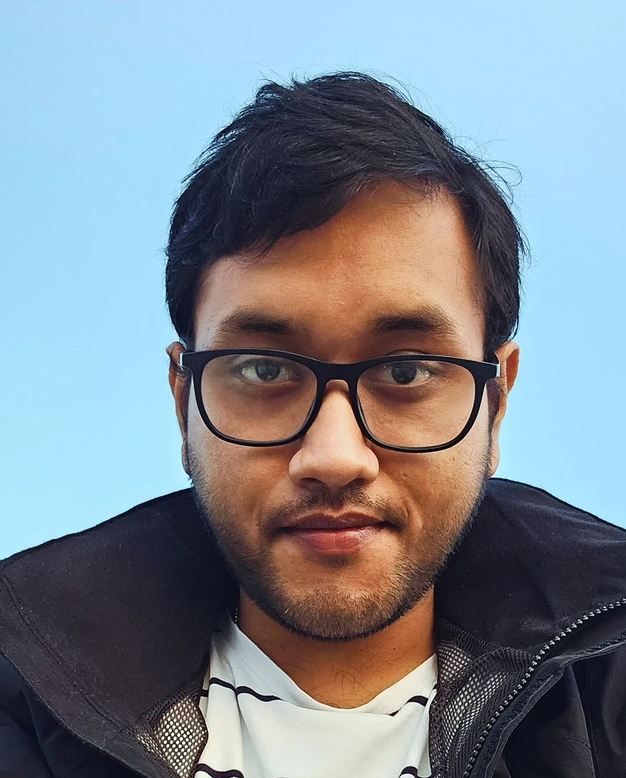
Design Engineer | Product Design, Visual Concepts, Prototyping
+45 71 62 24 00 | Aalborg, Denmark
somrkmv1997@gmail.com | 97arunabhasit027@gmail.com
Portfolio: arunabha22.github.io/arunabha-majumder
LinkedIn: linkedin.com/in/arunabha-majumder-681264107
PROFILE
Design engineer with a mechanical engineering background and a Diploma in Fine Arts (Painting). I take products from a hand sketch to CAD, prototypes and user testing, and I care about how a product looks and feels in people's hands as much as whether it works. I am finishing my PhD in Mechatronics and Robotics at Aalborg University (thesis expected March).
CORE SKILLS
- Design and visuals: Concept sketching, visual design, Adobe Illustrator, Adobe Photoshop, Procreate
- CAD: SolidWorks (CSWA), 3D modelling, technical drawings, Design for Assembly
- Prototyping and testing: 3D printing (Bambu Lab, Ultimaker Cura), prototypes, test rigs, user testing
- Communication: Presenting design choices to engineers, clinicians, students and conference audiences
PROFESSIONAL EXPERIENCE
Research Engineer, Product and Actuator Development (PhD project VIEXO) | 2023 - Present
Aalborg University, Aalborg, Denmark
- Designed a hybrid shoulder exoskeleton where a spring carries most of the arm load and a small 6 Nm motor adds the rest; it cut energy use by more than 25% (Best Paper Award, IFToMM ISRM 2026).
- Took the design from hand sketches to SolidWorks models and drawings, then 3D printed and rebuilt parts many times, improving fit, comfort and strength after each round of testing.
- Integrated the motor, encoder and force sensors into the frame and built custom test rigs.
- Collected data from 12 participants across 3 assistance modes and 2 loads using EMG (Qualisys data acquisition) and motion capture, so the design could be judged on real users.
- Worked in a team of 3 on an Assist-as-Needed controller (my part: equations such as the Fourier fit, and defining how the GUI should behave for the user); muscle effort dropped by more than 15%.
- Removed the need for a force sensor at the tip of a 5-bar parallel robot by estimating force from its variable-stiffness actuators (within 10% RMS error), cutting cost and mass; implemented an Arduino-based trigger to sync robot motion with Qualisys motion capture for arm impedance tests (6 participants).
- Taught and supervised Bachelor's students (2023 - 2025) and presented work at international conferences.
MTech Researcher, Pneumatic Artificial Muscles (Master's thesis) | 2020 - 2022
CSIR-Central Mechanical Engineering Research Institute (CMERI), Durgapur, India
- Fabricated and assembled pneumatic muscles to an existing lab design, collected test data on the lab's setup and used it to design the outer PID loop of a gain-scheduled controller (0.3-0.78% position error, IEEE CONECCT 2022).
Bachelor's Capstone, Upper-Limb Rehabilitation Exoskeleton | 2018 - 2019
Siddaganga Institute of Technology, Tumakuru, India
- Led CAD design, machining, assembly and user testing; Best Major Project Award and an INR 100,000 TATA Technologies Innovation Grant.
EDUCATION
PhD, Mechatronics and Robotics (defence expected in 2027) | 2023 - Present
Aalborg University, Department of Materials and Production, Denmark
Study abroad, National University of Singapore (NUS), Sep - Nov 2025
MTech, Mechatronics | 2020 - 2022
AcSIR - CSIR-CMERI, Durgapur, India
BTech, Mechanical Engineering | 2015 - 2019
Siddaganga Institute of Technology (VTU), India
Diploma in Fine Arts (Painting)
Bangiya Sangeet Parishad, India
TOOLS
- Visual: Adobe Illustrator, Adobe Photoshop, Procreate
- CAD and making: SolidWorks, 3D printing (Bambu Lab, Ultimaker Cura)
- Software: MATLAB/Simulink, Arduino, LaTeX; Python and LabVIEW (basic)
- Testing: Qualisys motion capture and data acquisition, Forsentec force/torque sensors
AWARDS AND PUBLICATIONS
- Best Research Paper Award, 9th IFToMM ISRM (2026); Certified SolidWorks Associate (CSWA); Best Major Project Award and TATA Technologies Innovation Grant (2019)
- Majumder, A., et al. "A Hybrid Actuated Shoulder Exoskeleton for Energy-Efficient Upper Arm Support." ISRM 2026, Springer. Also IEEE CONECCT 2022.
LANGUAGES AND INTERESTS
- English (C1), Bengali (native), Hindi (spoken), Danish (willing to learn)
- Painting and illustration; built a Go-Kart (2017) and an Efficycle hybrid vehicle (2018) with student teams
REFERENCES
Available upon request.

