Arunabha Majumder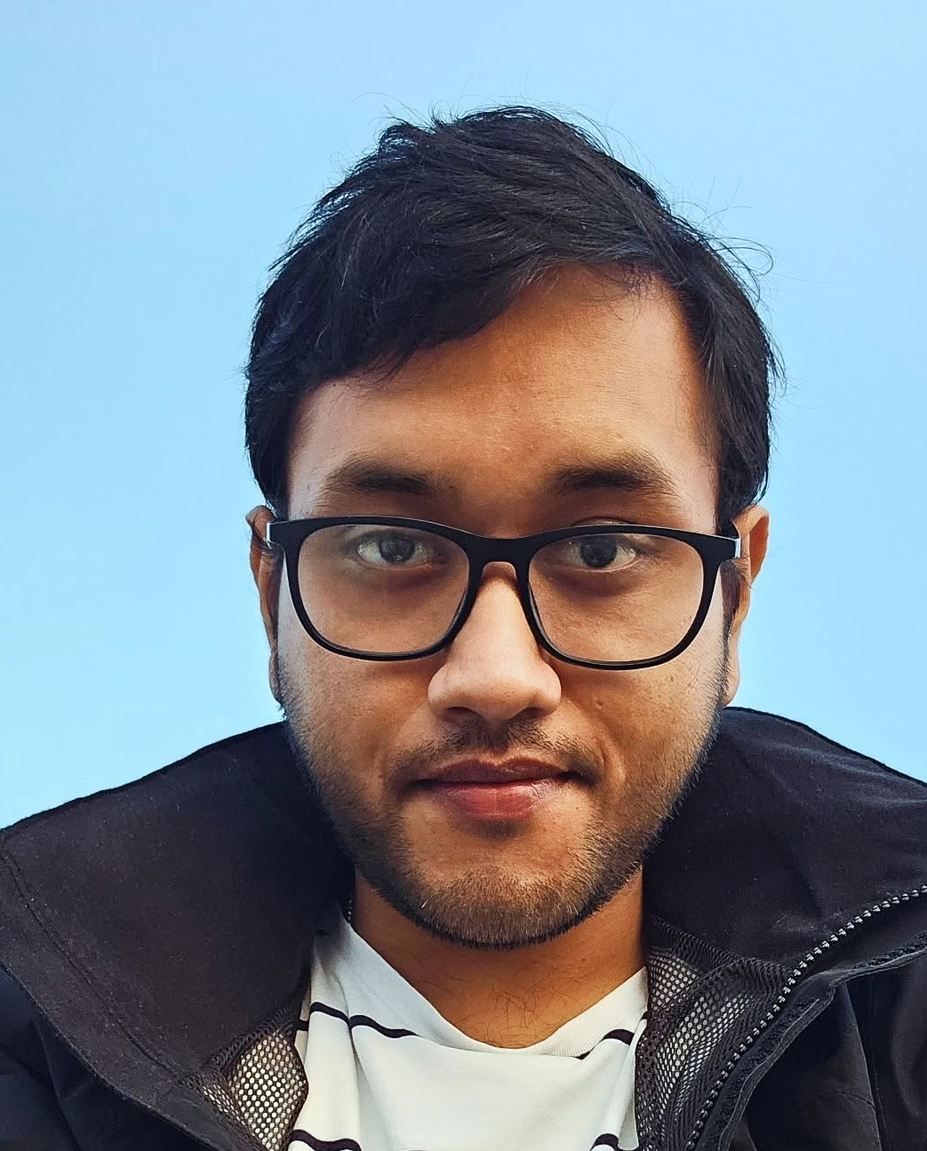
Mechanical Design Engineer
+45 71 62 24 00 | Aalborg, Denmark
somrkmv1997@gmail.com | 97arunabhasit027@gmail.com
Portfolio: arunabha22.github.io/arunabha-majumder
LinkedIn: linkedin.com/in/arunabha-majumder-681264107
PROFILE
Mechanical design engineer who turns ideas into 3D models, drawings, prototypes and engineering reports. For 3 years I have owned the mechanical design of a motor-assisted shoulder exoskeleton, from concept to tested hardware, including stiffness analysis in SolidWorks and design optimisation with a genetic algorithm. I work well across disciplines and explain designs clearly with sketches and reports. PhD in Mechatronics and Robotics at Aalborg University (thesis expected March).
CORE SKILLS
- CAD: SolidWorks (CSWA): 3D models, assemblies, 2D technical drawings, Design for Assembly
- Analysis and optimisation: Stiffness analysis in SolidWorks; design optimisation with a genetic algorithm
- Prototyping: 3D printing (Bambu Lab, Ultimaker Cura), iterative prototypes, custom test rigs, troubleshooting
- Integration: Motor, encoder and force sensor integration; Arduino; MATLAB/Simulink
- Testing: Qualisys motion capture and data acquisition, Forsentec force/torque sensors, user trials
- Sketching and visuals: Hand sketching of concepts, technical illustrations (Adobe Illustrator, Photoshop, Procreate)
PROFESSIONAL EXPERIENCE
Research Engineer, Shoulder Exoskeleton (PhD project VIEXO) | 2023 - Present
Aalborg University, Aalborg, Denmark
- Came up with and designed a hybrid shoulder exoskeleton where a spring carries most of the arm load and a small 6 Nm motor adds the rest; it cut energy use by more than 25% (Best Paper Award, IFToMM ISRM 2026).
- Owned the mechanical design from hand sketches to SolidWorks models and drawings, then 3D printed and rebuilt parts many times to improve fit, strength and ease of assembly.
- Optimised the exoskeleton design with a genetic algorithm and checked part stiffness with stiffness analysis in SolidWorks.
- Integrated the motor, encoder and force sensors into the frame and worked with control and software colleagues to get it running as one system; built custom test rigs.
- Collected data from 12 participants (EMG with the Qualisys data acquisition system and motion capture).
- Worked in a team of 3 on an Assist-as-Needed controller (my part: equations such as the Fourier fit, and defining how the GUI should behave); muscle effort dropped by more than 15%.
- Estimated tip force on a 5-bar parallel robot from its variable-stiffness actuators (within 10% RMS error vs a force sensor), so no extra sensor was needed; built an Arduino-based trigger to sync robot motion with Qualisys cameras for arm impedance tests (6 participants).
- Taught university courses and supervised Bachelor's students (2023 - 2025).
MTech Researcher, Pneumatic Artificial Muscles (Master's thesis) | 2020 - 2022
CSIR-Central Mechanical Engineering Research Institute (CMERI), Durgapur, India
- Fabricated and assembled pneumatic muscles to an existing lab design, collected test data on the lab's setup and used it to design the outer PID loop of a gain-scheduled controller (0.3-0.78% position error, IEEE CONECCT 2022).
Bachelor's Capstone, Upper-Limb Rehabilitation Exoskeleton | 2018 - 2019
Siddaganga Institute of Technology, Tumakuru, India
- Led CAD design, machining, assembly and testing; Best Major Project Award and an INR 100,000 TATA Technologies Innovation Grant.
- Student teams: built a Go-Kart (2017) and an Efficycle hybrid vehicle (2018).
EDUCATION
PhD, Mechatronics and Robotics (defence expected in 2027) | 2023 - Present
Aalborg University, Department of Materials and Production, Denmark
Study abroad, National University of Singapore (NUS), Sep - Nov 2025
MTech, Mechatronics | 2020 - 2022
AcSIR - CSIR-CMERI, Durgapur, India
BTech, Mechanical Engineering | 2015 - 2019
Siddaganga Institute of Technology (VTU), India
Diploma in Fine Arts (Painting)
Bangiya Sangeet Parishad, India
AWARDS AND PUBLICATIONS
- Best Research Paper Award, 9th IFToMM ISRM (2026); Certified SolidWorks Associate (CSWA); Best Major Project Award and TATA Technologies Innovation Grant (2019)
- Majumder, A., et al. "A Hybrid Actuated Shoulder Exoskeleton for Energy-Efficient Upper Arm Support." ISRM 2026, Springer. Also IEEE CONECCT 2022.
LANGUAGES
English (C1), Bengali (native), Hindi (spoken)
REFERENCES
Available upon request.

