

**Doctor Appointment Management Software**



**Software Requirements Specification (SRS) Document**

**Group - 1**

**Document Control :**

| **Project Revision History** | | | | | | | | |
| --- | --- | --- | --- | --- | --- | --- | --- | --- |
|  |  |  | |  |  |  |  |  |
| **Date** | **Version** | **Author** | **Brief Description of Changes** | | | | **Approver Signature** | |
| 27/10/2022 |  | Group - 1 | Basic design and documentation | | | |  | |
|  |  |  |  | | | |  | |

| **Team Members** |
| --- |

| **Employee ID:** | **Name** |
| --- | --- |
| 46275106 | Abburi Harshitha Chowdary |
| 46274550 | Alok Kumar Sahu |
| 46274781 | Amisha Bharti |
| 46274780 | Aparna |
| 46274551 | Arunabha Sarkar |

|  | | | |  |  |  |  |
| --- | --- | --- | --- | --- | --- | --- | --- |
|  |  |  | **Table of Contents** | |  |  |  |
| 1. | Introduction | | | |  |  | 4 |
|  | 1.1 | Purpose | | |  |  | 4 |
|  | 1.2 | Scope | | |  |  | 4 |
|  | 1.3 | Definitions, Acronyms, and Abbreviations | | |  |  | 4 |
|  | 1.4 | References | | |  |  | 5 |
|  | 1.5 | Overview | | |  |  | 5 |
| 2. | Overall Description | | | |  |  | 5 |
| 3. | Specific Requirements | | | |  |  | 6 |
|  | 3.1 | Functionality | | |  |  | 6 |
|  |  |  | 3.1.1DAMS_01 Doctor Registration | |  |  | 6 |
|  |  |  | 3.1.2DAMS_02 Receptionist | |  |  | 6 |
|  |  |  | 3.1.3 DAMS_03 Admin | |  |  | 6 |
|  |  |  |  | |  |  |
|  | 3.2 | Usability | | |  |  | 6 |
|  | 3.3 | Reliability & Availability | | |  |  | 6 |
|  |
|  | 3.4 | Security | | |  |  | 7 |
|  | 3.5 | Supportability | | |  |  | 7 |
|  | 3.6 | Design Constraints | | |  |  | 7 |
|  | 3.7 | Use Case Diagram | | |  |  | 7 |
|  | 3.8 | On-line User Documentation and Help System Requirements | | |  |  | 8 |
|  | 3.9 | 0 | Purchased Components | |  |  | 8 |
|  | 3.10 Interfaces | | | |  |  | 8 |
|  | 3.11 | | Licensing Requirements | |  |  | 8 |
|  | 3.12 | | Legal, Copyright, and Other Notices | |  |  | 8 |
|  | 3.13 Applicable Standards | | | |  |  | 8 |
| 4. | Supporting Information | | | |  |  | 8 |

**Software Requirements Specification**

1. **Introduction**

The introduction of the Software Requirements Specification (SRS) provides an overview of the entire SRS with purpose, scope, definitions, acronyms, abbreviations, references and overview of the SRS. The aim of this document is to gather, analyze and give an in-depth insight into the complete Doctor Appointment Management Software by defining all the requirements in detail.

**1.1 Purpose**

Purpose of this document is to describe the requirement to provide Doctor Appointment to the patient by receptionist. It aims to provide the appointment to the doctor related to their specific designation.

**1.2 Scope**

In this project the Doctor Appointment Management Software will allow to take the appointment of doctor by the receptionist to connect to the patient related to the doctor designation.

**1.3 Definitions, Acronyms, and Abbreviations**

| DAMS | Doctor Appointment Management Software |
| --- | --- |
| SRS | Software Requirement Specification |
|  |  |

**1.4 References**

1. System Requirements Specification Document

**1.5 Overview**

The remaining sections of this document provide a general description, including characteristics of the users of this project, functionalities, and other requirements of the proposed system such as functional requirements, supporting information etc.

1. **Overall Description**

Doctor appointment management system tracks doctors database and patients database, It is a file that is made on the basis of daily registration of patient, including Patient name, patient Id, and patient illness, and admin appointed the doctor according to their illness.

The details of the doctor are stored in the doctor database and details of the patient are stored in the patient database. The doctor database is controlled by the admin only, admin will update the details of the doctor and admin can see the appointments of the doctor. Receptionist stores all the details about the patients like name, phone number..etc.

1. **Specific Requirements**

The specific requirements are –

**3.1 Functionality**

**3.1.1. DAMS_01 Doctor Registration:**

A doctor can register by entering the details, doctor name, doctor Id and doctor designation, doctor phone number and whole database of the doctor controlled by admin only.

           The details are stored in the doctor database which will access by the doctor and

           the admin

**3.1.2. DAMS_02 The Receptionist**:

Receptionist stores all the details of patient like patient name, patient phone number and the patient illness in the patient database.

Admin will be presented with a list of available doctors with their designation, On selection of doctor designation patient appointment is confirmed with the specific doctor, and then these details are stored in a transaction file.

**3.1.3. DAMS_03 The Admin:**

             The admin can access this part of the system after logging in with a password.

1. When Receptionist will enter the details of patients like Patient name, Patient phone number, Patient illness, will be access by the admin and admin is going to provide the appointment with the doctor related to their illness like fever, cold, cough .. etc

1. When Doctor will enter the details like doctor name, doctor phone number, doctor designation it will be access by the admin and admin will appoint the patient to the doctor related to their designation.

**3.2 Usability**

The system is user-friendly by providing doctor appointment to patient by the admin.

**3.3 Reliability & Availability**

The system is available when the user is requested for service.

The system is available 24/7.

**3.4 Security**

NA

**3.5 Supportability**

The system is easy to maintain.

**3.6 Design Constraints**

The system is built using only C language.

**3.7 Use Case Diagram**

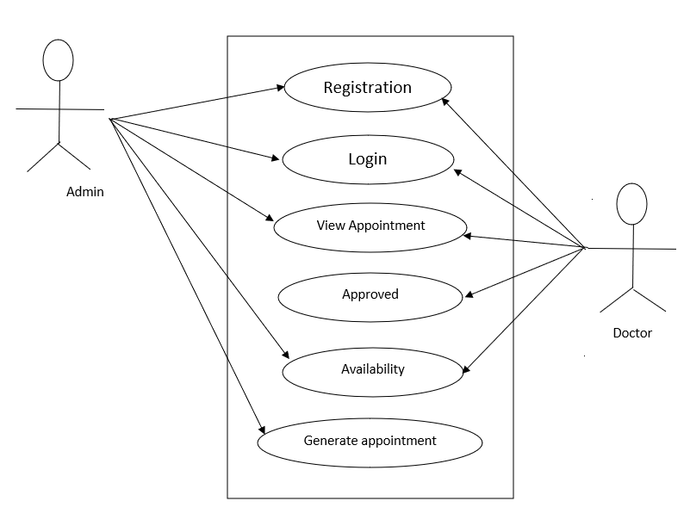

**3.8 On-line User Documentation and Help System Requirements**

Internet Connection, Desktop with Linux Terminal.

**3.9 Purchased Components**

Not Applicable.

**3.10 Interface**

File System Interface

**3.11 Licensing Requirements**

Not Applicable.

**3.12 Legal, Copyright, and Other Notices**

All rights reserved.

**3.13 Applicable Standards**

It shall be as per the industry standard.

1. **Supporting Information**

1.User case