Parquet has a few structural advantages over CSV that matter once your data gets beyond toy size.
The biggest one is that Parquet is columnar rather than row-based. It stores all the values for a given column together on disk, so if a query only needs a few columns out of a wide table, it can skip reading the rest entirely. CSV, being row-oriented, forces you to read every field of every row even if you only care about one column.
That columnar layout also enables much better compression, since values within a column tend to be similar in type and often in content (repeated strings, similar numbers), which compresses far more efficiently than mixed row data. It's common to see Parquet files be a fraction of the size of the equivalent CSV, sometimes 5-10x smaller.
Parquet also stores a schema and data types with the file itself: integers, floats, dates, booleans, nested structures, and so on are all preserved exactly. CSV is just text, so every reader has to guess types (is "01/02/03" a date? is "007" a string or a number?), and those guesses are a common source of subtle bugs. Related to this, Parquet supports nested and complex data (lists, structs, maps) natively, which CSV can't represent cleanly at all.
Performance-wise, Parquet files carry metadata like min/max statistics per column chunk, which lets query engines (Spark, DuckDB, Athena, BigQuery, etc.) skip entire chunks of data that can't match a filter, something CSV can't support since it has no internal structure to exploit. Reading and writing Parquet is also generally faster for large datasets because of this predicate pushdown plus the reduced I/O from columnar access and compression.
The tradeoffs worth knowing: Parquet isn't human-readable in a text editor, it requires a library to read/write (pandas, pyarrow, Spark, etc., rather than any text tool), and for very small datasets or simple one-off exports, CSV's simplicity and universal compatibility can still be the more practical choice.
- Columnar storage: Parquet stores data in a columnar format for efficient compression and encoding schemes. This leads to better storage use and faster query performance, especially for queries that only access a subset of columns.
- Predicate pushdown: Parquet supports predicate pushdown. Queries can skip reading unnecessary data by filtering data at the file level based on specific conditions. This feature improves query performance.
- Compression: Parquet supports various compression codecs, such as Snappy, Gzip, and LZO. This feature can significantly reduce the storage footprint of the data.
- Schema evolution: Parquet supports schema evolution, which adds or removes of columns without rewriting the entire dataset. Parquet is suitable for schema changes over time.
- Parallel processing: Parquet's columnar format and efficient encoding schemes make it well-suited for parallel processing frameworks like Apache Spark, which results in faster data processing and analysis.
When denormalizing data, it's essential to consider factors such as data volume, query patterns, and performance requirements. Denormalization can significantly improve query performance by reducing the need for complex joins and minimizing the amount of data scanned during queries. However, it can also result in data duplication and increased storage requirements.

The key steps in denormalizing relational data include the following:
- Data extraction: Extract the relevant data from the relational database, typically using SQL queries or database connectors.
- Data transformation: Flatten the normalized data by joining related tables and embedding related data into a denormalized structure. This process can involve techniques like data duplication, creating nested or repeated fields, and pivoting data.
- Data formatting: Convert the denormalized data into a format optimized for analytical processing, such as Apache Parquet or Apache ORC. These columnar formats provide efficient storage and querying capabilities for large datasets.
- Data partitioning and bucketing: Partition and bucket the denormalized data based on specific criteria, such as date or product category, to improve query performance and optimize storage.
- Data cataloging: Catalog the denormalized data in a metadata store like Data Catalog, including schema information, partitioning details, and data lineage.
- Data loading: Load the denormalized data into a data lake, such as Amazon S3, or a data warehouse, such as Amazon Redshift, for downstream analytical processing and consumption.
Schema evolution in Parquet means you can change a table's structure over time, adding columns, widening types, sometimes dropping columns, without having to rewrite every historical file to match the new shape. The trick is that each Parquet file carries its own schema in its footer metadata, and readers match columns by name rather than by position, so files with different (but compatible) schemas can coexist in the same dataset and get reconciled at read time.
Let's walk through a concrete example. Say you have an orders table, and back in January you write a file with this schema:
orders_2026_01.parquet
order_id: int64
customer: string
amount: double
In February, the business adds a promo system, so new files start including a discount_code column:
orders_2026_02.parquet
order_id: int64
customer: string
amount: double
discount_code: string
Both files sit in the same folder as part of one logical "orders" dataset. When a query engine reads across both, it looks at each file's own schema and lines columns up by name. For the January file, which has no discount_code column at all, it simply fills that column with null for every row from that file. For the February file, it reads the real values. You never touched the old file, and the query still returns a consistent four-column result.
A wrinkle here is that many engines don't do this reconciliation automatically unless told to, because assuming a fixed shared schema is faster. Spark, for example, requires you to explicitly set mergeSchema to true when reading a Parquet dataset with varying files, otherwise it may just use one file's schema (often the first or most recent) and ignore or error on the rest. Table formats built on top of Parquet, like Delta Lake and Iceberg, handle this more gracefully by tracking the logical schema centrally as a first-class concept, so evolution is explicit and versioned rather than inferred purely from whatever files happen to be sitting in storage.
Type changes work similarly but with narrower rules. Widening a type, like storing amount as float32 in old files and switching to float64 in new ones, or int32 to int64, is typically considered safe because the new type can represent every value the old type could. Readers can upcast automatically. Going the other direction, like narrowing double to float, is unsafe because it can lose precision, so it's generally not allowed as an automatic evolution; you'd need to explicitly cast or rewrite.
Renaming columns is the case that trips people up. Plain Parquet matches by name, so if you rename customer to customer_name in new files, the reader sees this as one column being dropped and a new, unrelated one being added; old files show null for customer_name and new files show null for customer. To handle true renames correctly, you need field IDs, a feature Parquet supports and that Iceberg in particular relies on, where each column gets a stable numeric ID at creation time that persists even if the column name changes later, so the engine can tell "this is the same column, just relabeled" rather than treating it as drop-plus-add.
So the short version: Parquet enables evolution by embedding schema per file and matching on name (or ID, when tracked), which lets additions and safe type widenings blend cleanly across old and new data, while renames and narrowing changes need extra tooling or table-format support to behave the way you'd actually want.

Question - in what cases you will choose ORC ? is parquet always efficient over ORC ? Any other data format out there?
ORC and Parquet are close cousins, both columnar, both splittable, both support compression and predicate pushdown, and the honest answer is that for most general-purpose analytics workloads today the choice is more about ecosystem than raw efficiency. That said, there are real differences worth knowing.
ORC (Optimized Row Columnar) grew up inside the Hive ecosystem and is still the more natural fit there. It tends to have an edge in a few specific situations. It has built-in, more granular indexing, with min/max statistics not just at the file level but at smaller "index stride" chunks within a stripe, plus optional bloom filters per column that you can enable explicitly. That makes point lookups and highly selective filters (like "give me the one row where user_id equals X out of a billion rows") often faster in ORC than in Parquet, because it can skip more aggressively. ORC also historically has had stronger native support for ACID transactions in Hive (insert, update, delete, merge), which matters if you're doing mutable tables directly in Hive rather than using a table format layer. And in some benchmarks, ORC's default compression (it favors Zlib/Zstd with its own encoding scheme) edges out Parquet slightly on certain highly repetitive columnar data, though this varies a lot by dataset.
So concretely, you'd lean toward ORC if you're deep in the Hive/Presto-on-Hive/older Hadoop stack where it's the native default, if you need Hive's built-in ACID merge/update/delete semantics without bolting on a separate table format, or if your access pattern is dominated by highly selective point queries where bloom filters help a lot.
Is Parquet always more efficient than ORC? No, and it's also not always less efficient, it genuinely depends on the data shape and query pattern. Parquet tends to win on ecosystem breadth: it's the default or best-supported format in Spark, Snowflake, BigQuery, Athena, DuckDB, pandas/Arrow, and it's the format underneath both Delta Lake and Iceberg, which are where most new lakehouse architectures are standardizing. For wide analytical scans, aggregations across many columns, and general interoperability across tools written in different languages, Parquet usually has the edge simply because more engines have deeply optimized Parquet readers, and Arrow gives it a very fast in-memory bridge. For compression ratio specifically, the two are usually within a few percent of each other; whichever wins depends more on the encoding chosen (dictionary vs run-length vs delta) and the compression codec (Snappy, Zstd, Gzip) than on the container format itself.
Beyond those two, there are a few other formats worth knowing depending on what you're optimizing for. Avro is row-based rather than columnar, which makes it a poor fit for analytical scans but a great fit for write-heavy, schema-evolving streaming pipelines, it's the standard serialization format for Kafka messages, and it has very robust, well-defined schema evolution rules built in from the start. Feather/Arrow IPC is essentially the on-disk form of Apache Arrow's in-memory columnar format, optimized for extremely fast reads and zero-copy sharing between processes, useful for short-lived data exchange rather than long-term storage, since it doesn't compress as well as Parquet or ORC. Delta Lake and Iceberg (and Hudi) aren't file formats themselves but table formats layered on top of Parquet, adding transactions, time travel, and proper schema evolution with metadata tracking, so in practice a lot of "should I use Parquet" decisions today are really "should I use raw Parquet or Parquet wrapped in Iceberg/Delta." And for niche cases, HDF5 and NetCDF remain common in scientific and numerical computing for large multidimensional array data (climate, genomics) rather than tabular business data, where Parquet's row-group model doesn't map as naturally.
Apache Arrow is worth understanding on its own because it solves a different problem than Parquet or ORC. Where Parquet and ORC are on-disk storage formats, meant for compact, persistent, compressed files sitting in cloud storage or HDFS, Arrow is an in-memory columnar format, meant for how data sits in RAM while a program is actively working on it. Its main purpose is to standardize that in-memory layout across languages and engines so that Python, Java, C++, Rust, Go, and R can all represent a columnar batch of data the exact same way in memory. That matters because historically, moving data between two systems, say a Python process and a JVM-based engine, required serializing to some intermediate format and deserializing on the other side, which is slow and wasteful. If both sides speak Arrow natively, they can often hand off the same memory buffers directly, sometimes with zero copying at all. This is why Arrow has become the backbone underneath a lot of modern tools: pandas 2.0's Arrow-backed dtypes, Polars, DuckDB, PySpark's vectorized UDFs, and the Parquet readers in most engines all decode Parquet's on-disk bytes into Arrow arrays before doing any actual computation on them. Feather is essentially Arrow's in-memory layout written to disk with minimal transformation, so it's extremely fast to read and write, but it doesn't compress as well as Parquet, making it better for short-lived data exchange than long-term storage.
A working comparison of row vs. columnar formats, on-disk vs. in-memory, and where table formats and Arrow sit in a real pipeline.

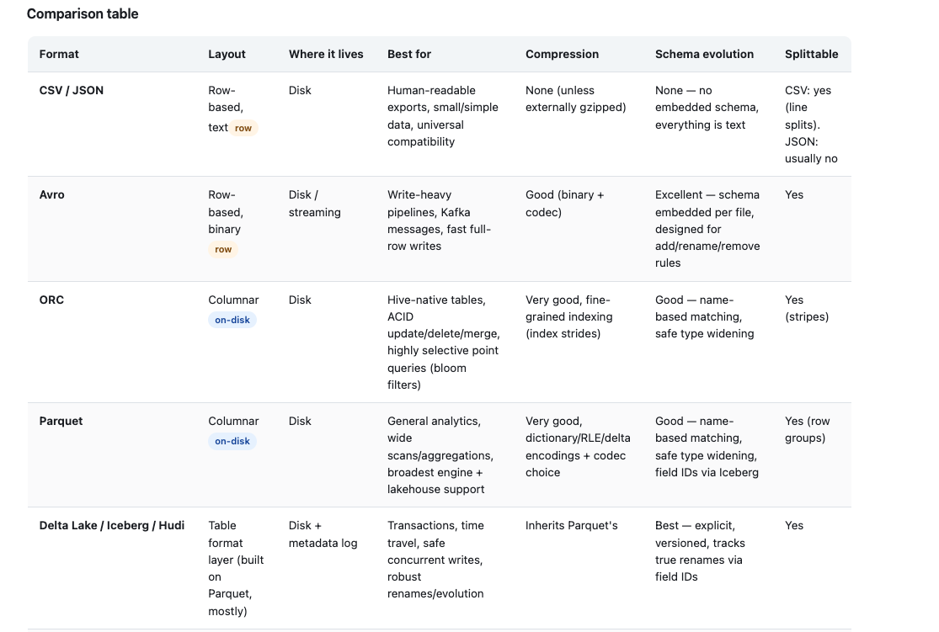
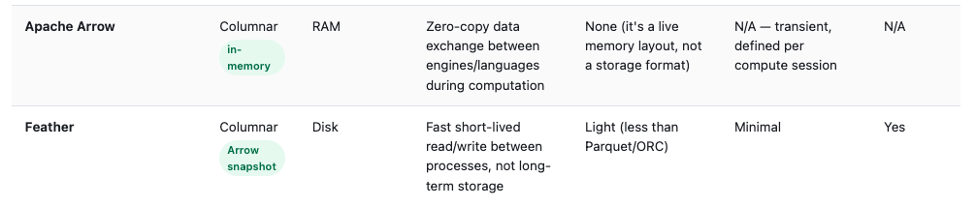
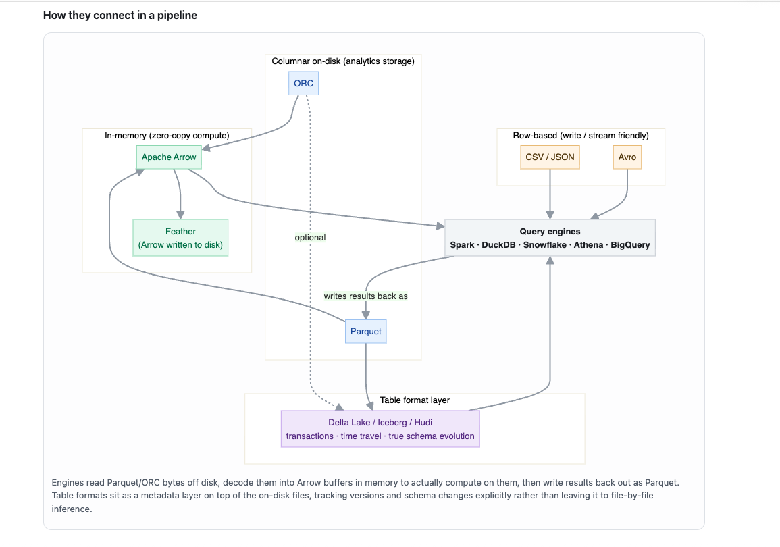The core distinction the diagram is built around: Parquet and ORC are two flavors of the same idea (compressed columnar files at rest), Avro and CSV are the row-based alternative optimized for writing rather than scanning, table formats like Iceberg and Delta wrap around Parquet/ORC to add transactions and proper versioned schema evolution, and Arrow is a different axis entirely, it's not competing for disk space at all, it's the shared in-memory representation that lets engines decode those on-disk files and hand data to each other without expensive conversion.
1. Is Delta Lake/Iceberg/Hudi a wrapper around ORC/Parquet to make them ACID?
Yes, that's essentially right, with one clarification: they don't modify the Parquet or ORC files themselves at all. Each individual file inside an Iceberg or Delta table is still just a completely normal, standalone Parquet file that any Parquet reader could open on its own. What these table formats add is a separate metadata layer sitting alongside the data files, typically a transaction log (Delta) or a set of manifest/snapshot files (Iceberg), that tracks which set of files currently constitutes "the table" at any given version. ACID behavior comes from how that metadata layer gets updated, not from the file format changing. A write operation writes new Parquet files, then atomically swaps a pointer in the metadata log to say "as of this commit, the table consists of these files." Readers always see a consistent snapshot because they resolve the table through that pointer, never by just listing whatever files happen to be in a folder. So it's fair to call it a wrapper, specifically a transactional bookkeeping layer wrapped around a collection of otherwise-ordinary Parquet (or ORC) files. One nuance: Delta Lake is essentially Parquet-only, Hudi is primarily Parquet with Avro used for its internal write-ahead logs, and Iceberg is the most flexible, it technically supports Parquet, ORC, or Avro as the underlying file format, though Parquet dominates in practice.
2. Does Avro/CSV get converted to Parquet/ORC for analytics, wrapped in something like Iceberg?
Yes, this is a very common real-world pattern, though not a strict rule. A typical flow: raw data lands first as Avro (common for Kafka streams) or CSV (common for exports/dumps from source systems), then an ETL or ingestion job reads that raw data and rewrites it as Parquet, often landing it directly into an Iceberg or Delta table so it gets versioning and transactional guarantees from the moment it becomes queryable. This is the idea behind the "bronze/silver/gold" or "raw/cleaned/curated" layering you'll see in lakehouse architectures: bronze is often close to the raw Avro/CSV/JSON, silver and gold are Parquet, usually under a table format. That said, it's not universal. Sometimes Avro stays as Avro forever because it's purely a streaming transport layer that never becomes a queryable analytical table, and sometimes CSV is just a one-time export nobody converts because nobody's running repeated analytical queries against it. The conversion happens specifically when something needs to be scanned and aggregated repeatedly at scale, that's when paying the one-time cost to convert into columnar format pays off.
3. Who converts into Arrow? What is Feather for? Who consumes it?
The conversion into Arrow happens automatically inside the reader itself, it's not a step you trigger separately. When PyArrow, DuckDB, Spark's vectorized reader, or any modern Parquet/ORC reader opens a file, decoding those on-disk bytes and materializing them as an in-memory columnar structure is the read operation, and that in-memory structure is Arrow (or an Arrow-equivalent layout). So "reading a Parquet file" and "getting Arrow record batches into memory" are effectively the same event happening under the hood.
Feather's purpose is speed of round-tripping, specifically minimizing the CPU cost of writing and reading. Parquet spends real computation on dictionary encoding, run-length encoding, and compression, which is worth it for long-term storage but adds overhead every time you read or write. Feather instead serializes Arrow's in-memory layout to disk with very little transformation, close to a raw memory dump, so writing and reading it is nearly as fast as a memcpy. The tradeoff is it compresses worse and produces larger files than Parquet, so it's a poor choice for a data lake or long-term warehouse table. It's consumed mainly in situations where speed between two Arrow-aware tools matters more than storage efficiency: passing a dataframe between Python and R on the same machine, checkpointing intermediate results between steps of a single analysis pipeline so a re-run doesn't pay full Parquet encode/decode costs, or short-lived caching within a workflow. You won't typically see Snowflake, Athena, or BigQuery treating Feather as a first-class table format the way they do Parquet.

