Design a large-scale clickstream event-ingestion platform that collects events from web and mobile applications and makes aggregated metrics available to dashboards within five minutes.
Requirements
volume
We expect:
- Web: 70,000 events/second average, 200,000 at peak
- Mobile: 30,000 events/second average, 100,000 at peak
So the platform should support 100,000 events/second on average and 300,000 events/second at peak. Traffic may grow by 10× over three years.
size
- Web event: approximately 1 KB on average
- Mobile event: approximately 2 KB on average
Some events may reach 10 KB, but that is uncommon. Assume events are JSON-encoded.
Yes. Some events contain:
- Pseudonymous user or device IDs
- IP addresses
- Coarse geographic location
- Session and account IDs
They do not contain passwords, payment-card data, or message contents.
The platform must support geographic and customer-segment analysis while complying with privacy requirements, including user-deletion requests and regional data-retention policies. How would you account for that in your design?

capacity estimates-
- Average raw data generated per day
- Raw storage required for three years

1 . 70,000 * 1kb + 30,000 8 2kb = 130,000 kb ~ 130 MB /sec
130*60*60*24 = 11,232,000 MB/day ~ 11,232 GB/day or 11.232 TB /day
    - TB * 365* 3 ~ 12,300 TB for 3 years space for raw data or 12.3 PB
- Peak ingress bandwidth today
Web : 200,000 events/ sec * 1kB ~ 200 MB
Mobile : 100,000 events /sec * 2 KB ~ 200 MB

Current peak ingress bandwidth is :
200 MB/sec web + 200 MB/sec mobile = 400 MB/sec

- Peak ingress bandwidth after 10× growth
400 * 10 = 4000 MB/sec ~ 4 GB /sec

• Average ingress: 130 MB/sec
• Current peak ingress: 400 MB/sec
• Future peak ingress: 4 GB/sec
• Raw data per day: 11.2 TB
• Three-year raw storage: approximately 12.3 PB, before compression and replication

Architecture
Events web - live stream service kafka S3 (web table , mobile table )
Events movile
storage
Aggregation logic -athena quicksight dashboard for reading and making graphs

Walk me through the processing between Kafka and Athena:
- What consumes Kafka events?
- How are five-minute aggregates produced?
- In what format and partition layout are they stored?
- How do you prevent duplicate events from inflating the metrics?
Your architecture sends Kafka data to S3 and then uses Athena and QuickSight. At 11.2 TB per day, repeatedly querying raw JSON with Athena could be slow and expensive.

Kafka → AWS Glue/Spark → partitioned Parquet in S3
↓
Glue Data Catalog
↓
Athena → QuickSight
One clarification: Athena does not store the aggregates; Spark writes them to S3, and Athena queries them.

Now consider this failure scenario:
A Spark job processes a five-minute window, writes some Parquet files to S3, and crashes before recording completion. The job restarts and processes the same Kafka offsets again.
How will you prevent duplicated output while still ensuring that no events are lost? Please discuss:
- Kafka offset management
- Idempotent or atomic writes
- Deduplication state
- Late-arriving events
10:00 — Event E1 occurs
10:04 — First job writes E1 into the 10:00 aggregate
10:05 — Job crashes before committing its Kafka offset
10:06 — Restarted job reads E1 again
10:20 — Event E2 arrives with event_time = 10:02
What mechanism ensures that:
- E1 is counted only once after replay?
- E2 is added to the correct 10:00 event-time window?
- The previously published aggregate is corrected safely?
Kafka
↓
Spark Structured Streaming + durable checkpoint
↓
Bronze: immutable raw events in S3
↓
Silver: deduplicated events by event_id
↓
Gold: five-minute event-time aggregates
↓
Athena → QuickSight
For correctness:
- Store event_id, event_time, ingestion_time, Kafka partition, and Kafka offset with each raw event.
- Let Spark checkpoints track offsets and streaming state.
- Deduplicate Silver data using event_id.
- Use a 30-minute watermark so late mobile events can update their proper event-time windows.
- Write Gold aggregates into a transactional table format such as Iceberg.
- Key aggregate rows by fields such as (window_start, geography, customer_segment).
- Upsert corrected aggregates instead of blindly appending new rows.
- Use atomic Iceberg snapshot commits so incomplete writes are not exposed.
- Autoscale consumers when Kafka lag rises; this solves catch-up speed, not duplication.
Lessons
• Always carry units through capacity calculations.
• Separate storage from query engines—Athena queries data; it does not store it.
• Kafka replay gives at-least-once processing, not automatically exactly-once output.
• Dashboard freshness and late-event tolerance are separate requirements.
• Scaling handles throughput; idempotency handles correctness.
- How do the checkpoint and event_id deduplication prevent replayed E1 from being counted twice?

Checkpoint says E1 may need processing
↓
Kafka replays E1
↓
Silver table checks event_id
↓
E1 already exists → no new row
↓
Gold aggregate remains unchanged
The checkpoint provides recovery and prevents losing data; it does not independently guarantee that a previously written event will never be replayed.
The event_id provides the crucial idempotency:
MERGE INTO silver_events AS target
USING incoming_events AS source
ON target.event_id = source.event_id
WHEN NOT MATCHED THEN INSERT ...
If E1 already exists, the retry becomes a no-op. We can also associate each micro-batch with a unique batch ID so retrying an already committed batch does not increment aggregates again.
A strong interview answer would be:
“After the crash, E1 may be replayed because its Kafka offset was not checkpointed. That is safe because the Silver table is upserted using event_id as the idempotency key. Since E1 was already committed, the replay does not create another row. Gold aggregates are then upserted from deduplicated Silver data, so E1 remains counted exactly once.”
Merge / upsert mechanism
Plain S3 objects do not support MERGE or UPDATE. S3 is object storage, not a database.
The Bronze, Silver, and Gold layers are better understood as logical data layers stored in S3:
S3
├── bronze/ Raw immutable Parquet/JSON files
├── silver/ Deduplicated table
└── gold/ Aggregated table
For Silver and Gold, we place a transactional table format over the S3 files—commonly Apache Iceberg, Delta Lake, or Hudi.
Iceberg supplies table metadata and atomic snapshots:
Spark/Glue issues MERGE
↓
Iceberg writes new Parquet files to S3
↓
Iceberg atomically commits new table metadata
↓
Athena reads the newest valid snapshot
For example, Spark can execute:
MERGE INTO silver_events target
USING incoming_events source
ON target.event_id = source.event_id
WHEN NOT MATCHED THEN INSERT *
Iceberg does not edit a Parquet file in place. It writes replacement data files and then atomically publishes a new snapshot. Readers either see the old valid snapshot or the new valid snapshot—not a half-written table.
A practical AWS design would be:
- Bronze: append-only raw files in S3
- Silver: Iceberg table in S3, deduplicated by event_id
- Gold: Iceberg tables in S3, containing five-minute aggregates
- AWS Glue Data Catalog: stores table definitions and points to Iceberg metadata
- Glue/Spark: performs transformations and MERGE operations
- Athena: queries the Iceberg tables
- QuickSight: displays Athena results
So your instinct was correct: if these were merely ordinary S3 folders, the proposed upsert would not work. The transactional table layer is what makes it possible.
2 - How does a 30-minute watermark allow late E2 into the correct 10:00–10:05 window?
These mechanisms have different jobs:
- Kafka offsets/checkpoints: track which Kafka records were consumed.
- Event time: when the user action actually occurred.
- Watermark: determines how long Spark keeps old event-time windows open for late data.
Suppose the latest observed event time is 10:20:
Latest event time: 10:20
Watermark delay: 30 minutes
Watermark: 09:50
E2 has:
event_time = 10:02
Because 10:02 is newer than the 09:50 watermark, Spark accepts E2 and assigns it to:
10:00 ≤ event_time < 10:05
The five-minute window may already have appeared on the dashboard, but it remains open for correction until the watermark passes it.
A strong answer is:
“E2 is a new Kafka record, so it is consumed normally from its own Kafka offset. Spark uses E2’s event time—not its arrival time—to place it in the 10:00–10:05 window. Since that window is still within the 30-minute watermark, E2 is accepted and the aggregate is updated.”

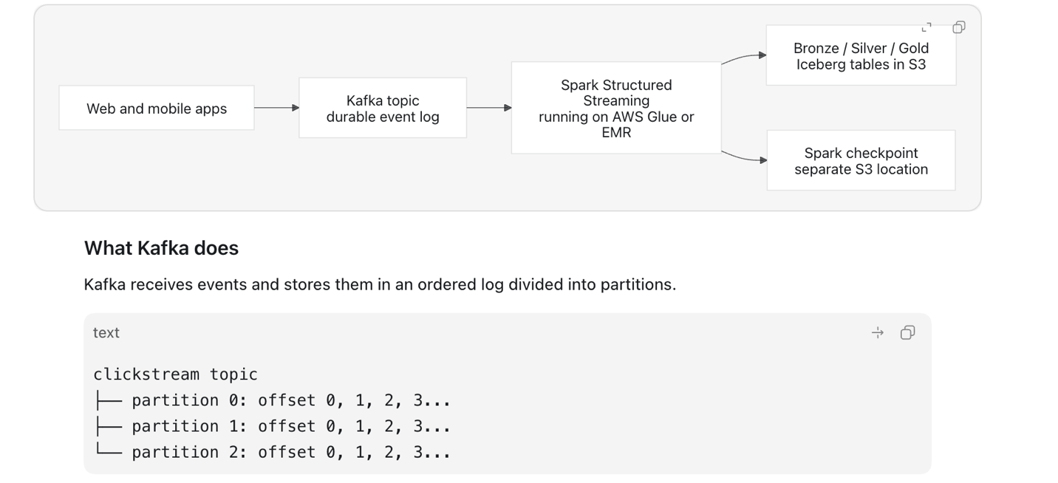
Each event receives an offset within its partition. Kafka retains the events for a configured period, allowing consumers to replay them.
Kafka’s responsibilities are:
- Absorb high event throughput.
- Buffer events if processing slows down.
- Preserve ordering within each partition.
- Allow consumers to read or replay events.
- Replicate events across brokers for durability.
On AWS, Kafka could run as Amazon MSK, which is AWS’s managed Kafka service.

Where Spark runs
Spark Structured Streaming is the consumer application. On AWS, it could run as:
- An AWS Glue streaming ETL job
- Amazon EMR
- Spark on EKS
For our design, we can choose an AWS Glue streaming job.
Spark continuously reads small batches of Kafka records:
Kafka offsets 100–199
↓
Spark micro-batch
↓
Validate and transform
↓
Write results to S3/Iceberg

Spark performs the actual work:
- Parse JSON.
- Validate schemas.
- Deduplicate events.
- Apply event-time windows.
- Calculate aggregates.
- Write Bronze, Silver, and Gold data.

What the durable checkpoint is
The checkpoint is maintained by Spark and stored in a durable location such as:
s3://clickstream-checkpoints/aggregation-job/
It records information such as:
- Kafka offsets processed by each Spark query
- Completed micro-batches
- Watermark progress
- Stateful deduplication information
- Window-aggregation state
Example:
Partition 0 processed through offset 500
Partition 1 processed through offset 620
Partition 2 processed through offset 475
If Spark crashes, a replacement Spark job reads that checkpoint and knows where to resume.

Kafka offsets versus Spark checkpoint
Component | Information it stores | Purpose
Kafka | Events and their offsets | Durable buffer and replay
Spark checkpoint | Processing progress and streaming state | Restore the failed Spark query
Iceberg | Committed table snapshots | Make S3 writes atomic and queryable
The essential idea is:
Kafka preserves the input. Spark processes the input. Spark’s checkpoint remembers processing progress. Iceberg safely commits the output.
A checkpoint reduces unnecessary replay, but replay can still occur around a failure boundary. That is why we also need event_id deduplication and idempotent output writes. These protections work together; none replaces the others.
```mermaid
flowchart LR
K["Kafka / Amazon MSK"] --> J1["Job 1<br/>Ingestion"]
J1 --> B["Bronze S3<br/>raw append-only events"]
B --> J2["Job 2<br/>validation + deduplication"]
J2 --> S["Silver Iceberg table<br/>clean unique events"]
S --> J3["Job 3<br/>five-minute aggregation"]
J3 --> G["Gold Iceberg table<br/>dashboard metrics"]
G --> A["Athena"]
A --> Q["QuickSight"]
```
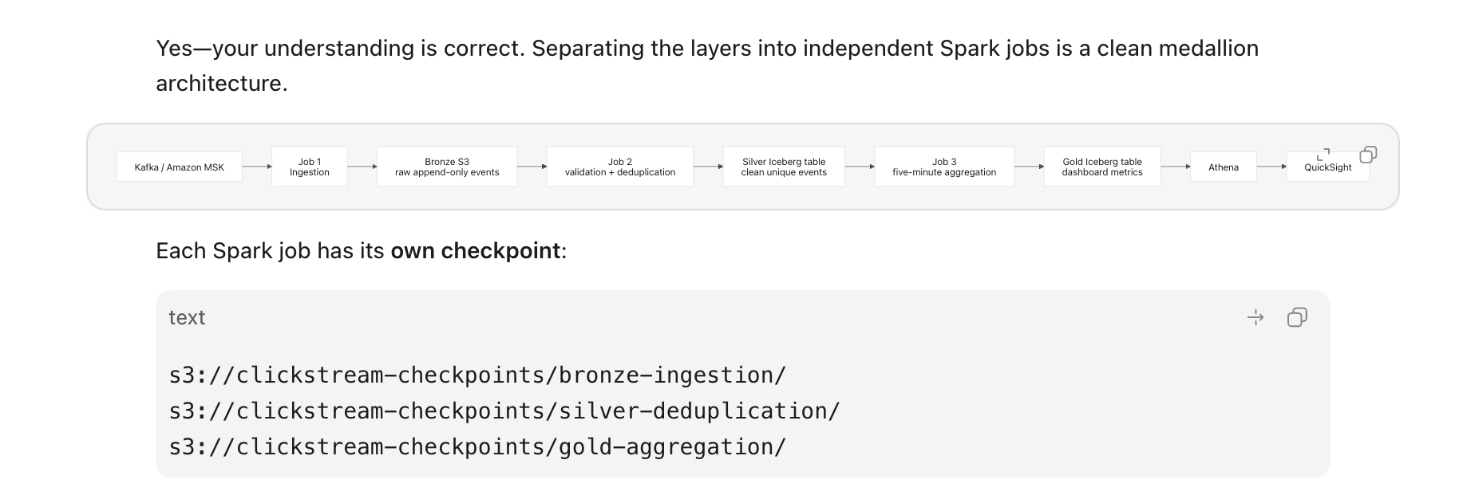

Job 1: Kafka → Bronze
This job:
- Reads Kafka.
- Adds Kafka topic, partition, and offset.
- Adds ingestion_time.
- Performs minimal parsing.
- Appends events to raw S3 storage.
- Preserves invalid and duplicate events for auditing and replay.
Bronze can be ordinary append-only Parquet files in S3. It does not require upserts.
s3://clickstream/bronze/event_date=2026-08-05/event_hour=10/

Job 2: Bronze → Silver
This job:
- Reads newly created Bronze files.
- Validates the schema.
- Standardizes timestamps and fields.
- Handles malformed records through a quarantine/DLQ path.
- Removes duplicates using event_id.
- Applies privacy transformations, such as masking IP addresses.
- Writes clean events into an Iceberg Silver table.
Silver benefits from Iceberg because it may require MERGE, corrections, deletions, and schema evolution.

Job 3: Silver → Gold
This job:
- Reads newly committed Silver events.
- Groups them into five-minute event-time windows.
- Aggregates by geography, customer segment, event type, and other dimensions.
- Handles late events with a watermark.
- Upserts corrected aggregates into a Gold Iceberg table.
For example, a Gold key could be:
(window_start, geography, customer_segment, event_type)

Why this separation is useful
- Bronze remains a trustworthy replay source.
- Silver owns event-level correctness.
- Gold owns business calculations.
- Each layer can fail or be reprocessed independently.
- Multiple Gold pipelines can reuse the same clean Silver data.
The trade-off is additional latency and operational complexity. To meet the five-minute dashboard SLA, each stage must process continuously or in short micro-batches—perhaps every 30–60 seconds—not as three separate five-minute jobs.
Your proposed structure is therefore valid and arguably clearer than a single Spark job writing all three layers. The refined version is:
Kafka buffers the events. The ingestion job appends them to Bronze. A second job produces deduplicated Silver events. A third job produces five-minute Gold aggregates. Each Spark job maintains a separate durable checkpoint.
Bronze
↓
One Spark job:
validate → deduplicate → aggregate
↓
Gold

That reduces storage because cleaned event-level records are not persisted separately.
This is reasonable when:
- Only the predefined Gold metrics are needed.
- Raw Bronze events remain available for replay.
- Few downstream consumers need cleaned event-level data.
- Recomputing from Bronze is acceptable.
- Storage cost is more important than reprocessing speed.
The trade-offs are important:
- Every new metric may require rereading and cleaning Bronze.
- Debugging is harder because no clean event-level dataset exists.
- Backfills become slower and more expensive.
- Multiple teams may implement different cleaning and deduplication logic.
- Privacy deletions and event-level investigations become more difficult.
- A Gold aggregation error requires replaying raw data.
Also, Gold is usually very small compared with Bronze and Silver. The storage decision is mostly whether to retain Silver—not Gold.
A balanced design would be:
Bronze: raw data, retained according to compliance policy
Silver: clean events, short retention such as 7–30 days
Gold: small aggregates, longer retention
Older Bronze data could move to a cheaper S3 storage class, while Silver is expired after the allowed replay and correction period.
For this particular interview, I would say:
“We can combine Silver processing and Gold aggregation into one Spark job to reduce latency and operational overhead, but I would initially retain Silver events for a short period. Silver provides a reusable, deduplicated source for debugging, late corrections, and new metrics. After 30 days, lifecycle policies can expire Silver while retaining compressed Bronze and compact Gold aggregates.”
That demonstrates cost awareness without sacrificing reliability and maintainability.

Question 3
The dashboard currently shows:
10:00–10:05 window
event_count = 1
At 10:20, late event E2 arrives with event_time = 10:02. The 30-minute watermark accepts E2 and assigns it to the same window.
Now Spark computes:
10:00–10:05 window
event_count = 2
How should the Gold Iceberg table safely change the existing count from 1 to 2 without creating a duplicate aggregate row?
Gold contains aggregated rows, so many event IDs contribute to one row. Its key should describe the aggregation dimensions:
(window_start, window_end, geography, customer_segment, event_type)

MERGE INTO gold_metrics AS target
USING recomputed_window AS source
ON target.window_start = source.window_start
AND target.geography = source.geography
AND target.customer_segment = source.customer_segment
AND target.event_type = source.event_type

WHEN MATCHED THEN
UPDATE SET event_count = source.event_count

WHEN NOT MATCHED THEN
INSERT (
window_start,
geography,
customer_segment,
event_type,
event_count
)
VALUES (
source.window_start,
source.geography,
source.customer_segment,
source.event_type,
source.event_count
);
The important detail is that Spark writes the absolute recomputed count, not an increment:
Initial Gold value: 1
E2 arrives
Recomputed value: 2
Gold updated to: 2
If the job fails and retries:
Gold currently: 2
Retry writes: 2
Final value: 2
It must not do this:
SET event_count = target.event_count + source.event_count
That could produce 3 after a retry.
So the complete answer is:
“Silver deduplicates individual events using event_id. Gold uses the event window and aggregation dimensions as its compound key. When E2 arrives, Spark recomputes the affected window’s absolute count as 2 and upserts that value into the Gold Iceberg table. Retrying the same update still writes 2, making the operation idempotent.”
That completes the E1/E2 failure scenario:
- Checkpoint: enables recovery.
- Silver event_id: removes replayed E1.
- Watermark: accepts late E2 into its event-time window.
- Gold idempotent upsert: safely changes the aggregate from 1 to 2.
Exactly—recomputing the entire Gold table for every new event would be unnecessarily expensive. Gold is updated incrementally by event-time window.
For this design, use five-minute tumbling windows:
10:00–10:05
10:05–10:10
10:10–10:15
Spark maintains temporary aggregation state for each active window:
Key:
(window_start, geography, customer_segment, event_type)

State:
event_count, unique_users, session_count, etc.
When E2 arrives with event_time = 10:02, Spark recomputes only its affected key inside the 10:00–10:05 window. It does not scan or rebuild the whole Gold table.
E2
↓
Determine event-time window: 10:00–10:05
↓
Update that window’s in-memory/state-store aggregate
↓
Upsert only the affected Gold row

When does the window become final?
We have:
- Window size: 5 minutes
- Allowed lateness/watermark delay: 30 minutes
The 10:00–10:05 window stays eligible for corrections until the watermark moves beyond the window’s end. Approximately:
Window ends: 10:05
Allowed lateness: +00:30
Approximately finalized: 10:35
The dashboard does not wait until 10:35. It can show an initial result around 10:05 and receive corrections until the window is finalized.
10:05 → Publish preliminary count
10:20 → E2 arrives; update count
10:35 → Window becomes final and Spark removes its state
An event arriving after finalization can be:
- Sent to a late-events table for audit
- Corrected later through a scheduled backfill
- Discarded only if the business explicitly accepts that loss

Efficient Gold storage
Partition Gold by a coarse time field, such as:
event_date
Potentially add hour if volume justifies it:
event_date=2026-08-05/event_hour=10
Do not create one physical partition per five-minute window; that usually creates excessive small partitions.
So the principle is:
Gold is computed incrementally for active five-minute windows. The 30-minute watermark determines how long those windows remain correctable. Only affected aggregate rows are upserted—not the entire Gold table.

Data model
Table1 web table
Event_type , system , cust_id, , sessionid , act id
Mobile2 table
Event_type , system , cust_id, , sessionid , act id
Address
city, state , country, sessionid, eventid
Device
Session id , device id , ip address

batch vs. streaming,
streaming upfront using kafka to read events fast the batch processing of events in 5 mins interval to athena so that report has 5 min atmost delayed data
scaling,
as data increase multi thread processing to support the load over years
reliability, -- stored in s3 raw data so its reproduceable and re run the intermediate stages
observability, -- scheduled jobs are monitored and restarted on any failures with alert mechanism
data quality, raw data is cleaned and process for nulls , date format , data format for key elements like event id , event type , session id
security, IAM enabled so only authorized folks/team can view raw / processed data along with dashboards under controlled groups
cost, x TB * rate + processing charge + dashboard visualization cost
and follow-up questions

You successfully covered:
- Requirement gathering
- Capacity estimation and unit correction
- Kafka ingestion and Spark Structured Streaming
- Bronze, Silver, and Gold layers
- Spark checkpoints versus Kafka offsets
- Event-level deduplication using event_id
- Five-minute event-time windows
- Thirty-minute watermarks
- Late-arriving events
- Iceberg tables and atomic upserts
- Idempotent Gold aggregation
- Storage-versus-correctness trade-offs
Your strongest improvement was recognizing that recovery requires several mechanisms working together:
Kafka → retains and replays input
Checkpoint → restores Spark progress and state
Silver → deduplicates by event_id
Watermark → permits bounded late arrivals
Gold upsert → safely corrects aggregate values
Your main practice area is capacity math with units. Always write every conversion explicitly.
Optional 15-minute homework:
Draw the final architecture from memory and explain the E1/E2 failure scenario aloud in under three minutes.
Architecture

s3 silver -event_id
Validation + deduplication on event_id
Ingestion to s3 spark job
Raw data s3 bronze
Kafka

Raw replayable /audit
athena

aggregation
quicksight
E1 failure – why replaying E1 dosen’t create duplicate

Replaying from the offset kafka reprocess the E1 and populates the raw s3 bronze but job spark ensures silver is duplicated using upsert
E2 how watermark with 30 min allow E2 to be part of
E2 arrives at 10:20 with event_time as 10:02 with watermark 30 min 9:50 , spark reads the event_time and put in window of 10:00 – 10:05 . Before agg was count 1 now count 2

